+

Postgraduate/Distance Learning
Assignment coversheet & feedback form

THIS SHEET MUST BE THE FIRST PAGE OF THE ASSIGNMENT YOU ARE SUBMITTING (DO NOT SEND AS A SEPARATE FILE)

For completion by the student:
Student Name: Nadine Fruin

Student University Email: 2020140@student.uwtsd.ac.uk
Module code:  HPCA7015  Module title:  Foundations in Cultural Astronomy and Astrology | Student ID number:  2020140 |  |  | Educational support needs:  Yes/No
Assignment title:
Are perceptions of the cosmos culturally conditioned?

Assignment due date: 10 June 2024
This assignment is for the 1st 2nd 3rd 4th 5th 6th module of the degree
I confirm that this is my original work and that I have adhered to the University policy on plagiarism.
Signed …Nadine Fruin…………………………………………………………
Email submission:if you are submitting this form via email, please tick this box □
(as a substitute for your signature) to confirm that you agree to the above declaration.
Assignment Mark
1st Marker’s Provisional mark
2nd Marker’s/Moderator’s provisional mark
External Examiner’s mark (if relevant)
Final Mark

NB. All marks are provisional until confirmed by the Final Examination Board.

For completion by Marker 1 :
Comments:

Marker’s signature: |  |  | Date:
For completion by Marker 2/Moderator:

Comments:

Marker’s Signature: |  | Date:
External Examiner’s comments (if relevant)

External Examiner’s Signature: |  | Date:

Are perceptions of the cosmos culturally conditioned?

This essay investigates if perceptions of the cosmos are culturally conditioned or if there is some essential reality to cosmologies. This is done by analysing and comparing the perception of the cosmos, in particular the artistic representations, in regard to black holes in the era of modern science and comparing it to dark matter in ancient Egypt. The paper starts with defining cosmology, black holes and culture, continues with the literary and pictorial expressions of black holes, followed by ancient Egyptian understanding of darkness and creation. It then compares the modern science’s approach and view to the ancient Egyptian’s and ends with a conclusion.

The root of the word cosmology is the Greek kosmos, meaning order as well as adornment. The manner in which Western scholars practice cosmology is as a science, the study or theory of the universe and its laws as an orderly system and specifically the study of the structure and evolution of the universe. Primack and Abrams define it as: ’Cosmology is a branch of astronomy and astrophysics that studies the origin and nature of the universe..’ Part of the study is trying to understand black holes, a term introduced by J.A. Wheeler, a theoretical physicist, in 1967. The mere existence of black holes troubled modern scientists so much they initially avoided studying them and even negated the fact they could exist. Wheeler himself writes about his intellectual struggles regarding the existence of black holes, namely that the mere idea of collapse of stellar masses ‘went against his grain. I just didn’t like it. I tried my hardest to find a way out, to avoid compulsory implosion of great masses ‘ The search for the factual, ‘observable’ truth of black holes, accepting their existence and the consequences for modern man and how he sees his place in the cosmic scheme of things, as well as if and how his view influences or is influenced by his culture, addresses the aim of this paper. A brief history therefore is necessary.

A black hole, mathematically speaking is ‘..as an infinitely dense, infinitesimally small point, surrounded by an unknowing sphere from which we get no light and no information’. From an astronomical perspective, a black hole is ‘an astronomical object with a gravitational pull so strong that nothing, not even light, can escape it’. (Figure 1) Einstein’s General Theory of Relativity, published in 1915 marked the beginning of the modern study of black holes. He made two major predictions which led to confusion and upheaval within the scientific community. The first one was it is the fate of massive stars to collapse behind an event horizon to form a ‘black hole’ and that the black hole will contain a singularity. An event horizon is, according to NASA, a notional boundary around a black hole beyond which no light or other radiation can escape, because the velocity needed to escape the black hole exceeds the speed of light, which is the speed limit of the cosmos. The black hole, collapsing behind this event horizon will contain a singularity, which is described as a moment, rather than a place and where the laws of Nature as humankind currently knows, don’t exist anymore. The Theory of Relativity indicates that the singularity lies at the end and at the beginning of (our) time: just before and at the moment of the Big Bang.

The confusion created within the scientific community by Einstein’s theory was, since black holes were not observable, Nature’s behavior of collapsing stars creating a black hole where no light could exit from and the existence of a singularity where there was no time, were so farfetched that this was a mere part of General Relativity’s mathematics, and Nature would ‘surely avoid creating them’. It was considered a mathematical possibility, but a natural impossibility. Einstein wrote in 1939 that ’black holes do not exist in physical reality’.

The consequence of the Theory of Relativity was modern scientists had to accept gravity was in its core related to space and time and it invited the formulation of a scientific theory about the end and beginning of time and that black holes played a major role. More precisely, a singularity sits at the center of a black hole and black holes are at the center of every galaxy ; every one incorporates the end and beginning of time. The intellectual disbelief of Einstein, Wheeler and modern scientists in general black holes could physically exist and were more than a mathematical possibility was grounded in the beliefs they, and other scientists of astronomy and astrophysicist academia, held to be possible and true. The question arises if their disbelief and initial negation of black hole reality was culturally defined.

Culture is to this day a very complex word to define and due to this difficulty, as Williams observes, this essay takes a broad approach to the word. The word cultura, from the latin colere has a range of meanings: ‘cultivate, protect, inhabit, honour with worship.’ He also adds the meaning that culture is ‘a particular way of life, whether of a people, a period, a group, or humanity in general, from Herder and Klemm.’ Modern scientists of astronomy, astrophysics and cosmology, in their desire to study the origin and nature of the universe, approach their studies from their particular way of life, which implies a particular view of and approach to life. Their particular approach is mathematical, opening the door to a calculated possibility, but it is also reality grounded in the observable and verifiable. In this sense their particular way of and approach to life, through modern science, can be termed as their culture.

Modern science, including astronomy, cosmology and astrophysics, up until Einstein, held the view of the cosmos defined by Newton (1642-1727). This view stated gravity was a force acting between masses, space and time existed independently from each other, were not influenced by planetary masses and the spin axis of a gyroscope would remain fixed with respect to absolute space. Einstein’s Theory of Relativity completely changed the Newton based worldview because he showed space and time have an absolute existence and are interwoven ‘into a single fabric called spacetime’, spacetime defines how matter moves and matter influences spacetime into curving and twisting and massive rotating bodies., e.g. earth, twist and curve their local spacetime. Thus, according to Einstein’s view of the cosmos gravity is spacetime curvature and ‘the spin axis of an orbiting gyroscope follows the warping and twisting of spacetime around earth.’ Summed up "matter tells spacetime how to curve, and curved spacetime tells matter how to move".

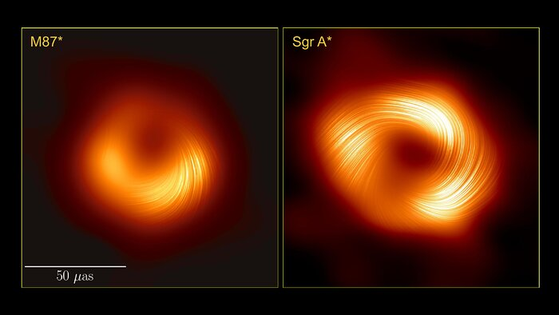
Newton’s order of the cosmos, which modern scientists had adopted as correct and proven, was disturbed and efforts were made to disprove the resulting discovery of black holes. The reality and behaviour of black holes, based on mathematical calculations and intellectual theories, were not as modern scientists and society had envisioned. Modern scientists’ intellect was shaken out of its view and belief of humankind’s creation and brought about an inner strife of having to accept theoretically, through mathematics, black holes could exist but feeling intellectually secure Nature would never physically ‘allow’ them to materialize. Academia and modern man’s particular view of life, their culture, defined what they considered cosmologically possible and impossible. Only when the evidence through observations were no longer avoidable, did academia accept the reality of black holes. Ergo, their perception of the cosmos was culturally conditioned.

The question arises, however, if there is an essential reality to the cosmos and to the reality of black holes. The accepted facts are black holes are at the core of every galaxy and they contain a singularity, a moment where the laws of nature as we know don’t exist. The singularity lies at the end and at the beginning of all time, before the Big Bang. Is there an essential reality of creation and is it only noticeable and known now, because humankind has the technology to see and photograph black holes or was this essential reality known to civilizations before the advent of science as modern man practices it? If this essential reality exists and was tapped into by earlier civilizations Plato’s writings about ‘Ideas’ or ‘Forms’ being the source of manifestation and Carl Gustav Jung’s archetypes and collective unconsciousness do not sound as far off possibilities. ‘Essentialism’ or ‘Universalism’ propagate an essence, a psychic idea or form, archetypes, underpinning the world as we know it, manifesting in the physical world and experienced through cultural expressions. Jung describes archetypes as

…the connection of spontaneous modern symbolism with ancient theories and beliefs is not established by direct or indirect tradition…It seems that their (his patients: author’s addition) unconscious worked along the same line of thought which has manifested itself time and time again in the last two thousand years. Such a continuity can only exist if we assume a certain unconscious condition as an inherited a priori factor…the inherited quality to be something like the formal possibility of producing the same or similar ideas over and over again. I have called this possibility the ‘archetype.

The a priori factor, the idea, the symbol which expresses itself over and over again can be explored in art, expressed in this case in the description and depiction of dark matter, of the end and beginning of time, of creation of the cosmos. Art could give clues and possible answers to the question if an universal essence exists.

Anish Kapoor, born in 1954, made pieces of art, black holes, using nanotechnology called ‘Vantablack’, created by Surrey NanoSystems in 2014 and a material which absorbs 99.8 percent of all visible light. Vantablack gives the impression it is completely flat due to its darkness. Kapoor played with the perception of darkness in his numerous pieces of art, particularly black circles or holes. Figure 2, when standing directly in front of the black hole, gives the impression of looking into a black surface, a flat void. However, looking at the black holes from the side, they are not flat but curved inwards. In Figure 3, an outer bulge, a curvature emerges which, when standing directly in front of it, cannot be seen. When moving to the side the curvature can be noticed. Figures 4 and 5, screenshots from a video, clarifies the point.



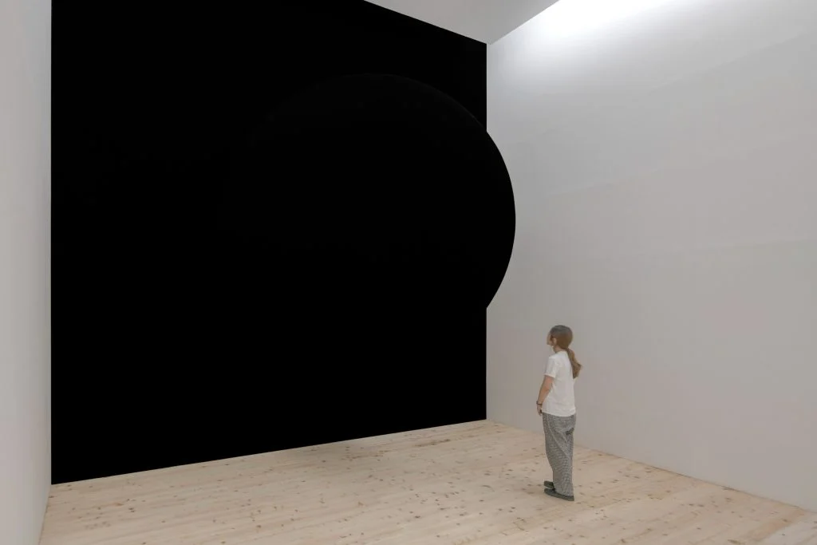

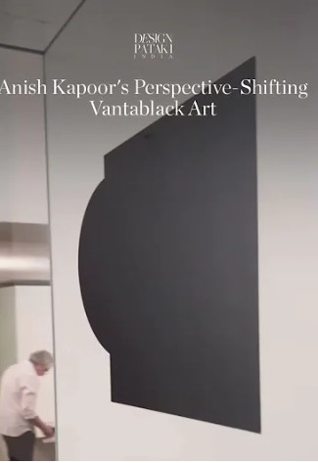



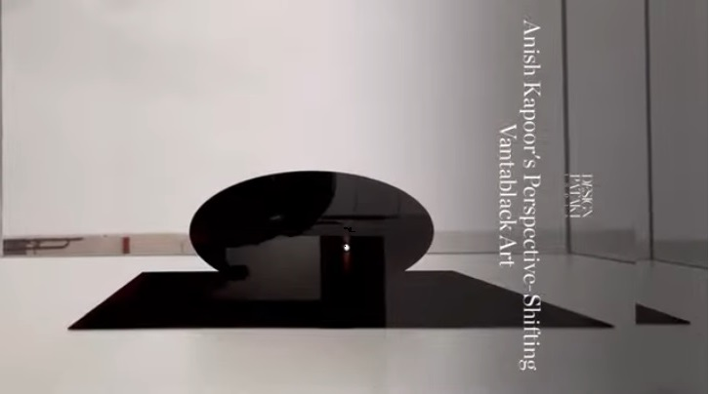

Kapoor created multiple works of art using Vantablack and imagined the black holes, the black dark void as the beginning of creation. For example, figure 7 depicts the origin of the world. Although he is not a cosmologist or astronomer the investigation by academia into black holes and seeing that within them all creation ends and begins might have impacted his approach to and view of black holes and the cosmos, so this view would be culturally conditioned. However, the direct relationship between academic knowledge on black holes and Kapoor is not clear so it could be argued the blackness of Vantablack triggered ‘other resources’ as he indicates himself in an interview: “Imagine a space that’s so dark that as you walk in you lose all sense of where you are, what you are, and especially all sense of time.” In such an environment, he believes, “something happens to your emotional self and in disorientation one has to reach in for other resources”.

The other resources, having to reach in, have possibly brought Kapoor to the underlying essence of life and its creation. Did he tap into the collective consciousness and emerge with the image of an archetype? Figure 5 shows a dark mass protruding out and when this figure is rotated, figure 6, it seems as if a dark mound rises out of darkness. The first computerized visualization of a black hole, figure 8, created in 1979 by the French cosmologist Jean-Pierre Luminet shows a mound surrounded by a ring of light around a black hole. He suggested this might accurately show the nucleus of a black hole.

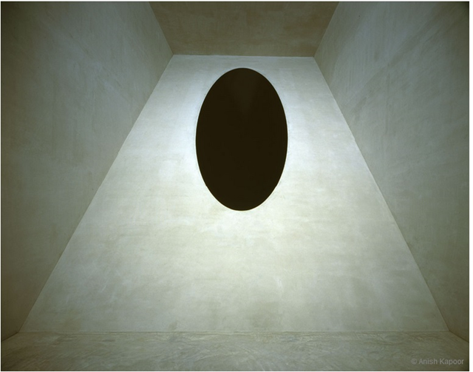

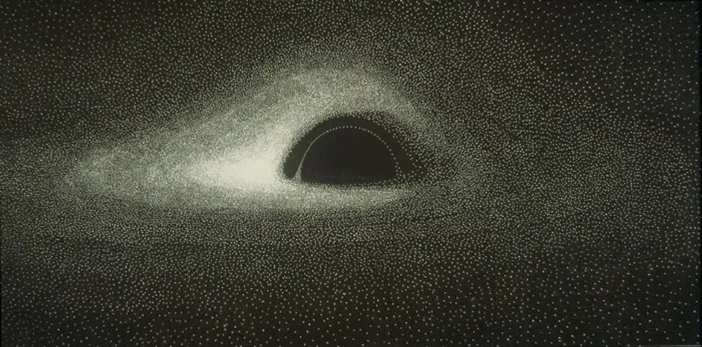

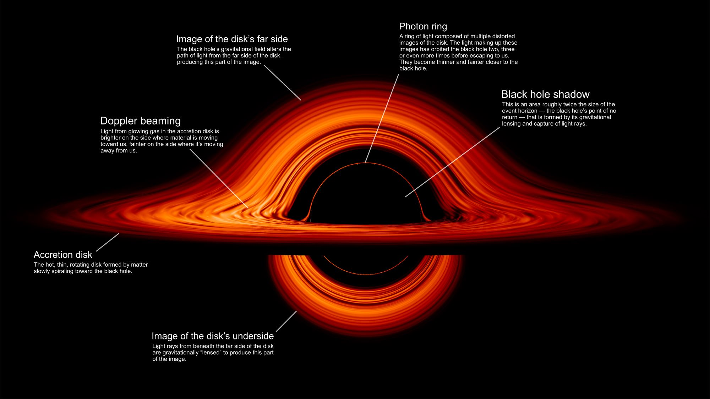

Luminet produced an image which was very close to the infographic NASA created in 2023, figure 9, to illustrate the characteristics and form of a black hole including the accretion disk, the matter swirling towards the black hole seen as light. Seen from a different perspective the infographic created by ESO, figure 10, helps to understand the image produced.

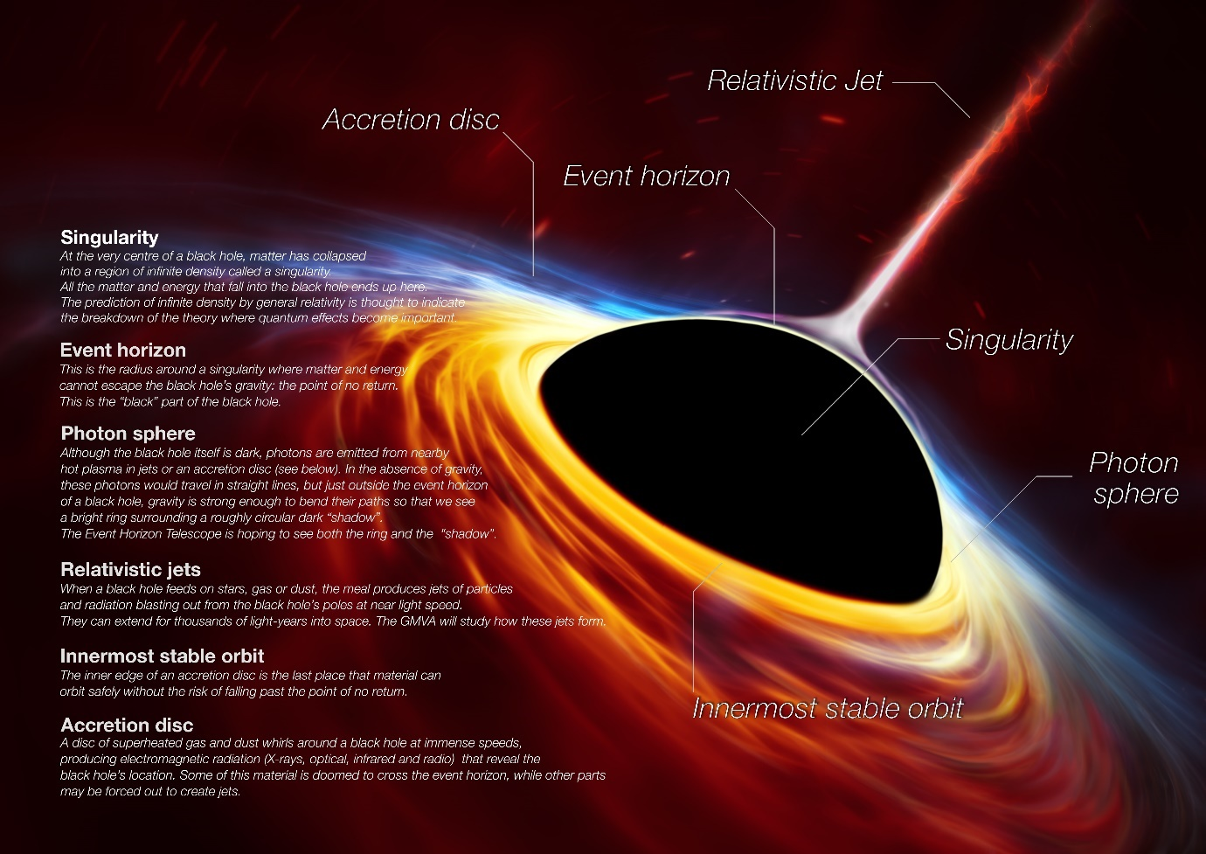

The representations of NASA, ESO and Luminet show a similar image: a black half sphere, a black mound protruding out of swirling cosmic matter into space. It is not surprising they have created a similar image since the findings of modern scientists led to this imagery. Kapoor’s depiction of the void in figure 6, a mound is emerging from black matter shows a similar depiction as Luminet, NASA and ESO’s pictures.

To investigate if a universal and transhistorical essence is at the core of reality and at the core of creation before the Big Bang the ancient Egyptian creation myth, more specifically the original, primeval creation event can shed light. James P. Allen writes about ‘The World Before Creation’ and that all centres of power considered they came from a state ‘Before the world was created the universe was a limitless ocean, whose waters stretched to infinity in all directions’ called Nun. Nun was called the watery one, was infinite, ‘lay in perpetual darkness’, was ‘hidden’ and was also characterised as ‘lostness’ This primeval water was not a real sea but a ‘black and formless Watery Abyss’ The act of creation was a mound of earth emerging from these primeval waters on which the Ogdoad stood: “the fathers and mothers of the sun disk … they floated in attendance on him and came to stand on the high hill from which the sun’s lotus arose” From the primeval mound the sun shone out as a lotus, giving the world light after darkness (figure 13). The importance of this imagery was such that many ancient Egyptian temple sanctuaries had a mound of earth within their walls and the hieroglyph depicting a mound with a sun band, figure 11, or sunrays, figure 12, commemorate the act of creation; the hieroglyph means to “appear”. What modern scientists call the Big Bang.

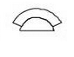


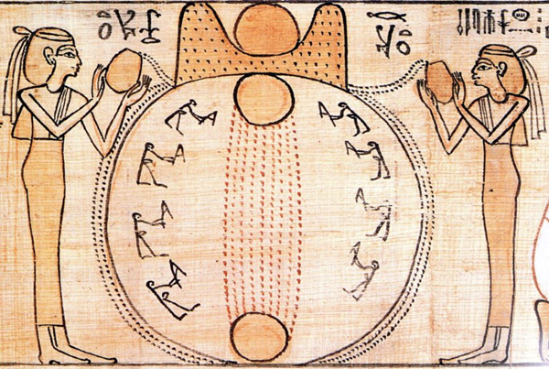

The description and imagery ancient Egyptians used to depict the primeval creation event, as the watery one, dark and hidden, evokes the ESO image, where the swirling matter can be seen and described as an ocean with tides and waves within whose centre the black hole is in a state of being, perpetually dark according to the Egyptians and hidden, for beyond the event horizon and within the centre of the singularity, unseen, the moment of pre-creation lies. From this dark sphere, the mound emerges and blasts relativistic jets of light into space, as depicted in the hieroglyph with the rays of light, appearing, (figure 12) as the sun’s lotus and seen in ESO’s infographic. The ancient Egyptian’s Atum, the Creative Principle pushed out the sun from the dark Abyss. ‘The creation of light was thus the first phase in the transition from the Primeval Watery Abyss to the existence of heaven and earth—the crucial turning point between eternal nothingness and the beginning of everything.’ Figure 13 shows the ancient Egyptian image of the mound, the black hole, from which the light and creation rises.

Kapoor’s art, Luminet’s simulated photograph, NASA’s infographic and particularly ESO’s artistic impression are very similar to the ancient Egyptians’ depiction of primeval creation. All show the beginning and end of creation as darkness, a void from which a mound emerges emitting rays of light, the beginning of heaven and earth. How can it be the images are so similar and creation and pre-creation are perceived in the same way by cultures with thousands of years between them? An explanation is this image is, as Jung states, a primeval image, an archetype: the unconscious manifests itself time and time again. Huxley describes a similar idea stating ‘The ground in which the multifarious and time-bound psyche is rooted is a simple, timeless awareness.’ The timeless awareness of humankind manifests through the ages and although the primeval image is depicted according to the cultural language of the era humankind lives in, the archetype is present. Kapoor speaks of the timelessness, losing the sense of time, when he gazes into a Vantablack hole and being urged to delve within himself for other resources. The other resources might well have been his ability and intuition to grasp the primeval image from the depths of the swirling sea of the collective unconscious.

The aim of this paper was to investigate through pictorial and literary art of black holes and dark matter if perceptions of the cosmos are culturally conditioned or if there is some essential reality to cosmologies. This was done by comparing modern humankind’s knowledge and imagery of black holes with ancient Egypt’s artistic expressions. Cosmology for modern scientists is the study and theory of the nature and origin of the universe and their culture, their particular way of life, as defined by Herder and Klemm, is a particular approach and a view of life based on mathematical theory and telescopic observations. Through their studies academia was forced, albeit resistance and disbelief, to accept the reality and behaviour of black holes, within whose centres the beginning and end of galactic creation lies, before the Big Bang. This adjustment of their views on the nature and creation of the universe showed modern scientists’ perceptions of the cosmos were culturally conditioned. The comparison with ancient Egyptian literary and pictorial representations of dark matter and the primeval creation event about the world before creation speaks of a limitless ocean in perpetual darkness, a black and formless watery abyss and hidden from which a mound of earth emerges and the sun shines, giving the world light after darkness. The image conveyed, particularly the mound emerging out of darkness, is similar to the art of Kapoor and the depictions of Luminet, NASA and in particular with the ESO infographic, making a case for the existence of an archetype, an essence to reality, an idea which expresses itself over and over again, as Jung writes, from ancient Egypt to the 21st century. Thus, the answer to the title of the paper is twofold: an essential reality exists, noticeable in the archetypical image of creation, but the (artistic) language used to depict this essential reality is culturally conditioned.

Bibliography

Allen, James P., Middle Egyptian, An Introduction To The Language And Culture Of Hieroglyphs, (Cambridge
University Press, 2014)
Campion, Nick, Astrology and Cosmology in the World’s Religions, (New York University Press, 2012)
Cascone, Sarah, Artnet, (2023), <https://news.artnet.com/art-world/anish-kapoor-vantablack-2391684>
[Accessed May 21, 2024]
Cox, Brian and Forshaw, Jeff, Black Holes, the Key to Understanding the Universe, (Dublin:
HarperCollins, 2022)
ESO (European Southern Observatory), <https://www.eso.org/public/images/eso1907h/> [Accessed May 25,
2024]
Hetherington, Norris D., The Encyclopedia of Cosmology: Historical, Philosophical and Scientific Foundations
of Modern Cosmology (New York: Garland, 1993)
Huxley, Aldous, The Perennial Philosophy, (London: Chatto & Windus, 1947)
Jung, Carl Gustav, Psychology and Religion, (New York: Princeton University Press, 1969)
Lesso, Rosie ‘What Is Anish Kapoor’s Connection To Vantablack’, The Collector, (2022),
<https://www.thecollector.com/what-is-anish-kapoors-connection-to-vantablack/> [Accessed April 7, 2024]
Luminet, Jean-Pierre, ‘Image of a Spherical Black Hole with Thin Accretion Disk’, Astronomy and
Astrophysics, 75 (1979)
NASA (National Aeronautics and Space Administration),
<https://www.nasa.gov/universe/what-are-black-holes/> [Accessed April 15, 2024]
Primack, Joel R. and Abrams, Nancy Ellen, The View From the Center of the Universe: Discovering Our
Extraordinary Place in the Cosmos, (Penguin Publishing Group. Kindle Edition, 2006)
Smethurst, Becky, A Brief History of Black Holes, (Pan Macmillan. Kindle Edition, 2022)
The Stanford Encyclopedia of Philosophy, <https://einstein.stanford.edu/SPACETIME/spacetime2.html>
[Accessed April 20, 2024]
The Creation of the World, Book of the Dead of Khensumose, c. 1075–945 B.C.E., Twenty-first Dynasty
(Kunsthistorisches Museum, Vienna)
Williams, Raymond, Keywords, A Vocabulary Of Culture And Society (New York: Oxford University Press,
1983)

Nick Campion, Astrology and Cosmology in the World’s Religions, (New York University Press, 2012), p.4.
Norris D. Hetherington, The Encyclopedia of Cosmology: Historical, Philosophical and Scientific Foundations of Modern Cosmology (New York: Garland, 1993), p.116.
Joel R. Primack and Nancy Ellen. Abrams, The View From the Center of the Universe: Discovering Our Extraordinary Place in the Cosmos, (Penguin Publishing Group. Kindle Edition, 2006), p.4.
Brian Cox and Jeff Forshaw, Black Holes, the Key to Understanding the Universe, (Dublin: HarperCollins,2022), p.15.
Cox and Forshaw, Black Holes, the Key to Understanding the Universe, pp.15-16.
Becky Smethurst, A Brief History of Black Holes, (Pan Macmillan. Kindle Edition, 2022), p. 4.
NASA, Black Holes, 2020 <https://www.nasa.gov/universe/what-are-black-holes/>
Cox and Forshaw, Black Holes, the Key to Understanding the Universe, p.2.
NASA, Black Holes, 2020 <https://www.nasa.gov/universe/what-are-black-holes/>
Cox and Forshaw, Black Holes, the Key to Understanding the Universe, p.2.
Cox and Forshaw, Black Holes, the Key to Understanding the Universe, p.3.
Cox and Forshaw, Black Holes, the Key to Understanding the Universe, p.3.
Cox and Forshaw, Black Holes, the Key to Understanding the Universe, p.16.
Raymond Williams, Keywords, A Vocabulary Of Culture And Society (New York: Oxford University Press, 1983), p.87.
Raymond Williams, Keywords, A Vocabulary Of Culture And Society, p.87.
Raymond Williams, Keywords, A Vocabulary Of Culture And Society, p.90.
The Stanford Encyclopedia of Philosophy, Einstein, 2007, <https://einstein.stanford.edu/SPACETIME/spacetime2.html>
Carl Gustav Jung, Psychology and Religion, (New York: Princeton University Press, 1969), pp. 187-188.
Jung Psychology and Religion, pp.103-104.
Rosie Lesso, ‘What Is Anish Kapoor’s Connection To Vantablack’, The Collector, (2022), <https://www.thecollector.com/what-is-anish-kapoors-connection-to-vantablack/>
Sarah Cascone, Artnet, (2023), <https://news.artnet.com/art-world/anish-kapoor-vantablack-2391684>
Jean-Pierre Luminet, ‘Image of a Spherical Black Hole with Thin Accretion Disk’, Astronomy and Astrophysics, 75 (1979), p.235.
ESO, black hole, (2019), <https://www.eso.org/public/images/eso1907h/>
James P. Allen, Middle Egyptian, An Introduction To The Language And Culture Of Hieroglyphs, (Cambridge University Press, 2014), pp.159-160.
Primack and Abrams, The View From the Center of the Universe, p. 44.
Allen, Middle Egyptian, p.160.
"The Creation of the World,", Book of the Dead of Khensumose, c. 1075–945 B.C.E., Twenty-first Dynasty (Kunsthistorisches Museum, Vienna)
Allen, Middle Egyptian, p.161.
Primack and Abrams, The View From the Center of the Universe, p.45.
Jung, Psychology and Religion, p.131.
Aldous Huxley, The Perennial Philosophy, (London: Chatto & Windus, 1947), p.38.
Raymond Williams, Keywords, A Vocabulary Of Culture And Society, p.90.
Jung Psychology and Religion, pp.103-104.

