Lewis Jones 1804902
lewis.jones150394@hotmail.com
Course: MSc Engineering Project Management
Supervisor: Andrew Thorn

Creating a SOLIDWORKS flow simulation to accurately determine damper pressure drop
DISSERTATION INTERIM REPORT

Table of Contents
Introduction 2
Identification of Problem & Reason for Project 3
Aims & Objectives of Project 4
Project Aim 4
Project Objectives 4
Project Plan 4
Research 4
Design & Construction of Test Rig 5
Damper Testing & Simulation Design 7
Simulation Validation 7
Project Plan 8
Researched Literature 9
References 14
Appendix 1 (Gantt Chart) 0

Introduction

With the increasing request from clients to confirm how a Flamgard Calidair damper affect the air pressure and flow within a duct to accurately determine fan velocity to enable a continuous air supply in buildings, Flamgard’s R&D department would have to construct a damper and physically test each unit to be able to answer this question. This often-created time delays and cost to the business as the labour required to carry out these tests were high; therefore, it was determined a Computational Flow Dynamics (CFD) simulation could be created to allow the company to provide rapid answers to this question and save money by not having to carry out extensive pressure drop testing.
The first stage was to create a pressure drop rig that utilised three different sizes of dampers to create a suitable date range to ensure accuracy of the simulation design, it was important this rig must conform to the industry standard British Standards document number EN 1751. Once constructed, dampers going through the production prosses could be tested to create a data sample to allow the author to compare any simulated values and ensure an accuracy of at least 10%. The author would then research various academic journals to optimise the simulation design and consider others experience and limitation of working with CFD simulations.
The research conducted determined there were several key points the author must consider when constructing the simulation. Firstly, was the validity of using the software SolidWorks, it was determined the ease of use of the flow simulation package and its increased use within modern industry such as Ramlan AND Darlis (2020) who described its use in the automotive sector. Secondly, the importance of setting up correct boundary conditions to the simulation. Research showed boundary conditions connect the simulation model to its surroundings and without properly defined conditions results are inaccurate and unreliable (Ahmadi AND Sefidwash, 2018). Finally, the author investigated methods of meshing the simulation by comparing a structure grid and an un-structured method, while also discussing the use of a Cartesian immersed-body mesh.
Finally, a project plan has been created to help guide stakeholders, sponsors, teams and the author through the various project phases. This also allows the author to break down the large-scale project into more manageable goals making sure the final outcome is achieved within the allotted time frame.

Identification of Problem & Reason for Project

Flamgard Calidair is a leading authority in the design and manufacture of high-quality and integrity specialist Heating Ventilation and Air Conditioning (HVAC) dampers and associated equipment. With our products having a global operation across multiple industries as diverse as Nuclear, Oil & Gas, Power Generation and Tunnel & Metro. In order to maintain this status, the company has focused upon innovation and further R&D to further improve projects and to ensure the company remains competitive in all markets. However, with any changes to original dampers tests need to be carried out to ensure compliance to relevant standards and the highest quality is maintained.
One test that is often carried out after new product design is what’s described as a “pressure drop” test. It aims to test the difference in air pressure in the ductwork on one side of the damper compared to the opposite which various industries refers to as the pressure drop. As air is drawn though a HVAC system with a damper fitted, that damper will create a resistance to the airflow (Marivani AND Hamed, 2017). Thus, any additional features added to the damper (such as insulation) can cause an increased pressure in the duct wasting energy and accelerating the wear and tear of the fan, as it must work harder to maintain the desired flow rate. Therefore, carrying out this test will determine the additional pressure caused by the damper and whether any design changes have increased the pressure to undesirable levels.
For this test to be carried out the damper first must be manufactured at 1m² to fit on the existing test rig owned by the business. However, this is manufactured at cost to the business including materials and labour. Furthermore, if there are any changes to the design as a result of the testing, the damper must be re-manufactured incurring further costs. To combat this, it is proposed that a simulation be created to test the damper in the design stages of the project to both reduce the cost significantly and time required to carry out testing. This ensures that Flamgard Calidair products at the forefront of HVAC damper technology and customer can receive accurate pressure drop data rapidly.

Aims & Objectives of Project

Project Aim

The aim of this project is to research and create a flow simulation using the CAD software SolidWorks to accurately predict the effect of pressure drop of a HVAC damper within a duct.

Project Objectives

To achieve the desired outcome, the objectives required will be illustrated below.

Project Plan
The initial phase is to create a project plan with the aid of Microsoft Excel, thus ensuring the project will be completed within the agreed upon time. A Gantt Chart then can be constructed using the same software which is required to track the progress of project related activities and will be come the focal point for ensuring timely completion of the project. The Gantt Chart will also indicate key milestones with durations of activities which to be reviewed regularly, while highlighting activities that are critical to the project also referred to as the critical path. This method will similarly allow the team to locate any “float” within project activates so resources can be allocated effectively to more critical tasks.

Research
Qualitative research will be carried out to establish the best methodology for the testing and any relevant standards associated with damper pressure drop. Initial research indicated this form of testing is specified in the British Standards document number EN 1751,
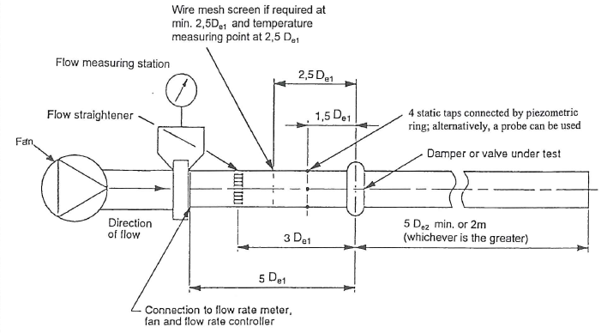
Figure 1 - BS EN 1751 Typical Test Arrangement
The test rig must be created to this figure and all test must be carried out in accordance with this document to ensure the simulation is in conformance to industry standards. Furthermore, academic papers will be reviewed to establish the best methods of optimising a Computational Flow Dynamics (CFD) simulation. As some details such as modelling and meshing strategies can have a significant impact on simulation accuracy (Zhou et al., 2017). For example, if the upstream section in a CFD model is not sufficiently long, the simulated flow of the element may not have fully developed before entering the test subject section, disrupting the essential requirement for flow coefficient calculation (Lisowski AND Rajda, 2013).

Design & Construction of Test Rig
As stated above the test rig must be designed to BS EN 1751 to ensure conformance to industry standards. Furthermore, in order to ensure the maximum number data is available for the simulation three duct sizes will be constructed, one at 300mm², 600mm², 1m². The preliminary sketches below show the initial rig design while factoring relevant standards.

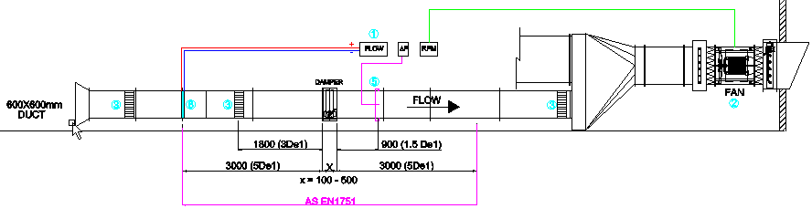
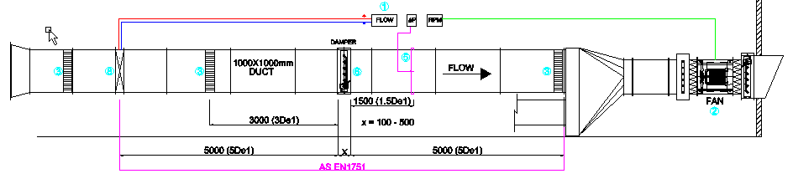
Figure 2 - 1m x 1m Test Rig Section
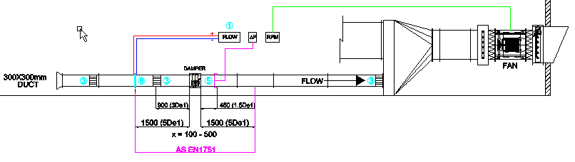
Figure 3 – 600mm x 600m Test Rig Section

Figure 4 - 300mm x 300m Test Rig Section

Once the design has been approved materials can be ordered and construction can begin.

Damper Testing & Simulation Design
Once the rig has been constructed, the testing phase can commence where different damper types of various sizes can be tested to gain a comprehensive set of data for simulation validation. Once enough data has been gathered, it can be consolidated into a spread sheet to be used at the validation stage. Furthermore, while testing is in progress the CFD simulation can be created using the flow simulation package in SolidWorks and preliminary tests on methodology and accuracy can be carried based on results from initial testing. Once the simulation has provided a pressure drop within an accuracy of 10% of the real test data, the simulation design will be moved into the validation phase.

Simulation Validation
Once, an accuracy of 10% has been recorded from the simulation, the next phase is to validate the CFD method by using it to carry out multiple simulation using different damper sizes. Using a predetermined damper sample size, the simulation will be repeated across multiple dampers and correlate the simulation results and the recorded values on the spreadsheet (within 10%). If the simulation does not match the recorded values the previous step will be repeated and variables in the simulation will be refined to attempt to improve accuracy. Once the author is satisfied with the data accuracy it will be passed on to the technical and workshop management staff for secondary checks and approval.

Project Plan

Below is a summary of all tasks associated with this project:

The project has been separated into five phases; this is to allow the author to hold phase reviews at specified points within the project. This will enable the author to determine if the project is keeping to its intended schedule, operating within budget and has successfully produced all of the required deliverables to date (Naybour, 2018). A Gantt chart has also been created (attached in the Appendix) to graphically represent project stages and progress.

Researched Literature

With the recent development of CFD studies, it is now possible to simulate and picture a complex flow field and aid design departments to learn more about the flow field within the damper. Thus, CFD simulation can be effective alternative experimental method to evaluate Flamgard’s designs and aid in design optimisation (Lisowski AND Rajda, 2013). As CFD has become a popular method of evaluation, the author will review various academic literature to determine best practice for creating simulations and researching other industries methods in order to optimise this simulation design.
Before the analysis of the main project can begin, the author is going to review academic literature to ensure the validity of the software the analysis will be carried out on. Therefore, a study by Joseph Wallace (2017) titled “Investigation of SOLIDWORKS Flow Simulation as a Valid Tool for Analysing Airfoil Performance Characteristics in Low Reynolds Number Flows” will be analysed. The author states a key advantage of this software is the ability to create virtual environments and testing units, in this case wind tunnels. Thus, allowing organisations to preform tests on new designs at higher rates due to a reduced timeframe and at a fraction of the cost of physical testing. This is point is reaffirmed by Ramlan AND Darlis (2020) who discussed the use of CFD simulations specifically SolidWorks and ANSYS CFX in the automotive sector to reduce research and development lead times and cost to provide competitive advantages. A further advantage of Solidworks as Stated by Wallace (2017) is the ability to apply to create and control the environment of which the object is tested within. For example, in the development of Heating, ventilation and air conditioning (HVAC) it allows users to design an efficient ventilation setup under the constraint of minimising energy use, thermal comfort and predictive control of building HVAC systems using real-time weather inputs (Morozova et al., 2018). Therefore, the author can determine conditions of the flow and necessary manipulations fluid type, velocity of the fluid and typical climate of the location where the damper will be placed. However, there are also disadvantages to using this methodology and software. For example, the accuracy of the CFD solution is only as good as the initial boundary conditions set to the numerical model (Ramlan AND Darlis, 2020). Boundary conditions define the inputs of the simulation model, these include conditions such as; velocity and volumetric flow rate determine how the fluid enters or exits the model. Other conditions such as; film coefficient and heat flux determine the interchange of energy between the model and its surroundings (Patel, 2013). Furthermore, boundary conditions connect the simulation model to its surroundings and without properly defined conditions results are inaccurate and unreliable (Ahmadi AND Sefidwash, 2018). Furthermore, to maximise the accuracy of a simulation the subject in questions will require accurate material properties and spatial conditions to truly understand the behaviour in a specific environment (Wynn AND Clarkson, 2018). Some users may be inexperienced with material properties leading to an inaccurate result; however, SolidWorks is equipped with a varied material library to input these values in for users to ensure validity of work (Wallace, 2017).
The previous section stated there is a significant importance in how the boundary conditions are set in the authors project, the next literature to be researched is a document prepared by CFDyna (2017) discussing the types of boundary conditions and their applications and limitations. In any simulation involving a fluid, there must be an entry and exit for the fluid and as the project is based around an internal simulation, this review will cover “Inlet”, “Outlet” and “Wall” boundaries as they are seen to be the most relevant by the author. The primary consideration of the “Inlet” boundary is to select between; static pressure, total pressure and mass flow rate, which will be based on the actual information available regarding the true operating conditions of the physical system and robustness of the solver (Lauren AND Nordstrom, 2018). The Inlet value based on this project will be governed by the velocity of the fan in the test rig, as the test being carried out will be taking the pressure drop caused by the open damper in a duct system in order for customers to accurately determine fan speeds to sufficient airflow in a HVAC system. The “Outlet” boundary condition wherever possible should be placed as far away as possible from the region that is being analysed. It should also be avoided in regions of strong geometrical changes or wake regions with recirculation (Tu AND Liu, 2015). The flow of the fluid when entering the outlet must be fully developed or there will be instability to the numerical procedure of the simulation and potentially leading toward an inaccurate result (Teleken et al., 2012). Therefore, the author will design the simulation in such a way that the “outlet” boundary has a weak or no influence on the upstream flow. Walls are required in CFD simulations to store a fluid or contain the expansion of gasses. Specifically, to this project the air flow will be moving through a duct network meaning an internal analysis is required. As the fluid is in a contained environment a “Wall” boundary condition is inputted into the equation as dependent on the type of material and shape of said wall it can generate a source of turbulence within the flow domain. Therefore, its surface characteristics may need to be considered to achieve the most accurate results (Hanbin et al., 2015). The constructed test rig is optimised in such a way that when the flow reaches the damper it should be fully developed at a continuous state due to the aid of flow straighteners and a tapered entry. Therefore, a “no-slip” condition is to be used for the simulation. According to research from Rapp (2017) a no-slip boundary condition is usually assumed at a solid surface where the fluid cannot penetrate, thus we assume the speed of the fluid layer within contact of the boundary is identical to the velocity of this boundary. Meaning there is no relative movement between the boundary and this fluid layer or no-slip (Semenov AND Rubio, 2015). Furthermore, Flamgard simulation is to determine the effect of the damper in the duct not the effect of the duct itself as this would have been calculated by the manufacturer of the duct network, as the pressure will inevitably drop the longer the network goes on and Flamgard simulation is only to one specific section. The author believes this boundary condition will isolate and determine solely the dampers performance as intended. Furthermore, when reviewing the BS EN 1751 it does not require the addition of surface and material of the duct to be included within the results.
Finally, after further research the author discovered another critical consideration to ensure highly accurate simulation results is a high-quality mesh. Meshing divides the physical domain into a finite number of discrete regions commonly referred to as cells. The numerical solution is then calculated inside individual cells by solving governing fluid flow equations inside (Ali, 2020). Mesh generation techniques can be divided into two categories of structured and un-structured each with merits and limitations. A structured mesh (as shown in figure 5) are identified by regular connectivity, typical element choices are quadrilateral in 2D and hexahedra in 3D. These meshes are usually highly space efficient since the neighbourhood relationships are defined by storage arrangement (Aissa et al., 2017).
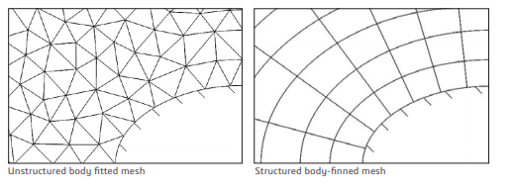
Figure 5 – Structured and Un-structured Mesh
However, the disadvantage of this method particularly for highly complex shapes is an increased rate in grid non-orthogonality or skewness that can cause unphysical solutions due to the transformation of the governing equations (Tu et al., 2013). Whereas, an un-structed mesh are identified by irregular connectivity meaning the node valence requirement is relaxed and any number of elements can meet at a single node (Ghaffari, 2015). Typical choices for this meshing technique are triangle and tetrahedral. An advantage of this method is a more convenient mesh adaptivity leading to a better mesh refinement, and unlike structured it can be used on complex shapers such as outlining the complex geometry of blood vessels (Tu et al., 2013). However, an un-structured grid requires a larger amount of computational memory for storing elements, nodes and a connectivity table to link them (Loseille, 2016). The structured mesh does not face this issue as the mesh is defined according to a specified pattern, thus CFD computation run time is reduced (Bonfiglioli et al., 2016). The author is going to use an alternative approach from these methods known as an immersed body mesh, in this method the creation of the mesh starts independently from geometry itself and the cells can arbitrarily intersect the boundary between solid and fluid (Buchan, 2019). Unlike traditional meshes mentioned above which require the user to mesh the surfaces of the body and then grow those surface meshes outwards into a three-dimensional volume mesh (Tryggvason, 2016). In the authors approach it makes it possible to use a Cartesian-based mesh, specifically Such a mesh can be defined as a set of cuboids (rectangular cells), which are adjacent to each other and to the external boundary of the computational domain, orientated along the Cartesian coordinates (Tu et al., 2018). SolidWorks have adapted this methodology into its Flow Simulation program by utilising technology known as SmartCells. SmartCells are Cartesian based meshes which are usually an order of magnitude smaller in size when compared to traditional CFD meshes and are still able to provide the same level of resolution and accuracy (Finkelstien, 2020). The advantage of using this method is give the user a software that prioritises speed and not compromising accuracy and make an easy to use system that does not require the user to adapt to the complexities or limitations of the software (Finkelstien, 2020).

References

Ahmadi, S. and Sefidvash, F. (2018) Study of Pressure Drop in Fixed Bed Reactor Using a Computational Fluid Dynamics (Cfd) Code. Chemengineering; Basel [online]. 2 (2), pp. 1-27. [Accessed 20 November 2020].
Aissa, M., Verstraete, T. and Vuik, C. (2017) Toward a Gpu-aware Comparison of Explicit and Implicit Cfd Simulations on Structured Meshes. Computers & Mathematics with Applications [online]. 74 (1), pp. 201-217. [Accessed 04 December 2020].
Ali, A. (2020) CFD Workflow Guide: How to Set Up a Fluid Dynamics Analysis. Simscale [blog]. 10th November. Available from: https://www.simscale.com/blog/2016/09/cfd-workflow-quick-guide/
Bonfiglioli, A., Paciorri, R., Nasuti, F. and Onofri, M. (2016) Handbook of Numerical Analysis. Vol 17. Italy: Elsevier.
Buchan, A.G., Dargaville, S. and Pain, C.C. (2019) A Combined Immersed Body and Adaptive Mesh Method For Simulating Neutron Transport Within Complex Structures. Elsevier [online]. 134, pp. 88-100. [Accessed 04 December 2020].
Finkelstien, A. (2020) “Under the hood” of SOLIDWORKS Flow Simulation Understanding SmartCell technology – Part 1. Computer Aided Technology [blog]. 3rd March. Available from: https://www.cati.com/blog/2020/03/under-the-hood-of-solidworks-flow-simulation/
Ghaffari, M., Hsu, C. and Linninger, A. (2015) Automatic Reconstruction and Generation of Structured Hexahedral Mesh For Non-planar Bifurcations in Vascular Networks. Computer Aided Chemical Engineering [online]. 37, pp. 635-640. [Accessed 04 December 2020].
Hanbin, Z., Xingying, L., Jinsen, G., Yajun, Z. and Zhiping, Z. (2015) The Difference Between Specularity Coefficient of 1 and No-slip Solid Phase Wall Boundary Conditions in Cfd Simulation of Gas–solid Fluidized Beds. Elsevier B.v [online]. 286, pp. 740-743. [Accessed 04 December 2020].
Ho, B. (2020) 5 Tips on How to Create a High-Quality Mesh. Simscale [blog]. 13th November. Available from: https://www.simscale.com/blog/2018/03/tips-high-quality-mesh/#:~:text=As%20a%20good%20mesh%20is,accuracy%20and%20quality%20is%20critical.&text=A%20low%2Dquality%20mesh%20will,an%20error%20due%20to%20instability. [Accessed 20 November 2020].
Laurén, F. and Nordström, J. (2018) Practical Inlet Boundary Conditions For Internal Flow Calculations. Computers & Fluids [online]. 175, pp. 159-167. [Accessed 20 November 2020].
Lisowski, E., Rajda, J. CFD analysis of pressure loss during flow by hydraulic directional control valve constructed from logic valves. Energ Convers Manage 2013; 65: 285–291.
Loseille, A. (2016) Handbook of Numerical Analysis. Vol 18. France: Elsevier.
Marivani, M., Hamed, M.S. (2017) Evaluate pressure drop of slat screen in an oscillating fluid in a tuned liquid damper. Computers & Fluids [online]. 156, pp. 384-402. [Accessed 04 December 2020].
Morozova, N., Capdevila, R., Trias, F.X. and Oliva, A. (2018) Towards Real-time Cfd Simulation of Indoor Environment. Iccfd10 [online]. 9 (13), pp. 1-15. [Accessed 20 November 2020].
Naybour, P. (2018) List and Describe Five Types of Review in The Project Lifecycle. Parallel [blog]. 19th January. Available From: https://www.parallelprojecttraining.com/list-and-describe-five-types-of-review-in-the-project-lifecycle/#:~:text=2)%20Stage%20reviews%20are%20similar,and%20identifies%20any%20corrective%20actions. [Accessed 10 December 2020].
Patel, M. (2013) Computational Fluid Dynamics (CFD) Simulation Benefits Practical Applications. Hitechcfd [blog]. 20th January. Available From: https://www.hitechcfd.com/cfd-knowledgebase/cfd-simulation-benefits-practical-applications.html [Accessed 20 November 2020].
Payri, R., Gimeno, J., Marti-aldaravi, P. and Bracho, G. (2013) Study of the Influence of the Inlet Boundary Conditions in a Les Simulation of Internal Flow in a Diesel Injector. Mathematical and Computer Modelling [online]. 57 (7), pp. 1709-1715. [Accessed 20 November 2020].
Ramlan, I.B.R. and Darlis, N.B.D. (2019) Comparison Between Solidworks and Ansys Flow Simulation on Aerodynamic Studies. Industry, Engineering and Innovation [online]. 1 (1), pp. 1-9. [Accessed 20 November 2020].
Rapp, B.E. (2017) Microfluidics: Modeling, Mechanics and Mathematics. 2nd ed.: Elsevier. [Accessed 20 November 2020].
Semenov, S. and Rubio, A. (2015) Droplet Wetting and Evaporation. 2nd ed.: Academic Press. [Accessed 20 November 2020].
Teleken, J.G., Werle, L.O., Parisotto, I., Marangoni, C., Meneguelo, A., Bolzan, A. and Machado, R. (2012) Computational Fluid Dynamics Simulation of the Feed Distribution System of a Falling Film Distillation Device. Computer Aided Chemical Engineering [online]. 31, pp. 845-849. [Accessed 20 November 2020].
Tu, J. and Liu, C. (2018) Practical Guidelines for CFD Simulation and Analysis. 3rd ed.: Butterworth-heinemann. [Accessed 20 November 2020].
Tu, J., Yeoh, G. and Liu, C. (2013) Computational Fluid Dynamics a Practical Approach. 2nd ed. Australia: Elsevier.
Tu, J., Yeoh, G. and Liu, C. (2018) Computational Fluid Dynamics. 3rd ed. Australia: Elsevier.
Tyggvason, G. (2016) Fluid Mechanics. 6th ed.: Elsevier.
Wynn, D.C. and Clarkson, P.J. (2017) Process Models in Design and Development. Research in Engineering Design [online]. 29, pp. 161-202. [Accessed 04 December 2020].

Appendix 1 (Gantt Chart)

