Definitions of social cohesion
See Fonseca et al, (2018) for reference details for each
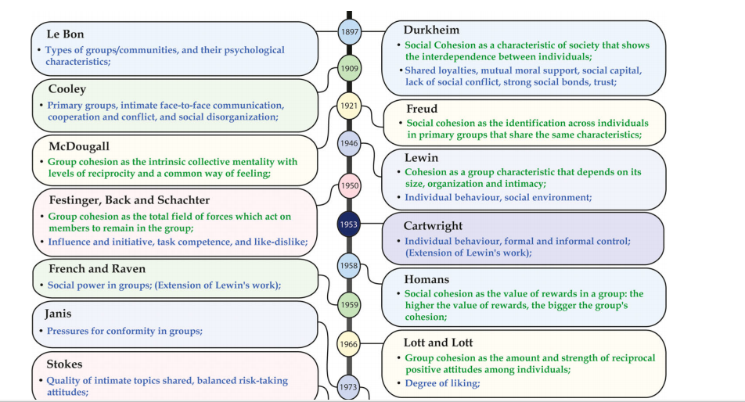
Fonseca, X,Lukosch, S and Brazier, F (2018) Social cohesion revisited: a new definition and how to characterize it. Innovation: The European Journal of Social Science Research. Online: https://www.tandfonline.com/doi/full/10.1080/13511610.2018.1497480 Accessed: 11/11/18


