How has the development of mark making formed illustration today and what methods are used to communicate ideas, with accuracy, through visual medium?

Lucilla Jones
P146009
BA Hons Illustration
5432 words
Jonathan Williams

Contents
Introduction
Chapter 1. – Illustration as a field
Chapter 2. – Communication through composition
Chapter 3. – Arrangement of imagery
Chapter 4. – Visual enquiry
Chapter 5. – Examining artistic intentions- Quentin Blake
Chapter 6. – Functions within illustration
Chapter 7. – Language within illustration
Conclusion

How has the development of mark making formed illustration today and what methods are used to communicate ideas, with accuracy, through visual medium?

Introduction
The English word illustration, finds its origins from the Latin word illumination. It holds the original meaning ‘intellectual enlightenment’ from the French word ‘illustrate’ meaning to shed light on. This established the category of art that is illustration, its intention being used to give explanation about a topic to the viewer.
Mark making is the practice of drawing out depictions and stories. It has developed as a form of communication to convey our thoughts, conclusions and ideas with others. From written text and symbols to pictures we’ve used images to convey and spread information to a greater number of people.
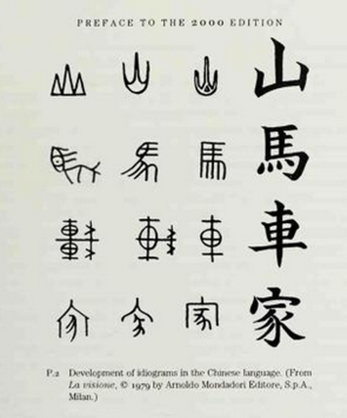
The first forms of this practice started as cave paintings; animals and images painted on cave walls to present and describe what they have seen and pass on knowledge. “Art and the ability to think of abstract concepts is what distinguishes our species from other animals” (Ghosh, 2014). Using imagery as an early form of communication shows that the purpose lying behind any form of mark making was to express a message or implication. “In the history of human ancestry, most scripts started out as pictograms, as rudimentary images” (Gombrich, 1960: p.xxxi) An example of this would be Chinese characters, based on physical articles they have evolved from pictures to characters representing words today. The development of the characters for mountain, horse, chariot and house (see fig.1) exemplify how a process of simplification refined these into one style of font directly from the original picture representations.
Fig.1 -Development of Chinese characters; Mountain, horse, chariot and house, from the book ‘Art and Illusion’ by Ernst Gombrich.

Principally, these symbols are a means of imparting notions to an extensive amount of people by using a method the majority would comprehend. Originally, information would have only been interpretable as pictures of recognisable objects until forms of text were established among communities.
Interestingly, text in many ways has receded back to artistry, diverse fonts and designs used to embellish wording for use in artistic pieces of work such as books and advertisements. This causes it to become part of the picture, decorating it appropriately. Calligraphy was the first form of art developed through text, Chinese people have cultured a unique art form through Chinese calligraphy.

1. Illustration as a field
As with all art, illustration is strongly grounded in perception. However, illustration has associations with description more directly, compared with other fields of art which use more ambiguous forms, leaving interpretation open to the viewer. Illustration has objective standards, being used for narrative, journalism, scientific and technical use, it has the intention of being easily interpretable, its purpose being to give clear explanation through visual image. Abstract art, as a contrast, has an unrealistic approach and tends to be an expression of shape and colour frequently without physical or visual reference and lack of discernible representation. It opposes reality, creating abnormal imagery adverse to fine art which uses realistic imagery and demonstrates more accuracy to the real world. In my opinion, illustration sits in the middle, being expressive and alternative, however, accurate and pronounced to what the piece means to suggest. “Away from the contextual need for literal truth, illustration becomes unfettered by reality, and one’s imagination is free to create images and conjure up atmospheres.” (Male, 2017: p.9) Illustration has aptitude to fluctuate its approach and behaviour within the field of art and overtime its applicability has broadened.
Illustration became recognised as a field within art after the founding of the Society of Illustrators in 1901 (Male, 2017: p.9). Over the past century, the practices it has undertaken and purposes for it have increased, alongside commercialisation, entertainment, the rise in technology and the ability to mass produce, provoking elicit demand for it. After only starting with use in book illustrations, scientific documentation and designing work such as in fashion. Now expanding into comic books, graphic novels, picture books, cartoon animations, concept art, video games, advertisements, product design and so on.
Illustration is a composition of imagery used to give a visual likeness, providing insight into the thought behind the picture and to communicate predetermined concepts. Over time illustration has expanded to exhibit unique styles and aesthetic arrangement for the viewer to behold something in another way. This practice enhances expression and draws out new perspectives from which to view things moving away from the realistic and literal and focusing on figurative form.

2. Communication through composition
Today, there is great focus on feeling and mood demonstrated in illustrative works. This is done to show the atmosphere and bring out sensory information about the environment. Molly Bang describes how the formation of a piece of art affects our emotional response and thought process towards it through deconstructing the shape, angle colour and mood in the book ‘Picture This: How Pictures Work’ (1991, p.2). She says; ‘We feel very differently about a triangle if we see it as a sailboat than if we see it as a shark fin.’ From this we take that the attention to detail and composition of shape in a piece of artwork is important to give clarity to what is happening and what feelings we should receive from the whole picture.
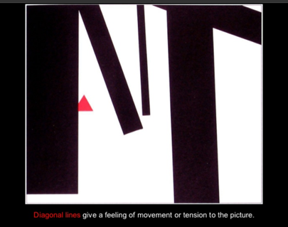
Through this book, Bang dissects the scenery and characters in her little red riding hood picture book. Showing us that straight, level lines cause us to have a sense of stability toward the image, however tilted, jagged, enlarged shapes give a more threatening, unsteady tension to pictures, changing the dynamic to suggest motion, altering our view of the image entirely (see fig.2). As Bang says in ‘Picture this’; “gravity is the strongest physical force that we are consciously aware of” (1991, p.56) meaning that we acknowledge it within a picture. That’s why images of tilting shapes look off balance and steep slopes look unsteady. To make sense of an image in our minds we bring it into reality to decipher aspects of it and relate components to it such as this, understanding the mood and ideas it’s supposed to give us.
Fig.2- Illustration from ‘Picture This’ by Molly Bang.

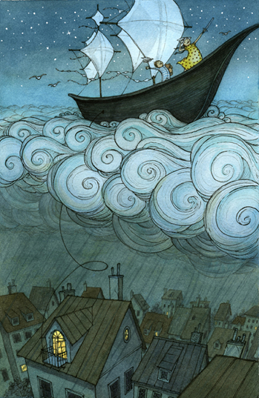
Bang also states; “the addition of a new element can modify the effect of the other elements or even change them completely”. (1991: 24) For example; changing conditions such as colour, including tones and hues of a colour, can alter the mood as we relate emotions, feelings, places and even states of being to colours, consequently, temperature can generally be determined by warmer or colder colour. As justification for the importance of colour is how often it is used in descriptive pieces of writing, frequently delineating what isn’t shown visually for the imagination to conjure up the imagery and along with feeling. Eliza Wheeler administers the colour yellow in her painting, ‘Sky sailing’ for visual connection between the dress and window light (see fig.3). The surrounding colours can be adapted to appoint new meaning; the clouds could be black to show a storm, or the sky could be another colour to change the time of day. Colour, as Doonan states in ‘Looking at pictures in Picture books’, “creates a convincing physical world and, at the same time, suggests various moods while remaining true to a pallet of natural hues.” (1992: p.40). I disagree with Doonan’s proposition that only natural colours can be used to create impression of mood.
Fig.3 – ‘Sky Sailing’ illustration by Eliza Wheeler.

Matt Rockefeller’s artwork upholds this view as he uses unnatural colours to demonstrate an overall ambiance within each scene and idea for a world he has created. Generally using a limited colour pallet, from this we can gather what the world might be like. In fig.4 he uses a limited pallet of purple hues across the whole painting. Light, pale pastel colours give off a calm sensation, using the colour purple he’s suggested a magical world. I think unnatural colours applied to things, for example the purple light from the lamp imply unusual things, which spike interest and give new concepts to consider.
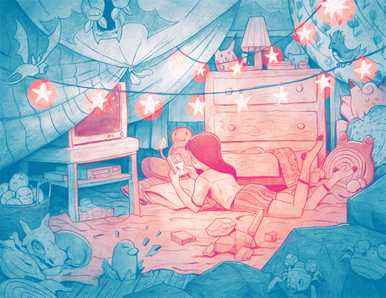
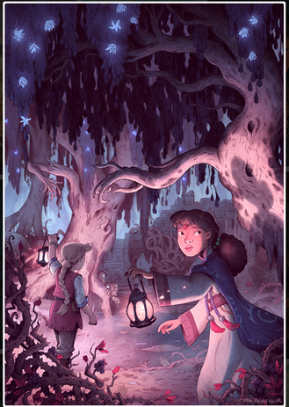
In the first painting he’s used variations of the singular colour purple, however the second pencil drawing uses 2 dissimilar colours; pink and blue, (see fig.5) to differentiate between the parts of the picture he has separated in this way. Pieces done in singular colours can be hard to separate aspects of, as shown in the blue areas and pink areas of the drawing, however the areas of greater tonal change within those hues allow our brains to easily discern and isolate objects. For example, the area of pink in the centre is lighter than the surrounding. Rockefeller seems to have blended objects into
Fig.5 – Illustration from pokemon zine by Matt Rockefeller.

Fig.4 - Cover illustration by Matt Rockefeller for The Secret of Dreadwillow Carse by Brian Farrey.

the area purposefully with intention for the viewer to spend time analysing the drawing to look for the objects hidden within it.
Overall tonal contrast within artwork assists our mind to acknowledge parts of the piece effortlessly. It gives the image a source of light and uplifts or weighs down the piece by amount of dark and light tones used. It also creates depth to the artwork, bringing out the lighter areas and hiding the darker areas.

3. Arrangement of imagery
Placement of objects can adjust the composition of a piece, altering the flow of how your eye looks across the picture. Sizing of objects within the piece creates depth and the idea of distance taking it into further dimensions and producing more space, as many more, small distant shapes can fit into the background. This has a great effect on hierarchy of the image’s content, focal points and objects are greatly enhanced if brought forward, highlighted or set apart from the rest of a picture. Hierarchy determines the subject of the image and its most important attributes. Placement also gives us a viewpoint from which to look from within the image enabling us to have a sense of involvement and direction within the piece. “Rhythm alters a viewer’s perception, can help achieve continuity and depth and is used to link visuals and text content together.” (Sherin, 2013 p.56). Well constituted artwork assists your eyes to follow a flow of pictorial impressions, and or words, by their positioning creating an effectively arranged piece. It’s components working well together giving a path set out, drawing the viewer’s eye to across the page in the predetermined manner.
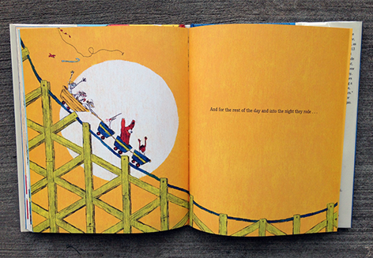
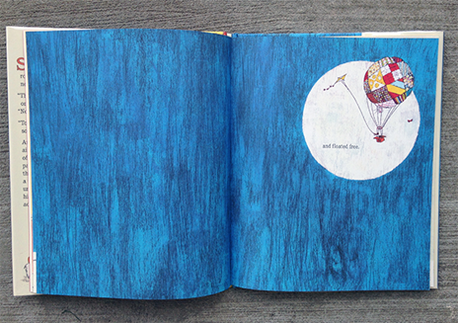
An example of highlighting imagery is used in Philip Stead’s book; ‘Sebastian and the Balloon’ in which particular objects are backed by a white circle. This breaks them away from the coloured background spotlighting them where they can be seen clearly without surrounding pattern or colour hampering the image’s clarity (see fig.6 and 7). White is a plain colour that doesn’t interfere with other colourings due to the fact it’s very bright and clear. We don’t tend to hold any emotional value towards white, being more of a void, seen also as a setting for something to fill, be placed or drawn upon. Stead made a good choice of colour to reinforce the balloon, the balloon accommodating many colours has tidier background to be exhibited upon.
Fig.6 – Illustration from ‘Sebastian and the Balloon’ by Philip C. Stead.

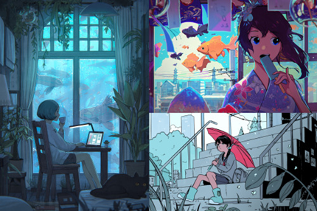
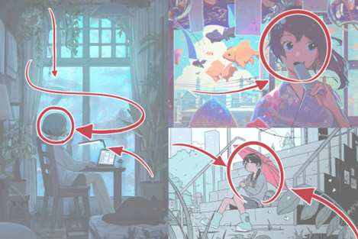
An illustrator whom I think defines flow within layout accordingly is an internet artist going by the name ‘PiNe’. The pieces below (fig.7) demonstrate how the use of placement draws forward elements of the image, allowing less important areas to stray into the distance however still contributing to the overall affect by integration of colour and shape that match and build up the background of the piece. Overall deconstruction implements distinction of the important values of the image and enhances depth within the image allowing us as viewers to associate with it in a relative way. Shapes attribute to the direction your eye follows and in these images, PiNe has used vines, poles and aligned objects such as fish for your eyeline to move along towards the focal points. These images have significant awareness toward shape and line, this gives the whole painting structural form. Vertical parallel lines in the first painting give it a long form. The round shapes used in the second painting adds a more floating free feel to the painting and in the third painting diagonal alignment of the steps crossed by the adverse direction of the plants and the umbrella.
Fig.7 -Artwork by internet artist ‘PiNe’ showing how their layouts have been composed.

Using this information and observing the painting ‘sky sailing’ (Fig.3), it’s noticeable that the yellow dress and the yellow light are reflections of each other, balancing out the page level in each corner. It is also apparent that the layout of this piece is constructed along diagonal lines. The ship directs your eye in the one direction, the clouds move diagonally the opposite way, after which your eye is drawn to the window light in the house which has been brought forward and then trail off along the rooftops. From this layout we gather that a rocking motion is evident, appropriate for the theme of the illustration, it leads your eyes back and forth sleepily downwards.
A sense of balance is applied to artwork such forms as colour distribution, gradient and tones balance in arrangement of objects, arrangement of lines, balance in weight and spacing of lines. This has become a key technique of fashioning content and a logical hierarchy of aspects within an image has come about with balance of each contributing aspect in the piece. This provides a clear structuralised production that is proficient to the when read. Equilibrium establishes balance between elements weighting the piece to look stable (Rudolf, 1974: p.31). It brings stability back to natural form and a sense of evenness within the work.
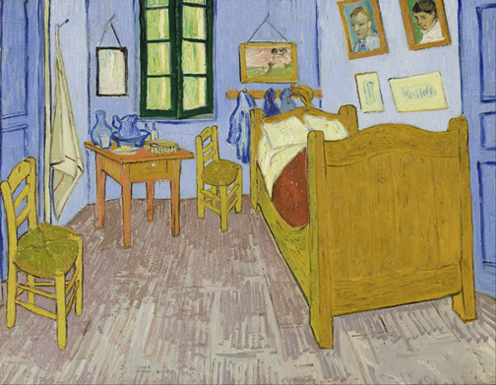
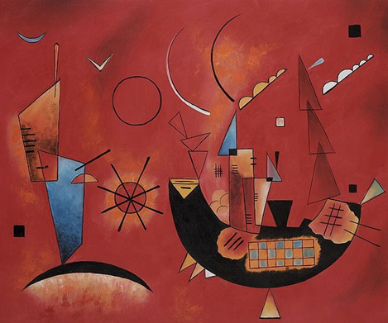
Many abstract pieces of work show unbalance and irrelevance to the real-world, Kandinsky’s work tends to consist of off kilter shapes stacked in unbalanced manners. In his piece ‘Mit und Gegen’ he displays moving towers of shapes piled on top of each other (see fig.8). Flat perspective is another style which upholds unbalanced form. Van Gogh used this disposition in his painting ‘The Blue Room’, in which objects look as though they’re leaning in obscure directions (see fig.9). Due to the shapes within objects being recognised and painted as they are seen from other viewpoints, the objects become tilted. We see this in the chairs in Van Gogh’s painting as they look like they would from above, not from across a room. Visual trajectory is treated differently when we look at something with flat perspective, we realise that we’re looking at a picture and not at reality.
Fig.9 - Painting by Vincent van Gogh titled ‘Bedroom in Arles’.

Fig.8 – Painting by Wassily Kandinsky titled ‘Mit und Gegen’.

4. Visual enquiry
I would say, the way we look at the world is proved through the way we look at art. We decipher images using what we know about the world around us and subconsciously have response towards the artwork. Assorted styles of art have formed for various uses and purposes to convey intended thoughts refined into what they are for the targeted audience. For example; many children’s books are based on learning about situations and the world around them. Visual imagery is used for children as easily interpretable information that catches their attention over words. Illustration is a strong form of language conveying demonstrations, more readily and effectively than text.
Because sight is a child’s major natural form of learning, giving information about the world around them, picture books act as visual aids for them to associate to their environment through ascertainment and reasoning. “The construction of mental images encourages the use of prior knowledge as a part of creating vivid representations of prose.” Enabling children to use visual comprehension as a way to decipher and facilitate text, using mental images to refer to in early reading stages (Gambrell, Jazwitz, 1993). They give the child a method of reading situation before text, and assists them in applying meaning to the words they will eventually be able to read. Using imagery as an approach to learning opens new pathways of problem solving and creative perception. It is a more engaging and interest provoking form of learning and studies have shown that children who worked with text illustrations, constructing mental images while listening to sentences outperformed those who learnt with plain text (Gambrell, Jazwitz, 1993). This shows that visual and auditory learning is more effective and visual diversity within pieces of information allows for easier discernment. For instance; highlighting and colouring sections of information in a piece of plain text tends to help recalling that information, what people often do to learn when studying.
Nikolajeva talks about how literary studies often ignore the visual work in ‘How picture books work’ (2001). Bosman discusses how parents feel picture books are a holdback on children’s education and decide on skipping out on them altogether. However, she also weighs in that “Many parents overlook the fact that chapter books, even though they have more text, full paragraphs and fewer pictures, are not necessarily more complex.” (2010). This brings forward the question of whether pictures are needed for continued learning in the development of children, as once reading becomes an accomplished skill, words tend to deliver more information than pictures. Words elucidate in detail exactly what is meant, as with pictures messages are often vague, clarification unspecific due to the fact several connotations can be gathered from one piece of work and intention of message may be deceptive. Alongside the fact that it takes time to analyse a visual piece identifying its features to deconstruct meaning.
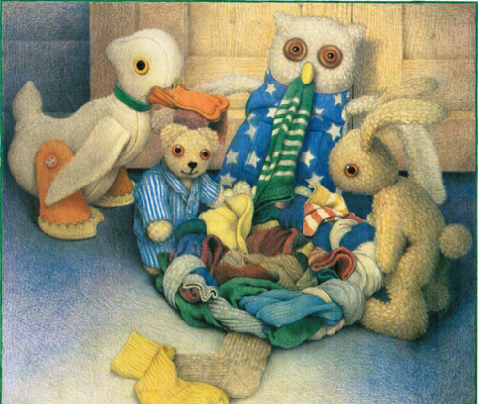
Vision remains our most dominantly used sense; we examine and determine factors by observation through sight. “Visual perception concerns the acquisition of knowledge. This means that vision is fundamentally a cognitive activity.” “Visual knowledge about the environment is obtained by extracting information.” (Palmer 1999, pp.5-6). From deconstructing what the brain enquires upon visually and using recognition of familiar objects our minds construct definition.
Nonetheless, visual imagery certainly helps with developing an understanding in young children. Old bear by Jane Hissey is a great example of relation of flat images to physical articles, she draws a range of various fabric textures of soft toys that they would relate to feeling at their age and consider what they are looking at. In the book ‘Old Bear’, Jane Hissey has used particular methods of mark making and materials to create the desired effect of each textures so we can identify the feel of each fabric by sight, applying our brains to distinguish sensory information from visual image (see fig.10).
Fig.10 -Illustration from the book ‘Old Bear’ by Jane Hissey.

Jane Doonan talks about how every mark matters in a piece of work. She says, “The movement of a pen or brush and the organisational decisions, made either consciously or unconsciously, and the medium itself induce an experience in the beholder” (1992: p.12). Every line, colour and detail contribute to the overall effect the piece gives, marks implying their own significance to what they are in the piece, each mark, descriptive in its own way and arranged to convey that description. Characteristics and feelings are connected to tones of colours and weight and stroke of linework. Doonan states that “Jane Hissey’s crayon conjures the warm comforting feel of felt and fur and old worn carpeting” showing that the impressions made on paper can be relatable to textures we feel. Component’s like soft lines made for bear’s fur make a calmer representation than a piece of work with harder roughly made markings. Again, we relate physical receptivity and atmospheric qualities to the artwork, giving us the sense of the world the work means to create.

5. Examining artistic intentions- Quentin Blake
Picture books are fantastic models of teaching children about the world, showing visual explanation on situations within our culture and describing social interactions or types of people they may encounter. Perception and reasoning vary across societies and cultures, picture books expose us to the culture we grow up in within our early years of development. A lot of vivid information is needed to convey these thoughts in a simple way to children and that’s where illustration makes it easier to clarify these ideas.
Many characterisations are used in children’s books to show them how people act and how personalities are divergent. There have been many stereotypical attributes given to character types to determine type of character easily. Visiting Cardiff museum’s Quentin Blake exhibition, I found his work addresses these principals as he brings across identity through his characterisations.
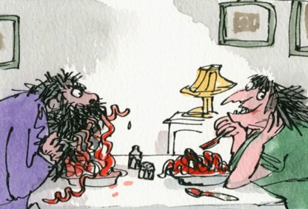
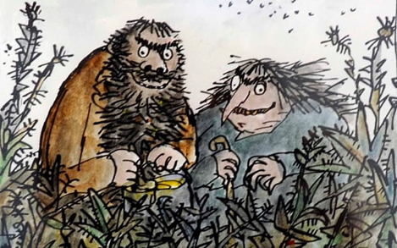
His drawings of; ‘The Twits’ (fig.11 and 12) depict very ugly, scary looking individuals, the drawing style used here is a lot more chaotic to emphasise this; harsh, thick lines with opposing direction are used alongside dirty, drab colours. They have unfriendly faces with crooked smiles and a lot of emphasis is put on the angry dark lines used for eyebrows. Blake has succeeded in making them appear unpleasant with thought put into the linework, angling and colour of the characters.
Fig.11 and 12 -Illustration of ‘The Twits’ by Quentin Blake.
However, a contrasting character of Blake’s; ‘The BFG’ (fig.13), has been designed to look friendly. Thinner and gentler lines in a more round and loose formation were used alongside mellow pastel colours, creating a far more relaxed sketch by comparison.
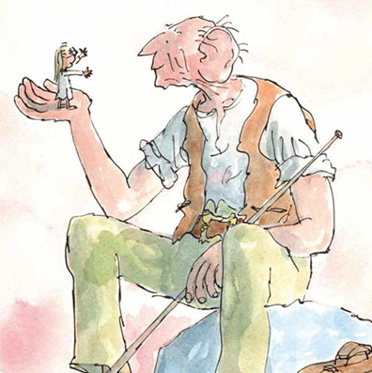
Roald Dahl writes in the Twits (1980); “If a person has ugly thoughts, it begins to show on the face. A person who has good thoughts cannot ever be ugly. You can have a wonky nose and a crooked mouth and a double chin and stick-out teeth, but if you have good thoughts it will shine out of your face like sunbeams and you will always look lovely.” I think this is where Blake brought the idea of stereotypical character attributes to match personalities into his work as you can see the variations in expression which all of his characters display. However, he also exemplifies traits through a character’s mannerisms; The Twits, having greedy grabbing hands and The BFG being more open and gentle of manner alongside The BFG looking relaxed sitting down, The Twits have a very animalistic way of standing, wily eyed and hunched over figures.
Fig.13 -Illustration of ‘The BFG’ by Quentin Blake.

Blake uses a childlike, scribbly style, something which children would express within their own drawings, “the dots for eyes, the flappy hands and flat, happy, feet” (Wilson, 2016). This brings art to a simple understanding of linework, flowing into basic, non-detailed shapes that assemble each character in a caricatured manner.
‘Blake’s characters are always on the move, but rarely walking. They run, leap, trot, dance, ride, skip, spin’ (Wilson, 2016) His drawings provide happy and childlike energy, something to give children a visual in response to the text and to identify with the fun and activity created in it. Blake recounts his drawings as being in anticipation of something happening now, continually. Even the linework has movement within it, all lines connecting across the illustration, colour flickering across the characters and merging across outlines.
An aspect Blake expresses in his characterisations is the exaggeration of bodily features used as a way of portraying personality, again in a stereotypical manner. For example; The BFG has large ears alongside the calm face and laid-back eyebrows, this gives the idea that he is understanding, willing to sit and listen to people. In comparison to The Twit’s very angry looking eyebrows made with harsh, jagged lines giving a sense of wickedness. Another characteristic is their enlarged noses that look like they’re very nosey people, again emphasising the fact that they’re selfish and take from other people. Looking at the exhibition I realised how much diversity he puts into his characters, building an individual in each characterisation.
The word caricature comes from the Italian word; caricatura, translating as the word exaggerate. It’s meaning being a description or imitation that exaggerates striking characteristics. This practice has been used through many cartoon styles of art in order to create a unique impression of life in their work. It establishes the fact that nothing is perfect and that we are all unique, capturing an individual person’s unique face and personality provides artwork you can read into.
Blake explains; an illustrator must choose which moment to illustrate and which not to because sometimes the words can do it better and other times pictures are a more definitive medium. Illustrators applying illustrations to text aim to establish a working alteration of description between word and text.

6. Functions within illustration
Many forms of illustrative artwork differ in the intention of their function and between artists. Every person has a slightly unique way of drawing and composing their artwork. This is because we are all exposed to different influences, different inspirations, from the world and from other artists, different cultures, different methods of creating art and we all perceive things in our own ways.
The function of the category of artwork is determined by what the market group of people an artist is creating it for. “Fundamental to this is knowing exactly what type of response is required of the audience and whether or not they would ‘buy’ the message being communicated” (Male, 2017: 22). The artwork needs to function correctly to be suitable for the intended buyers. For instance; children’s books should appeal to children, an advertisement must commend the product and a greetings card should complement its theme of use and type of person you would give it too.
Children’s books tend to contain colourful illustrations with lively and vibrant styles to provide interest and usually plenty to look at to catch the eye and play on the imagination. Maurice Sendak’s work for instance is very detailed and playful, encouraging curiosity towards the strange and uniquely designed characters and scenery. He uses subdued tones to portray an eerie otherworldly feel of night-time which work together all in a grey hue to form a limited colour pallet (see fig.14). Axel Scheffler’s art in comparison is very bright and colourful, characters distinguished from each other and from the scenery by their unique colours (see fig.15). His linework is sparse but important, singular lines balancing out across the fur of the animals, he uses colours that complement the colour of the animal juxtaposed to Sendak’s multitude of small crosshatched scratches which act as shading.
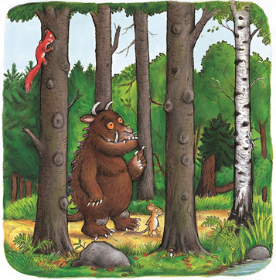
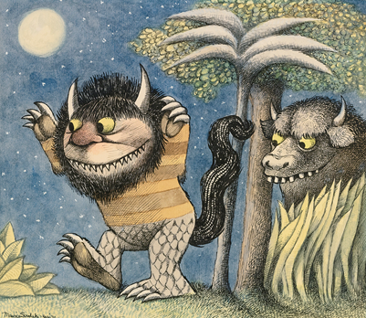

Fig.15 -Illustration from ‘The Gruffalo’ by Axel Scheffler.

Fig.14 -Illustration from ‘Where the wild things are’ by Maurice Sendak.

Both exhibit playful illustrations in order to interact pictorially with children’s imagination and perform a story. A picture book’s objective is to interact with the child reading in hope they may learn and engage with the imagery. Dick Bruna, the illustrator of Miffy draws her so that in almost every frame she constantly has her head turned toward the viewer, involving them in the story, as though asking what they think about each individual situation happening in the book. As observing pictures allows the child to contemplate and problem solve, to ask questions encouraging self-reliant imagination this is a method of engaging the child. Bruna explains; “What matters is reducing everything to its essence. Every shape captures the imagination, and I leave plenty of space for children’s imagination.” (Dawood, 2017). His work offers the idea that less is more, and it is for a limited colour pallet of bright colours that are in keeping with each other. Accuracy is not important in this field of illustration as the simpler the illustrations are the easier the information is to break down for children.
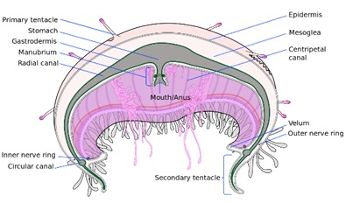
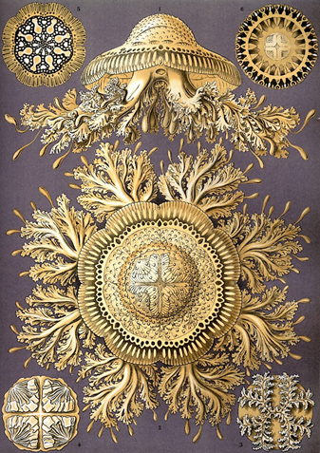
In opposition to this, scientific illustration, fixates attention on accuracy, the illustrations noting all the parts of physical objects. Physical reference is necessary in this circumstance as precise documentation of the object is the requirement. Ernst Hackle’s work (fig.16.) is an early example of this ornate and detailed style of presenting studies of organisms, today photographs tend to be used, however for enlargement and improved angling for labelling areas illustrations will be used for more basic, undetailed diagrams, the detailed methods have been striped back to simplicity in the same way, making understanding simpler (see fig.17). Basic colours and shaping are used for clear and concise descriptions through the drawings, the simplicity in his work allows for a tidy finish where shapes are clearly distinguishable.
Fig.16 -Illustration of jellyfish by Ernst Haeckel.

Fig.17 –Illustrated diagram of a jellyfish.

Despite accuracy in artwork being a staple in many periods through time, attempts to define reality through skill it is not necessary to create something to earn the label of art. Picasso said, “It took me 4 years to paint like Raphael, but a lifetime to paint like a child.” Showing that he felt that there was more to art than solely depicting the real world, there is skill in creating your own concepts and styles. There is opportunity under the tangible umbrella that is art to do more than duplicate imagery from the world around us, to instead, revitalise and create novel ideas.
Illustration uses personal insight used to communicate with the viewer, exposing them to alternative perspectives, processes and styles of mark making. Techniques and artists’ individual compositions constantly introduce new ways of thinking and applying these perceptions into a physical image. Artists learn from other artists and expanding on concepts, therefore advancement in interpretation will always be made. Influence from previous works evoking thought to inspire new notions.

7. Language within illustration
Doonan specifies that there is more than one method of deducing representation through artwork; denotation and exemplification. Denotation is symbolic, recognising a minimalist picture of an apple accurately to the artist’s designation shows that certain symbols, colours and delineations have become semiotic factors within art. Exemplification, yields concepts that have no direct implication (1992, p.15). Evidently, we can administer a source of expository information from the art in addition to the text itself, which, with text as an accompaniment, gives substantial definition to the artwork. It still gives us something else to read into, seeing the semblance and moods presented by the image. Illustration tends to lie with the former method, process of refinement of a piece of art brakes down structure into simple, condensed proportion.
Language is discovered through illustration, a descriptive way of delivering conceptualisations. Communication of ideas is derived through semiotic association, we have created signs and symbols to pose as designated. They are visual associations “ratified by collective agreement” which make up “realities localised in the brain.” (Saussure, 1983: 15). Our perception is heavily linked to both nature, the culture we reside in and anthropology, we have developed ideas stemming from these in our environment.
With this examination, the question is raised, can illustration be interpretable across language and cultural barriers? A psychological angle is taken when contemplating artwork. The mind selects areas of the picture for observation, still recognises focal points and colours still hold emotional values.
Silent cartoons, such as traditional ‘Tom and Jerry’ episodes, are successfully coherent across cultural boundaries, as there is no language to follow, the story is described entirely visually. Despite exhibiting stylised characterisations, the traditional idea of cat and mouse is displayed, alongside regular household surroundings being recognisable, preventing any struggle of recognition. Therefore, a universal understanding can be conveyed through artwork that is non-reliant on words. Illustration being expressive of thoughts, notions and feelings is deliberately made to be understood easily by everybody regardless of age or language spoken.

Conclusion
Overviewing the systematic approaches used to fabricate well-presented artwork, thought has been invested within the piece to refine ideas down to progress towards the finally selected product. Over time every artist learns how to develop these skills, pursuing appropriate form and balance as to not overcrowd or skew the result. Eventually, “Artists are sensitive to this requirement when they arrange the pictorial objects in a painting or the elements in a piece of sculpture.” (Rudolf, 1974: p.14).
Mark making has improved across years of development in art to give structure and psychological indication towards desired interpretation. Explicit designing of pieces is necessary to draw correct conclusions from what is seen.
Illustration amongst other forms of communicative systems is successful for many reasons. Although it is not recognised as a language itself, the construction of grammar behind it and its prosperity in many areas of communicating understanding proves its intention and operation functions the same as one. Methods of delivering ideas work effectively and accurately for the person beholding the image as to what is intended on being portrayed.

Bibliography
Reading list:
Bang, M. 1991, Picture This: How Pictures Work, Chronicle books, California, United States
Bond K. 2010, Fine Artist vs. Illustrator [Online], Available: http://faso.com/fineartviews/18678/fine-artist-vs-illustrator [25 Oct 2017]
Bosman, J. 2010, Picture Books No Longer a Staple for Children, [Online] Available: http://www.nytimes.com/2010/10/08/us/08picture.html?_r=1
Caricature, [Online] Available: https://en.oxforddictionaries.com/definition/caricature
Chandler, D. 2002, Semiotics: The Basics, Routledge, New York, second edition
Dahl, R. 1980, The Twits, Puffin Books, London
Dawood, S. 2017, Remembering Dick Bruna: the illustrator who brought us Miffy, [Online] Available: https://www.designweek.co.uk/issues/20-26-february-2017/remembering-dick-bruna-illustrator-designer-who-brought-us-miffy/
Doonan, J. 1992, Looking at Pictures in Picture Books, Thimble Press, Stroud, United Kingdom
Gambrell, L. Jazwitz, P. 1993, Mental imagery, text illustrations and children’s story comprehension and recall, Reading Research Quarterly, Vol. 28, No. 3, pp. 264-276, International reading association
Gentry, J. 2010, Parents—Empower Children as Thinkers with Picture Books! Available: https://www.psychologytoday.com/blog/raising-readers-writers-and-spellers/201010/parents-empower-children-thinkers-picture-books
Gombrich, E. 1960, Art and Illusion, Bollingen foundation, New York
Ghosh, P. 2014, Cave paintings change ideas about the origin of art, [Online], Available: http://www.bbc.co.uk/news/science-environment-29415716
Harrod, H. 2008, Dick Bruna, creator of the Miffy books, talks about his life and work, [Online], Available: http://www.telegraph.co.uk/culture/donotmigrate/3557810/Dick-Bruna-creator-of-the-Miffy-books-talks-about-his-life-and-work.html [7 Dec 2017]
Johnson, M., Posner, M., Rothbart M., 1991, Components of Visual Orienting in Early Infancy: Contingency Learning, Anticipatory Looking, and Disengaging, [Online] Available: file:///C:/Users/night/Documents/Johnsonvisor.pdf [20 Nov 2017]
Lambert, M. 2006, Evaluating and Using Picture Books, Beginning Reader Books and Illustrated Books, [Online], Available: http://megandowdlambert.com/wp-content/uploads/InFORMed-Lambert.pdf
Male, A. 2017, Illustration: A Theoretical and Contextual Perspective, Bloomsbury Publishing, London
Nikolajeva, M. 2001, How Picturebooks work, 1st edition, Routledge, Oxford, United Kingdom
Nodleman, P. 1990, Words About Pictures: Narrative Art of Children's Picture Books, University of Georgia Press, Georgia, United States
Palmer, S. 1999, Vision science: Photons to phenomenology, Bradford Book, Massachusetts
Rudolf, A. 1974, Art and Visual Perception: A Psychology of the creative eye, University of California press, London, UK, 1974 expanded and revised edition
Saussure, F. 1983, Course of General Linguistics, Chicago
Sherin, A. 2013, Design Elements, Using Images to Create Graphic Impact: A Graphic Style Manual for Effective Image Solutions in Graphic Design, Rockport Publishers, United States
Stead, P. 2014, Sebastian and the balloon, Roaring book press, New York, United States
Victoria, 2015, Dick Bruna. Artist, [Online], Available: https://medium.com/art-stories/dick-bruna-artist-c31316340233 [7 Dec 2017]
Wilson, F. 2016, Quentin Blake by Ghislaine Kenyon review – the brilliant illustrator at work, [Online] Available: https://www.theguardian.com/books/2016/mar/03/quentin-blake-in-the-theatre-of-the-imagination-ghislaine-kenyon-review [21 Nov 2017]

Reference list:
Bang, M. 1991, Picture This: How Pictures Work, Chronicle books, California, United States, p.2
Bang, M. 1991, Picture This: How Pictures Work, Chronicle books, California, United States, p.24
Bang, M. 1991, Picture This: How Pictures Work, Chronicle books, California, United States, p. 56
Bond K. 2010, Fine Artist vs. Illustrator [Online], Available: http://faso.com/fineartviews/18678/fine-artist-vs-illustrator [25 Oct 2017]
Caricature, [Online] Available: https://en.oxforddictionaries.com/definition/caricature
Chandler, D. 2002, Semiotics: The Basics, Routledge, New York, second edition
Dahl, R. 1980, The Twits, Puffin Books, London
Dawood, S. 2017, Remembering Dick Bruna: the illustrator who brought us Miffy, [Online] Available: https://www.designweek.co.uk/issues/20-26-february-2017/remembering-dick-bruna-illustrator-designer-who-brought-us-miffy/
Doonan, J. 1992, Looking at Pictures in Picture Books, Thimble Press, Stroud, United Kingdom p.15
Doonan, J. 1992, Looking at Pictures in Picture Books, Thimble Press, Stroud, United Kingdom p.12
Doonan, J. 1992, Looking at Pictures in Picture Books, Thimble Press, Stroud, United Kingdom p.40
Gambrell, L. Jazwitz, P. 1993, Mental imagery, text illustrations and children’s story comprehension and recall, Reading Research Quarterly, Vol. 28, No. 3, pp. 264-276, International reading association
Gombrich, E. 1960, Art and Illusion, Bollingen foundation, New York, p.xxxi
Ghosh, P. 2014, Cave paintings change ideas about the origin of art, [Online], Available: http://www.bbc.co.uk/news/science-environment-29415716 [30 Nov 2017]
Cross section jellyfish, 2008, [Online], Available: https://en.wikipedia.org/wiki/File:Cross_section_jellyfish_en.svg [2 Dec 2017]
Palmer, S. 1999, Vision science: Photons to phenomenology, Bradford Book, Massachusetts, pp. 5-6
PiNe, 2017, Pine’s art blog: reply to question from corgifoxi, [Online], Available: http://ppinne.tumblr.com/
Male, A. 2017, Illustration: A Theoretical and Contextual Perspective, Bloomsbury Publishing, London, p.9
Male, A. 2017, Illustration: A Theoretical and Contextual Perspective, Bloomsbury Publishing, London, p.9
Male, A. 2007, Illustration: A Theoretical and Contextual Perspective, Bloomsbury Publishing, London, p.22
Nikolajeva, M. 2001, How Picturebooks work, 1st edition, Routledge, Oxford, United Kingdom, p.3
Picasso, P. Quote, Available: https://www.goodreads.com/quotes/62706-it-took-me-four-years-to-paint-like-raphael-but [6 Dec 2017]
Rockefeller, M. 2014, Pokemon zine, photoshop drawing, Available: http://mrockefeller.tumblr.com/post/94764841073/here-are-all-five-spreads-from-the-pokemon-zine-i
Rockefeller, M. 2015, The Secret of Dreadwillow Carse, Photoshop piece, Available: http://mattrockefeller.com/
Rudolf, A. 1974, Art and Visual Perception: A Psychology of the creative eye, University of California press, London, UK, 1974 expanded and revised edition, p. 14
Rudolf, A. 1974, Art and Visual Perception: A Psychology of the creative eye, University of California press, London, UK, 1974 expanded and revised edition, p. 19
Sherin, A. 2013, Design Elements, Using Images to Create Graphic Impact: A Graphic Style Manual for Effective Image Solutions in Graphic Design, Rockport Publishers, United States, p.56
Wilson, F. 2016, Quentin Blake by Ghislaine Kenyon review – the brilliant illustrator at work, [Online] Available: https://www.theguardian.com/books/2016/mar/03/quentin-blake-in-the-theatre-of-the-imagination-ghislaine-kenyon-review [21 Nov 2017]

