University of Wales Trinity Saint David
School of Engineering

Tata Steel mechanical properties Improvement in IF steel

Charlie Morgan 2219665

2026

BEng Material science ACMA 6013

Abstract
This project investigates the root causes of metallurgical property failures in DX57 interstitial-free (IF) steels processed on the Zodiac galvanising line at Tata Steel Llanwern. The project also assesses the feasibility of implementing Impulse Magnetic Process Online Control (IMPOC) to improve visibility of mechanical property variation across the full coil length. Metallurgical failures were identified as a significant quality-related cost to the business due to rework through the Automotive Finishing Line (AFL).

The literature review examined the relationship between IF steel metallurgy, processing conditions, and mechanical properties. Focus remained on controllable Zodiac processing parameters such as furnace annealing conditions and temper mill elongation. Six Sigma DMAIC methodology was reviewed and applied to structure the investigation to identify process improvements.

Mechanical property failure mode analysis identified proof strength as the primary source of non-conformance in DX57 steels. Capability analysis displayed that the process was off-centre and shifted towards the upper specification limit, resulting in failures associated with elevated proof strength values. Investigation of processing conditions, supported by findings from the literature review identified temper mill elongation as the optimal parameter for reducing proof strength. A pilot study reducing temper mill elongation from 1% to 0.8% reduced mean proof strength by 13 MPa compared with 2025 production performance, and 9.5 MPa compared with the most recent DX57 production batch, resulting in improved process capability.

IMPOC was evaluated as a non-destructive method for monitoring mechanical properties across the full coil length of IF material. Regression modelling and pilot studies indicated a strong correlation between IMPOC readings and destructive tensile results (R² = 0.96). A pilot study conducted with IMPOC in shadow mode confirmed that IMPOC can identify non-conforming material that would not be detected using dual-end testing.

Acknowledgements
Firstly, I’d like to thank my project supervisor Andrew Thorn, for his support and guidance throughout this project.

Secondly, I’d like to thank everyone who supported me in Tata Llanwern, including the technical, production and the engineering teams. I’d also like to thank the SQTs for their efforts and determination to allow the project to be successful. Finally, I am thankful to my parents, girlfriend, and my daughter for motivating me throughout the project.

Declaration of Authenticity
This thesis is the result of the author’s original research. It has been composed by the author and has not been previously submitted for examination which has led to the award of a degree.

Signed: Charlie Morgan Date: 15/05/2026

Contents
Abstract ii
Acknowledgements iii
Declaration of Authenticity iv
List of Figures x
List of Tables xiii
Acronyms xiv
1 Introduction 1
1.1 The need for the continuous improvement project 1
1.2 An introduction to Tata Steel 1
1.3 Tata Steel Llanwern operations 2
1.3.1 Receipt of coils 2
1.3.2 ZODIAC (Zinc and other Developments In Alloy Coatings) 3
1.3.3 Automotive Finishing Line (AFL) 6
1.4 Aims and objectives 7
1.4.1 Project 1: investigation of mechanical property failures in IF DX57 steels 7
1.4.2 Project 2: evaluation and implementation of IMPOC for proof strength prediction 8
2 Literature review 9
2.1 Mechanical properties derivation 9
2.1.1 Proof strength (RP0.2) 9
2.1.2 Ultimate tensile strength (UTS) 9
2.1.3 Uniform elongation (A_{g}) 10
2.1.4 Total elongation (A) 10
2.1.5 Strain hardening exponent (n-value) 10
2.1.6 Plastic strain ratio (R-value) 11
2.1.7 Mechanical properties specification 11
2.2 Chemical composition 12
2.2.1 Role of alloying elements 13
2.2.2 Zirconium (Zr) 14
2.2.3 Titanium (Ti) 15
2.2.4 Manganese (Mn) and phosphorous (P) 16
2.2.5 Silicon (Si) 16
2.2.6 Carbon (C) 16
2.2.7 Sulphur (S) 16
2.3 IF steel overview 18
2.4 Processing factors affecting DX57 metallurgical properties 18
2.4.1 Furnace influence 18
2.4.2 Skin pass rolling (temper mill) influence 21
2.5 Impulse Magnetic Process Online Control (IMPOC) 23
2.5.1 Industry studies on IMPOC 23
2.6 Six sigma 25
2.7 Literature review summary 25
3 Define 26
3.1 Problem statement 26
3.2 Project scope 26
3.3 Project charter 27
3.4 Project Planning and Timeline 27
3.5 High-Level Process Layout 28
3.6 Voice of the Customer (VOC) 29
3.6.1 Mechanical properties performance 29
3.6.2 Surface Quality and Zinc Coating 30
3.6.3 Customer Confidence and Tata Steel’s reputation 33
3.7 Critical to Quality (CTQ) 33
3.8 IMPOC overview 34
4 Measure 36
4.1 Destructive Mechanical Testing (DET) overview 36
4.2 Alignment of the current testing process to customer CTQs 37
4.3 Data collection plan 38
4.3.1 Data to collect 38
4.3.2 Data sources 38
4.3.3 Time period 38
4.4 DX57 Mechanical Properties failure modes investigation 38
4.5 Mechanical properties failure mode focus point – proof strength 39
4.6 Capability analysis of DX57 proof strength 40
4.6.1 Process data 40
4.6.2 Overall capability 40
4.6.3 Potential (within) capability 41
4.6.4 Capability findings 41
4.7 Chemistry impact on pass vs failure 41
4.8 Furnace pyro validation 42
4.8.1 Establishing Stable Sampling Conditions for IMPOC Validation 43
5 Analyse 45
5.1 DX57 high proof failures investigation 45
5.2 Detailed process flow 45
5.3 Ishikawa Diagram 46
5.4 Five whys 47
5.4.1 Temper mill five whys 47
5.4.2 Furnace five whys 48
5.5 Ease Impact Diagram 48
5.6 Key tasks identified 49
5.7 Temper mill review – ease impact step 1 49
5.7.1 Current elongation transitions at 1% on the temper mill 51
5.8 Assessing IMPOC feasibility – ease impact step 2 52
5.9 Regression modelling for IMPOC calibration 52
5.9.1 Model structure 53
5.9.2 Regression model variables selection 53
5.9.3 Model development and methodology 54
5.9.4 Regression results 54
5.10 Pyro maintenance – ease impact step 3 56
5.11 Ensure OSCAR is running to required conditions – ease impact step 4 56
5.12 Scheduling controls – ease impact step 5 56
6 Improve 57
6.1 DX57 proof capability improvement 57
6.2 Temper mill elongation optimisation 57
6.3 Risk assessment for reduced temper mill elongation 57
6.4 Temper mill elongation reduction pilot study 58
6.4.1 Pilot study control group 58
6.4.2 Trial group 59
6.4.3 Comparative analysis 60
6.4.4 Pilot study limitations 60
6.5 IMPOC implementation 61
6.6 MECHIMPP 61
6.7 IMPOC out of control action plan (OCAP) – Mech IMPP 61
6.8 IMPOC FMEA 63
6.9 IMPOC validation study (shadow mode) 63
7 Control 67
7.1 DX57 processing changes 67
7.1.1 Standard operating conditions 67
7.1.2 FMEA 67
7.1.3 Process Monitoring and Verification 68
7.2 IMPOC implementation strategy 68
7.3 IMPOC hold logic 68
7.4 IMPOC hold actioning training 69
7.4.1 IMPOC hold assessment 70
8 Conclusions and Recommendations / Future Work 72
8.1 Conclusions and limitations 72
8.1.1 DX57 metallurgical investigation findings 72
8.1.2 DX57 metallurgical investigation limitations 73
8.1.3 IMPOC implementation findings 73
8.1.4 IMPOC limitations 74
8.2 Recommendations and future work 74
8.2.1 Short-term recommendations 74
8.2.2 Long-term recommendations 74
9 References 75

List of Figures
Figure 1 - Zodiac divert breakdown 1
Figure 2 - Zodiac rejection breakdown 1
Figure 3 – High-level Llanwern operations layout 3
Figure 4 - Zodiac entry layout 4
Figure 5 - Zodiac process layout 6
Figure 6 - Zodiac exit layout 6
Figure 7 - AFL schematic 7
Figure 8 - Stress-strain plot from a tensile sample (Emmetcosten, 2019) 9
Figure 9 – Impact of ferrite stabilisers on the austenite phase (Bhadeshia & Honeycombe, 2006) 14
Figure 10 - Relative strength of ferrite formers (Bhadeshia & Honeycombe, 2006) 14
Figure 11 - Precipitation behaviour of steels with varying Ti/N ratios (Huang, et al., 2025) 15
Figure 12 - Percentage of MnS inclusions in steels with varying S composition (Sun, et al., 2022) 17
Figure 13 - Manganese Sulphide inclusions at the fracture surface of a transverse tensile specimen (Maciejewski, 2015) 17
Figure 14- Volvo automotive body with types of steels used (Berczeli & Weltsch, 2018) 18
Figure 15 - Influence of soak time on the tensile strength of 40% cold rolled steel at 900˚C (Raji & Oluwole, 2012) 19
Figure 16 - Influence of the soaking time of annealing on the yield strength of the 40% cold drawn low-carbon steel annealed at 900˚C (Raji & Oluwole, 2012) 19
Figure 17 - Effect of soak time and temperature on R-value (Ovens, 2023) 20
Figure 18 - Effect of grain growth on [111] volume fraction and mean R-value with a soak temperature of 850 °C (Ovens, 2023) 21
Figure 19 - Influence of soak time on grain size and R-Value at 850 °C (Ovens, 2023) 21
Figure 20 - Varying skin-pass elongation effect on proof and tensile strength. Open symbols represent skin pass tests performed with no tension applied to the strip while full symbols represent tests performed with 1500N tension (Grassino, et al., 2012) 22
Figure 21 - Influence of skin-pass elongation on proof and tensile strength values (Hoggan, et al., 2002) 22
Figure 22 - Comparison of material strength variation under different processing conditions (Sommers, et al., 2017) 24
Figure 23 - The real inductance measurements (using the U-shaped EM sensor at a frequency of 10Hz) for a commercial DP600 material (with 79% ferrite, average grain size 10±4µm) machined to thicknesses of 1mm - 4mm (Jolfaei, et al., 2019) 24
Figure 24 - Zodiac metallurgical failures by steel grade 26
Figure 25 - Project Charter 27
Figure 26 - Project Gantt Chart 28
Figure 27 - High-level galvanising process layout and the effect each section can have on the mechanical properties 29
Figure 28 – Lüders bands on a low-carbon steel (Arora, 2025) 30
Figure 29 - Excessive dross affecting surface appearance (Duran, 2007) 31
Figure 30 - Roll marks due to a damaged roll (SCRIBD, 2020) 31
Figure 31 - Broken lamination (SCRIBD, 2020) 32
Figure 32 - Excessive flaking due to inadequate zinc adhesion (Galvanising, 2023) 32
Figure 33 - EMG IMPOC schematic (GmbH, 2025) 35
Figure 34 – Dog-bone specimen dimensions (Hibbert, et al., 2019) 36
Figure 35 - Instron tensile testing machine (Instron, 2019) 37
Figure 36 - DX57 mechanical property failure breakdown 39
Figure 37 - DX57 proof strength capability analysis 40
Figure 38 - Chemistry comparison on pass vs failure DX57 material 42
Figure 39 - Comparison of Zone 9 strip pyro to Williamson Pyro under operating conditions 43
Figure 40 – Temper mill engagement – showing process stability at ~370m 44
Figure 41 - Detailed process flow chart 46
Figure 42 - DX57 Ishikawa diagram 47
Figure 43 - Temper mill five-whys analysis 47
Figure 44 - Furnace five-whys analysis 48
Figure 45 - Next steps generated from five whys analysis 48
Figure 46 - Top five highest-scoring next steps from ease-impact analysis 49
Figure 47 - Relationship between temper rolling elongation and proof strength on IF steels (Ovens, 2026) 51
Figure 48 - Dissolution of TiC during annealing at varying temperatures (Ovens, 2026) 51
Figure 49 - DX57 temper mill elongation transitions across 2025 52
Figure 50 - Multiple linear regression model 55
Figure 51 - Regression model error distribution (MPa) 55
Figure 52 - Regression model error distribution (%) 56
Figure 53 - Risk assessment for temper mill elongation change on DX57 material 58
Figure 54 – DX57 grade control group capability analysis 59
Figure 55 - DX57 trial group on 0.8% temper mill elongation capability analysis 60
Figure 56 - Out of control action plan (OCAP) for IMPOC unavailability 62
Figure 57 - IMPOC FMEA 63
Figure 58 - IMPOC proof strength trace for C16943800 (M29543000) 64
Figure 59 - Temper mill and tension leveller elongation trace for C16943800 (M29543000) 64
Figure 60 - IMPOC proof strength trace for C18965800 (M29645000) 65
Figure 61 - Temper mill and tension leveller parameters for C18965800 (M29645000) 65
Figure 62 - IMPOC proof strength trace for coil C19820800 (M29721000) 66
Figure 63 - Temper mill and tension leveller trace for C19820800 (M29721000) 66
Figure 64 - DX57 grade elongation change FMEA 67
Figure 65 - IMPOC hold generation ruleset 68
Figure 66 – IMPOC hold logic showing a passing trace and failing trace exceeding ±15 MPa limit 69
Figure 67 - IMPOC hold action decision making 70
Figure 68 - IMPOC hold competency assessment 71

List of Tables
Table 1 - BS EN 10346:2015 mechanical properties specification (CEN, 2015) 12
Table 2 - Chemical composition of IF steels (CEN, 2015) 13
Table 3 - CTQ linked to the VOC 34
Table 4 – Alignment of customer CTQ’s to the current DET regime 37
Table 5 - Ease impact generated from next steps list 49

Acronyms
Acronym / symbol | Definition
A | Total elongation
AFL | Automotive Finishing Line
Ag | Uniform Elongation
BS EN | British Standard European Norm
CTQ | Critical to quality
DET | Dual-End Testing
DFF | Direct Fire Furnace
DMAIC | Define, Measure, Analyse, Improve, Control
DX57 | Ultra-formable steel grade
Fe-Zn | Iron-Zinc
HCD | High Current Density
IF | Interstitial Free
IMPOC | Impulse Magnetic Process Online Control
ISO | International organisation for Standardisation
Mn | Manganese
MPa | Megapascal
Nb | Niobium
OSCAR | Operational System Control and Reporting
P | Phosphorous
Ppm | Parts per million
Ra | Surface Roughness
RP0.2 | 0.2% Proof Strength
RT | Radiant Tube
S | Sulphur
Si | Silicon
SQT | Shift Quality Technician
Ti | Titanium
TL | Tension Leveller
ULCREX | Ultra-Low-Carbon Recrystalised Steel
UTS | Ultimate Tensile Strength
VOC | Voice of the Customer
YPE | Yield Point Elongation
Zn | Zinc
Α | Ferrite Phase
Γ | Austenite Phase
Ε | True Plastic Strain
Σ | Stress

Introduction

The need for the continuous improvement project
During the 2025 calendar year, failures to meet customer metallurgical specifications (‘OS-MET-LIMITS’) resulted in material diverted to the Automotive Finishing line (AFL). Each diversion incurred a cost of £175 per tonne, equating to an annual cost of £1,452,500. The combined diversion and rejection rate represented the largest quality-related cost at Tata Llanwern.

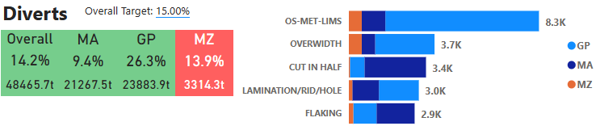

Figure 1 - Zodiac divert breakdown

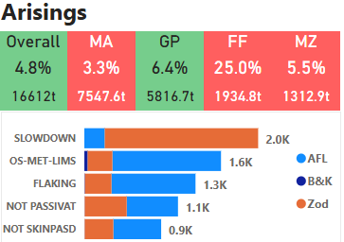

Figure 2 - Zodiac rejection breakdown

An introduction to Tata Steel
Tata Steel in Europe was formerly known as Corus Group, a British-Dutch steel company, and was acquired by Tata Steel in April 2007. The company has a prominent presence in the UK and has committed £1.25 billion towards the transition from traditional blast furnace steelmaking to electric arc furnace (EAF) steelmaking at Port Talbot. Tata’s UK operations supply numerous types of steel, with each site designed to optimise production to a specific sector of the market​ (Steel, 2025). The current UK operations are as follows:

Port Talbot – previously responsible for the conversion of iron ore and coal into steel slab. Following the closure of the blast furnace in September 2024, the sole purpose is now strip products.

Llanwern – supplies both automotive and engineering galvanised (zinc-coated) steel.

Trostre – produces 100% recyclable steels used in packaging applications, including food and beverage cans.

Corby – produces high quality thin-walled steel tubes for numerous applications.

Hartlepool – produces large diameter steel tubes for construction, infrastructure, and renewables (Steel, 2025).

Tata Steel Llanwern operations

Receipt of coils
Steel strip that has undergone pickling and cold rolling (referred to as hard iron) is transported from Port Talbot to Llanwern by rail. The Zodiac is a galvanising line which applies a zinc coating for improved corrosion resistance. Figure 3 shows a high-level process tree of Tata Llanwern operations.

Figure 3 – High-level Llanwern operations layout

ZODIAC (Zinc and other Developments In Alloy Coatings)
Zodiac is a versatile galvanising line capable of producing a wide range of grades and corrosion-resistant coatings to meet customer needs. Currently, the Zodiac produces galvanised steel destined for engineering and automotive applications. The most recent innovation is Magi Zinc coatings (coatings containing additional magnesium and aluminium), offering superior properties over traditional hot-dip-galvanised zinc coatings. The small additions of Mg-Al layered double hydroxides increase corrosion resistance, meaning the same corrosion performance can be gained with lighter coatings on the steel (Steel, 2025). The primary functions of these coatings are to protect the substrate from corrosion by acting as a sacrificial layer, increasing the lifespan of the steel substrate.

Entry process
Hard iron coils are loaded via cranes onto the entry coil carts. Two payoff reels are installed at the entry section to enable continuous processing. The head end of a coil loaded onto the line is welded to the tail end of a coil currently in the line. The entry accumulator also allows the process to remain continuous by giving the entry section the required time to complete welds prior to the coil entering the galvanising process.

To ensure adequate adhesion, the steel substrate must be thoroughly cleaned to remove residual oils and contaminants from previous processing. HCD tanks use sodium hydroxide on the substrate to break down contamination, while abrasive rolls clean off the debris to ensure surface cleanliness prior to galvanising. The entry schematic is presented in Figure 4.

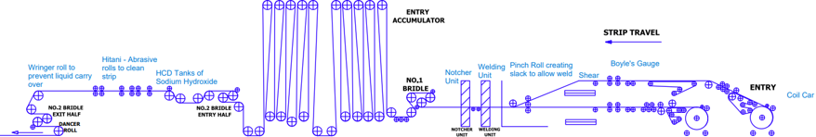

Figure 4 - Zodiac entry layout

Zodiac process section
Post-cleaning, the steel enters the furnace section. Initially, it enters the preheat section which is a direct fire furnace (DFF). This heats the substrate up to approximately 700 °C, any remaining contamination such as oil is removed via oxidation of the strip, further ensuring a clean substrate for when reduction takes place. This promotes uniform temperature distribution and begins the transformation of the steel’s microstructure by raising it into the recrystallisation zone.

Combustion of a controlled fuel-air mixture generates an open flame that directly heats the steel strip as it passes through the furnace. Each zone becomes an increasing oxygen deficient atmosphere by adjusting the gas/air ratios to become fuel rich. This reduces the oxide layer formed in the initial furnace zones. The last section of the DFF is the most reducing as it enters Z4 and Z4a.

Following the DFF section the radiant tube sections (RTs) are made up of the gas radiant section and the electric radiant section. This has a completely reducing atmosphere to ensure there is no oxygen inside, removing any small amounts of oxide layer remaining on the strip after processing in the DFF. This is achieved by a controlled H₂-N₂ mixture with a low dew point, avoiding re-oxidation.

This is the primary annealing stage and has the greatest influence on microstructure and mechanical properties. The microstructure is influenced by soak time and furnace temperatures, governed by specific annealing cycles for different steel grades. Temperatures typically range from 800–900 °C in this section, promoting recrystallisation and grain growth resulting in steel phase changes.

The furnace cooling section decreases the steel’s temperature at a controlled rate to eventually match the temperature of the zinc bath at 465 °C. Cooling rate is significant in achieving the desired metallurgical properties as it dictates the phase transformations in the steel, as well as the grain size of specific steel phases. In low-carbon steels, moderate cooling allows the formation of uniform ferrite grains and avoids localised brittle phases such as coarse pearlite. In high carbon steels, controlled cooling promotes pearlite and carbide precipitation resulting in a uniform microstructure (Li, et al., 2021).

The next stage of the process is galvanising, the strip passes through the snout, which is submerged below the surface of the molten zinc bath. This prevents oxide layers from forming on the strip and maintains the furnace atmosphere. As the strip leaves the zinc bath, a set of air knives control the coating weight by blowing nitrogen onto the strip. Adjustments to the pressure, knife distance and skew allow for tight tolerance control. The strip enters the final cooling section bringing temperature down between 100 –150 °C, before passing through a water quench bringing temperature down to 40 °C.

The steel passes through a temper mill, where two work rolls are driven by two backup rolls to apply a controlled force of up to 1000 N. This work hardens the strip and allows for controlled elongation setpoints which typically range from 0.8% to 1.7%. This improves yield and tensile strength depending on the elongation applied, due to improved dislocation density. The temper mill is also responsible for the final product’s surface roughness (Ra), this is particularly important to automotive customers as it improves paint adherence to the steel strip. This also improves surface quality by creating a uniform surface appearance and improves shape from previous processing.

The next important section to the project is the tension leveller, this helps to control shape via cassettes that are offset to elongate the strip before it passes through the flattener roll to improve any previous shape related defects. This will also improve proof and tensile strength, more noticeably on ferritic IF grades because their low dislocation density makes them more sensitive to small amounts of plastic deformation ​(Shen, et al., 2026)​. The Zodiac process schematic can be found below in Figure 5.

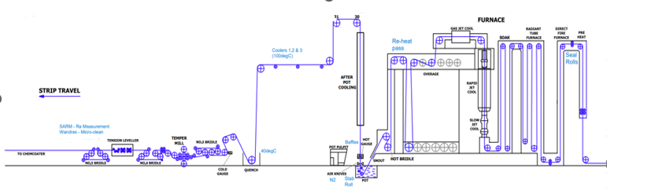

Figure 5 - Zodiac process layout

Zodiac exit section
Finally, the steel goes through the exit accumulator which allows the process to be continuous before entering the bottom and top surface inspection rooms. This ensures the steel meets customer requirements for the final application of the finished part. The steel is side trimmed to the desired customer width prior to exiting the line off tension reel one or two. The exit layout is shown below in Figure 6.
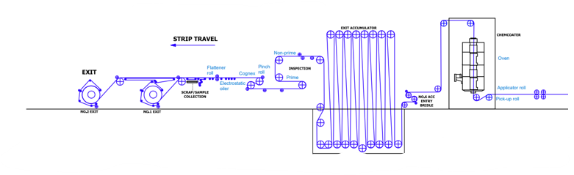

Figure 6 - Zodiac exit layout

Automotive Finishing Line (AFL)
The AFL is a rework line, as shown in Figure 7. This is designed to remove defects that have occurred in the upstream processing, deemed unsuitable for the customer. Reworking also occurs to take front and back samples on coils that have failed metallurgical properties (MET), along with the required discard of non-conforming material. Diverts reduce profits made on coils by a total of £175 per tonne, currently all material failing to meet MET requirements is processed through the AFL. This postpones arrival times for customers, leading to a potentially missed delivery date and decreased customer satisfaction.
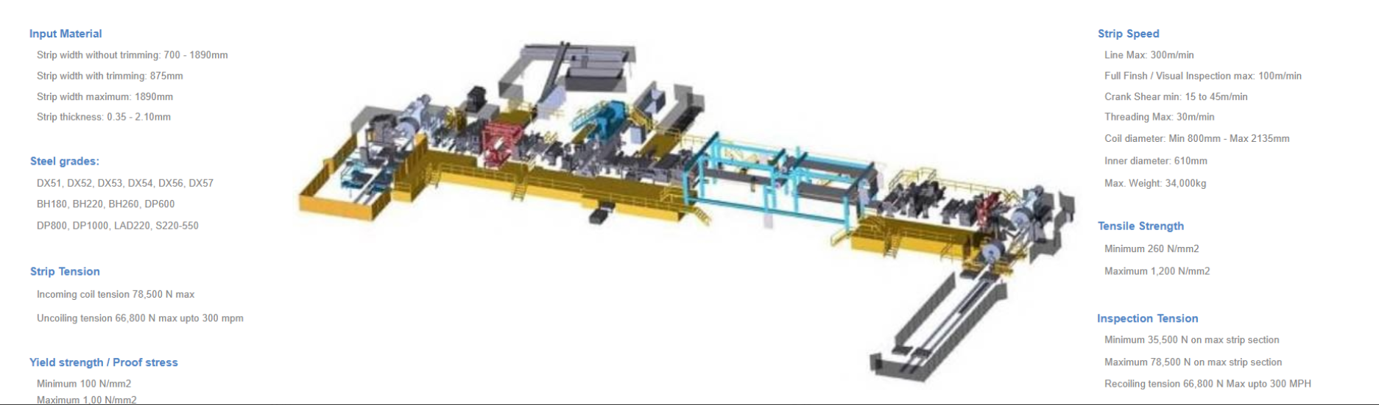

Figure 7 - AFL schematic

Aims and objectives

Project 1: investigation of mechanical property failures in IF DX57 steels

Aims
To investigate the root causes of metallurgical property failures in IF DX57 steels and reduce non-conforming material output.

Objectives
- Review a range of literature relating to the metallurgy, processing, and mechanical properties of DX57 steels to establish technical framework for the investigation.

- Characterise metallurgical failures in DX57 steels using mechanical test data.

- Identify the root causes of mechanical property failures using six sigma methodologies to understand capability and improve performance.

- Develop actions aimed at reducing metallurgical failures to reduce the associated quality costs.

Project 2: evaluation and implementation of IMPOC for proof strength prediction

Aims
Evaluate the feasibility of implementing IMPOC as an alternative method for mechanical property verification on IF steels and assess its potential to provide enhanced quality output.

Objectives
- Review the principles of IMPOC to understand the application for IF steels.

- Assess the correlation between IMPOC measurements and conventional tensile results for IF steel grades.

- Determine whether a single-end tensile test, supported by IMPOC live coil readings is a suitable and reliable measurement under BS EN standards.

- Compare the advantages and limitations of IMPOC compared with dual-end destructive testing from industrial studies.

- Evaluate IMPOC’s ability to predict proof strength across the full coil length, comparing readings with destructive test readings.

Literature review

Mechanical properties derivation
The engineering stress-strain curve shown in Figure 8 provides the basis for retrieving the required mechanical properties. The initial linear region represents elastic deformation, from which the modulus of elasticity can be derived. The onset of plastic deformation defines the yield strength, while the maximum stress on the curve corresponds to the ultimate tensile strength. Beyond this point, localised deformation (necking) occurs, eventually leading to material fracture (Emmetcosten, 2019).

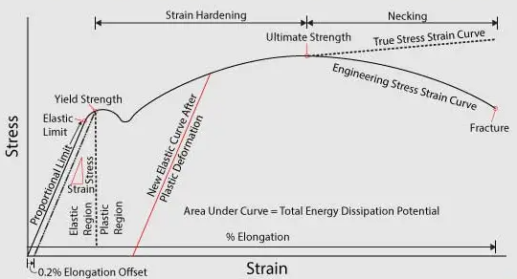

Figure 8 - Stress-strain plot from a tensile sample (Emmetcosten, 2019)

Proof strength (RP0.2)
Proof strength denotes the stress at which a plastic strain of 0.2% occurs during tensile testing (Damm, 2025). This determines the stress at which the material begins to deform permanently, marking the transition from elastic to plastic deformation. A line parallel to the initial elastic slope and offset by 0.2% strain is used to identify its intersection with the stress-strain curve, to obtain the proof strength (Raval, 2026).

Ultimate tensile strength (UTS)
The UTS denotes the maximum stress achieved during a tensile test. This is represented by the peak of the stress-strain curve before necking occurs, resulting in a stress drop (Raval, 2026).

Uniform elongation (A_{g})
Uniform elongation corresponds to the strain at maximum stress and defines the limit of uniform plastic deformation. Beyond this point, strain localisation and necking occur. It is measured as a percentage strain and corresponds to the strain value on the x-axis of the stress-strain curve (ISO, 2019).

Total elongation (A)
Total elongation shows the total percentage elongation that occurs to the sample at the point of fracture, representing material ductility. This is expressed as a percentage of the original length as shown in equation 1. Higher elongation values indicate greater plastic deformation prior to fracture, increased energy absorption, and improved resistance to brittle fracture (Raval, 2026).

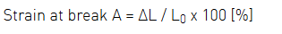

Equation 1 - total elongation formula (Raval, 2026)

Strain hardening exponent (n-value)
The strain hardening exponent (n) describes the ability of a material to undergo uniform plastic deformation by increasing its strength with strain. Higher n-values promote uniform deformation and delay the onset of necking, improving formability (Antoine, et al., 2006). Equation 2 describes how stress increases as the material plastically deforms, where n represents the rate at which stress increases with strain, where:

- σ = True stress (MPa)

- K = Strength coefficient (MPa)

- ε = True plastic strain

- n = Strain hardening exponent

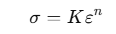

Equation 2 - n value equation (Antoine, et al., 2006)

Plastic strain ratio (R-value)
The R-value, also known as the Lankford Coefficient, describes how a sheet metal distributes plastic deformation between width and thickness during tensile deformation. A high R-value indicates less thinning, greater deformation in width, demonstrating good deep-drawing capability for complex geometries during pressing operations (Hamada, et al., 2011). Equation 3 shows the calculation of the R-value, which represents the ratio of the true Width strain to true thickness strain.

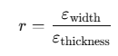

Equation 3 - R-value equation (Schaeffler, 2023)

Mechanical properties specification
Table 1 displays the IF mechanical properties specification ranging from DX51–DX57 under the BS EN 10346:2015 standards. As the DX grade increases from DX51–DX57, customer specification limits become progressively tighter, particularly for mechanical properties relating to formability.

Table 1 - BS EN 10346:2015 mechanical properties specification (CEN, 2015)

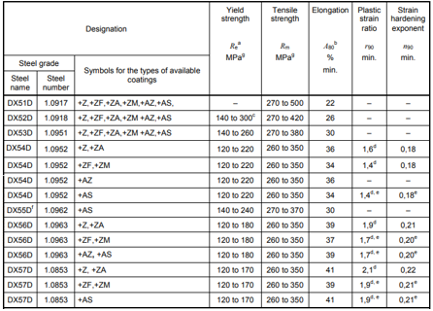

Chemical composition
Table 2 outlines the chemical composition specifications of IF steels according to the BS EN 10346:2015 standards (the current release standard), providing guidance on chemical composition specifications. As C is reduced in grade numbers DX51–DX57 formability increases meanwhile composition changes minimally, displaying the impacts of processing conditions. Grade numbers DX51–DX57 correlate with increasing deep-drawing capacity, however the major drawback as formability increases is the loss of tensile and proof strength.

DX51 contains the highest carbon content of the grades, with a maximum of 0.18%, resulting in the highest strength potential but reduced formability (CEN, 2015). The progression from DX52 to DX57 reflects increased control of solute content and processing conditions rather than chemical composition changes. DX56 and DX57 are regarded as ultra-formable steels suitable to produce complex inner door panels where high tensile strength is not required (Rana, et al., 2007).

Table 2 - Chemical composition of IF steels (CEN, 2015)

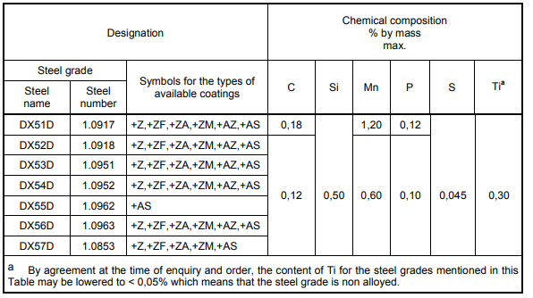

Role of alloying elements
(Bhadeshia & Honeycombe, 2006) outlined that the primary role of alloying elements in IF steels is to stabilise the ferrite phase through the action of α-stabilisers, thereby promoting the desired formability characteristics. The addition of ferrite-stabilising elements progressively closes the γ-field (austenite region), as shown in Figure 9. Diagram (a) shows an open γ-field, where the austenite region extends to higher temperatures, permitting a wider range of solidification pathways. Diagram (c) shows a closed γ-field resulting from ferrite stabilisers, promoting ferrite formation. Figure 10 provides an insight into how ferrite stabilising varies with individual elements.

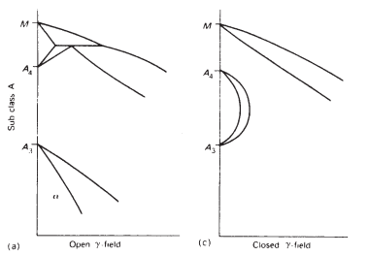

Figure 9 – Impact of ferrite stabilisers on the austenite phase (Bhadeshia & Honeycombe, 2006)

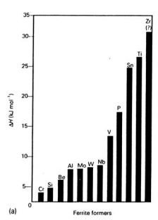

Figure 10 - Relative strength of ferrite formers (Bhadeshia & Honeycombe, 2006)

Zirconium (Zr)
Although zirconium has the strongest affinity for carbon and nitrogen, its compounds precipitate at high temperatures as coarse particles. This results in poor dispersion, limited grain boundary pinning, and inadequate control of recrystallisation (Ul-Hamid, 2020).

(He & Baker, 2015) reported that Zirconium additions promote the formation of Zr-rich carbonitrides with sizes ranging from ~100 nm to greater than 1 μm, indicating coarse and heterogeneous precipitation. Such particles are significantly less effective at grain boundary pinning and microstructural control than the fine Ti-based precipitates used in IF steels.

Titanium (Ti)
Titanium is one of the most important alloying additions in IF steels due to its strong affinity for carbon and nitrogen. As an interstitial scavenger, Ti forms stable TiC and TiN precipitates, removing carbon and nitrogen from solid solution, improving ductility and formability. This mechanism reduces the risk of strain ageing as free C/N can precipitate, causing an increase in strength and the formation of Lüders bands under forming (Zheng, et al., 2024).

TiC and TiN precipitates function as nucleation sites during hot rolling and annealing, promoting fine and uniform grain structures. Furthermore, these precipitates impede dislocation motion, providing additional strengthening without significantly reducing ductility. An increase in the Ti content increases the number of precipitates formed, as shown in Figure 11 (Huang, et al., 2025).

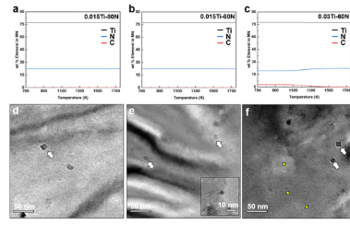

Figure 11 - Precipitation behaviour of steels with varying Ti/N ratios (Huang, et al., 2025)

Manganese (Mn) and phosphorous (P)
(Zhang, et al., 2009) highlighted that both Mn and P are added in small quantities to achieve solid solution strengthening and compensate for the strength reduction associated with removing carbon and nitrogen from solid solution.

However, excessive P can promote grain boundary embrittlement and intergranular fracture, resulting in reduced ductility. P also influences the growth of iron-zinc (Fe-Zn) intermetallic compounds, negatively influencing galvanising behaviour (Song, et al., 2024).

Silicon (Si)
(Pang, et al., 2017) reported Si acts as a substitutional solute within the ferrite lattice, contributing to ferrite stabilisation. Si atoms create local lattice distortions within the body centred cubic (BCC) ferrite structure, impeding dislocation movement and increasing strength.

(Sánchez, et al., 2023) suggested that Si reduces the solubility of iron in molten zinc, promoting intermetallic layer growth and increasing the likelihood of brittle coating formation during galvanising.

Carbon (C)
C is restricted to extremely low levels in IF steels, particularly in DX52–DX57 grades, typically between 30-40 ppm. (Gavriljuk, 2015) found that C strengthens steels through carbide formation but simultaneously reduces ductility. The absence of significant free carbon suppresses yield point elongation (YPE), preventing Lüder’s lines.

Nitrogen was identified as having a greater impact on strength than C due to its ability to distort the lattice locally, providing strong resistance to dislocations. This highlights the importance of vacuum degassing at the point of casting and the level of Ti present to form TiN precipitates.

Sulphur (S)
Sulphur is kept to minimal levels as specified by the BS EN 10346:2015 standards (Table 1). (Sun, et al., 2022) investigated the influence of S content on steel properties and reported S combines with Mn to form MnS inclusions. As S content increases, both the size and number of MnS inclusions increase, along with their tendency to form elongated stringers with the rolling direction. These inclusions create anisotropy and act as stress concentrators, promoting crack propagation. Figure 12 demonstrates the impact S content has on MnS inclusions, with samples containing 0.01% (A), 0.06% (B) and 0.132% (C).

(Maciejewski, 2015) further investigated the influence of MnS inclusions tensile properties. Longitudinal tensile properties were mostly unaffected, transverse properties displayed significant deterioration. Yield strength, UTS and elongation decreased by 24.6%, 23.8% and 77% respectively. Figure 13 shows an optical micrograph at 200 µm of the fracture surface of a transverse tensile specimen, displaying the presence of MnS inclusions.

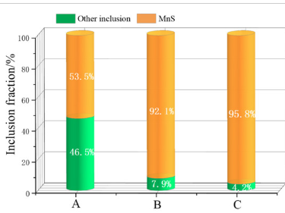

Figure 12 - Percentage of MnS inclusions in steels with varying S composition (Sun, et al., 2022)

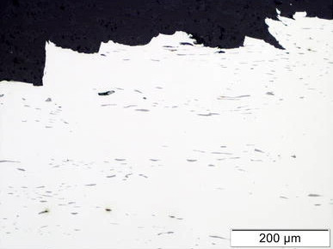

Figure 13 - Manganese Sulphide inclusions at the fracture surface of a transverse tensile specimen (Maciejewski, 2015)

IF steel overview
Interstitial-free (IF) steels are a class of ultra-low-carbon steels widely used in the automotive industry for applications such as body panels due to their excellent formability. This is attributed to their predominantly ferritic structure, providing high ductility and toughness. IF steels contain a minimal composition of both carbon and nitrogen, typically between 30–40 ppm, achieved through vacuum degassing ​(Kishore, et al., 2022)​.

To further limit free carbon and nitrogen, additions such as titanium and niobium are used to form stable precipitates such as TiN and NbC ​(Xing, et al., 2022). This metallurgy results in great elongation capabilities, low yield and tensile strengths, and high r values. However, improved formability is accompanied by reduced strength, making grain refinement critical following the Hall-Petch relationship (Sinha, et al., 2022). Figure 14 characterises an automotive body by steel strength, where dark blue represents IF formable steels.

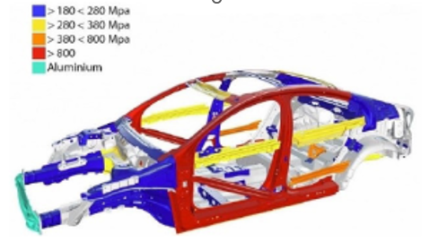

Figure 14- Volvo automotive body with types of steels used (Berczeli & Weltsch, 2018)

Processing factors affecting DX57 metallurgical properties

Furnace influence
(Raji & Oluwole, 2012) investigated the effect of soak time on low-carbon steel subjected to 40% cold reduction and annealed at 900 °C. Figures 15 and 16 display that increasing soaking time at elevated temperatures reduces both yield and tensile strength due to enhanced recovery, recrystallisation and grain growth processes.

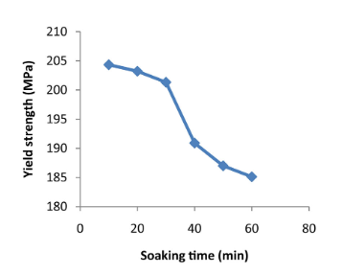

Figure 15 - Influence of soak time on the tensile strength of 40% cold rolled steel at 900˚C (Raji & Oluwole, 2012)

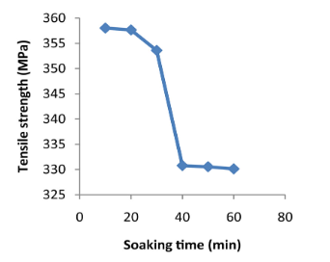

Figure 16 - Influence of the soaking time of annealing on the yield strength of the 40% cold drawn low-carbon steel annealed at 900˚C (Raji & Oluwole, 2012)

During soaking, the microstructure undergoes progressive recovery, recrystallisation and grain growth. Initially, recovery reduces dislocation density through annihilation and rearrangement, leading to a slight decrease in strength. With increased soak time, recrystallisation occurs, where new strain-free ferrite grains nucleate and grow, replacing the deformed microstructure and significantly reducing proof strength. Prolonged soaking promotes grain growth, increasing ferrite grain size and further lowering strength in accordance with the Hall–Petch relationship (Hong, et al., 2023).

(Ovens, 2023) carried out internal research at Tata Steel Llanwern to understand the influence of furnace parameters on R-value. Figure 17 shows low-carbon steels exhibit higher R-values and that increasing soak time and temperature promotes further increases.

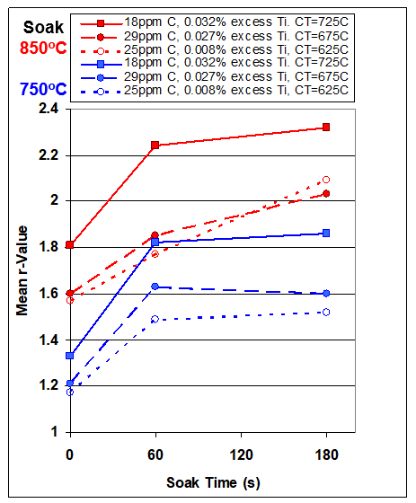

Figure 17 - Effect of soak time and temperature on R-value (Ovens, 2023)

(Li, et al., 2021) showed that R-value increases with stronger γ-fibre texture, demonstrating the [111] orientation identified as the optimum texture to achieve a high R-value. Internal research conducted by (Ovens, 2023), shown in Figure 18, suggests grain growth increases the number of grains with the desired [111] texture, hence R-value increases. This suggests higher annealing temperatures give greater grain growth to provide a higher R-value, this is further backed up by Figure 19.

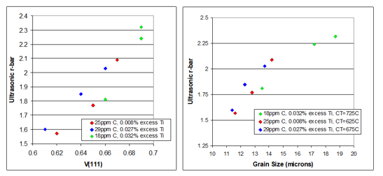

Figure 18 - Effect of grain growth on [111] volume fraction and mean R-value with a soak temperature of 850 °C (Ovens, 2023)

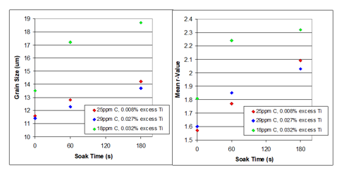

Figure 19 - Influence of soak time on grain size and R-Value at 850 °C (Ovens, 2023)

Skin pass rolling (temper mill) influence
(Grassino, et al., 2012) demonstrated that ultra-low-carbon steels exhibit a parabolic relationship between skin-pass elongation and proof strength. This study identified an initial reduction in proof strength of approximately 30 MPa as elongation increased to 0.5–0.9%, which was attributed to the suppression of discontinuous yielding behaviour and Lüders-band formation. Beyond this region, proof strength increased due to work hardening introduced by additional plastic deformation. Figure 20 shows the influence of skin pass elongation on proof and tensile strength on steels containing 0.005% C and 0.0659% Ti.

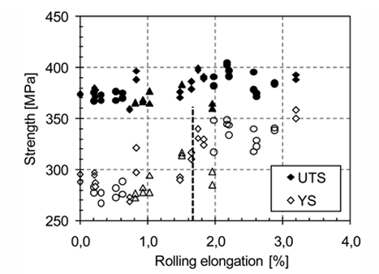

Figure 20 - Varying skin-pass elongation effect on proof and tensile strength. Open symbols represent skin pass tests performed with no tension applied to the strip while full symbols represent tests performed with 1500N tension (Grassino, et al., 2012)

(Hoggan, et al., 2002) investigated the relationship between skin passing and tension levelling on the strength of ultra-low-carbon recrystallised (ULCREX) and low-carbon recrystallised (LCREX) steels. ULCREX steels exhibit greater sensitivity of proof strength as strain increases due to their initial low dislocation density. Figure 21 concludes that ultra-low carbon steels are less susceptible to discontinuous yielding effects than higher carbon grades, due to minimised levels of free carbon in solid solution.

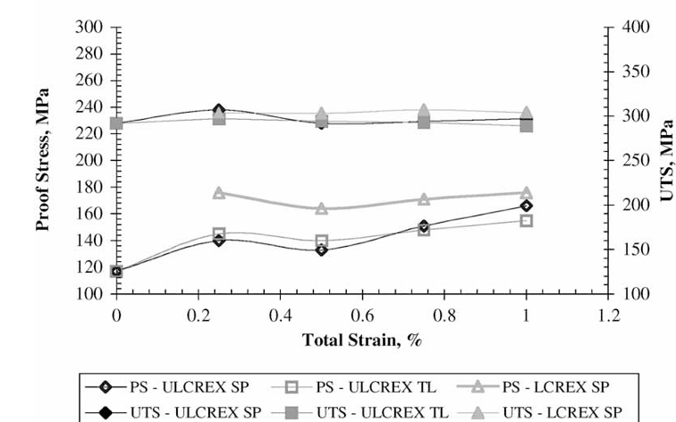

Figure 21 - Influence of skin-pass elongation on proof and tensile strength values (Hoggan, et al., 2002)

Impulse Magnetic Process Online Control (IMPOC)
A single-end tensile test representative of the entire coil length is accepted under the BSEN 10436:2015 standard (CEN, 2015). IMPOC has been implemented by numerous European steel producers to monitor the techno-mechanical properties, particularly proof and tensile strength. IMPOC operates using a magnetisation and read-back principle.

The moving steel strip is periodically magnetised to saturation using two magnetising coils. The extremely sensitive magnetic field probes measure the gradient of residual magnetic field strength in A/m² on both sides of the steel strip. Averaging the measurements from both sensors compensates for strip vibration and improves measurement reliability. The resulting magnetic response can then be correlated with proof and tensile strength (Peyton, et al., 2016).

Industry studies on IMPOC
(V.Matyuk, et al., 2004) evaluated the use of IMPOC on a hot dip galvanising line. The study concluded that IMPOC improved productivity by reducing line stoppages associated with destructive and non-destructive sampling inspections. Also, IMPOC provides an accurate measurement of mechanical properties across a whole-coil length.

(Sommers, et al., 2017) investigated a smart furnace set up combining IMPOC values with furnace temperatures to optimise quality output. Figure 22 shows the clear improvement in proof strength variation by combining IMPOC readings with furnace conditions. This suggests IMPOC can accurately predict mechanical properties and understand the impact of microstructural changes through furnace temperature and soak time.

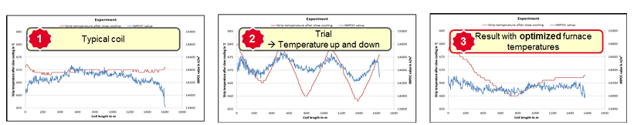

Figure 22 - Comparison of material strength variation under different processing conditions (Sommers, et al., 2017)

(Jolfaei, et al., 2019) used samples provided by Tata Steel to investigate IMPOC results on DP material and identified material thickness as a key variable to include for IMPOC modelling. Figure 23 demonstrates that the inductance is strongly affected by material thickness on a DP600 sample. These findings demonstrate material thickness is a critical variable within IMPOC regression models. This study also showed that magnetic permeability is affected by the ferritic fraction and ferrite grain size in the steel. This displays the relationship between magnetic permeability and tensile strength. This suggests the grain size and ferrite fraction directly impact magnetic and mechanical behaviour.

This established a relationship between magnetic permeability and tensile strength, as both ferrite fractions and grain size influence magnetic and mechanical behaviour.

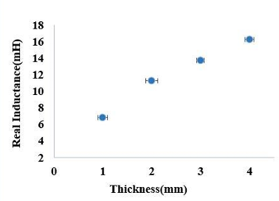

Figure 23 - The real inductance measurements (using the U-shaped EM sensor at a frequency of 10Hz) for a commercial DP600 material (with 79% ferrite, average grain size 10±4µm) machined to thicknesses of 1mm - 4mm (Jolfaei, et al., 2019)

Six sigma
Six Sigma is a data driven methodology used to optimise processes, improve quality, and enhance efficiency. It was developed by Motorola in the 1980s as a data-driven approach focused on reducing defects, improving consistency, and enhancing customer satisfaction. Six Sigma emphasises quality improvement by systematically reducing process variation through statistical analysis and process optimisation (Ghelani, 2023).

One problem-solving strategy within Six Sigma is DMAIC (Define, Measure, Analyse, Improve, Control), a structured quality-improvement cycle aligned with the Deming continuous-improvement philosophy, consisting of five interconnected stages used to systematically enhance process performance (Enache, et al., 2023). As a statistical metric, Six Sigma quantifies process performance by measuring how many standard deviations (σ) the process mean is from the nearest specification limit. This provides a direct measure of process capability relative to defined tolerances, where higher sigma levels indicate lower process variation and a reduced likelihood of producing non-conforming outputs (Tseng & Chen, 2022).

At a Six Sigma (6σ) performance level, the process is considered highly capable, corresponding to approximately 3.4 defects per million opportunities (DPMO), or 99.99966% yield, under the conventional long-term process shift assumption (Graafmans, et al., 2021).

Literature review summary
The literature review identified that the mechanical properties of IF steels are strongly influenced by chemical composition and processing conditions. Research suggests properties such as proof strength and R-value can be affected by furnace soak conditions. Also, skin-pass rolling (temper milling) significantly influences proof strength of IF steels due to minimised free carbon and low dislocation density.

Furthermore, industrial studies suggest IMPOC has the capability to accurately predict mechanical properties, allowing for full coil monitoring. IMPOC reduced the volume of destructive tests and improved line efficiency by reducing line stoppages to obtain tensile samples.

Define

Problem statement
The Zodiac line has experienced a significant quality issue, resulting in 8,300 t of product being diverted to the AFL at a cost of £175 per tonne. This equates to a total cost of £1,452,500.

Project scope
The Zodiac galvanising line processes a vast range of steel grades, therefore the project required refining to identify a focus point. The 8.3Kt of metallurgical failures were further broken down by steel grade to gain a better understanding of problematic grades, as shown in Figure 24.

The pareto analysis identified XSESG and MS4+Z (DX57 equivalent) grade as having a combined not right first-time tonnage (NRFT) of 2526t, costing £442,050 during calendar year 2025. The DX57 steel grade has a NRFT% of 25%, highlighting poor capability that requires investigating. Also, the feasibility of replacing dual-end testing (DET) with an IMPOC reading supported by a single-end test (SET) must be assessed to ensure the alternative provided accurate and reliable tensile results

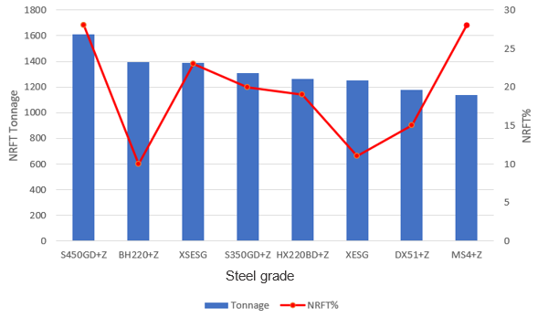

Figure 24 - Zodiac metallurgical failures by steel grade

Project charter

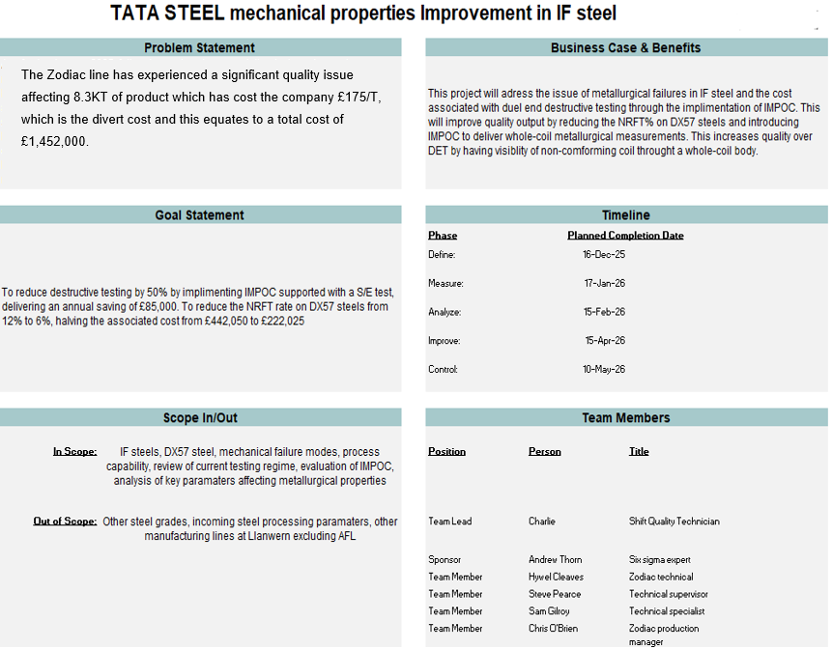

Figure 25 - Project Charter

Project Planning and Timeline
The Gantt chart displayed in Figure 26 was developed to support structured project planning and ensure alignment with the project scope. The chart translates the high-level timeline defined in the project charter into specific tasks and milestones across the DMAIC phases.

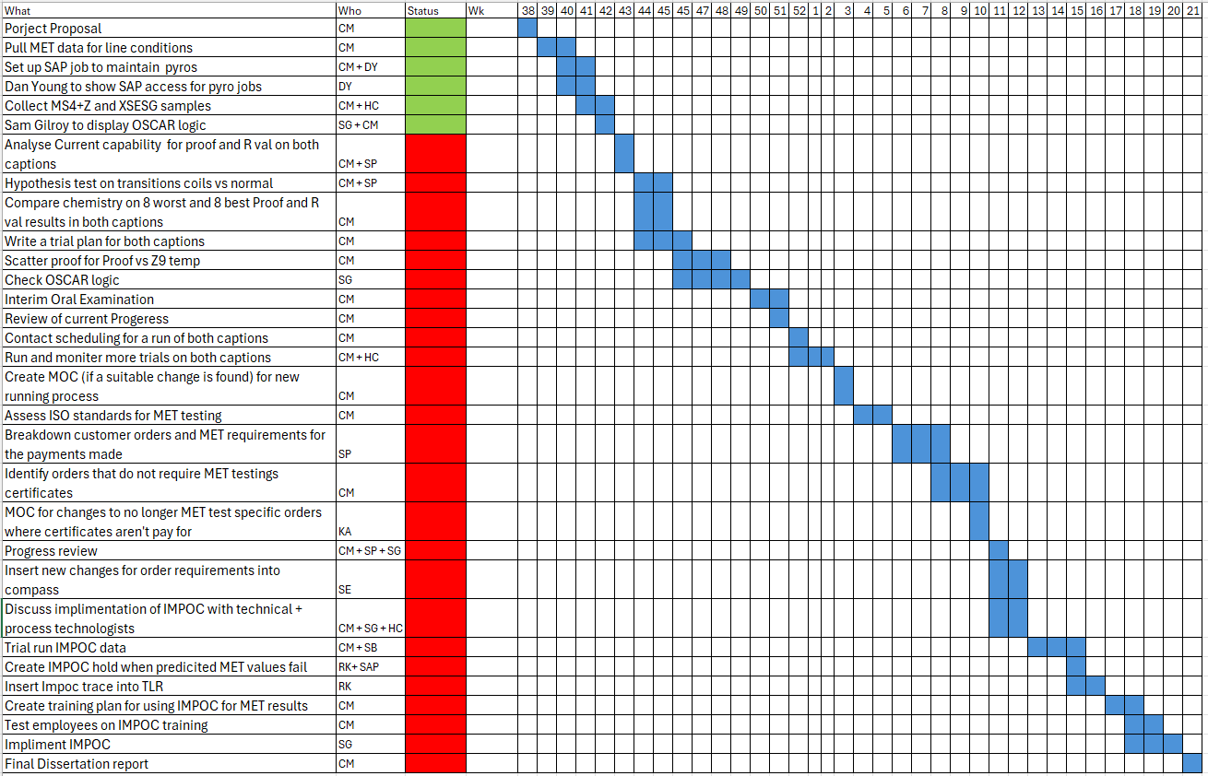
Figure 26 - Project Gantt Chart

High-Level Process Layout
The high-level process layout was created with the support of the Zodiac technical team. The purpose of this diagram is to simplify the process flow, identifying key boundaries throughout the stages that influence metallurgical properties, highlighted red in Figure 27. The intention is to establish an agreed understanding of the product flow and key variables opposed to a detailed operation layout, which can contribute to critical-to-quality inputs that will be discussed later in the define phase.

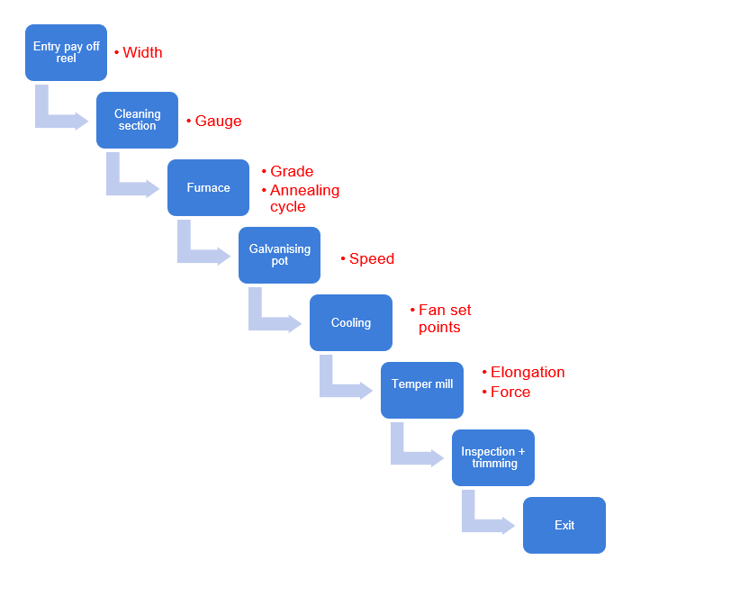

Figure 27 - High-level galvanising process layout and the effect each section can have on the mechanical properties

Voice of the Customer (VOC)

Mechanical properties performance
Mechanical properties performance is a key aspect of automotive steels, with IF steels being characterised as low strength and highly formable. Customers expect the material to deform uniformly during forming operations, without cracking, tearing or strain localisation. If excessive strain localisation occurs, defects such as Lüders (stretcher strain) bands appear and are regarded as being highly unacceptable for automotive applications, as illustrated in Figure 28.

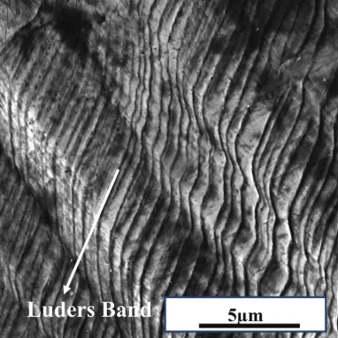

Figure 28 – Lüders bands on a low-carbon steel (Arora, 2025)

As IF steels are used in deep drawing applications, the steel must be able to form complex geometries while maintaining predictable behaviour throughout the entire coil length. Failure during pressing operations results in scrap, production delays for the customer, increased costs and a complaint which will affect relations with Tata. Furthermore, customers expect that mechanical test results are representative of the entire coil body. The current DET method cannot account for mid-coil variations, reducing customer confidence in material conformity. Mechanical property specifications are discussed in Section 2.1.7.

Surface Quality and Zinc Coating
Surface quality is paramount in the automotive industry due to both functional and aesthetic requirements, in terms of defects present and coating weight results on both surfaces. Customers expect the whole coil to be coated within specification and contain minimal defects, Figures 29 and 30 show dross and roll marks defects respectively, which are common defects on a galvanising line.

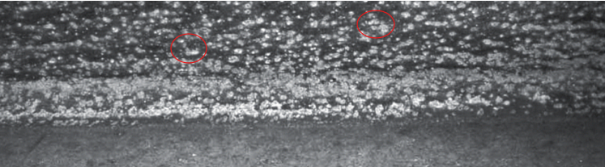

Figure 29 - Excessive dross affecting surface appearance (Duran, 2007)

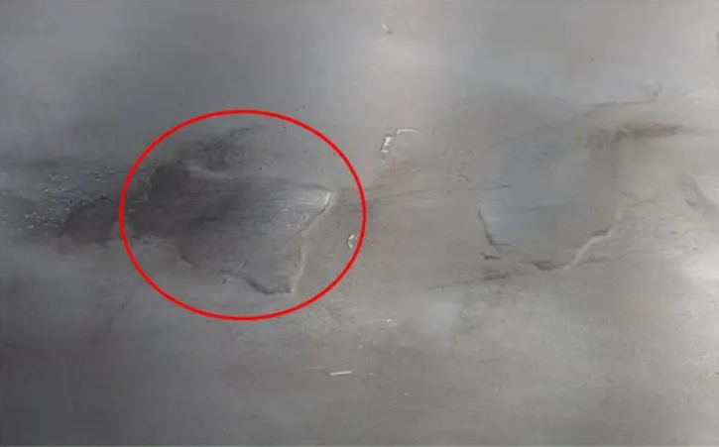

Figure 30 - Roll marks due to a damaged roll (SCRIBD, 2020)

Defects such as broken laminations (which occur during casting due to contaminants such as phosphorous) and holes can cause further cracking or failure during pressing operations, resulting in scrap and rework. The lamination in Figure 31 would require removal prior to releasing to customer.

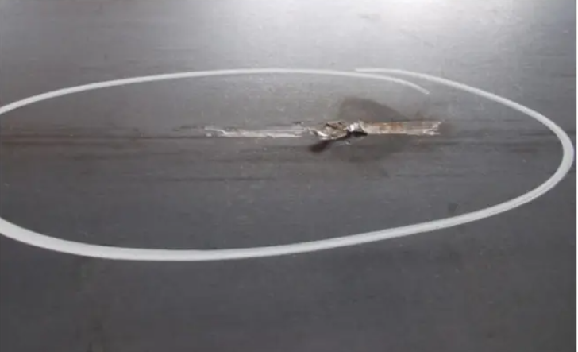

Figure 31 - Broken lamination (SCRIBD, 2020)

Customers expect strong zinc coating adhesion to the steel substrate. Poor adhesion due to surface oxides may not always be visible at the point of galvanising, leading to flaking during forming conditions. The zinc flakes contaminate customer presses, leading to additional quality issues and potential downtime. This situation severely impacts customer satisfaction and the downstream processing efficiency. An example of flaking visible after pressing is shown in Figure 32.

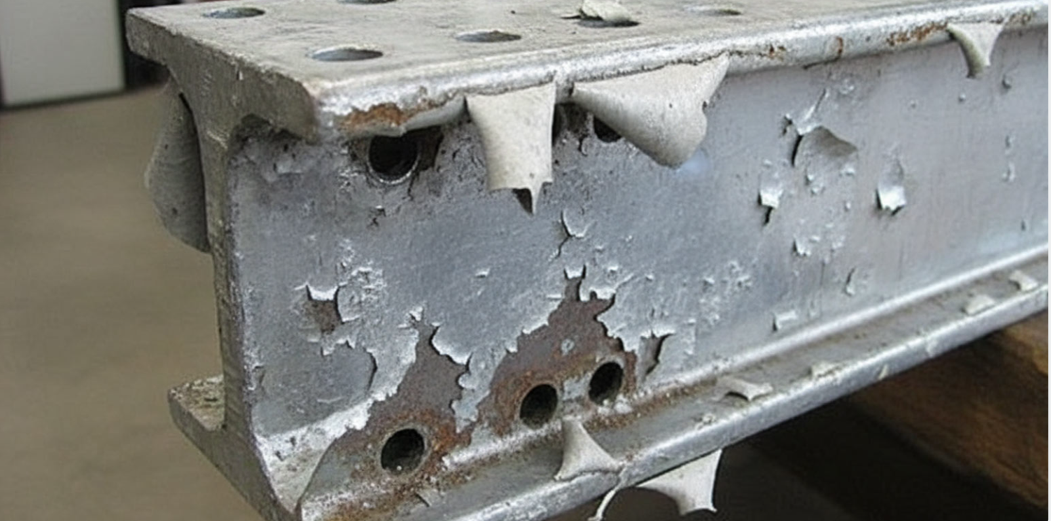

Figure 32 - Excessive flaking due to inadequate zinc adhesion (Galvanising, 2023)

Customer Confidence and Tata Steel’s reputation
Customer confidence and trust are fundamental to maintaining successful long-term supplier and customer relationships. Customers must have confidence that the supplied steel will behave as expected, meet specified standards, and be delivered on time.

Transparency and reliability of mechanical properties values are critical. Customers expect tensile tests to be representative of the entire coil, rather than isolated locations. Significant deviations between supplied results and actual performance in customer operations negatively impact confidence in the Zodiac galvanising line’s capability.

Strengthening the testing regime through improved property variation visibility will enhance trust in Tata Steel. Demonstrating continuous improvement and proactive quality control reinforces Tata Steel’s reputation as a supplier committed to reliable, high-quality steel to the automotive market.

Critical to Quality (CTQ)
Table 3 summarises the Critical to Quality characteristics derived from the Voice of the Customer. These CTQs convert the VOC into measurable performance requirements that the Zodiac galvanising line must achieve to meet automotive customer expectations and reduce the current cost associated with poor capability.

Table 3 - CTQ linked to the VOC

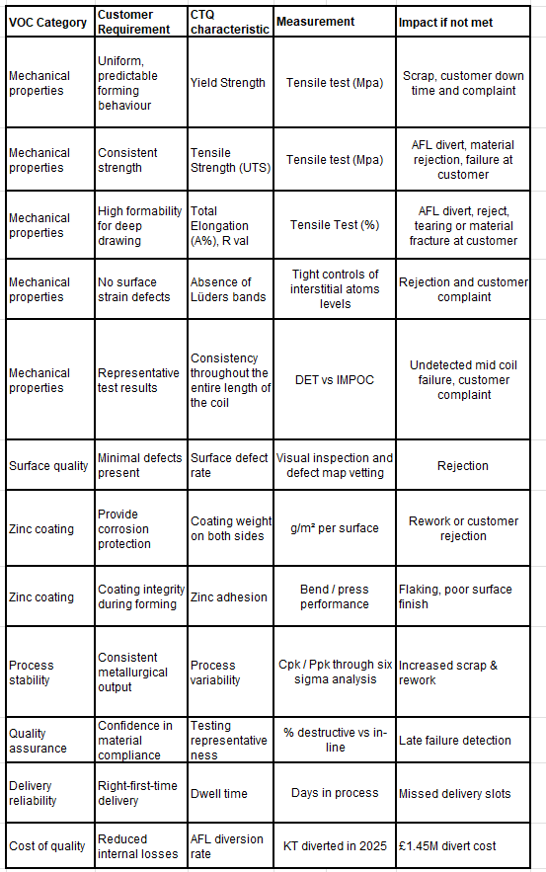

IMPOC overview
The current dual-end testing strategy provides measurements at the head and tail end of a coil and cannot detect variations occurring throughout the coil. Consequently, alternative technologies and methodologies capable of providing continuous mechanical property monitoring warrant investigation. A technology identified as a potential countermeasure is IMPOC.

IMPOC is a magnetic-inductive, non-destructive inline measurement system designed to continuously determine mechanical properties during the production of ferromagnetic steel strips. IMPOC consists of paired magnetising and sensing coils positioned above and below the strip, which periodically magnetise the steel and measure the resulting gradient of the residual magnetic field as shown in Figure 33.

This magnetic field gradient correlates with mechanical behaviour, enabling real-time monitoring of mechanical properties over the full coil length. IMPOC output is then correlated with results from destructive testing to derive predictive relations for proof and tensile strength (GmbH, 2025). The implementation of IMPOC would reduce destructive tests by 50%, yielding an annual saving of £85,000.

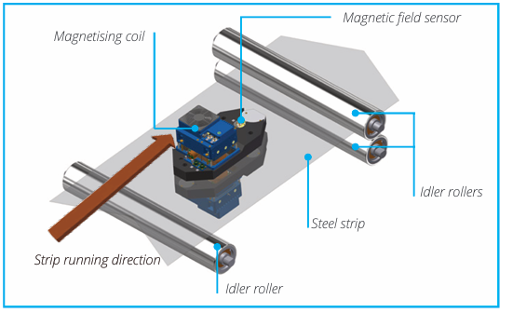

Figure 33 - EMG IMPOC schematic (GmbH, 2025)

Measure
The purpose of the measure phase is to establish a robust baseline for both the DX57 failure investigation and the IF quality improvement using IMPOC. This will be completed by examining the current DET regime and its limitations by aligning the CTQs, defining a structured data plan, and quantifying DX57 mechanical property failure modes.

Destructive Mechanical Testing (DET) overview
Mechanical properties of automotive IF steel produced on the Zodiac galvanising line are currently assured through destructive mechanical testing (DET). Sampling occurs at the head and tail end, with the results representing the entire coil length.

DET involves tensile testing a dog-bone specimen (Figure 34) using an Instron tensile testing machine (Figure 35). During testing, the specimen is subjected to uniaxial tensile loading until fracture, generating stress-strain data from which key mechanical properties are determined. While DET provides accurate point measurements at the sampled location, its destructive nature limits sampling frequency and coverage across the entire coil length.

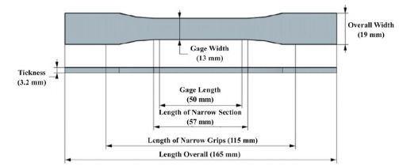

Figure 34 – Dog-bone specimen dimensions (Hibbert, et al., 2019)

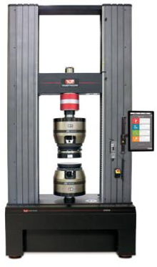

Figure 35 - Instron tensile testing machine (Instron, 2019)

Alignment of the current testing process to customer CTQs
Table 4 provides a comparison between customer CTQs and the current MET testing regime to highlight the limitations affecting the Zodiac galvanising line’s quality output.

Table 4 – Alignment of customer CTQ’s to the current DET regime

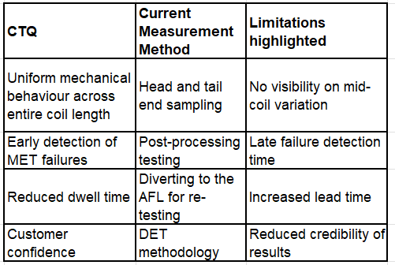

Data collection plan
The data collection plan defines the data required to investigate the current DX57 mechanical property failure modes and to support the evaluation of IMPOC as a potential improvement to IF steel quality monitoring.

Data to collect
- Frequency and types of failures linked to specific mechanical properties.

- Mechanical property results to support capability analysis.

- Incoming chemistry

- Coil live processing data including furnace temperature, line speed, temper mill elongation, width, and gauge.

Data sources
- Coil production records in Microsoft SQL servers to provide furnace temperature, line speed, temper mill elongation, width, gauge, and chemistry certificates.

- Port Talbot mechanical property recordings

Time period
The data will be retrieved from calendar year 2025 by time filtering in Microsoft SQL

DX57 Mechanical Properties failure modes investigation
To understand common failure modes of DX57 material, failure data was analysed and categorised by mechanical property deviations, as summarised in Figure 36. The analysis highlights proof strength as the most significant failure mode.

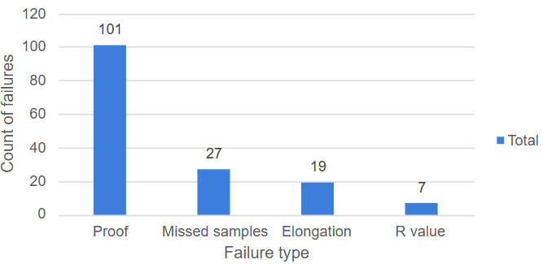

Figure 36 - DX57 mechanical property failure breakdown

Missed samples occurred due to engineering issues on the Zodiac galvanising line, where the shears failed to cut on both the head and tail end resulting in a divert to the AFL for new samples. As this is an engineering problem rather than a metallurgical problem, missed samples will be filtered from the analysis.

Elongation failures were influenced by furnace cycle transitions at the weld. This resulted in insufficient annealing temperature, which limited grain growth and incomplete softening after recrystallisation. As transitions are a natural part of the process on Zodiac and depend on sufficient scheduling, this will also be filtered from the analysis.

R value failures occurred due to sampling errors at the test laboratory. The R value was not obtained from these results due to early fracture of the tensile specimen, resulting in a divert to the AFL for new samples. Early fracture occurs due to sampling and testing-related factors, including specimen preparation defects and grip misalignment resulting in localised stress concentration. These findings demonstrate the limitations of the current testing regime while further supporting the potential benefits of introducing IMPOC.

Mechanical properties failure mode focus point – proof strength
The analysis of DX57 mechanical property failure modes in Figure 36 has demonstrated that proof strength non-conformance is the most significant failure mode contributing to metallurgical failures. Based on these findings, proof strength was selected as the primary focus for capability analysis and further investigation.

Capability analysis of DX57 proof strength
The DX57 proof strength lower and upper specification limits (LSL = 120 MPa, USL = 170 MPa) were retrieved from the BS EN 10346:2015 standards (see section 2.1.7, Table 1). Figure 37 presents the capability analysis on proof strength performed with data gathered from the data collection plan.

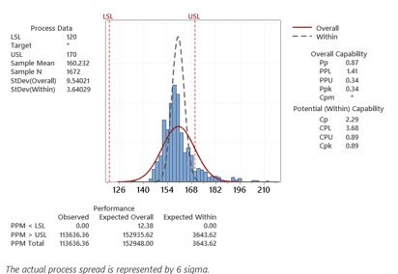

Figure 37 - DX57 proof strength capability analysis

Process data
A sample mean of 160.232 MPa indicates that the process mean is off-centre, sitting closer to the USL of 170 MPa. An overall standard deviation value of 9.54021, compared with a within standard deviation value of 3.64029 indicates most process variation arises from long-term factors opposed to short-term variation.

Overall capability
The overall capability metrics account for both short-term variation and long-term drifts. A Pp value of 0.87 indicates the overall process spread exceeds the specification width, demonstrating poor long-term capability. The PPL of 1.41 is greater than the PPU of 0.34, clearly showing the mean is closer to the USL. A Ppk value of 0.34 indicates poor long-term performance and significant process instability.

Potential (within) capability
The potential (within) capability accounts for short-term variation. A Cp value of 2.29 shows short-term variation is low showing potential for good capability. The CPL value of 3.68 is greater than the CPU value of 0.89, indicating there is minimal risk of failing due to low proof strength. However, the process mean remains positioned towards the USL, confirming that the process is poorly centred and explaining why all failures occur due to high proof strength. The Cpk was 0.89, despite the tight spread within capability, it is still poorly centred showing risk of failure.

Capability findings
The capability analysis has identified the mean is shifted towards the USL and the process has poor long-term capability. The PPM > USL was 113,636.36 whereas the PPM < LSL was 0, this is significant as it shows all failures are due to a high proof value above the USL. Further investigation into processing conditions and chemistry is required to determine the root cause of failing high proof.

Chemistry impact on pass vs failure
All DX57 material analysed across 2025 complied with the BSEN 10346 standards for the DX57 steel grade. To evaluate the relationship between chemical composition and metallurgical performance, Figure 38 compares the chemistry of twenty coils that passed MET requirements against twenty coils that failed MET requirements. All elements appear to exist at similar compositions for both failures and passes, apart from Mn. The coils that passed MET contained 0.03% more Mn, this is added in small quantities to increase strength via solid solution strengthening mechanisms (see section 2.2.4).

This suggests failures are not occurring due to chemistry differences, therefore processing conditions on the Zodiac galvanising line will be the primary focus for the investigation.

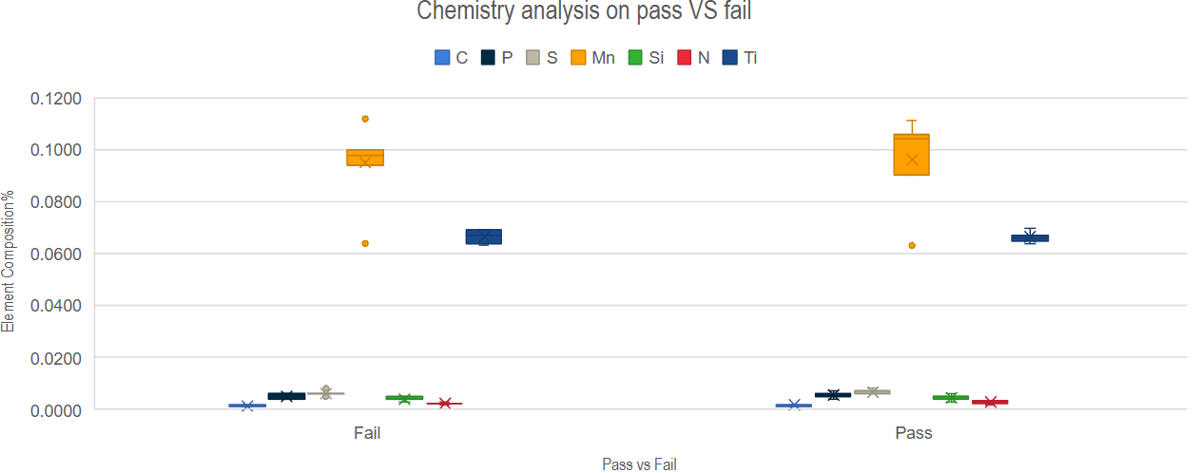

Figure 38 - Chemistry comparison on pass vs failure DX57 material

Furnace pyro validation
Another variable that merited analysis due to being a potential cause of metallurgical failures was furnace temperature measurements. To ensure the accuracy and reliability of furnace temperature measurements, the furnace pyrometers are routinely calibrated. The Zodiac operates with two furnace pyrometers: the Z9 strip temperature pyrometer and the Williamson pyrometer. Both units are calibrated to the exact roll bite location as the strip passes over the roll. This setup provides redundancy, with the Williamson pyrometer acting as a watchdog for the Z9 strip temperature pyrometer to ensure the continuation of production in the event of a failure in temperature readings.

The calibration interval was reviewed with the relevant teams and reduced from 10 weeks to 6 weeks to ensure accurate furnace data. Figure 39 compares pyrometer readings over 4 weeks, demonstrating that the current temperature measurements are accurate and dependable.

Figure 39 - Comparison of Zone 9 strip pyro to Williamson Pyro under operating conditions

Establishing Stable Sampling Conditions for IMPOC Validation
Mechanical property variation is most significant during product transitions, particularly at the front end of the coil. Under normal operating conditions, the first 50 m of strip is affected while process parameters stabilise to the new product requirements. Once the line conditions have adapted, the processing conditions become stable and representative of steady-state production.

As a result, front-end destructive tensile testing is more likely to capture transition-related variation rather than representative mechanical properties produced under stable processing conditions. Therefore, back-end destructive testing was chosen to support IMPOC validation. This approach allows laboratory mechanical property results to be compared against IMPOC readings under stable processing conditions, while IMPOC itself continues to monitor variation throughout the full coil length.

Figure 40 shows a transition from an engineering steel that does not require tension levelling or temper rolling to an automotive steel requiring both parameters. This type of transition is more significant as both the tension leveller and temper mill need to be brought online. This demonstrates that front-end sampling may not provide a representative measurement of stable production conditions and supports the use of back-end tensile testing for IMPOC correlation and validation.

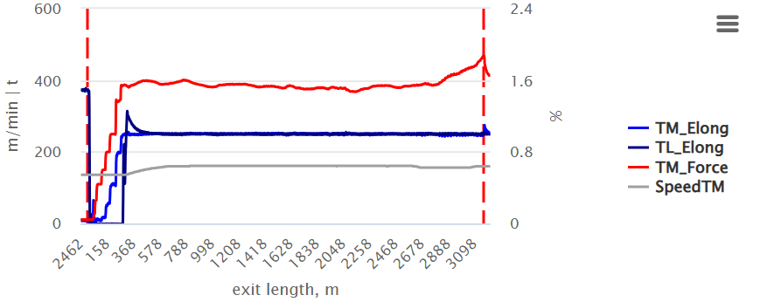

Figure 40 – Temper mill engagement – showing process stability at ~370m

Analyse
The objective of the analyse phase is to perform a root cause investigation into DX57 high proof failures and evaluate the feasibility of IMPOC as an in-line quality monitoring system to replace DET.

DX57 high proof failures investigation
The measure phase capability analysis demonstrated that all DX57 failures occur due to test values being above the USL. Therefore, this section will focus on identifying relevant processing conditions that potentially contribute to elevated proof strength values, causing the mean to shift towards the USL.

Detailed process flow
Figure 41 illustrates a detailed process flow that was created with key stakeholders in the process to understand key variables at specific process stages. KPIVs (Key Process Input Variables) were assigned to each process stage, the flow chart shows visibility on upstream and downstream KPIVs. Upstream KPIVs represent pre-annealed steel with the primary variables being chemistry, width, gauge, furnace temperature cycle, and line speed. Downstream KPIVs represent roll force and tension settings for the temper mill and elongation applied by both the temper mill and tension leveller.

The key downstream KPOVs (Key Process Output Variables) include the effect in microstructure and grain growth, texture development and baseline proof and tensile strength. Downstream KPOVs primarily influence proof strength. This is achieved through roll force and strip tension resulting in the applied elongation. The detailed process flow suggests that both downstream and upstream processing affect proof strength, however downstream processing potentially causes increased proof strength through additional plastic deformation post annealing.
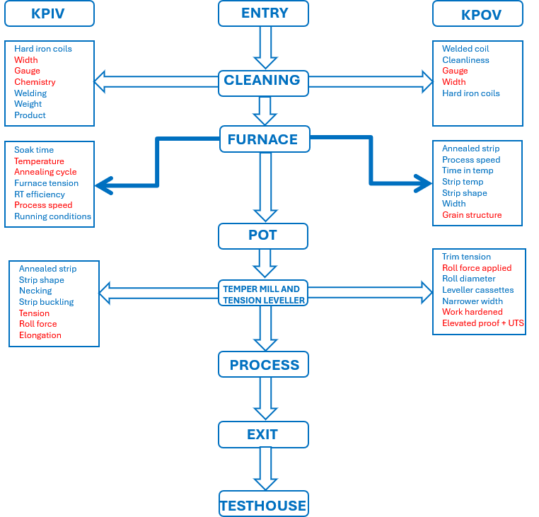

Figure 41 - Detailed process flow chart

Ishikawa Diagram
A meeting was scheduled with production, engineering, and technical teams to brainstorm influences on high proof strength failures in DX57 material. This ensured all aspects were covered including operational, metallurgical and control methods. The Ishikawa diagram shown in Figure 42 provides a structured methodology to explore potential causes for high proof failures. Several causes were highlighted based on their influence on proof strength. These included pyro accuracy and calibration, elongation, Oscar logic (automated control of the Zodiac line), schedule, furnace aims, and temper mill aims.

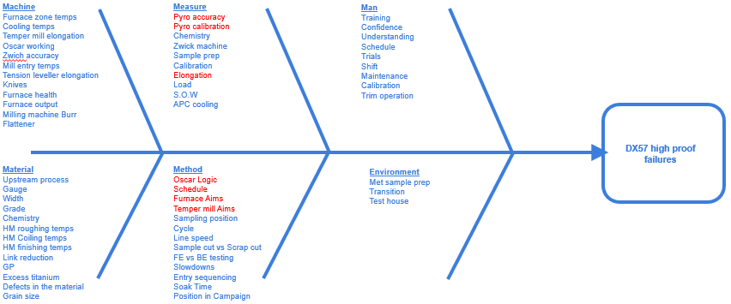

Figure 42 - DX57 Ishikawa diagram

Five whys
Both incoming chemistry and furnace pyro calibration have been eliminated from causes to explore based on the measure phase findings (see sections 4.7 and 4.8). The five whys problem solving tool combined production, engineering, and technical teams to identify all possible contributing factors to high proof failures.

Temper mill five whys
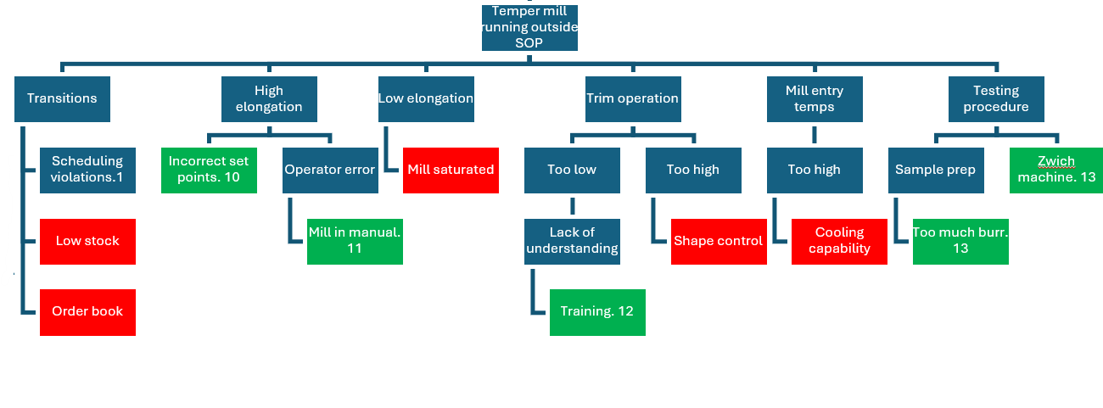

Figure 43 - Temper mill five-whys analysis

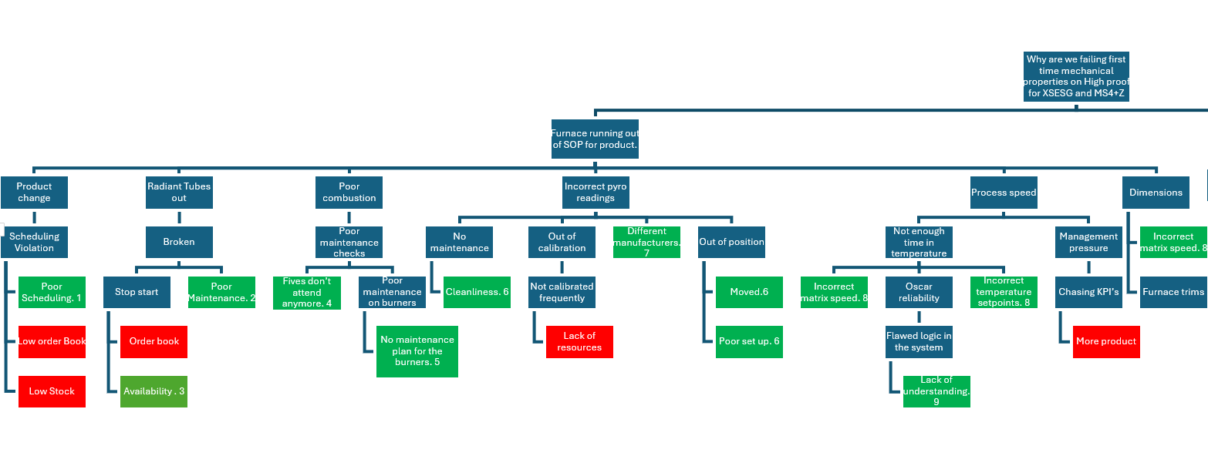
Furnace five whys

Figure 44 - Furnace five-whys analysis

Ease Impact Diagram
Next steps were created to mitigate potential problems raised during the problem solving, the agreed full list of next steps can be found in Figure 45.

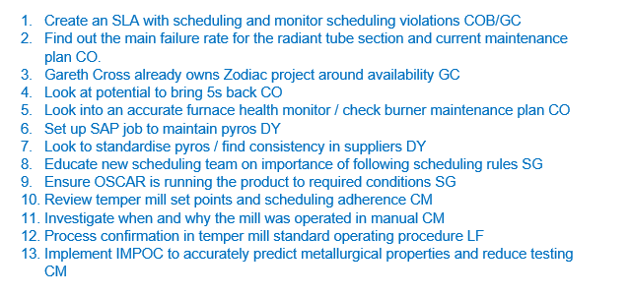

Figure 45 - Next steps generated from five whys analysis

The ease-impact matrix shown in Table 5 was generated to prioritise resources to specific countermeasures that have high impact meanwhile balancing ease and cost.

Table 5 - Ease impact generated from next steps list

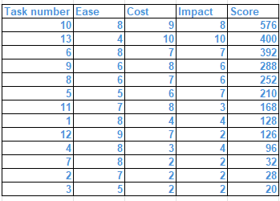

Key tasks identified
The top five scoring countermeasures were chosen to implement quick wins that have high impact on the project while offering cost efficient countermeasures.

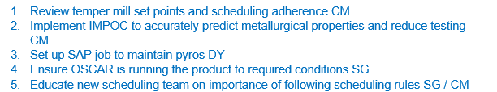

Figure 46 - Top five highest-scoring next steps from ease-impact analysis

Temper mill review – ease impact step 1
While soak time may reduce proof strength through increased grain growth, implementation would require a reduction in line speed and increase energy costs. This led to temper mill optimisation scoring the highest in the east impact analysis. Currently, the temper mill elongation is set at 1% for DX57 material. As this is an ultra-soft grade, excessive plastic deformation may introduce additional work hardening, causing the mean proof strength to shift towards the USL. Currently, DX57 material is processed with an average soak temperature of 800 °C.

Figure 47 shows a trial in a mini-lab setup conducted at 800 °C and 850 °C on varying temper mill elongations to assess the impact of a higher soak temperature to increase grain growth and further reduce proof strength.

However, the proof strength was significantly higher following annealing at 850°C and decreased initially with increasing temper mill elongation. This behaviour is attributed to the instability and dissolution of titanium carbide (TiC) at elevated soak temperatures, allowing carbon to return to solid solution. The presence of interstitial carbon promotes the formation of Cottrell atmospheres, whereby carbon atoms diffuse to and pin dislocations, increasing the stress required for plastic deformation. This results in an increase in yield point elongation and proof strength (Zhao, et al., 2000). Consequently, the material no longer exhibits fully interstitial-free (IF) behaviour, resulting in reduced formability and increased risk of cracking during forming operations.

This demonstrates that if downstream processing parameters do not sufficiently reduce proof strength to centre the distribution, increased soak time at controlled temperatures below the TiC dissolution threshold may contribute to a reduction in proof strength.

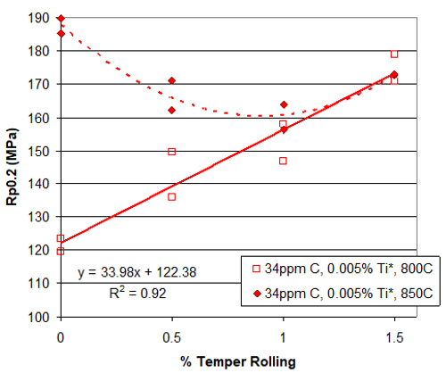

Figure 47 - Relationship between temper rolling elongation and proof strength on IF steels (Ovens, 2026)
To understand the impact of soak temperature on TiC stability during annealing, a study was conducted using a mini-lab set-up to review the evolution of free carbon across a temperature range of 675–900 °C.

Figure 48 shows that increasing annealing temperature increases free carbon due to the thermal dissolution of TiC precipitates. This effect becomes significantly more pronounced above approximately 850 °C, suggesting TIC stability is significantly reducing. Furthermore, the results highlight that increased levels of titanium reduce the amount of free carbon at a given temperature. This is because Ti stabilises free C by forming TiC precipitates, reducing the level of free C in solid solution. This is important in IF steels because free C increases proof strength and reduces ductility.

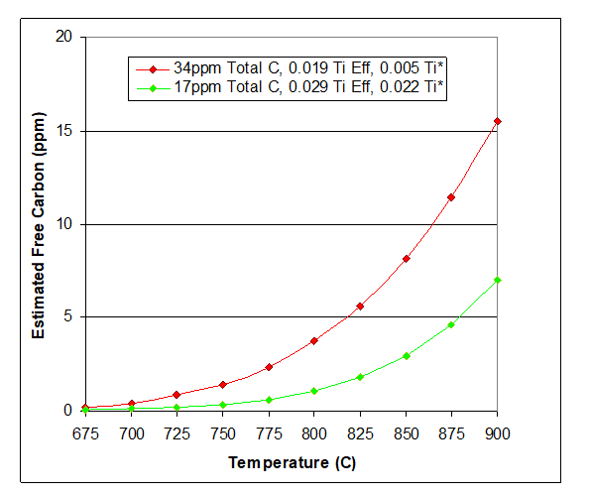

Figure 48 - Dissolution of TiC during annealing at varying temperatures (Ovens, 2026)

Current elongation transitions at 1% on the temper mill
Figure 49 highlights the most frequent change in elongation is -0.3%, meaning temper mill elongation was on 1.3% then reduced to 1% on the DX57 material. This is followed by -0.7%, a change from 1.7% down to 1%. The temper mill parameter changes will affect the first 50 m of a DX57 coil, highlighting a potential root cause of the high NRFT% on DX57 material as the temper mill is introducing excessive work hardening the first 50m until the temper mill adjusts to new conditions.

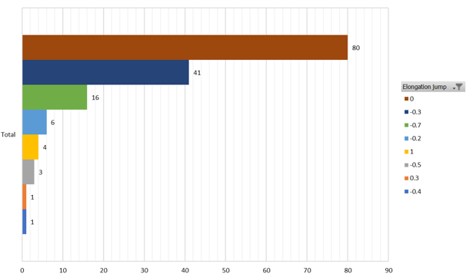

Figure 49 - DX57 temper mill elongation transitions across 2025

Finally, it is worth noting the capability analysis was produced using DET methodology. This is a limitation of the analysis, as the results only provide visibility at two isolated points on the coil rather than across the entire coil body, further highlighting the advantage of introducing IMPOC.

Assessing IMPOC feasibility – ease impact step 2
As identified throughout both the Define and Measure phases, the current DET regime lacks whole-coil visibility. The literature review identified that a single test representative of the whole-coil body is considered acceptable (see Section 2.5). Under Lean Six Sigma principles, any requirement that exceeds customer or regulatory expectations is considered wasteful and should be reduced where possible, as it consumes resources without adding value (Widiwati & Nurprihatin, 2025).

Regression modelling for IMPOC calibration
The purpose of the regression model is to evaluate whether IMPOC can reliably represent proof strength behaviour. A regression model was developed to calibrate IMPOC output against destructive proof strength values. The objective of this model is to establish the relationship between IMPOC measurements, key processing parameters and measured proof strength values of IF material.

Model structure
A multiple linear regression model was selected as it allows the combined influence of several independent variables to be assessed simultaneously. The multiple linear regression model equation is shown in equation 4.

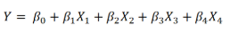

Equation 4 - Multiple linear regression model equation

Where:
- 𝑌 is the dependent variable.
- 𝛽₀ is the intercept.
- 𝑋₁,𝑋₂,𝑋₃ 𝑎𝑛𝑑 𝑋₄ are the independent variables.
- 𝛽₁,𝛽₂,𝛽₃ 𝑎𝑛𝑑 𝛽₄ are the regression coefficients

Regression model variables selection
The dependent variable in the model is proof strength, as this represents the target variable to be predicted. The independent variables selected for the model are:

- IMPOC value
- Temper mill elongation
- Tension leveller elongation
- Material gauge

Temper mill and tension leveller elongation were selected as these parameters directly affect proof behaviour through plastic deformation, while gauge influences the mechanical response of the strip under both deformation and magnetic measurement.

Hot mill furnace and cold mill reduction parameters were considered for the model, however their influence on proof strength is expressed indirectly through the final mechanical response of the strip. In addition, these upstream processing parameters cannot be adjusted directly during Zodiac processing.

Annealing furnace parameters at the Zodiac were also considered for the model due to the influence on microstructure and mechanical properties. However, IMPOC measurements are sensitive to the microstructure of the steel resulting from annealing, meaning furnace influence is captured within the IMPC value. For example, fine grains will create more grain boundaries which creates an increased resistance to magnetic domain movement. Whereas coarse grains will demonstrate less resistance, hence indicating the IMPOC value indirectly reflects the furnace influence on mechanical properties.

Finally, incoming steel chemistry values were also assessed but exhibited little variability across the dataset due to compliance with the BS EN 10346:2015 standards. The inclusion of chemistry parameters therefore would not improve the model performance and risked introducing unnecessary complexity without enhancing the predictive ability.

Model development and methodology
A training dataset was constructed using measured proof strength values obtained from tensile testing, guided by the data collection plan (see section 4.3). This data was plotted alongside corresponding process and IMPOC data.

A multiple linear regression approach was used to generate coefficients and an intercept defining the calibrated relationship between the independent variables and proof strength. The model used a large data set across 2025 consisting of 1400 observations to provide a strong prediction.

Regression results
Figure 50 illustrates the relationship between measured proof strength and proof strength predicted by the regression model. A strong linear relationship is observed with an R² value of 0.96, indicating that the model accurately captures the underlying behaviour of the data.

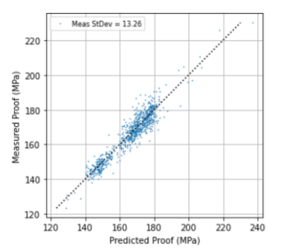

Figure 50 - Multiple linear regression model

An error-distribution analysis was conducted to further evaluate the relationship between destructive-test and predicted-model values. Figure 51 illustrates the IMPOC error distribution, with a standard deviation of 4.33 MPa, indicating a narrow spread.
The error distribution is centred around zero, therefore the model does not over or under predict proof strength. Figure 52 shows a percentage standard deviation of 2.57%. This level of prediction error is considered acceptable for quality monitoring supported by a single-end test, given that the variation falls within typical tensile-testing variation for galvanised steel samples.

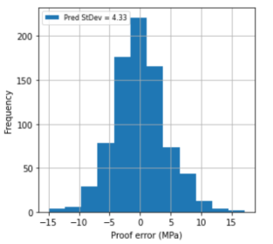

Figure 51 - Regression model error distribution (MPa)

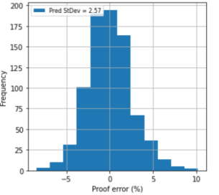

Figure 52 - Regression model error distribution (%)

Pyro maintenance – ease impact step 3
The five whys problem solving session identified a lack of planned maintenance on the furnace pyros during planned downtime. A maintenance task has now been scheduled every 6 weeks during line stoppages to clean the furnace pyros and assess their condition, ensuring repairs are completed when wear begins to occur rather than after failure.

Ensure OSCAR is running to required conditions – ease impact step 4
OSCAR (Operational System Control and Reporting) is an automated process control system that controls line speed, furnace temperature, and process conditions related to product furnace cycle, width, and gauge. This system was developed by the Zodiac technical process manager to reduce energy costs and gas usage. Following review with the technical process team, OSCAR shown strict compliance with the standard processing conditions for DX57 material.

Scheduling controls – ease impact step 5
A meeting was conducted with the scheduling, technical, and production teams to improve understanding of scheduling controls and reduce NRFT MET failures. The scheduling team was previously unaware of the cost implications associated with scheduling violations and the significant impact these violations can have on mechanical property readings throughout the first 50 m of strip. The team now understands both the financial impact and process consequences associated with breaking scheduling rules and will begin strictly following the current scheduling controls already in place.

Improve
The aim of the Improve phase is to reduce DX57 proof failures by re-centring the process mean away from the USL and validating IMPOC to improve quality control on IF material.

DX57 proof capability improvement
To reduce proof strength values of DX57 grade steels, a trial was conducted to reduce temper mill elongation.

Temper mill elongation optimisation
Currently, the temper mill is set to 1.0% on DX57 material, potentially over work hardening the material. Additionally, material processed at 1.7% and 1.5% elongation on the temper mill is commonly followed by material processed at 1.0% elongation, violating scheduling rules leading to NRFT diversions.

A proposed solution is to reduce temper mill elongation to 0.8%. The aim of this change is to reduce the work-hardening effect introduced during temper milling. Additionally, tighter scheduling controls allowing a maximum elongation transition of 0.2% will be implemented.

Risk assessment for reduced temper mill elongation
The risk assessment presented in Figure 53 was created to evaluate the impact of reducing temper mill elongation from 1.0% to 0.8%. This considered potential risks including reduced formability, process instability, and incorrect setpoint application. The findings supported progression to a pilot trial under controlled conditions. A formal FMEA will be developed in the Control phase to support long-term risk management.

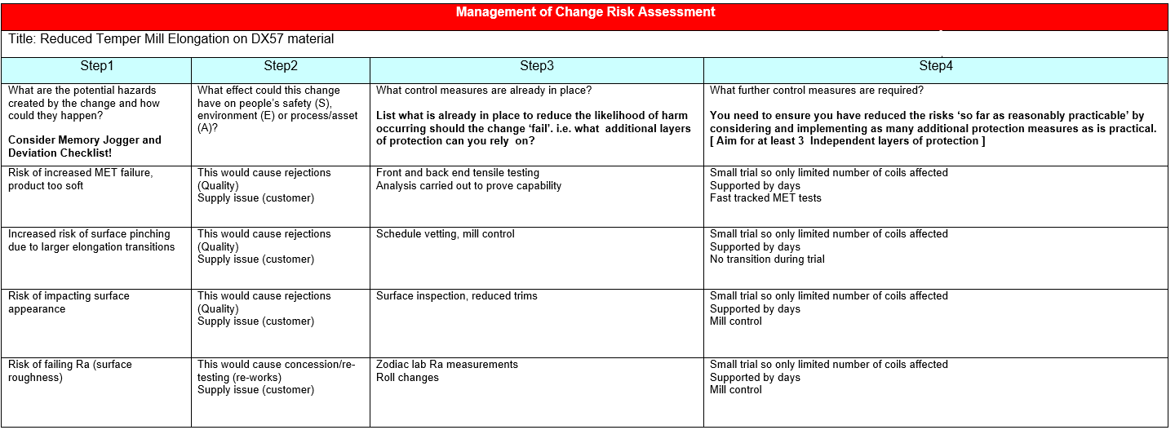
Figure 53 - Risk assessment for temper mill elongation change on DX57 material

Temper mill elongation reduction pilot study
The objective of this pilot study was to evaluate the effect of reducing temper mill elongation from 1.0% to 0.8% on proof strength performance in DX57 IF steel. This trial tests the hypothesis identified in the Analyse phase that temper mill elongation is a primary driver of elevated proof strength and associated variability.

A controlled trial was conducted on DX57 material while keeping width and gauge constant at 1600 mm x 0.8 mm. The trial group was compared against the most recent batch of DX57 material produced on the Zodiac galvanising line.

Pilot study control group
Figure 54 presents the capability analysis completed on the most recent batch of DX57 material produced on the Zodiac. The mean proof strength value was 156.7 MPa, which is shifted towards the USL of 170 MPa. The standard deviation is 5.21 MPa, with Cpk and Ppk values of 0.85, indicating that the process is not capable, as values below 1.33 are considered incapable for production processes.

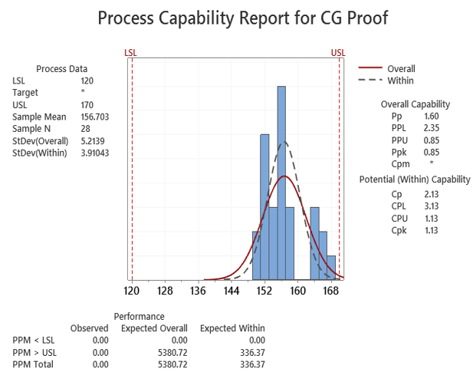

Figure 54 – DX57 grade control group capability analysis

Trial group
A separate capability analysis was created for the trial group, presented in Figure 55. The mean proof value for the trial group was 147.2 MPa, the standard deviation was 2.87 MPa, with Cpk and Ppk values of 2.64. The mean has shifted more centrally by moving away from the USL, while a Cpk value greater than two demonstrates a highly capable process.

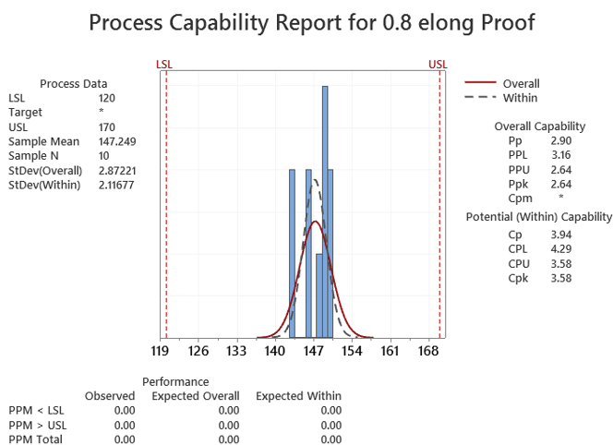

Figure 55 - DX57 trial group on 0.8% temper mill elongation capability analysis

Comparative analysis
The reduction in elongation resulted in a clear shift away from the USL towards the centre of the proof strength specification range, due to a mean proof strength reduction of 9.454 MPa.
Capability has significantly improved, with the Cpk value increasing from 0.85 to 2.64.

Pilot study limitations
The trial was constrained by material availability. Following the blast furnace closure at Port Talbot, lead times for producing trial material increased to approximately 10 weeks. In addition, the trial material was sourced from Tata Steel India, further limiting flexibility in order volume and scheduling.

As a result, the achievable sample size was small (n = 10). While this limits the statistical power of the study, the magnitude of the observed change in both mean proof strength and process variation is significant. This provides strong evidence to support the hypothesis that reducing temper mill elongation leads to a reduction in measured proof strength in DX57 IF steel. Further process capability analysis on DX57 production runs is required to give more of an insight into process capability.

IMPOC implementation
As IMPOC is intended to support a single-end testing strategy and replace DET, a key risk identified is IMPOC system failure or unavailability. In such cases, coils would need to be diverted to the AFL to obtain a front-end sample to meet release requirements, incurring a cost of £175 per tonne. To mitigate this risk, a contingency strategy is required to provide a reliable backup to IMPOC, ensuring compliance with release standards without requiring coil diversion.

MECHIMPP
In the event of an IMPOC system failure, the MECHIMPP system will serve as a backup. This redundancy ensures that mechanical property monitoring can continue uninterrupted. MECHIMPP predicts the through-coil proof strength based on temper mill load and tension leveller elongation on IF steel. Despite MECHIMPP providing a reliable fallback, IMPOC provides a more accurate prediction due to the magnetic field measurement. Therefore, through coil measurements predicted by MECHIMPP will only be used when IMPOC is unavailable.

IMPOC out of control action plan (OCAP) – Mech IMPP
The OCAP shown in Figure 56 defines clear operator guidance on decision pathways to ensure continued compliance with release standards in the event of an IMPOC failure.

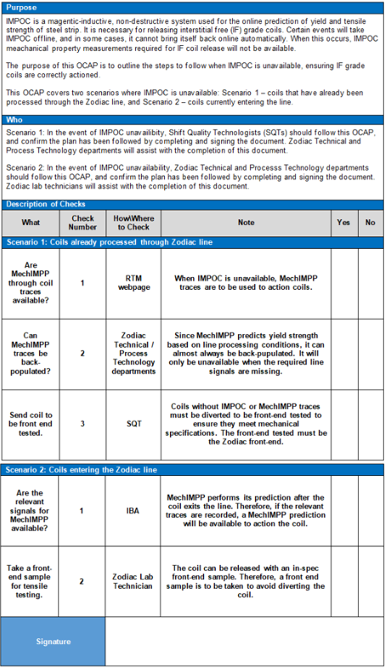

Figure 56 - Out of control action plan (OCAP) for IMPOC unavailability

IMPOC FMEA
Figure 57 shows an FMEA focusing on risks associated with IMPOC implementation, including system failure, incorrect signal interpretation, and operator misuse. High-risk failure modes were prioritised, and mitigation actions were defined to ensure IMPOC could function as a reliable and sustainable alternative to destructive testing.

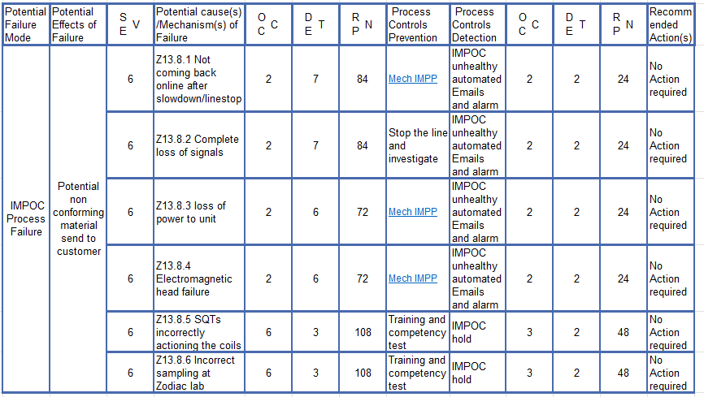

Figure 57 - IMPOC FMEA

IMPOC validation study (shadow mode)
A pilot study was conducted to evaluate the performance of IMPOC as a quality monitoring tool. For a five-week period, IMPOC was operated across full IF steel coil lengths in shadow mode, while the current DET regime was maintained. This provided live insight into IMPOC readings against DET values to highlight advantages and limitations of introducing IMPOC supported by a back-end test.

Figure 58 shows the IMPOC proof strength trace for an example coil C16943800. The trace shows that the head and tail ends of the coil were within specification, which aligned with the passing DET results. However, a significant drop in proof strength occurred between 10–180 m, falling out of the acceptable specification range. Under DET, this deviation would potentially go undetected, increasing the risk of non-conforming material reaching customer.

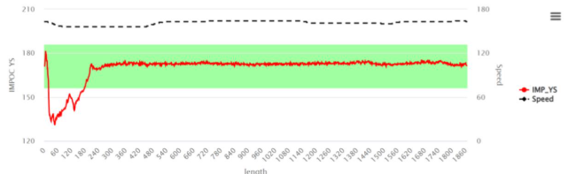

Figure 58 - IMPOC proof strength trace for C16943800 (M29543000)

Figure 59 shows the temper mill and tension leveller elongation traces for coil C16943800. At the head end, the tension leveller was on, and the temper mill elongation was beginning to increase. Although temper mill elongation was low, the combined effect of tension levelling and limited temper milling enabled the coil to pass MET. As the tension leveller went offline and the temper mill elongation began to increase, a corresponding drop in proof strength would be expected, causing this section to fall outside mechanical specification. This explains the dip between 10–180m in Figure 58, highlighting a significant advantage of IMPOC. A tensile test was performed on the non-conforming material discarded at the AFL with a proof value of 137 MPa at 50 m and 147 MPa at 120 m further verifying the IMPOC values.

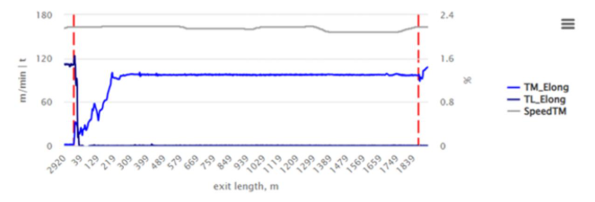

Figure 59 - Temper mill and tension leveller elongation trace for C16943800 (M29543000)

The IMPOC trace for coil C18965800 presented in Figure 60. This coil passed DET, with IMPOC matching the tensile result at 155 MPa. IMPOC identified a non-conforming region between 700–2025 m, a tensile test was performed on a sample from this region at the AFL, and a value of 118.2 MPa was obtained. A second non-conforming region was identified through IMPOC at 2180–2330 m, a tensile test performed at 2300 m obtained a value of 148.1 MPa, falling below specification and matching the IMPOC value.

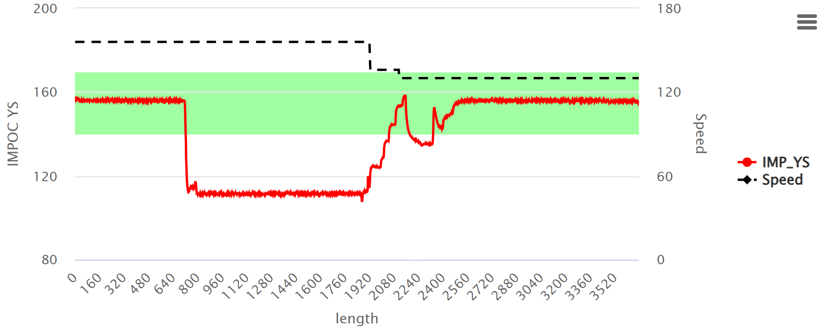
Figure 60 - IMPOC proof strength trace for C18965800 (M29645000)

Figure 61 illustrates the temper mill and tension leveller parameters for coil C18965800. It is evident the temper mill came offline at 700–2025 m. When the temper mill returned online, roll force was lost, hence reducing elongation from 2180–2330 m. This explains the drop in proof strength in the IMPOC trace, as well as the second small drop below specification.

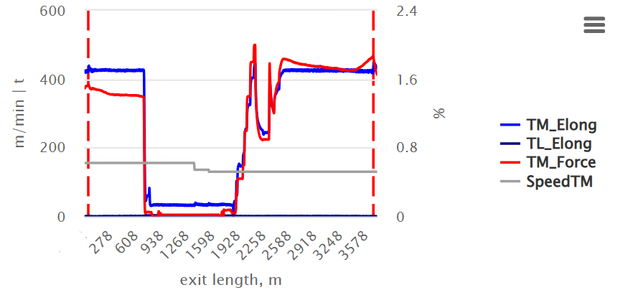
Figure 61 - Temper mill and tension leveller parameters for C18965800 (M29645000)

Figure 62 shows the IMPOC proof strength trace for coil C19820800. A drop in proof strength is evident from 1470m–1510 m with a corresponding value of 120 MPa at the tail end of the coil. This coil failed MET under DET due to the back-end value failing at 119.6 MPa, further validating the IMPOC prediction accuracy.

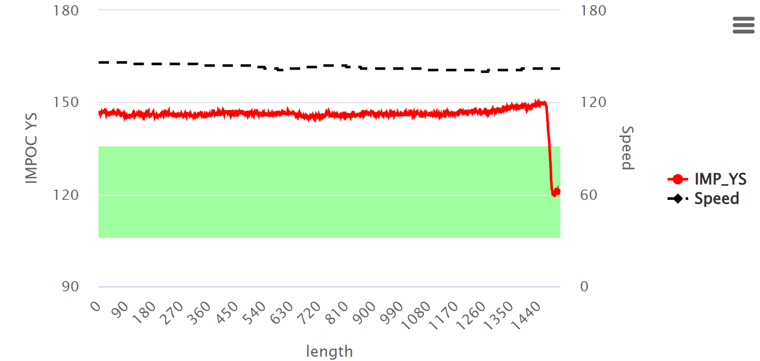

Figure 62 - IMPOC proof strength trace for coil C19820800 (M29721000)

The temper mill and tension leveller trace for C19820800 can be found below in Figure 63. Processing is stable until a sharp drop in temper mill elongation down to 0% on the tail end of the coil, explaining the sharp dip seen on the IMPOC trace.

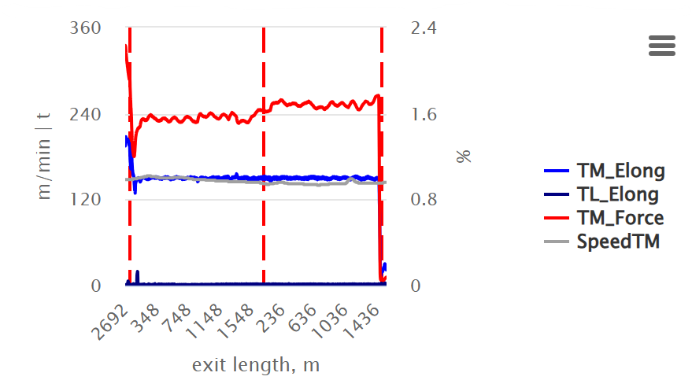

Figure 63 - Temper mill and tension leveller trace for C19820800 (M29721000)

Control
The control phase introduces standard operating procedures, monitoring systems, and training plans to sustain the previous improvements identified in the project.

DX57 processing changes

Standard operating conditions
To maintain improvements identified during the pilot study, the temper mill elongation for DX57 IF material has been standardised at 0.8%. In addition, scheduling controls have been implemented to limit elongation step changes to a maximum of 0.2%, and the scheduling team has been upskilled on the impact of breaking these rules. The combined effect of these measures is expected to reduce process variability.

FMEA
The risk assessment created during the Analyse phase has been converted into an FMEA to introduce the required countermeasures to improve the process (see section 6.3). The FMEA shown in Figure 64 identifies key failure modes associated with reduced temper mill elongation such as the risk of increased MET failures. Appropriate control measures have been implemented to mitigate these risks, such as ongoing monitoring of process capability. If DX57 proof strength results continued to demonstrate poor capability, further parameters such as tension leveller, furnace conditions and temper mill elongation will be reviewed.

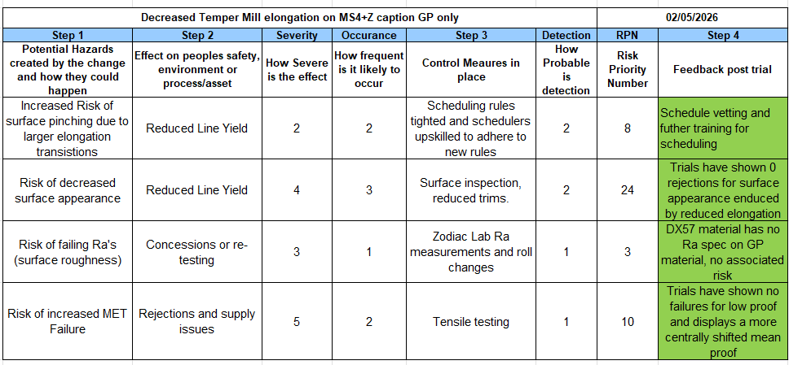

Figure 64 - DX57 grade elongation change FMEA

Process Monitoring and Verification
Further proof strength capability analysis will be carried out during DX57 production runs to ensure the changes made have a positive impact on MET performance. The project will be aiming for a Cpk value above 1.33 to meet the minimum acceptable capability target.

IMPOC implementation strategy
Transitioning from DET to IMPOC supported with a single end test is a significant change to implement. A strategy plan was completed with key stakeholders to ensure a robust process is in place.

IMPOC hold logic
The ruleset shown in Figure 65 determines whether a coil requires an IMPOC hold or can be released directly to customer. For a coil to pass the IMPOC YS rule, the proof strength measured by IMPOC throughout the entire coil length must remain within ± 15 MPa of the TE tensile result. This value was selected to provide an allowance for normal mechanical property variation across the full coil length. Any coil exceeding this threshold will be held awaiting further review from the shift quality technologist (SQT). A ruleset for holding coils with insufficient coverage from IMPOC was also implemented, this situation would require further tensile testing. Figure 66 presents an example of a trace that passed the IMPOC release criteria and a trace that was automatically placed on hold due to excessive variation.

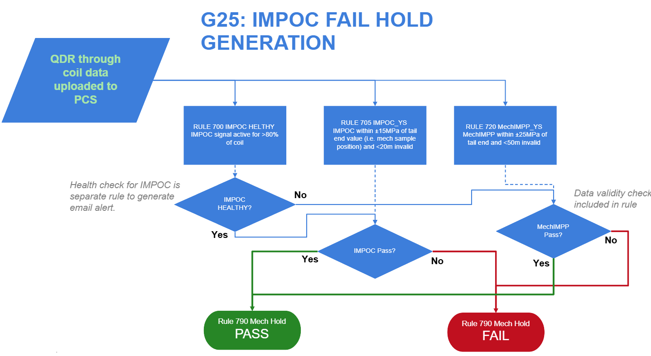

Figure 65 - IMPOC hold generation ruleset

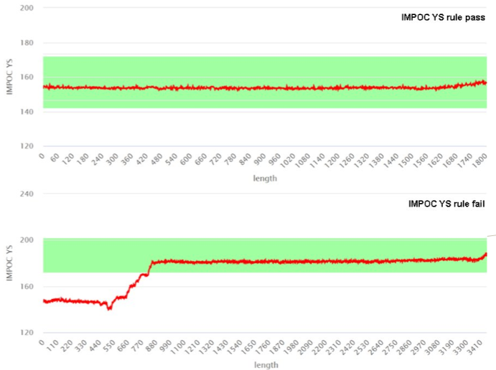

Figure 66 – IMPOC hold logic showing a passing trace and failing trace exceeding ±15 MPa limit

IMPOC hold actioning training
The decision-making flowchart provided to Shift Quality Technologists for the management of IMPOC holds can be found in Figure 67. This flowchart provides clear guidance to ensure non-conforming material is contained and correctly actioned prior to reaching the customer.

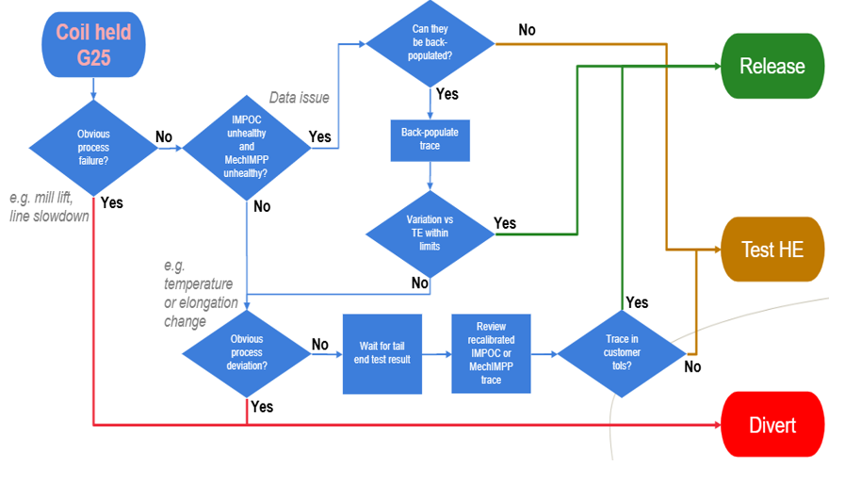

Figure 67 - IMPOC hold action decision making

IMPOC hold assessment
The first question from the IMPOC competency assessment is shown in Figure 68. The assessment contained fifteen questions given to SQTs to assess decision making in different scenarios. All SQTs successfully completed the assessment, displaying competence in managing IMPOC holds by achieving full marks.

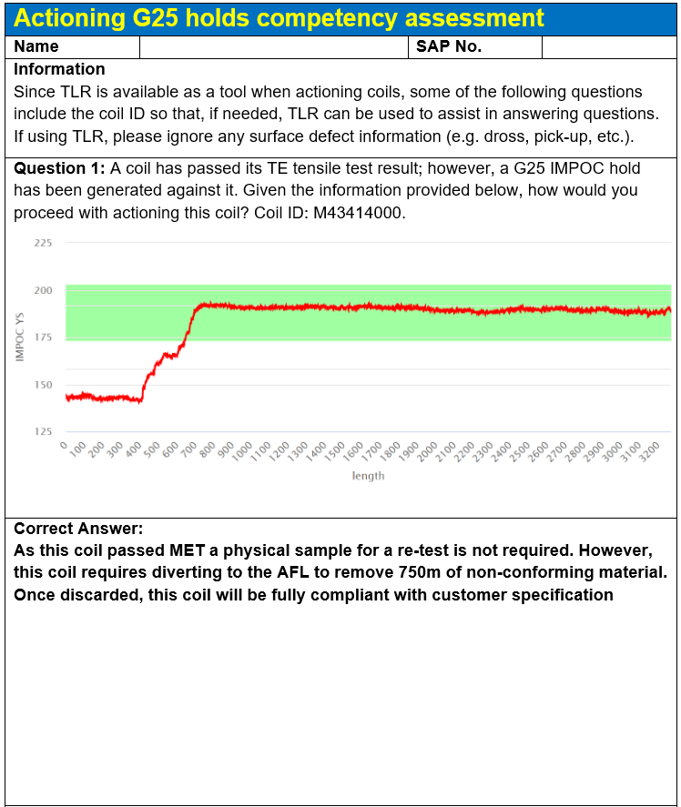

Figure 68 - IMPOC hold competency assessment

Conclusions and Recommendations / Future Work

Conclusions and limitations

DX57 metallurgical investigation findings
The investigation identified elevated proof strength as the most significant DX57 mechanical mode. A capability analysis performed in the Measure phase displayed a poorly centred process due to the mean proof strength sitting closely to the USL. Problem-solving during activities conducted during the Analyse phase identified the temper mill as a potential significant contributor to elevated proof strength values through additional work hardening. Internal mini-lab trials further supported this theory, demonstrating that temper mill elongation has a significant impact on proof strength (Ovens, 2026).

The pilot study reducing temper mill elongation from 1% to 0.8% reduced the mean proof strength from 160.232 MPa across 2025 to 147.2 MPa. The dataset was compared to the most recent batch of DX57 material which achieved a mean proof strength value of 156.703 MPa. This significantly improved process centring and reduced the likelihood of exceeding the USL. Additionally, scheduling controls limiting elongation transitions will support the reduction of NRFT failures and minimise proof strength variation.

The findings has a strong relation to published literature on the effect of temper rolling IF steels. (Grassino, et al., 2012) found that ultra-low-carbon steels have a parabolic relationship between temper milling and proof strength. At lower elongations, strength decreases due to discontinuous yielding. As elongation increased above 0.5-0.9%, work hardening results in improved strength readings.

Similarly, (Hoggan, et al., 2002) concluded that ultra-low-carbon steels exhibit reduced susceptibility to discontinuous yielding compared with higher carbon grades. The study also identified that increasing elongation increases proof strength due to work hardening and increased dislocation density.

However, internal trials indicated a linear relationship between elongation and proof strength on DX57 steels annealed at 800 °C, as opposed to a parabolic relationship found by (Hoggan, et al., 2002) and (Grassino, et al., 2012). The internal trial did identify a parabolic relationship at an annealing temperature of 850 °C, suggesting that lower annealing temperatures may promote more stable proof strength behaviour within the Zodiac process.

DX57 metallurgical investigation limitations
Factors such as annealing conditions were not prioritised due to the associated increased energy costs, reduced production throughput, and risk of negatively impacting other mechanical properties identified during the Analyse phase. Additionally, the available sample population during the pilot study was limited due to a 10-week lead time associated with trial material production, restricting the ability to assess process behaviour on a larger scale.

IMPOC implementation findings
The project assessed the feasibility of implementing IMPOC as a quality-improvement strategy to replace the conventional dual-end destructive testing (DET) methodology for IF steels. The measure phase identified mechanical property variation occurs on the head-end of a coil during transitions. Therefore, to ensure the tensile test represents stable processing, the tail-end was selected to support IMPOC readings.

The Analyse phase demonstrated a strong correlation between IMPOC proof strength measurements and conventional tensile test values, confirming IMPOC can provide reliable mechanical property monitoring across the full coil length. This provided a significant advantage over DET, which only evaluated mechanical properties at discrete sampling locations.

Further work conducted during the Improve phase operating IMPOC in shadow mode demonstrated that IMPOC significantly improved visibility of mechanical property variation throughout the full coil length. This enhances quality protection by optimising non-conforming material identification and minimising the likelihood of customer complaints due to brittle fracture during pressing operations.

These findings are supported by published literature relating to IMPOC. (V.Matyuk, et al., 2004) concluded that IMPOC improves productivity by reducing destructive test requirements while increasing the visibility of mechanical property variation across the full coil length. Similarly, (Sommers, et al., 2017) found that IMPOC measurements could be integrated with processing conditions to reduce strength variation.

The project successfully implemented rulesets to hold coils exceeding ±15 MPa variation from the tensile result, or coils with incomplete IMPOC readings across the length. Also, operator decision making guidelines, competency assessments, and an OCAP in the event of IMPOC failure supports in protecting the customer from receiving material outside of the specification.

IMPOC limitations
Despite the strong correlation of IMPOC readings with tensile testing, the project was limited by the IMPOC duration of five weeks in shadow mode. Consequently, IMPOC will remain in shadow mode to gain a larger quantity of production data prior to becoming live.

Recommendations and future work

Short-term recommendations
The reduced 0.8% temper mill elongation on DX57 steels requires consistent monitoring of process capability indices to ensure sustained improvement in proof strength performance. Further investigation is required on the influence of temper mill roll force, strip tension and tension levelling to fully understand factors that influence proof strength.

IMPOC will remain in shadow mode to validate mechanical property readings, IMPOC hold logic and SQT decision making. Continuous monitoring combined with SQT feedback will support in the refinement of IMPOC hold logic and improve understanding of IMPOC limitations.

Long-term recommendations
IMPOC will be taken out of shadow mode and used as the mechanical property release point supported with a tail-end tensile test. Full IMPOC implementation will yield a saving of £85,000 due to a reduction of 50% in tensile tests. Further investigation is required to understand IMPOC readings on additional steel grades such as DP. This would allow IMPOC to become the release point for varying grades, further reducing the cost associated with destructive tensile testing.

Further work is required to reduce the cost of failing to meet customer metallurgical specifications. The pareto analysis in Section 3.2 Figure 24 displays numerous grades with a high failure rate that require an investigation to improve capability.

Overall, the project successfully achieved its stated aims and objectives by improving DX57 process capability and demonstrating the feasibility of IMPOC as an alternative to DET.

References
Antoine, P., Vandeputte, S. & Vogt, J.-B., 2006. Empirical model predicting the value of the strain-hardening exponent of a Ti-IF steel grade. Materials Science and Engineering, 433(2), pp. 55-63.

Arora, D. A., 2025. Material science concepts, Steelmaking Process, Strengthening of Materials. [Online]
Available at: https://studymeta.com/test-series/f/luders-band
[Accessed 20 December 2025].

Berczeli, M. & Weltsch, Z., 2018. Experimental studies of different strength steels MIG brazed joints. Periodica Polytechnica Transportation Engineering, 46(2), pp. 63-68.

Bhadeshia, H. & Honeycombe, R., 2006. Steels: Microstructure and Properties. 3rd ed. Amsterdam: Elsevier.

CEN, 2015. EN 10346:2015 – Continuously hot-dip coated steel flat products – Technical delivery conditions, European Committee for Standardization: Brussels.

Damm, B., 2025. Tensile test of steel – insight into the mechanical properties. UnionStahl.

Duran, B. A., 2007. Dross inclusions. [Online]
Available at: https://galvanizeit.org/knowledgebase/article/dross-inclusions
[Accessed 28 December 2025].

Emmetcosten, 2019. The Stress Strain Curve | Intro To Structural Engineering. Engineering Design and Analysis.

Enache, I.-C., Enache, I.-C. & Enache, I.-C., 2023. Reducing the Scrap Rate on a Production Process Using Lean Six Sigma Methodology. Processes, 11(4), p. 1259.

Galvanising, V., 2023. Long-Term Flaking Concerns with Hot-Dip Galvanized Coatings: Causes, Prevention, and Remediation. [Online]
Available at: https://www.hotdipgalvanizing.com/technical-resources/long-term-flaking-concerns-with-hot-dip-galvanized-coatings-causes-prevention-and-remediation#
[Accessed 29 December 2025].

Gavriljuk, V. G., 2015. Influence of interstitial carbon, nitrogen, and hydrogen on the plasticity and brittleness of steel. Steel in Translation, 45(10), pp. 747 - 753.

Ghelani, H., 2023. Six Sigma and Continuous Improvement Strategies: A Comparative Analysis in Global Manufacturing Industries. International Journal of Scientific Research and Management (IJSRM), 11(8), pp. 954-972.

GmbH, E. A., 2025. MPOC – Online measurement of tensile and yield strength, Product brochure, Revision 00. [Online]
Available at: https://www.bst.elexis.group/fileadmin/user_upload/emg/Prospekte/QA_Product_brochures_EN/20251120_Brochure_IMPOC_Rev00_EN.pdf
[Accessed 10 January 2026].

Graafmans, T., Turetken, O., Poppelaars, H. & Fahland, D., 2021. Process Mining for Six Sigma. Bus Inf Syst Eng, pp. 277-300.

Grassino, J., Vedani, M., Vimercat, G. & Zanella, G., 2012. Effects of Skin Pass Rolling Parameters on Mechanical. International Journal Of Precision Engineering and Manufacturing, 13(11), pp. 2017-2025.

Hamada, J.-i., Ono, N. & Inoue, H., 2011. Effect of Texture on r-value of Ferritic Stainless Steel Sheets. ISIJ International, 51(10), pp. 1740-1748.

He, K. & Baker, T., 2015. Effect of Zirconium additions on Austenite grain coarsening of C–Mn and microalloy steels. Materials Science and Engineering: A, 256(2), pp. 111-119.

Hibbert, K. et al., 2019. The Effects of Build Parameters and Strain Rate on the Mechanical Properties of FDM 3D-Printed Acrylonitrile Butadiene Styrene. Scientific Research Publishing, 9(27), pp. 2164-5752.

Hoggan, E., Scott, R., Barnett, M. & Hodgson, P., 2002. Mechanical properties of tension levelled and skin passed steels. Journal of Materials Processing Technology, Volume 125-126, pp. 155-163.

Hong, S.-H., Kim, J. H., Lee, J. H. & Suh, D.-W., 2023. Influence of starting microstructure on the microstructure evolution during annealing and the yield strength in Nb-Ti microalloyed cold-rolled steel. Materials Science and Engineering: A, Volume 868.

Huang, Y. et al., 2025. Titanium Modulated the Occurrence States and Strain Aging Resistance of Residual Element Nitrogen in Scrap-Based Low-Alloy Steels. Materials, 18(21), p. 4842.

Instron, 2019. 980 Series Universal Testing System. [Online]
Available at: https://www.instron.com/en/products/testing-systems/universal-testing-systems/high-force-universal-testing-systems/5989-floor-model/
[Accessed 1 November 2025].

ISO, 2019. Metallic materials — Tensile testing — Part 1: Method of test at room temperature, s.l.: s.n.

Jolfaei, M. et al., 2019. Non-Destructive Measurement of Microstructure and Tensile Strength in varying thickness commercial DP Steel Strip using an EM Sensor. Journal of Magnetism and Magnetic Materials, Volume 473, pp. 477-483.

Li, L. et al., 2021. Texture Evolution with Different Rolling Parameters of Ferritic. Metals, Volume 11, p. 1341.

Maciejewski, J., 2015. The Effects of Sulfide Inclusions on Mechanical Properties and Failures of Steel Components. Journal of Failure Analysis and prevention, Volume 2015, pp. 169-178.

Ovens, L., 2023. Investigation into the metallurgy of IF steels, Newport: TATA STEEL.

Ovens, L., 2026. Investigation into the effect of processing paramaters on IF steels, newport: TATA STEEL.

Pang, J. C. et al., 2017. Effect of silicon and aluminium in ferrite on tensile and impact properties. Materials Science and Technology, 33(15), pp. 1806-1810.

Peyton, A. et al., 2016. The Application of Electromagnetic Measurements for the Assessment of Skin Passed Steel Samples. 19th World Conference on Non-Destructive Testing 2016.

Raji, N. A. & Oluwole, O. O., 2012. Effect of Soaking Time on the Mechanical Properties of Annealed Cold-Drawn Low Carbon Steel. Scientific Research, 3(8).

Rana, R., Bleck, W., Singh, S. & Mohanty, O., 2007. Development of high strength interstitial free steel by copper precipitation hardening. Materials Letters, 61(14), pp. 2919-2922.

Raval, B., 2026. Tension Testing of Metallic Materials: Procedure, Standards & Properties. Indinitalab.

Sánchez, C., Bustos, O., Artigas, A. & Bruna, H., 2023. Silicon Effect and Microstructural Evolution of Hot Dip Galvanized Coating of Structural Steels. Metals, 13(11), p. 1892.

Schaeffler, D., 2023. Metal Properties: Plastic Strain Ratio (r-Value). MetalForming.

SCRIBD, 2020. Steel Defect Guide. [Online]
Available at: https://www.scribd.com/document/444104269/Steel-Defect-Guide
[Accessed 29 December 2025].

Sinha, M., Yadav, S. & Ghosh, S., 2022. A novel observation of Widmanstätten ferriteand pearlite by thermo-mechanical processing ofinterstitial-free steel. Materials and Manufacturing Processes, 37(15), pp. 1766-1771.

Sommers, U., Klein, C. A., Brühl, F. & Sasse, C., 2017. INTELLIGENT FURNACE TECHNOLOGY FOR ANNEALING AND GALVANIZING LINES. abm week, 21(1).

Song, Y., Zhang, H. & Ren, L., 2024. review of research on MnS inclusions in high‐quality steel. Engineering Reports, 6(5), pp. 1-21.

Steel, T., 2025. Benefits of Magi Zinc. [Online]
Available at: https://www.tatasteeluk.com/automotive/key-products/magizinc
[Accessed 2 October 2025].

Steel, T., 2025. Our operations. [Online]
Available at: https://www.tatasteeluk.com/about-us/our-operations
[Accessed 2 October 2025].

Steel, T., 2025. TATA STEEL - about us. [Online]
Available at: https://www.tatasteeluk.com/about-us/our-operations
[Accessed 2 October 2025].

Sun, M. et al., 2022. Effect of Sulfur Content on the Inclusion and Mechanical Properties in Ce-Mg Treated Resulfurized SCr420H Steel. Metals, 12(1), pp. 1 - 136.

Tseng, C.-C. & Chen, K.-C. C.-S., 2022. Estimation of the Six Sigma Quality Index. Mathematics, 10(19), p. 3458.

Ul-Hamid, A., 2020. Microstructure, properties and applications of Zr-carbide, Zr-nitride and Zr-carbonitride coatings: a review. Center for Engineering Research.

V.Matyuk, et al., 2004. TESTING OF MECHANICAL PROPERTIES OF THE LIGHT-GAUGE ROLLED PRODUCTS OF LOW-CARBON STEELS IN THE ZINC GALVANIZING LINE BY THE PULSE MAGNETIC METHOD. NDT.

Widiwati, I. T. B. & Nurprihatin, F., 2025. The implementation of Lean Six Sigma approach to minimize waste at a food manufacturing industry. Journal of Engineering Research, 13(2), pp. 611-626.

Zhang, Z. T. et al., 2009. Effect of Alloying Elements, Water Vapor Content, and Temperature on the Oxidation of Interstitial-Free Steels. Metallurgical and Materials Transactions, 40(4), pp. 550-556.

Zhao, J., De, A. & Cooman, B. D., 2000. Kinetics of Cottrell atmosphere formation during strain aging of ultra-low carbon steels. Materials Letters, 44(6), pp. 374-378.

Zheng, Y. et al., 2024. Research on the strengthening mechanism of Nb–Ti microalloyed ultra low carbon IF steel. Journal of Materials Research and Technology, 30(1), pp. 5785-5803.

