

Assessment component: Financial performance and management

Student Name:

Pew Peakhom

Student ID:

2433833

Module Name: Financial Management

Module Code: LCMB 7002

Lecturer’s Name:

Isaiah Oino

Term 1

Submission date:
2
21-04-26

Executive Summary
This report extensively focuses on the Hyundai company's financial performance for the last five years. The financial calculation showcased a significant and upward trend in the performance of the company. The major driver of this result is strong cost optimization, pricing strategies and rising sales. Increasing liability is one of the major concerns which requires an effective restructuring. The analysis highlighted that equity financing will be the most suitable source for restructuring the company's financial condition. In this evaluation key investment appraisal technique has been used to get an understanding of the visibility of the three projects. The outcome of this financial calculation demonstrates that three projects will not be suitable for the company because of the possibility of negative return after the project life cycle.

Table of Contents
Introduction 4
Financial Health Check 4
Analysis of Financial Statements 4
Ratio Analysis 6
Trends, Strengths and Threats 6
Working Capital Management Analysis 9
Assessment of Cash Operating Cycle 9
Recommendation of Strategies to Improve Liquidity 10
Comparison of long-term vs short-term financing options 11
Strategic Financial Restructuring Plan 12
Recommended Financial Restructuring Options 12
Impact on Shareholder Value, Debt Structure, and Operational Flexibility 13
International and Ethical Considerations 14
Investment Appraisal and Capital Budgeting 16
Analysis of three investment options 16
Investment decision and recommendation 18
Capital rationing decision 20
Conclusion 20
Reference List 21
Appendices 24
Appendix 1: Ratio Table 24
Appendix 2: Calculation for Project A 26
Appendix 3: Calculation for Project B 27
Appendix 4: Calculation for Project C 28

Introduction
This report includes a financial analysis for the last 5 years with the help of ratios for the Hyundai Company. The identification of core strengths and weaknesses of the company will be done in this part. Working capital Management analysis will be done to assess the cash operating cycle and strategies to improve liquidity through working capital reforms. A financial restructuring plan will be prepared, including shareholder value and debt structure. Investment appraisal and capital budgeting with the help of NPV, ARR, Payback period, PI and IRR will also be done for 3 projects.

Financial Health Check

Analysis of Financial Statements
The income statement shows a clear upward trend in revenue, which increases continuously from 2020 until 2024. The five-year results show that the company improved its ability to control expenses, achieved better operational efficiency, and gained stronger control over its pricing strategy. The company is operationally efficient and market competitive through its successful maintenance of increasing profits after 2021.
The balance sheet has shown effective expansion of assets as total assets increased through their property, plant, and equipment, financial services receivables and joint venture investments (Hyundai Motor Company, 2024). The current expansion for Hyundai has highlighted it has made continuous investments strategically in its production facilities and technological development and its financial operations. There is a growth in the current assets which resulted in improved ability to handle short-term financial needs for making payments in short term loans and advances (Keown et al., 2024). Total liabilities increased because the company obtained more long-term debt and debentures which caused total liabilities to increase steadily. The evidence shows that Hyundai is using external debt to fund its business expansion.
The company experienced higher cash expenditure from its core business operations which rose to ₩5,661,641 million after starting at ₩2,518,760 million during the 2024 fiscal year. The company achieved a profit increase for the year 2024 however the company experienced a fall in its operating cash because it experienced a ₩35,159,625 million operating asset and liability reduction. In 2022 to 2020, the company has increased its need for working capital because its inventory and receivables have grown while its payables have decreased.
The cash flow also shows heavy spending on capital projects as Hyundai has increased its cash outflow for investments from ₩8,649,391 million during 2023 to ₩14,623,489 million during 2024. In 2020 to 2021, the company experienced a decline in its net cash used in investing activities, which shows that there is a reduction in investment between these years due to the heightened pandemic phase. The most significant cash outflows come from the company's acquisition of property and plant and equipment and intangible assets and its investments in joint ventures and associates.

Ratio Analysis
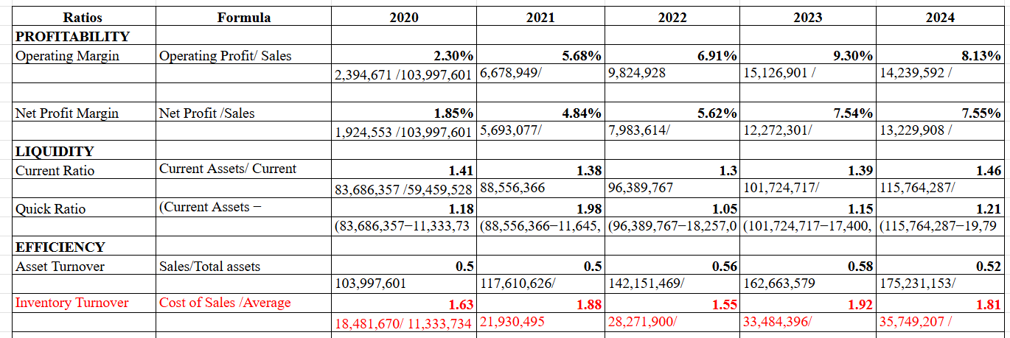
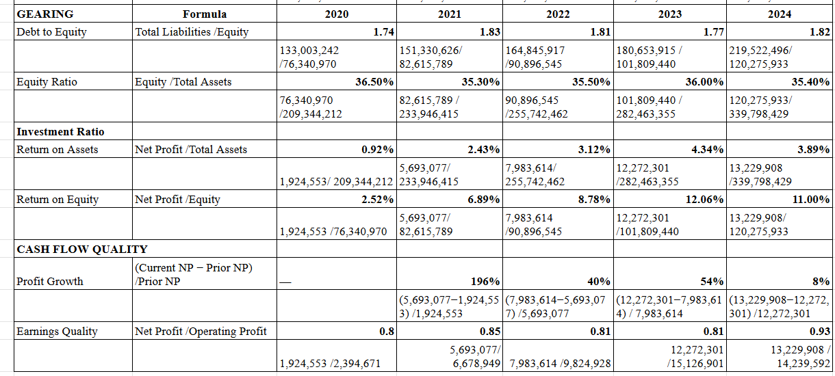
Figure 1: Ratio Analysis
(Source: Hyundai Annual Reports)

Trends, Strengths and Threats
The five-year ratio analysis demonstrates that Hyundai Motor Company evolved from being a moderate-margin manufacturer in 2020 to becoming an efficient global automotive company by 2023-2024. The most visible trend appears in operating margin as the trends show a growth from 2.30% in 2020 to 5.68% in 2021, 6.91% in 2022 and 9.30% in 2023, but a decline in the ratio in 2024 to 8.13%. Net profit margin showed an increase from 1.85% in 2020 to 4.84% in 2021, then to 5.62% and an exceptional growth to 7.55% in 2024, while operating margin climbed sharply until 2023 before slightly moderating in 2024. The company demonstrates substantial progress in controlling expenses in EV production, establishing pricing authority, and managing diversification of its products (Atrill and McLaney, 2017). This shows a temporary decrease, which results from higher input expenses and additional capital expenditures, and the return to normal activity levels after exceptional 2023 results.
The liquidity ratios demonstrate a steady short-term financial strength that is slowly developing into a stronger financial status (Maramis et al., 2024). The current ratio was seen to be greater than 1.30 for the entire five-year duration and reached 1.46 in 2024, which shows growth and stability through its working capital management and through its ability to generate cash from operations. The quick ratio shows improvement from 1.18 in 2020 to 1.21 in 2024 which us due to global EV production capacity development. As Hyundai has made significant investments in its electric vehicle (EV) platforms. Hyundai Motor Company, 2024). The increased sales of electric vehicles (EVs) result in businesses receiving more cash while their receivables turnover improves, which leads to an increase in their liquid current assets that include cash and short-term financial instruments.
The efficiency ratio shows the productivity capacity of the Hyundai company, but their overall outcome remained positive. The asset turnover ratio increased from 0.50 in 2020 to 0.58 in 2023, which demonstrates better asset usage for generating revenue. The ratio reached 0.52 in 2024 because total assets grew rapidly following capital investments and the expansion of financial services receivables and the growth of long-term operating lease assets (Binsaddig et al., 2023). The company has seen efficiency losses in the short term, which show that Hyundai has made certain investments for its future sales performance. The inventory turnover showed fluctuations in performance throughout the period, but a strong performance has been maintained as it increased from 1.63 times in 2020 to more than 1.88 times in 2021 and slightly reduced to 1.81 times in 2024. The company improved its stock management system, which led to faster product movement, even though global supply chain disruptions affected its operations.
The gearing ratio shows ina moderate but stable capital structure for Hyundai, which is effective to understanding the borrowing capacity of the company in the last 5 years. The debt-to-equity ratio shows that it lies between 1.7 times and 1.9 times in the five years. The equity ratio for Hyundai has seen a range between 35% and 36%, which means that Hyundai uses both debt and equity to finance its growth. The stable results of these metrics indicate that the organization follows strict financial management practices while it limits its risk exposure (Aldo, 2022). Hyundai will need to depend more on outside funding sources because its total liabilities increased in 2024 due to higher debenture and long-term debt obligations which it needs to finance its expansion and technology development.
The investment performance ratios demonstrate their most significant development. The return on assets increased from 1% in 2020 to an approximately 4% level in 2024 because of improved asset efficiency and high business profitability. Return on equity demonstrated even more significant growth, increasing from 2.52% in 2020 to over 11% in 2024. The trend shows that investors receive higher returns from their investments while management improves capital usage throughout the company (Saputra, 2022). The main cause of Hyundai Motor Company's Return on Equity (ROE) growth originates from its operational activities instead of financial leverage. The improvement results from two main factors which include higher profits from rising worldwide vehicle sales and strong market demand for electric vehicles like the Hyundai Ioniq 5 and the better operating performance of the company. The company finances its electric vehicle technology development and international production expansion through increased debt which partially drives ROE growth while actual profitability and effective asset management sustain the gains.
The operational performance of the company has strengthened because cash flow quality indicators show positive results. The period from 2020 to 2023 shows that net profit was high due to the strong post-pandemic recovery of Hyundai and operational expansion. Hyundai has seen an expansion in its profits and liquidity through a growth rate that declined to 8 % in 2024. The earnings quality ratio reached 0.93 in 2024 because a greater share of accounting profit now derives from business operations instead of non-operational elements (Nazar and Mawarni, 2023).
There are three key strengths of the company, Hyundai, which represent its primary organizational advantages. The business has seen an increase in financial success through its strong profit growth and maintained financial stability by providing higher returns to shareholders and managing stock effectively (Hyundai Motor Company, 2024). The company's asset growth through its strategic investments enables it to sustain its market position through the upcoming years in both the electric mobility and financial services markets.
The ratio trends show multiple threats to business operations because the 2024 asset turnover decline shows that business growth will outstrip revenue achievements, thus decreasing operational effectiveness. The combination of moderate leverage and rising long-term debt increases the risk of interest rate fluctuations and financial obligations to the company (Odhiambo et al., 2025). Profit growth is also slowing down because the global automotive industry faces stronger competition and higher operational costs. The company faces potential operational challenges because its operating margin has decreased, raw material prices and technology development expenses and market competition will impact its financial results.

Working Capital Management Analysis

Assessment of Cash Operating Cycle
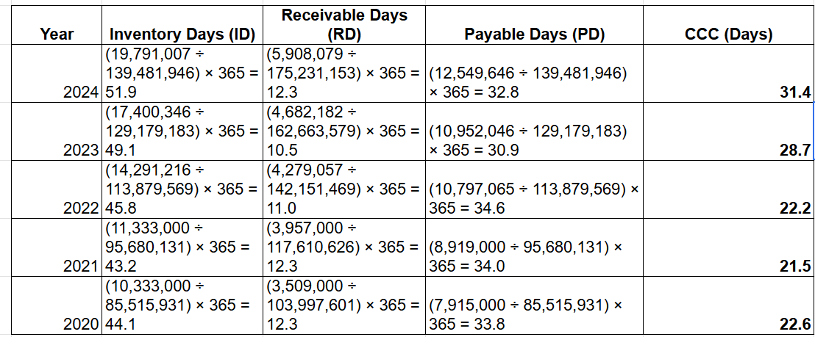
Figure 2: Cash Conversion cycle
(Source: Hyundai Annual Reports)
Hyundai's working capital position from 2020 to 2024 provides a strong foundation for operational continuity and financial flexibility. The cash operating cycle measures how effectively a company transforms its inventory and receivable assets into cash while handling its payment responsibilities with its inventory turnover and receivable balance management (Zaher and Illescas, 2022). The Cash Conversion Cycle (CCC) of Hyundai Motor Company shows a gradual increase over the five-year period. The CCC increased from 22.6 days in 2020 to 31.4 days in 2024, indicating that the company is taking slightly longer to convert its investments in inventory and receivables into cash. Hyundai Motor Company uses moderately aggressive financing methods to establish its working capital policy. The company maintains relatively lower receivable periods while extending payable days to suppliers, allowing it to finance part of its working capital through short-term liabilities. The organization achieves better liquidity and operational efficiency through its current strategy, but the approach brings higher financial risk during cash flow fluctuations.

Recommendation of Strategies to Improve Liquidity
Hyundai must adopt multiple strategies that will enhance its working capital management and improve its liquidity position. Considering its receivable collection process, Hyundai must focus on stricter credit examination procedures while adding new digital credit tracking capabilities such as AI and increasing its early payment discount program. Financial services operations should develop improved risk assessment methods which will decrease collection times while allowing sales to continue increasing.
Second, inventory optimization must be adopted by Hyundai in its supply chain operations. Through advanced demand forecasting techniques and effective supply chain analytics tools such as Blockchain inventory management systems to achieve global production facility inventory reduction and decreased inventory storage times (Jones, 2025). The company can improve its turnover efficiency by entering into supplier partnerships that help the company in its production planning processes and actual regional sales requirements.
Hyundai should extend supplier payment terms in situations where it does not harm relationships with suppliers. The company can maintain cash for extended periods by negotiating better payment terms while enabling its suppliers to access funds through supply chain financing solutions (Atrill and McLaney, 2017). This will help the company to effectively improve performance as well as maintain the cash ratio for better financial performance.
Fourth, better cash flow forecasting is required by the business, and improved treasury management would lead to better liquidity management in the short term. The efficient distribution of excess cash into temporary financial assets will boost profits while maintaining business operational capabilities. Cash flow forecasting will also be done with the help of effective AI tools, which can improve Hyundai's performance in the operational department.

Comparison of long-term vs short-term financing options
An effective working capital management requires a careful decision between short-term and long-term financing options. In this complex business landscape, financing plays a crucial role in supporting financial flexibility and sustainability. In this context, short-term financing options include bank overdrafts, short-term loans, trade credit and commercial papers (Cowling and Yang, 2025). These components in the short term are extensively used to finance day-to-day operational requirements, such as inventory purchase and accounts receivable gaps. The primary advantage of the short-term financing option is the flexibility, which will allow the company to quickly cover the debt obligation and respond effectively towards the changing consumers' preferences. Additionally, short-term loans involve lower interest rates as compared to long-term borrowing, which makes it cost-effective in stable economic conditions. On the other hand, excessive short-term financing can also increase the refinancing risk and lead to a higher borrowing cost. This financial option also includes additional liquidity pressure because repayment obligations occur frequently.
Across the globe, most companies have adopted long-term financing options in their operational activities to maintain financial sustainability. In this context, this strategic financial approach involves equity, corporate bonds, and long-term bank loans. Considering that, all these types of long-term financing options are utilised in the business landscape for investment and expansion purposes, which allows companies to sustain in the market for a long time. However, the major merit of this option is to enable companies to achieve better financial stability as well as reduce liquidity pressure because of the long-term option. Moreover, fixed-rate bonds allow companies to protect from the interest rate volatility and also enhance financial resilience in this competitive landscape. This long-term financing option supports companies for strategic growth and aligns with the global trend of technological upgradation because all these require a significant amount of investment at the starting point. In the case of Hyundai, the rising liabilities need to include long-term financing options to stabilize the capital structure and improve the credit ratings. Despite that, this option carries a higher interest rate, which will raise the interest expenses in the business.
The above discussion showcased the difference between short-term and long-term financing options. The analysis showcased that excessive debt in short-term financing will negatively impact the liquidity because it becomes expensive after the initial stage. On the other hand, long-term financing provides a predictable cost structure but involves commitment of fees and long-term borrowing costs. In terms of flexibility, short-term financing will allow for rapid adjustment across the working capital cycle, where long-term financing supports stable liquidity needs and strategic investment stability. Therefore, based on this in-depth analysis, a balanced financing strategy will be more applicable for the company, where conservative working capital will be based on short term financing, and long-term financing will be utilized for permanent working capital requirements. This mixed approach will minimize risk and control the borrowing risk, which will contribute to operational flexibility.

Strategic Financial Restructuring Plan

Recommended Financial Restructuring Options
The company's recent financial performance showcased those liabilities have significantly increased over the last five years. Considering the financial condition needs restructuring to maintain balance and financial stability in this technology-driven industry. In this context, one of the most effective restructuring options is a controlled equity injection through institutional partnership (Shem and Mupa, 2024). This strategic move will not only help to restructure the financial conduct but also allow the firm to maintain strong profitability and improve investors' confidence. Increasing equity will be most visible, as well as reducing dependency on debt and lowering the financial risk under this volatile situation. Additionally, a stronger equity base will also enhance the debt-to-equity ratio and enhance the financial resilience and creditworthiness.
The industry has undergone significant transformation over the years, requiring substantial investment in battery production, R&D, and digital transformation (Men et al., 2023). In this dynamic environment, equity financing offers long-term capital without a fixed repayment obligation, helping to mitigate financial risk. However, the company's asset base has grown considerably to ￦339,798,429 million; asset growth must not be directly proportional to optimal efficiency. Selling underperforming or non-core businesses could potentially improve asset utilization and efficiency. A strategic divestment plan will enable Hyundai to focus on its core competencies in high-growth EV and mobility sectors. It can also streamline operations and unlock financial resources for innovation-driven initiatives. Additionally, asset optimization may lead to more sustainable operating margins. Instead of pursuing a full merger, the company might consider joint ventures in battery manufacturing and advanced mobility software. This model minimizes capital expenditure and distributes risks associated with technology development. In an industry driven by technological advancement and innovation, restructuring through joint ventures introduces a new level of competitiveness without increasing debt.

Impact on Shareholder Value, Debt Structure, and Operational Flexibility
In a business, restructuring is one of the essential components in the capital structure by aligning with the current financial condition. In the case of the chosen firm restructuring, a strategic shift will significantly enhance shareholders' wealth as well as help to maintain operational flexibility. In the current landscape, the company's operating and net profit result has been significantly improved within a year. This financial enhancement highlighted that they have maintained a strong profitability and also integrated better capital utilization. In this situation, equity-based restructuring can dilute earnings per share, but it will help to create long term value for shareholders. Multinational companies need to focus on sustainable profitability rather than short-term dilution because it will create flexibility in the business ecosystem. However, equity-based restructuring will also help to reduce financial distress from the balance sheet, which will positively impact the investors' confidence and market valuation (Nguyen et al., 2025). The discussion demonstrates there is a potential to create more shareholder value through this restructuring process.
The company's current financial condition showcased growing liabilities over the last five-year period. In this complex and competitive business environment, growing liabilities are an additional financial risk, which creates a significant financial impact in the long term (Civelek et al., 2023). However, the company's growth in assets is a positive aspect, but this significant rise in liabilities can create a vulnerable financial situation in the long term if market demand faces volatility. Therefore, to decrease the liability amount, equity model-based restructuring is one of the most suitable options. This equity financing option will allow the company to reduce excessive debt pressure and help to create strength in long-term solvency (Blessing and Sakouvogui, 2023). Maintaining a balanced capital structure between liabilities and equity will enable the firm to improve its creditworthiness as well as help to reduce the interest burden. In this capital-intensive industry, maintaining lower leverage is significantly crucial to protect profitability during the lower demand situation, and it will also assist in safeguarding shareholders' value.
A company's success majorly depends on the operational efficiency, which contributes noticeably to the financial result. In this situation, this financial restructuring strategy will also play a critical role in improving operational efficacy. The company's recent operational ecosystem has been majorly dependent on the excessive debt structure, where reducing this burden will allow the firm to gain greater freedom to allocate capital towards more advanced innovation, technology and research and development. This strategic move not only enhances operational efficiency but will also allow the firm to get a competitive advantage in the changing consumer demand landscape. Furthermore, to enhance operational efficiency, the company can also include strategic alliances and joint ventures, which will further enhance the capability of sharing technological risk and reducing the capital burden of large-scale investments. In the rapidly changing automobile sector, flexibility is one of the most crucial aspects, which will enable faster adoption to match consumer demand. Therefore, a balanced and less constrained financial structure will help the company to create the capacity to respond proactively to the competitive pressure.

International and Ethical Considerations
The company operates across the globe with a diverse tax jurisdiction, where financial restructuring must be considered with the corporate tax deficit and cross-border policies. The optimizing tax structure can improve net return while ensuring alignment with global transparency regulations (Elumilade et al., 2022). Worldwide governments are increasingly providing EV subsidies and green incentives, where restructuring strategies must be aligned with these policy frameworks to maximize financial benefits. However, aggressive tax structuring can create reputational damage and regulatory risk in the international market. Therefore, restructuring decisions should balance tax optimization with transparency and compliance to maintain investors' confidence and protect the company's brand reputation. On the other hand, in the international market, one of the major threats is the volatile economy as well as exchange rate fluctuation that significantly affects revenues, procurement cost and debt servicing obligations. Considering that, currency volatility can distort financial performance when earnings are converted into a particular currency. In this international threat, the company should adopt a currency hedging strategy, diversify the manufacturing location and establish long term supply coordination with vendors.
In the recent business landscape, maintaining ethical consideration is a crucial component of long-term sustainability. In this case, ethical consideration is a central part of financial restructuring decisions. The company has to ensure that restructuring strategies do not negatively impact employees, communities or environmental standards. The transition to EV will provide strength to the commitment of the company towards sustainability, as maintaining ethical sourcing of materials for the battery will continue to be of critical concern. Furthermore, ESG performance increasingly influences investors' decision-making and access to capital markets. The company's transition towards electrical mobility must support environmental standards, where several significant risks of battery and other materials are included. Considering that, financial restructuring should priorities sustainable investment, ethical procurement policies and transparent reporting practices. Despite maintaining the ethical aspect of the CSR and ESG framework, the businesses also have to maintain ethical supply chain management to enhance brand value across their market.

Investment Appraisal and Capital Budgeting

Analysis of three investment options
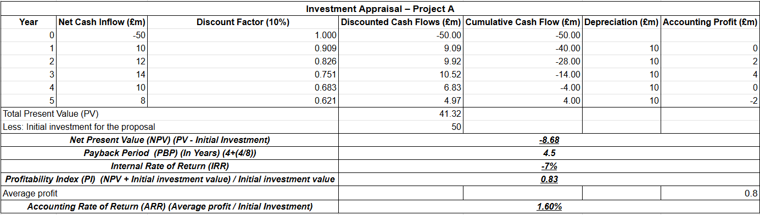
Figure 2: Analysis of investment potential of project A
(Source: Self-Developed)
Analysis of investment options has become a crucial part of any business's long-term project feasibility. In this context, three investment options have been analyzed for the company through key investment appraisal techniques. The first project A, which required an initial capital investment of £50 million, generated the necessary cash flow over the five years. Considering these cash flows NPV has been calculated, which demonstrates the difference between the present value of future cash inflows and the initial investment (Arjunan, 2022). The outcome of the NPV of this project showcases a negative value of –£8.68m, which has been derived from a total present value of £41.32m and is based on the discount rate of 10%. However, the above figure 1 showcases that in this project payback period will be 4.5 years, which indicates that under the project lifecycle, the investment amount will be recovered. In this complex business dynamic, payback period (PBP) indicates how long a project takes to recover the initial investment amount (PA Angelopoulou et al., 2025). Additionally, the profitability index (PI) for this project stands at 0.83, where a value below 1 indicates that this project will generate insufficient value per pound of investment [Refer to Appendix 2].The accounting rate of return (ARR) in the above calculation of project A showcases 1.6%, which is significantly below the expected cost of capital. Furthermore, the negative IRR of -7% indicates that the projects shown are having insufficient cash inflows to pay back the investment. This overall analysis of the project does not show any financially viable option in this complex business environment.
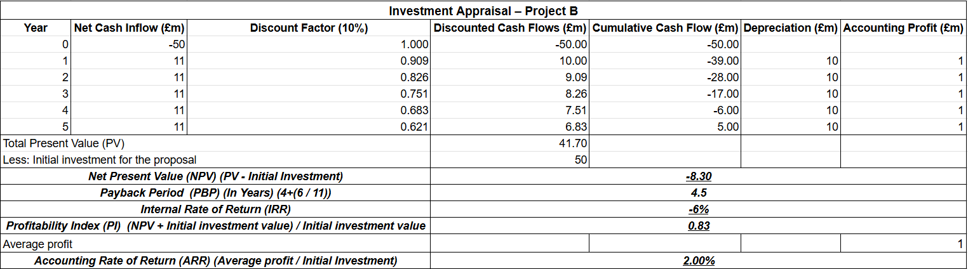
Figure 3: Analysis of investment potential of the project B
(Source: Self-Developed)
The second option of project B showcased noticeable similarities with the previous project, where the cash flow is stable for the five consecutive years. This stability in cash flow will help the company to reduce operational volatility. However, the above Figure 2 demonstrates the possible outcome from the project, where NPV of this project B stands with a negative value of –£8.30m, based on total discounted inflows of £41.70 [Refer to Appendix 3]. This result showcased that the project will not be able to create economic value and can fail to meet the wealth maximization objective. Additionally, the PBP stands at 4.5 years, which is similar to project A, which shows recovery of the initial amount will occur at the end of project life. Although the PI represents the ratio of the present value of inflows to the initial investment, a value below 1 indicates that the projects will generate insufficient value for the pound (Kadam and Singh, 2025). The calculation showcased for project B PI stands at 0.83 same as project A, which indicates that £1 invested generates only £0.83 in present value terms.
Project B has an Accounting Rate of Return (ARR) of 2.00% and an Internal Rate of Return (IRR) of -6%. Although Project B has a slightly stronger accounting profit position than Project A, it is still an extremely low rate of return for the investment. From a value creation perspective, it is evident that with an IRR of -6%, Project B is still unable to generate sufficient returns to pay back the initial investment of £50 million when taking into consideration the time value of money.
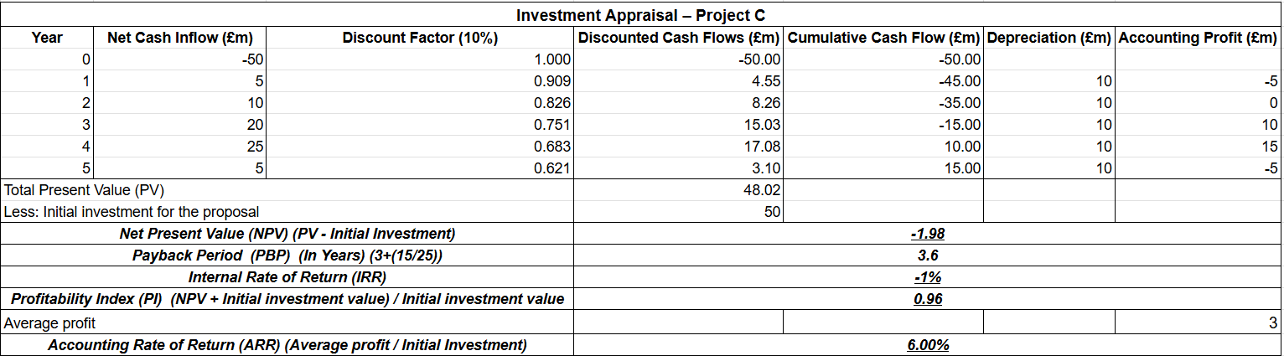
Figure 4: Analysis of investment potential of the project C
(Source: Self-Developed)
The third investment option for the company has been analyzed under the different cash flow structures, which provide a different outcome as compared to the other options. In this context, the NPV value of the firm stands at –£1.98m, which is negative but in better condition than the projects A and B. This negative NPV outcome showcased that this project will also fail to provide economic value to the company. Additionally, the result might be better than the other project, but it does not have any financial value in a real-world scenario. On the other hand, the PBP of this option stands at the most suitable position with 3.6 years estimation. This shows that within a project lifecycle, the investment amount will be recovered within four years. This lower PBP of this project will mitigate liquidity risk, but the presence of a negative NPV value will reduce the financial stability. Additionally, the PI position is significantly closer to 1, which was the highest across all the investment options. This shows that the project has better potential as compared to the other two projects. The above Figure 3 demonstrates that this project achieves a higher ARR at 6%, where the IRR stands at -1%. The ARR result indicates that it is evident that Project C can achieve substantially higher profits per dollar of investment compared to Projects A and B. Although the IRR is still negative, it is considerably closer to zero and is closer to the 10% discount rate than it is to negative infinity.

Investment decision and recommendation
The above discussion showcased different aspects of proposed investment options through the key investment appraisal techniques. The results demonstrate that three projects will not provide any positive economic value because of the negative NPV. As the principles of corporate finance suggest, the project must be accepted if the NPV is positive, as this suggests that the returns received from the projects undertaken are more than the cost of capital or the return on investment. In this case, the results obtained from the evaluation of the three projects indicate that the NPV values are negative. This suggests that the value of the firm will decrease, as the present value of the cash inflows received is less than the initial cost. From a theoretical perspective, the NPV rule is closely associated with the shareholder wealth maximization theory, which asserts that managers should make investment decisions that will enhance the value of the firm, hence shareholders. The negative NPV is inconsistent with this theory because it will result in the loss of wealth and hence the inefficient allocation of financial resources. Thus, accepting any of the projects will not be in line with the principles of financial management. Moreover, investing in these projects with negative NPVs could also add to the financial risk of the organization. This is because the capital of the organization is limited, and investing in these unprofitable ventures could limit the organization’s ability to invest in more profitable ventures in the future. Therefore, based on the above financial analysis and the theoretical aspect of capital budgeting, it is evident that the company should reject the three projects.
Despite this numerical analysis, several qualitative factors are also included in the market, which will have an impact if the firm chooses any option from these three. In this context, the company operates in the automobile manufacturing sector, where in recent times the market has been significantly converted to the electric vehicle (EV) option. This scenario of this market has changed the overall landscape as well as created additional regulatory pressure. In this context, in the EV industry, political and regulatory risks are significant, where companies have to focus on carbon emissions, import tariffs, battery sourcing regulations, and EV subsidies, which can directly impact the project viability (Apata et al., 2023). Another important factor is technological risks. The EV industry is a dynamic industry, especially with regard to battery technology, charging infrastructure, and autonomous driving. If the project that has been chosen involves technology that becomes outdated, there could be a threat to competitiveness. Technological risks can be mitigated through constant investment in R&D, forging partnerships with tech companies, and using flexible production methods. Additionally, market and consumer-related risks are also present in this industry, where consumers' preferences significantly shift because of pricing sensitivity, charging accessibility and brand reputation.

Capital rationing decision
In terms of capital rationing, the company’s total investment funds, which are restricted to £100 million, will not be able to undertake all the proposed projects. In such a case, the company will have to select the best combination of projects that will provide the maximum value given the capital constraint. In such a situation, the projects should be ranked according to their overall financial strength and performance using the capital budgeting techniques. The analysis of the three projects showcased that A, B and C will not be capable of providing any types of positive return in the near future. Therefore, investing any amount will not return any value to the company, as well as will create additional financial pressure.

Conclusion
The above discussion in this report showcases Hyundai's financial performance over the last five years and also suggests an appropriate investment option. The numerical analysis highlighted that the company's financial condition has been significantly improved because of the strong print strategy and increased sales. The increased liabilities over the years are one of the major concerns, where restructuring through equity financing will be more suitable. The investment appraisal analysis highlighted that no project will add any economic value, and rejected all will be the most effective option.

Reference List
Aldo, M., (2022). The Effect of Gearing, Price Earnings Ratio, Interest Rate, Risk on Abnormal Return. Indonesian Interdisciplinary Journal of Sharia Economics (IIJSE), 5(2), pp.751-767.
Apata, O., Bokoro, P.N. and Sharma, G., (2023). The risks and challenges of electric vehicle integration into smart cities. Energies, 16(14), p.5274.
Arjunan, K., (2022). A new method to estimate NPV and IRR from the capital amortization schedule and the advantages of the new method. Australasian Accounting, Business and Finance Journal, 16(6).
Atrill, P., and McLaney, E. (2017). Accounting and Finance for Non-Specialists (10th Edition). Pearson Education. ISBN: 9781292135601
Binsaddig, R., Ali, A., Al-Alkawi, T. and Ali, B.J., (2023). Inventory Turnover, accounts receivable turnover, and manufacturing profitability: an empirical study. International Journal of Economics and Finance Studies, 15(1), pp.1-16.
Blessing, H. and Sakouvogui, G., (2023). Impact of liquidity and solvency ratios on financial performance: a comprehensive analysis. Indonesia Auditing Research Journal, 12(3), pp.102-115.
Civelek, M., Krajčík, V. and Fialova, V., (2023). The impacts of innovative and competitive abilities of SMEs on their different financial risk concerns: System approach. Economía Copernican, 14(1), pp.327-354.
Cowling, M. and Yang, H., (2025). What sources of finance are firms least likely to use. Finance Research Letters, 80, p.107385.
Elumilade, O.O., Ogundeji, I.A., Achumie, G.O., Omokhoa, H.E. and Omowale, B.M., (2022). Optimizing corporate tax strategies and transfer pricing policies to improve financial efficiency and compliance. Journal of Advance Multidisciplinary Research, 1(2), pp.28-38.
Hyundai Motor Company, (2024). Annual Report 2024. AnnualReports.com. Available at: https://www.annualreports.com/Click/31159 (Accessed: 28 February 2026).
Jones, J., (2025). The Role of Artificial Intelligence in Enhancing Demand Forecasting and Supply Chain Decision-Making.
Kadam, M. and Singh, N., (2025). A Study of Identification of Capital Budgeting Tools Applied in Investment Decision. Bioscan, 20, pp.671-676.
Keown, A.J., Martin, J.D., and Petty, J.W. (2024). Foundations of Finance (10th Global Edition). Pearson Education. ISBN: 9781292742168.
Maramis, L.A., Koagouw, H.U.H., Tandi, A.A., Tampen was, M.A., Rompas, J., Robot, R.F. and Lusiana, D., (2024). Analysis of Liquidity Ratio and Profitability Ratio on Financial Performance at PT PLN (Persero) In 2019–2022. Scientific Research Journal (SCIRJ), 12(5), pp.15-24.
Masila, D. K; Mwania, P and Kaiti, J. (2025). The influence of cash management practices on the financial performance of tier 1 Deposit Taking SACCOs in Kenya. Journal of African Interdisciplinary Studies, 9(10), 230 – 238.
Men, F., Dong, F., Liu, Y. and Yang, H., (2023). Research on the impact of digital transformation on the product R&D performance of automobile enterprises from the perspective of the innovation ecosystem. Sustainability, 15(7), p.6265.
Nazar, M.R. and Mawarni, A., (2023). Return on asset, return on equity, and net profit margin: influence stock price. Jurnal E-Bis, 7(2), pp.444-457.
Nguyen Thi, C., Anh, K.T. and Tran, K.B.N., (2025). Corporate distress and financial restructuring decisions in different stages of life cycle. Journal of Economics and Development, 27(3), pp.264-276.
Odhiambo, J.D., Murori, C.K. and Aringo, C.E., (2025). Financial leverage and firm performance: An empirical review and analysis. East African Finance Journal, 4(1), pp.25-35.
Papangelopoulou, M.D., Alexakis, K. and Askounis, D., (2025). Assessment methods for building energy retrofits with emphasis on financial evaluation: a systematic literature review. Buildings, 15(14), p.2562.
Saputra, F., (2022). Analysis effect return on assets (ROA), return on equity (ROE) and price earnings ratio (PER) on stock prices of coal companies in the Indonesia Stock Exchange (IDX) period 2018-2021. Dinasti International Journal of Economics, Finance and Accounting, 3(1), pp.82-94.
Shem, A.M. and Mupa, M.N., (2024). Turnaround Financing: Legal and Financial Considerations for Distressed Companies. Iconic Research and Engineering Journals, 8(4), pp.19-37.
Zaher, H. and Illescas, G.M., (2022). The Cash Conversion Cycle: A Systematic Literature Review. Economic and Social Development: Book of Proceedings, pp.18-35.

Appendices

Appendix 1: Ratio Table
Ratios | Formula | 2020 | 2021 | 2022 | 2023 | 2024
PROFITABILITY
Operating Margin | Operating Profit/ Sales | 2.30% | 5.68% | 6.91% | 9.30% | 8.13%
 |  | 2,394,671 /103,997,601 | 6,678,949/ 117,610,626 | 9,824,928 /142,151,469 | 15,126,901 / 162,663,579 | 14,239,592 / 175,231,153
Net Profit Margin | Net Profit /Sales | 1.85% | 4.84% | 5.62% | 7.54% | 7.55%
 |  | 1,924,553 /103,997,601 | 5,693,077/ 117,610,626 | 7,983,614/ 142,151,469 | 12,272,301/ 162,663,579 | 13,229,908 / 175,231,153
LIQUIDITY
Current Ratio | Current Assets/ Current Liabilities | 1.41 | 1.38 | 1.3 | 1.39 | 1.46
 |  | 83,686,357 /59,459,528 | 88,556,366 /64,236,787 | 96,389,767 /74,236,472 | 101,724,717/ 73,362,103 | 115,764,287/ 79,509,643
Quick Ratio | (Current Assets − Inventories) / Current Liabilities | 1.18 | 1.98 | 1.05 | 1.15 | 1.21
 |  | (83,686,357−11,333,734)/ 59,459,528 | (88,556,366−11,645,641)/ 64,236,787 | (96,389,767−18,257,000)/ 74,236,472) | (101,724,717−17,400,346) / 73,362,103 | (115,764,287−19,791,007) / 79,509,643
EFFICIENCY
Asset Turnover | Sales/Total assets | 0.5 | 0.5 | 0.56 | 0.58 | 0.52
 |  | 103,997,601 /209,344,212 | 117,610,626/ 233,946,415 | 142,151,469/ 255,742,462 | 162,663,579 /282,463,355 | 175,231,153/ 339,798,429
Inventory Turnover Ratio | Cost of Sales /Average Inventory | 1.63 | 1.88 | 1.55 | 1.92 | 1.81
 |  | 18,481,670/ 11,333,734 | 21,930,495 /11,645,641 | 28,271,900/ 18,257,000 | 33,484,396/ 17,400,346 | 35,749,207 / 19,791,007
GEARING | Formula | 2020 | 2021 | 2022 | 2023 | 2024
Debt to Equity | Total Liabilities /Equity | 1.74 | 1.83 | 1.81 | 1.77 | 1.82
 |  | 133,003,242 /76,340,970 | 151,330,626/ 82,615,789 | 164,845,917 /90,896,545 | 180,653,915 / 101,809,440 | 219,522,496/ 120,275,933
Equity Ratio | Equity /Total Assets | 36.50% | 35.30% | 35.50% | 36.00% | 35.40%
 |  | 76,340,970 /209,344,212 | 82,615,789 / 233,946,415 | 90,896,545 /255,742,462 | 101,809,440 / 282,463,355 | 120,275,933/ 339,798,429
Investment Ratio
Return on Assets | Net Profit /Total Assets | 0.92% | 2.43% | 3.12% | 4.34% | 3.89%
 |  | 1,924,553/ 209,344,212 | 5,693,077/ 233,946,415 | 7,983,614/ 255,742,462 | 12,272,301 /282,463,355 | 13,229,908 /339,798,429
Return on Equity | Net Profit /Equity | 2.52% | 6.89% | 8.78% | 12.06% | 11.00%
 |  | 1,924,553 /76,340,970 | 5,693,077/ 82,615,789 | 7,983,614 /90,896,545 | 12,272,301 /101,809,440 | 13,229,908/ 120,275,933
CASH FLOW QUALITY
Profit Growth | (Current NP − Prior NP) /Prior NP | — | 196% | 40% | 54% | 8%
 |  |  | (5,693,077−1,924,553) /1,924,553 | (7,983,614−5,693,077) /5,693,077 | (12,272,301−7,983,614) / 7,983,614 | (13,229,908−12,272,301) /12,272,301
Earnings Quality | Net Profit /Operating Profit | 0.8 | 0.85 | 0.81 | 0.81 | 0.93
 |  | 1,924,553 /2,394,671 | 5,693,077/ 6,678,949 | 7,983,614 /9,824,928 | 12,272,301 /15,126,901 | 13,229,908 / 14,239,592

Appendix 2: Calculation for Project A
Investment Appraisal – Project A
Year | Net Cash Inflow (£m) | Discount Factor (10%) | Discounted Cash Flows (£m) | Cumulative Cash Flow (£m) | Depreciation (£m) | Accounting Profit (£m)
0 | -50 | 1.000 | -50.00 | -50.00
1 | 10 | 0.909 | 9.09 | -40.00 | 10 | 0
2 | 12 | 0.826 | 9.92 | -28.00 | 10 | 2
3 | 14 | 0.751 | 10.52 | -14.00 | 10 | 4
4 | 10 | 0.683 | 6.83 | -4.00 | 10 | 0
5 | 8 | 0.621 | 4.97 | 4.00 | 10 | -2
Total Present Value (PV) |  |  | 41.32
Less: Initial investment for the proposal |  |  | 50
Net Present Value (NPV) (PV - Initial Investment) |  |  | -8.68
Payback Period (PBP) (In Years) (4+(4/8)) |  |  | 4.5
Internal Rate of Return (IRR) |  |  | -7%
Profitability Index (PI) (NPV + Initial investment value) / Initial investment value |  |  | 0.83
Average profit |  |  |  |  |  | 0.8
Accounting Rate of Return (ARR) (Average profit / Initial Investment) |  |  | 1.60%

Appendix 3: Calculation for Project B
Investment Appraisal – Project B
Year | Net Cash Inflow (£m) | Discount Factor (10%) | Discounted Cash Flows (£m) | Cumulative Cash Flow (£m) | Depreciation (£m) | Accounting Profit (£m)
0 | -50 | 1.000 | -50.00 | -50.00
1 | 11 | 0.909 | 10.00 | -39.00 | 10 | 1
2 | 11 | 0.826 | 9.09 | -28.00 | 10 | 1
3 | 11 | 0.751 | 8.26 | -17.00 | 10 | 1
4 | 11 | 0.683 | 7.51 | -6.00 | 10 | 1
5 | 11 | 0.621 | 6.83 | 5.00 | 10 | 1
Total Present Value (PV) |  |  | 41.70
Less: Initial investment for the proposal |  |  | 50
Net Present Value (NPV) (PV - Initial Investment) |  |  | -8.30
Payback Period (PBP) (In Years) (4+(6 / 11)) |  |  | 4.5
Internal Rate of Return (IRR) |  |  | -6%
Profitability Index (PI) (NPV + Initial investment value) / Initial investment value |  |  | 0.83
Average profit |  |  |  |  |  | 1
Accounting Rate of Return (ARR) (Average profit / Initial Investment) |  |  | 2.00%

Appendix 4: Calculation for Project C
Investment Appraisal – Project C
Year | Net Cash Inflow (£m) | Discount Factor (10%) | Discounted Cash Flows (£m) | Cumulative Cash Flow (£m) | Depreciation (£m) | Accounting Profit (£m)
0 | -50 | 1.000 | -50.00 | -50.00
1 | 5 | 0.909 | 4.55 | -45.00 | 10 | -5
2 | 10 | 0.826 | 8.26 | -35.00 | 10 | 0
3 | 20 | 0.751 | 15.03 | -15.00 | 10 | 10
4 | 25 | 0.683 | 17.08 | 10.00 | 10 | 15
5 | 5 | 0.621 | 3.10 | 15.00 | 10 | -5
Total Present Value (PV) |  |  | 48.02
Less: Initial investment for the proposal |  |  | 50
Net Present Value (NPV) (PV - Initial Investment) |  |  | -1.98
Payback Period (PBP) (In Years) (3+(15/25)) |  |  | 3.6
Internal Rate of Return (IRR) |  |  | -1%
Profitability Index (PI) (NPV + Initial investment value) / Initial investment value |  |  | 0.96
Average profit |  |  |  |  |  | 3
Accounting Rate of Return (ARR) (Average profit / Initial Investment) |  |  | 6.00%

