Module title: THE GLOBAL BUSINESS ENVIRONMENT
Module Lecturer: Dr. Rexon
Global Business Environment Assessment 1
Student name: Nikola Bachvarov
Student ID:1914252

Table of Contents
Introduction 3
Analysis of the car manufacturing industry of the UK 4
Major environmental forces of the UK car manufacturing industry 4
PESTEL analysis 4
Porter’s five forces analysis 6
Assessment of opportunities and challenges to gain competitive advantages 8
SWOT analysis 8
Porter’s generic value chain model 9
Product life cycle stage 10
Conclusion 12
References 13

Introduction
The car manufacturing industry is one of the most developed and growing industry in the UK as well as in the global market. The environment of the car manufacturing industry shape by several environmental forces. The car manufacturing companies of the UK industry focus to achieve market advantage for long term market sustainability. This essay will recognize and analyze the major forces that shape the environment of the car manufacturing industry in the UK. Also, it will assess the several opportunities and challenges of the car manufacturing industry of the UK that assist the companies to obtain a competitive advantage to sustain in the market.

Analysis of the car manufacturing industry of the UK
The car manufacturer of the UK market faces a reduction in sales and an increase in the level of market competition due to the coronavirus pandemic. Car is one of the most attractive luxurious products as well as necessary products of the higher level of a citizen of the United Kingdom (Anish, 2017). The economy faces a slow and downturn for the pandemic that reduces the economic capability of the people in the market. For this reason, the car manufacturers seek cost efficiency in the market from the production to selling activities in the market. Also, it motivated the car manufacturers to achieve economies of scale to obtain long-term business sustainability through attaining competitive advantage (Wu, 2014). This essay will analyze the car manufacturing environment to identify the major forces in the market through PESTEL analysis and Porter’s five forces model. Also, it will critically assess the opportunities and challenges of the market to position the car manufacturing companies and gain a competitive market advantage for the business.

Major environmental forces of the UK car manufacturing industry

PESTEL analysis
Companies conduct the situational analysis of the UK car manufacturing industry through PESTEL analysis. It provides a clear understanding of the existing market environmental information. It helps the manufacturers to determine the effective marketing strategy.
Figure-1: PESTEL analysis of the UK car industry
Source: (Kulkarni, 2017)
Political forces: the economic ups and downs force the government to impose several tax regulations on the car manufacturing market. The imposed tax on raw materials increases the product's price in the market as well reduces the sales in the global market (Ansart, 2016). The parliamentary democracy system of the UK keeps the market stable to invest more for car manufacturers. Besides, the government makes lower barriers for car exporting in the global market that helps the car manufacturing companies to maximize the revenue.
Economic forces: the car industry mostly dependent on the economic forces in the UK market. The economic fluctuations affect the company’s operations in the market from production to selling of the manufactured cars. The coronavirus pandemic downs the economy of the market and reduce the capability of the people to purchase luxury products. So, the economic forces are unfavorable for the car manufacturers.
Social forces: the people of the UK market has a high level of income and consciousness about the car industry (Musgrove, 2018). A large number of car owners uses highly luxurious cars in the UK that says to the marketers that luxurious car product has a high demand in the market. Besides most of the people thinks that car increase their social prestige in society and they ready to pay high prices for the renowned brands of car that manufactured in the UK.
Technological forces: the car manufacturing industry is highly developed with advanced modern technology. Companies’ changes model with the upcoming technology and made the car available in the market according to the technological changes (Sreerekha, 2018). also, the car manufacturers get importance on eco-friendly technology like using solar power attract the customers more in these market that is favorable to boost the industry in the future.
Legal forces: there has some specific rules, regulations, and laws on the car manufacturing industry in the UK market. The government fully cares about consumer rights acts if some of the customers make complain about the definite car manufacturing company (Kulkarni, 2017). Besides, there have some laws to protect the patents and copyrights of the intellectual property in the market. Also, companies need to maintain the carbon emissions rate that the government set on themselves to make the environment clean and safe.

Porter’s five forces analysis
Five forces analysis of the UK car manufacturing industry will identify the competition, threats, opportunities, and market power of several companies in the market.
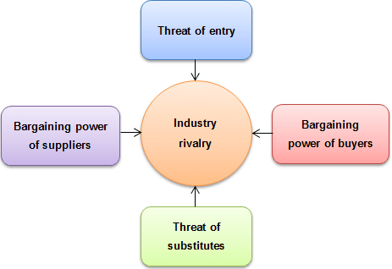
Figure-2: porter’s five forces analysis of the UK car industry
Source: (Porter, 2017)
Rivalry among the existing competitors: in the UK car manufacturing industry, the rivalry among the existing competitors is So, high in the market. Some large multinationals like Nissan, Aston Martin, Jaguar, and Bentley create a highly competitive market in the UK (Grigolon, 2012). Besides, the growing demand for luxurious cars motivated car manufacturing companies to invest more in the market that increases competition in the market.
Threats of new entrants: the highly turnaround profitable car industry is lucrative for the car manufacturers of the UK industry. But here have some entry barriers in the industry like higher investment capability, cope up with the advanced technology and rules and restrictions to survive in this highly competitive market (Evren, 2018). Though the car manufacturing industry of the UK has some barriers, new companies always focus on entry into the industry because of the lucrative profitability of the industry. So, the threats of new entrants to the industry are medium for the companies.
Threats of substitutes: the threats of substitute products for the UK car industry are bicycles, subways, and buses in the market. The people of this market enjoy car riding and still the personal car using is favourite to the people of the UK (Grigolon, 2012). Besides, the substitute products don’t reliable to give outstanding ride performance according to the convenience, comfort, and flexibility in the market. So, the threat of substitute’s product in the UK car industry is low for the car manufacturing companies.
Bargaining power of customers: the competition among the existing car manufacturers in the UK is high which means the customers have a lot of choices to choose select one among them. Customers get full information and they compare the car design, quality, and model with other companies’ products to purchase the final one. So, the company cannot impose higher prices in the market (Schmidt, 2018). So, the customers' bargaining power is high in the industry.
Bargaining power of suppliers: the number of suppliers is a lot in the UK car manufacturing industry. Also, the suppliers’ always try to provide high-quality raw materials to become reliable suppliers to the manufacturing company. There has a lot of opportunities to switch easily from one supplier to another in the industry. So, the bargaining powers of suppliers is very low in the UK car manufacturing industry.

Assessment of opportunities and challenges to gain competitive advantages

SWOT analysis
SWOT analysis will identify and indicates the strengths, weaknesses, opportunities, and threats of the car manufacturing industry of the UK following here.
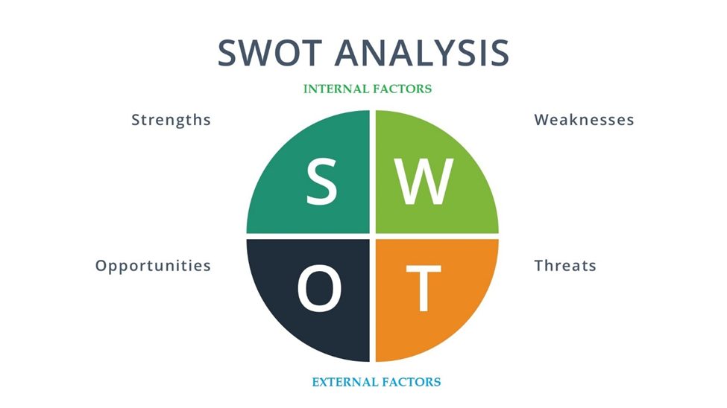
Figure-3: SWOT analysis of the UK car industry
Source: (Robin, 2018)
Strengths: the car manufacturing industry of the UK is a growing industry that also gets the benefit of economic growth to boost up the performance in the market. Car manufacturing companies increase the efficiency in the cost management to produce a car that helps them to achieve economies of scale and maximize the value of the resources (Anish, 2017). Besides the growth of the new and advanced technology helps the companies to provide several designs and models on a low budget. The demand in the Asian market also assists the car manufacturing companies to survive in the market.
Weaknesses: the car industry in the UK is positive according to its market growth but it’s very slow to adapt to the global market and compete with global competitors in the market. Customers’ bargaining power is So, high in this industry that a company cannot implement the marketing strategic planning as they want (Ansart, 2016). On the contrary, they have to consider the competitor’s market offerings and design their products according to the market situation. Besides the economic downturns for the coronavirus pandemic also force the industry to make slow growth.
Opportunities: the car manufacturing industry of the UK has several opportunities to serve the customers in different ways profitably. Companies have the opportunity to invent the eco-friendly car that will use solar energy to run (Musgrove, 2018). Also, the companies can invent some way to reduce the use of the fuel to provide fuel-efficient products in the market that helps them to achieve a competitive advantage over the market competitors. Besides the strategic alliances’ opportunity with the global market consider as the opportunities for the car manufacturers till now.
Threats: one of the most important threats to the car manufacturing industry in the UK is increased competition. If the company isn’t able to achieve economies of scale in production and invent new ideas to serve the market, it is impossible to survive in the industry profitably (Kulkarni, 2017). Also, the volatile fuel price in the global market makes ups and downs demand in the global car market. Besides the car industry of the UK needs higher-level investments to practice in the market as well as huge investments for the research and development in this market.

Porter’s generic value chain model
The value chain model of porter suggests a systemic process maintaining effective chronology from collecting raw materials to building profitable customer relationships in the market. The value-creating process of the UK car manufacturing industry is discussed here with the help of Porter’s generic value china model.
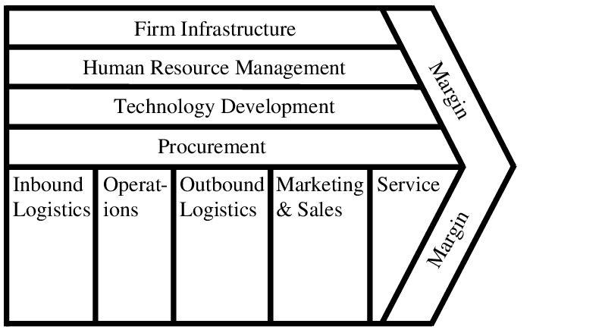
Figure-4: Porter’s generic value chain model
Source: (Porter, 2017)

Inbound logistics: The suppliers of the raw materials and necessary technology are So, available and reliable in the market. Companies can easily collect the necessary things from the market and have the opportunity to easily switch suppliers for more opportunities (Schmidt, 2018). Companies collect design elements, technological innovation, necessary parts for car manufacturing from the global market suppliers to improve business competitiveness.
Operations: companies implement production planning in the operations stage. The car manufacturing companies of the UK industry take the bits of help of advanced and modern technology, recruiting highly skilled employees, and ensure the in-touch production process to achieve customers' confidence in the car model.
Outbound logistics: companies distribute the final product to the selected showrooms and appointed retailers in this stage. Most of the companies have their showrooms across the UK market as well as in the global market (Wu, 2014). Companies also use secondary retailers’ distributors to ensure a highly effective network in the market.
Marketing and sales: Besides their direct method of sales, some of the companies use retail distributors to sell the car in the market. Companies implement promotional activities in the market through advertisements in television, newspaper, and social media platforms (Sreerekha, 2018). Also, they provide price discounts and several monetary promotional activities to increase sales in the market that helps them to earn a large amount of revenue to sustain in the market.
Services: car manufacturing companies in the UK always very sincere to provide post-purchase services to customers. They try to make the customers loyal to the brands for a lifetime through high-quality services in the market. It ensures a positive customer retention rate to the brands that help to achieve market advantage.

Product life cycle stage
Companies in the UK car manufacturing industry maintain a standard life cycle stage and strategy for their market offerings. Here this essay will discuss the four stages of the product life cycle of the UK car manufacturing industry.
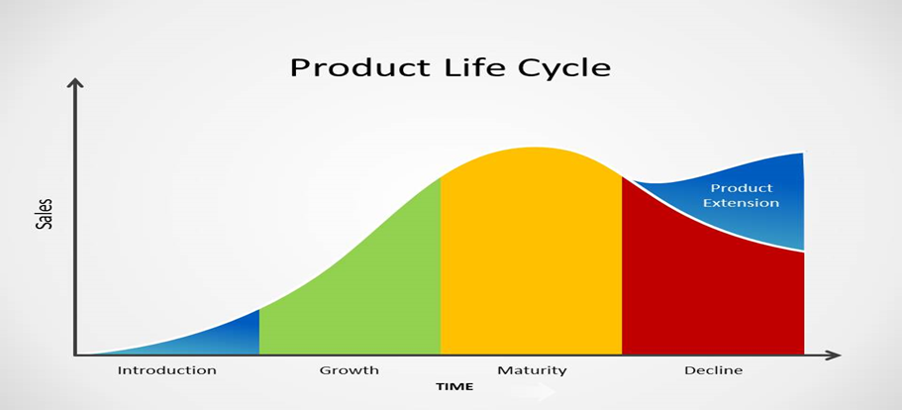
Figure-5: Product life cycle stage of the UK car industry
Source: (Schmidt, 2018)
Introduction stage: companies research the market environment to make an effective product design for the customers. They produce the product and offer it in the market and conduct promotional programs to familiarize the brands to the customers (Evren, 2018). The home market gets the opportunity most of the time to get the product available.
Growth stage: in this stage, the specific car model started to sell them in the market and a lot of potential customers show curiosity towards the model in the market. Companies try to set a reasonable price and started to gain profit, and provide effective communications with the market stakeholders.
Maturity stage: maturity stage is the longest and profitable stage for car manufacturers in the market. Companies provide a lot of promotional programs and campaigns to make the stage as long as possible (Anish, 2017). A lot of product sale in this stage and several types of market feedback comes towards the brands. The success of a brand depends on this stage that helps to achieve market sustainability.
Decline stage: the sales volume started to decrease in this stage of the product life cycle chronology. Most of the time companies launch a new model in the market and withdraw the existing model of the car (Robin, 2018). Also, some of the companies occasionally redesign the model and implement strong promotion in the market to make further growth of the model.

Conclusion
The car manufacturing industry is a growing and potential industry for the companies to make quite safe investments. But some of the forces change the market environment and force the environment to adapt to the changes in the market. Companies try to adopt the changes to increase the operational efficiency for business sustainability through achieving a market advantage in the market. The coronavirus pandemic forces the industry to a slow rate of growth during these days. Hope the economy will regain its positive growth and the car manufacturing industry of the UK will boost its performance in the global market.

References
Anish, A., 2017. Modelling and Analysis of a Car for Reducing Aerodynamic Forces. International Journal of Engineering Trends and Technology, 47(1), pp.1-17.
Ansart, S., 2016. Co-production of the car as a 'service': involving customers in the value chain. International Journal of Automotive Technology and Management, 6(1), p.45.
Evren, Y., 2018. Supply Networks in the Car Industry. Do Peripheral Economies Perform Specific Tasks? Lessons from the UK Car Industry. International Planning Studies, 7(4), pp.283-302.
Grigolon, L., 2012. Public Support for the European Car Industry: An Integrated Analysis. SSRN Electronic Journal, pp.45-51.
Kulkarni, M., 2017. Development of Strategic Value Chain Framework for the UK Car Manufacturing Industry. Global Journal of Flexible Systems Management, 19(S1), pp.21-40.
Musgrove, H., 2018. The UK car industry. Meeting the challenge head-on. Electronics and Power, 32(1), p.47.
Porter, M., 2017. Creative industries value chain: The value chain logic in supply chain relationships. Marketing and Branding Research, 4(3), pp.227-235.
Robin, W., 2018. Decline in UK car manufacturing. Metal Powder Report, 73(5), p.225.
Schmidt, P., 2018. The Effect of Car Sharing on Car Sales. SSRN Electronic Journal, pp.22-28.
Sreerekha, T., 2018. A Study on Evaluation and Effectiveness of Training and Development of Employees in Car manufacturing Industry. International Journal of Trend in Scientific Research and Development, Volume-2(Issue-3), pp.562-568.
Wu, J., 2014. SWOT Analysis and Research on the Information Application Model of the Car Industry Cluster. Applied Mechanics and Materials, 571-572, pp.115-119.

