

Programme: Master of Business Administration
Module: Marketing Management
Module code: LCMB7024
Title: Assessment Component 1 – Individual Report
Word count: 2500
Lecturer: Dian Mayasari
Student Name: Krinal Bhikhubhai Gandhi
Student ID: 2504763
Submission Date- 24th October 2025

Table of Contents
Introduction 3
1: Critical Analysis of Two Macro Marketing Actors 3
1.1 Technological Factors 3
1.2 Political and Legal Factors 6
2: Strategic Responses of Pioneers and Followers 7
2.1 BT Group’s strategic Responses (Pioneer) 8
2.2 Vodafone UK’s Strategic Responses (Follower) 9
2.3 Comparative Evaluation 11
Conclusion 12
References 14

Introduction
This report examines the ways in which political/legal and technological pressures within the UK macro marketing environment influence business competitiveness and strategy within the telecommunication industry. Both of these variables are particularly most critical within innovation- and infrastructure-driven industries, where rapid digitalization and state intervention routinely redraw market forces.
The focus is on BT Group and Vodafone UK, two leading companies operating under the same environmental conditions but performing different strategic functions. BT Group is an innovator who likes to be first to adopt new technology and set industry standards, whereas Vodafone UK is a follower, developing known advancements to improve efficiency and responsiveness to the marketplace.
The goal of this report is to explore how such firms respond to technological and regulatory changes, and how their positions strategy impact performance, innovation, and compliance.
The structure of the report is as follows: Section 1 explores the key technological and political/legal drivers influencing the UK telecoms sector. Section 2 evaluates BT's and Vodafone's strategic response. Section 3 compares their strategies by adaptability and competitiveness. Conclusion summarises the findings and determines the impact of outside forces on organisational strategy and long-term success.

1: Critical Analysis of Two Macro Marketing Actors

1.1 Technological Factors
Technology has transformed the UK telecom sector in recent decades. Technological progress in fields such as 5G technology, artificial intelligence (AI), automation, and cloud-based digital services has revolutionized the manner in which telecom operators offer connectivity, engage with customers, and compete in the market. The growing adoption of IoT (Internet of Things) devices and the continuous rise in demand for high-speed data services have been challenges and opportunities for telecom operators alike.
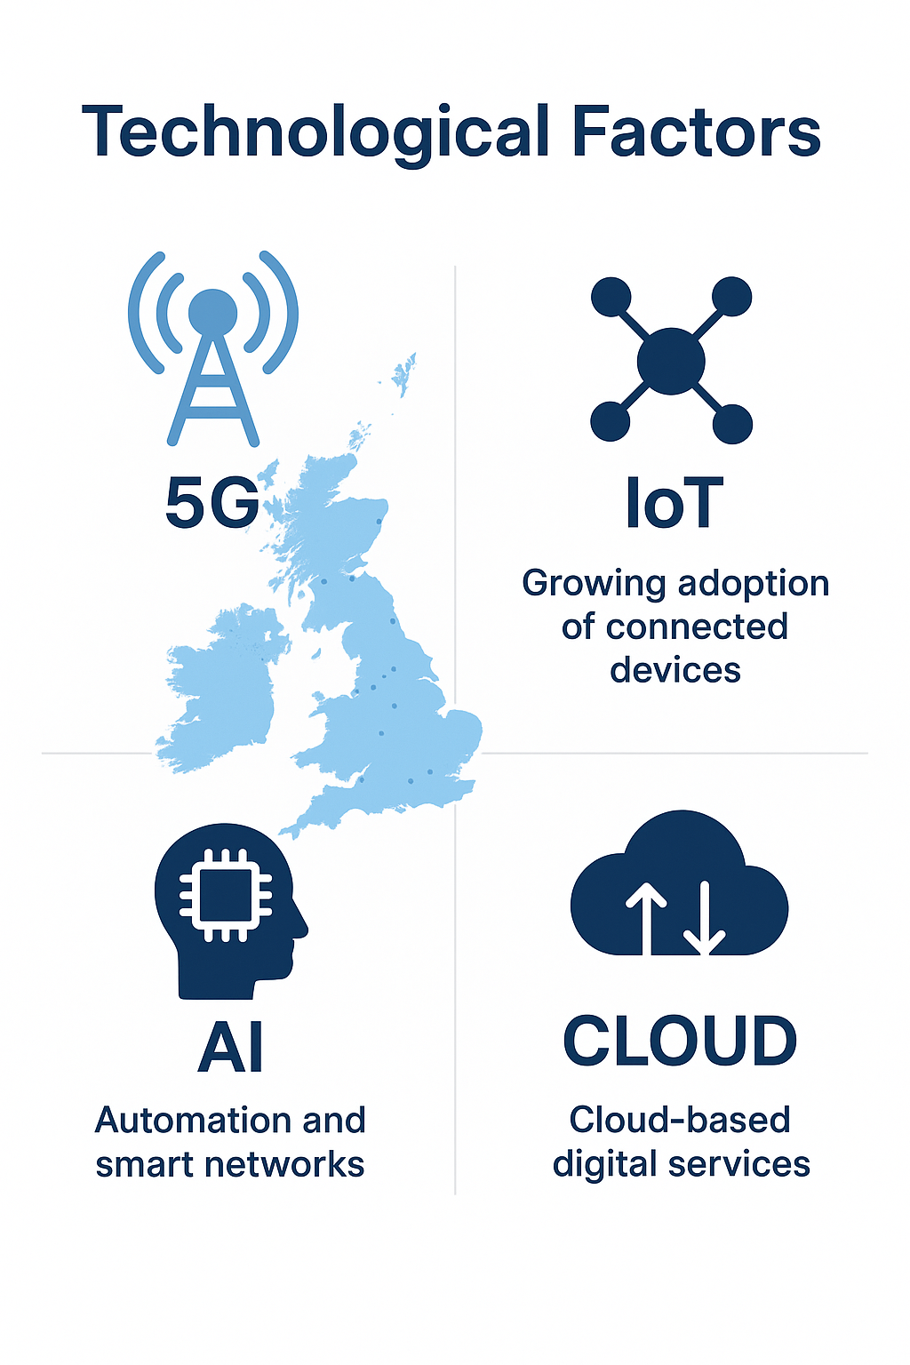
- Opportunities for BT (Pioneer)
Being an innovation leader, BT Group has never ceased investing in new technology. It was the UK providers' first to deploy broadband and fibre networks, and it continues to lead 5G rollout (BT Group, 2023). This early expenditure keeps BT firmly in the position of being an innovation leader in technology while locking down long-term contracts with the UK government and major business customers. BT's forward-looking innovation provides it with the pioneer advantage, permitting it to shape industry standards and customer expectations.
Besides its telecoms core, BT diversified into digital media (BT Sport), cloud computing, and cyber protection, attesting to its vision to become an all-embracing digital solutions provider (Ofcom, 2023). These diversifications demonstrate how technology allows BT to generate multiple sources of income while further building its brand as a pioneering organisation.
- Threats for BT (Pioneer)
Technology also creates BT challenges. Constantly upgrading and improving services is costly, and with technology evolving at such a rate, new services are soon outdated. BT is also facing the challenge of digital platforms like WhatsApp and Zoom, as well as new telecommunication companies offering cheaper or more flexible services.
BT's bigger and older infrastructure can make it harder to introduce new technologies timely. Systems switching takes time and is expensive, and this can create a window of opportunity for new or smaller ones to catch up. It is a common danger facing first movers that innovate ahead early but at high cost and with diminished flexibility (Grant, 2022). Additionally, legacy infrastructure maintenance and building next-generation networks come with added complexity and costs.
- Opportunities for Vodafone UK (Follower)
Being a follower, Vodafone UK may adopt inspiration from BT's tech choices and the response of the market before investing large amounts. In doing this, Vodafone will avoid risks and conserve capital while still benefiting from tested technologies. For example, Vodafone has been able to expand its 5G network coverage by emulating BT's past rollouts, making it more affordable and quality.
The customers also replicate technology but possess it. Customer experience is improved by Vodafone through digital services like the My Vodafone App and VOXI, which are youth customer-focused with data-driven, personalized propositions. Vodafone gets to craft marketing campaigns for specific customer groups with the assistance of data analysis and artificial intelligence (AI), which lead to happiness and loyalty among customers (Statista, 2024). Vodafone's "everyone connected" project is also a sign of a strategy in which commercial aims are to be balanced with social good, which can form the basis for regulatory goodwill.
- Threats for Vodafone UK (Follower)
Among the key weaknesses of Vodafone is that it is prone to following behind the innovator. When it follows, it has a tendency to react to trends and not to create them, and this has the effect of making the brand less innovative and less likely to be able to charge premium prices.
Third-party vendors such as Ericsson or Nokia also rely on Vodafone for network equipment, limiting its own response time to make strategic moves.
Both companies also must contend with cybersecurity threats and increasingly stringent data-protection demands from customers and regulators. Implementation of the UK Data Protection Act and the latest ICO guidance is a constant operational cost that is worth paying but prevents loss of customer trust.

1.2 Political and Legal Factors
The UK telecom industry is strongly affected by government rules, policies and laws. These political and legal factors make sure companies compete fairly, protect customers and give more people access to digital services.
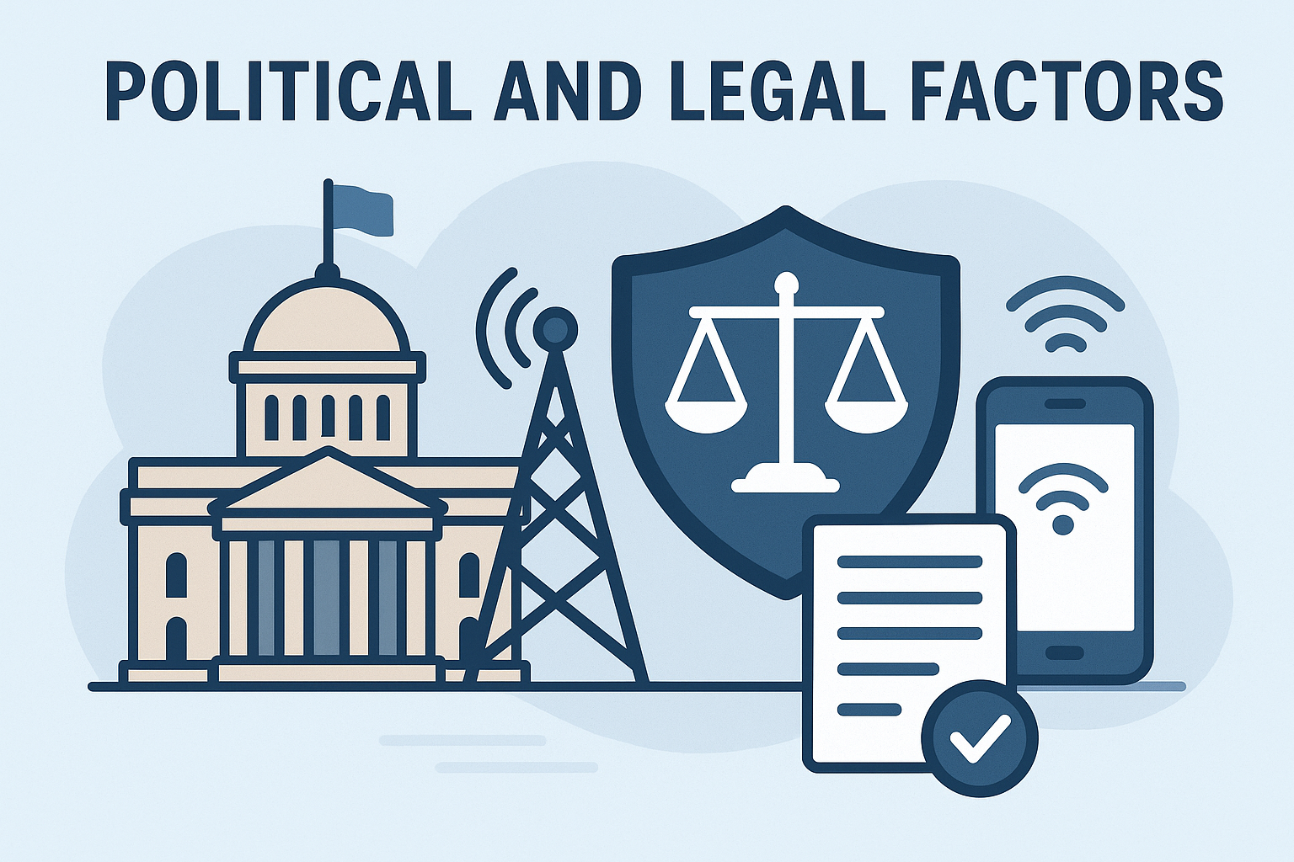
- Opportunities for BT (Pioneer)
Government projects that support digital growth give BT Group many opportunities. Programs like Project Gigabit and the Digital Connectivity strategy aim to bring high-speed broadband to the whole country (UK Government, 2022). Since BT already has large networks, it can benefit from government support and funding to expand its services. Such public-private collaboration often favours operators with proven delivery capability and extensive existing infrastructure.
BT's early adherence to data protection law like the UK Data Protection Act (2018) and GDPR has also helped it gain a good reputation as a reliable provider. Conducting business in line with the law in terms helps BT win advantage in a sector where customer trust is of high value. Such a public-private partnership is likely to help incumbent operators with proven delivery capability and extensive existing infrastructure.
- Threats for BT (Pioneer)
At the same time, strict rules can limit BT’s freedom. Ofcom controls pricing and market power to keep competition fair, which can restrict BT’s flexibility. Chances in government policies or political uncertainty – like discussion about Huawei’s role in UK 5G networks – can also create challenges for BT’s supply chain and investment plans (BBC News, 2021).
BT also has to spend a lot to follow laws on data privacy, network security and employee rights which can reduce profits.
- Opportunities for Vodafone UK (Follower)
As a follower, Vodafone UK benefits from learning from pioneers like BT. By observing the successes and failures of first movers, Vodafone can avoid mistakes and invest in technologies that are already proven effective. This approach helps the company save resources and achieve a lower-risk strategy.
For example, Vodafone has expanded its 5G network by learning from BT’s early rollout experiences, allowing for a more cost-efficient deployment. Vodafone also uses digital platforms such as the My Vodafone App and its VOXI brand to improve customer experience and target younger demographics. These strategies demonstrate how followers can compete through personalisation, data-driven marketing, and customer engagement, even if they are not technological leaders (Statista, 2024).
- Threats for Vodafone UK (Follower)
However, strict regulations can cause problems for Vodafone. Ofcom limits pricing and market control to make sure competition is fair, which can restrict Vodafone’s strategies. Brexit-related regulatory divergence and ongoing debates over supplier approvals create sourcing uncertainties that can delay network refreshes or increase costs. Political changes or debates, like those around Huawei and 5G networks, create uncertainty in planning and investment (BBC News, 2021). Vodafone also faces high costs to meet legal requirements for data privacy, network security and employee rights, which can reduce profits.

2: Strategic Responses of Pioneers and Followers
Following the analysis of technological and political/legal factors, this section looks at how BT and Vodafone respond strategically to these external influences. It examines the actions both companies take to say competitive and succeed in the UK telecommunications market.

2.1 BT Group’s strategic Responses (Pioneer)
As one of the leading UK telecommunication pioneers, BT Group continues to set the pace for innovation, digital infrastructure, and network evolution. Its strategic responses are driven by its first-mover advantage, R&D focus, and ability to deal with regulatory complexity. The role of BT aligns squarely with marketing models such as the Ansoff Matrix, 7Ps of the Marketing Mix, and Blue Ocean Strategy that help it remain competitive and customer-centered.

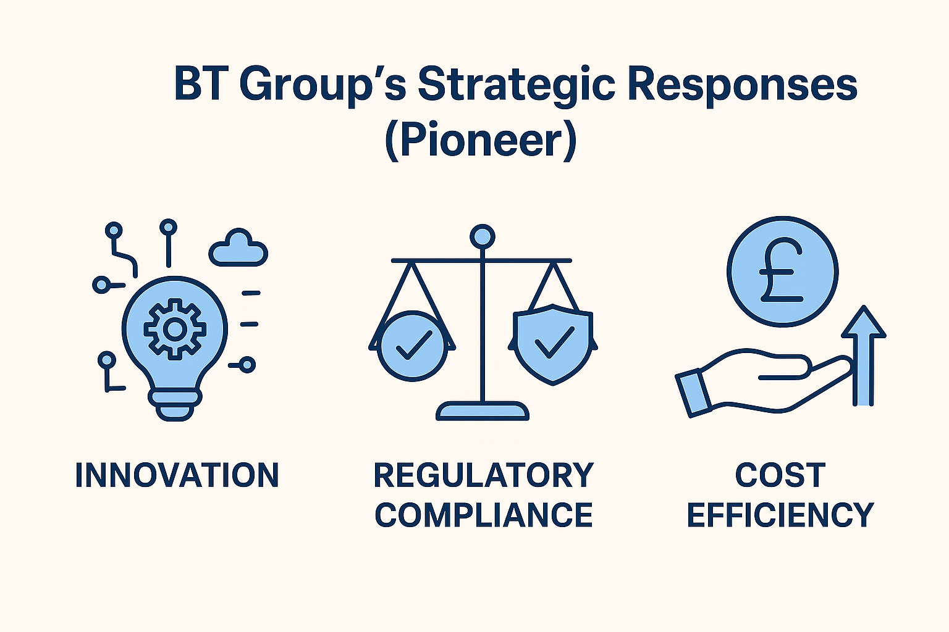
- Technological Responses
BT primarily employs Ansoff's product development strategy, which includes extending current products and introducing new digital offerings for current markets. In BT's 7Ps Product component, the company has extended its services beyond conventional telecommunication to include BT Cloud Voice, IoT products, and cybersecurity solutions. Such products enhance the company's value proposition and support business customers with their digital transformation initiatives.

On Process and Place, BT's leadership 5G technology adoption through its EE subsidiary demonstrates the capacity of network infrastructure innovation to augment service delivery and customer connectivity. Its five-year collaboration with Amazon Web Services (AWS) to build AI-ready networks is indicative of its use of dynamic capabilities to transform operations and be at the forefront in technology.
Employing Blue Ocean Strategy, BT has ventured into untapped niches such as digital security, managed IT services, and smart infrastructure, differentiating it from price competitor rivals (Kim and Mauborgne, 2015). By integrating innovation and technological differentiation, BT solidifies its brand's Position as a high-quality, trusted national provider.
- Political/Legal Responses
BT's People and Process strategies are informed by stakeholder management and close political relationships. Through its working with the UK government on broadband creation, BT aligns its Public Relations and CSR activities with the nation's digital agenda, entrenching its brand image and social legitimacy.
The legal separation of Openreach is another example of BT's strategic reaction to regulatory threat without divesting control of the infrastructure. The step is consistent with core competence theory (Prahalad and Hamel, 1990), insofar as BT outsources non-core activities but maintains its core competencies in network management.
By incorporating compliance, efficiency, and customer focus into its marketing mix, BT guarantees competitiveness as a solid and innovative telecom leader.

2.2 Vodafone UK’s Strategic Responses (Follower)
As a follower market, Vodafone UK is focused on flexibility, customer engagement, and affordability in contrast to being a technology innovator. Its plans are most connected with the Ansoff Matrix, Porter's Differentiation, and the 7Ps model, by which it achieves a firm position despite late entry into markets like that of market pioneers BT.
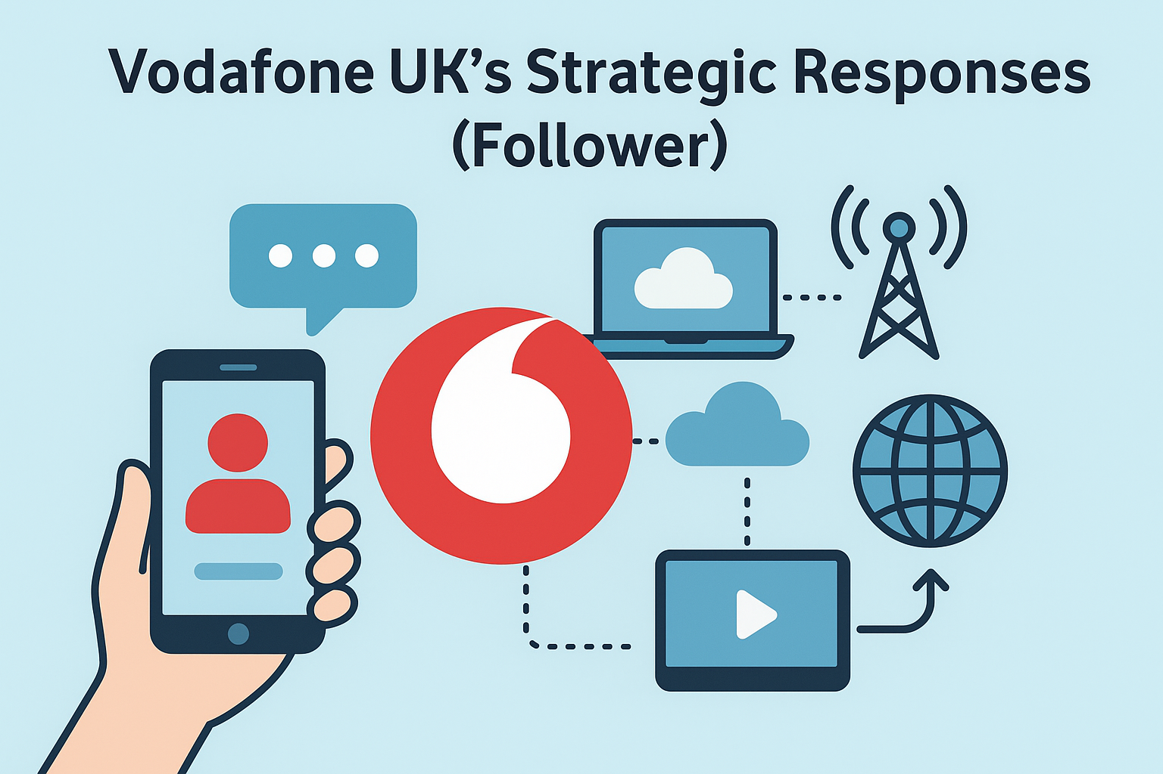
- Technological Responses
Vodafone employs both market development and market penetration approaches of the Ansoff Matrix to expand new consumers while reinforcing loyalty among current customers. In its 7Ps, Vodafone's Product strategy lies on flexible and customer-focused products, such as flexible data plans, family bundles, and its VOXI brand for young consumers.
The Price dimension shows Vodafone's mass differentiation strategy, offering competitive prices with the ability of high-end servicing. Through BT's learning from its 5G rollout, Vodafone partnered with Nokia and Ericsson in a strategic alliance to deploy its 5G network more cost-efficiently—a case of exerting follower advantage in order to reduce R&D expenses.
Under the Process and Physical Evidence dimensions, Vodafone's "Digital First" approach has revolutionized customer experience through digital self-service capabilities and integration in the cloud. Through collaboration with Accenture and AWS, Vodafone has facilitated modernizing its back-end infrastructure to deliver faster product roll-outs and improved service delivery. This transition reflects the dynamic capabilities framework, where the company continually reinvents its in-house processes in order to keep up with evolving markets.
- Political/legal Responses
Vodafone's international coverage means its People and Partnerships initiatives are informed by global and not encumbering home-country regulation. With a risk management and environmental scanning focus, Vodafone ensures compliance across the various jurisdictions and minimizes exposure to local policy fluctuations.
Its CSR initiatives—namely the "Everyone Connected" programme—show the way that Vodafone integrates Promotion with social purpose. By championing digital inclusion and sustainability, the company enhances its image and supports UK government agendas. This is a case of shared value creation; wherein corporate responsibility supports both brand value and long-term business sustainability.
In the light of the 7Ps, Vodafone's emphasis on customer experience (People), technological transformation (Process), and social responsibility (Promotion) ensures differentiation as a follower, enabling it to stay competitive in a mature market.

2.3 Comparative Evaluation
BT Group and Vodafone UK exemplify political/legal and technology-driven strategic responses aligned with dominant marketing and management paradigms. The roles of pioneer and follower shape how each uses these strategies to achieve market competitiveness.
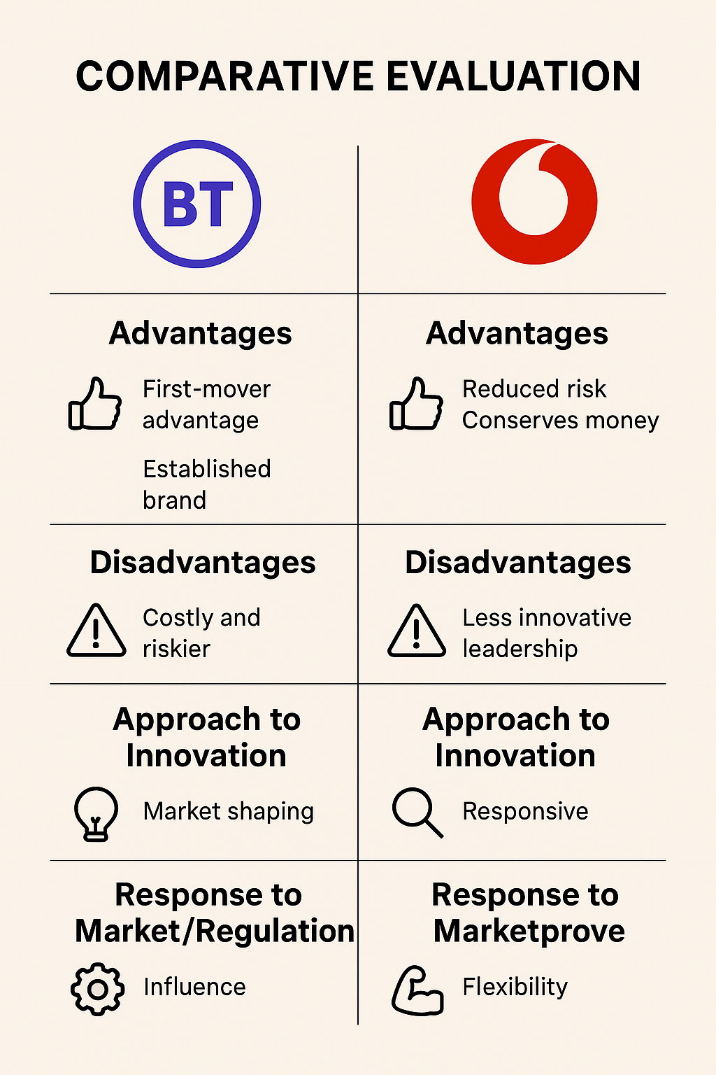
Evaluated from the 7Ps Marketing Mix perspective, BT's strategy emphasizes Product, Process, and Place aligned with a strategy of differentiation and innovation. By investing in cloud services, cybersecurity, and 5G networks early on, BT is aligning with the product development strategy of the Ansoff Matrix by selling current products with new technology in an attempt to increase customer value. Its leadership in digital infrastructure and its deal with AWS are instances of Blue Ocean Strategy where the company is trying to create un-contested market spaces rather than compete on prices. But BT's large capital outlay and regulatory restrictions keep its price flexibility in check and subject it to greater sensitivity in political and legal policy changes.
Its opposite, Vodafone UK, demonstrates a market penetration and growth strategy consistent with the follower advantage theory. The firm employs 7Ps to emphasize Price, Promotion, and People—price affordability, customer engagement, and CSR initiatives like "Everyone Connected." Leverage on proven technologies and BT's pioneering spending and learning from the same, Vodafone keeps R&D costs and time-to-market low. Its partnership with Nokia, Ericsson, and AWS indicates dynamic capabilities, which facilitate quick response to market and regulatory trends. But follower mind-set of a follower strategy is restrictive to Vodafone's creative leadership and can cap long-term brand uniqueness.
To Porter's differentiation strategy, BT's innovation-driven strategy fits as it captures high brand equity and first-mover advantage but at tremendous operating risk and cost. Vodafone's low-cost, customer-centric strategy, then, is Porter's focus strategy that prioritizes flexibility and value above technology dominance. Ultimately, both work in its own right: BT achieves competitive leadership through innovation and government support, while Vodafone achieves stability and customer trust through flexibility and effective use of resources.

Conclusion
Lastly, this report has explained how political/legal and technological drivers in the UK macro marketing environment significantly impact telecommunication giants such as BT Group and Vodafone UK. The analysis revealed that while both companies are confronted with the same external constraints, their variant strategy directions—as leader or pioneer, and follower—tend to dictate how they change, innovate, and compete.
BT's long-term investments in evolving technologies and coordinated regulation are a continuation of an innovation-led, differentiation strategy using frameworks like the 7Ps, Ansoff Matrix, and Blue Ocean Strategy. BT can hold its firm market base despite high operating expenses and tight regulatory grip. Vodafone UK, on the other hand, capitalizes on follower advantage by cheap exploitation of proven technology, customer-centric products and services, and CSR-motivated brand positioning. With the incorporation of flexibility and data-driven marketing into its 7Ps strategy, Vodafone is competitive without being a technological pioneer.
At a broader level, the comparative analysis proposes that each strategy is better suited to its environment: BT's innovation wins leadership and brand strength, while Vodafone's adaptability assures operational efficiency and customer loyalty. The outcomes propose that building sustainable long-term success in the UK telecommunications market depends on building a strategic balance between innovation, compliance, and customer value generation.

References
BBC News. (2021) Huawei ban: UK to remove equipment from 5G networks by 2027. BBC News. Available at: https://www.bbc.co.uk/news/technology-53403793 (Accessed: 10 October 2025).

BT Group plc. (2024) Annual Report 2024. BT Group. Available at: https://www.bt.com/bt-plc/assets/documents/investors/financial-reporting-and-news/annual-reports/2024/2024-bt-group-plc-annual-report.pdf (Accessed: 10 October 2025).

BT Group plc. (2025) Annual Report 2025. BT Group. Available at: https://www.bt.com/bt-plc/assets/documents/investors/financial-reporting-and-news/annual-reports/2025/2025-bt-group-plc-annual-report.pdf (Accessed: 10 October 2025).

Deloitte. (2024) Telecommunications Predictions 2024. Deloitte Insights. Available at: https://www2.deloitte.com/uk/en/insights/industry/technology/telecommunications-industry-outlook.html (Accessed: 10 October 2025).

Grant, R.M. (2022) Contemporary Strategy Analysis. 11th edn. Chichester: John Wiley & Sons.

Imperial College London. (2024) The UK Telecommunications Sector 2024. Centre for Sectoral Economic Performance. Available at: https://www.imperial.ac.uk/media/imperial-college/research-centres-and-groups/centre-for-sectoral-economic-performance/Telecoms-report-FINAL.pdf (Accessed: 10 October 2025).

Information Commissioner’s Office (ICO). (2024) Guide to the UK General Data Protection Regulation (UK GDPR). ICO. Available at: https://ico.org.uk/for-organisations/guide-to-data-protection/uk-gdpr-guidance-and-resources (Accessed: 10 October 2025).
Kim, W.C. and Mauborgne, R. (2015) Blue Ocean Strategy. Expanded edn. Boston: Harvard Business Review Press.

Ofcom. (2024) Communications Market Report 2024. Ofcom. Available at: https://www.ofcom.org.uk/research-and-data/multi-sector/cmr (Accessed: 10 October 2025).

Ofcom. (2025) Annual Report and Accounts 2024–2025. Ofcom. Available at: https://www.ofcom.org.uk/about-ofcom/latest/annual-report (Accessed: 10 October 2025).

Parliament of the United Kingdom. (2023) Telecommunications Infrastructure and Security: Committee Report. House of Commons Library. Available at: https://researchbriefings.files.parliament.uk/documents/CBP-9800/CBP-9800.pdf (Accessed: 10 October 2025).

Prahalad, C.K. and Hamel, G. (1990) The Core Competence of the Corporation. Harvard Business Review, 68(3), pp.79–91.

PwC. (2024) UK Telecoms Outlook 2024. PwC United Kingdom. Available at: https://www.pwc.co.uk/industries/technology-media-and-telecommunications/insights/uk-telecoms-outlook.html (Accessed: 10 October 2025).

Statista. (2024) Telecommunications in the United Kingdom – Market Overview. Statista. Available at: https://www.statista.com/topics/3095/telecommunications-in-the-uk (Accessed: 10 October 2025).

Statista. (2024) Vodafone UK Market Share 2018–2024. Statista. Available at: https://www.statista.com/statistics/376635/vodafone-market-share-uk (Accessed: 10 October 2025).

UK Government. (2022) Project Gigabit: Delivery Plan. Department for Digital, Culture, Media and Sport. Available at: https://www.gov.uk/government/publications/project-gigabit-delivery-plan (Accessed: 10 October 2025).

Vodafone Group plc. (2024) UK and Three UK Investor Presentation. Vodafone Group. Available at: https://investors.vodafone.com/~/media/Files/V/Vodafone-IR/documents/performance/financial-results/2024/vodafone-uk-and-three-uk-investor-presentation.pdf (Accessed: 10 October 2025).

Vodafone Group plc. (2025) Annual Report 2025. Vodafone Group. Available at: https://investors.vodafone.com (Accessed: 10 October 2025).

