The importance of effectively monitoring guest service approaches- A Report.
(Word count: 1500+/- 10%)

By

CHAUDHRY MUHAMMAD ASIM
STUDENT ID: 2246597
MODULE LEAD: Charlotte Joyner

BMIH4003

Table of Contents
Executive Summary 3
Introduction 3
Service Culture 4
Defining Service Culture 4
Strategies for Building Customer Loyalty 3
Responding to Guest Reviews 4
Benefits of Service Culture: 5
Drawbacks of Service Culture: 5
Comparing Hotels 6
Hotel Standards 7
Reputation management 7
Online Reputation Management 8
TripAdvisor 8
Travelodge 9
Marriott's acquisition 9
Conclusion 10
Recommendations 10
References 11

Executive Summary
This report will look into the details of how important it is for a hotel to keep a careful eye on its customer service indicators and it will have an in-depth analysis on important topics including hotel standards, service culture, and brand management (Huselid, 1995). This report aims to shed light on these fundamental characteristics of the hospitality industry and offer solutions for the pressing issues the industry is now facing in the rapidly changing corporate world.

Introduction
The quality of service is very important to the hospitality sector especially in the hotels located in the United Kingdom and around the world. Hotel success is heavily impacted by several factors, such as their impeccable reputation, the standard of their service culture, and the strict standards they uphold. The report would also analyse hotel standards, branding, service culture, and reputation management (Bhatti & Qureshi, 2007).

(Kismet, 2015)

Service Culture
Each hotel's service concept may be summed as "service culture." It conveys the overall experience of the hotel and the level of service that guests may expect to get when visiting it. Comparing the service philosophies of various hotels is crucial when looking for the best customer care practices. This can be termed as service excellence and is defined as asserting extraordinary service that goes beyond what customers expect. It is possible to build a solid reputation, happy clients, and loyalty by immediately meeting and even exceeding consumers' needs and wants.

(Holmes, 2023)

Strategies for Building Customer Loyalty
Developing a loyal customer base is crucial for long-term success. Hotels may improve their customer service, customisation, problem-solving speed, and loyalty programs to draw and keep guests (Shukla, Sufi, Joshi, & Sujatha, 2022). Sustaining client loyalty is crucial for a business's long-term financial success and efficient word-of-mouth marketing.The issue of bogus reviews is a big one. They are against the law and bad for a hotel's image (Bruns-Smith, Choy, Chong, & Verma, 2015). A TripAdvisor crew is entrusted with looking for red flags in review data to uncover possibly fake reviews. A 2019 Travelodge case study illustrates the negative consequences that can arise from fake reviews. It is important to address both favorable and unfavourable input from customers. It is appropriate to express gratitude for the encouraging comments. Replying with regret, showing compassion, and offering a solution are all seen as appropriate responses to negative comments.

Benefits of Service Culture:
- Enhanced Guest Satisfaction: Increased customer satisfaction and loyalty are a direct result of a company-wide dedication to providing outstanding customer service.
- Positive Reputation: This is built by continuously providing exceptional service, which in turn gains the respect and allegiance of current and potential customers.
- Employee Engagement: Studies have shown that cultivating a customer-focused culture may improve staff happiness and retention rates.
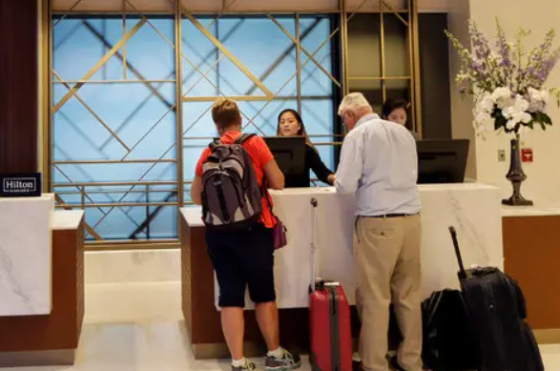
(Schwartz, 2019)

Drawbacks of Service Culture:
- High Expectations: Sustaining an outstanding quality of service might lead to increased client expectations, making it harder to live up to those expectations.
- Employee Burnout: A company's constant pursuit of service excellence may lead to employee dissatisfaction and exhaustion (Matjaž, Zoran, & Andreas, 2014).
- Cost Implications: The additional costs associated with providing premium services have the potential to impact an organisation's financial performance and pricing policies.

Comparing Hotels
The report compares and contrasts the two businesses to highlight the differences in the customer service cultures of Airbnb and Hilton.
Hilton Hotels are well known for consistently offering excellent quality and service. They take great satisfaction in giving each customer individualised attention, and their service concept is strongly rooted in traditional hospitality.
Airbnb is spearheading a paradigm shift in the hospitality sector by prioritising the cultivation of a tourist community that honors and cherishes each individual's distinctive attributes. Airbnb hosts provide a range of lodging options, allowing guests to immerse themselves in the local customs (Tanja & Borka, 2008). After comparing the two customer cultures, it is clear that Hilton places a high value on brand integrity and reliability, making sure that every guest enjoys a reliable and consistent experience. On the other hand, Airbnb takes a progressive approach by welcoming diversity and making the most of the trend towards personalised travel experiences for every visitor.

(Luz-Zuluaga, 2019)

Hotel Standards
Maintaining brand consistency and quality of service is a challenge for hotels. For example, Premier Inn maintains consistency using centralised procurement, quality assurance management, standard accommodations, and rules (Vega, et al., 2014). While star ratings vary amongst rating organisations, they all have a big impact on how good a hotel is judged to be. Getting a 5-star rating requires taking into account the property's location, the services it offers, the quality of its materials, and its outstanding amenities.

Reputation management
A planned and deliberate method of monitoring, regulating, and improving an organisation's position or image—often as seen by its stakeholders or the public, is known as reputation management (Main, 2002). It entails defending and enhancing one's reputation, responding to criticism, and upholding a favourable perception of one's brand.
There are several important ways to actively protect and enhance one's reputation. Monitoring reviews, comments, and social media mentions both offline and online is crucial for seeing problems before they become serious. Taking part in community affairs, asking for input, and settling disputes are all activities that promote kindness.

(Jenni, 2019)

Online Reputation Management
In today's digital age, online reputation management (ORM) is a critical component of brand image management. (Olsen & Connolly, 2000). Brand management is the process of keeping an eye on, improving, and protecting a company's online identity. This means keeping an eye on and controlling internet conversations about a certain brand. Organisations need to consider many important considerations while managing their internet image. Having a trustworthy online presence is essential, and one way to do this is by highlighting your accomplishments, goods, and favourable reviews on your official website and other online channels. The maintenance and observation of an organisation's online reputation is critical to ORM (Achmad & Yulianah, 2022). This means always keeping an eye out for user feedback, both favourable and bad, on social media platforms and review websites. It is critical to address criticism politely and swiftly.

TripAdvisor
When it comes to accommodations and things to do when visiting a place, TripAdvisor is among the most trustworthy sites. Because of its large number of visitors, it is a trustworthy resource for finding reviews and suggestions. TripAdvisor's influence on the hotel sector is noteworthy. By revealing information about visitor choices, experiences, and views, it serves as a real-time market research tool. Through active involvement with the site, hotels may obtain insights into the elements that influence their TripAdvisor reputation (Bisgaard, 2004).

(Gudmund, 2013)
Management must respond to unfavourable evaluations because of the disproportionate effect that one unfavourable review may have on a hotel's reputation. Hotels may avoid or lessen bad news by promptly and effectively handling tourist concerns.

Travelodge
Travelodge, a hotel brand, conducted a case study in 2019 and received a great deal of positive reviews, most of which were five stars. Concerns about the validity of the assessments were raised when it was discovered that 48% of these assessors had no prior experience contributing (Collis & Rukstad, 2008). False reviewers come from a variety of backgrounds, such as service providers, company owners looking to improve their reputation, former workers looking for compensation, relatives and friends looking to show support, and consumers looking to save money. Online platforms and organisations must take proactive measures to counteract false reviews through strict control and regulation, given the possibility of personal benefit and the immoral reasons driving such behaviour.

Marriott's acquisition
Marriott's acquisition of Starwood was an example of the combination of two well-known hospitality enterprises (Delizo & Esguerra, 2013). Using a strategic partnership, they may use their combined proficiency and experience to provide a wider range of services to their shared clientele.
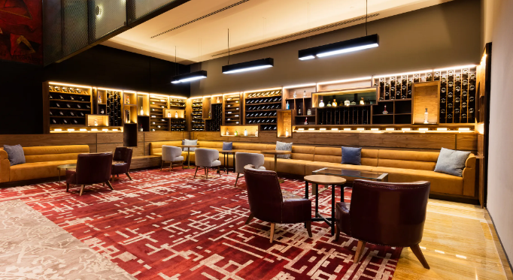
(SUSANNAH, 2018)
This has an impact on the hospitality industry as a whole by forcing rivals to adjust to the new realities of competitiveness in the global market. As rivals strive to equal the combined organisation's size and range of offerings, the merger of Marriott and Starwood may encourage growth in the hospitality sector. Furthermore, patrons have access to reward programmes that provide a wider range of hotels, providing them with more options and value. Employees might gain more experience by working in different areas within the company (Ivanov & Zhechev, 2012).
Consistent brand and service quality requirements need strict adherence to processes. This calls for ongoing expenditures on cutting-edge technology, the execution and observance of training programmes, system monitoring, and adherence to relevant legal and regulatory requirements.

Conclusion
Effective monitoring of guest service practices is essential for maintaining a positive reputation, a robust service culture, high-quality hotel standards, and consistent branding in the hospitality industry. (Alrawadieh, Alrawadieh, & Cetin, 2021). Both financial performance and client retention are directly impacted by these variables.

Recommendations
- Investing in effective online reputation management solutions that can track and reply to visitor comments coming from different online sources is one such tactic.
- Encourage staff members to follow the hotel's unique service culture in all of their dealings with guests.
- Setting clear policies and quality control methods is essential to maintaining the highest hotel standards.
Establishments that put these suggestions into practice will be better able to draw and keep guests, run more smoothly and succeed in the cutthroat hotel sector.

References
Achmad, W., & Yulianah, Y. (2022). Corporate Social Responsibility of the Hospitality Industry in Realizing Sustainable Tourism Development. Enrichment: Journal of Management,, 1610-1616.
Alrawadieh, Z., Alrawadieh, Z., & Cetin, G. (2021). Digital transformation and revenue management: Evidence from the hotel industry. Tourism Economics, 328-345.
Bhatti, K., & Qureshi, T. (2007). Impact of employee participation on job satisfaction, employee commitment and employee productivity. International review of business research papers,, 54-68.
Bisgaard, S. (2004). Six Sigma and the bottom line. In Quality Progress, 57-62.
Bruns-Smith, A., Choy, V., Chong, H., & Verma, R. (2015). Environmental sustainability in the hospitality industry. Best practices, guest participation, and customer satisfaction.
Collis, D., & Rukstad, M. (2008). Can you say what your strategy is? In Harward Business Review, 82-90.
Delizo, G. A., & Esguerra, M. A. (2013). Online hotel reservation and management system for the college of international tourism and hospitality management. International Journal of Computers & Technology, 1201-1229.
Gudmund, L. (2013). Hilton Frankfurt – Airport hotel next to departure. Retrieved from King Goya: https://www.kinggoya.com/hilton-frankfurt-airport-hotel-next-to-departure/
Holmes, L. (2023, February ). Fattal checks in to Brighton’s Grand Hotel. Retrieved from Property Week: https://www.propertyweek.com/news/fattal-checks-in-to-brightons-grand-hotel/5124028.article
Huselid, M. (1995). The impact on human resource management practices on turnover, productivity, and corporate financial performance. Academy of Management Journal, , 635–672.
Ivanov, S., & Zhechev, V. (2012). Hotel revenue management–A critical literature review. Tourism Review, 175 -197.
Jenni, R. (2019, June). Hotel review: Hilton Madrid Airport. Retrieved from Business Traveller: https://www.businesstraveller.com/tried-and-tested/hotel-review-hilton-madrid-airport/
Kismet, G. (2015). A - Z INDEX of ENGLISH HOTELS. Retrieved from kismetgirls: http://www.kismetgirls.com/Travel/Hotels/A_To_Z_Index_Of_English_Hotels_United_Kingdom.htm
Luz-Zuluaga, P. (2019, April). Night view of the Hilton Hotel in Cartagena, Colombia. Retrieved from Alamy: https://www.alamy.com/night-view-of-the-hilton-hotel-in-cartagena-colombia-image311450998.html
Main, H. (2002). The expansion of technology in small and medium hospitality enterprises with a focus on net technology. Information Technology & Tourism, 167-74.
Matjaž, D., Zoran, S., & Andreas, H. (2014). Development and evaluation of an e-learning course for deaf and hard of hearing based on the advanced Adapted Pedagogical Index method,. Interactive Learning Environments, 35-50,.
Olsen, M., & Connolly, D. (2000). Experience-based travel: how technology is changing the hospitality industry. Cornell Hotel and Restaurant Administration Quarterly, 30-40.
Schwartz, K. (2019). Thriving Hotel Industry Scrambles for Workers. Retrieved from The new york Times: https://www.nytimes.com/2019/09/09/travel/hotel-jobs.html
Shukla, B., Sufi, T., Joshi, M., & Sujatha, R. (2022). Leadership challenges for Indian hospitality industry during COVID-19 pandemic. Journal of Hospitality and Tourism Insights.
SUSANNAH, R. (2018). Business travelers and well-heeled vacationers choose this name-brand hotel for its location, within walking distance of Zócalo and the Palace of Fine Arts. Retrieved from CN Travellers.
Tanja, A., & Borka, J. B. (2008). A Case Study of Usability Testing - the SUMI Evaluation Approach of the EducaNext Portal. WSEAS Transactions on Information Science and Applications, 175-181.
Vega, R., R. R., C. E., S. E., Sole, E., & Miro, J. (2014). Development and Testing of Painometer : A Smartphone App to Assess Pain Intensity. The Journal of Pain,.

