Diana-Lidia Bejan (1914605)

Cover Letter

Miss Diana-Lidia Bejan
123 Baker Street, London W1U 5TY
1914605@student.uwtsd.ac.uk

Dear Mr. Shane,
We are a group of five enthusiastic and confident people who has opened a recycle cardboard company called Little Houses LTD, and our product is to produce handmade little houses for kids, from large castles to miniature toys. We are looking for an investor helping us moving forward by investing £20,000 in our business and we will give back 20% from our profit. From our point of view what we try to do is by making people recycle more cardboard helping avoid deforestation in this country, to achieve to be fewer cutting trees and more people helping the environment by recycling cardboard. We are a limited company being there from the morning until 6PM, or even more, making sure every day we will achieve the wanted amount of cardboard recycle and making enough little houses to complete our batch. Moreover, we would like contributing a small percent from the recycled cardboard by donating little houses to orphanages. We will love to have the chance to encourage more people recycling cardboard by helping us to make more kids happy with our product. Looking forward for your reply and thank you in advance for making the time by reading our business plan.

Sincerely,
Little Houses Team

Business Plan
for
LITTLE HOUSES LTD

Executive summary
Our business product is making little houses and miniature toys for kids from cardboard recycle, designed, and personalised as the customer prefer, non-colour or multi-coloured. We will produce four types of little houses; the first product will be large castles with four castle turrets with roofs and four large castle walls. The second product will be a playhouse, the third it will be a doll houses-open fronted and the last one will be toy castle which will include four turrets, four walls and 4 turret tops.
We are hoping that every parent who wants their kids having a little house to play with are going to encourage our business and make our market grow, besides having happy kids also we will have a happy environment by reusing the cardboard. We are aware that are many companies recycling cardboard, and this can be a challenge for us, but after doing our research we do not find any company in United Kingdom that makes little houses for kids from recycle cardboard. We are aware that everything can go in a different direction because there are a lot of companies who produce little houses for kids from wood, plastic or others materials but not cardboard, and we hope to make this business not competitively for others, but to be the first one in United Kingdom who can help the environment, make people recycle more cardboard then before and making more kids happier.
According to our marketing consultant, Loredana Ciurean, she identified a various of competitors like Wicken Toys and Paperpod which are producing wooden playhouses, plastic playhouses, play tents and tepees, and cardboard playhouses. However, she will make a SWOT analysis about them, where it will explain their strengths, weaknesses, opportunity, and treats. Furthermore, she will use SWOT analysis for our company as well and she will give details about sales in Russia, United Kingdom, Germany, France, and United States of America. She will explain the impact of coronavirus pandemic how is increasing the sales on toys and games from an average of less than million dollars per week to how many million dollars per month.
As we said before we are a group of five people, who invested £1000 each and our most important aim is to receive foundations to grow our business. Our Human Resources manager, Madalina Niculae will speak more about how much money we need from investors and what percentage we will give back. However, we want to expend our company, making different products from recycle cardboard and if possible, to open at least one more company in any country from European Union. Furthermore, she will speak more about our management, what are our roles in this company and what are our duties.
Roxana Ciubotariu, who is our Technical Operational Manager will speak more about our technologies and how to improve our business in a technological way. She will introduce you how we will purchase the recycled cardboard, which suppliers we will use and how are we going to deliver our products. In addition, about our equipment we will use a machine with which we will press the cardboard and our sales will be operating to the guests by ordering online, and we will deliver them personally in London, outside we will use post-delivery. Furthermore, she will use PESTEL, speaking about politics, economics, social, technological, environmental, and legal in our company.
Daniela Dumitru, our Finance Manager will speak about our financial plan, capital requirements, sources of finance which are from personal income and savings, personal survival budget, sales forecast, income statement which she will show that our business will be able to make a profit from £700-£950 in the years 2021-2023. After she will speak about our balance sheet which we will show the balance sheet for three years, cash flow statement and at the end about break even analysis where she will get a point of 4 which indicates that our company, Little Houses Ltd has to sell at least 4 batches of products.
Overall, our funding requirements are £20,000 and we will give back 20% after our fist sells, because in the beginning we want to purchase our equipment, we want to invest more in our little houses by finding more suppliers and for that we need money to buy a van and hire a driver at least for one day per week. Furthermore, with some of the money invested we will make our business more known by opening a store in London, from where people can buy little houses for kids from recycle cardboard, but first we want to be able to make delivery at least and by that we need money for traveling with our personal cars to deliver the products. In this amount we will make sure that after selling and achieving our aims and objectives, we will give back to our investors more than 20%, depending on our selling if we will have customers. In addition, we hope that our company we will help the environment, minimize the global warming, and reduce pollution.

Aims and objectives
Our aims are to save money by reusing cardboard, open at least one international company and even expend our company globally. We really aim to sell at least 5 castles in the first week, over 2 playhouses and 10 toy castles.
Our objectives are to encourage more people to recycle cardboard, and by doing that to prevent deforestation in United Kingdom. We are hoping that in 5 years to reduce pollution and minimize global warming by recycling and protect the environment and reduce the quantity of waste from waste sites.
Table of contents
- Cover letter
- Executive summary
- Table of contents
- Business description and history
- Business structure
- Product description
- Market analysis
- Operations
- Technology plan
- Management and organisation
- Social responsibility and sustainability
- Development, milestones and exit plan
- Financial data

Every one of us not having experience in this domain but doing multiple research our knowledge is at a medium level. My name is Diana-Lidia Bejan, my role in this company being the CEO, I believe my skills like communication, time management, problem solving, decision making and listening can help me run a successful business. In addition, I do not have any work experience in this field but I can say that the most important in this company is the recycle part, loving the environment and knowing that by recycling you can make the world more clean.
Loredana Camelia Ciurean, being our marketing consultant has the ability and knowledge about how to place a product on the market for others to want it and pay for that product. Not having experience with the market but making research about how to advertise any product in 21st century she can make a good impression by implementing marketing strategies.
Roxana Madalina Ciubotariu, our technical operations manager is coordinating all the production activities and ensuring that the costs are effective. Without any experience in this field she can run our production having the skills necessary, excellent communication skills and strong leadership skills.
Madalina Cristina Niculae, one of the best people in recruitment is having the role in human resources, training and implementing a knowledge about our business to every employee or everyone who has the privilege to be a part of our company, her skills working with people is helping our business grow.
Our account manager Daniela Carmen Nicoleta Dumitru is managing the financial part in this company, not having experience in this domain she can rely on her skills, being a good mathematician and having good communication skills.

Business description and history
Little Houses LTD, being our first company that we are opening, my partners and I are hoping to have a successful business and profitability company. In a short term our objectives are to sell at least 10 castles in the first month and 5 miniature toys, in a medium term to produce as many little houses for kids knowing that is a necessity for them, being able to be more busy and letting parents more time with themselves. However, for a long-term objective we want to grow and expand our business in different countries. The mission of this company is to encourage people to recycle more cardboard. Our business is all about recycling, making little houses for kids, especially in this pandemic period of COVID-19 were a little house keeps kids occupied and happy, and makes parents freer. We hope that in the future to have a bigger team, working hard for achieving our goals faster.
The location of our company is 123 Baker Street, London W1U 5TY, zone 1 which will be open from Monday to Friday between 8AM to 6PM, excluding bank holidays. Every week one of us is going to drive personally and collect cardboard from some of the hotels that wants to provide cardboard to be recycled, and we are hoping in the future that the business will grow and we will be able to employee more staff, as we need at least one driver.

Business structure

Diana-Lidia Bejan
CEO

FINANCE
MARKETING
Technical Operations
H.R.

Loredana Camelia Ciurean
Marketing Consultant
Daniela Carmen Nicoleta Dumitru
Financial Manager

Roxana Madalina Ciubotariu
Technical Operations Manager
Madalina Cristina Niculae
Human Resources Manager

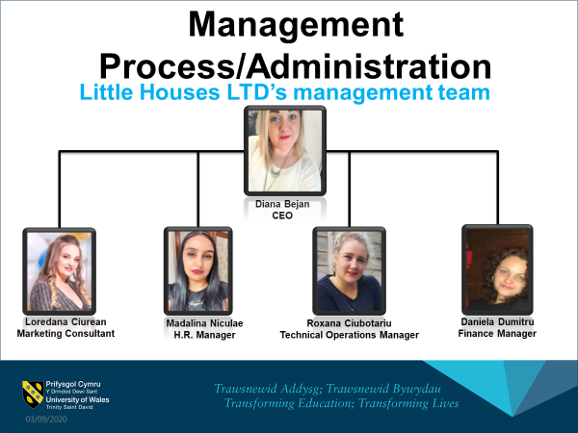

Loredana Camelia Ciurean (1913750)

MARKETING

Product description
Little Houses LTD will produce handmade cardboard houses for little kids from recycled cardboard. Our product is formed from different sizes and models. From large castle houses to miniature toys. Every product will be designed and drowned, painted, and personalised as required or colour-in cardboard designs, where kids can cover it with their own creativity.
We will produce 4 different models and sizes of products:
- Large Castle - will include 4 castle turrets with roofs and 4 large castle walls.
Size: 2286 x 2286 x 1956 mm (90” x 90” x 77”)
- Playhouses
Size: 914 x 685 x 1295 mm (36” x 27” x 51 “)

- Dolls house – open fronted
660 x 330 x 812 mm (26” x 13” x 32”)

- Toy castle – miniature of playhouse, will have 4 turrets, 4 walls and 4 turret tops
Size: 660 x 660 x 305 mm (26” x 26”x 12”)
Perfects gifts for little ones, all products will be over painted and decorated as customers required or came in blank canvas for kids’ creative works of art. The products will be delivering in durable corrugated cardboard pieces, easy for assembly and storage. All products will be environmentally friendly, fully recyclable, and biodegradable.
Market analysis
Target customers
Principals worries in people life are children, our company came in parents help, keeping the kids entertained, with a large eco-friendly, portable, easy to use and creative, a variety of products which will be destinate for toddlers and kids, age 2-13years. Our potential customers will be all people which are looking for gifts for children’s birthdays, families with children’s, schools, nurseries and play groups. In the beginning our target region, will be national and in the future, we want to expand international.
Because of high demand of educational toys as Montessori toys, in present, parents are looking for multifunctional toys. The cardboard playhouses are perfect innovative and educational tools for little ones. Our playhouses are not just walls and a roof, are multifunctional toys, educational and game functions. These have playing role and develop children’s fine motor skills, creativity, imagination and social skills by learning colours, letters, numbers, or art. Our playhouses came in parents and teachers demand. Because personalisation is in trend, we think that a best toy is when a child can personalize with their original ideas. Our products will be created mostly for indoors games, portable, safety and very easy to assembly.
Our price will be defined by monopolistic competition. Monopolistic competition is distinct by a lot of small business and consumers, where the products are different and producers have control over the price, the barriers to entry and out of the market are low. In short term the supernormal profit is probable but in a long term the profit will decrease, as more firms enter to the market because of low barriers to entry and innovation, the consumers will choose to buy alternative products of new entered companies. Cardboard toys are a new market, are not too many competitors in this area and the price will be defined by our cost of production and our existing competitors on the market.

Market and Competition
According to Statista.com the global market toys and games is predictable to increase annually at CAGR of 4,4 % during 2020-2023 and according to Motor Inteligence.com the rate is expected to grow at CAGR of 9,91% during 2020-2025 period. In last years, a growth in the popularity of toys and games was interactive and multi-functionals toys. Children has been very compatible with these types of toys. In consumers demands, there in a growing need for figures, plush toys, puzzles, sports equipment, and pre-school products. The demand of toys and games based on cartoon characters, TV shows, and movies are best sales in the market. The first 5 players in the market are: Mattel Inc., Lego Group, Hasbro Inc., Takara Tomy Co. Ltd, Banday Namco Holdings Inc.
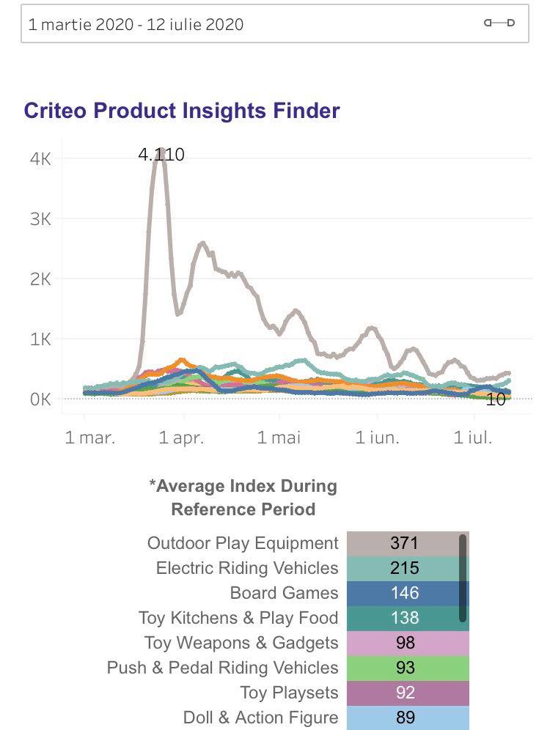
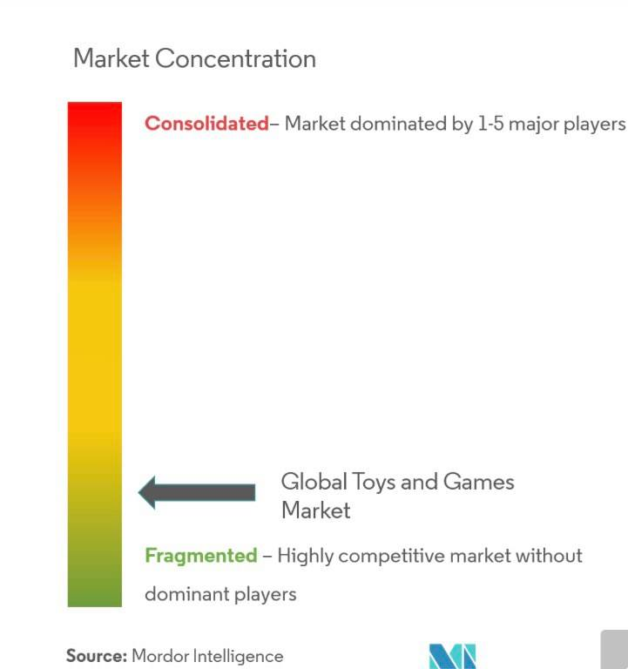The coronavirus pandemic has remarkable changes in people life and their behaviour, people spend more time at home with their family and children. The kids are at home more than ever, restaurants and playground are closed, parents need to spend more qualitative and educational time with theirs little ones, so many households are turning to fun and educational activities for kids’ entertainment. Due to Coronavirus, according to Criterio.com demands in Art & Drawing toys increase in Russia +35%, UK +141%, Germany +159%, France + 261% and US +653%. According to Media Radar during coronavirus sales ad spending on toys and games increase from an average of less than 3 $ million per week in February to 7 $ million per week in March, with more than 50% in just one month.
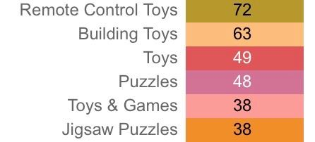

Source Criterio.com
Our competition are companies which produce wooden playhouses, plastic playhouses, play tents and tepees and cardboard playhouses. The reason of choosing this type of market is my personal experience, social media research, eBay and Amazon reviews and price research, focused groups and family and friends. The kids are most important thinks in people life, always parents will be in searching for perfect toy in develop kid’s abilities. The multifunctionality of toy is a positive point in customized. The cardboard material offers us the opportunity to play with models and size of the products. The price of material offer accessibility for all types of customers and is friendly environmental. According to eBay.com and Amazon.com the price of wooden playhouses vary from £400-£1500, plastic playhouses vary from £100-£500, play tents and tepees from £30-£200 and cardboard the most cheaper and best accessible price for all consumers, vary from £15-£150. The idea came with demand of protecting the environment and love for little ones. After an online research, I discover that the innovation in market toys is increasing and friendly environmental products are on the same curve. We were looking for a product to combine both sides and we found that cardboard toys meet all our needs.

Competitor analysis:
Swot Analysis

Strengths  - Reviews Trustpilot 4,9/5, 4859 reviews.  - Offer a variety of wood products.  - The wood material is sustainable, durable, and sturdy.  - Outdoors toys.  - Large playhouses for a big number of kids; | Weakness  - The products require a large space to install it.  - The wood playhouses are very heavy and not portable.  - Needed a big investment for buying it,  Costly.  - Inaccessible for everyone.
Opportunity  - Multifunctionality of products.  - Small number of wood manufacturers in UK.  - Develop a greater online presence by create an online app.  - Massive budget for advertising.  - Experienced company; | Treats  - Competitors, sellers of alternative products: plastic or cardboard toys.



Strengths  - Experienced cardboard creation company.  - Large number of cardboard creations products.  - Cardboard material is eco-friendly, recycled.  - The products are safe, portable, and easy to use for kids.  - Best Indoor products.  - Price is accessible for every type of consumer; | Weakness  - The products came just in blank canvas without drawing design.  - The cardboard material is not durable, is fragile and unstable.
Opportunity  - Advertise the products and became a top seller in cardboard creations.  - Attract a larger potential client.  - Expand the cardboard creation worldwide.  - Small number of business in cardboard creation.  - Opportunity to sales the products for the big companies in toys industry. | Treats  - Monopolistic competition;

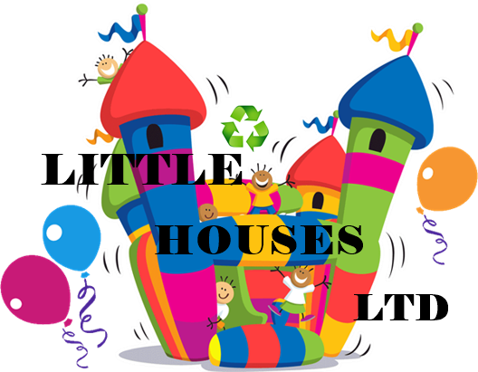
Strengths  - Variety of products in cardboard creations.  - The products came designed and personalised as customers demand.  - Material is recycled and protect the environment.  - Products are easy to use, safety and easy transferrable.  - The products are multifunctional, educational and play roles.  - Accessible for everyone.  - Everyone can be a potential client because, the product is destinate for kids, but people can buy it also as a gift for friend with kids. | Weakness  - The cardboard material can be breakable, and people are looking for durable products.  - Unexperienced team.  - New company in the toys market.
Opportunity  - Promote the products in national plan and expand its worldwide.  - Small number of business in cardboard recycled creations.  - Promote and sell the products on eBay, Amazon websites and gain the potential customers and good reviews.  - Promote the products on social media. | Treats  - Competition  - Lack of resource for advertising

Marketing and sales plans
Little Houses LTD will be competitively priced comparable with other players on the market, our products will be cheapest on the market but not very low than other prices on the market, the price will be determinate by our cost product and competition. In the beginning our company will create a personal website for information and online orders. Our target customers, as people more than 20 years old, will be reach by advertising online, social media (Facebook, Instagram) and kids under 12 years, by advertising trough media, local television, and YouTube platform. Our plans also are to sell the products on eBay and Amazon marketplaces. The promotion campaign will be funded through cash flow process.
Social Media promoting:
In social media is essential to know the target audience, once set up our audience we will know what kind of accounts we need to create to attract our customers. Anyone can be a potential customer for us, from parents to friends or colleagues, grandparents, families which want to buy gifts for kids. In this case, our target audience does not have limits at age, interests, jobs, location, or average income. We can use all type of accounts to attract them: Facebook, Instagram, Pinterest, Snapchat, YouTube, Tweeter and Linked. We will create our business website and business accounts for every platform, we will start promoting by posting regularly using hashtags, stories, images, blog posts, link sharing and videos. We will use a social media calendar to know when we need to post to achieved our target audience for every platform. Facebook and Instagram will be used to attract people from age > 18 years, YouTube we will us to attract kids with an average of age 12-15 and not only. Tweeter and Linked we will us to interact with potentials suppliers, competition and potentials partners or employees.
Google search engine promoting:
After setting up our company website, we will create a google business account. This account helps our company to gets found easier and faster by potentials customers who are looking for our products. One more advantage in setting up an google business account is that our company will be listed on google maps and search. This help us to collect reviews which is an important marketing tool in people eyes. Reviews build customer trust and credibility; they can increase our company’s website traffic and quality rank in search engines.
Television advertising:
When our company budget will increase, we plan to allocate some funds for television advertising, this type of promotion requires more funds. This help us in builds company brand and keeps brand in peoples mind. We will start with local television and will increase advertise national depending on company funds.

References

- To start the business without struggling too much or wasting too much money, we will be making a few products at first with a low cost and as we more people come in and buy from our business, we will be making more and more cardboard houses and also raise the prices a little bit more. Therefore, our income will grow with time.
- Our first milestone is to get the income of £ 456.38. Then to get more customers.
- We will also buy a few cardboard pieces, but also use some of already used boxes since our business is made for recycling and making the environment a better place for everyone.

Roxana Madalina Ciubotariu (1914603)

OPERATIONS

Our little houses will be promoting recycling cardboard and show that there is no need of a new cardboard to do an amazing, creative, and less toxic product from cardboard which was recycled. Our goal is to catch the people attention and kids time to spend in something which can give them new knowledge about a house itself, learnt by physical playing not from virtual one, also we try to reintroduce physical games instant of the ones on the phone , laptop or computer. It is a hard work to fight with virtual world when it comes to speak about kids however with the right potential and product, we can influence them step by step.
Our little houses made by recycled cardboard will be product in a labour which will be rent by me and my partners , the cardboard will be procured from two hotels and we will be recycling it, after will be cut into pieces to start building the little houses , there will be the main model for houses however we can do something different if our customers is asking to. The models can be simple or coloured, including more pieces or less. Because is a small business and on the beginning me and my partners will be making this work, producing, selling, delivering.
Being new starters we do not have too many choices, there will be a website where people can find our products and order them, the delivery will be made by us and the cost of it may be taxed from customers or can be free, depend how much they are going to buy. The payment will be by card because will be online and if there is going to be any issue we are going to give the money back, however there will be less chances of having a problem as long me or one of my colleagues will be making the delivery and the product will be checked before is going to be on the customer hands.
There will be two suppliers, hotels where me and one of my partners used to work in there a long time.
Name and location supplier | Items and prices | Payment | Reason of choosing
Hotel Motel One London Tower-hill 24-26 Minories, Tower, London EC3N 1BQ | cardboard | monthly | Previous workplace
Hotel Novotel Blackfrias 46 Blackfriars Rd, South Bank, London SE1 8NZ | cardboard | monthly | Previous workplace

Equipment
For our cardboard there will be needed a machine which will press it until will be plate. Our company does not own it at the moment, also other kinds of equipment as cutters, glows, apron.
For transport will be used one of our personal cars until there will be brought one for company, on the beginning our sells will be only on the city and for outside orders will be sent on postal way.
As an important step and needed is legal requirements, here are some of the important ones which the company must have before it is opened:
-Register the business: before the company will be opened, we need to register it
-Obtain cover: our company is going to be a small one, however we need cover if something happens
-Fare opportunities: to be equal with other businesses
- Be aware of laws information: we need to have knowledge about the laws and premises
-Checking on employees right to work: every person which wants to be employee in our company must be checked if have right of working in the country, true identity ID or any act
-Having contract written: every company have a contract to offer to employees, different in same part however with the same purpose, to give the guarantee to employee and to employer too that is doing a legal hiring
-Health and safety: training should be done in every workplace to show that every employee is aware of the danger at the workplace and how to avoid it
-National minimum per economy: the annual pay must me no less than minimum per economy
-Report for national tax (HMRC): as a prof of legal working every staff should be reported to pay a national tax
-Pensions: as an employee request they can or cannot have a pension tax
For opening this company will be needed some types of insurance, they are:
-Employers liability insurance: in case there is any employee which can put the company in danger this insurance is going to protect
-Public liability insurance (in case our doing affects public people)
-Building insurance: this is very important even if the building is already owned by the company
-Product liability (for any injuries or damage of product)
-Engineering insurance: if there is going to be any problems with electricity or any broken things this insurance is going to cove and repair
Our business should be covered if anything happens because it is hard to see a big dream going down.
As every other business we have our goal, to extend our company international in few years, however our closer goal is to have a partnership and collaboration with other companies already knew by people, and target our customers , secondly is to employee staff in future , to make an activity to teach them , train them as our plan say ,and the last is staff check, to see if they contribute , how is the contribution, are they improving their skills, or if will be any extra teaching , for all of this we will need foundation around £210.000 . Our financials will depend on income any other costs, me and my partners will be trying to keep a balance between.
As any other places we are going to pay the rent for our labour, the light, wireless, electricity and different things which must be paid from us as combustible for car because of delivery, materials for our products, tools, equipment.
Due Covid-19 many businesses are in danger of closing down not only because of less customers , the government can consider the business not necessary to be open at the time, most affected parts will be political and economic, the companies are at big risk , there is not any income, they are getting money on the beginning however there is no any insurance that will be surviving until the end.
PESTLE analysis is very important in a business in special before opening a business, because is analysing the situation and the reasons and gives an idea for people who want to open a business.
The impact of Covid-19 for the small businesses until now almost broth them to final closure, they are fragile when it comes to speak about finance , and because of this virus in all world is an economic shock, a big number of businesses are expecting financial support however as a small business we have to think that there could big a risk that in this situation to receive a negative answer from government, as a company which does not employee staff we can consider one point, and other point can be less contact face to face with people, because of social distancing. In this situation most of companies are cutting the hours of employees because of less sells and non-profit, some of them are closing down, in our company will not be this problem now because we are not hiring any employee until we are not putting the business up and start having profit.

Political+ Economic+ Social+ Technological+ Legal+ Environmental = PESTLE

Key terms – keeping a trust relationship between us and our suppliers, keeping a satisfaction in both sides, good value of our little houses, customers trust.
As a new company we will prove a quality in our little houses and guarantee of spending the time in something creative and educative for kids.
Our company will not require staff because as five partners we are going to share our work and start the business, all of us have creativity, construction, team work, cooperation skills, some of us did this kind of work before.
Little houses LTD will take life in a labour at the address 123 Baker Street, London W1U 5TY, our customers will find us online, because there is not going to be any shop at the moment, however we will try to give all we can to meet customers wishes. As a company which wants to have a good reputation, a good value of our products we will have a web site where our customers can leave feedback, or any idea of a new model, also there will be email address and a phone number which will be working in specific time where we can be contacted by people which are interested in what we are doing. The company is going to give the best product and delivery safety to our customers.

Technology plan
Technology is the skills, knowledge and processes used to product in a good service. We are living in a modern world and with the time passing the technology took a big update in a people life, from letters to text messages from the phone or video call. Our business will benefit of technology because this will be our way to get to be known by our customers, from local and other countries and also will be the key point due Covid-19.
In our business will be used some of technology methods, something like:
- Phone- for our calls, phone messages
- Laptop-emails from our customers, to see our web page, for ordering new equipment
- machine for cardboard (digital)- this machine have a touch screen where the person which is going to use it will choose the option which is correct or needed and also have some buttons in case is getting broken and need to be stopped.
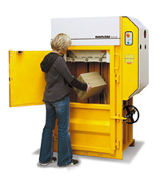
We are going to put the cardboard into the machine until is getting full, then the machine is going to press the cardboard until is becoming like a big box in a different form. This machinery is not hard to use however people need to have training before to use because can be accidents easily and really serious injuries.
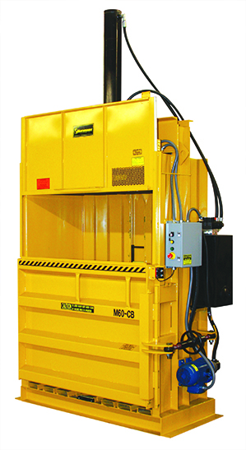

This machine is based on electricity and should be places in a dry space to avoid any danger and people which are not trained to use this should avoid trying to use it for not meeting any incident.

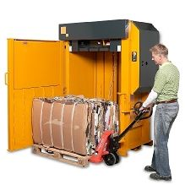

When the machine finish pressing the cardboard inside will be two strings which will be keeping it together and then will come out on a support and pull by an hand forklift , is going to help and avoid back injuries, and if there is no available can be taken out by two people .
Because we are going to sell online there will be transaction from customers, and this is going to be the way we take the money from them and another technology which is going to be used.

Madalina Cristina Niculae (1914612)

Management and organization
For the establishment of this company, Little Houses LTD, have contributed equally to the social capital Diana-Lidia Bejan, Loredana Camelia Ciurean, Roxana Madalina Ciubotariu, Madalina Cristina Niculae and Daniela Carmen Nicoleta Dumitru, loving a clean environment, with the desire to start a business that will delight both children and their parents. Each owns 20% of the company's shares. Our management team of five does not have enough experience in this domain, but it has good skills to manage and organize a business.
The management team of Little Houses Ltd has the following structure: CEO, marketing consultant, production manager, human resources manager and account manager.

Diana-Lidia Bejan, 28 years old, is the Chief Executive Officer (CEO) of this company, being he higher position in this company. Diana does not have experience as a CEO, but she has 2 years old experience as a supervisor in a hotel. The Chief Executive Officer is responsible for the success of the entire organization. She has the ultimate authority to make final decisions regarding the business. CEO has general responsibility for the creation, planning, implementation, and integration of the strategic direction of an organization. Because the role of the CEO carries a significant responsibility, responsibility and authority within an organization, the CEO has these additional responsibilities as she runs the business:
- communicating any decision on company’s behalf with the other shareholders, customers or public.
- management of the development and implementation of the general strategy of the organization.
- leads, directs, and evaluates the work of other managers, depending on the reporting structure of the organization.
- assessing the organization's success in achieving its objectives
- maintaining awareness of the internal and external competitive landscape, expansion opportunities, customers, markets, new developments, and industry standards.
- demonstrating the leadership needed to make the success of the organization's mission.
- evaluating risks to the company and ensuring their monitoring and minimisation
CEO is a key player in terms of whether and how well an organization will succeed.
Unless she does not have experience as a CEO, Diana Bejan has a lot of skills gained as a supervisor and assistant manager, that will help her to do a good job in running her business. Here you can find some skills that a CEO needs to have, and Diana found it in herself.
- the ability to be innovative, bringing innovation to the business
- a risk taker
- optimistic
- coordinating and communicating with team members
- the ability to act
- the ability to control the emotion
- the ability to trust others
A Chief Executive Officer (CEO) with less than one-year experience, as Diana, can expect to earn an average total compensation (includes tips, bonus, and overtime pay) of £46,365 based on 26 salaries.

Loredana Camelia Ciurean, 26 years old, is the marketing consultant of Little Houses Ltd. She studied Economics and Econometrics in a higher education institution in Romania. She does not have experience in this domain of recycle or production, but she has the necessary skills to be a marketing consultant. She is the right person to describe the business’s products and put it on the market. As a marketing consultant her job is to research the market regarding customer’s services or products.
The job duties of a marketing consultant are:
- to supply excellent procedures and to add the latest developments of thoughts in communication.
- to create effective working relationship with partners and channels
- to inform marketing strategies by creating detailed reports with research and analysis findings.
- recommends specific marketing approaches and spending budgets to achieve the customer's desired sales goals.
- set marketing tracking methods to help each customer to evaluate performance over time.
Loredana Ciurean is perfect for this job because she has got a lot of skills that makes her the perfect person for this job. She is paying attention to all details for everything, she is innovative, creative, has a good time management skill. Loredana has a lot of other skills such as: organization, planning, multi-tasking, financial skills, leadership, and she is familiarity with media channels.
As a marketing consultant, without experience in domain, her salary will start from around £30000/year, and after two or three years of experience, the salary can be around £40000/ year.
Roxana Madalina Ciubotariu is the Technical Operations Manager of Little Houses Ltd. She ensures the effective coordination of all project activities in order to achieve the objectives set to the highest quality standards. Her duties are to coordinate the activities within the project by directly supervising the technical teams, consultants and other collaborators involved, to establish long-term collaborative relationships with partners, clients, beneficiaries, to prepare the project budget and cash flow for the final contracts in accordance with the proposal submitted, the beneficiary's comments and the activities planned to take place, ensuring the necessary resources for its proper conduct, to propose measures and solutions to improve the technical performance of network construction teams, to Implement work protection and PSI measures for technicians together with the person in charge on this line, maintain an up-to-date knowledge of technical processes, functions and requirements.
For all these duties she needs to have some skills required to help her to meet all the tasks of her job.
- Higher studies completed in the technical field (IT, telecommunications)
- The ability to inspire and motivate others in the activity.
- Planning and strategic action.
- Ability to build and develop talent (high-performance employees to support the goals of the organization)
- Interest in maximum satisfaction of internal and external clients.
- Knowledge of English – advanced level.
- Excellent computer skills: Word, Excel, PowerPoint.
The average salary for a Technical Operations Manager in United Kingdom is around £40000/year.

Madalina Cristina Niculae is the Human Resources Manager of our company. Regardless of the company's field of activity, a good human resources manager must be like a mentor or leader who knows the potential of each employee and seeks various strategies to highlight him, thus increasing the productivity of his department. In addition to this, the human resources manager must know how to coordinate teams, choose the right employees, so as to accelerate and facilitate all processes within the company, considering the general objectives of the company. For this reason, the manager must define a set of important skills. First of all, order is a key element for any human resources manager, given that he works with documents, draws up all kinds of files and documents. Besides this quality, there are a whole range of skills that determine the performance of a manager and Madalina found it in herself:
- to know how to evaluate the performance of any employee.
- to know how to budget for the human resources department
- to have knowledge of solutions that can be applied in crisis situations to reduce labour costs
- to know what she needs to do to motivate each individual employee
- to like to work with people and has a penchant for active listening
- to can manage projects and coordinate teams to achieve them
- to understand change very well and helps employees do the same and adapt to any new situation
- to have business management skills and knowledge of the field of negotiation
- to have the ability to solve problems and possible conflicts related to the job
- to know how to communicate clearly and transparently both in writing, by e-mail, and verbally, on the phone, at the meeting

In general, the responsibilities of a human resources manager follow two main directions: responsibilities related to employees' salaries (thus, a human resources manager must calculate the salaries of each individual, receive medical certificates, draw up payrolls, liquidation, monthly declarations on obligations to the budget) and responsibilities related to recruitment and personal administration (coordinates the entire activity in the human resources department, develops and implements strategies for the development of the human resources department taking into account the general objectives and policies of the company, deals with the recruitment, selection, hiring, training and training of employees, prepares the job descriptions of the employees, according to the fields of activity and positions in the organization chart and manages and establishes the recruitment budget.)
The salary of an HR manager varies according to his experience, the degree of responsibility he has in the company, the knowledge, and studies he graduates and many other aspects that differ from one company to another. On average, however, a manager's salary can reach more than £40000/year.

Daniela Dumitru is the financial manager of Little houses LTD. The financial manager deals with all questions related to financial problems, ways of financing, investing, and spending money, as well as profit rates in general. The ability of a financial manager to adapt to change, to seek sources of financing, investment and to manage wisely brings success to the whole company. The financial manager is in charge of planning, organizing, choosing the appropriate framework for certain tasks. It also deals with decision-making, management, and financial control over financial means. Given the complexity of this function and the possibilities offered by a quality financial manager in the company where he is employed, he must hold at the same time the characteristics of an entrepreneur and a finance expert.
Basic tasks of a financial manager are financial planning and prudence, use of capital, tips in making business decisions, preparation of financial reports, budgeting and planning, measurement and control of results, analysis of financial activities and implementation of appropriate activities based on analysis, modelling and financial prudence, improving cost control.

Social responsibility and sustainability
The social responsibility of companies is the concern of managers to take actions that protect and improve both the well-being of the company and the interests of the organization. This concern is demonstrated by managers who consider both the long-term interest of their firm and the company's relations with the environment (company) in which they operate. Business also means people and the environment.
Our company called “Little Houses Ltd” is for the beginning a small company which is producing little houses for children using recycled cardboard. Our dream is to grow up on the market and make more children happy and also their parents, knowing that in this way they are helping themselves maintaining their children focussed on good and constructive activities, but also the planet because we are using recycled cardboard to help the planet breath more without cutting more threes.
Recycling is the process where the products used are transformed into new products. The main long-term objective is of course the conservation of the environment. Recycling preserves natural resources that would otherwise turn into raw material for producing new goods. Recycling reduces energy consumption, pollution, and greenhouse gas emissions.
The greatest benefit of recycling cardboard and paper is the preservation of the environment. 90% of the pulp of cellulose used in paper production comes from trees. The ecological benefits of cardboard recycling are translated quite quickly into financial benefits because recycling comes with cheap (if not free) raw material for manufacturers who would otherwise have to purchase new and expensive raw material. Since environmental degradation and global warming are global challenges and both governments and companies around the globe are trying to reduce their costs and impacts on natural resources, we can say with certainty that cardboard recycling is an industrial process by which everyone has only to gain. Corporate social responsibility means maximizing the good and minimizing the negative effects your company has on the diverse interests of these stakeholders.
Helping our company to grow up means helping planet to breath more fresh air.

Daniela Carmen Nicoleta Dumitru (1916141)

The business environment becomes more dynamic in the 21st century. The nature of the business, the way of operation and managing it have been changed drastically. Managing the enterprise in this era is a huge opportunity for personal employment and growth. In this part of the assignment, the detailed financial plan for the new business idea have been developed. The new business idea is to produce, promote and supply the new recyclable cardboard houses. However, the demand for the recyclable cardboard houses has been increased a lot in the recent time as the people spent more money in home décor and exclusive things. This business will have a very good growth potential. In this connection, appropriate financial planning is required in order to address the financial needs and develop the growth plan for the near future.

Personal skills and experience
The success of the business organisation largely depends on the experience and expertise of its management and personnel (Carroll and Buchholtz, 2014). Each and every member of the team has different types of skills and expertise. As a team member, I also have some limited level of experience, knowledge and skills that will be helpful in preparing and developing my assigned tasks.
For development of the financial planning, the knowledge and skills in this field are required. I have worked as the accounting executive at a super shop which helped me to address different types of transactions that an organisation has, to prepare the budget for costing and sales, to develop and analyse the financial statements. These experiences will help me to address these issues in the proposed business. Besides such experience, my knowledge and skills gathered from the academic career in business studies will be very crucial as well.
For running the business, various skills, talents, and traits are required by the related personnel, especially, in the new enterprise where there are less specialised people. Because of the financial limitation and volume of the work, most of the entrepreneur or manager need to play different roles (Ghemawat et al., 2010). However, I have some transferable skills through which, I believe, I can create value for the enterprise. My knowledge in the business, especially in the field of accounting and finance will be helpful for the business. I can manage the accounting and finance department of the proposed enterprise. Moreover, I can train the other personnel regarding this issue. My software skills can also be utilised by training other people.
There is always a scope of improvement in the modern business environment. My skills and experience need to be developed on the continuous basis in order to ensure the sustainability and competitiveness in the long run. However, I think that my communication skills and leadership skills need to be developed further. I can improve my communication skills through proper knowledge gathering and practising more. The leadership skills can be improved through playing different roles and working within the team. Thus, by improving the required skills, knowledge and expertise, anyone can be turned into a competent asset for the business organisation.

Financial Plan
For the success of the business organisation, the preparation and development of the viable and justifiable financial plan is must. Financing is regarded as the blood of the organisation. Therefore, the efficient and effective management of the funding in different operational procedures shape the performance of the business organisation (Brigham and Ehrhardt, 2013).
Capital Requirements
First of all, the requirement of the financing needs to be addresses accurately. By analysing all the potential business operations and activities, the funding requirements need to be calculated. At the beginning, such capital assets requirements need to be addressed. However, in order to produce and supply the “Recyclable cardboard houses”, the following capital assets will be required initially-
List of capital assets
Particulars | £
Printing machine | 200
Packaging machine | 100
Tools and equipment | 100
Total | 400
Table: Capital Assets Requirements
Source: Self-developed
In the above table, the major capital expenditures have been addressed. Besides the capital expenditure, the working capital is required as well at the beginning in order to purchase the raw materials and run the business initially. Approximately, £ 100 will be required as the working capital at the beginning. Therefore, a total of (£ 400 + £ 100) = £ 500 will be required as the capital which needs to be collected from various sources.

Sources of Finance
Before staring the business, the potential sources of finance need to be addressed properly. There are primarily two types of financing- equity financing and debt financing. The equity financing can be regarded as the internal financing while the debt financing can be explained as the external financing (Higgins and Reimers, 2015). Each and every type of financing has pros and cons. The financing for this business can be collected from any of these sources or combination of these sources.
For the new enterprise like the proposed business plan, the financing from the internal sources would be easier than the external financing. In this business plan, most of the financing requirements will be obtained from the internal financing. The cost of internal financing is relatively cheaper than that of the external financing for the new business. The equity financing is also less risky for such business. On the other hand, there are many sources of external financing or debt financing but for the new business, they may not be viable or applicable. Only the bank loan and venture financing may be feasible for the new business (Higgins and Reimers, 2015).
However, for the development of the proposed business, only the equity financing will be obtained because of being very small in nature. The fund sourcing plan is as follows-
Sources of funds | Amount (£)
Personal income and savings | 400
Temporary borrowing from friends | 100
Total | 500
Table: Sources of funds for the business
Source: Self-developed
The above table shows the funding sources for the proposed business. 80% of the funding will come from the personal income and savings of the team members. The rest amount will be collected from other friends.

Personal Survival Budget
The business enterprise is developed in order to extract the income from it and reduce the financial difficulties of the persons. In order to measure the feasibility and viability of the business enterprise, the personal survival budget play a huge role. For this reason, the personal survival budget is considered as the part of the financial plan of the business. However, the personal survival budget involves the minimum amount of money required in order to survive in life, by paying required bills and essential expenditures (Brigham and Ehrhardt, 2013). For running the business, it is essential that, the such minimum requirement of money is fulfilled from the business. As the student, the personal financing requirements are low for the team members. Moreover, there are other sources of funding them. So, the average personal survival budge for each team members would be approximately £ 100. Since, this business is completely new, it may not be possible to meet the minimum survival budget from the profit of this proposed business at the initial level.

Sales Forecast
Forecasting the expected level of sales is a crucial part of the financial planning. The product of the new business enterprise is the recyclable cardboard houses, the demand for which is increasing in the recent years. But in the next years, the demand for this product may be not be increased in the overall scenario and even the overall demand may fall as well.
However, the demand for the product of “Recyclable cardboard houses” will be low at the beginning because of the new brand, but with the quality products at reasonable pricing, the demand for product of proposed business will be increased over the time. The projected sales for the next five years have been presented below-
Year | Rate of Increase | Sales (£)
2021 | - | 1500
2022 | 10% | 1650
2023 | 15% | 1898
2024 | 12% | 2125
2025 | 10% | 2338
Table: Sales Forecast
Source: Self-developed
The above table shows that, the demand for the products of the proposed business will be increased at the increasing rate in the next two years. After that, the demand will be increased at the decreased rate.

Income Statement
The income statements for three years have been projected as below-
Projected Income Statement
Particulars | 2021  (£) | 2022  (£) | 2023  (£)
Sales | 1500 | 1650 | 1898
Cost of Sales
Raw Materials | 400 | 440 | 506
Office Rent | 60 | 66 | 75
Salaries | 130 | 143 | 164
Selling and Marketing | 60 | 66 | 75
Utilities | 50 | 55 | 63
Depreciation | 20 | 22 | 25
Interests | 25 | 27 | 31
Other expenses | 20 | 22 | 25
Tax | 15 | 16 | 19
Net Profit | 720 | 792 | 910
Table: Projected Income Statement
Source: Self-developed
The income statement shows that financial performance of the business entity over a particular period of time (Van Horne and Wachowicz, 2014). The above table shows the projected income statement for three years. It shows that, after meeting all the expenditures, the business is able to make a profit of £ 720, £ 792, and £ 910 in the year of 2021, 2022 and 2023, respectively.

Balance Sheet
The balance sheets for three years have been projected as below-
Projected Balance Sheet
Particulars | 2021  (£) | 2022  (£) | 2023  (£)
Non-current assets | 375 | 400 | 425
Current assets | 175 | 187.5 | 200
Total assets | 550 | 587.5 | 625
Non-current liabilities | 125 | 125 | 125
Current liabilities | 175 | 212.5 | 250
Equity | 250 | 250 | 250
Total liabilities and equity | 550 | 587.5 | 625
Table: Projected Balance Sheet
Source: Self-developed
The balance sheet shows that financial position of the business entity at a particular point of time (Brigham and Ehrhardt, 2013). The above table shows the projected balance sheet for three years.
Cash Flow Statement
The cash flow statements for three years have been projected as below-
Projected Cashflow Statement
Particulars | 2021  (£) | 2022  (£) | 2023  (£)
Cash flows from operating activities | 765 | 841 | 967
Cash flows from investing activities | (100) | (120) | (125)
Cash flows from financing activities | (25) | (27) | (31)
Increase (or decrease) in cash & cash equivalents | 640 | 694 | 811
Cash & cash equivalents at the beginning of the year | 500 | 1140 | 1834
Cash & cash equivalents at the end of the year | 1140 | 1834 | 2645
Table: Projected Cash Flow Statement
Source: Self-developed
The cash flow statements show the movement of the cash and cash equivalent over the years (Van Horne and Wachowicz, 2014). The above table shows the projected cash flow statements of the proposed business for the year 2021, 2022 and 2023. However, the cash flow statements show sufficient availability of the cash in all three years.

Break Even Analysis
The product of the new business is the recyclable cardboard houses. Such products are manufactured in a batch. In order to calculate the break-even point for the business it is required to address some financial figures. The estimated required information is below-
Average annual fixed cost = £ 120
Average turnover from each batch of products = £ 50
Average variable costs per batch of products = £ 20
Break Even Point = 120 / (50 - 20)
= 4.00
Here, the calculated break-even point is 4 which indicates that, in order to sustain a “zero” operating loss, the business entity must produce and sell at least 4 batches of the products. However, the expected turnover is more than the break-even point. Therefore, the business plan is feasible and viable to be undertaken and further initiatives can be taken.

Diana-Lidia Bejan (1914605)
Conclusion
Little Houses Ltd is a recycling company who from recycle cardboard produce little houses for kids. In addition, our business is going to impress a lot of people and hopping that one day we will expend our company by making more products and making more kids happy with our little houses. We hope that Little Houses Ltd will make a change in the world, because our first thought was to encourage more people to recycle cardboard or even other recycling materials, our plan besides becoming an popular company we want to prevent deforestation in United Kingdom.
Thank you for making time to read our business plan and we hope that you will invest in our company.
References:
Advameg, Inc. (2020) BUSINESS PLAN, KID'S WORLD [Online]. Available from: https://www.referenceforbusiness.com/business-plans/Business-Plans-Volume-03/Indoor-Playground.html (Accessed 21 July 2020).
Andrew Maund, Michaela Schriek, Paul K. Tinkler (2017) Certificate in Higher Education: Skills for the Workplace Student YearBook, Sage Publication. Ch.5, pp. 482-493
Byte start (2005-2020) Which types of insurance must your business have? [Online]. Available from: https://www.bytestart.co.uk/business-insurance-must-have.html (Accessed: 29 August 2020).

Helen Lucas (2019), Legal requirements for starting a business [Online]. Available from: https://citrushr.com/blog/hr-management/legal-requirements-for-starting-a-small-business-uk/ (Accessed: 28 August 2020).

Laura Burns (2020), 4 Potential political risks arising from Covid-19 [Online]. Available from: https://www.willistowerswatson.com/en-GB/Insights/2020/04/four-potential-political-risks-arising-from-covid-19 (Accessed: 29 August 2020).

LiL HOUSE Ltd (2020) 8 Useful Tips for Buying a Good Indoor or Outdoor Playhouse for Kids [Online]. Available from: https://lil-house.com/useful-tips-for-buying-good-indoor-playhouse-for-kids/ (Accessed 21 July 2020).
Motorintelligence.com (2020) Industry-reports. Toys and games market [Online]. Available from: https://www.mordorintelligence.com/ (Accessed 20 July 2020).
Satista (2020) Toys and hobby [Online]. Available from: https://www.statista.com/outlook/14020000/102/construction-sets-models/europe?currency=gbp#market-revenue (Accessed 20 July 2020).
Servier International (2019) What is Corporate social responsibility [Online]. Available from: https://www.youtube.com/watch?v=1bpf_sHebLI (Accessed: 30 August 2020).
Tim Berry (1996-2020), How and where to write about technology in your business plan [Online]. Available from: https://articles.bplans.com/how-and-where-to-write-about-technology-in-your-business-plan/ ( Accessed: 29 August 2020).

3WM Ltd (2020) The paper collection [Online]. Available from: https://www.paperpod.co.uk/pages/about-us (Accessed 20 July 2020).

Business plan presentation
FOR



