Professional Career Development

Name of Student: Caruntu Raluca Elena
Module Code: BMSW4005
Student ID: 2010421
Lecture name: Lloyd Beharry

Table of Contents

Task 01- Role Play 2
Task 02- Report 3
Introduction 3
Personal Reflection on the role plays for the post-Assistant Financial Manager 3
Summary of reflecting using the SWOT framework 6
Personal Development plan according to reflection 7
Conclusion 8
Reference 9
Appendix 10

Task 01- Role Play

- Why do you think you are suitable for the job?
- Where you want to see yourself after 5 years?
- How this work experience will benefit you to develop you career?
- Explain what was your outline of main responsibilities and key duties in previous job?

- How do you think your co-workers would describe you?

Task 02- Report

Introduction
Getting an ideal job and becoming a success in professional life is always a challenging task for job candidates. The research on the current job market is telling that 62% of the candidates are highly concerned about their preparation for their ideal job position and 48% of the candidates are actively manages their skills and abilities for their desired placement (Pfeifer and Strunk, 2020). As the recruiters are getting the benefits of recruiting from local and international markets, the job seekers must be qualified enough to compete with other candidates. A job seeker must be qualified with proper background education and blessed with different hard and soft skills that are necessary for becoming a success in the placement. For example, the hard skills for a financial manager are knowledge about the business environment, economy, political condition, share market conditions, data analysis, market research and other different sources of financing and management skills. On the other hand, soft skills are related to proper communication, leadership, negotiating, networking and motivating skills that help to control and influencing others for getting the job done with high efficiency (Pfeifer and Strunk, 2020). While completing this task, I have performed the role of recruiters and also the job-seeking candidate for the post of Assistant Financial Manager on the firm Mark and Spencer. This report is going to reflect my career development planning, current skills and further development for making me competent for my ideal job.

Personal Reflection on the role plays for the post-Assistant Financial Manager
While playing the role of a recruiter and job candidate, I have experienced and realised some new learning about my current conditions and the following section has reflected this learning using the KOLB reflecting model which is concerned with experiential learning. It reflects the personal experience and systematically analyses, describe, evaluate and take improvement actions continuously for further development. There are four types of experiences which are concrete, reflective, abstract and active that have described below (Chirikhin, 2014).
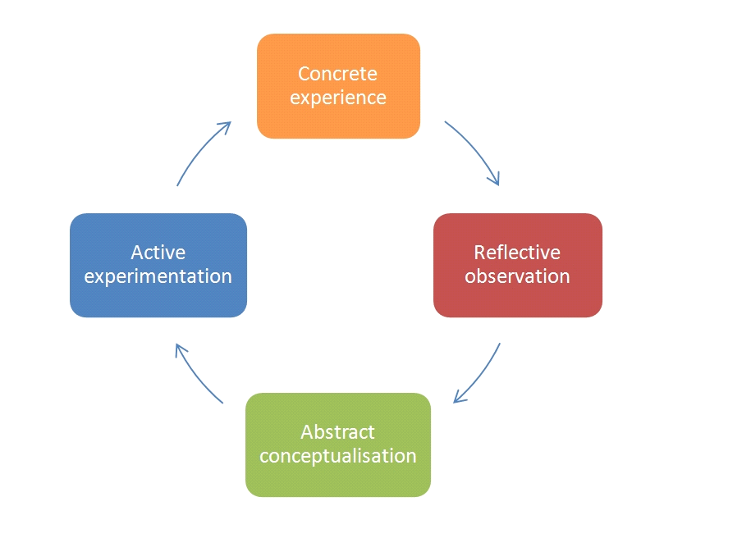
Figure: KOLB reflecting model
Source :( Chirikhin, 2014)
Concrete experience:
Concrete experience is learning from a real-life event on a specific matter. In this task, I have played a role of recruiter and a candidate also for the financial manager post. I have seen that most of the candidates are conscious and have very good knowledge about the academic background of financial management but they have very little practical knowledge about the current financial world. I felt good confident in the role-playing session. I feel that I have attained some good knowledge about business and financial management that are mandatory to run the assigned duty of a financial manager. I think that I have made good communication with candidates and others for describing my skills and abilities to make me competent for that post and I will be able to utilise my communication and interpersonal skills for my professional life (Cook, 2018). I think that there needs more development in the area of data modelling, negotiating, problem-solving because I have very little knowledge and could not make good conversation while talking about different advanced models of data analysing, negotiating with clients while arranging funds and how I can make the proper utilisation of the funds for adding value to the firm.
Reflective observation:
Reflective observation is related to the evaluation of the situation based on favourable and unfavourable factors. In the role-playing section, the most effective factors were my education knowledge because it gives me a good knowledge of how the financing world is operating and how the value of the firm can be increased by utilising different capital budgeting tools, tax shield benefits, optimising leverage and capital structure(Wongsarnpigoon, 2018). My good knowledge about group tasks and different leaderships styles like situational, contingency, democratic and autocratic have helped me to manage different business problems in that interview. I have made strategic planning for my idea job and my preparation according to this has made me advanced than the others. Some factors were my negative point because I have very little practical working knowledge and using different advanced data processing tools that are common in the financing world. My time management ability and relational problem-solving ability with the inability to make quick decisions were my negative point and it reduced my competitive advantages over the other candidates.
Abstract conceptualisation:
Abstract conceptualisation is related to determining the different ways by which the situation could be handled differently or could get a better result. As I have suffered from the lack of practical working experience, I am determined to work as an intern student in the finance department of a business organisation and it will make me confident and able to run my duty properly. I am also determined to improve my problem-solving ability so that I can relate all possible outcomes of different options and can ensure good financial management of the firm with quick decision making. The problem-solving ability will also increase the capital budgeting decisions and able to make a good investment of the funds (Taysi and Orcan, 2015). I am also determined to improve my asset management and distributions of the funds so that value can be added by reducing the wastage and value destructive investments. Initially, I will make a SWOT analysis of my skills and make a development plan and ensure my improvements in those areas.
Active experimentation:
Active experimentation is related to the application of the new theoretical realisation and evaluates the new learning and improves the learning that creates another new cycle of reflection. I have attained my practical knowledge, data analysing ability, resource management and problem-solving with active skill management and training. Now I have realised that the continuous development of the skills and abilities are highly important for becoming more competent (Lurgi and Robertson, 2011). I have made a plan for practising the current skills and distribute the time for acquiring new knowledge one by one. I will improve my time management, strategic planning, professional degree and personal development for the future and this reflecting model have remained effective for me by giving proper guidelines to follow the situation and improve my skills and abilities for getting my ideal job.

Summary of reflecting using the SWOT framework
Strengths  Knowledge about business and financial management  Communication and interpersonal  Leadership Quality  Data Analysis ability | Weaknesses  Resource allocation and distribution  Formal presentation and negotiation  Advanced software-based data analysis  Practical knowledge and Problem-solving
Opportunities  Technological advancement  Indeed, LinkedIn, Facebook, YouTube  Professional degree  Internship opportunity | Threats  Covid-19 threat  High competitions  Lack of self-control  Limited time management
Figure: Summary of personal SWOT analysis
Source: Self
SWOT is related to the personal strengths, weaknesses, opportunities and threats that are showing the present condition of any job-seeking candidate. While reflecting on my role, I have determined that I have strengths for business and finance related education background, better communication and interpersonal role. My leadership and data analysis ability are also my strengths for good financial management, team management and take good financing decisions.
I have realised that I have weaknesses in resource allocation and controlling which is a prime concern in that financial management as finance deals with funds and resources for attaining value. For doing that work I need to be proficient in data analysing using advanced software because data-based decisions give high success in financial management (Vaněk, Mikoláš and Žváková, 2017). I need to be more proficient in quick problem solving and quick decision making for running the business smoothly.
Some resources are opportunities for me because they will help me to attain new knowledge and improve my current proficiency. Advanced technology will help me to make good communication and networking with recruiters and provide me job-related information. I will be able to do online classes for a professional degree and different internet-based study materials for improvement. YouTube tutorials, motivational videos; online based exams are my opportunity for improvement.
There are some threats and the Covid-19 is the main threat because the business firms are reducing their recruitment and limited their internship placement that is a threat to acquiring practical knowledge. The rate of placement has reduced by 53% from February 2020 to June 2021. The high competition in the job market is also another threat (Ge and Haller, 2021). My limitation of merit, self-control and lack of time can be a substantial threat to developing my employability by adopting diversified skills and abilities.

Personal Development plan according to reflection
Skills | Action plan | Deadline
Resource management | Resource management is the key to financial management and I will improve my resource management skills by applying capital budgeting skills, budgeting, forecasting and other accounting tools that will ensure the cost and benefits of resource distributions. A proper balance will be maintained and the decisions will be controlled properly (Thacker, 2012). I will follow the variance calculation and control my negative variance for improving resourcing management skills. | March 2022
Practical Knowledge | I will get a placement as an intern student in a business organisation and work as a junior assistant financial manager for getting practical knowledge. I will also participate in project management of the financing team that will make me more competent in the financing task. | December 2022
Software-based data analysing | I will get admitted to a professional data analysis program for learning different data management and analysis tools using advanced Excel and other statistical applications (Krappmann and Letzel, 2012). I will practice one hour of data analysis daily and will try to follow a practical example for data analysing skills and improve decision-making skills. | December 2021
Problem-solving | I will follow several financial problems of the business organisations and will solve the problems according to following the costs and benefits of every possible outcome. The best possible outcomes will be taken and the practice of problem-solving will improve my financial problem-solving ability. I will also take suggestions from my professor for evaluating my improvements. | March 2022
Presentation and negotiation | I will attend public speaking, debating and case competitions on business problems so that I can make proper data analysis and make a good presentation. I will follow the strategies of good presentation and practice it regularly to get confidence and reduce my nervousness in public speaking. I will make good networking with business professionals and follow the skills of negotiation in practical life that will improve my skills. | March 2022
Improve self-control | I will follow a to-do list and compete for my task timely under the priority based. This will help me to attain good control over myself and to do well in my academic, personal and professional life. | March 2022
Proper time management | The daily routine will be followed and proper time will be distributed for the specified task. The routine and follow the task will enable me to use my time and ensure proper management of time for academic and professional purposes. | March 2022

Conclusion
The job candidates must acquire the necessary knowledge, skills and abilities according to the current demands of the recruiters to get their expected placement and being a success in professional life. While knowing the requirements of the recruiters, a candidate needs to make a development plan and follow the plan for self-development. The role-playing task has made me conscious and I have learned the required skills for starting my professional life as a financial manager (van Esch, Black and Arli, 2020). I am following the continuous development plans and hope to be successful in my placement timely and be successful in my career utilising those knowledge, skills, abilities and ways of self-development.

Reference
Cahyadiana, W. (2020). PENGARUH HARD SKILL DAN SOFT SKILL TERHADAP SELF EFFICACY MAHASISWA. PSIKOVIDYA, 24(1), pp.1–7.
Chirikhin, A. (2014). Reflecting Firm Value Model and DVA/CVA. SSRN Electronic Journal.
Cook, S. (2018). Good communication is key to good care. BMJ, p.k1704.
Ge, S. and Haller, H. (2017). Job Market Signaling and Returns to Education. Southern Economic Journal, 84(3), pp.734–741.
Krappmann, M. and Letzel, T. (2012). Achroma: a software strategy for analysing (a-) typical mass-spectrometric data. Analytical Methods, 4(4), p.1060.
Lurgi, M. and Robertson, D. (2011). Automated experimentation in ecological networks. Automated Experimentation, 3(1), p.1.
Pfeifer, B.J. and Strunk, D.R. (2020). Getting Back to Work: Cognitive Behavioural Predictors of Depressive Symptoms and Job Search Success. Journal of Clinical Psychology, 72(6), pp.591–605.
Taysi, E. and Orcan, F. (2015). The conceptualisation of forgiveness among Turkish children and adolescents. International Journal of Psychology, 52(6), pp.473–481.
Thacker, R.A. (2012). Introduction to special issue on Human Resource Management certification. Human Resource Management Review, 22(4), p.245.
van Esch, P., Black, J.S. and Arli, D. (2020). Job candidates’ reactions to AI-Enabled job application processes. AI and Ethics.
Vaněk, M., Mikoláš, M. and Žváková, K. (2017). Evaluation Methods of Swot Analysis / Metody Vyhodnocení Swot Analýzy. GeoScience Engineering, 58(2), pp.23–31.
Wongsarnpigoon, I. (2018). Finding the Positive: Reflective Observation of an Advising Session. Relay Journal, pp.317–329.

Appendix
Job application for the post: Assistant Financial Manager
23 July 2021
The Human Resource Manager
Mark and spencer
London, UK

Dear sir/Madam,
Application for the post of Assistant Financial Manager
I am highly interested in the post of assistant financial manager in your organisation and I have attached my CV for your kind consideration.
I have good background education about the financing task as I have completed my graduation on the business background and learned important knowledge about economics, business and financing. I am highly oriented with different kinds of financing, financial management, capital budgeting and financial reporting. I have worked in two different organisations as an intern student in the finance department and attained good experience to deal with different financial problems.
I am highly confident with my communication, interpersonal, leadership and team working skills by which I will be able to perform my assigned task as a financial manager in your organisation. I will be able to add value to your organisation utilising my data analysis skills, knowledge about data entry, high proficiency in the technological framework.
I have improved my skills in data analysing and can analyse data using MS Excel, Strata and other different statistical framework. I am also oriented with solver, optimisation, scenario analysis and applying different knowledge of financial management.
I will be highly pleased if you allow me to attend an interview and give me a chance to discuss my skills, abilities, knowledge and qualities further.
Thanks for your consideration
Yours sincerely
Raluca

Personal Information: Raluca
Email: Raluca420@gmail.com
ADDRESS: Down Street, 1230
London, UK
Career Objectives
To work in a challenging corporate environment where there is equal opportunity for career development. I have a keen interest to work in the financial sector and want to add value to the corporation by utilising my knowledge and innovative ideas.
Education
Business Background Student of University of Wales
Personal Skills
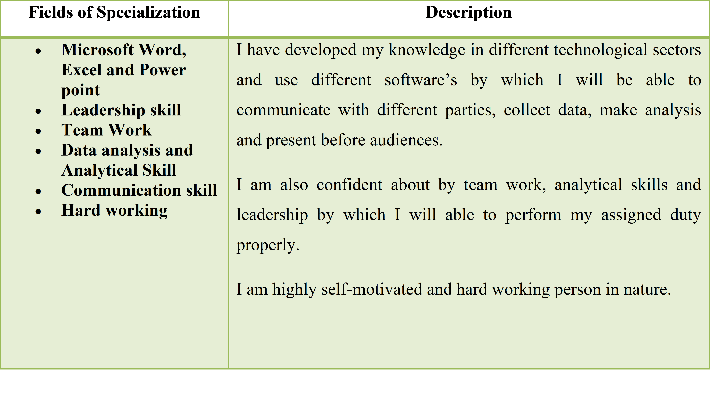
Other interests
I have a good interest in the corporate world, share market and other forms of local and international financing. I follow the business news, case study and do project management related to business areas. I like travelling, gardening and reading in my leisure period. I like debating and team working.
Reference
Herese Procter, HRM, Tesco

