Responsive Web Design and Development
  - Lecture 5 Lab Tutorial Exercise

Installing and Configuring WAMP Server

Exercise 1: Installation
- Launch control panel and uninstall any previous versions of WAMP.
- Go to http://www.wampserver.com/en/ and click the Download link to download and install WAMP Server.
- Run the downloaded installation file. If you want you can change the default browser and editor to your preferred choices.
- When it is done, go to the Windows start menu and type in WampServer to locate the program and launch it.
- Check the Task Icon tray to ensure that your W icon is green/orange.
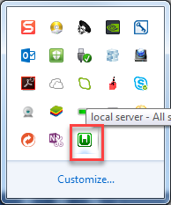
- Open up a browser window and try browsing to: http://localhost/. You should have a window similar to the following.
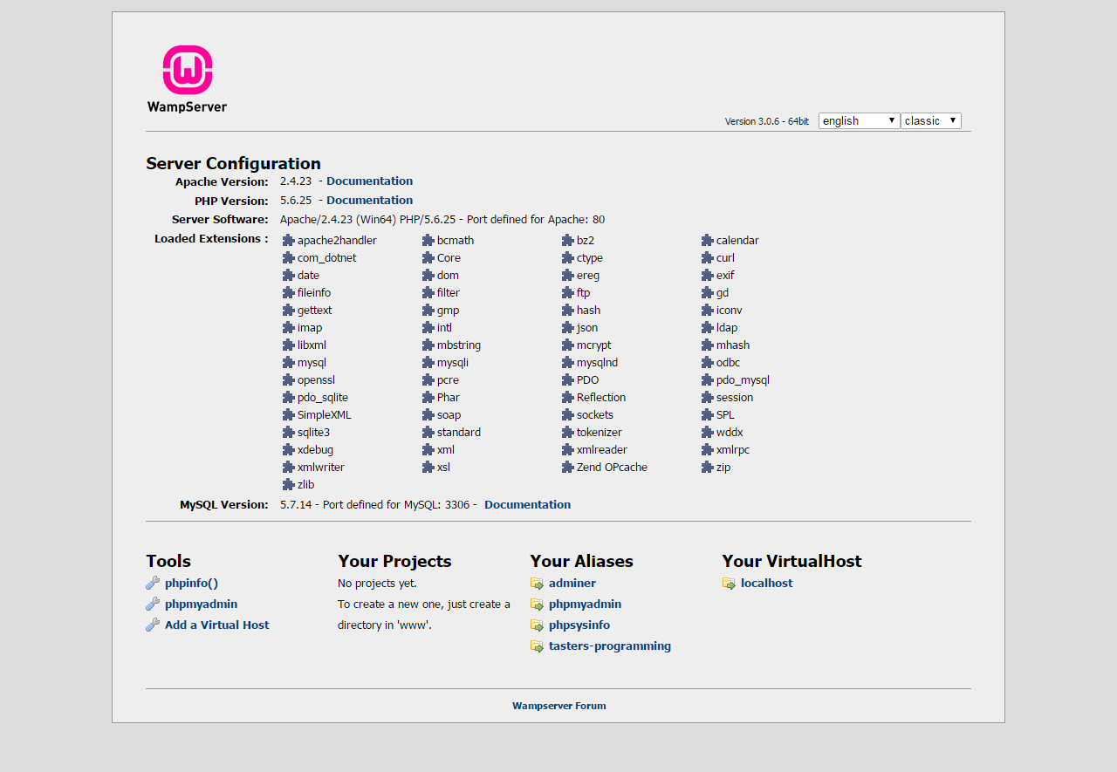

- Note: If you do not have a window similar to the following, it is likely there is a port conflict. The first web server installed runs on port 80, so it is possible you have another web server installed.
- If your server is okay, skip to Exercise 2, otherwise carry on.
- Go to the following folder directory on your computer: C:\wamp64\bin\apache\apache2.4.23\conf
- Right-click on the file called httpd.conf and select Edit with NotePad++
- Do a search for the word “Listen” – You should find text similar to the following. You need to replace 80 with another port number. Try a number like 8081 or similar (Check out this link for commonly used port numbers to identify a free one to use). Make note of the number you use.
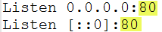
- Do another search for the word “Servername”. You should find something similar to the following. Replace 80 with your chosen port number from the last step.
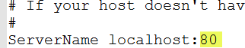
- Save the changes and click the WampServer “W” icon in the task bar area and select “Restart all Services”. Once the icon turns green, browse to the page http://localhost:[your port number]/ e.g. http://localhost:88/ if using port 88.
If that still doesn’t work, contact me.

Exercise 2: Making Wamp Server Accessible from Other Computers
- Localhost only works from the machine the web server is installed on. To grant access from other machines and your devices, you will need to provide access via the computer’s IP address.
- From the start menu, open up the command prompt – do a search for “cmd”.
- At the command prompt, type in ipconfig and press enter. In the resulting message, make note of your IP address
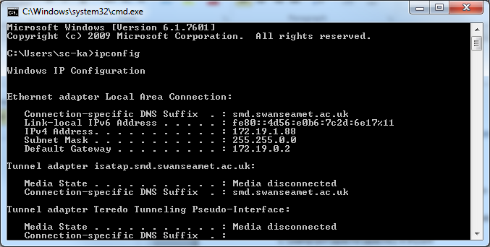
- Open up the httpd.conf file from the following location – right-click on it and select Edit with Notepad++
C:\wamp64\bin\apache\apache2.4.23\conf
- Do a search for either of the following. If you can’t find option a, try option b, and if you can’t find either, contact me.
  - DocumentRoot "${INSTALL_DIR}/www
  - DocumentRoot "c:/wamp/www
- Look for onlineoffline tag towards the closing </Directory> tag and replace Require local (mine is commented out) with Require all granted as shown
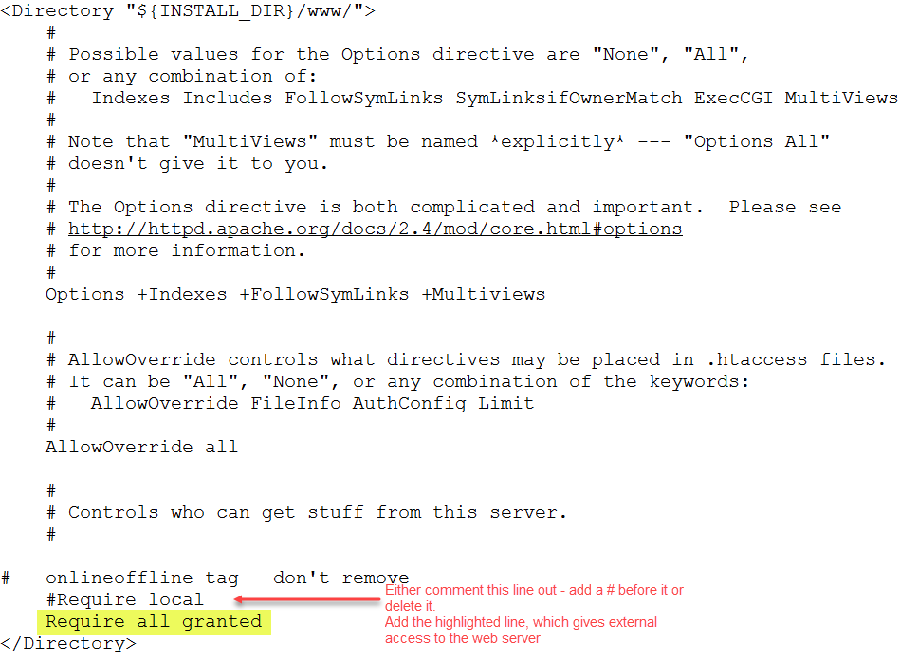
- You will need to restart your WAMP server for the changes to take effect. From the little WAMP “W” icon in the task bar, click on Restart All Services and give it a minute or two.
- Open up a browser and now using your IP address, see if you can access your wamp server – add the port number if required. For example:
  - http://172.19.1.88/
  - http://127.19.1.88:8080/ - this server uses port number 8080
- If it doesn’t work, contact me.

Exercise 3: Configuring aliases
- Most times you save your web development work on your USB. For example, I may save all my web development work for Responsive Web Design in the following folder of my USB (J: drive).
J:\Modules\Responsive Web Design
- You can get your web server to point to your USB drive folder. You can also point to other folders not under the www folder on your computer.
This is useful when you want to test your website(s) on other devices as you will probably need a URL (web server address) to load.
- From the little WAMP “W” icon in the task bar, click on Apache Alias Directories Add an Alias.
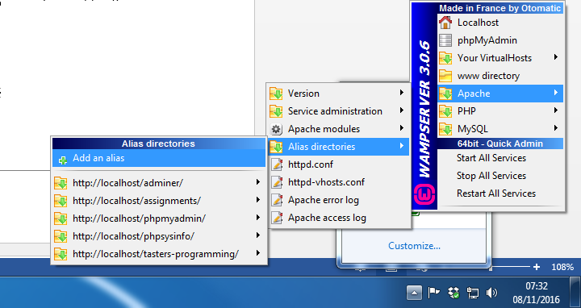
- You should get a command prompt window.
- First you need to supply an alias name for the folder you want to point to.
  - This should be an easy to remember name (preferably no spaces), for example, rwdd.
  - Hit the enter key when done.
- Next, you will be prompted for the location of the folder you want to point to.
  - Type in the location using forward slashes and add a trailing slash at the end.
  - For example: j:/Modules/Responsive Web Design/
  - Press enter when done.
- As long as you have entered the folder location correctly, it should confirm that the alias has been created successfully. Press Enter to exit. You should have a screen similar to the following (showing my aliases to my assignment marking web folder). If you were unsuccessful, you will have to repeat the steps again.
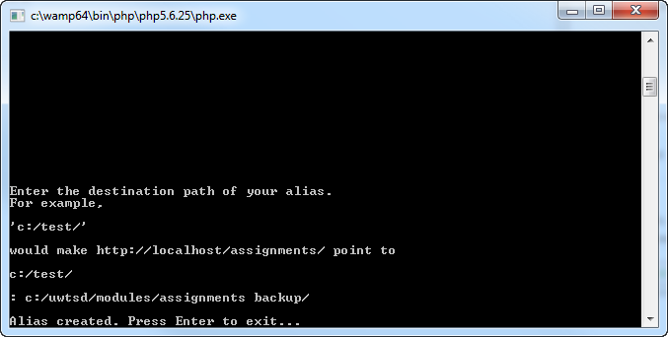
- Now go back to your wamp server homepage, you should now see the alias listed.
- Unfortunately, by default WAMP sets up the new aliases (virtual hosts) with local access only.
- Go to the following location on your computer:
C:\wamp64\alias
- Look for a file with the name of the new alias you just created and open it with Notepad++. Make the changes as highlighted below.
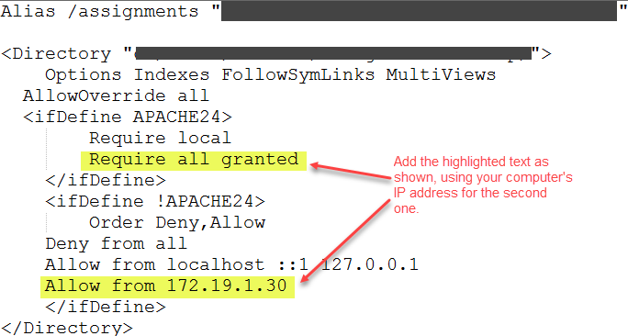
- Save the changes.
- You will need to restart your WAMP server for the changes to take effect. From the little WAMP “W” icon in the task bar, click on Restart All Services and give it a minute or two.
- Now, try browsing from another computer or a personal device.
- If it doesn’t work, contact me.

