Machine Workshop Tom Schultze 1802180
19th November 2019
2nd Machining Session with Dave Cooper
Machine Workshop
Milling session

Health and Safety
-ALWAYS before entering workshop wear appropriate safety equipment.
Equipment worn this session:
-Eye protection: safety goggles
-Protective clothing: dust coat provided by uni and steel toe caps

- Remove burs from workpiece (WP)
- Square up WP on level surface
- Start measuring WP
- Measured and marked WP after technical drawing (Fig. 1)

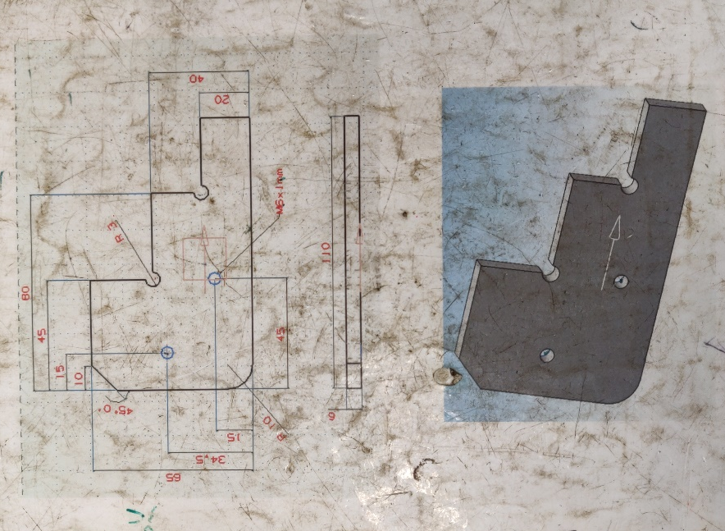

Figure 1: Technical drawing of WP

Dave explains M6= 6mm outer diameter and thread pitch usually 1mm
6-1=5
Use 5mm tap drill

- Use centre punch
- Centre drill to WP
- Drill relief hole with pillar drill
- Repeat for every hole
Die= to thread bolts
Tap= to thread hole
- To tap get tap wrench perpendicular to workpiece
- Use lubricant as to not destroy threads
- 360 turn, 180 turn back as to remove shavings and to preserve thread
- Use all the thread of tap wrench
- Use hacksaw for roughing process (Fig. 2)
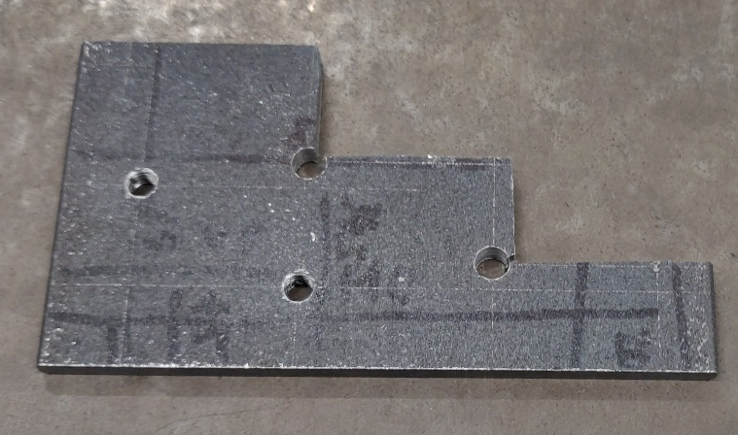

Figure 2: Roughed out WP

- For milling process
- Zero y and z
- Take off 0.5mm at once
- Set the shoulder
- Zero z and x
- And mill the required material amount

End of session

