

Business skills for International Hotel Industry
(M4X01915_LON)
Lecturer: Dale Clark
Assignment Part 2

Contents

Introduction………………………………………………………………..page n:3
Legal legislative risk…………………………………………………………... page n:4
Liability …………………………………………….. page n:5 and n:6
Data protection………………………………………………………………. page n:7
Health and safety…………………………………………………………………page n:8
Food hygiene…………………………………………………………..
Risk management……………………………………………………….
Licensing……………………………………………………………………
Hotel proprietors act 1956………………………………………………………….

Introduction

In this assignment I’m going to prepare a report on what I’ve learned from the module and analyse the legal legislative risk that managers and employees need to consider in the hotel industry. Areas to consider are; liability, data protection, health and safety, food hygiene, risk management, licensing, including key provisions within Hotel Proprietors Act 1956.
The hotel industry is governed by several law and regulations. Institutions in the industry must adapt and comply to these laws which is different in every country.
In exploring risk management and drawing up a quick history relating to this subject, I realize that there are three distinct periods preceded the years 2000:
- At the end of the 1980s, the Risk Management was mostly a simple claims management, possibly with consistent monitoring of policies and insurance premiums.
- In the early 1990s, needs are widening: Risk Managers are beginning to carry out a much more comprehensive management of insurance (policies, premiums, claims). At the same time, prevention measures and survival plans are being implemented to counter the Business Continuity Plan crises.
- At the end of the 1990s, new challenges come to supplement the activity of the Risk Managers: it is the emergence of the risk management proper, including the development of the concept of "risk mapping". It is now necessary to identify the risks (residual, target or raw), to evaluate them, to define control measures and to simulate different scenarios of incidents to be analysed.
The legislative risk has some areas whom I’ll analyse in this report.

Legal legislative risk

The purpose of evaluating this risk is to try to protect at maximum both guests and employees. It includes, labour laws, privacy and data protection etc…
It’s important for managers to know those laws, so they can provide adequate services to our guests in accordance with them.
Regarding the employees, there are permanent, temporary and underage workers, all of whom are subject of different legislation in order to ensure their rights and fairness accordingly.
In the hospitality industry, managers need to be aware of many things such as the hygienic conditions, security, confidentiality and privacy. Also, they must know the legal duties and avoid placing clients at risk. Hence the importance of knowing and awareness of all laws in order to prevent exposure to risk of lawsuits or even worst closure of business.

Liability

“Hotels can be held liable when hotel guests who are on their property are injured, or have their personal property stolen. There is a common law “innkeeper’s duty” which states that “innkeepers” are responsible for injuries to and theft from their guests”
The most common claim from hotel guests is for negligence and very rare for intentional action.
As hotels adopt more and more services it’s very important to well and regularly train employees, that’s the best way prevent problems.
Secure every facility is also important, for example hiring security staff for extern areas (parking). Know when to stop serving alcohol.

Data protection

According to a recent Salesforce report, consumers have limited confidence in how companies use their data. According to this report, 59% of consumers believe that their personal information is vulnerable to a security breach, while 54% believe that companies do not care about the interests of consumers.
Our industry needs to improve the confidence of customers by trying to be more transparent and allow them to control how their data is collected. This is in direct benefit for the business because the client is more likely to stay faithful and to recommend our hotel.
While the issue of data security and privacy may not seem important in light of day-to-day hotel management constraints, the potential impact on a brand of a data or non-data breach -respect for privacy can be huge.

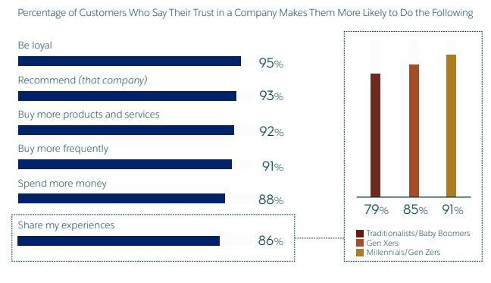

Health and safety

This chapter encompasses all sectors in the hotel like, restaurants, bar, clubs, parking, pools, lobby, tennis courts etc…
Every hotel must invest on safety upgrade and be up to date whit the laws.
Like every big brand of hotels is seeing a constant stream of guests arrive and depart, our goal is to ensure their stay is enjoyable and without accidents and injuries.
For that reason, it’s good to try identify the hazards previously
- Try to identify all the possible hazards.
- Decide which members of staff may be harmed.
- Evaluate the risk and calculate what precautions you need to take.
- Write down your findings and implement a plan of action.
- Make regular reviews of your findings
In my opinion is better if we hire a health & safety expert to carry out the assessment.

Food Hygiene

There is a very easy way to control the food hygiene and it’s called Hazard Analyses Critical Control Points (HACCP) this is a method of food safety control developed in the United States by a NASA-based laboratory with the assistance of Pillsbury since 1959, the objective of which is prevention, elimination or reduction at a level of acceptable for any biological, physical, chemical and allergenic hazard.
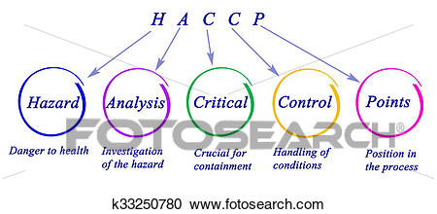

According to Schmidt (1995), the World Health Organisation (WHO) defined the food and water borne illness as regardless of the presenting symptoms and includes any disease of an infectious or toxic nature caused by or thought to be cause by the consumption of food or water. Therefore, food and water borne disease is caused by various microbiological, chemical and physical hazard includes illness which may be present in food or water.

Risk management

There are so many risks for managers, I want to mention what happen in Nashville Marriott in 2008. The ESPN host and celebrity Erin Andrews (sport journalist) was a guest in the hotel in question, where Michael David Barret (3rd person) was able to manipulate the peepholes and has succeeded to film Erin while she was nude. She decided to sew the hotel and the stalker for 75 million dollars. The case went on trial in February 2016, Barret claimed that the hotel desk clerk just gave him Andrew’s room number without asking any further questions. The results were that the Nashville Marriot owed 27 million in the judgement. It’s an example of many risks faced in hospitality industry and show is the need of a good risk management strategy.

Licensing

This industry is regulated by many states and local authorities requiring detailed and different licensing for the hotel, bar and restaurants to pursue commercial activities.
The most important role and responsibility of the management of the licensed premises is to ensure health and safety of the employees and the consumers (Rowe et al., 2010).

Hotel proprietors act 1956
Under the Hotel Proprietors Act 1956, a “hotel” means an establishment held out by the proprietor as offering food, drink and, if so required, sleeping accommodation, without special contract, to any traveller presenting himself who appears able and willing to pay a reasonable sum for the services and facilities provided and who is in a fit state to be received. A hotel within this definition is deemed to be an "inn".

