Research Methodology
A knowledge and comprehension gap was observed in the literature review about whether social media impacts a person's impression of the police. The technique used in this study and the rationales that drive these research decisions will be discussed in this chapter.
Gratton and Jones (2010) eloquently define research as being "a systematic process of discovery and advancement of human knowledge," which is echoed by Djellal et al. (2003) As they state research is the basis for increasing the store of knowledge, encompassing human, cultural, and societal understanding, as well as the use of this stock of information to develop new ideas.

Research is complex, as Schwartz (2008) explains that at a university level, he found that pupils could not comprehend how difficult research may be. Moreover, it is challenging to conduct adequate research to enhance and support their work. Understanding the difficulty behind conducting effective research is to understand what data collection is, "Kabir (2016) Defines data collection as the systematic collecting and measurement of data regarding variables in a study in order to answer a research question, test hypotheses and define conclusions. There are numerous methods of collecting data, such as questionnaires, interviews, observations, and social media monitoring. To name a few, these methods are widely used, and I will discuss them further throughout the methodology.
Arthur and Hancock (2009) created the idealized research process to guide researchers through conducting their studies (figure 1). this was created as four main steps with numerous subheadings, equally as necessary as the last. The formula they created allows researchers to be structured and methodical in their approach of undertaking the understanding of the research questions, data collection methods and forming conclusions, to name a few. This is a theoretical guide on how to best conduct research.

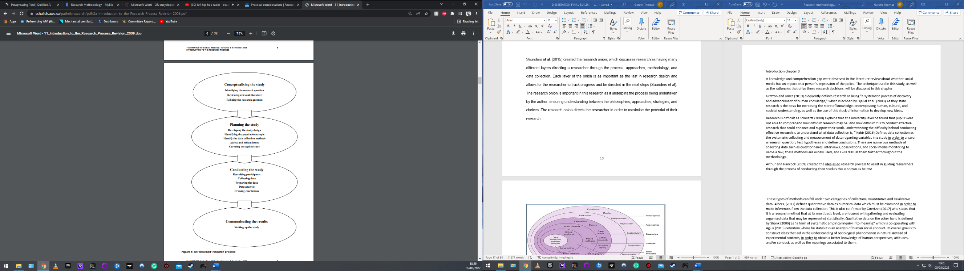
Figure 1: An 'idealized' research process

A further concept of research was created by Saunders, Lewis and Thornhill (2019) where they created what is known as the research onion (figure 2). At its most basic level, Saunders' research onion illustrates the various considerations that ought to undertake while designing a research technique. As researchers work inwards from the exterior of the onion, researchers will come across a variety of options, ranging from notorious and philosophical to strategic and practical.
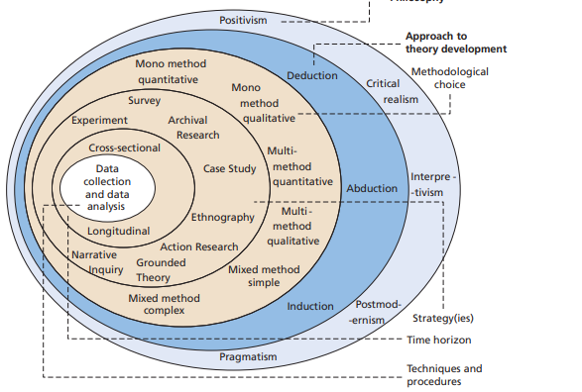
Figure 2: The 'research onion'

The primary purpose of this research is to answer the question of whether social media platforms have an impact or influence on the public's perception of the police. There is mindfulness towards utilizing these research methods to produce the fairest and most consistent result to answer the question. There is consideration towards the method of collection of the data.

Data collection methods can fall under two categories of collection, Quantitative and Qualitative data. Albers (2017) defines quantitative data as numerical data which must be examined to make inferences from the data collection. This is also confirmed by Goertzen (2017), who states that it is a research method that, at its most basic level, are focused on gathering and evaluating organized data that may be represented statistically. Qualitative data, on the other hand, is defined by Shank (2006) as "a form of systematic empirical inquiry into meaning", which is co-operating with Agius's (2013) definition where he states it is an analysis of human social conduct. Its overall goal is to construct ideas that aid in the understanding of sociological phenomena in nature instead of experimental contexts, to obtain a better knowledge of human perspectives, attitudes, and conduct, as well as the meanings associated with them.

Understanding the data collection methods, quantitative data would be more prevalent in answering the research question posed as this is provides a less biased and more scientific answer as a significant quantity of data is gathered and objectively examined. This almost eliminates bias, and if other academics analyzed the data, its results would always be the same.
The research strategy will be to create a survey that underlines pertinent questions to provide to any age demographic; this is chosen to produce results bracketed between ages, allowing more specific results. Jones et al. (2013) concluded that survey research is a unique technique to collect quantitative data from many people. Surveys provide several advantages, including high sample size and hence increased statistical significance, the capacity to collect vast volumes of data providing direct results. Ponto (2015), however, raises the concerns for surveys as she states survey research, like any study, has the potential for a range of causes of error. Practitioners can better identify how and whether the results from a survey research study relate to practice if they are mindful of the potential causes of inaccuracy and measures to enhance survey research. This returns to the earlier research models discussed enforcing a correct methodology when beginning the research to reduce such errors.

The survey will consist of closed questions, allowing the data collected to be concise, direct, and minimal. Hyman and Sierra (2016) explain that closed questions have the advantage of allowing participants not to struggle when undertaking the survey stating it would be more engaging and yields quick results. Consideration needs to be taken when designing the survey. Khandelwal (2021) found numerous issues as to why participants do not answer but mainly that the surveys were too long, and the designer was asking too much from its participants. Therefore, consideration has been made to keep the survey to approximately fourteen questions with few responses to each question. The questions will include asking participants if they use social media, their thoughts on the use of social media, information surrounding views on policing on social media. The survey will be constructed on the website surveymonkey.co.uk and posted on social media spaces giving the best possible chances of gaining results pertinent to the research question. It will also be shared amongst the users to allow social media users to share the survey with their peers to obtain an enormous scope of participation. The survey will run for approximately thirty-one days, and answers only within the thirty-one-day period will be collected. Rice et al. (2017) found that online populations provide a unique viewpoint and exposure to a different demographic, each with its own set of constraints and limits. It is vital to understand the benefits and drawbacks of employing different populations for research, just like it is necessary to understand the benefits and drawbacks of any study. Certain studies would not be viable or suitable to conduct with online audiences; however, it is incredibly pertinent to focus on social media users for this study.

Once results are collected, they will be displayed as raw data in graphs, which will allow for direct and easy feedback to display. The data collected will allow the author to draw inferences and make clear conclusions. Kelly (2020) defines this as data analysis and explains it as the process of cleansing, transforming, and analyzing raw data to obtain usable, relevant information that may help the researcher make better conclusions.

However, there are some possible limitations concerning the specific study; as stated previously, there was thought into numerous ways of collecting data such as interviews, social media monitoring, and observation. Due to the time constraints of this study, it is thought to be impracticable to conduct these data collection methods and, in some considerations, unethical to do so. As explained by Sociology Group (2019), interviews can be highly time-consuming and not cost-effective and provide information that could be obtained by the questionnaire in a fraction of the time even though Michigan.gov (2012) produce the argument that it would be easier to clarify answers and provide flexibility.

Thought has been given to potential problems underlying the questionnaire. The participants will need to want to engage, and there may not be any participant engagement yielding improper results. Kennedy and Vargus (2001) concluded that surveys are robust and found that people's cultural and emotional biases influence non-participation, which will need to be taken into consideration by the researcher concerning the sampling pool and accessibility to the survey.

To summarise, the research conducted has been done methodically and structured following guidance from predecessors. The data collection will be using quantitative data collected via an open public forum survey. The demographic of people who can access this is not determined. However, age groups will be defined in the survey. This allows an enormous scope of people to answer and provide accurate findings, which will allow the researcher to draw inferences from the results. After consideration, this method is deemed the most feasible and ethical way of collecting raw quantitative data in the research under such time constraints.
1427

Bibliography
Agius, S.J. (2013). Qualitative research: its value and applicability. The Psychiatrist, [online] 37(6), pp.204–206. Available at: https://www.cambridge.org/core/journals/the-psychiatrist/article/qualitative-research-its-value-and-applicability/51B8A4C008278BA4BA8F518060ED643C.
Albers, M.J. (2017). Quantitative Data Analysis—In the Graduate Curriculum. Journal of Technical Writing and Communication, 47(2), pp.215–233.
Arthur, A. and Hancock, B. (2009). Introduction to the Research Process. [online] Available at: https://www.schulich.uwo.ca/pathol/research/pdf/2a_Introduction_to_the_Research_Process_Revision_2009.pdf.
Djellal, F., Francoz, D., Gallouj, C., Gallouj, F. and Jacquin, Y. (2003). Revising the definition of research and development in the light of the specificities of services. Science and Public Policy, [online] 30(6), pp.415–429. Available at: https://halshs.archives-ouvertes.fr/halshs-01133147/document.
Goertzen, M.J. (2017). Chapter 3. Introduction to Quantitative Research and Data. Library Technology Reports, [online] 53(4), pp.12–18. Available at: https://www.journals.ala.org/index.php/ltr/article/view/6325/8275.
Gratton, C. and Jones, I. (2010). Research methods for sports studies. London ; New York Routledge.
Hyman, M. and Sierra, J. (2016). (PDF) Open- versus close-ended survey questions. [online] ResearchGate. Available at: https://www.researchgate.net/publication/282249876_Open-_versus_close-ended_survey_questions.
Jones, T., Baxter, M. and Khanduja, V. (2013). A Quick Guide to Survey Research. The Annals of The Royal College of Surgeons of England, 95(1), pp.5–7.
Kabir, S.M. (2016). METHODS OF DATA COLLECTION. [online] ResearchGate. Available at: https://www.researchgate.net/publication/325846997_METHODS_OF_DATA_COLLECTION#:~:text=Data%20collection%20is%20the%20process.
Kelly, K. (2020). What is Data Analysis? Types, Methods and Techniques [2022 Edition] | Simplilearn. [online] Simplilearn.com. Available at: https://www.simplilearn.com/data-analysis-methods-process-types-article#:~:text=Data%20analysis%20is%20the%20process
Kennedy, J.M. and Vargus, B. (2001). Challenges in Survey Research and Their Implications for Philanthropic Studies Research. Nonprofit and Voluntary Sector Quarterly, 30(3), pp.483–494.
Khandelwal, M. (2021). 7 Reasons why you don’t get enough survey responses. [online] www.surveysensum.com. Available at: https://www.surveysensum.com/blog/reasons-why-you-dont-get-enough-survey-responses/.
michigan.gov (2012). The Pros and Cons of Data Collection Methods. [online] Available at: https://www.michigan.gov/documents/mentormichigan/Data_Collection_Methods--pros_and_cons_2_403346_7.pdf.
Ponto, J. (2015). Understanding and Evaluating Survey Research. Journal of the advanced practitioner in oncology, [online] 6(2), pp.168–71. Available at: https://www.ncbi.nlm.nih.gov/pmc/articles/PMC4601897/.
Rice, S., Winter, S.R., Doherty, S. and Milner, M. (2017). Advantages and Disadvantages of Using Internet-Based Survey Methods in Aviation-Related Research. Journal of Aviation Technology and Engineering, [online] 7(1). Available at: https://docs.lib.purdue.edu/cgi/viewcontent.cgi?article=1160&context=jate.
Saunders, M., Lewis, P. and Thornhill, A. (2019). Research Methods for Business Students. 8th ed. New York: Pearson.
Schwartz, M.A. (2008). The importance of stupidity in scientific research. Journal of Cell Science, 121(11), pp.1771–1771.
Shank, G.D. (2006). Qualitative research : a personal skills approach. Upper Saddle River, N.J.: Pearson Merrill Prentice Hall.
Sociology Group (2019). Advantages and Disadvantages of Interview in Research. [online] Sociology Group. Available at: https://www.sociologygroup.com/advantages-disadvantages-interview-research/.
Westerman, M.A. (2006). What counts as “good” quantitative research and what can we say about when to use quantitative and/or qualitative methods?. New Ideas in Psychology, 24(3), pp.263–274.

