

MODULE CODE: Digital Skills for Personal Development and Business Growth BMSW4008

ASSESSMENT COMPONENT: PORTFOLIO

STUDENT NAME: Katie Pentland

STUDENT NUMBER: 2504786

LECTURER: Phillipa

DATE: 20/10/25
I confirm that I have not presented any AI generated materials as my own work.
I confirm that I have copies of my drafts, notes, and other resources I used, which I may be asked to provide in evidence.

Contents
Task 1 3
Assessment of Digital Skills 3
References 4
Task 2 4
LinkedIn Learning Certificates for Office365 4
Task 3 5
Essay on Relevance of Excel in professional and personal life. 5
References 5
Task 4 6
7 Minute Reflective Presentation 6
References 6

Task 1

Assessment of Digital Skills
700 words on your assessment of digital skills plus recommendations and badges you have completed because of this report
(5 references)

Digital skills involve the use of digital devices, including computers, mobile phones, tablets, smartwatches, and laptops. Through these devices, I can process, store and access information; manage emails and files, create and use spreadsheets and communicate through online chats and video calls. These abilities reflect the importance of digital literacy in today's world. (Hecker and Briggs 2021) In an era where digital technology permeates every aspect of life, acquiring and developing digital skills have become crucial, especially for college students preparing to enter a highly digitalized workforce.
I have explored various tools and platforms within the digital world to support my learning and development. I have become familiar with Moodle. Moodle is a popular, flexible Virtual Learning Environment that is designed to support face-to-face teaching with a wide range of versatile online tools, as well as providing a place to upload resources for courses. (University of Cambridge, 2025)

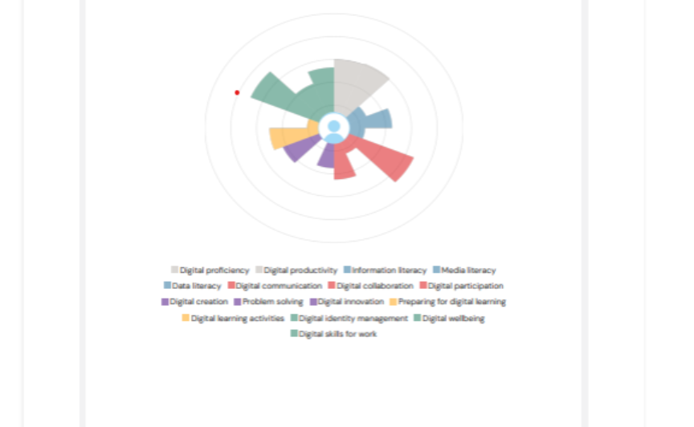
I have also completed Jisc, which is a digital tool that helps me access my own digital capabilities. Using this tool has helped me identify areas where I feel confident in and areas that I need to improve on. I found it very useful as it has made me more aware of the steps, I need to take to further my development.

Jisc discovery tool diagram (2025)
I have developed a much stronger understanding of how to use Microsoft Outlook effectively to support my studies. I have learned how to write a professional email by beginning with a clear purpose, a structure to the main body, and ending with a professional sign-off. I have also gained confidence in creating and sending meeting invitations, responding to emails appropriately, and the use of a calendar function has been beneficial; it allows me to set reminders, schedule deadlines, and manage my time more effectively.
In Addition, I have gained a deeper understanding of the features and benefits Office 365 offers. I am aware that it’s a productivity tool, where I can access various programmes such as Microsoft Word to create documents, and Microsoft Teams for keeping in contact with people. Microsoft Excel for spreadsheets, Microsoft Outlook for email and Microsoft PowerPoint for presentations. There are other programmes such as Microsoft Publisher, Microsoft Access and OneDrive for storage. These applications contribute to improving my productivity, teamwork and digital literacy skills.
Furthermore, I have explored different types of artificial intelligence tools.
AI system development, five core components—learning, reasoning, problem-solving, perception, and linguistic intelligence—work together to form the foundation of artificial intelligence. These elements collectively contribute to the diverse and multifaceted capabilities exhibited by AI, enabling it to adapt, learn, and make informed decisions in various contexts. (Khan,2024)
I have gained an understanding of how ChatGPT works, which is a program trained on a vast amount of text from the internet. It allows users to interact through text prompts, voice and images. It can assist in drafting essays and emails, translating languages, and even creating images. It can produce incorrect information as it is populated from the internet, which can sometimes be from unreliable sources. Stated from Khan

Notebook LM is an AI writing tool which can help users upload documents and convert them into a podcast. Which I find particularly useful, as all students have different learning styles. This means I can obtain and process information more effectively.
Adobe Firefly is another AI tool I have used. which allows users to create images for text prompts, text to sound effects, image to video, enhance speech and generative fill applications. I believe this could be useful to create visual communication, for example, to assist during presentations and build creative skills.
Overall, I have developed strong digital skills, which have improved my ability to work effectively. I have become more confident using a range of tools such as Adobe Firefly and Moodle, which have supported my academic progress and in professional environments where digital literacy is essential.
References
(Hecker and briggs,2021)
Enhancing Digital Literacy in Higher Education: A Comprehensive Analysis of Digital Skill Development Among College Students - ProQuest
JISC. (n.d.). Discovery tool. [online]
Discovery tool | Building digital capability (Accessed 30th October 2025)
University of Cambridge (2025) moodle
Moodle | Student Systems (Accessed 30th October 2025)
Khan, Arshad. Artificial Intelligence: a Guide for Everyone, Springer, 2024. ProQuest Ebook Central, http://ebookcentral.proquest.com/lib/trinity/detail.action?docID=31572159.
Created from trinity on 2025-10-30 22:14:46.

Task 3

Essay on Relevance of Excel in professional and personal life.
Write a 1000 word essay on Relevance of Excel in professional and personal life.
8 references
Use the following information create an Excel spread sheet, looking at income and expenditure of a typical family of 4 over the course of a year. Use formulars to achieve answers and add headings and highlight the different aspects of the finances, be realistic with the monetary amounts used for each area.
Income | Amount per month £££ | Expenditure | Amount per month £££
Wage 1 |  | Rent/Mortgage
Wage 2 |  | Council tax
Trust Funds |  | Electric
Stocks/Share payouts |  | Gas
Universal credit |  | Water rates
Student Finance |  | Food
Other |  | Car insurance
 |  | Car Tax
 |  | Fuel
 |  | Child Care Costs
 |  | Loans/credit cards
 |  | Other eg Birthdays/savings/holidays

Embed your excel here

References

Task 4

7 Minute Reflective Presentation
Create a PowerPoint presentation using techniques learned in class, reflecting on the module and what you have learned.
Maximum of 15 slides Minimum 7
You will reference your work where appropriate.
Embed PowerPoint here

References

