Individual Development
Assignment by Rachel Williams
Student Number: 2006206
Word Count: 3,197 (including references)

Access to published blogs:
https://20062066.wixsite.com/my-site

Blog 1

The importance of early attachment to healthy socioemotional development.

Social and emotional development is widely seen as one of the key aspects to the overall healthy development of the child. Underpinning this early development theory is the importance of emotional stability and warm relationships from the time of birth (Lindon, 2004, p.85).
Bowlby’s views on the theory of attachment place emphasis on the pressing emotional needs of very young children and express secure attachment as a central idea that the bond of affection between the child and the primary caregiver is a crucial building block for healthy development (Lindon, 2004, p.87).


(PsychAlive, 2012)

The experiences of early childhood are important as they shape how children make sense of and react to their social world and there are vast amounts of research which suggest that separation issues and a lack of meaningful relationships from such a young age can result in serious cognitive and emotional delays in children (Rutter et al. 1998. Cited in Lindon, 2004, P. 89).

As shown on the graph below, as of 31st March 2020, 7,172 children in Wales were being looked after by local authorities (Statistics & Research, 2020). Many of these children were born into unfortunate circumstances where there is an increased risk of being exposed to trauma and neglect due to a breakdown in family structures.

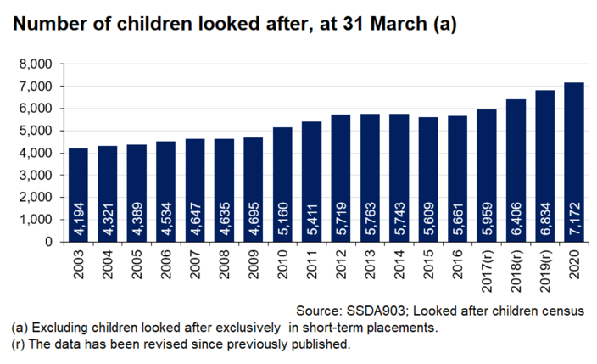


This was unfortunately the case for Leo, adopted son of Darran and Tim who have been sharing his journey through their Instagram platform. Leo was born with bilateral moderate hearing loss, which Darran explained made the crucial, first year of his life that much more difficult. Leo suffered neglect as an infant and as a result spent the first year of infancy without the appropriate care for his hearing impairment, meaning that Leo was almost ‘completely deaf as he either wasn’t wearing his aids or they were ill fitting’ (Lincoln-Shaw, 2021); a scenario that could have been avoided had he had the appropriate care.

One study, undertaken by Rutter et al (1998. Cited in Lindon, 2004, p.87), found that orphaned children who were not adopted until between 12-18 months of age experienced serious emotional and psychological deprivation, which led to developmental consequences that are difficult to alleviate when children are adopted into a loving family.

This was evident in Leo’s case. Speaking to Darran, he explained that Leo’s suffering in his infancy had physical consequences that have caused ongoing issues. For a period of 14 months, Leo was regularly withholding stool for lengthy periods of time (Lincoln-Shaw, 2020). Episodes like this are an especially common problem amongst children with neurodevelopmental issues and can result in irritability and behavioural change (Cohn, A. 2009); both of which are associated with maladaptation and the development of insecure bonds of attachment in infancy. Leo’s dads have an understanding that he was withholding stool regardless of the pain it caused him, in order to achieve a sense of control. During these episodes, Leo’s discomfort was clearly reflected in his behaviour. Tim recalls Leo ‘lashing out, biting and screaming until his lips would turn purple’ (Lincoln-Shaw, 2021).

The question that confronts us is this; are these behavioural changes and challenges a direct result of the development of early avoidant, resistant or disorganised attachment styles? Researchers Thompson, Simpson and Berlin carried out a meta-analysis of all existing quantitative research of early attachment theory. Their findings indicated that early attachment security was ‘strongly correlated with children’s social competence with peers and fewer aggressive behavioural problems’ (2021, P. 190). However, they also suggested that while secure attachment was directly associated with reducing externalising symptomatology in children, it’s association with internalising symptoms such as withdrawal, anxiety and depression is negligible, falling below the threshold for defining a weak effect (Thompson, Simpson and Berlin, 2021, P. 190).

This suggests that healthy socioemotional development in children is reliant upon more than just the theory of attachment. Interaction with peers and adults other than the primary caregiver is essential for child development as it ‘helps to increase their understanding of, and ability to participate in, the social world in which they live’ (Littleton and Miell, 2005).
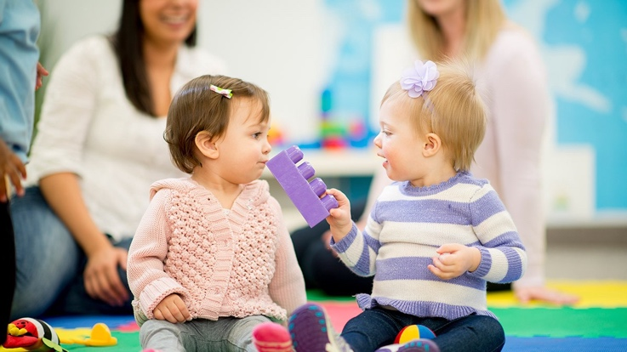

(Burke, 2017)

This notion of peer interaction is evident in the foundation phase curriculum in Wales today, where there is a significant emphasis placed on outdoor learning. Following case study visits to schools, Passy and Gilchrist (2017, P. 46, 47, 48.) reported that children’s levels of communication and self-management improved when they were participating in learning in the outdoor context, which in turn had a positive effect on their confidence and self-esteem. Practitioners from these case study visits recalled children becoming more engaging and inquisitive, concluding that over all the children demonstrated an improved ability to form new relationship patterns with staff and fellow pupils.

Although attachment theory has long been considered as a key component of healthy social and emotional development in children, new research emphasises that it is not solely responsible and in fact, the role of the practitioner and the environment is of equal importance.

Blog 2

Gender Stereotypes – Fighting the Stigma

“Just respect it, even if you think it’s a phase – how are we supposed to work out who we are, if you’re contradicting who we’re trying to be?” (Khan, 2017)

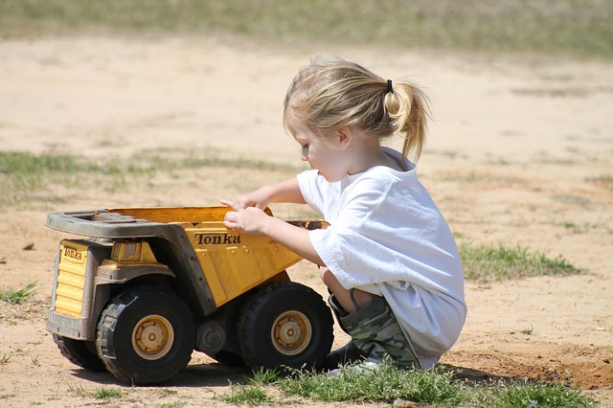

(Arritt, 2017)

Gender stereotypes are a biproduct of the historical reinforcement of sexual roles and expectations within society. Infants are exposed to sex stereotypes and labelling from birth. From the colours of the clothes they wear, to the toys they are given and even in the way in which adults treat them (Honig, 1983. Cited in Charlesworth 1995. P. 382); taking a gentle approach and offering more nurturance to girls whilst opposingly applauding a boy’s strength and size and offering them a positive response to playing with ‘male’ stereotyped toys like building blocks and trucks (Bussey & Bandura, 2004. Cited in Bee & Boyd, 2007. P. 295).

There have been large bodies of research which suggest gender development is a product of environmental influences, the reinforcement of society’s norms and values and is learned as a result of modelling and imitation. Bandura et al, (1963) in particular focused on the theory of imitation which they consider to be the quickest type of learning in humans and animals. Mischel (1966) further suggested that ‘children learn sex roles by being reinforced directly for doing sex-appropriate things and for imitating same sex role models.’

It is important to note at this juncture that sex and gender are associated but are not the same, nor are they interchangeable (Grammarly, 2020). Sex refers to a person’s biological make up, hormones and chromosomes whereas gender identity and expression is how a person chooses to present themselves to the outside world.

In recent years however, it is becoming more and more apparent that the lines between gender identity and gender stability (Kohlberg, 1966) are blurring and the battle to erase the stigma surrounding the issue of gender constancy and transgender individuals is ongoing. Critics object to transgenderism as it ‘confines children to traditional views about gender’ rather than releasing them from gender binary and reducing the pressure to conform to heteronormativity (Brunskell-Evans and Moore, 2018. P. 2).

Until recently, the underrepresentation of LGBTQ(IA+) individuals in our school settings was partly responsible for causing a delay in healthy cognitive and emotional development in children. Although primary schools in Wales are required under the Education Act 2002 to have a policy to deliver a sex and relationships education programme, findings by the Welsh Government in 2017 found that sex and relationships education in primary schools in Wales was rarely inclusive of children’s diverse needs, expressions and experiences, and too heteronormative overall (Sex and Relationships Education Expert Panel. P. 7). In addition to this they also discovered that approximately one third of schools in Wales were not providing any staff training in safeguarding young people specifically about issues relating to sexual health (School Health Research Network, 2015).

The lack of diversity and inclusion in the curriculum up until this point had contributed to issues of bullying, transphobia and a lack of awareness amongst peers; creating a hostile environment for children who identified with the LGBTQ(IA+) community. Children’s Commissioner for Wales reported that due to a lack of understanding, actions of insensitivity and threatening behaviour inflicted on gender fluid children were not always robustly challenged and that the correct support for pupils is not always in place (2020).

Although there has been a large societal shift and a rise of positive attitudes toward gender fluid individuals in recent years, there are still barriers to overcome. Going forward, under the new curriculum for Wales, children’s rights and gender equity will be a core underpinning principle for all areas of learning and experience (Sex and Relationships Education Expert Panel, 2017. P. 12). Informed by the protective articles embedded in the UNCRC, the classroom and school settings in Wales will become a safe place for children to express themselves and will provide opportunities for all children to build their knowledge and understanding of diversity, allowing them to form allies and support their peers.

It is evident that the early research of gender development, specifically Kohlberg’s theory of gender constancy (1966) whereby his thesis suggests that gender remains the same in spite of superficial changes and external appearances, is now outdated and is quickly evolving. Educating from foundation phase level by promoting inclusion and celebrating diversity is essential for the health and wellbeing of children and a key component to achieving gender equity and acceptance, and alleviating gender-based stigma within in society.

Blog 3

what is the most Stimulating tool for Language Development?

Unlike other species in the animal kingdom, approximately one year after birth, human infants begin to speak. They begin to communicate effectively and develop a capacity for spoken language. Whether or not they already possess this capacity for linguistic communication is something which is an ongoing debate amongst practitioners, theorists and psychologists alike.

There are many stimulants which are considered impactful to the development of comprehensive language and linguistic skills in children. Nativist and cognitive theorist Noam Chomsky suggests that language learning is something that happens when the child is placed in an appropriate environment (1987, P. 519) but that the fact that children learn language quickly and effortlessly, with little instruction indicates that human beings are physiologically and neurologically well adapted to the use of language.

The earliest theories of language development were based on the idea that children learn language through imitation (Bee and Boyd, 2007, P. 228). Imitation is commonly understood to play a key role in the development of language, as infants tend to pick up on the language that they are exposed to. Masur (1995) found that ‘toddlers who readily imitate adults when they are speaking a new word, are found to have the most rapid vocabulary growth in the first year or two of language explosion’ (Cited in Bee and Boyd, 2007, P. 228), indicating that imitation is a key component to language development.

This notion of imitation and the early perception of language which occurs in the pre linguistic phase of infancy is practiced by and communicated between adults and babies in a remarkably similar way across the globe. A linguistic technique referred to as ‘motherese’ and more scientifically known as infant- directed speech (Bee and Boyd, 2007, P. 229), is a technique used predominantly by primary caregivers but has also been known to be imitated and used by children as young as 4 years old (Dunn and Kendrick, 1981, P. 579).

Referred to as the Baby Talk Register, adults, and indeed children, of a vast variety of cultures tend to communicate with infants by modifying their own language. Adults firstly tend to use a higher pitched voice to draw the attention of the infant. Once the attention is drawn by a special tone, the simplicity and repetitiveness of the adult’s speech will help the child to pick out repeated grammatical forms, hence effectively aiding their language development (Bee and Boyd, 2007, P. 230).

Associated with oral language imitation is the Skinnerian approach of systematic reinforcement, a thesis advocated by operant conditioning and behavioural theorist B.F. Skinner (1957). Skinner believed that children best learned language through positive reinforcement, giving a reward for articulating correct grammatical formations. A behaviourist theory emphasises change that originates in the environment through learning (Charlesworth, 1996, P. 3). This is the idea that if children hear simplified language, imitate it and are rewarded for making sounds, they will learn to talk. A simple gesture of a smile or a happy facial expression is enough to positively reinforce language development, meaning that from Skinner’s point of view, the process of learning will advance a lot quicker (1957).


(Howland, 2019)

However apparent the use of imitation and reinforcement are in our parenting methods; it is important to acknowledge the role of social learning and the environment. The foundation phase in Wales, first introduced in 2010, encompasses the developmental needs of children and uses the business of ‘play’ as the vehicle for holistic, experimental learning (Welsh Government, 2015). Foundation phase classrooms are set out to enrich experiences of language development. Social learning theorist Vygotsky emphasised the importance of role play to language development and discussed the benefits of using a technique called scaffolding to build on what language the children already have. He famously said, ‘what a child can do with assistance today, she will be able to do by herself tomorrow’ (Vygotsky, 1978, p. 87. Cited in Bettany, Smallshaw and Barney, 2021, p. 63). This has seen activities of continuous provision such as ‘Ty Bach Twt’ become a staple for the majority of nursery and infant school settings.

Discovery learning is encouraged in the foundation phase and, although it is common for infants to develop their own ways of speaking, the acts of reinforcement and scaffolding are recommended tools to advance the child’s skills and knowledge. However, oral literacy pedagogy and language development comes with its challenges for practitioners. In order to implement effective techniques for teaching oracy in the medium of both English and Welsh, teachers will require explicit initial training and continuous professional development strategies will need to be implemented ongoing. Regular assessment will be required in order to establish which techniques are most effective (Donaldson, 2015).

Narrowing down which is the most effective tool for language development may be difficult, but the large bodies of research suggest that when each component is aligned and implemented correctly, the possibilities of successful language development for schools and children are endless. Choosing the correct tools is dependent upon the response of the child but acknowledging the role of the environment and social learning should be at the forefront of modern pedagogy.

Blog 4

The rise of technology and its effects on physical and cognitive development

The last two decades have seen a dramatic shift in the way of technology and the digital era. Percolating through into many elements of modern life, the lives of children whom educators work with will be ever more deeply infused with the richness and challenges that this era brings (Bettany, Smallshaw and Barney, 2021, p. 72).

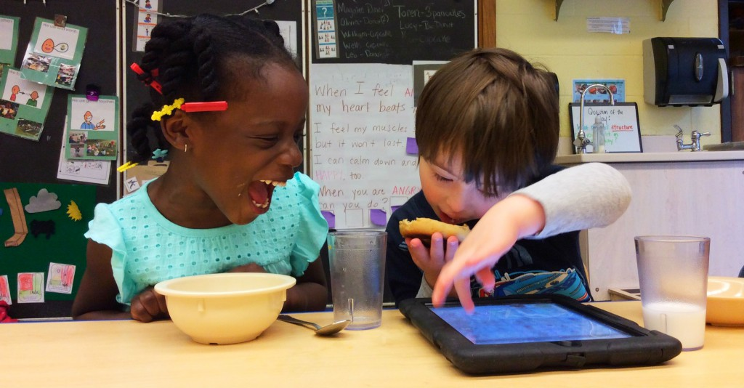

(Ledford, 2016)

Learning in the digital era has presented new demands, with children needing to adapt the required skills and knowledge to thrive in a technology rich society. While technology presents itself as an asset to aid the cognitive development of children, it is important to consider whether this comes at a cost to physical literacy. With children becoming reliant on technology for the majority of their play, they are suffering limiting challenges to their creativity and imagination, as well as limiting necessary challenges to their bodies to achieve optimal sensory and motor development (Rowan, 2017).

Although the majority of early research is focussed on the concept of cognitive development, it is paramount to understand the importance that physical development has as an underpinning component of child development overall. It is through the enjoyable practice of crawling, grasping and handling objects that vital neural connections in young brains are built. Continued experience in these areas of development is essential to enable infants to form the complex neural pathways on which they will build continuous learning (Lindon, 2009, p. 120).

One approach to understanding the relationship between physical and cognitive development is the brain-based learning approach. This approach emphasises the importance physical movement has to promoting learning. The opportunity to move is linked with mental alertness and emotional well-being; and prior to the introduction of the foundation phase framework in Wales (2010), active ‘brain breaks’ were used as an effective way for practitioners to aid concentration in young children (Lindon, 2009, p. 128).

Speaking on Dr Chatterjee’s podcast ‘Feel Better, Live More’, neuroscientist Shane O’Mara (2019) explains how the brain functions like a muscle, meaning that facilitating regular physical movement will dynamically increase optimal brain function. The part of the brain responsible for learning and memory, namely the Hippocampal formation, is scientifically proven to increase in volume as a result of regular activity, correlating directly to the improvement of the memory and learning functions it supports (O’Mara, 2019).

The reliance on technology for play in the early years has resulted in children becoming more sedentary than they are evolved to be. Sedentary bodies being bombarded with chaotic sensory stimulation is viewed by critics as resulting in serious delays of attaining child developmental milestones (Rowan, 2017). Critics argue that being conditioned to the high-speed nature of technology from a very young age, means that children are entering schools lacking the ability to retain attention and self-regulate; in many cases leading to significant behaviour management problems for teachers in the classroom (Rowan, 2017).

However, when used correctly, digital technology can provide invaluable support for improving classroom interaction and learning and can complement non-technology activities in developing manual dexterity (Bettany, Smallshaw and Barney, 2021, p. 64). Digital devices often have buttons and switches and different physical input methods such as a mouse, keyboard, controller or touch screen which diversifies opportunities for children to explore their natural kinaesthetic urgences and the world around them (Bettany, Smallshaw and Barney, 2021, p. 65).

Educational research carried out by Mercer, Hennessy and Warwick (2019) found that the use of technology in the classroom improved levels of collaboration, reasoning and academic attainment but that it’s important to understand that it is the pedagogy that is paramount to developing cognitive abilities in children and that digital technology is simply an additional, beneficial tool when used with the correct intentions.

In addition to this, an Estyn effective practice report published in 2016 also found that digital technology devices have become essential tools used to engage and inspire pupils to be creative and independent learners (Estyn, 2016). Since the introduction of the Digital Competence Framework (2008) in Wales, the concept of digital citizenship has been a key aspect to primary education with emphasis placed on developing the cognitive skills to connect, collaborate and communicate with the wider community in a responsible, safe way.

It is clear that in this twenty-first century age, the digital revolution is shaping many aspects of children’s lives and it is paramount that they are given the opportunities to fully immerse themselves in it. Allowing digital technology to enhance the learning environment will enrich their experiences and provide an invaluable advantage to increasing their capacity for overall individual development.

Reference List

- Arrit, A. (2017) “Tomboy” needs to go [Blog] Available at: https://uiwomenscenter.wordpress.com/2017/10/30/tomboy-needs-to-go/ (Accessed: 28 March 2021).
- Bee, H. and Boyd, D. (2007) The developing child. 11th Ed. Boston: Pearson Education.
- Bettany, J. and Smallshaw, R. and Barney, D. (2021) ‘Child Development’, in Maisey, D. and Campbell-Barr, V. (ed.) Why do teachers need to know about child development? London: Bloomsbury Academic.

- Brunskell-Evans, H. and Moore, M. (2018) Transgender children and young people. Born in your own body. Available at: https://www.google.co.uk/books/edition/Transgender_Children_and_Young_People/OPlVDwAAQBAJ?hl=en&gbpv=0 (Accessed: 25 March 2021).
- Burke, G. (2017) A brief overview of the developing brain: how you can help your kids thrive as they grow [Blog] Available at: https://medium.com/@galynburke/child-development-post-3-of-3-when-your-kids-become-capable-of-certain-tasks-and-why-1c4e28be26c6 (Accessed: 28 March 2021).
- Charlesworth, R. (1995) Understanding child development. 4th Ed. London: Delmar Publishers.
- Children’s Commissioner for Wales. (2020) Take pride: Rights for LGBT* young people in Wales. Available at: https://www.childcomwales.org.uk/our-work/sallys-blog/take-pride/ (Accessed: 24 March 2020).
- Cohn, A. (2020) ‘Stool Withholding’ Journal of paediatric neurology, 1(1), pp. 29-30. (Accessed: 20 March 2021) DOI: 10.3233/JPN-2010-0350.
- Curriculum for Wales (2015) The foundation phase framework. Available at: https://gov.wales/sites/default/files/publications/2018-02/foundation-phase-framework-revised-2015.pdf (Accessed: 26 March 2021).
- Donaldson, G. (2015) Successful Futures. Available at: https://gov.wales/sites/default/files/publications/2018-03/successful-futures.pdf (Accessed: 26 March 2021).
- Dunn, J. and Kendrick, C. (1981) The speech of two- and three-year-olds: baby talk and the context of communication. Available at: file:///Users/rachelwilliams/Downloads/the-speech-of-two-and-three-year-olds-to-infant-siblings-baby-talk-and-the-context-of-communication.pdf (Accessed: 26 March 2021)
- Estyn. (2016) Digital technology in primary school life. Available at: https://www.estyn.gov.wales/effective-practice/digital-technology-primary-school-life (Accessed: 28 March 2020)
- Grammarly. (2020) ‘33 LGBTQ(IA+) Terms You Should Know in 2020’, Grammarlyblog. [blog]. 8th June. Available at: https://www.grammarly.com/blog/lgbt-terms/?&utm_source=google&utm_medium=cpc&utm_campaign=10827645800&utm_targetid=dsa-1233402314764&gclid=CjwKCAjwxuuCBhATEiwAIIIz0ULNm65uEJ06roJCY5aLZRaKQ9wCyN0fJ-Ez0P2ABpUU3Oe9mfQiXhoCws4QAvD_BwE&gclsrc=aw.ds (Accessed: 25 March 2020).
- Howland, G. (2019) When do babies clap? Plus, how to encourage this milestone. [blog]. Available at: https://www.mamanatural.com/when-do-babies-clap/ (Accessed: 28 March 2021).
- Ledford, J. (2016) Peer interactions. [blog]. Available at: https://ebip.vkcsites.org/peer-interactions/ (Accessed: 28 March 2021).
- Lincoln Shaw, D. (2021) Instagram. Williams, 12 March.
- Lincoln Shaw, D. (2021). Available at: https://www.instagram.com/p/CMSbLQYF7eJ/ (Accessed: 28 March 2021).
- Lincoln Shaw, T. (2021) Instagram. Williams, 14 March.
- Lindon, J. (2004) Understanding child development. Linking theory and practice. Hodder Education.
- Mercer, N. and Hennessey, S. and Warwick, P. (2019) ‘International journal of educational research’, Dialogue, thinking together and digital technology in the classroom: Some educational implications of a continuing line of inquiry, 97(1), p. 1.
- O’Mara, S. (2019) ‘Discussion with S. O’Mara’. Interviewed by R. Chatterjee. Feel better, live more [podcast] Apple Podcast.
- Passy, R. and Gilchrist, M. (2021) ‘Child Development’, in Maisey, D. and Campbell-Barr, V. (ed.) Why do teachers need to know about child development? London: Bloomsbury Academic.
- PsychAlive. (2012) What is your attachment style? [blog] Available at: https://www.psychalive.org/what-is-your-attachment-style/ (Accessed: 28 March 2021).
- Rowan, C. (2017) ‘The impact of technology on the developing child’, The Blog. [blog]. 6th December. Available at: https://resources.finalsite.net/images/v1599775329/meadowridge/egl0gou4wdg1abuvsss1/ImpactofTechnologyonDevelopingChildren.pdf (Accessed: 27 March 2021).
- Sex and Relationships Education Expert Panel (2017) The future of the sex and relationships education curriculum in Wales. Available at: https://gov.wales/sites/default/files/publications/2018-03/the-future-of-the-sex-and-relationships-education-curriculum-in-wales.pdf (Accessed: 25 March 2021).
- Statistics and Research. (2020) Children looked after by local authorities: April 2019 to March 2020. Available at: https://gov.wales/children-looked-after-local-authorities-april-2019-march-2020 (Accessed: 28 March 2021) graph.
- Thompson, R., Simpson, J. and Berlin, L. (2021) Attachment. The fundamental questions. Available at: https://books.google.co.uk/books?id=MsofEAAAQBAJ&source=gbs_navlinks_s (Accessed: 15 March 2021).

