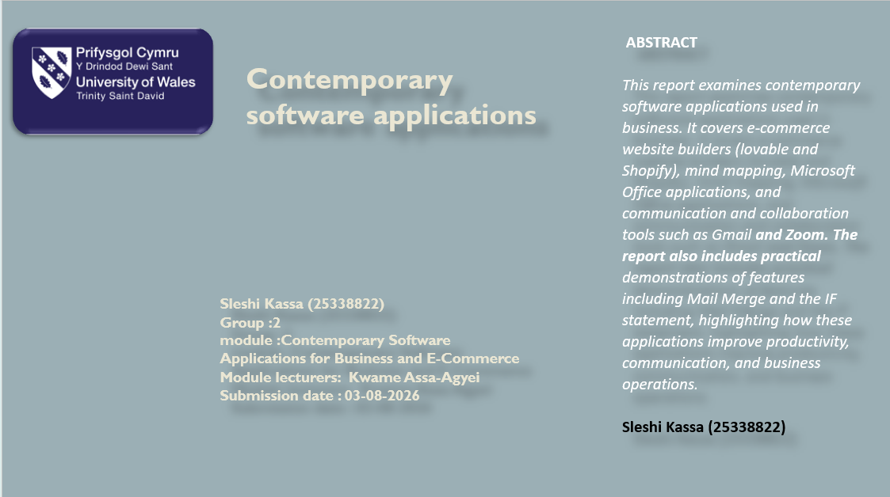

Introduction 2
Task 1. e-Commerce Website builders/software solutions 2
1.1 Lovable 2
1.2 Shopify 3
Task 2: Mind Map of Contemporary Software Applications 4
2.1 Describe Mind Mapping and Explain Its Benefits 4
2.2 Create a mind map of contemporary software application 5
Task 3. Office Applications 6
3.1 Four office software solutions for business operations 6
Ms Word 6
Ms Excel 7
Ms PowerPoint 8
Ms Access 9
3.2 Test any two features 9
Mail Merge 9
IF function 14
Task 4. Communication and Collaboration applications 16
4.1 One Contemporary Communication and One Online Collaboration Application 16
Gmail 16
4.2 Test one feature of a freely available Communication (1) and one feature of a Collaboration (1) application 17
4.3 Test the Microsoft Teams Collaboration Application 21
Conclusion 25
References 25

Introduction

Contemporary software applications play a vital role in improving business productivity, communication, and online operations. This report explores key software solutions, including ecommerce platforms, Microsoft Office applications, mind mapping tools, and communication and collaboration applications. It also demonstrates selected software features to show how these tools support efficient business processes.

Task 1. e-Commerce Website builders/software solutions

1.1 Lovable

Lovable is a contemporary AI-powered website and web application development platform that enables users to build websites by describing their ideas in natural language. Instead of writing code manually, users can enter prompts explaining the type of website or application they want, and the platform automatically generates the design, user interface, and functionality. Lovable combines artificial intelligence with no-code and low-code technologies, making website development faster and more accessible for individuals, entrepreneurs, and businesses with limited programming knowledge [1].
Key Features of Lovable
Lovable offers several features that simplify website development. It uses artificial intelligence to generate websites and web applications based on user prompts, reducing the need for manual coding. The platform supports no-code and low-code development, allowing users with little technical experience to create professional websites. It also produces responsive designs that automatically adapt to desktops, tablets, and smartphones. Furthermore, Lovable can integrate with databases and external APIs, enabling websites to connect with services such as payment gateways and cloud-based applications. Its rapid prototyping capability allows businesses to quickly develop and test ideas before creating a final product [1], [2].
Advantages of Lovable
Lovable provides several benefits for businesses and individual users. Its user-friendly interface makes website development accessible to beginners without programming skills. The AI-powered development process significantly reduces the time required to build websites, enabling businesses to launch their online presence more quickly. It also helps lower development costs by automating many design and coding tasks. Additionally, the platform produces professional-looking websites and is particularly suitable for startups and small businesses that require fast and cost-effective digital solutions [1], [2].
Disadvantages of Lovable
Despite its advantages, Lovable has some limitations. AI-generated websites may not provide the same level of flexibility and customization as websites developed through traditional programming methods. Businesses with complex technical requirements may require additional coding to implement advanced functionality. Furthermore, some premium features, integrations, and higher usage limits are only available through paid subscription plans, which can increase costs as business requirements expand [1].
Summary
Overall, Lovable is an innovative AI-powered website development platform that simplifies the process of creating websites and web applications. Its ease of use, rapid development, and AI-driven capabilities make it a suitable solution for startups and small businesses, although users with more complex requirements may experience limitations in customization and advanced functionality [1], [2].

1.2 Shopify

Shopify is a cloud-based e-commerce platform that enables individuals and businesses to create, manage, and operate online stores without requiring advanced technical knowledge. Founded in 2006, Shopify provides a comprehensive solution for selling products and services online by offering website hosting, customizable store themes, payment processing, inventory management, and marketing tools within a single platform. Its user-friendly interface allows businesses of all sizes to establish an online presence and manage daily e-commerce operations efficiently [3].
Key Features of Shopify
Shopify provides a wide range of features designed to support online businesses. It offers a website builder with professionally designed and mobile-responsive themes that enable businesses to create attractive online stores. The platform includes secure payment processing through Shopify Payments and supports multiple third-party payment gateways. Shopify also provides inventory management tools that allow businesses to monitor stock levels, process orders, and manage product catalogues efficiently. In addition, the platform includes built-in search engine optimisation (SEO) tools, digital marketing features, analytics dashboards, and an extensive app marketplace that allows businesses to extend the functionality of their online stores according to their operational requirements [3], [4].
Advantages of Shopify
Shopify offers several advantages that make it one of the most popular e-commerce platforms. Its intuitive interface enables users with limited technical knowledge to create and manage professional online stores quickly. The platform provides secure hosting, regular software updates, and reliable customer support, reducing the need for businesses to manage technical infrastructure. Shopify also supports multiple sales channels, allowing businesses to sell products through websites, social media platforms, and online marketplaces from a single management system. Furthermore, its extensive library of applications and integrations enables businesses to customize and scale their online stores as they grow [3], [4], [5].
Disadvantages of Shopify
Despite its many strengths, Shopify has some limitations. The platform operates on a monthly subscription model, which may be expensive for small businesses with limited budgets. Additional costs may also arise from purchasing premium themes, installing paid applications, or using third-party payment gateways that charge transaction fees. Although Shopify offers many customization options, implementing highly advanced functionality often requires knowledge of Shopify's Liquid programming language or the assistance of professional developers. These factors can increase the overall cost and complexity of maintaining an online store [3], [5].
Summary
Overall, Shopify is a powerful and reliable e-commerce platform that enables businesses to create, manage, and expand their online stores efficiently. Its comprehensive features, ease of use, and scalability make it suitable for businesses ranging from small start-ups to large enterprises. However, businesses should carefully consider the subscription costs and potential customization requirements when selecting Shopify as their preferred e-commerce solution [3].

Task 2: Mind Map of Contemporary Software Applications

2.1 Describe Mind Mapping and Explain Its Benefits


Mind mapping is a visual technique used to organize information around a central idea by connecting related topics with branches. It helps individuals and organisations present information clearly, making it easier to understand relationships between ideas. In business, mind maps are commonly used for brainstorming, project planning, problem-solving, and decision-making [6].
Mind mapping offers several benefits in business operations. It improves organization by presenting information in a logical structure, encourages creativity during brainstorming sessions, and supports effective planning by breaking complex tasks into manageable parts. It also enhances communication and collaboration by providing teams with a clear visual representation of ideas, helping them work more efficiently [6].

2.2 Create a mind map of contemporary software application
The following mind map illustrates different categories of contemporary software applications that support day-to-day business operations. These applications help organisations improve productivity, communication, collaboration, security, data management, software development, and employee training. By organizing the software into related categories, the mind map provides a clear overview of how different applications contribute to efficient business processes

Figure 1. Mind Map of Contemporary Software Applications.
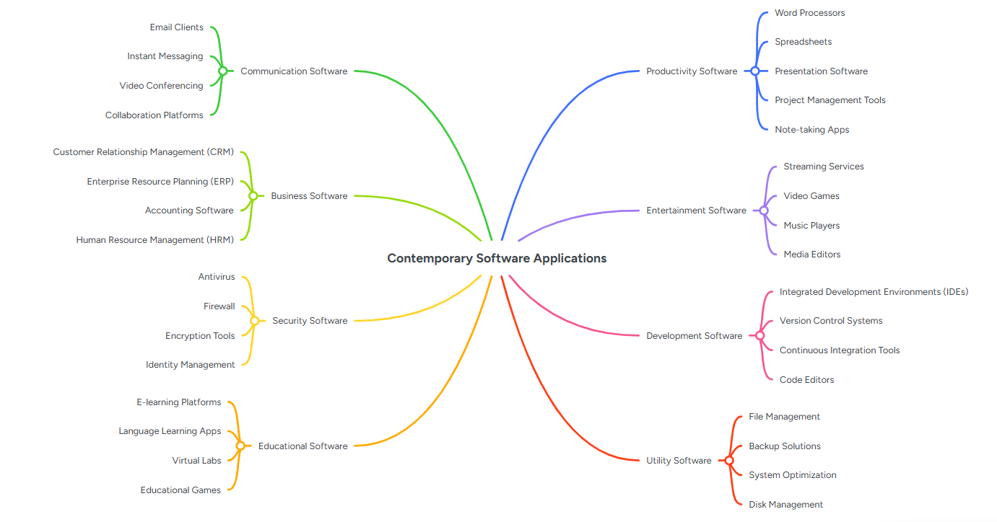
Figure Caption:
Figure 1: Mind map showing the major categories of contemporary software applications used to support business operations, including productivity, communication, business, security, educational, entertainment, development, and utility software.

Task 3. Office Applications

3.1 Four office software solutions for business operations

Ms Word


Microsoft Word is a word processing application developed by Microsoft that is widely used for creating, editing, formatting, and sharing documents. It is commonly used in businesses, educational institutions, and government organisations to prepare letters, reports, meeting minutes, proposals, and other professional documents. Microsoft Word provides a user-friendly interface and a wide range of tools that help users produce high-quality documents efficiently [7].
Key Features
Microsoft Word offers several features that improve document creation and editing. These include spell and grammar checking, formatting tools, templates, tables, images, SmartArt, headers and footers, page numbering, mail merge, and collaboration features such as comments and Track Changes. It also allows users to save documents in different file formats, including PDF, making documents easier to share [7].
Benefits
Microsoft Word helps businesses create professional documents quickly and accurately. Its formatting and editing tools improve document quality, while features such as Mail Merge save time by automatically generating personalised letters and emails for multiple recipients. The collaboration tools also enable multiple users to review and edit documents efficiently, improving teamwork and productivity [7].
Limitations
Although Microsoft Word is a powerful application, it has some limitations. Most advanced features require a Microsoft 365 subscription, which may increase costs for some users. In addition, very large or complex documents can sometimes become slow to edit, and compatibility issues may occur when documents are opened using different word processing software [7].

Ms Excel


Microsoft Excel is a spreadsheet application developed by Microsoft that is widely used for organizing, analyzing, and managing data. It is commonly used in businesses to perform calculations, create budgets, manage financial records, analyse sales data, and generate reports. Excel provides a range of built-in formulas, functions, and data analysis tools that help users process large amounts of information accurately and efficiently [8].
Key Features
Microsoft Excel includes a variety of features that support data management and analysis. These features include formulas and functions, charts, PivotTables, conditional formatting, sorting and filtering, and data validation. It also supports functions such as IF, VLOOKUP, and Goal Seek, which enable users to perform calculations, analyse data, and automate repetitive tasks. Excel can also create graphs and charts to present data visually, making it easier to identify trends and patterns [8].
Benefits
Microsoft Excel helps businesses improve efficiency by automating calculations and reducing manual errors. It enables users to organise and analyse large datasets quickly, supporting informed decision-making. Features such as PivotTables and charts simplify data analysis, while formulas save time by performing calculations automatically. Excel is widely used in accounting, finance, inventory management, and project planning because of its flexibility and powerful analytical capabilities [8].
Limitations
Despite its advantages, Microsoft Excel has some limitations. Large spreadsheets containing complex formulas may become slow to process and difficult to manage. Data entry errors can also affect the accuracy of calculations if not carefully checked. Additionally, Excel is less suitable for managing very large databases or allowing multiple users to edit the same file simultaneously without cloud-based collaboration tools [8].

Ms PowerPoint


Microsoft PowerPoint is a presentation software application developed by Microsoft that is widely used to create and deliver professional presentations. It is commonly used in businesses, educational institutions, and organisations to present information, reports, project proposals, and training materials in a clear and engaging way. PowerPoint allows users to combine text, images, charts videos, and animations to communicate ideas effectively [9].
Key Features
Microsoft PowerPoint provides a range of features for creating visually appealing presentations. These include professionally designed templates, themes, animations, slide transitions, charts, SmartArt graphics, images, videos, and speaker notes. It also supports collaboration features that allow multiple users to edit presentations and present remotely using Microsoft 365 [9].
Benefits
Microsoft PowerPoint helps businesses present information in a professional and organised manner. Visual elements such as charts, images, and animations improve audience engagement and make complex information easier to understand. It is widely used for business meetings, employee training, sales presentations, and project proposals. Additionally, collaboration and cloud storage features enable teams to work together efficiently on presentations [9].
Limitations
Although Microsoft PowerPoint is a powerful presentation tool, creating high-quality presentations can be time-consuming and requires good design skills. Overusing animations or adding excessive text can reduce audience engagement and make presentations less effective. Furthermore, some advanced features require a Microsoft 365 subscription, which may increase costs for users [9].

Ms Access


Microsoft Access is a database management system (DBMS) developed by Microsoft that is used to store, organise, and manage large amounts of data. It is commonly used by businesses to manage information such as customer records, employee details, inventory, and sales data. Microsoft Access combines a user-friendly interface with database management tools, allowing users to create and manage databases without requiring advanced programming skills [10].

Key Features
Microsoft Access provides several features for managing and analyzing data. These include tables for storing data, queries for retrieving and filtering information, forms for entering and updating records, and reports for presenting data in a structured format. It also supports relationships between tables, helping users organise data efficiently while reducing duplication. Additionally, Access allows users to automate tasks using macros and create customised database applications [10].
Benefits
Microsoft Access helps businesses organise and manage large volumes of data efficiently. It improves data accuracy by reducing duplication through relational database design and allows users to retrieve information quickly using queries. The software also simplifies data entry through customised forms and generates professional reports to support decision-making. Its integration with other Microsoft Office applications, such as Excel and Word, further enhances productivity and data sharing [10].
Limitations
Although Microsoft Access is suitable for small and medium-sized businesses, it has some limitations. It is not designed to manage very large databases or support a high number of simultaneous users, making it less suitable for large organisations. Additionally, advanced database design and automation features may require users to have some knowledge of database concepts and Microsoft Access tools [10].

3.2 Test any two features

Mail Merge
Mail Merge is a Microsoft Word feature that allows users to create multiple personalised documents, such as letters, certificates, or emails, using a single template and a data source. This feature saves time and improves efficiency by automatically inserting recipient information into each document
Step 1: Create the Data Source
A student data list was created in Microsoft Excel containing fields such as Student ID, First Name, Last Name, Course, and Email. This spreadsheet was saved and used as the recipient list for the Mail Merge process.

Table 1. Student Data Source

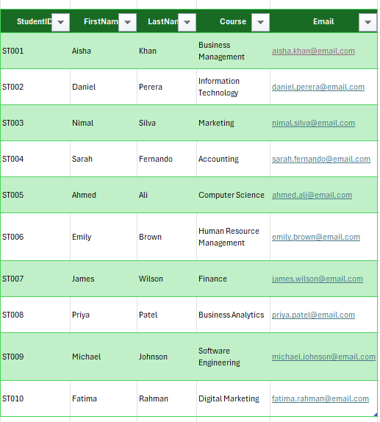

Step 2: Start Mail Merge
In Microsoft Word, the Mailings tab was selected, followed by Start Mail Merge, and Letters was chosen as the document type.
Figure 1. Starting the Mail Merge Process

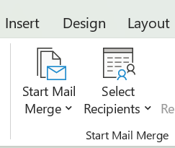

Step 3: Select the Recipients
The Excel spreadsheet containing the student information was selected using Select Recipients > Use an Existing List. Microsoft Word successfully imported the student records.
Figure 2. Selecting the Recipient List

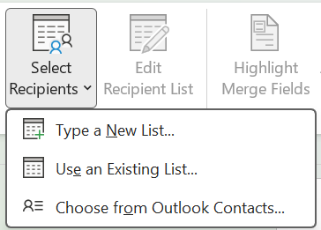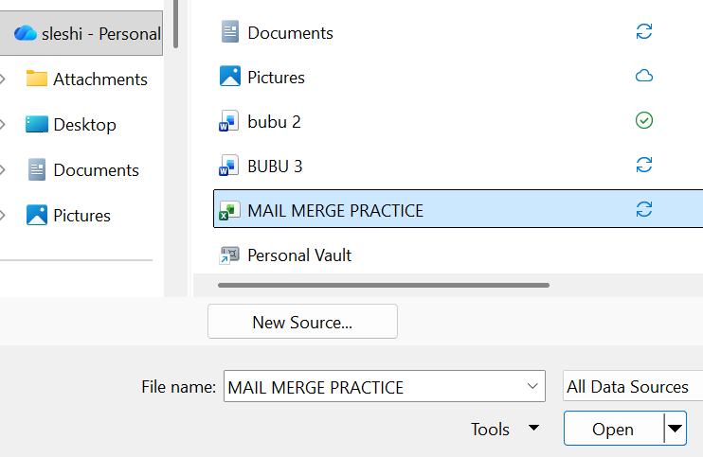

Step 4: Insert Merge Fields
Merge fields, including First Name, Last Name, Student ID, and Course, were inserted into the letter template to personalise each document.
Figure 3. Inserting Mail Merge Fields

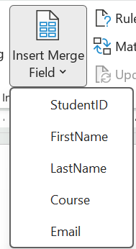
Step 5: Preview and Complete the Mail Merge
The Preview Results option was used to verify that each student's information appeared correctly. Finally, Finish & Merge was selected to generate individual personalised letters for all students.
Figure 4. Completed Mail Merge Output



Figure 5. sample
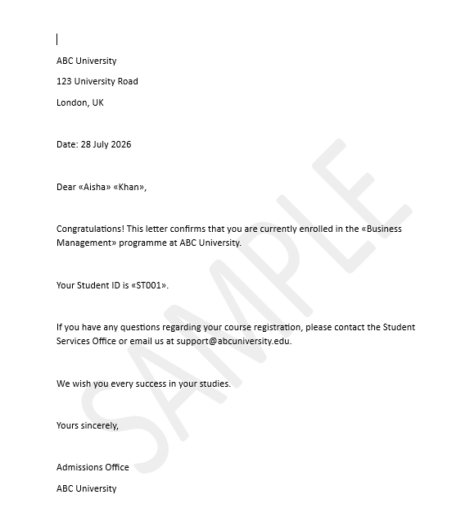

IF function
Step 1: Create the Dataset
A loan application dataset was created in Microsoft Excel containing customer information, including Customer ID, Customer Name, Credit Score, Annual Income, Employment Status, and a Decision column.
Figure 6. Loan Application Dataset
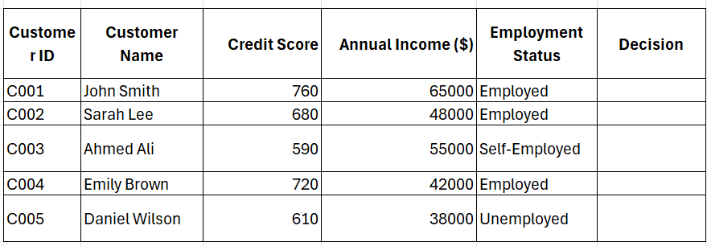

Step 2: Enter the IF Formula
The IF function was entered into the Decision column to evaluate each customer's loan application based on their credit score, annual income, and employment status. A nested IF statement combined with the AND function was used to classify each application as Approved, Review Required, or Rejected according to the predefined business rules.

Figure 7. Entering the IF Formula

step 3: Verify the Formula
The Function Arguments dialog box was used to verify that the formula had been entered correctly. Excel evaluated the logical conditions and displayed Approved as the expected result for the first customer, confirming that the formula was functioning correctly before it was applied to the remaining records.
Figure 8. Verifying the Formula Using the Function Arguments Dialog Box

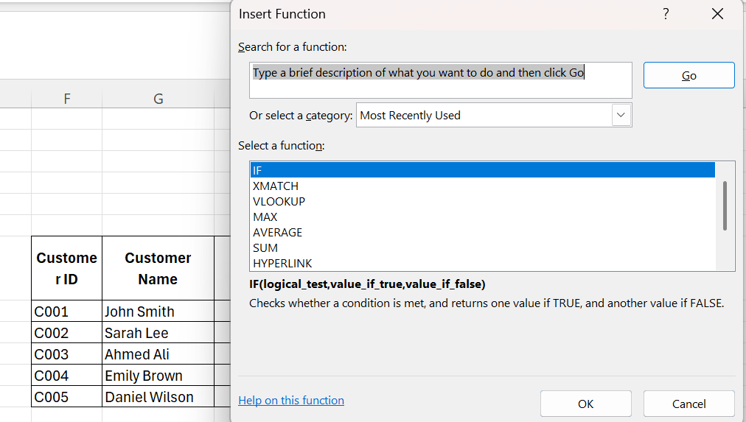
Step 4: Apply the Formula
After confirming that the formula produced the correct result, it was copied down the Decision column using the fill handle. Excel automatically evaluated each customer's details and assigned the appropriate loan application status based on the predefined conditions.
Figure 9. Applying the Formula to the Remaining Records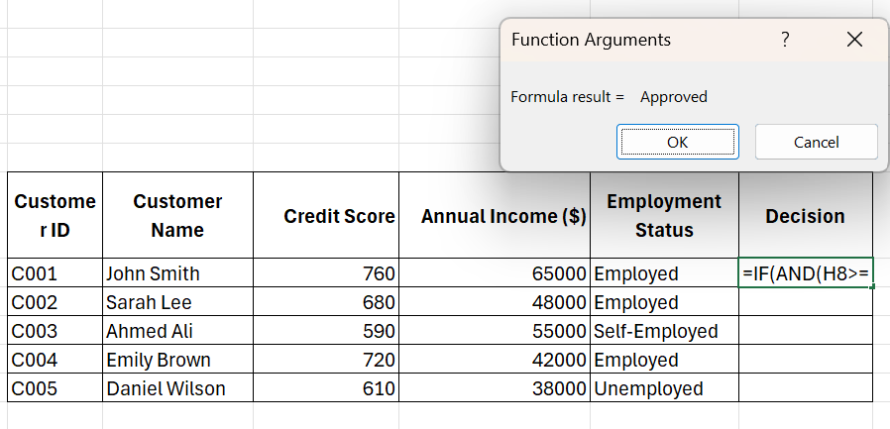
Figure 10. Completed Loan Application Assessment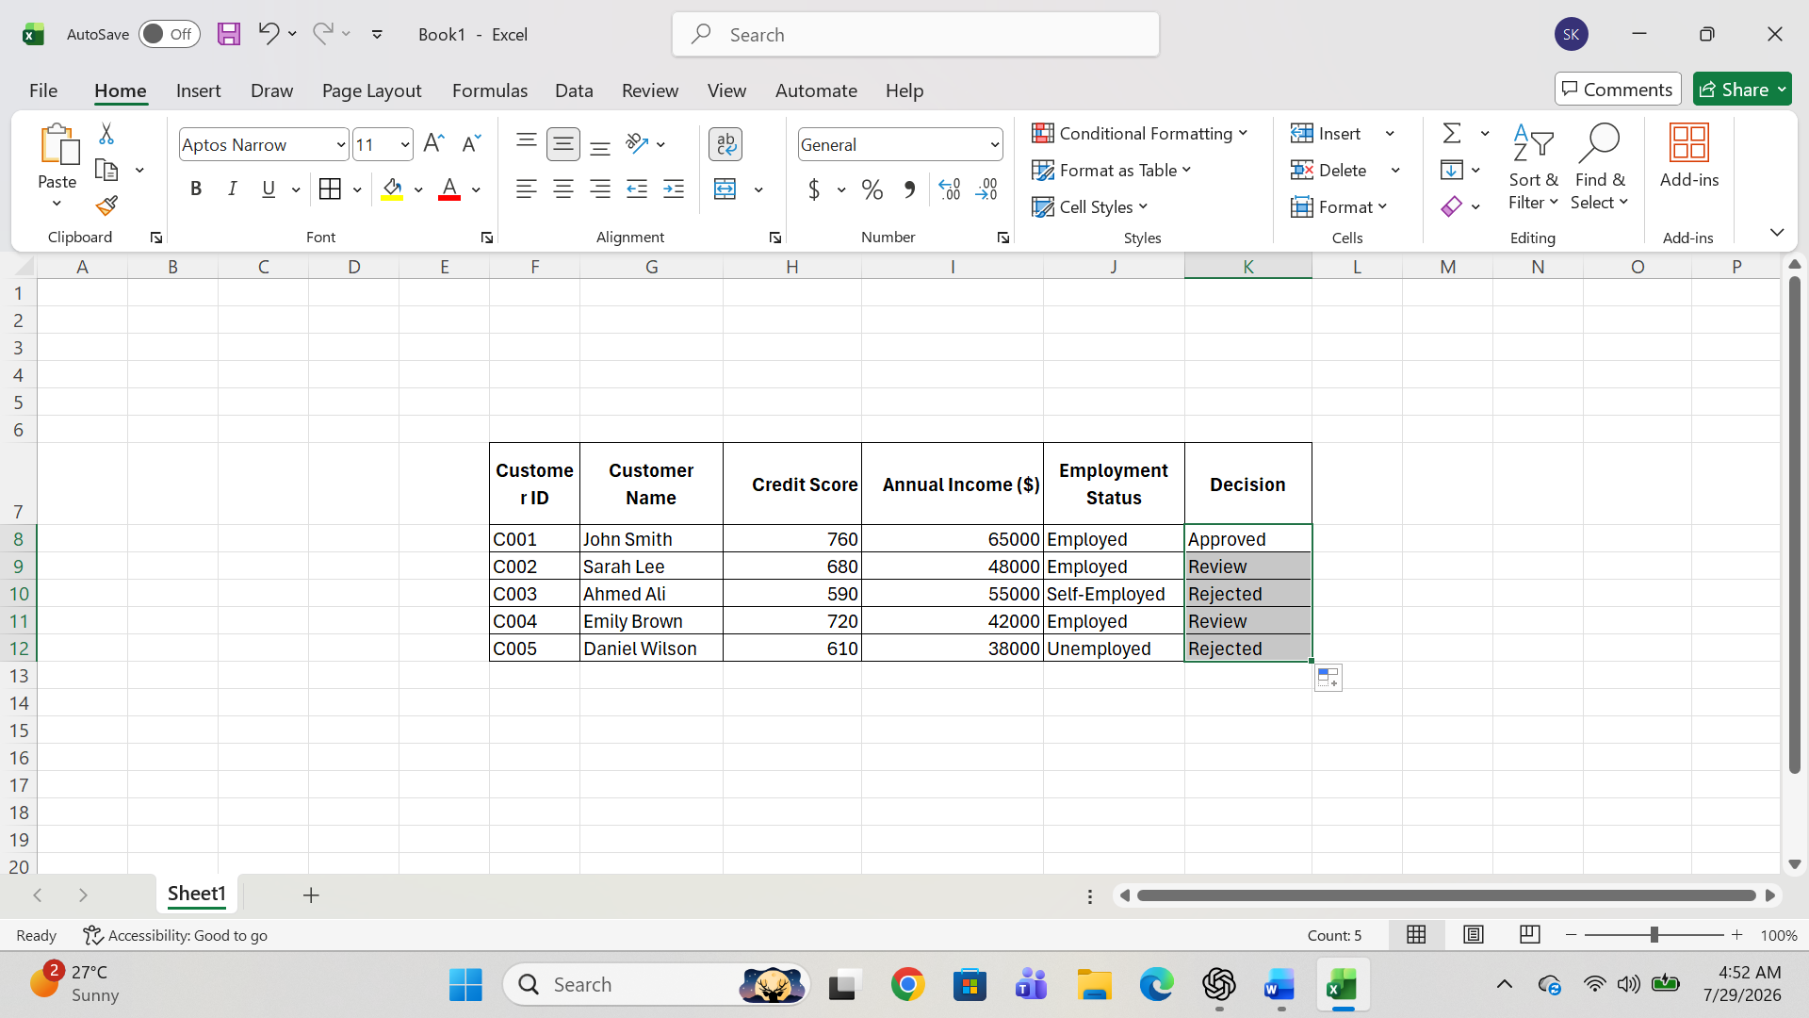
Result
The IF function was successfully tested using a loan application example. The formula checked each customer's credit score, annual income, and employment status, then automatically showed Approved, Review Required or Rejected based on the conditions. This activity showed how Microsoft Excel can make decisions automatically, save time, reduce manual work, and improve accuracy in business tasks [8].
Note
The example of a loan application used in this practical activity is a simplified scenario created to demonstrate the use of the IF function in Microsoft Excel. In practice, banks and financial institutions use much more sophisticated software, advanced algorithms, and large volumes of customer and financial data when assessing loan applications. This example was developed solely to demonstrate my understanding and practical skills in using logical functions within Excel Task 4. Communication and Collaboration applications

Task 4. Communication and Collaboration applications

4.1 One Contemporary Communication and One Online Collaboration Application

Gmail

Gmail is a cloud-based email service developed by Google that enables users to send, receive, and manage electronic messages over the internet. It is widely used by individuals, businesses, educational institutions, and government organisations for both personal and professional communication. Gmail provides a user-friendly interface and integrates with other Google Workspace applications, allowing users to manage emails, calendars, contacts, and files from a single platform [11].
Key Features
Gmail offers a range of features that support effective communication. These include sending and receiving emails, file attachments, labels and folders for organising messages, powerful search capabilities, spam and phishing protection, email scheduling, and integration with Google Drive, Google Meet, and Google Calendar. Gmail also supports access from web browsers and mobile devices, allowing users to communicate from almost anywhere [11].
Benefits
Gmail enables fast and reliable communication between individuals and organisations. Its search tools help users locate messages quickly, while spam filtering improves security by reducing unwanted emails. Integration with other Google Workspace services improves productivity by allowing users to share files, schedule meetings, and collaborate efficiently. Its cloud-based design also ensures that emails are synchronised across multiple devices [11].
Limitations
Although Gmail offers many advantages, it requires an internet connection for full functionality. Users may also have privacy concerns when storing sensitive information in cloud-based email services. In addition, organisations with strict security requirements may need additional security measures such as multi-factor authentication and email encryption [11].

4.2 Test one feature of a freely available Communication (1) and one feature of a Collaboration (1) application

Step 1: Sign in to Gmail
A Gmail account was accessed through a web browser by signing in with a Google account. After successful authentication, the Gmail inbox was displayed, providing access to email management features such as the Inbox, Sent, Drafts, Spam, Trash, Labels, and Google Workspace applications.

Figure 11. Gmail Inbox
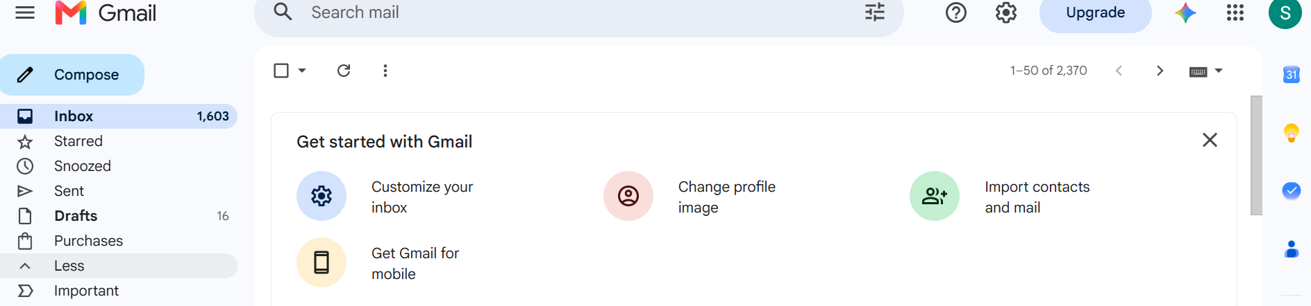

Step 2: Compose a New Email
The Compose button was selected to create a new email message. The recipient's email address was entered in the To field, followed by a subject line and the email content. The built-in formatting tools were used to format the message by changing the font style, applying bold text, and organising the content into a professional email.
Figure 12. Composing a New Email
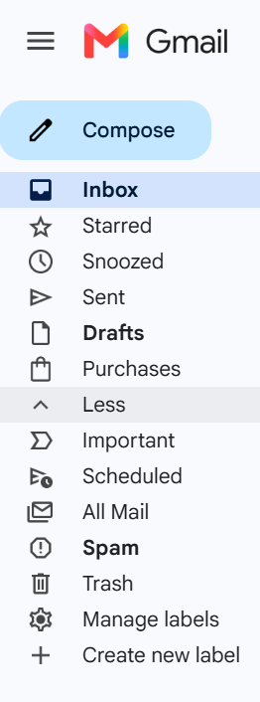

Step 3: Attach a File and Insert Additional Features
The Attach Files (paperclip) option was used to upload a document from the computer.

Figure 13. Attaching a File and Using Gmail Features
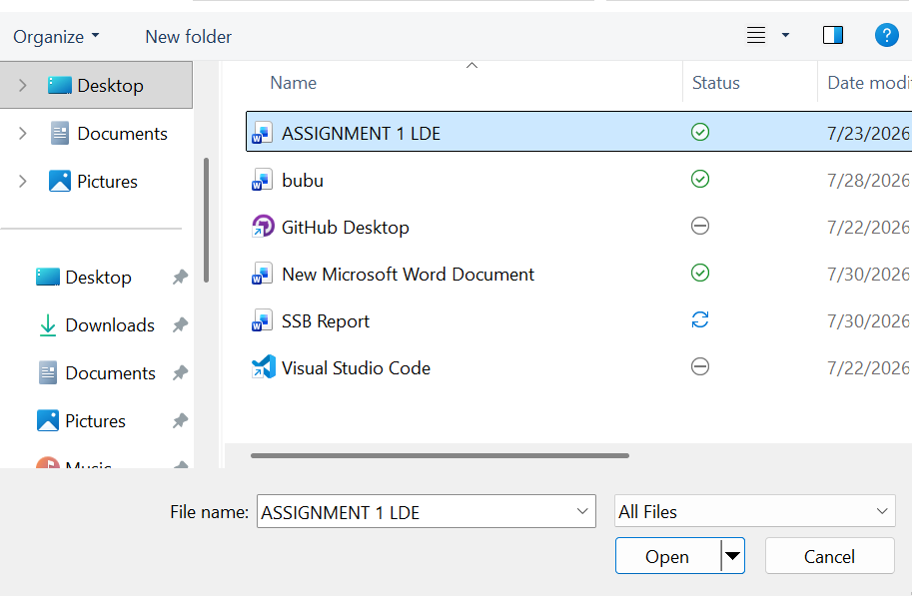

Step 4: Schedule or Send the Email
After reviewing the email, the message was either sent immediately using the Send button or scheduled for delivery using Gmail's Schedule Send feature. This feature allows users to choose a specific date and time for the email to be delivered automatically.
Figure 14. Sending or Scheduling the Email
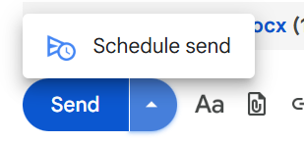

Step 5: Verify the Sent Email
The Sent folder was opened to confirm that the email had been delivered successfully. The sent message, including the subject, recipient, attachment, and timestamp, was visible in the list of sent emails. This confirmed that the communication process had been completed successfully.

Figure 15. Sent Email Confirmation

Result
The Gmail communication application was successfully tested by composing a professional email, formatting the message, attaching a document, and sending it to a recipient. Additional Gmail features, including email search, labels, and message organisation, were also demonstrated. These features improve communication by enabling users to send information quickly, organise emails efficiently, and manage business correspondence more effectively [11].

Note
This practical activity demonstrates only the core communication features of Gmail. In real business environments, organisations commonly use Gmail as part of Google Workspace, where it integrates with services such as Google Calendar, Google Drive, Google Meet, Contacts, and shared collaboration tools. Businesses may also use advanced features such as custom email domains, administrative controls, data loss prevention, security policies, and multi-factor authentication to support secure communication across large organisations. This practical exercise was completed to demonstrate my understanding and practical skills in using Gmail as a contemporary communication application [11].

4.3 Test the Microsoft Teams Collaboration Application
Step 1: Sign in to Microsoft Teams
The Microsoft Teams desktop application was opened, and a Microsoft account was used to sign in. After successful authentication, the Teams home screen was displayed, providing access to features such as Chat, Teams, Calendar, Calls, and Activity.
Figure 16. Microsoft Teams Home Screen

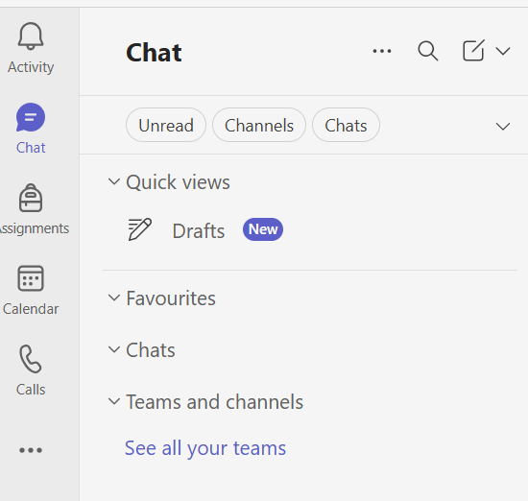

Step 2: Schedule a New Meeting
The Calendar section was opened, and the New Meeting option was selected. A meeting title, date, time, and duration were entered. After completing the meeting details, the meeting was saved and added to the Teams calendar.
Figure 17. Scheduling a Microsoft Teams Meeting
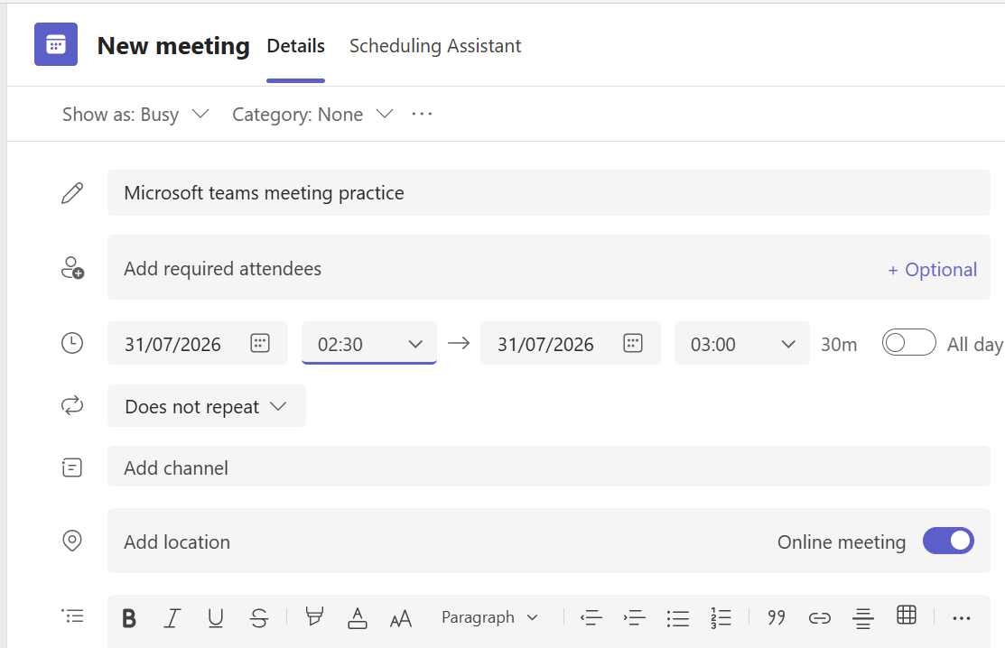

Step 3: Copy the Meeting Invitation
After scheduling the meeting, the meeting details were opened and the invitation link was copied using the Copy Link or Copy Invitation option. This link can be shared with participants to allow them to join the meeting.
Figure 18. Copying the Meeting Invitation
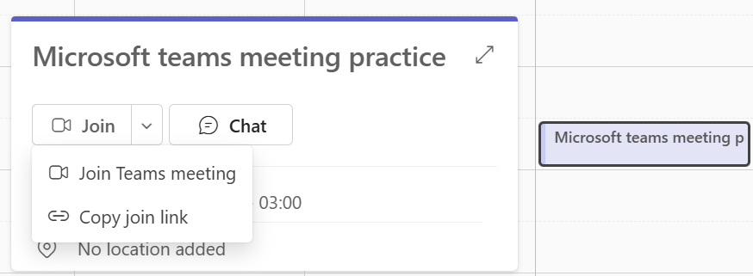

Step 4: Start the Meeting
The scheduled meeting was started by selecting the Join button. During the meeting, the microphone and camera controls were available, allowing audio and video to be enabled or disabled as required.
Figure 19. Starting the Microsoft Teams Meeting
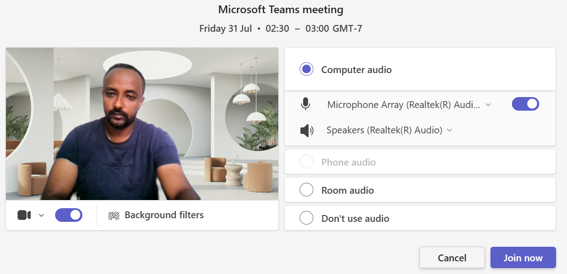

Step 5: Share the Screen
The Share option was selected to present the desktop or an open application window during the meeting. Screen sharing enables participants to view presentations, documents, or other content in real time, supporting effective collaboration.
Figure 20. Screen Sharing in Microsoft Teams

Step 6: End the Meeting
After completing the meeting, the Leave button was selected, followed by End Meeting. This closed the meeting and completed the collaboration activity.
Figure 21. Ending the Microsoft Teams Meeting


Result
The Microsoft Teams collaboration application was successfully tested by scheduling a meeting, copying the meeting invitation, starting the meeting, sharing the screen, and ending the session. These features demonstrate how Microsoft Teams supports online collaboration by enabling virtual meetings, content sharing, and effective communication between users [12].

Note
This practical activity demonstrates the core collaboration features of Microsoft Teams. In business environments, organisations commonly use additional features such as team channels, file sharing, meeting recordings, live captions, breakout rooms, task management, and integration with Microsoft 365 applications including Outlook, Word, Excel, PowerPoint, and OneDrive. These features improve teamwork and support collaboration across distributed teams [12].

Conclusion
This assignment explored different types of contemporary software applications used in business and everyday work. It explained two e-commerce software solutions, the use of mind mapping, Microsoft Office applications, and communication and collaboration tools. The practical activities helped demonstrate how Microsoft Word, Excel, Gmail, and Microsoft Teams can be used to complete common business tasks.
Overall, these software applications improve communication, increase productivity, support teamwork, and make work more efficient. Completing this assignment improved my understanding of how modern software is used in real organisations and helped me develop practical skills in using these applications effectively.

References
[1] Lovable, "Documentation," 2025. [Online]. Available: https://docs.lovable.dev/. [Accessed: 16-Jul-2026].
[2] Lovable, "Lovable," 2025. [Online]. Available: https://lovable.dev/.[Accessed: 16-Jul-2026].
[3] Shopify, "Shopify Help Center," 2025. [Online]. Available: https://help.shopify.com/. [Accessed: 16-Jul-2026].
[4] Shopify, "Shopify," 2025. [Online]. Available: https://www.shopify.com/. [Accessed: 16-Jul-2026].
[5] Shopify, "Shopify Blog," 2025. [Online]. Available: https://www.shopify.com/blog. [Accessed: 16-Jul-2026].
[6] MindManager, "What Is Mind Mapping?," 2025. [Online]. Available: https://www.mindmanager.com/en/mind-map/. [Accessed: 16-Jul-2026].
[7] Microsoft, "Microsoft Word," 2025. [Online]. Available: https://www.microsoft.com/microsoft-365/word. [Accessed: 16-Jul-2026].
[8] Microsoft, "Microsoft Excel," 2025. [Online]. Available: https://www.microsoft.com/microsoft-365/excel. [Accessed: 16-Jul-2026].
[9] Microsoft, "Microsoft PowerPoint," 2025. [Online]. Available: https://www.microsoft.com/microsoft-365/powerpoint. [Accessed: 16-Jul-2026].
[10] Microsoft, "Microsoft Access," 2025. [Online]. Available: https://www.microsoft.com/microsoft-365/access. [Accessed: 16-Jul-2026].
[11] Google, "Gmail Help," 2025. [Online]. Available: https://support.google.com/mail/. [Accessed: 16-Jul-2026].
[12] Microsoft, "Microsoft Teams," 2025. [Online]. Available: https://www.microsoft.com/microsoft-teams. [Accessed: 16-Jul-2026].

