Programs in C and documentation

Part A/B

Joshua Batchelor – 1802076

Gaynor Thomas
Contents
A1. What is a variable and why are they important in writing programs? 3
A2. Explain why the for-loop can also be referred to as a counting-loop and give an example of when you would use it. 3
A3. Explain what an array is, what their features are, and give an example of when you would use one. 4
2A – show name, age and height program 5
2B – calculation of an area of a circle program 7
2C – Calculate the price and work out the VAT from total price 10
2D – Jackpot game 13

A1. What is a variable and why are they important in writing programs?

A variable is an a data value that can be changed or referenced throughout the different elements of the code [1]. They can also be used as a referencing system for the program to understand the code more clearly as the program is being executed. The variables are set memory allocations that are set for the data to be held from the program [1]. The variables can be called to whatever reference you may decide as this data reference can be used throughout your programs code that you design. The variables are an easier way to write the programs as you store the values in these variables and declare them throughout the entirety of the program code [1].

By the user creating variables it allowed the program to set what types of data that can only be stored in that certain variable, by doing that step it allowed the users to set a specific data entry that can only be stored within that variable [1]. This made sure that the users can only select several different data types that can be entered into the variable [1]. An example is a string typed variable can only except letters and a float variable can only allow numbers and numbers with decimal points. This minimized the amount of mistakes that might be entered into the program. This reduced the amount of memory allocation that has been assigned to each of the variables as the program [1]. This makes sure that the program now knows what data is going to be stored in that variable, so the memory allocation will only allocate for the type of variable that is going to be stored in each variable that has been created [1].

A2. Explain why the for-loop can also be referred to as a counting-loop and give an example of when you would use it.

A for loop has been referred as a counting loop as a for loop because the user states how many times they want the loop to run or until the loop has a specific requirement that needs to be met before the loop end. This type of loop will only be used if the user knows how many times the program wants to loop, as the users will state how many times to loop within the programs code. This loop is used as the counted loop can be restricted as how many times the program is going to loop before the program finishes. The other types of loops cannot restrict the amount of times the loop can be used. The counted loop will have a set of requirements that need to be set for the loop to end before the loop automatically closes the program due to the users not meeting the requirements that need to be met by the program.

Counter Program Example

#include <stdio.h>

void main()
{
int number,i;

printf("Enter the number you wish to stop at: ");
scanf("%d", &number);
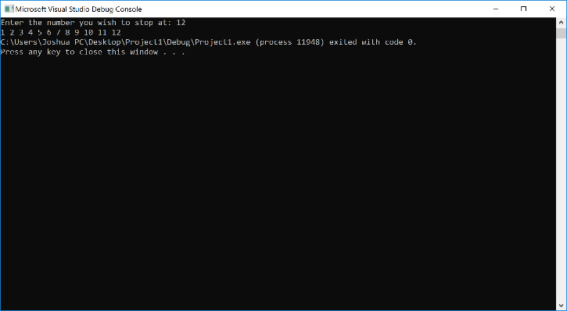
for (i = 1; i <= number; i++)
{
printf("%d ", i);
}
}

A3. Explain what an array is, what their features are, and give an example of when you would use one.

A array is a type of data structure that is used to store a set of data that has the same type that is going to be used by using that array that has been set. These arrays that are set can hold a range of different types of data that can be used within the different parts of the program. Arrays are used to store the data that has been created by users input or the output that the program has created and stored into the array that has been created. Arrays will also save on the memory allocation that will be set whilst the program is running, this will be key when a large program is running as this will save more memory allocation. This will save the user from declaring individual variables for each of the data packets that has to be saved. Each of the user inputted data will be saved into one array which will be declared as one variable. When declaring an array the user has to say how much data packets they want to save within that array. They do this by declaring the array variable and declare how much data that is going to be saved within the array.

2A – show name, age and height program
Get the user to enter their name, age and height into the program
Get the program to store the values that have been entered by the user in the right data type for each variable
Get the program to display each of the values that the user has entered the different variables that have been set
Pseudocode
Set char name to 20 characters
Set name and height to a float variable
Get name, height and age from users and store in named variables
Print name, age and height to the users

Program code
#include <stdio.h>

void main()
{
char name [20];
float age, height;

printf("Please Enter your name: ");//this is the question that will be asked within the program
scanf("%s", &name);//this is the statement that will allow user input and store it in a variable of your choice
printf("You have entered %s", name);

//these are the following questions that will be asked later in the program

printf("\nPlease enter your age: ");
scanf("%f", &age);
printf("Your age is %.0f", age);//%.0f shows the age variable without any decimal points

printf("\nPlease enter your height in feet: ");
scanf("%f", &height);
printf("Your height is %.1f", height);

}

Testing
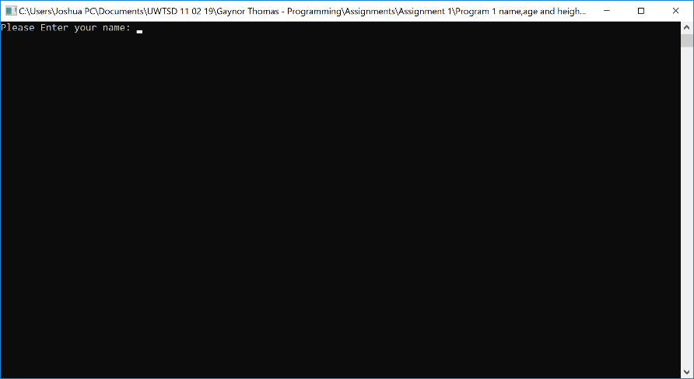

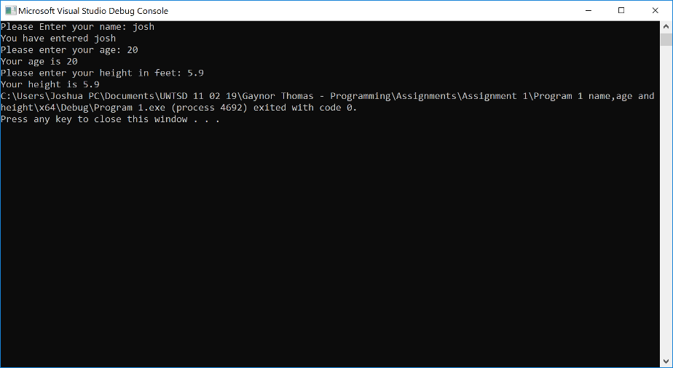

2B – calculation of an area of a circle program
Circle -
Firstly get the radius value from the users
Calculate the radius value by PI radius²

Triangle –
Get the base value from the users and store the value in a variable
Get the height value and store this in a suitable named variable
Then to work out the blue area we minus the triangle area off the circle area
Finally display the answer to the user showing the value of the blue area of the circle

Pseudocode
Set all base, radius, height, triangle area, circle area and blue area to floats
//calculate the circle area
Get radius value from user then store in radius variable
Then calculate circle area by PI * r² store in circle area
Print the answer for the calculation of the circle area
//calculate the triangle area
Get triangle area values from the user and store in base and height variables
Calculate triangle area by base * height / 2 store in triangle area
Print triangle area for the users
//calculate the blue area
Calculate blue area by circle area – triangle area store in blue area variable
Finally print blue area variable for the users

Program code
#include <stdio.h>
#define PI 3.142
void main()
{

float base,radius, height,trianglearea,circlearea,bluearea;

//get the radius value from the users and store it into a suitable variable

printf("Please enter a radius value: ");
scanf("%f", &radius);

//calculate the circle area by doing a PI r2 calculation

circlearea = PI * (radius*radius);

//display the calculated value for the circle to the users

printf("\nCircle area is: %.2f", circlearea);

// user enters base and height to calculate the triangle area

printf("\n\nPlease enter a base value: ");
scanf("%f", &base);

printf("\nPlease enter a height value: ");
scanf("%f", &height);

//calculation for triangle section

trianglearea = base * height / 2;

printf("\ntriangle area is: %.2f", trianglearea);

//calculation for the circle pie r2

bluearea = circlearea - trianglearea;

//show the results from the calculation, which shows the blue area of the circle

printf("\n\nThe calculated blue area is : %.2f\n\n", bluearea);

}

Testing
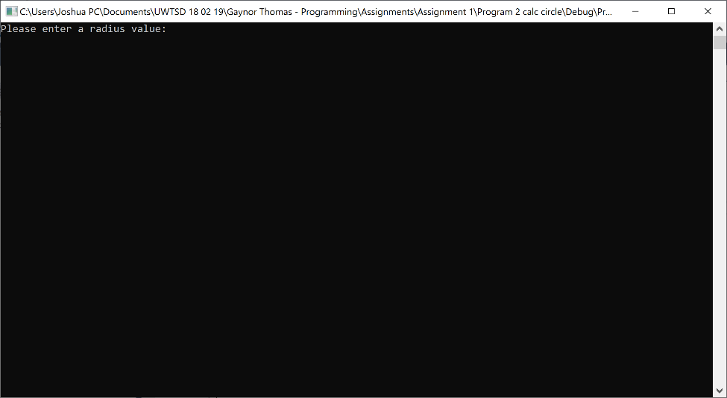

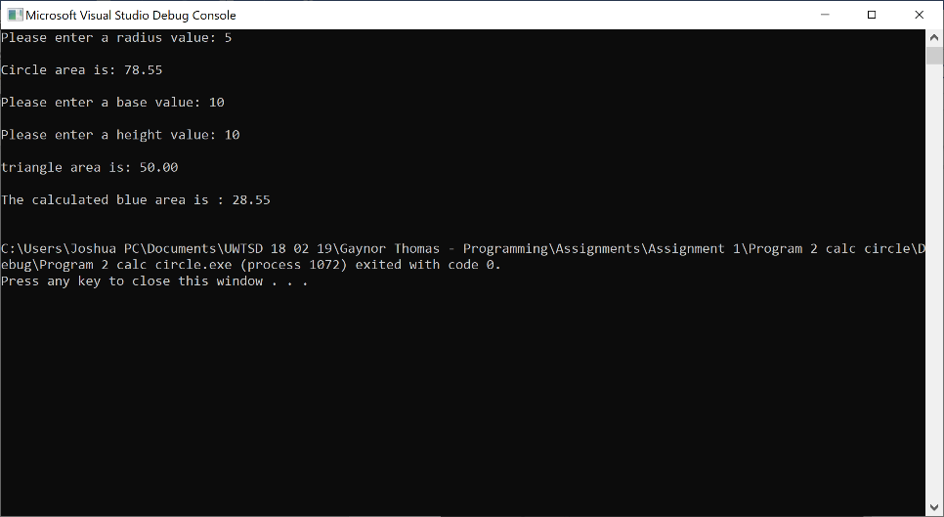

2C – Calculate the price and work out the VAT from total price

First get the 5 prices from the users
Once the 5 prices are in the variable array work out the totals price of the 5 array items
Next work out the VAT value by total * 0.2 store in a VAT variable
Show the VAT amount to the users
Finally work out the final amount with 20% VAT by total + VAT value
Show the final figure to the users

Pseudocode
Set enter price, total=0, vat value, net to floats
Set I to an int
For (each value that is entered)
{
each value that is entered
store in enter price [5]
total = total + enter price[5]
}
Print the total to the users
Work out the vat value by vat value = total * 0.2
Work out the net sum by total + vat value
Print out the vat value that has been added onto the gross
Print out the final amount the user must pay which is the net amount

Program Code
#include<stdio.h>
void main()
{
float enterprice[5];
float total=0,vatvalue,net;
int i;

for (i = 0; i < 5; i++)//loops 5 times for the users
{
printf("Enter product price: ");//gets the product prices from users and stores them in an array
scanf("%f", &enterprice[i]);

total = total + enterprice[i];//adds all prices together to give the total
}

printf("\n\nThe total price is: %.2f", total);//shows the total to the users

vatvalue = total * 0.2;//gives 20% VAT on the total in the total variable

net = total + vatvalue;//calculates the net

printf("\n\nThe Vat value is: %.2f ", vatvalue);//shows the VAT amount from the total

printf("\n\nThe total price is: %.2f\n", net);//Prints the final net amount for the users

}

Testing
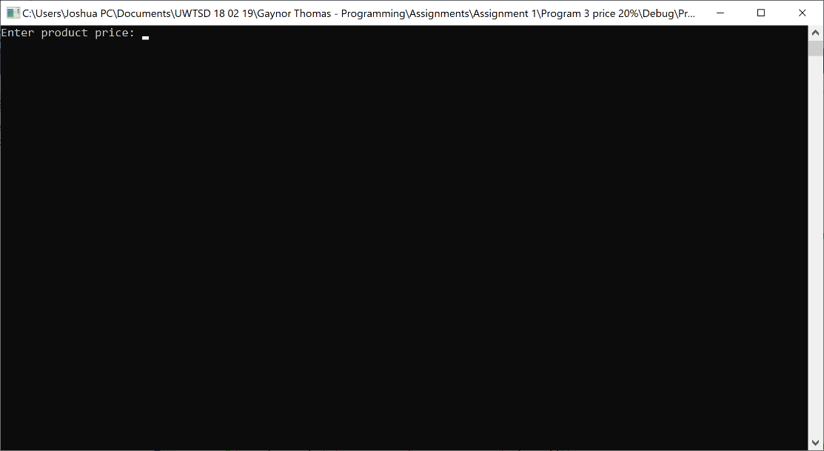

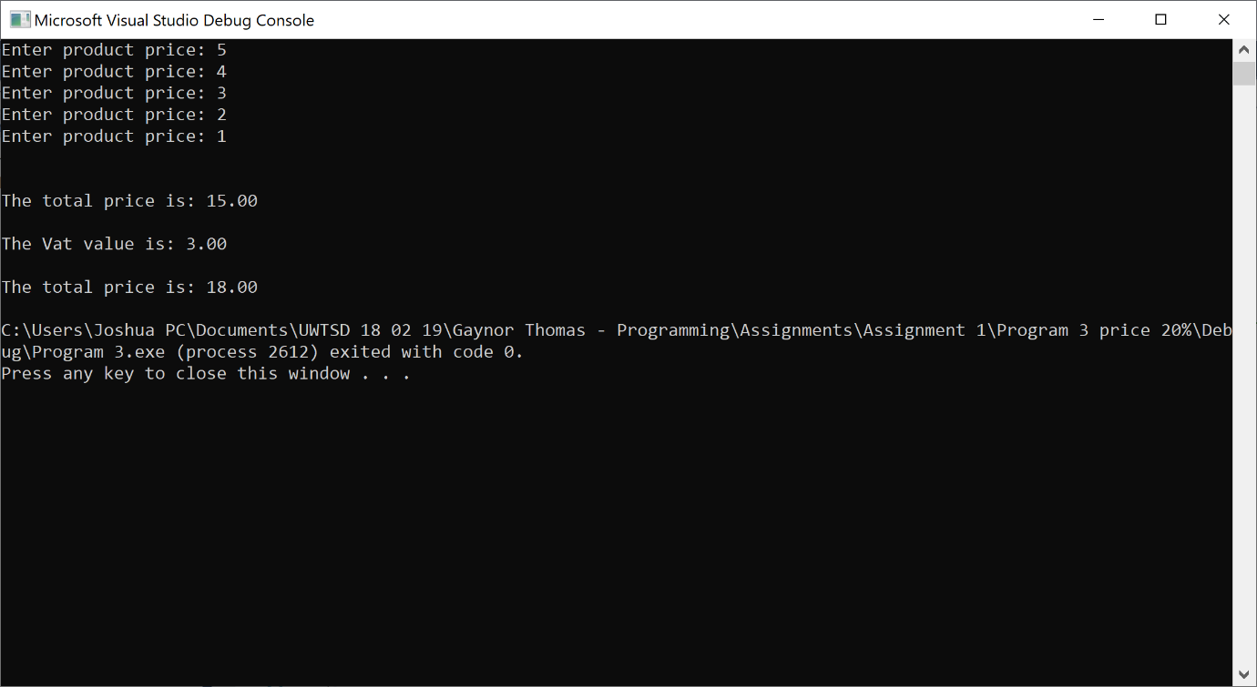

2D – Jackpot game
Ask user if they want to play the jackpot game
If the user says yes -
The program will generate three numbers between 1 and 5
Depending on what the program generates it will give the user points
Depending on what 3 numbers are rolled different points are awarded to the user
It will then ask the users if they want to plan again they can loop this process
Once the user presses no
The program will show them there points total and shows a thank you message

Pseudocode
Print do you want to play the jackpot game (yes/No)
While (choice == y)
Print your lucky number is – generate 3 random number between 1 and 5
If (number are not equal to 4,4,4)
Print well done , you received 20 points
Points = points + 20
}
elseIf (number are not equal to 3,3,3)
Print well done , you received 20 points
Points = points + 20
}
elseIf (number are not equal to 2,2,2)
Print well done , you received 20 points
Points = points + 20
}
elseIf (number are not equal to 1,1,1)
Print well done , you received 20 points
Points = points + 20
}
elseIf (number have a five within the three numbers)
Print well done , you received 100 points
Points = points + 100
}

elseIf (number are equal to 5,5,5)
Print well done , you received 2000 points
Points = points + 2000
}

Print how much points the user has

Print if the user want to play another game
}
If(user presses no)
{
Print a sentence thanks for playing, maybe another time
}

Program Code
#include <stdio.h>
#include <stdlib.h>
#include <time.h>

void main()
{
int myrand1,myrand2,myrand3;
float points;
int low = 1; //lowest range
int high = 5; //highest range
char choice;
srand(time(NULL)); //used to select the numbers at random

printf("Do you want to play JACKPOT game? (y/n)"); //asking player if they want to start the jackpot game
scanf(" %c", &choice);

while (choice == 'y')
{
printf("\nOK...here we go...your lucky numbers are...");
myrand1 = rand() % (high - low + 1) + low; //get random number
myrand2 = rand() % (high - low + 1) + low; //get random number
myrand3 = rand() % (high - low + 1) + low; //get random number
printf("%d, %d, %d", myrand1, myrand2, myrand3);

///////////////////////////////////////////////////////////////////////////////////////////////////////////////////
if (myrand1 == 4 && myrand2 == 4 && myrand3 == 4)
{
printf("\n\nWell done, you have recieved a bonus 20 points");
points = points + 20;
}
else if (myrand1 == 3 && myrand2 == 3 && myrand3 == 3)
{
printf("\n\nWell done, you have recieved a bonus 20 points");
points = points + 20;
}
else if (myrand1 == 2 && myrand2 == 2 && myrand3 == 2)
{
printf("\n\nWell done, you have recieved a bonus 20 points");
points = points + 20;
}
else if (myrand1 == 1 && myrand2 == 1 && myrand3 == 1)
{
printf("\n\nWell done, you have recieved a bonus 20 points");
points = points + 20;
}
////////////////////////////////////////////////////////////////////////////////////////////////////////////////////

////////////////////////////////////////////////////////////////////////////////////////////////////////////////////

else if (myrand1 == 5 || myrand2 == 5 || myrand3 == 5)
{
printf("\n\nWell done, you have recieved a bonus 100 points");
points = points + 100;
}

else if (myrand1 == 5 && myrand2 == 5 && myrand3 == 5)
{
printf("\n\nWell done, you have recieved a bonus 2000 points");
points = points + 2000;
}

///////////////////////////////////////////////////////////////////////////////////////////////////////////////////

printf("\n\nYour points are: %.0f", points);//shows the users how much points they have earned

printf("\n\n\nDo you want to play JACKPOT? (y/n)");//asks the users if they want to play again
scanf(" %c", &choice);
}
printf("\n\nOK, maybe play another time\n\n");//if they say no this message will appear
}

Testing
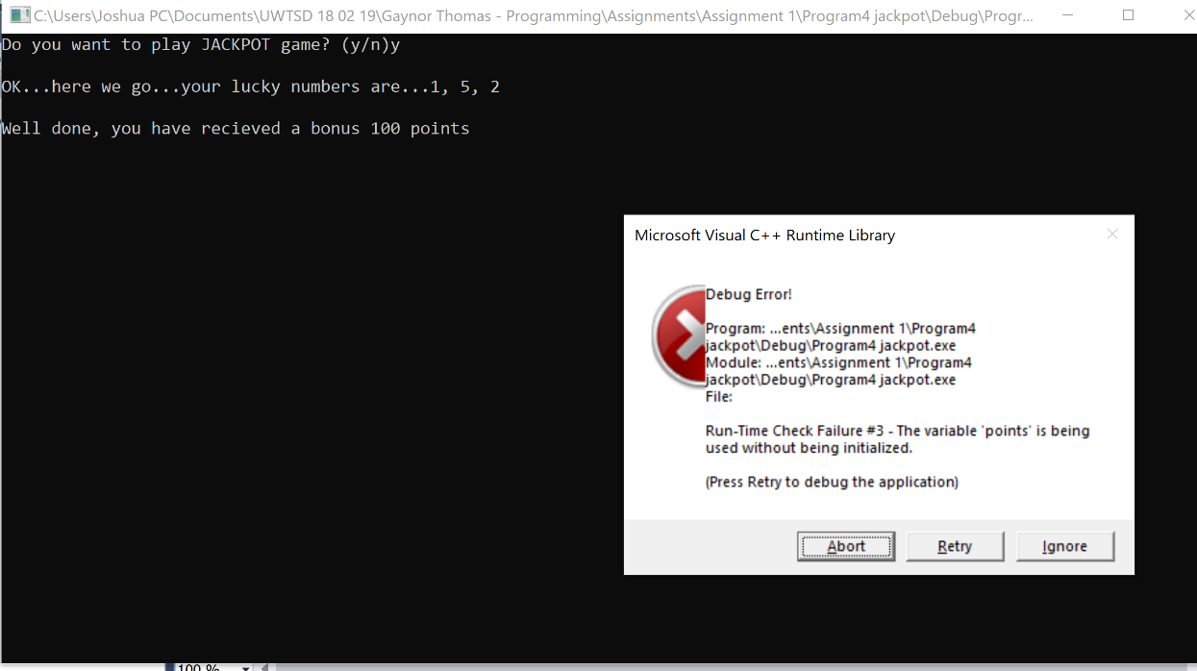
Fail

Resolve 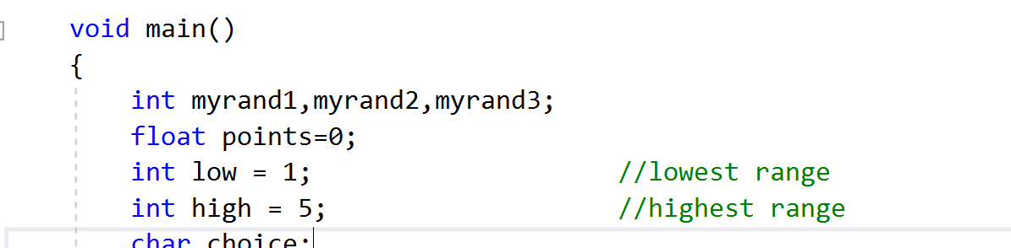
Give a value to the points variable as it hasn’t been initialized with a start value



