Managing the Customer Experience: BMSW 5103
Customer Relationship Management Emerging Themes
Part 1 – Report

Report Length: 2,727 words

Executive Summary
Customer touchpoints significantly influence the customer's experience and perception of the brand. Customer experience is critical for building a long-term relationship and enhancing customer satisfaction and loyalty. Brand experience is shaped by the customer experience and can impact the company's reputation, sales, and customer retention rates. Deliveroo can optimize touchpoints, improve the customer journey, and enhance customer satisfaction, loyalty, and retention rates. The critical literature review on customer experience highlights the importance of customer experience for companies like Deliveroo, as it is crucial for building customer loyalty and trust. Deliveroo heavily relies on technology to enhance the customer experience, such as GPS tracking and real-time order tracking, and actively seeks feedback from customers to improve its services. Co-creation is also recognized as a strategy for enhancing the customer experience, as involving customers in the design and delivery of products and services can lead to more personalized and engaging experiences. It has been recommended that Deliveroo should focus on providing high-quality customer service through all communication channels. It was also suggested that Deliveroo should improve delivery time estimates and notifications by providing more accurate and real-time updates to customers.

Table of Contents
Executive Summary 2
Introduction 4
Section A: Customer touchpoints, experience, and Brand experience 4
Defining the concept of touchpoints concerning Deliveroo 4
Examining the customer touchpoints at Deliveroo 5
Customer experience and brand experience at Deliveroo 7
Customer Journey Map of Deliveroo 7
Examination of Customer experience and brand experience at Deliveroo 8
The importance and suitability of selecting the themes- customer touchpoints, customer experience and brand experience- concerning Deliveroo. 9
The impact of customer touchpoints, customer experience and brand experience on customer relationship management (CRM) at Deliveroo. 10
Recommendations 11
Section B: A critical literature review on the customer experience 12
A critical literature review on customer experience: Deliveroo’s perspective 12
A critical literature review on customer experience: Co-creation perspective 13
How will understanding these two concepts help shape customer experience for Information Technology firms? 14
References 15

List of figures
Figure 1: Customer touchpoints concerning Deliveroo. 5
Figure 2: Customer Journey Map of Deliveroo (Self-designed, based on Hoyer, MacInnis and Pieters, 2016) 8

Introduction
Customer experience entails the impression that customers get throughout the customer journey while availing the products and services (Hoyer, MacInnis and Pieters, 2016). This paper will be divided in two sections: section A and B. Section A will explore the customer touchpoints, customer experience, and brand experience. On the other hand, section B will conduct a critical literature review. The selected case study company is Deliveroo, a British food delivery company. It was established in 2013 and now it operates in a number of countries, including the UK, Ireland, Singapore, France, Germany, Spain, United Arab Emirates, Qatar, etc. (Deliveroo., 2022). The company employed around 3,100 employees and earned a revenue of £1.824 billion in 2021 (Deliveroo ., 2022).

Section A: Customer touchpoints, experience, and Brand experience

Defining the concept of touchpoints concerning Deliveroo
Touchpoints refer to the various points of contact that a customer has with the company throughout their interaction with the brand (Mathras et al., 2016). These touchpoints can include the initial search for the platform, placing an order through the website or mobile application, receiving order confirmation, delivery time estimation, real-time order tracking, delivery, and customer service. The concept can be explained in a diagram below.
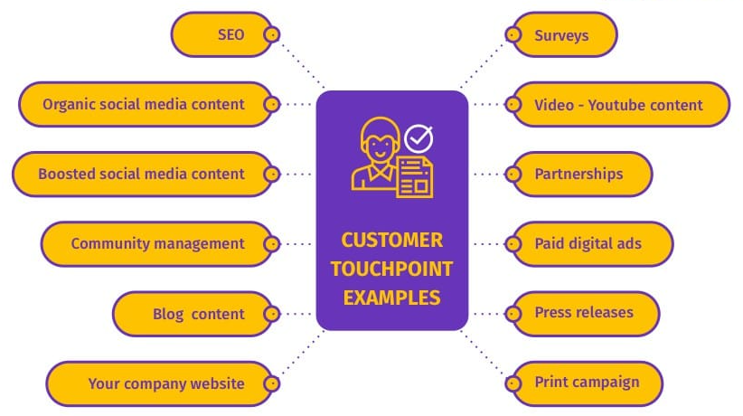
Figure 1: Customer touchpoints concerning Deliveroo.

Examining the customer touchpoints at Deliveroo
Effective digital marketing tactics, SEO, and email marketing to trigger customers’ need to purchase online: Customers face this touchpoint when they interact with Deliveroo's marketing channels such as emails, social media ads, or online advertisements (Cohen, Pham and Andrade, 2018). Effective digital marketing tactics help the company to reach out to more potential customers, increase brand recall, and generate interest in their service.
User-friendly website, menu design, variation of offers on the website and mobile app: Customers encounter this touchpoint when they visit Deliveroo's website or mobile app (Hoyer, MacInnis and Pieters, 2016). The importance of this touchpoint is critical for Deliveroo's success. Customers expect a seamless user experience while placing orders and browsing menus, and a poorly designed website or mobile app can lead to frustration, increased cart abandonment rates and lower customer satisfaction.
Availability of reviews and ratings of restaurants and delivery experience: Customers encounter this touchpoint when they browse the restaurants and read the reviews and ratings on Deliveroo's website or mobile app (Mathras et al., 2016). The importance of this touchpoint lies in the fact that it helps to build trust with the customers and improve their experience.
Quality of customer service via phone, email or chat support: Customers experience this touchpoint when they need assistance from Deliveroo's customer service team (Hoyer, MacInnis and Pieters, 2016). This touchpoint is crucial for Deliveroo, as customers expect prompt and efficient customer service to resolve their issues.
Ease in placing orders, online secured payment options, cash on delivery options: Customers encounter this touchpoint when they place orders on Deliveroo's website or mobile app. This touchpoint is vital for Deliveroo, as a seamless and secure ordering and payment process can lead to increased sales and customer satisfaction (Cohen, Pham and Andrade, 2018).
Delivery time estimates and delivery notifications: Customers experience this touchpoint when they place an order and receive delivery time estimates and notifications (Mathras et al., 2016). This touchpoint is critical for Deliveroo because customers expect transparency and real-time updates on their order status. Failure to provide accurate delivery time estimates and notifications can lead to customer dissatisfaction, negative reviews, and lower customer retention rates (Durante and Griskevicius, 2016).
Delivery packaging and presentation of food: This touchpoint is essential for Deliveroo, as it can impact the customer's perception of the overall experience (Hoyer, MacInnis and Pieters, 2016). A poor delivery packaging or presentation of food can lead to customer dissatisfaction and negative reviews.
Availability of the customer service team for any complaints or inquiries: Customers face this touchpoint when they need to contact Deliveroo's customer service team for any complaints or inquiries (Cohen, Pham and Andrade, 2018). The importance of this touchpoint for Deliveroo is critical because customers may have queries or complaints that need to be resolved promptly.
Loyalty programs, rewards, Gift card options for frequent customers: Customers face this touchpoint when they are frequent customers of Deliveroo and are eligible for loyalty programs, rewards or gift card options (Mathras et al., 2016). The importance of this touchpoint for Deliveroo lies in the fact that it can increase customer retention rates and incentivize repeat purchases, leading to increased sales and revenue.

Customer experience and brand experience at Deliveroo

Customer Journey Map of Deliveroo
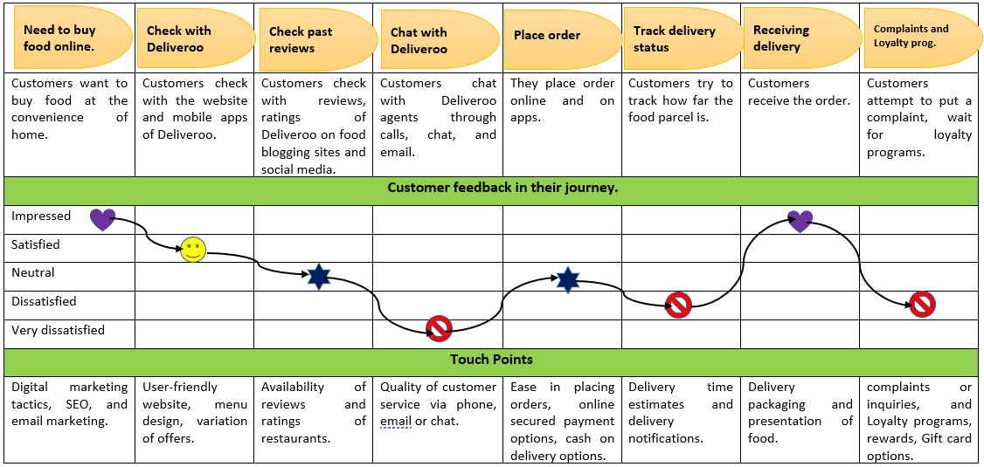
Figure 2: Customer Journey Map of Deliveroo (Self-designed, based on Hoyer, MacInnis and Pieters, 2016)

Examination of Customer experience and brand experience at Deliveroo
Need to buy food online: To trigger the customer's need to purchase online, Deliveroo invests in effective digital marketing tactics, SEO, and email marketing. The positive feedback will lead to a good first impression of Deliveroo, enhancing the brand experience. A positive experience at this stage will make the customer more likely to continue with the purchase and recommend Deliveroo to others (Durante and Griskevicius, 2016).
Check with Deliveroo: Deliveroo invests in a user-friendly website, menu design, and variation of offers to provide a seamless user experience. The actions taken by Deliveroo include providing an easy-to-navigate website and mobile app with clear menu options, attractive offers, and a search function (Deliveroo ., 2022). Hence, the feedback was positive. A satisfied customer at this stage will be more likely to proceed with the purchase and may even return for future purchases.
Check past reviews: Deliveroo provides reviews and ratings to help customers make informed decisions while choosing restaurants (Deliver .. 2022). The actions taken by Deliveroo include providing an easy-to-use review and rating system with accurate information. Neutral feedback does not necessarily impact the customer's decision to purchase (Mothersbaugh et al., 2020). However, if the reviews and ratings are not helpful, it can lead to customer dissatisfaction, negative brand experience, and loss of trust.
Chat with Deliveroo's agents: Deliveroo invests in providing quality customer service via phone, email, or chat support (Deliveroo ., 2022). Deliveroo initiated actions, include providing a responsive and efficient customer service team to resolve queries and complaints promptly. Very dissatisfied feedback at this stage can lead to negative brand experience and loss of trust. Poor customer service can lead to customer frustration, negative reviews, and customer churn (Durante and Griskevicius, 2016).
Place orders: Deliveroo invests in providing a secure and hassle-free ordering and payment process. The jobs done by Deliveroo are providing a seamless ordering process, online secured payment options, and cash on delivery options (Deliveroo .., 2022). Neutral feedback at this stage does not necessarily impact the customer's decision to purchase.
Track delivery status: Deliveroo strives to provide real-time delivery time estimates and notifications to keep customers informed about their order status (Deliveroo ., 2022). The company took many jobs, such as providing accurate delivery time estimates and real-time updates. Dissatisfied feedback of customers can lead to negative brand experience and loss of trust (Solomon et al., 2017). Customers expect transparency and real-time updates on their order status, and any issues with the delivery process can lead to customer dissatisfaction, negative reviews, and decreased customer retention rates (Mothersbaugh et al., 2020).
Receiving delivery: Deliveroo exerts efforts to ensure that the delivery packaging is sturdy, and the presentation of food is appealing to the customer (Deliveroo ., 2022). Impressed feedback at this stage leads to positive brand experience and increased customer loyalty. A positive delivery experience can lead to customer satisfaction, positive reviews, and increased customer retention rates (Stephen, 2016).
Ease with which customers can place complaints and loyalty programs such as gifts of reward points: Deliveroo tries to provide an easy access to its customer service team through multiple channels and loyalty programs to retain loyal customers and incentivize repeat purchases (Deliveroo ., 2022). Dissatisfied feedback at this stage will lead to negative brand experience and loss of trust (Mothersbaugh et al., 2020). A complicated complaint system or ineffective loyalty programs can lead to customer frustration, negative reviews, and decreased customer retention rates.

The importance and suitability of selecting the themes- customer touchpoints, customer experience and brand experience- concerning Deliveroo.
The touchpoints a customer faces with Deliveroo will significantly influence their experience and their perception of the brand (Stephen, 2016). Identifying and analyzing these touchpoints allows Deliveroo to understand the customer's journey and how it impacts their overall experience with the company.
Customer experience is shaped by the touchpoints, and it is critical for Deliveroo to deliver a positive experience at every stage of the customer journey (Mothersbaugh et al., 2020). By focusing on the customer experience, Deliveroo can identify pain points, improve the customer journey, and enhance customer satisfaction, loyalty, and retention rates.
Brand experience is the perception of the brand by the customers, and it is shaped by the customer experience (Stephen, 2016). A positive customer experience at every touchpoint enhances the overall brand experience, leading to increased customer loyalty and retention, and word-of-mouth recommendations. A negative experience at any touchpoint can lead to negative brand experience, affecting the company's reputation, sales and customer retention rates.

The impact of customer touchpoints, customer experience and brand experience on customer relationship management (CRM) at Deliveroo.
Customer touchpoints provide opportunities to interact with customers, gather information, and build relationships, which are essential for effective CRM (Mothersbaugh et al., 2020). By understanding the touchpoints, Deliveroo can identify opportunities to improve interactions with customers, enhance customer engagement and loyalty, and strengthen the customer relationship (Solomon et al., 2017). For instance, by providing a seamless and user-friendly website, Deliveroo can encourage customers to return and increase customer retention rates.
Customer experience is critical for CRM because it significantly affects the customer's perception of the company and the likelihood of building a long-term relationship (Stephen, 2016). A positive customer experience at every touchpoint can enhance customer satisfaction and loyalty. Deliveroo can use customer feedback and data to identify areas where the customer experience can be improved, address any issues, and provide solutions to enhance customer satisfaction and loyalty.
Brand experience is also essential to CRM because it can impact the customer's perception of the company and the likelihood of building a long-term relationship. By delivering a consistent and high-quality brand experience at every touchpoint, Deliveroo can differentiate itself from competitors, increase customer loyalty, and create brand advocates who recommend the company to others (Mothersbaugh et al., 2020).

Recommendations
Quality of customer service: Deliveroo needs to focus on providing high-quality customer service through all communication channels. Additionally, Deliveroo can improve the chatbot technology to provide accurate responses and reduce waiting times for customers.
Delivery time estimates and notifications: Deliveroo can work on improving its delivery time estimates and notifications by providing more accurate and real-time updates to customers. This can be achieved through the use of technology such as GPS tracking and real-time order tracking, providing regular updates on the delivery status to customers.
Complaints and loyalty programs: Deliveroo can improve its complaints and loyalty programs by providing customers with easy access to customer service channels and creating a more user-friendly complaints process. Deliveroo can also offer more attractive loyalty programs.

Section B: A critical literature review on the customer experience

A critical literature review on customer experience: Deliveroo’s perspective
The Importance of Customer Experience for Deliveroo
Several scholars have highlighted the importance of customer experience for companies like Deliveroo. Hsee and Tsai (2018) argue that the customer experience is crucial for building customer loyalty and trust. Morales, Amir and Lee (2017) note that companies must deliver exceptional customer experiences to remain competitive and succeed in the long run. Deliveroo's success is largely dependent on the quality of its customer experience, which includes the ease of placing orders, the quality of delivery, and the customer service provided.
The Role of Technology in Enhancing Customer Experience at Deliveroo
Deliveroo heavily relies on technology to enhance the customer experience. Hofacker, Malthouse and Sultan (2016) suggest that technology can help companies personalize the customer experience and build a more engaged customer base. Deliveroo uses technology such as GPS tracking and real-time order tracking to provide accurate delivery time estimates and notifications to customers (Deliveroo ., 2022). This technology helps to manage customer expectations and improves the overall delivery experience. Additionally, Chrysochou (2017) argues that technology can help companies like Deliveroo to create a seamless customer experience by providing easy-to-use websites and mobile applications.
The Importance of Feedback for Improving the Customer Experience at Deliveroo
Feedback is essential for improving the customer experience at Deliveroo. Stephens (2016) highlights the importance of feedback for companies to make data-driven decisions and continuously improve the customer experience. Deliveroo uses customer feedback to identify areas of improvement, address issues, and provide solutions to enhance customer satisfaction and loyalty (Deliveroo ., 2022). Deliveroo also provides multiple channels for customers to give feedback, such as the customer service team and online surveys. By actively seeking and responding to feedback, Deliveroo can improve the customer experience and build stronger relationships with its customers (Morales, Amir and Lee, 2017).

A critical literature review on customer experience: Co-creation perspective
Co-creation as a Strategy to Enhance Customer Experience
Co-creation, or the process of involving customers in the design and delivery of products and services, is increasingly being recognized as a strategy for enhancing the customer experience. Chen and Pham (2019) argue that co-creation can lead to more personalized and relevant experiences for customers. Mandel et al. (2017) suggest that co-creation can help companies to create a deeper emotional connection with customers. By involving customers in the design and delivery of products and services, companies like Deliveroo can create more engaging and meaningful experiences for their customers.
The Role of Technology in Facilitating Co-creation at Deliveroo
Technology plays a critical role in facilitating co-creation at Deliveroo. Murphy and Dweck (2016) suggest that technology can help companies to involve customers in the design and delivery of products and services. Deliveroo uses technology such as its website and mobile application to involve customers in the delivery experience, such as providing real-time delivery updates. Zhang and Benyoucef (2016) suggest that technology can also help to gather customer feedback and ideas for co-creation. By using technology to facilitate co-creation, Deliveroo can involve its customers in the design and delivery of its services, leading to a more engaging and satisfying customer experience.
Co-creation and the Creation of Brand Advocates at Deliveroo
Deliveroo consumers may become brand ambassadors via co-creation. Co-creation may make consumers happier and more inclined to recommend the brand, according to Arora et al. (2020). Brand supporters may boost firm sales, according to Hoyer, MacInnis, and Pieters (2016). Deliveroo can enhance sales and income by integrating consumers into service design and delivery. According to Mathras et al. (2016), co-creation may generate a cycle of consumer interaction that increases loyalty and advocacy.

How will understanding these two concepts help shape customer experience for Information Technology firms?
Understanding Customer Experience from the Firm's Perspective
Understanding customer experience from the firm's perspective can help information technology (IT) firms like Softcat, IRIS, Cazoo, Zopa, and Darktrace to design and deliver more effective products and services. Hsee and Tsai (2018) argue that customer experience is crucial for building customer loyalty and trust. IT firms that prioritize customer experience can create a competitive advantage by delivering a superior customer experience. For example, Monzo, a UK-based mobile-only bank, has created a user-friendly and efficient mobile application, providing a seamless customer experience for its customers (Wewege, Lee and Thomsett,2020).
Co-Creation and Customer Experience in IT Firms
Mandel et al. (2017) suggest that co-creation can help companies to create a deeper emotional connection with customers. By involving customers in the design and delivery of products and services, companies can create more engaging and meaningful experiences for their customers. For example, Hopin, an online events platform, has co-created its product with customers to provide a user-friendly and customizable virtual event experience for its clients (Gao et al., 2021).
The Role of Technology in Enhancing Customer Experience for IT Firms
IT firms can leverage technology to enhance the customer experience, including co-creation efforts. Murphy and Dweck (2016) suggest that technology can help companies to involve customers in the design and delivery of products and services. For example, Darktrace, a cybersecurity firm, has leveraged machine learning and artificial intelligence to provide real-time cyber threat detection, enhancing the security and protection of its clients (Qumer and Ikrama, 2022).

References
Arora, N., Charm, T., Grimmelt, A., Ortega, M., Robinson, K., Sexauer, C., and Yamakawa, N. (2020). A global view of how consumer behavior is changing amid COVID-19. Mcknsey and Company.
Chen, C. Y., and Pham, M. T. (2019). Affect regulation and consumer behavior. Consumer Psychology Review, 2(1), 114-144.
Chrysochou, P. (2017). Consumer behavior research methods. In Consumer perception of product risks and benefits (pp. 409-428). Springer, Cham.
Cohen, J. B., Pham, M. T., and Andrade, E. B. (2018). The nature and role of affect in consumer behavior. In Handbook of consumer psychology (pp. 306-357). Routledge.
Deliveroo plc., (2022). 2021 Annual Report. [Online] Available at https://dpd-12774-s3.s3.eu-west-2.amazonaws.com/assets/9916/4856/5872/Deliveroo_plc_Annual_Report_2021.pdf [Assessed date 17 February 2023]
Durante, K. M., and Griskevicius, V. (2016). Evolution and consumer behavior. Current Opinion in Psychology, 10, 27-32.
Gao, Z., Sheng, J., Wang, Z., and Yao, Y. (2021, December). The Application of POCD Framework to Current Online Platform Venture Capital Investment. In 2021 3rd International Conference on Economic Management and Cultural Industry (ICEMCI 2021) (pp. 2934-2939). Atlantis Press.
Hofacker, C. F., Malthouse, E. C., and Sultan, F. (2016). Big data and consumer behavior: Imminent opportunities. Journal of consumer marketing.
Hoyer, W. D., MacInnis, D. J., and Pieters, R. (2016). Consumer behavior. Cengage learning.
Hsee, C. K., and Tsai, C. I. (2018). Hedonomics in consumer behavior. In Handbook of consumer psychology (pp. 637-655). Routledge.
Mandel, N., Rucker, D. D., Levav, J., and Galinsky, A. D. (2017). The compensatory consumer behavior model: How self-discrepancies drive consumer behavior. Journal of Consumer Psychology, 27(1), 133-146.
Mathras, D., Cohen, A. B., Mandel, N., and Mick, D. G. (2016). The effects of religion on consumer behavior: A conceptual framework and research agenda. Journal of Consumer Psychology, 26(2), 298-311.
Morales, A. C., Amir, O., and Lee, L. (2017). Keeping it real in experimental research—Understanding when, where, and how to enhance realism and measure consumer behavior. Journal of Consumer Research, 44(2), 465-476.
Mothersbaugh, D. L., Hawkins, D. I., Kleiser, S. B., Mothersbaugh, L. L., and Watson, C. F. (2020). Consumer behavior: Building marketing strategy. New York, NY, USA: McGraw-Hill Education.
Murphy, M. C., and Dweck, C. S. (2016). Mindsets shape consumer behavior. Journal of Consumer Psychology, 26(1), 127-136.
Qumer, S. M., and Ikrama, S. (2022). Poppy Gustafsson: redefining cybersecurity through AI. The Case for Women, 1-38.
Solomon, M. R., White, K., Dahl, D. W., Zaichkowsky, J. L., and Polegato, R. (2017). Consumer behavior: Buying, having, and being (Vol. 12). Boston, MA: Pearson.
Stephen, A. T. (2016). The role of digital and social media marketing in consumer behavior. Current opinión in Psychology, 10, 17-21.
Stephens, D. L. (2016). Essentials of consumer behavior. Routledge.
Wewege, L., Lee, J., and Thomsett, M. C. (2020). Disruptions and digital banking trends. Journal of Applied Finance and Banking, 10(6), 15-56.
Zhang, K. Z., and Benyoucef, M. (2016). Consumer behavior in social commerce: A literature review. Decision support systems, 86, 95-108.

