“A detailed analysis of one child’s holistic development, with justification for the next steps in learning.”

Introduction

This essay will aim to analyse the holistic development of a specific child, with justification for the next steps in their learning. The main purpose of my research is to emphasise the importance of understanding and listening to the children’s perspectives of their learning experience, as opposed to seeing them as a passive object in the research (Qvortrup et. al, 1994, p.2).

The research study will take place in School X, situated in Powys. The name of the school will remain anonymous to ensure that confidentiality is maintained at all times. The school has 210 pupils, on roll with around 37% of pupils identified as having additional learning needs. School X is a lively and successful school which provides exciting learning opportunities to its pupils. For my second part of my Professional Teaching Experience (PTE) I was placed in the Year 1 / 2 class consisting of 23 children (please see figure 1 for class layout). During the observation week of PTE, I had the opportunity to observe the children during focus tasks, continuous provision and play times. From this, I was able to select the child I thought would be best suited to this study. To ensure confidentiality is maintained, the name of my target child will remain anonymous and will be referred to as Child A. Child A is a male member of the mixed Year 1 / 2 class. Child A is 6 years of age, his ability group is Mercury (MAT pupils) and he is in the Yellow group for Read, Write, Inc (RWI). General observations evidence that he is always ready to learn and is a valuable contributor to the classroom during carpet time who is always willing to participate and provide an answer to questions.
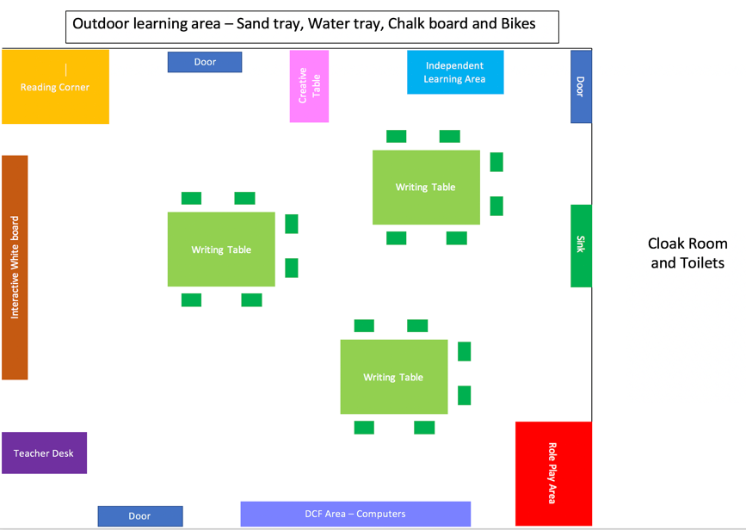

Figure 1: Classroom Layout
Data collection
In order to analyse the holistic development of a child, every area of their learning, development and growth must be observed and analysed (Brodie, 2018). The main approach to the research and data collection process is modelled on the Mosaic Approach which places emphasis on the significance of pupil voice and listening to the child’s perspective of their learning. According to Clark and Moss (2001;2003) “this approach was developed during a research study to include the ‘voice of the child’ in an evaluation of a multiagency network” emphasising the importance of listening of considering the child’s thoughts and feelings about their learning experience. The Mosaic approach consists of a wide range of data collection methods which will be evaluated, analysed and combined to gain an understanding of the child’s perspective of their learning and their academic ability, whilst providing justification for their next steps in learning.
These methods consist of observations, photographs, collection and analysis of the child’s work, a learning walk and semi-structured interviews which will provide me with the opportunity to collect, evaluate and analyse qualitative data results. According to Clark (2005, p.13) “The name, the Mosaic approach, was chosen to represent the bringing together of different pieces of perspectives in order to create an image of children’s worlds both individually and collectively” placing an emphasis on the importance of exploring children’s own perceptions with regards to their interests, hobbies and academic achievements (Christensen and James, 2000).
As previously stated, the research was based on qualitative data which allows for various philosophical approaches to collecting data as it does not gather numerical information but allows the use of semi-structured interviews and open-ended questionnaires (Merriam and Tisdell, 2015). Furthermore, according to multiple research, the qualitative data approach focuses on understanding, exploring new ideas and discovering specific patterns in the child’s learning through the use of observations and semi-structured interviews during placement.
Limitations of qualitative data???
Although there are many strengths to the use of the Mosaic approach, there are also limitations. According to Clark (2005, p.20) “One of the disadvantages of working within the confines of a research study is the limited time available for such listening”. As highlighted by Clark and moss (2001;2003) children are to be seen as “meaning makers” and “skilful communicators” where the researcher listens to the child’s perspective of their learning. However, during the research it became evident that there was limited time available due to only being at the placement for 3 weeks.
Observations

Observations are a systematic approach to data collection which enables the researcher to examine a child in their natural settings (Quales, 2008). According to the Welsh Assembly Government (WAG) (2008, p.6) “Through observing and listening, practitioners are able to gather evidence before and after children have been taught a skill” enabling practitioners to monitor and assess the child’s progression and identify gaps in their learning. Furthermore, the use of observations allows practitioners to use a variety of teaching methods in order to determine the learning preferences for a specific child (WAG, 2008). Although there are many advantages to the use of observation in the classroom, according to Palaiologou (2012, p.96) one of the main limitations is that “capturing what actually happens or a certain behaviour or activity divorces it from its history” suggesting that although observations allow the collection of a wide range of data, they do not always evidence the cause of the behaviours. Therefore, suggesting that observations are not always a valid method of data collection.

Learning walk and Photographs

According to Stout, Kachur and Edwards (2015, p.19) “learning walks are treated as technical solutions that alone would change teacher practice and improve student learning” suggesting that learning walks are an effective tool to accompany research as they allow the researcher to experience the places that are special to the child and aid their learning. Also enabling the child to take photographs of the areas around the school which promote effective learning for them. Whilst on the learning walk, Child A was able to take photographs of the ‘important things and places’ around the school which aid their learning (Clark, 2005), thus allowing them to take ownership of their learning and to be “experts in their own learning” (Clark and Moss, 2005).

Semi-structured interviews

The final research method used was an informal discussion with the class teacher and Child A. The use of interviews and discussions in a qualitative piece of research allows the researcher to ask a variety of questions in order to gain the relevant information to inform their research topic. One of the main benefits to the use of interviews and discussions is that they allow the participant to discuss their personal feelings, opinions and perceptions of their own learning through face to face contact and are not influenced by the opinions of their peers (Crowther, Lancaster and Lancaster, 2009). This is also supported by WAG (2008, p.6) who states that “it is important that practitioners listen to children as well as watch them when observing, as they can learn a great deal about children’s learning and understanding through listening to their speech” emphasising the importance of talking to the child and respecting their opinions and perspectives. In addition, the use of discussions with the class teacher will enable me to gain an insight into the child’s level of ability, chronological and reading age and how they behave in general on a day-to-day basis. In contrast, it is evident that there are many strengths to the use of interviews and discussions. However, one of the main limitations is that the main goal is to gather a range of information from a wide range of subjects (Edwards and Holland, 2013). However, due to the short time scale of the placement and the ‘Fitness Fortnight’ which took place, causing disruptions to the teaching timetable, there was limited opportunity for discussions to take place around a wide range of subjects.

Ethical Considerations

Whilst conducting the research, it was evident that there are many ethical issues to consider. Research and data collection processes which involve human beings requires that all humans are treated fairly and in accordance with the standards and values which affirm their human rights (Oliver, 2003). To ensure the ethical considerations are adhered to at all times and that the participant is treated ethically, the ethical guidelines from the British Education Research Association (BERA) (2018) were followed. Prior to beginning the research process, permission for the research to take place was obtained from the class teacher (see appendix 1) and permission from the child’s parent was also obtained for their child to be a participant in the research (see appendix 2). The data collected was anonymous and the name of the school and the participant remained anonymous to ensure confidentiality is maintained. In addition, during the research process, the participants will be constantly reminded that if they wish to withdraw from the research they have the right to do this under the principle of freedom act (Oliver, 2003).

Analysis of Child’s work and Next Steps
Monitoring and assessment of a child’s holistic development throughout school is a vital aspect to support their progression. In order to analyse Child A’s holistic progression, the ASK model was taken into consideration and implemented during the research. According to Nottingham (2013, p.4) the ASK model takes into the consideration the “attitudes (positive attitudes towards learning, curiosity and persistence), the skills (the ability to carry out the necessary wider skills) and the knowledge (familiarity with concepts) of a learner” which enabled me to assess and monitor the child’s progression in each area of learning whilst taking into to consideration his next steps for learning (see figure 2 for example of the ASK model).
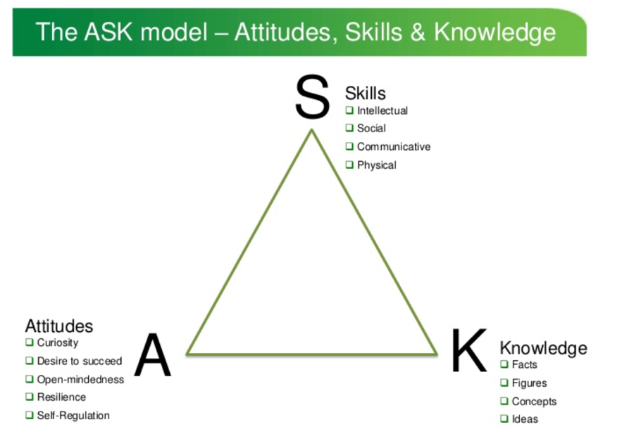

Figure 2: The Ask model

Language, Literacy and Communication (LLC)
LLC: Reading

During the first Read, Write, Inc (RWI) session with Child A, I asked him what element of the RWI session he enjoyed most, to which he replied, “I enjoy reading because reading is fun”. This related to the photographs Child A took. When asked to take photographs of his favourite areas in school, Child A took a photograph of the school reading area (appendix 3) and went on the explain that he liked the book corner because he “likes to read in a quiet area” as the classroom is too noisy to read. During a discussion with the class teacher, it because evident that Child A “has a lot of input at home with Mam who reads with him most nights in comparison to other children in the class” which evidences the impact on parent involvement and the affects it has on a child’s motivation to read (Nottingham, 2013). Furthermore, this supports the ASK model in relation to Nottingham (2013) and the impact families have on a child’s motivation to read and is further supported by a case study carried out in America by Wigfield and Guthrie (1997) who reviews the literature supporting the impact family influences have on children in relation to children’s’ motivations for reading. According to Wigfield and Guthrie (1997, p.69) “children whose early encounters with literacy are enjoyable are more likely to develop a predisposition to read frequently and broadly in subsequent years” emphasising the importance of home input to encourage and motivate children to want to read instead of seeing it as a chore. A more recent study carried out by Yusof in 2010 found that “almost 50% of children are not interested in reading” suggesting that instead of children reading because they want to read, they are ‘reading reluctantly’ as they do not want to read. Furthermore, Chakravarthy (2001) suggests the importance of an intimate relationship between a mother, her child and reading will lead to a positive impact in raising the child’s interest and motivation to read.

In relation to the discussion with the child and the photographs he took of the reading area, a reading record was completed during the PTE to monitor and assess Child A’s progress (aooendix 3). The reading record evidences that Child A’s reading age is 7 showing that he is currently above target for his actual age of 6 and is at Outcome 5. In relation to The Foundation Phase Framework (2015, p.53) on Outcome 5 the child should be able to track print and should have “growing accuracy, fluency and emphasis” this again is evidenced in the Reading Record for Child A in (appendix 3) as he displayed a clear understanding of the books he was reading and was beginning to use emphasis when required. Furthermore, Child A showed a great deal of knowledge and understanding of the Power words during the RWI activity as evidenced in the observation form (appendix 4) where he was able to draw on his own knowledge of his feelings and place the word ‘miserable’ into a real-life meaningful sentence, relating back to the ASK model of the knowledge of the learner.

Next Steps: LLC: Reading

With the intention of supporting Child A’s learning and progression in reading, consideration must be placed in relation to his next steps for learning. Following a discussion with the class teacher, it became evident that in order for Child A to progress onto Foundation Phase Outcome 6, he needed encouragement to “read independently and are able to establish meaning whilst reading fluently and expressively” thus emphasising the importance of children being able to read independently by the time they leave the Foundation Phase. In addition to this, Child A requires further support in using clear expressions when reading aloud, this can be supported by the popular intervention strategy of ‘Modelled Reading’. According to the Council for the Curriculum, Examinations and Assessment (CCEA) (2019, p.3) “children develop a disposition to read as stories and books are read to them” children see the reader as a role model and they often imitate their behaviour, for example they will imitate the way the reader has read a certain passage. It later became evident that the main strategy which would be effective for Child A in this instance would be for the teacher to read a passage and for Child A to read the passage back to the teacher immediately, mimicking the exact expressions the teacher has used. This will enable him to become familiar with noticing the clues in the passage which will guide him to using the correct expression whilst building in confidence. Furthermore, as previously identified, Child A may benefit from being given a certain passage to read through different emotions, for example ‘sadness’ which will then emphasise the expressions required during this passage. This is further supported by the CCEA (2019, p.3) who states that “children participate by listening and observing the expert at work” providing the child with the opportunity to listen to the text being read correctly by the teacher, encouraging the child to imitate and use the same correct expression they previously heard, enabling Child A to progress onto Outcome 6.

Mathematics

During the Maths session which included the learning objective of “How to break down numbers into 100s, 10s and units” Child A displayed excellent subject knowledge and understanding of the concept of each place value. As evidenced by the worked collected and analysed (appendix 5 and 6) Child A is able to count 1 more, 1 less independently and use the number square independently. However, when counting 10 more or 10 less, Child A required support to use the number square. Emphasis was placed on Child A’s passion to learn new things and evidenced a willingness to ask for support from additional adults, in relation to the attitudes strand of the ASK model (Nottingham, 2013), evidencing his curiosity to learn new skills. Furthermore, as evidenced by work collected for place value of numbers (appendix 7), Child A evidenced a strong understanding of subject knowledge and the place value of each number and was able to speak the numbers and write them independently and correctly up to 1000. In relation to the Foundation Phase Framework (2015) Child A is currently achieving a significant amount at Outcome 4 as he is able to count sets of objects reliably, he is able to order numbers up to 100, adding 1 more, 10 more and subtracting 1 less and 10 less. Furthermore, Child A is also able to use place value in numbers up to 1000 as demonstrated in the work collected (appendix 7).

Next steps

Mathematical development is a significant aspect to young children, the Curriculum Guidance for the Foundation Stage (QCA, 2000) focuses on “what the children must learn and understand in order to develop as mathematical thinkers” and highlights the significance and ongoing importance of the development of mathematical learning in order for children to develop a clear understanding. In order for children to develop their mathematical knowledge, understanding and skills, they must first begin to enjoy learning and exploring through maths (Pound, 2008). Due to this, I feel the task I set for Child A was not challenging enough as he was able to complete the task at a fast pace. According to Silver and Stein (1996) children need to establish how to select their own numerical values in order to implement them into a problem-solving task, this will then lead to significant progress and development in their Mathematical Outcome at the end of Foundation Phase. Therefore, the intervention activity I think will best suit Child A is to allow him to gain ownership of his learning, providing him with the opportunity to personalise his learning and become more self-directed (Bray and McClaskey, 2015). In order to do this, Child A will be provided with opportunities to create and build his own numbers, to challenge his learning. Furthermore, based on a research project carried out by Roger (2007) practitioners should take into account the ability of each child, ensuring to offer consistent challenging activities and providing them with opportunities to take ownership of their learning.

Personal, Social and Emotional and Well-being

When asked to take photographs of his favourite areas around the school, Child A instantly referred to the ‘Nurture Room’ (appendix 8) because “it makes me feel happy because it is calm and safe” thus emphasising that the nurture room is a safe and welcoming environment. In contrasts, Child A did not take any photographs of the carpets area, independent learning area or the role play area where he has the opportunity to participate in play-based learning activities with his peers. However, in relations to the Foundation Phase Framework (2015) Child A is currently achieving Outcome 4 as he is able to cooperate in play independently and with peers, he is able to concentrate on a task and is also able to comfort and help other children when they are sad or upset (this is evidenced in an example of PSE work in appendix 9). This further supports the ASK model (Nottingham, 2013) in relation to Child A’s skills, socially and communicatively with his peers. The Well-being of a child is paramount to every school, according to National Child’s Bureau (2019, p.7) “school years are key to developing social and emotional skills, knowledge and behaviours” emphasising the importance that the well-being of a child is taken into consideration on a daily basis and support is provided when required. In addition to this, as evidenced in a written Observation (appendix 10) on the 2nd May 2019 Child A began the school day looking drained and very tired, impacting on his academic learning. During a discussion with the Child, he expressed how little sleep he had received the night before due to a young sibling keeping him away. From this, Child A’s Well-being was effected during the school day leading to a lack of academic effort and involvement. As a result of this, Child A did not consume lunch that day and also fell asleep during the 4th session of the day. Although Child A is currently at Outcome 4 academically, it is evident that his Well-being needs requiring addressing with regards to home life.

Next steps

In order to progress onto Outcome 5, interventions needs to be set in place both at home and school to ensure the Well-being of Child A is paramount and his school life is not affected. In order for Child A to maintain a high standard of Well-being, the intervention Emotional Literacy Support (ELSA) will be implemented into his weekly routine. According to Steiner (1997, p.23) “Emotional literacy improves relationships, created loving possibilities between people…and facilitates the feeling of community” emphasising the importance of being emotionally literate and having confidence to discuss and have control over his feelings with his peers. Furthermore, according to the ELSA network (2017) pupils feels supported by having “special” time with the designated ELSA staff and feel valued and listened to. I feel this would benefit Child A as during the observation, he did not initially discuss the cause for concern with a member of staff, instead he sat and allowed his emotions to override him, causing him to become upset. Therefore, I feel ELSA intervention would benefit Child A and aid them in progressing from Outcome 4 to Outcome 5.

Knowledge and Understanding of the World

Knowledge and Understanding of the World (KUW) is a vital aspect to the child’s learning experience in schools. According to WAG (200, p.4) “knowledge and understanding of the world relates to children…wider world” thus suggesting the importance of developing skills and knowledge based on natural events which occur. During the first KUW session, Child A was able to participate and discuss what the different types of Cyclones are, evidencing a great understanding of the different types of Tropical Storms which affect the World. In relation to the ASK model (Nottingham, 2013) Child A evidenced a wide range of knowledge in regard to facts and ideas about Cyclones. This is evidenced in a piece of KUW work collected (appendix 11), Child A demonstrated a good understanding of the different types of Cyclones and was able to listen, concentrate and write a sentence independently. Furthermore, in regard to the work collected for KUW, Child A also demonstrated a good level of questioning drawing on prior knowledge. From this, it is evident that Child A is currently attaining Outcome 4 overlapping with Outcome 5 in relation to the Foundation Phase Framework (2015). Child A was able to follow simple instructions and was able to remember the significant event from The Wizard of Oz (Tornado), allowing him to link prior knowledge to the questions asked on the fact file template. Furthermore, Child A was able to show an understanding of what he had found off the internet by orally feeding back to his peers.

Next steps

With the intent on aiding Child A to progress from Outcome 4 and 5 overlapping, consideration must be placed into his next steps of learning. During a discussion with the class teacher with, it became evident that one of the way Child A could progress onto the next Outcome would be to provide him with a wider range of resources to carry out the task of creating a fact file. The initial planning for the session required staff to sit with each group and operate the iPad, supporting the children to find out the different facts about each Cyclone. During the monitoring and assessment element of the session, it became evident that many children found this task too simple, they needed further challenging. According to Costa (1998, p.400) “students languish in classrooms working on tasks that offer limited scope for learning and provide opportunities for the development of the intelligent behaviours necessary for success in life” emphasising the importance of setting a challenge task for the More Able and Talented (MAT) pupils to ensure that they are always working towards progressing onto the next steps in learning. Therefore, in order to support and aid Child A with in progressing onto Outcome 5 I feel the best intervention which can be set in place would be to ensure that future planning includes a challenge task for Child A to ensure that he is able to work towards a higher Outcome and is provided with the correct opportunities to develop and build on his skills and knowledge.

However, one limitation to this would be that he may feel there is too much pressure being placed on him, this could lead to him becoming withdrawn from the activity. To ensure this does not happen, a challenge task will be set on a specific table and all members of the class will be encouraged to work towards completing the challenge task, this will then ensure inclusion in the classroom. This is further supported by Salazar, Norton, and Tuitt, (2009) who suggests that an inclusive classroom is where all students are encouraged and feel supported to learn and explore ideas, it is a place where thoughts, academic achievements and mutual respect are promoted and valued at all times.

Physical Development

Children’s Physical Development, energy, and enthusiasm for movement should be constantly promoted and encouraged throughout their education (Foundation Phase Framework, 2015). When asked to take photographs of his favourite places around school, Child A took a photograph of the outdoor learning environment (appendix 12) because “there are lots of fun activities to do and I like to play on the bikes and run with my friends” emphasising his passion for the outdoors and physical development. After various informal observations and photographs of Child A using the outdoors it is evident that Child A has strong fine and gross motor skills. Fine and gross motor skills are vital to the progression or a child (Hurley, 2000) and provide children with the ability to participate in everyday activities, with experience and development, the skills become automatic and children need not think about putting them in place (Zwicker and Harris, 2009). The connection between physical and motor skills is supported by Charlesworth (2017, p.230) who stated that “both are critical areas in the lives of children” emphasising the importance of progression in these areas to ensure the child is able to achieve their best Outcome. During a discussion with the class teacher and as evidenced in the photographs of the Physical Development session (appendix 13) Child A is currently at Outcome 4 for Physical Development in accordance to the Foundation Phase Framework (2015), he is able to run whilst kicking a ball and has displayed good movement skills whilst controlling the speed and direction of his movements. Furthermore, Child A was able to evidence the link between physical development and motor skills through good pencil control whilst carrying out writing activities to ensure his handwriting was neat and legible (appendix 14).

Next steps

In order to progress onto Outcome 5, Child A must begin to display confidence in jumping off apparatus and also be able to bounce a ball with one hand. During informal observations of Physical Development lessons, it is evident that Child A is already able to catch a ball with two hands and ride a two-wheeled bike. However, in order to achieve Outcome 5, he must first display the ability to fully meet the success criteria of Outcome 5. According to the Welsh Assembly Government (2008, p.3) “setting a high level of activities that encourage body awareness or movement competence will provide the opportunity for children to develop physical literacy” emphasising the balancing and controlling, opportunities physical literacy provides to the children. An activity I would like to set in place to support the progression of Child A in Physical Development relates to Physical Literacy. The activity is a ‘Spell Your Name Workout’ (appendix 15) which provides children with the opportunity to participate in a fitness workout without realising. This activity can be done in the classroom or outdoors, providing the children with a wider range of environments and apparatus to include whilst sequencing their name with the different movements. According to Bear et al., (2007, p.??) “physical activity is related not only to optimal functioning of your muscles but also to optimal functioning of your brain”. Therefore, the use of Physical Literacy will stimulate the brain of Child A by getting them to think of each letter in their name and link it to which movement they must perform to match the letter. Although there are benefits to this intervention activity, one limitation would be that some children are unable to spell their name independently, this may then have an effect on their self-esteem as they may feel embarrassed whilst carrying out this activity in front of their peers. To prevent this from happening, as the class teacher will be aware of the children who may require support, this can be done by writing the child’s name on an A3 piece of paper along with each movement they must perform to enable each child to participate in the activity regardless of their ability level.

Conclusions

