Emotional Intelligence

The importance of Self-Awareness

Component Two — Report

University of Wales Trinity Saint David
Executive Summary
This report discusses the vital nature of self-awareness to managers in contemporary organisations and assesses how five systematic problems that state gratitude, time in nature, solitude, better sleep and pausing before responding contribute to the growth of the self. Based on modern studies, the report found self-awareness to be a cornerstone of emotional intelligence, allowing managers to be exposed to their feelings, an appreciation of the impacts of their actions on others, and more ethical, compassionate, and performance-oriented decisions. Self-aware managers have been found to achieve better employee relationships, work-related conflict, and organisational performance in the post-COVID workplace, where employee wellbeing and psychological safety are put at the centre, and flexible leadership styles are favoured over others.
The report critically evaluates the theoretical principles of frameworks of every challenge and illustrates how they may be coordinated with the available concepts in mindfulness, positive psychology, and emotional regulation. The report's analysis of personal experiences of three challenges within the Reflective Cycle developed by Gibbs shows considerable results of positive changes in emotional awareness, stress regulation, and interpersonal awareness. Patterns in emotional triggering, values and behavioural tendencies are also outlined in these reflections.
In general, the results indicate that it is meaningful to tackle these problems regularly, as it enhances the level of self-awareness and emotional intelligence. The report finds that such practices should be incorporated by managers into their daily activities, and a six-month development strategy is proposed to maintain further growth.

Table of Contents
Emotional Intelligence 1
The importance of Self-Awareness 1
Component Two — Report 1
1. Introduction 4
2. Critical Analysis of the Importance of Self-Awareness in Managers 4
3. Critical Discussion of the Underlying Concepts (Challenges) 6
3.1 Gratitude 6
3.2 Spending Time in Nature 6
3.3 Practising Solitude 6
3.4 Getting Sufficient Sleep 7
3.5 Pausing Before Reacting 7
4. Reflection (Gibbs’ Reflective Cycle) on Three Challenges 8
Challenge 1: Expressing Gratitude 8
Challenge 2: Practising Solitude 9
Challenge 3: Pausing Before Reacting 10
5. Conclusion 11
6. Six-Month Development Plan 11
References 13

1. Introduction
Emotional Intelligence (EI) is no longer a frivolity in the modern organisational environment, particularly among managers who have to deal with complicated interpersonal dynamics and high emotional pressure. EI facilitates adaptive and resilient leadership as it is defined as the capacity to perceive, understand, regulate and utilise emotions in self and others (Salameh-Ayanian et al., 2025).
Among the five key dimensions of EI, namely, self-awareness, self-regulation, motivation, empathy, and social skills, the first one is self-awareness. Self-awareness is the ability to know emotional conditions, triggers, strengths and weaknesses, along with understanding the influence on behaviour and decision making. It has been indicated that self-aware leaders prove to be better persons to make reflective decisions, elicit trust and composure under pressure (Dahir 2025).
Self-awareness is becoming increasingly relevant in a business world that is rapidly transforming and volatile due to the post-COVID pressures, remote working, and fluctuating team relationships. Not only do leaders who develop such awareness speak in a more authentic tone, but they are also more likely to encourage employee engagement, performance, and psychological well-being (Greely 2024). Furthermore, there is a growing body of evidence that leadership based on emotional intelligence may result in a significant level of competitive advantage. Recent research has shown that high-EQ leaders can create a level of performance enhancement of up to 40% in such areas as coaching, decision-making, and influence (EQfluence 2024).
This report critically examines the importance of self-awareness as a part of contemporary management science. It considers appropriate practices, makes a reflection that is based on a structured reflection, and provides a six-month development plan to improve conscious structure and general emotional intelligence.

2. Critical Analysis of the Importance of Self-Awareness in Managers
Self-awareness has been accepted as a key element of emotional intelligence (EI) and is an important aspect of effective leadership and management. Self-awareness helps managers in contemporary organisational contexts to lead authentically, make decisions, handle stress, and build trust among his or her teams.
First, self-aware managers have a realistic comprehension of their emotions, values, strengths, and weaknesses. This kind of self-knowledge helps them to coordinate their behaviour with organisational values and the organisational goals, which ultimately results in conscious and principled decision-making (IOE 2025). As reported in a study conducted by the Institute of Organisational Effectiveness, emotionally self-aware leaders are trustworthy as their sincerity makes people believe in them (Salameh-Ayanian et al., 2025). Leaders who are able to express their motivations well and when they can notice that they are under stress or other feelings of emotion will be less prone to decision making on the spur of the moment and letting their feelings run riot in making judgments.
Emotional control also occurs with self-awareness. Managers can avoid reactive behaviour and stay composed at the time of stress by noticing their internal bases of emotion triggers when the situation is getting out of hand (Well, 2024). This has a direct contribution to organisational resilience. Self-aware leaders project the image of calm and consistency, hence stabilising the team in turbulent environments, including when facing a crisis or uncertainty. Moreover, they also ensure that they limit stress in the team by being able to manage their own emotional state, thus they have reduced contagion perpetrated by themselves and other individuals.
The other significance of self-awareness is in communication and empathy. Emotionally aware leaders will be more sensitive to the way they are appearing, such as their tone, their body language, as well as their reaction to others (Alasmari et al., 2025). A different study conducted by a journal in management science stated that self-awareness plays a great part in improving relationships in the workplace, which leads to building trust and a culture of teamwork (Ilori 2024).
Notably, self-awareness does not merely involve personal insight: it is a tactical ability of contemporary organisations. The article published by Forbes (2024) argues that it is the understanding of self that helps leaders to be aware of the blind spots by using feedback systems, including 360-degree evaluations, and work on them (Cecchi-Dimeglio 2024). The process of feedback and reflection in this way leads to developing effectively and keeping the leaders abreast of the times and requirements of the organisation.

3. Critical Discussion of the Underlying Concepts (Challenges)

3.1 Gratitude
The practice of gratitude helps people to pay intentional attention to the positive elements in life, which facilitates emotional reflection and awareness of what is important to them. In a recent free study, it was established that trait gratitude is highly associated with improved emotion regulation and well-being. General and body-focused gratitude had a positive relationship with emotion regulation, which subsequently forecasted life satisfaction and self-compassion (Dennis and Ogden, 2025).
Being thankful regularly makes a person more conscious of the values in personal lives, social relationships, and moods. Gratitude encourages self-examination of personal lives, as well as external association relationships, hence cultivating emotional intelligence.

3.2 Spending Time in Nature
Nature helps to enter meditative states, relieve stress and even rest the mind, helping to better reflect on internal feelings. Developmental psychology research indicates that nature affiliation has been the mediating factor between emotion regulation (especially during early childhood), which results in minimised stress levels and enhanced attentional control (Ríos-Rodríguez et al., 2024).
Natural time gives a person an opportunity to forget his or her everyday needs, enabling him to look inward and be emotionally clear. This contemplative moment may assist people in determining how they feel, triggers and values. The availability of nature in an urban or high-density workplace can be restricted.

3.3 Practising Solitude
Voluntarily, solitude leads to high levels of self-reflection, identity-building, and thinking. One study has shown that self-reflection has a mediation effect on solitude and identity development. In addition, a positive redirection of solitude positively alters low-arousal positive affect, which is a sign of restoration of emotions (Zulkifli et al., 2024).
Solitude can provide the space of mind to challenge inner voices, evaluate life stories, and have insights into the motivations and behaviours. It assists in the incorporation of the emotional experiences, culminating in improved authenticity (Meda 2025). Solitude is not always good; it may be perceived as loneliness when applied in a negative perspective. The moods of loneliness are directly based on the perception of the person and the attitude that the person has with regard to being alone.

3.4 Getting Sufficient Sleep
A higher quality of sleep aids emotional control, cognitive control, and impulsiveness, and allows individuals to have a clearer understanding of themselves. Recent studies indicate that the lower the quality of sleep, the higher the problems in the regulation of the emotional process through the mediation of daytime dysfunction and weaker self-control (Wang et al., 2024). The other research on adults has established that people with higher sleep quality engage more adaptive emotion-regulation strategies (Parsons et al., 2022).
By sleeping well, it is easy to take clear reflections about emotions, identification of emotional changes, and recover from emotionally straining days. Sleep is a reactionary element to numerous external determinants (Schedule of work, stress, environment) and hence it cannot be controlled easily.

3.5 Pausing Before Reacting
Such practice develops self-regulation through establishing a state of awareness between the triggering emotional response and reaction, and thus breaking the reactive modes. This is even though direct experimental research investigating pausing before responding is rare, but emotion-regulation studies in this field provide a strong rationale in favour of interruption (breathing, reappraisal), which enhances emotional control and awareness. Structured reappraisal and regulation are also under analysis via emerging interventions (including robot-led interventions) (Laban et al., 2025).
Training oneself to pause allows one to get used to a way to monitor their emotional arousal, to figure out what triggers the particular reaction and to decide on the way of responding more intentionally. This will eventually develop an understanding of individual emotional reactions and default reaction patterns.

4. Reflection (Gibbs’ Reflective Cycle) on Three Challenges
Reflective Cycle by Gibbs (1988), the reflective cycle by Gibbs is a properly organised model of thinking (McLeod 2025).
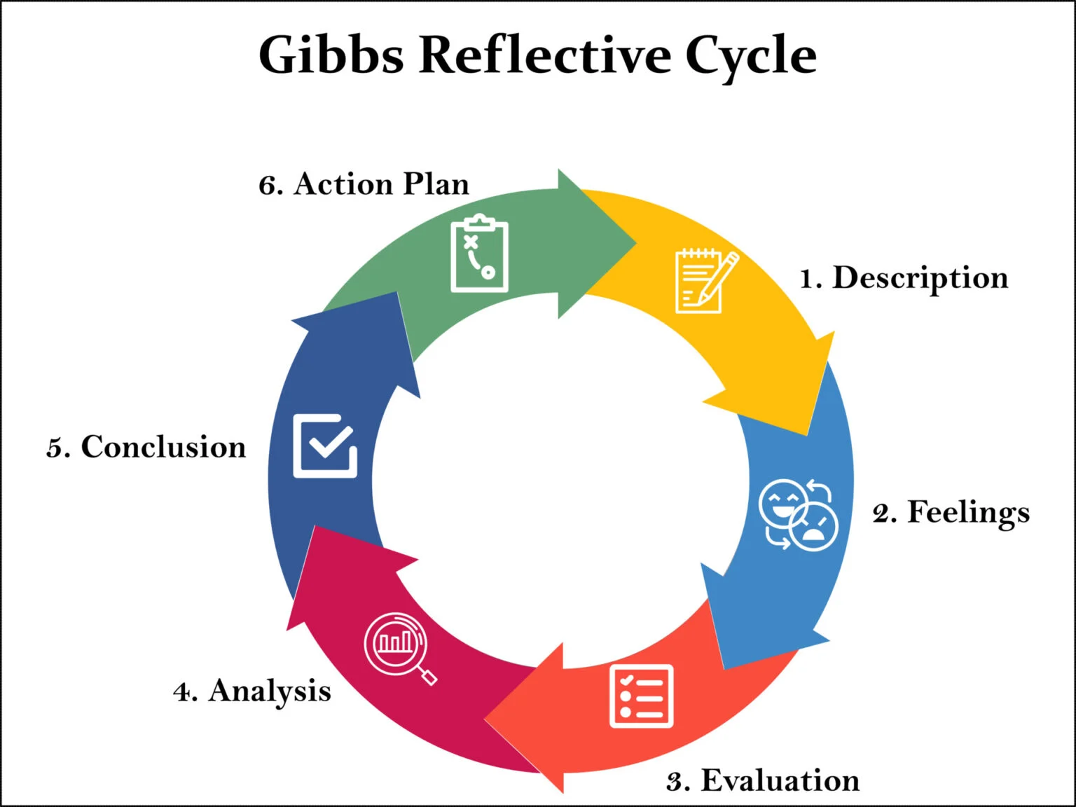
Figure 1: “Gibbs’ Reflective Cycle”
(Source: McLeod 2025)

Challenge 1: Expressing Gratitude
Description: I would list three things that I was thankful about at night over one month. This may be in the form of little interactions at the workplace, of a supportive team partner or when one is enjoying some level of personal rest.
Feelings: The initial experience of this practice was that I found it to be really constrained and insignificant if I was attempting to create positivity. Gradually, over the days, I even started to sense some actual changes, a nudging of the warmer side of the mind, a feeling of gratefulness and a light domination of slightly proud consciousness of positive signs I would otherwise blind myself.
Evaluation: This was mostly a successful experience. Not only has the practice raised me in a better mood and more conscious of generally positive feelings all through the day, but it also allowed me to notice patterns: similar themes of helpful co-workers, small successes, and personal advantages continued to repeat.
Analysis: Gratitude journaling brings greater emotional introspection based on the ability to concentrate on good moments to learn to have an actual understanding of values and emotional stimuli. It is theorised based on research that gratitude has been linked to the management of emotions and well-being. As an example, the sample of a recent investigation has reported that there is a positive relationship between trait gratitude and other strategies related to emotion regulation and satisfaction with life (Lin 2022).
Conclusion: This difficulty was able to encourage self-understanding as I was able to see recurring emotional themes. It also exposed the frequency at which I also underrate non-demanding positive experiences. But to have the charm, I must go deeper than surface gratitude and relate entries to emotional depths.
Action Plan: I will keep a gratitude journal after the first month; however, change the practice: every week, I will compose a more in-depth gratitude note that will relate the positive experience of gratitude to my emotional triggers and values. I will also remind myself in the evenings to make certain that I do not skip when I am tired..

Challenge 2: Practising Solitude
Description: I spent 10 minutes of my mornings solely, undistracted by any canal: no phone, music, only sitting down here and minding my thoughts and my feelings and then going to work.
Feelings: I was nervous and nervous in the beginning; my brain was going into overdrive when I had no distractions. However, a week later, my feet were more stable, and my presence and clarity over how I felt upon going to work shift were more relaxed.
Evaluation: This was a very successful practice. It provided me with room to psychologically loosen up for the day, to note constant anxieties (such as customer-to-customer stress) and to accept ambition or fear. Nevertheless, it did not occur daily because of oversleeping or haste, which decreased the consistency.
Analysis: Solitude offers a thinking or introspective vessel through which one gets to process their emotions and define their self-concept. Psychological theories of self-reflection opine that unstructured, silent minutes allow the self-concept to become clearer and allow one to understand his or her motives and identity better (Thomas 2023). Applying the Gibbs model of reflection contributes to making those observations meaningful, in accordance with which, by assessing my emotions, identifying common themes, and designing the next adjustments, I can develop self-awareness in a systemic way.
Conclusion: The solitude exercise played a significant role in assisting me to notice my regular inner conversations and emotional ground. It enhanced my inward-looking ability. The only difference is that here, the consistency makes the difference, as days off dilute the habit.
Action Plan: I will make my solitude time a scheduled appointment in my calendar after the form of a recurring early morning appointment, a reflection one. I will increase this to 15 minutes on weekends and then go through a brief journaling exercise to note down any insights that will come to mind. I will also always go to a do-not-disturb set-up on my phone to keep off spammers.

Challenge 3: Pausing Before Reacting
Description: I resolved to stop when I found myself in emotionally provoking situations, especially at work, by just taking a break by breathing in deeply and counting to five before I developed a response, as opposed to responding instantly.
Feelings: In the beginning, it was difficult to stop and express them. I feared I would be inauthentic and laggardly. However, the more I practised, the less defensive and the more empathetic I became, the more composed and deliberate I felt; the more present.
Evaluation: It was a very realistic challenge that occurs in a day work environment. It made me de-escalate tension, respond more thoughtfully and be professional about it.
Analysis: One can choose to react instead of responding to it before it goes to the emotional head by noticing internal emotional inflation. Such interruptions (such as breathing or reappraisal) are beneficial to emotion regulation, supported by the mindfulness and cognitive-behavioural frameworks. Mindfulness training has been demonstrated to be more effective in the ability to detect chronic emotions and managing reactions as demonstrated (Smith et al., 2024).
Conclusion: The practice was very effective in enhancing my emotional control. It encouraged an understanding of myself about what triggers me and enabled me to build more affirmative communication. But I should do more of instilling the habit in such a way that it does not become a conscious exercise, but is more of a natural one.
Action Plan: To establish a stronger version of this practice, I will combine pausing with brief mindfulness practices: I will conclude every pause with a 10-second breathing practice or with some sort of grounding statement. I will also write a reflection in the form of a diary every week about the triggers that I stop and pay attention to, identifying any trend, and reflecting on the possible alternative response approaches.

5. Conclusion
The growth of self-awareness is one of the essential skills that a manager would need in the modern organisational post-COVID environment, in which emotional intelligence, wellbeing, and empathetic leadership have a profound impact on performance and retention. The five obstacles, gratitude, nature connection, solitude, enough sleep, and pause before reacting, provided useful models in identifying emotions, comprehending behaviour patterns and enhancing self-regulation. The retrospective of these experiences by use of the Gibbs cycle demonstrated something important about my values, emotional triggers and interpersonal habits. Altogether, these activities empowered my emotional intelligence and full preparedness as a leader.

6. Six-Month Development Plan
Objective | Activities | Timeline | Measurement / Metrics
Sustain Gratitude & Reflection | Sessions of gratitude journals every day and weekly reflection. | Months 1–6 | Diary entries, theme of feelings found, and a report on mood.
Deepen Emotional Regulation | Meditation: practice of suspension + mindfulness breathing. | Months 1–6 | Record of events, pre/ speakhow.
Expand Reflective Practice | Continue daily solitude + structured journaling after shifts. | Months 2–6 | The reflection logs and content themes of triggers and coping strategies.
Seek External Feedback | Obtain emotional behaviour feedback on the part of colleagues and the manager. | Months 3–6 | Such things as feedback sessions, blind-spot identification.
Track EI Progress | Complete an EI self-test (validated test) every two months. | Months 1, 3, 5 | Changes in the EI score, subdomain (self-awareness).
Well-Being Check | Track sleep, stress, and well-being via a diary or app. | Months 1–6 | Quality of sleep, rating of stress, and levels of emotional exhaustion.

References
Alasmari, A.A., Awad, R.A., Alshowair, A.M., Albattal, S.M., AlMutairi, A.H., Abdel-Azeem, A. and Kofi, M., 2025. Emotional Intelligence and Leadership Styles Among Managers in Primary Healthcare Centres, Riyadh, Saudi Arabia. Journal of Healthcare Leadership, pp.285-295.
Cecchi-Dimeglio, P. 2024. How self-awareness elevates leadership effectiveness, Forbes. Available at: https://www.forbes.com/sites/paolacecchi-dimeglio/2024/02/14/how-self-awareness-elevates-leadership-effectiveness/ (Accessed: 18 November 2025).
Dahir, M.A. 2025 The importance of emotional intelligence in leadership, Journal of Human Resource & Leadership. Available at: https://stratfordjournalpublishers.org/journals/index.php/journal-of-human-resource/article/view/2625 (Accessed: 18 November 2025).
Dennis, A. and Ogden, J., 2025. The Role of Emotion Regulation in Body-Focused Gratitude: Impacts on Well-Being, Body Compassion, and Behavioural Intentions. International Journal of Applied Positive Psychology, 10(1), pp.1-19.
EQfluence 2024 The Game-Changing Research, EQfluence Group. Available at: https://schoolofeq.com/blog/eq-research-2024.html (Accessed: 18 November 2025).
Greely, B. 2024 The Power of Emotional Intelligence in Leadership: Nurturing Relationships, Driving Success, Journal of Organizational Culture, Communications and Conflict. Available at: https://www.abacademies.org/articles/the-power-of-emotional-intelligence-in-leadership-nurturing-relationships-driving-success-16995.html (Accessed: 18 November 2025).
Ilori, K.M. 2024 Navigating Workplace Relationships: The Impact of Emotional Intelligence (Self-Awareness and Social Skills) among Managerial Staff at the University of Ibadan, International Journal of Academic Management Science Research (IJAMSR). Available at: https://ijeais.org/wp-content/uploads/2024/10/IJAMSR241021.pdf (Accessed: 17 November 2025).
IOE 2025 Emotional Self-Awareness for Leaders, Institute of Organization Effectiveness. Available at: https://www.instituteofoe.com/2025/04/19/the-importance-of-emotional-self-awareness-for-leaders/ (Accessed: 18 November 2025).
Laban, G., Wang, J. and Gunes, H., 2025. A Robot-Led Intervention for Emotion Regulation: From Expression to Reappraisal. arXiv preprint arXiv:2503.18243.
Lin, Z., 2022. Emotion regulation strategies and sense of life meaning: The chain-mediating role of gratitude and subjective wellbeing. Frontiers in Psychology, 13, p.810591.
McLeod, S. 2025 Gibbs reflective cycle, Simply Psychology. Available at: https://www.simplypsychology.org/gibbs-reflective-cycle.html (Accessed: 18 November 2025).
Meda, R. 2025 Alone, Not Lost: How Solitude Shapes Strength, Creativity, and Authenticity, MEDA Foundation. Available at: https://meda.foundation/alone-not-lost-how-solitude-shapes-strength-creativity-and-authenticity/ (Accessed: 18 November 2025).
Parsons, C.E., Schofield, B., Batziou, S.E., Ward, C. and Young, K.S., 2022. Sleep quality is associated with emotion experience and adaptive regulation of positive emotion: An experience sampling study. Journal of Sleep Research, 31(4), p.e13533.
Ríos-Rodríguez, M.L., Rosales, C., Hernández, B. and Lorenzo, M., 2024. Benefits for emotional regulation of contact with nature: a systematic review. Frontiers in Psychology, 15, p.1402885.
Salameh-Ayanian, M., Tamer, N. and Jabbour Al Maalouf, N., 2025. The importance of emotional intelligence in managers and its impact on employee performance amid turbulent times. Administrative Sciences, 15(8), p.300.
Smith, R., Persich, M.R., Chuning, A.E., Cloonan, S., Woods-Lubert, R., Skalamera, J., Berryhill, S.M., Weihs, K.L., Lane, R.D., Allen, J.J. and Dailey, N.S., 2024. Improvements in mindfulness, interoceptive and emotional awareness, emotion regulation, and interpersonal emotion management following completion of an online emotional skills training program. Emotion, 24(2), p.431.
Thomas, V., 2023. Solitude skills and the private self. Qualitative Psychology, 10(1), p.121.
Wang, W., Zhu, Y., Yu, H., Wu, C., Li, T., Ji, C., Jiang, Y. and Ding, D., 2024. The impact of sleep quality on emotion regulation difficulties in adolescents: a chained mediation model involving daytime dysfunction, social exclusion, and self-control. BMC Public Health, 24(1), p.1862.
Well, T. 2024 The Double-Edged Sword of Self-Awareness in Leadership, Psychology Today. Available at: https://www.psychologytoday.com/us/blog/the-clarity/202409/the-double-edged-sword-of-self-awareness-in-leadership (Accessed: 18 November 2025).
Zulkifli, N.A.B., Maisarah, S. and Muñoz, N. 2024 Self-Reflection as a Mediator Between Solitude and Identity Development, Journal of Assessment and Research in Applied Counseling (JARAC). Available at: https://journals.kmanpub.com/index.php/jarac/article/view/3914 (Accessed: 18 November 2025).

