Gulab Uddin – 1708842
Lecturer: Yohan Mendis
Developing Workplace Critical Thinking
BMSW5002

Contents
Introduction 1
Management theory related to own role and the impact of this role upon value, belief and attitude 2
Management Theories and relationship to own role in workplace 5
Role in workplace affected by value, Belief and Attitude 10
Conclusion 13
Reference 14

Table of Figures
Figure 1 Rokeach Belief Model 3
Figure 2 Scientific Management Techniques 5
Figure 3 Scientific Theory of Management 6
Figure 4 Fiedler's Contingency Model 7
Figure 5 LPC Scale 8

Introduction
The main bases that shape a person’s attitude are values, beliefs and attitudes. These are the basic building blocks of human characteristics and human nature. If thought in an organisational aspect, then the employees from different cultural and social heritage is thought to be following different mindsets as well. Thus, value and belief set one’s behaviour and according to that a person. The objective of a manager has to be to properly handle all the employees of the organisation and satisfy the other stakeholders related as well. Only then the whole organizational success can be achieved (Pratkanis, Breckler and Greenwald, 2014). This assessment discusses the impacts of managers mindsets and their formation of own value belief and attitudes. Then the assessment redirects these the primary building blocks of every managers characters and tries to incorporate them in an organisational context. For the purpose of this assessment the organisation chosen in this aspect is Sainsbury. Sainsbury is one of the largest retail chains in UK being established in the year 1976 by two brothers Karl and Theo. From then it has kept strong competition with even larger retail stores like Tesco, Aldi, Morison etc. Sainsbury operates in more than 20 countries having a total of more than 11 thousand stores worldwide. Being such a large retail chain, Sainsbury believes in small retail shop setups and thus stores are designed and planned according to a convenient size for the customer this is one of the major unique selling propositions for Sainsbury over the competitors (Sainsbury.com, 2019). As a retail manager of one of the stores of this large retail chain, I would try to identify my own beliefs and values and examine my behaviours towards the employees and the organisational as a whole to understand the impacts of the total managerial theories regarding my management process.

Management theory related to own role and the impact of this role upon value, belief and attitude
Management theories are developed to establish a proper management structure for the leaders to manage a whole team. There are a lot of successful management theories among which managers can choose from according to own belief and mindset. It quite depends on a manager on how to select and develop a suitable management style for own self in order properly direct a team.
Value Belief and Attitude
Belief value and attitude are already considered to be the basic structure and the primary stage of a totally shaped human nature and behavior. The human being who possess a certain human culture and a certain nature must have some own belief and values which shape up all the activities performed by the individual (Elliott and Turnbull, 2010). There are several theories to discuss the impact of value belief and attitude on human nature and the impact of these theories on organizational management aspect. One of the most discussed theories in this case is the Rokeach’s theory of belief value and attitude.
Rokeach’s theory on belief value and attitude: On the year 1970, a famous psychologist Milton Rokeach formed up a theory to understand the basic human behavior building blocks or the beliefs values and attitudes (Connerley and Pedersen, 2015). This theory is known as the RVS theory or Rokeach Value Survey which the result of which has been published in the book named the “The Nature of Human Values”. Rokeach identified the core aspects of the belief, value and attitude and defined the slightest of differences between these aspects (Matthews, 2019). For example, the belief of a certain person arises from the very beginning of the learnings of the human life. Beliefs can be like a person has to obey his or her parents and a person must always speak the truth. These things may result as the belief. According to my belief in Sainsbury, I always try to keep customer on first priority. Customer deserves the topmost attention in this case and our value is to provide everyday with a competitive pricing to the customers so that we have advantage over the competitors. Rokeach categorised belief in to three different parts which are the evaluative, existential and perspective belief. These beliefs are the most basic and primary building blocks of one’s attitude. If the graph included in the assessment is seen, then it can be seen that belief stays in the middle of the circle as the most basic content of one’s character and behavior process. Belief is the result of the person’s viewpoint on the society and how the total society has been introduced to that person. Thus, belief generally has a positive mindset and which latter forms the values. One belief can be that telling lies is a bad human gesture and should not be done. Again, after accomplishing or experiencing a certain aspect, a certain kind of belief can be raised such as humanitarian work is good can be understood after conducting this type of social services. My belief towards Sainsbury employees to develop proper interpersonal skills in order to ensure a proper and direct communication with the other employees and customers as well.
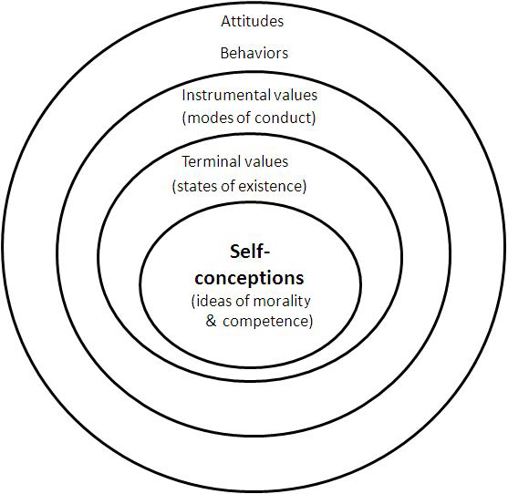
Figure 1 Rokeach Belief Model
Source: (Mouton and Wildschut, 2015)
After the belief comes the values of the human being which are the stronger perception than beliefs. Values result in ones formed beliefs in the primary stages. Values result from the strongest of perceived ideas of human being. The person who is trying to develop own consciousness about a certain aspect develops the certain values which serve as another shaper of the total attitude. Values are again divided in to two aspects they are the terminal value that is the states of the existences and another one is the instrumental or the behavioural value. Values are very brief in a human mind and thus are very low in number as well. Value are thus shaped by beliefs which ultimately shape the attitude of a certain human being (Humphrey, 2011). For example, the honesty of leading a life and honesty in the workplace can be a perfect example of a terminal value of a human being and the higher position in the organisation can be the example of the behavioural mode of the value. Attitudes are finally shaped by the shaped value and belief through which one behaves upon towards a certain aspect. Thus, attitudes are formed in the means of behaviours which are moved by the values and beliefs inherited throughout the learning of the whole life. While working in a workplace like Sainsbury, I have to show proper attitude and behaviour shaped by my proper value and belief otherwise there will be not optimum result or output from the organisational viewpoint. If a person has a good value and belief, his behaviour and attitude towards others will also be good and he is likely not to harm others and bring out the optimum output from any given input (Brookfield, 2010). Thus, it is very important for a manager to possess strong mental values and beliefs to depict them in proper attitude and behaviour in the organisation. Being a store manager there, I possess some strong value and belief of my own which are also reflected on my total managerial process and system in the long term. The management theories related towards my values and beliefs are the scientific management theory and the contingency theory of management.

Management Theories and relationship to own role in workplace
Management theories dictate the total process of a decision maker to manage a team. The managers and supervisors play a vital role in any sector of an organisation. The person who has to lead a team of certain people has to follow some certain strategy in order to get the best output from the people (Renesch and Chawla, 2016). The management theory describes these all in one and structures the total decision-making process of the manager as well. The management theory of FW Taylor is known as the scientific theory of management. The organisation is developed on the theory of the management that is practiced by the managers of the higher levels.
Scientific Theory of Management and its impact: The scientific theory of management was developed by Frederick Winslow Taylor. Thus, this theory of management is also known as Taylorism. There are some principles of the scientific theory of management. These principles let a manager to perform his or her duties properly in order to properly manage a team. The main goal of the scientific management process is to develop a source of effectiveness and efficiency for the people of the organization (Grint, 2014). There are some major principles regarding this theory is that the “Rule of thumb” working method has to be replaced with simple and scientific working methods. Because it determines the most efficient way to achieve any task. Rule of thumb method does not always provide the best results but scientific method promises to deliver the most efficient result possible in any task.
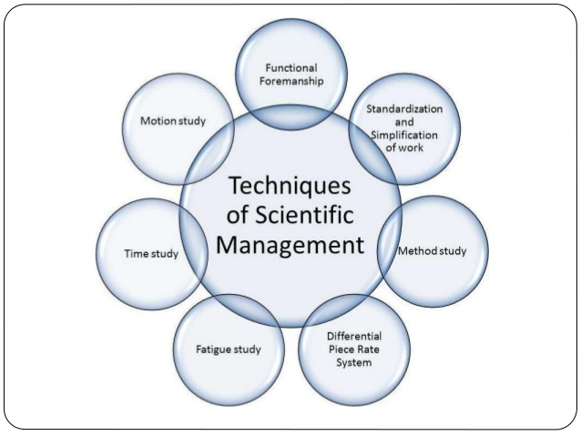
Figure 2 Scientific Management Techniques
Source: (Pratkanis, Breckler and Greenwald, 2014)
The scientific theory of management also suggests to train employees scientifically. This helps to get the best out from the employees with the best outputs in the sectors they are serving in. The scientific management theory also suggests to serve in the best and efficient working methods possible. In Sainsbury, as a store manager I try to follow this management theory as per my requirements (Humphrey, 2011). As the store manager, I have to manage my subordinates and associates who are in responsibility of the store. There might be a lot of ways to accomplish a task but the scientific management theory suggests that the most efficient in both manner of cost and time should be used to get the optimum output. The scientific theory of management also suggests that managers should not hand down all the tasks to the subordinates. Rather the manager plays the role of the pioneers in this case.

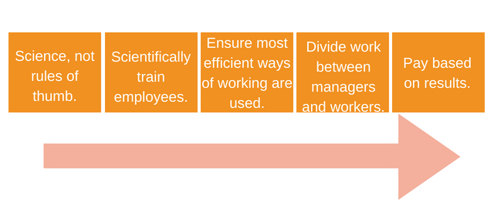
Figure 3 Scientific Theory of Management
Source: (Mouton and Wildschut, 2015)
Managers have to look after the duties delegated as well perform some tasks as example for the subordinates so that the employees and workers do not feel oppressed and gets the example of how to do a task rather this works as a motivation for the employees and the subordinates as well. Also, the payment needs to be based on the output of the employees as well. The output or the ultimate result of any task defines how much effort one has given to the task and how much one needs to put more in order to achieve the outcome. If the pay rate for employees or workers is fixed then the employees will not get motivation to go that extra mile (Renesch and Chawla, 2016). But with the proper payment according to ones given effort and earned result, everyone will feel the motivation to perform the tasks as per requirement. In Sainsbury I have to provide proper instructions to the personnel so that they do not conduct any mistakes in the activities and I have to divide the tasks to my store personnel properly as well. Again, there is special bonuses and performance management tactics for the employees so that they can work properly and bring out the optimum result as well.
Contingency Theory of Management: According to my belief and attitude I follow another theory of management that is the contingency theory of Fred Fiedler’s invented management theory which is the contingency management or the leadership theory as well. Fiedler was a scientist who discovered an important aspect of managing teams in the mid-1960s which is known as the contingency theory of management. This model describes the situation as a source of behavioural aspect for a manager and the decisions or the behaviour of the manager should be based on the situation not any other aspect. In this management theory, the manager is to develop
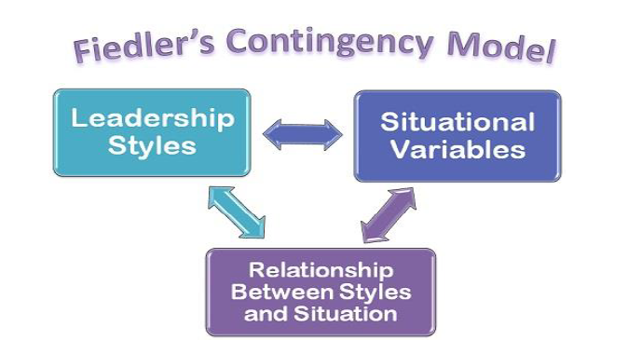
Figure 4 Fiedler's Contingency Model
Source: (Connerley and Pedersen, 2015)
a situational understanding for the managerial approach of the team management. In an organisational aspect, there might be employees from different backgrounds and there might be a variety of customers with variety of demands. Specially in large retail chain like Sainsbury, there is always a rush of customers which demands for new situations and problems with every transaction. These situations demand for contingency approach of management and thus I have to follow this certain management model in order succeed in my management tasks properly, as suggested by Matthews (2019). The contingency model suggests a situational leadership theory which describes the leadership style to be used according to each subordinate categorised by a Least preferred Co-Worker questionnaire known as LPC (Elliott and Turnbull, 2010). Sainsbury follows a strict rule for situational leadership model and helps the people to identify certain types of leadership traits and theories according to different type of leaderships. This questionnaire has certain model of categorizing theory of employees from employee’s mindset being hostile or supportive, unfriendly or friendly, cold or warm, tensed or relaxed etc.
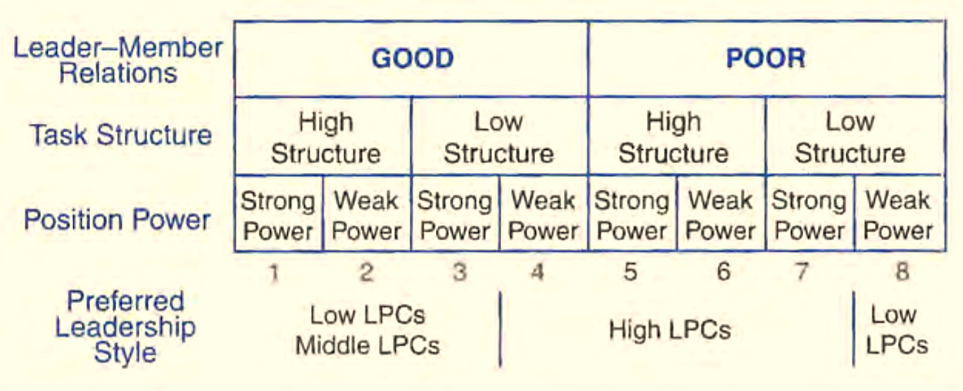
Figure 5 LPC Scale
Source: (Humphrey, 2011)
The LPC scoresheet helps me to understand my own leadership styles and traits and helps me to develop a new kind of relationship with each individual subordinate. I am likely to be ore relationship building leader in this aspect, to understand more properly about the employees and understand their mindsets properly too. Then comes the situational variables which describes the relationship between the leader and the team member, the structure of the task provided and the leaders’ mindset of own position. According to these aspects I try to judge the situation of Sainsbury store continuously and fix a certain leadership style for a certain group of people and changed it according to circumstances (Grint, 2014). The most effective leadership style according to this model is the high LPC model which is followed by me while I lead my subordinates in the store as store manager.
Weakness of the theories: There are some certain weaknesses of both these theories in the workplace (Costa, 2011). The contingency theory has certain criticism for not being flexible from time to time. Contingency theory questionnaire is developed to assess the quality of the leaders and the leader’s goals if not matched with the subordinates than it creates problems for the subordinates in the management of the organisation. Then again, there are some certain issues if one falls in the middle line of the LPC sore then there is no proper guidance in the leadership style to be followed. Also, the score of the questionnaire is difficult to be measured in an unbiased method and manner thus there are some issues in this case of the management as well. There is also some criticism of the scientific theory of management as well. Scientific theory often does not consider the humane side of the employees rather is more of a goal-oriented theory which is not proper in this era of humanitarian management process (Connerley and Pedersen, 2015). It thinks of the employees less like a human and more like a machine. The standards set by this method is not properly set keeping the humanitarian impacts on the employees. Then again, the reward system of the management process is not justified in this method as the people are being treated only for the tasks being performed and not the other factors affecting the tasks. This creates unhealthy competition as well as unemployment as well which is a very unwanted situation by the employees as well.
Both of the management style in this case has certain disadvantages at some point of the model. These theories are developed following a certain structure for that if that structure is not followed, there might be an issue in the management. Thus, as a manager in Sainsbury, I try to comply both of the theories and establish a proper management style accordingly. So that the shortcomings of the both theories are not presented and the theories are followed as a proper way of speeding up the total store management process and developing a proper system to ensure the management is being done properly.

Role in workplace affected by value, Belief and Attitude
In the workplace, I had to deal with a huge crowd of customers daily and have to manage a team consisting of twenty-five members in my store. There are a lot of activities and performances issues in the store that has been happening every day. These performances are being affected by my own value, belief and attitude. Also, the activities of the day to day tasks differ from time to time due to different work aspects and mindsets. Following are some aspects through which my own mindset gets affected while serving as a store manager.
Ethical Consideration and Values: There is always a ethical constraint in every sector of employment and in large retail chain like Sainsbury, the situation is much more crucial. Sainsbury stores are designed for relentless grocery and retail purchasing experience for the customers and to ensure this for my store is my responsibility. There is sometimes certain constraint such as return of the product, discounts to be provided and some other issues where the ethical consideration gets more crucial. It becomes very tough to draw the fine line between unethical and illegal aspect of a certain workflow (Clark, 2013). For example, one day a customer in the store came back with an expired product which was a third party product. The customer was a loyal Sainsbury store purchaser and had a membership card of the store as well. The customer wanted to return the product and purchase some other things which was quite against the legal perspective of Sainsbury store as the store does not permit certain type of exchange policy for the third-party sourced products (Sainsbury.uk, 2019). A time span was needed to accomplish the proper process of the return of the product but as the customer was loyal customer and had a strong influence over other customers in the area, I had to return the product to the customer’s immediately and could not wait for the total return procedure as this was mostly what was needed in this aspect.
Leadership Traits: The main tasks performed in any organisation are by the leaders. Thus, the success of any organisation is marked by the leader’s qualities and attributes towards the organisation and the organisational aspect of the leadership (Brookfield, 2010). In Sainsbury as store manager I also have to lead a team of more than twenty people which has to be done very consciously as different employees have different role to play in the organisation no single instruction and motivation aspect can be effective for the total team. So, I have to be careful in leading my team properly. As I have a strong ethical aspect of leadership and my values in this aspect are strong, I tend to follow my own beliefs and my behaviours towards the total leadership trait is thus shaped like that as well. I try to keep up with the modern day leaders and follow their attribute for even managing my team in the store because I believe, as the days are passing by, newer and newer methods of leadership and motivation are being established and no single method of leadership and motivation can be proper for any organisational aspect for any leader. Thus, I follow the contingency model and situational leadership and change my leadership aspect as per the needs and wants of my employees and the problems that arises from the daily aspect of the customers as well (Sainsbury.uk, 2019). I try to maintain a friendly leadership relation with my subordinates as my belief is if the subordinates are free to share their thoughts and problems with me, I will be able to mange them well and push them towards the goal of the whole store.
Customer Service: Customers are the main aspect of any business organisation and for retail chain like Sainsbury, the stores are the places where customers come in contact with the total organisational aspect. The retail stores set the brand in the mindset of the customer. This mindset then defines the total brand to them as this is the primary and mostly only contact point with the organization and themselves. (Humphrey, 2011) Thus, ensuring the best experience to the customer is my ultimate goal in this aspect. Because, in my believe and values I tend to consider that every customer is important and each of the customer contribute to the total growth of the store. Thus, my behaviour to each customer remains the same and friendly because the customers are the ones contributing the profit to the stores. If the customers are contented, they will spread word of mouth which will be more beneficial for the store and finally the store will be more popular within the area. In retail chain stores, popularity in an area is very important to get over the competitors of the area. Thus, the customer satisfaction ensuring capability should be ensured by every store manager. According to this mindset, I try to guide my store employees and subordinate and my behaviour towards them is guided accordingly to the organisational aspects and the goals as well. I try to ensure every customer gets the proper attention and try to ensure the store adds value to every customer lives as well.

Conclusion
Finally, it can be stated that the three building blocks of human characteristics shape the total behaviour and mindset of a certain person. These aspects are the belief, value and attitude. If these aspects are built up properly then a person is sure to become a proper manager and the theories of the management can also be applied by that person as well. Each and every person in the society is different so it may be very common to understand the fact of importance in the case of the employees in order to determine the proper mindset to control the employees as well. A manager should be aware of the differences of the employees and be aware of the environmental external factors as well in order to properly manage the aspect of the employees of the organisation. Keeping this in mind, there should be no hard and fast rule followed in managing employees in the workplace rather the situational methods can prove to be the best ones.

Reference
Brookfield, S. (2010). Developing critical thinkers. Baltimore, MD: Laureate Education, Inc.
Clark, C. (2013). Creative nursing leadership & management. Sudbury, Mass.: Jones and Bartlett Publishers.
Connerley, M. and Pedersen, P. (2015). Leadership in a diverse and multicultural environment. Thousand Oaks, Calif.: Sage Publications.
Costa, A. (2011). Developing minds. Alexandria, Va.: Association for Supervision and Curriculum Development.
Elliott, C. and Turnbull, S. (2010). Critical thinking in human resource development. London: Routledge.
Grint, K. (2014). Leadership, management and command. [Place of publication not identified]: Palgrave Macmillan.
Humphrey, D. (2011). Customer service. Mason, OH: South-Western Pub.
Matthews, P., (2019). Workplace learning: developing an holistic model. The learning organization, 6(1), pp.18-29.
Mouton, J. and Wildschut, L. (2015). Leadership & Management. Cape Town: African Minds.
Pratkanis, A., Breckler, S. and Greenwald, A. (2014). Attitude Structure and Function. Hoboken: Taylor and Francis.
Renesch, J. and Chawla, S., (2016). Learning organizations: Developing cultures for tomorrow's workplace. CRC Press.
Sainsbury.uk (2019). Sainsbury Grocery Stores - Quality Food. Everyday Low Prices. [online] sainsbury.uk. Available at: https://www.Sainsbury.uk/.

