DS 1 Template

My Screenshots/Photos
- Please add 4–6 screenshots or photos of your digital life.
- You can use your phone or laptop.
- For each screenshot, write one or two sentences explaining what it shows.

Screenshot/Photo 1
[Insert Photo/Screenshot below]
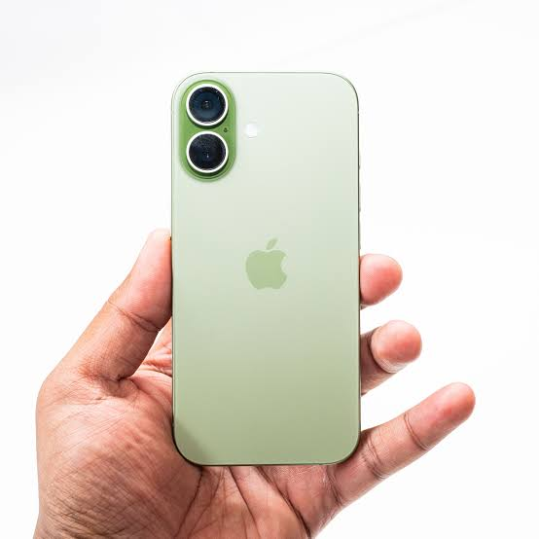
[Write what this shows of your digital life] This phone is used for making phone calls and text messages. This phone I also use it for adding appointments to my calendar. The most I use this phone for is taking pictures of work and the memories I make with my children.

Screenshot/Photo 2
[Insert Photo/Screenshot below]
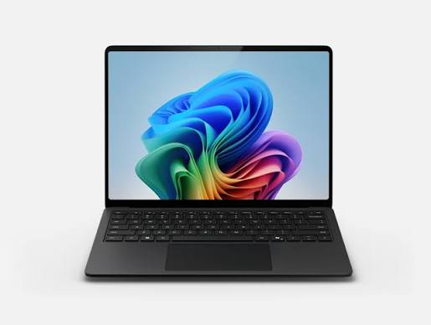
[Write what this shows of your digital life] this laptop is used for making spreadsheets and invoices. I also use this laptop for looking up information on the internet.

Screenshot/Photo 3
[Insert Photo/Screenshot below]
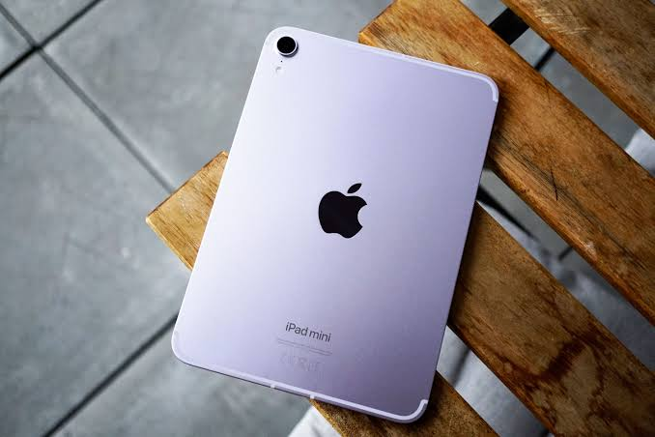
[Write what this shows of your digital life] I used an Ipad or watching movies on the go and it is also used for learning quiz games for my children.

Screenshot/Photo 4
[Insert Photo/Screenshot below]
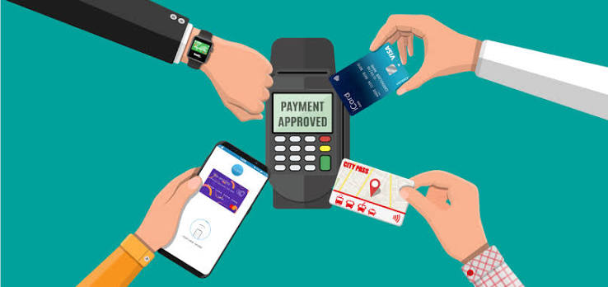
[Write what this shows of your digital life] I use contactless to make payment in my every day buys it is also good for taking payment from clients.

Screenshot/Photo 5
[Insert Photo/Screenshot below]
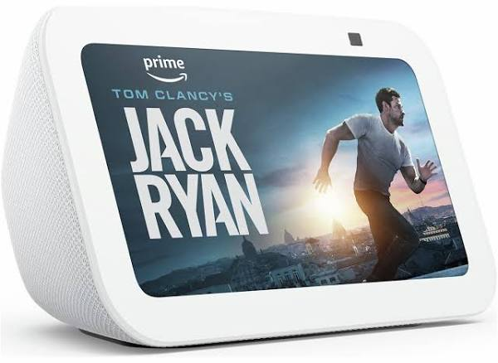
[Write what this shows of your digital life] this alexa is used for my alarm every morning. I also use this for information i.e: checking the weather, whats the lagest animal in the world, but most of all I use alexa for playing my favourite music.

Screenshot/Photo 6
[Insert Photo/Screenshot below]
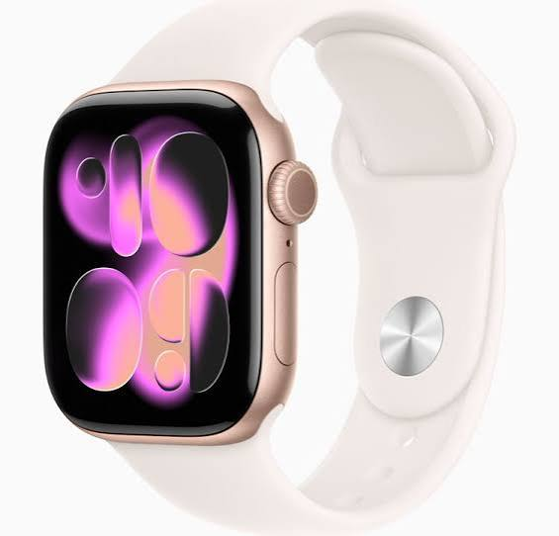
[Write what this shows of your digital life] this apple watch is used to tell me the time and keep track of my health. I also use this watch as hands free for phone calls when I’m unable to get to my phone.

My Short Reflection
- Write 5–8 simple sentences about your digital life.
- You can use the sentence starters below if helpful.
I use digital tools every day I am very confident when I’m using my phone and watch, as I have been using them for a long time. I would like to improve my skills on a laptop feel quite confident I will learn quickly because I I do enjoy learning things that I need to use for every day life as so much is digital now so it is very important.

Sentence starters
- I use digital tools to …
- I feel confident when I …
- I want to improve …
- I often use these tools: …
- I sometimes feel nervous about …
- I hope this module will help me …
- Digital skills are important for me because …
You can write more if you want.

Submission Checklist
Before you submit, please check:
​​​ ☒ I added 4–6 screenshots
☒ I wrote short sentences for each screenshot
☒ I wrote my short reflection
☒ My work is my own
☒ My file opens correctly
​​☒ My file opens correctly

