
University of Wales Trinity Saint David
Wales Institute of Science and Art

Engineering Project Technical Report

Workshop & Practice (ACHA4011)

Nathaniel Fullylove
2101005
November 2021

Contents Page

Contents Page…………………………………………………………………………….……..1
1. Introduction…………………………………………………………………………………..2
2. Research.……………………………………………………………………….………………3
2.1 Engineering Team Structure…………………………………………………..3
2.2 Engineering Team Departments…………………………………………….4
3. Methodology………………………………………………………….………………….….5
3.1 Product Development……………………………………………………………5
4. Discussion……………………………………………..……………………………….……..6
4.1 Issues, Legislation & Standards……………………………………………..6
4.1.1 Health & Safety…………………………………………………….6
4.1.2 Environmental & Ethical Issues…………………………….6,7
4.1.3 Standards……………………………………………………………..7
5. Conclusion……………………………………………………………………………………..8
6. Reference List………………………………………………………………………………...9

1. Introduction

This Technical Report will explain the engineering involved in producing a Formula 1 car, and the engineering groups that are formed to make the different areas of an F1 car. This includes the work that goes into managing the team, making sure it meets the new regulations and is done on time. But most importantly making the car competitive. The report will go into detail on how each aspect of the race car is built, this will include not just Aerodynamics and Powertrain, but all aspects. It will touch on the non-engineering sides that come into play when making a race car. It will explain the steps involved in making an F1 Car, and then the impact this has on the world. Finally, it will touch on how I wish to develop as an engineer throughout the course of my career.

2. Research

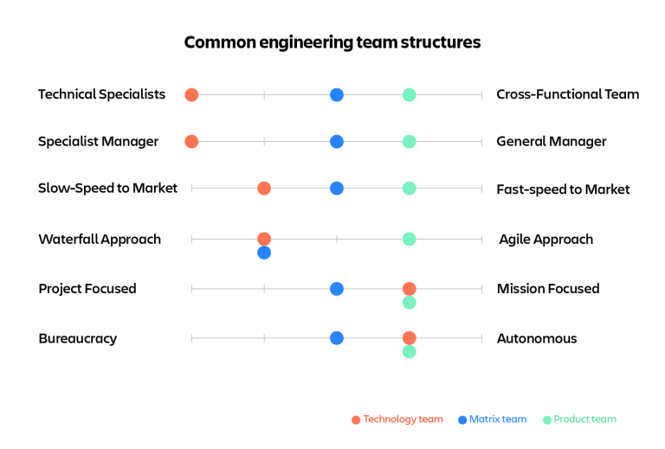
  - 2.1 Engineering Team Structure –
Figure 1: Common Engineering Team Structures (Austin, 2019).

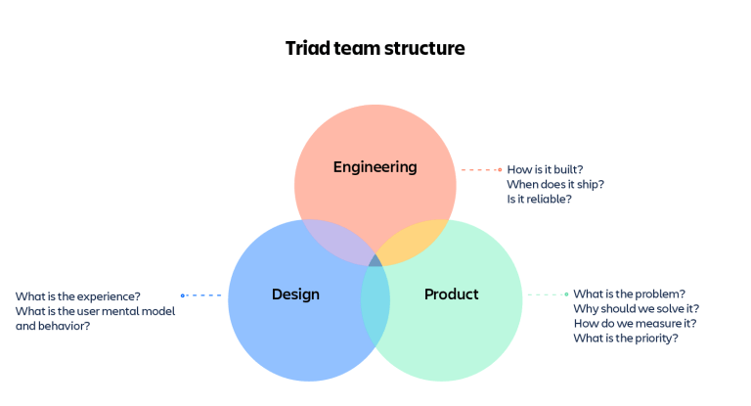
There is not one right way to structure an engineering team, as there are so many factors that come into play when you are producing a Formula 1 car. That is why many engineering teams decide to regularly adapt their team structure to make sure that they are operating at maximum efficiency, which is very important when creating an F1 car as you are pressured by a time constraint, having to finish before the next season starts. This is shown in figure 1, which shows different team structures that are orientated towards different objectives. However, F1 team structures often are centralised as they have a clear chain of command and communication. The managers at the top of the structure give the orders and make the decisions, which then runs down the chain to the lower departments. Although, due to the dynamic environment of an F1 engineering team, the lower managers will make minor decisions to avoid to bring the whole team to a halt, waiting for an answer from higher up.
Figure 2: Triad Team Structure (Austin, 2019).
Figure 2 illustrates the different areas of a team structure. This shows how those departments would act, and what they would be working on.
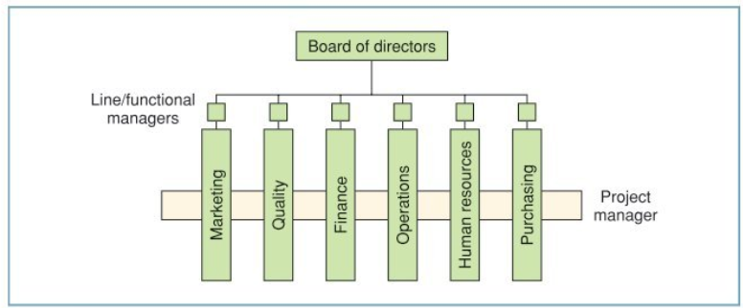
Figure 3 depicts a typical team structure for an engineering team, albeit a simplified one, it still shows the flow of communication from the top down to the different departments in the team. If the figure contiued, it would branch off into more trees showing the sub-departments and so on.
Figure 3: Project Organisational Structure, (Maylor, 2010, p.11).

  - 2.2 Engineering team Departments –
When making a Formula 1 car, there will be different departments that do various things to design and produce the car. For example, Aerodynamics is a big part of the team, especially since there are big aero changes happening to next year’s cars. There is the Powertrain department, whose focus is performance of the engine. This is not limited to ICE (Internal Combustion Engine) units any more, it includes hybrid technology, which means this department needs people with electrical expertise. Chassis is another big department involved, but it isn’t just about making a quick car. The car needs to last a full season, so another department needed for the engineering team is Durability. There are more departments behind the scenes such as CAD. A Finance department will need to communicate to make sure that the team is on budget. There are also data analysts testing components for there strength, fatigue stresses, balance, etc.
Each department must adhere to a set of professional standards, to ensure that what they are producing is safe to use. They must be alert to the way their behaviour affects others working around them. Each engineer must respect the health and safety regulations in place ensuring that they remain safe and that others do too. They should also be aware of issues raised by anyone and not ignore them, as this could lead to major problems or could even result in a fatality.

3. Methodology

  - 3.1 Product Development –
To begin, all departments should create an assessment of the risks involved before starting anything, to help determine whether the project is viable to the company. This is reinforced by
“To succeed, the promoter’s team should then assess the uncertainties of meeting the project objectives. If the risks are not identified, success cannot be achieved.” (Smith, 2002, p. 11)
The team would start designing parts and components and then bring their concepts together for their respective departments, for example, the Chassis department would get a mock-up of the body. All teams should be in constant communication with each other as they produce designs of everything to make sure the components fit together correctly. This will then enable the team to see how the finished vehicle will look when assembled and see if there are any issues with it. Once these designs have been ratified by the main departments responsible for producing the car, they can begin to build a prototype of it to conduct tests in wind tunnels, stress laboratories, etc. Data analysts will then begin to simulate projected data on the parts and designed car. After numerous tests and simulations have been completed, then begins the development stage where all the different departments begin trying to improve their designs further in order to eke out maximum performance. Once the prototype car has reached a point at which the managers are happy, the production stage can commence. This is followed by the assembly of the components as soon as they are ready so as not to waste time. Any problems can be treated as they arise. Once a first build has been made tests and simulations are repeated to confirm problems have been resolved.
To aid continued efficiency, departments run projects simultaneously so that no time is wasted waiting for another department to be ready to start, thus enabling them to be able to work on other projects. For example, setting Aerodynamics to work simultaneously with Chassis on separate areas, would enable Aerodynamics to work on the front or rear wings, while Chassis get the main body completed. Aerodynamics can then start on the main body work. This shows that having Aerodynamics working on something that may not necessarily be in the correct order of production, reduces the time lost waiting for other departments.

4. Discussion

  - 4.1 Issues, Legislation & Standards –
  - 4.1.1 Health and saftey
All engineering production teams carry a certain amount of risk, from minor cuts to fatalities. Therefore, when working within a production team, every member needs to be alert and aware of their surroundings when working on their own or with others, so as not to put themselves, or others, in danger. They must also adhere to the safety precautions put in place by the company they work for to protect themselves, including going through rigorous training procedures to ensure they know how to act safely when working on the car and the surrounding environment.
“It shall be the duty of every employer to ensure, so far as is reasonably practicable, the health, safety and welfare at work of all his employees.” (Health and Safety at Work Act, 1974)

  - 4.1.2 Environmetal & Ethical Issues
When it comes to environmental issues there is a lot to think about when talking about F1 cars, such as, where do the materials come from and how are they produced? Do the parts come from all over the world, or do you manufacture them? What distance are they travelling to reach the assembly?
There are lots of materials that go into making an F1 car, so deciding where you get the raw materials from, or whether you purchase the parts to reduce costs must be considered. Due to recent changes in public consciousness on how we treat the planet, it is now considered unethical to order parts and transport them from overseas due the increased carbon footprint this creates.
Also, the impact of gathering the resources must be taken into account when making an F1 car, as this can cause massive amounts of damage to the planet. Oil drilling to manufacture plastics and lubricants, and lithium mining for the batteries both have a massive negative impact on the environment.
People also care about how the product is produced, so if the employees are expected to work in inhumane conditions, then consumers will not be happy. However, it is not just the workers making the parts, but it is also the conditions employees are working in to gather the raw materials.
Therefore, as a manager, there are lots of things to consider when leading an engineering team to ensure that you are acting ethically and are not negatively impacting the environment. However, acting ethically requires spending more money so it is about creating a balance between the two and positive marketing.

  - 4.1.3 Standards
The standards of the industry for F1 cars are the regulations set by the FIA (Fédération Internationale de l'Automobile), For example, there was a budget cap introduced for the 2021 season. This limited the amount of money available to spend on cars and drivers, so this had to be considered when planning the production of the car for that season. The FIA added new regulations that determine the amount of time teams are allowed to spend in wind tunnels. This then forces you as the manager to spend time more wisely when using the wind tunnel. For the 2022 season there will be substantial changes to the regulations to bring the teams to a closer level, such as drastic changes to the aerodynamics of the car to reduce the downforce effect from the floor.

5. Conclusion

Overall, to run a successful engineering team when creating an F1 car, I would need to oversee all the departments working on the car and listen to the issues brought up by each of them, and then make sure that all departments are working efficiently to complete their tasks, in order to make a competitive car. This could include the designing of parts, attaching the parts, building the components, and the correct completion of testing, primarily stress testing to make sure that parts don’t break easily endangering the user of the car. I would also help departments through any problems as to help speed up the process to rectify the issue. To help the efficiency and to speed up rectifying a conflict, I would guide the involved departments through problem solving the issue.
In terms of my development to become a successful motorsport engineer, I will continually strive to progress my knowledge and continued learning of the industry. Due to the progressive and dynamic nature of motorsport engineering, you need to be continually innovating in order to keep ahead of your competitors. In terms of career my as an engineer it could be devastating if I do not stay ahead. I will work to become a Chartered Engineer to further develop my abilities and prove my worth as an engineer, with the help of IMechE to complete this.

6. Reference Page

Austin, J. (2019) How should you structure your engineering team? [Figure 1, Figure 2]. Available at: https://www.atlassian.com/blog/technology/engineering-team-structure (Accessed: 28 November 2021)
Health and Safety at Work Act 1974, General Duties. Available at: https://www.legislation.gov.uk/ukpga/1974/37/part/I/crossheading/general-duties (Accessed: 28 November).
Maylor, H. (2010) Project management. Fourth edition. Harlow, England: Pearson.
Smith, N.J. (2002). Engineering project management. 2nd edn. Ames, IA: Blackwell Science.

