
University of Wales Trinity Saint David
Motorsport Engineering Beng Hons

Engineering Materials
Materials and Manufacturing (ACHA4025)

George Campling
2503449

Word Count: 1952
26/04/2026

Contents:

- Introduction…………………………………………………………………………………...1
- Selecting a Material………………………………………………………………………….2
- Tensile Test Methodology…………………………………………………………………...5
- Test Results…………………………………………………………………………………11
- Analysis……………………………………………………………………………………...14
- Conclusion…………………………………………………………………………………..16
- References………………………………………………………………………………….17

Figures:
- Figure 1, Example Ashby Chart…………………………………………………………….2
- Figure 2, TecQuipment Tensile Test Rig…………………………………………………...5
- Figure 3, Aluminium Alloy Test Sample……………………………………………………6
- Figure 4, Mounted Specimen……………………………………………………………….7
- Figure 5, Zeroed Dial Indicator……………………………………………………………..7
- Figure 6, Load Nut…………………………………………………………………………...8
- Figure 7, Dial Indicator Movement Display………………………………………………..9
- Figure 8, Test Specimen Failure………………………………………………………….10
- Figure 9, Stress vs Strain Chart…………………………………………………………..12
- Figure 10, Display of Necking……………………………………………………………..13

Tables:
- Table 1 – Collected Data…………………………………………………………………..11

Equations:
- $UTS=\frac{F}{A} \left(Equasion 1\right)$……………………………………………………………………..14
- $Gradient=y=mx+c \left(Equasion 2\right)$…………………………………………………….14
- $Gradient=\frac{∆Stress}{∆Strain} \left(Equasion 3\right)$………………………………………………………….14

Abbreviations:
- CNC – Computer Numerical Controlled
- DFM – Design for Manufacturing
- UTS – Ultimate Tensile Strength
- GPa – Giga Pascal

Chapter 1 – Introduction:

In this report I shall be conducting a review into the failures of two driveshafts on a Prodrive Dakar rally racer, competing in the ultimate class of the competition.
The drive shafts have been made identically to previous iterations of the component, however a change in material suppler has occurred, and the aluminium alloy grades suitability for this application is in question.
Research shall be conducted into how to suitably select a material for a certain application, and some of the test methods that can be conducted on test samples of material candidates.
A sample of the aluminium used shall have a tensile test performed on it, and the results shall be analysed to evaluate its suitability for this application.
Finaly from this test the yield strength, ultimate tensile strength, and Young’s modulus shall be calculated.

1
Chapter 2 – Selecting a Material:

When selecting the best material for any application there are a series of procedures that one could follow to narrow down the wide array of materials that could be chosen. In this context we are looking at a case where a drive shaft has failed on two separate occasions, and we need to analyse if the aluminium alloy was the best material chosen for this application.
To begin the selection process, one has to have a basic understanding of the material properties of the four basic families that materials are categorised into, metals, ceramics, polymers, and composites (Engineering Gone Wild, 2026). As we are looking at a drive shaft, we have to translate our specific component requirements into functional properties exhibited by a material. From this initial selection stage, we can rule out polymers and ceramics, as we know that the material properties that they exhibit are not suitable for the high stresses a cyclically rotating shaft goes through (Engineering Gone Wild, 2026).

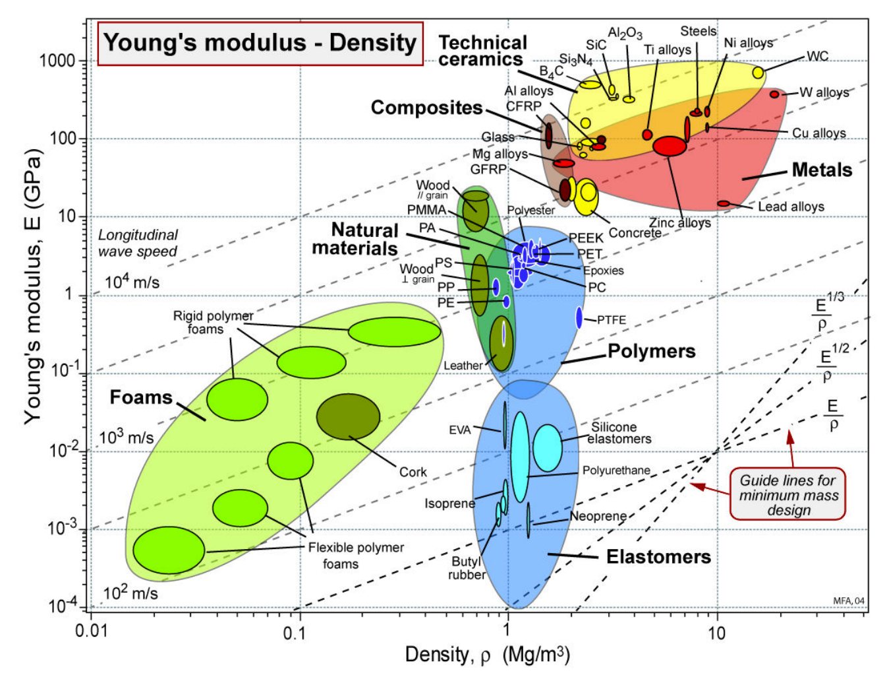
2
Figure 1, Example Ashby Chart (GRANTA CES 2009 EDUPACK, 2009).
From this point with our remaining material candidates, the standard engineering practice is to draw up something known as an Ashby chart (example can be seen in figure 1 above). This helps to visualise what a part must do (Engineering Gone Wild, 2026). The chart itself shows two properties against each other, for example Youngs modulus and density. The chosen properties however can be expanded into both physical properties such as tensile strength, hardness, elasticity, etc… and environmental properties such as a materials ability to resist rust (and other forms of chemical degradation), and peak operating temperatures (Engineering Gone Wild, 2026).
Once all materials are plotted on the chart, one can draw a selection line. This line designates the required performance of all the materials, where anything below the line does not meet the desired performance of said material property, these materials can be cut from the selection process (Engineering Gone Wild, 2026). With the remaining materials filters can be added for further factors such as cost.
With the final selection of materials (if it hasn’t been narrowed down to one) it is important to consider the ease of manufacture, when concerning what application the material and resulting component shall be used in (Engineering Gone Wild, 2026). In this case as an aluminium alloy was used. It would be a very safe assumption to assume that the shafts had been CNC milled, a fast and relatively cost effective manufacturing method for low volume parts, that could be both done in house (if CNC equipment is owned), or contracted to an external manufacturer. However on the extreme side, and in some specific cases, if the drive shaft were chosen to be made out of carbon fibre (a composite), costs would be higher due to the expense of material, manufacture duration, and the difficulty of manufacture without material failure.
Finaly “prototypes, testing and DFM feedback refine the selection” (Engineering Gone Wild, 2026).
There are multiple ways in which one could go about testing a material, before committing to the costs of prototyping. One could perform tensile tests (one to be performed and analysed in further detail later), compression tests, creep tests, etc… (McClements, D. Keane, P, 2026). Most of these tests require a small sacrificial material sample (these tests being known as destructive tests) which does necessitate spending an amount on said samples, however one can gain an understanding for material performance, behaviour, failure modes and how to quality control the material, all through analysing the results from these tests (McClements, D. Keane, P, 2026).
3
Performing these test does have some difficulties and potential inaccuracies, in the fact that there is potential for human error, equipment limitations, and in extreme cases sample contamination. Compliance with testing standards also needs to be strictly followed, as fines can be received for factors such as not performing the tests safely (McClements, D. Keane, P, 2026).

4
Chapter 3 – Tensile Test Methodology:

First to begin the process of tensile testing a material, one must acquire or gain access to a tensile testing rig. In this case the tensile test rig used was acquired from TecQuipment, a link can be found in chapter seven, references. Said rig can be seen below:

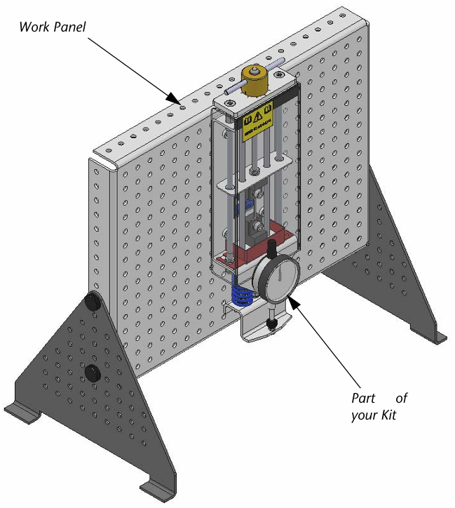
5
Figure 2, TecQuipment Tensile Test Rig (TecQuipment Ltd, 2012).
Once the specifications of the specific rig have been gained, one can acquire test specimens of an appropriate size and dimensions. The thicker ends of the sample are used for securing each end into the rig, and the thinner section shall have the force from the rig exerted on it. The exact dimensions of force exerted area are as follows, 30.12mm length, 2mm width and 1mm height. One will see that there is a small notch on one end of the sample, this indicates that that end should be mounted in the bottom most chuck of the rig. The sample can be seen in figure 3.

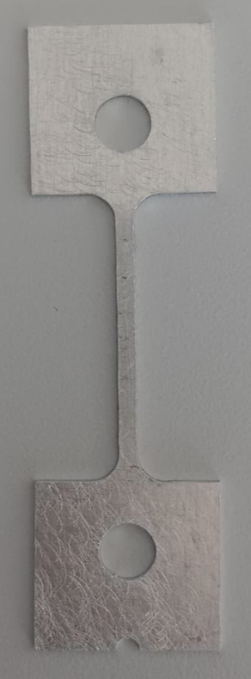
Figure 3, Aluminium Alloy Test Sample

Figure 4 (next page) shows how the test rig should look once the test specimen is secured. It is also of the utmost importance that the operator zeroes the dial indicator (or clock) before commencing the test. This can be done by gently twisting the tile round to the zero position (see figure 5, next page).
6
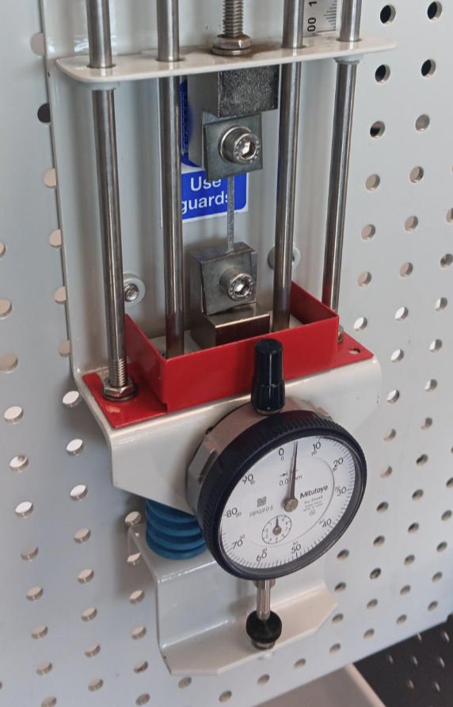
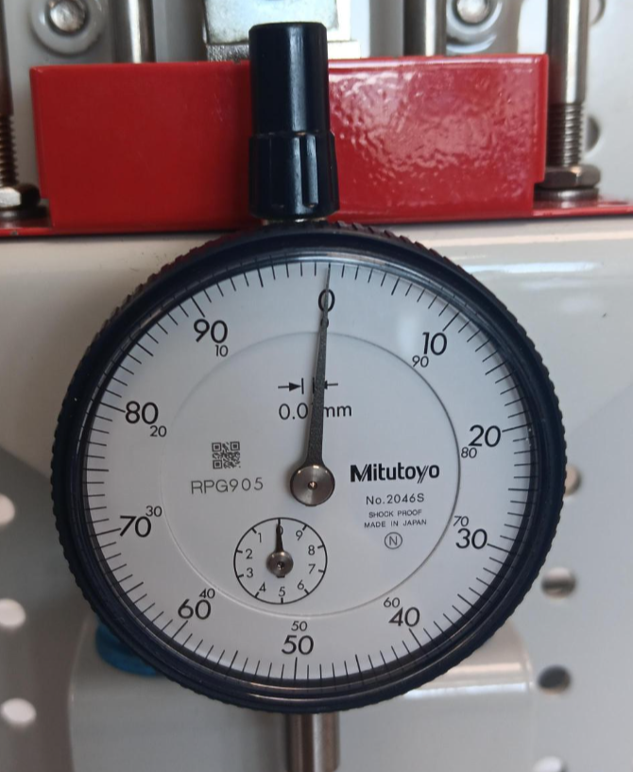
Figure 4, Mounted Specimen

7
Figure 5, Zeroed Dial Indicator
The operator shall see that the load nut is located on the top of the test rig, along with 10 incremental marks surrounding it. With each full turn of the load nut the tensile tester pulls the top chuck upwards by 1mm, each increment being 0.1mm. this is displayed in figure 6.

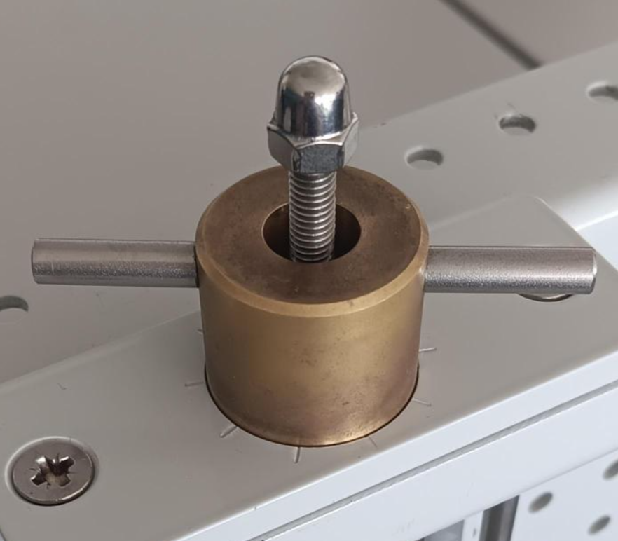
Figure 6, Load Nut

Once a table for the results is drawn up, the experiment can begin. For our test it was decided to collect the movement in the dial indicator in increments of 0.2mm from the load nut. As force is exerted onto the test specimen, the specimen shall stretch resulting in movement displayed on the dial indicator, see figure 7.
8
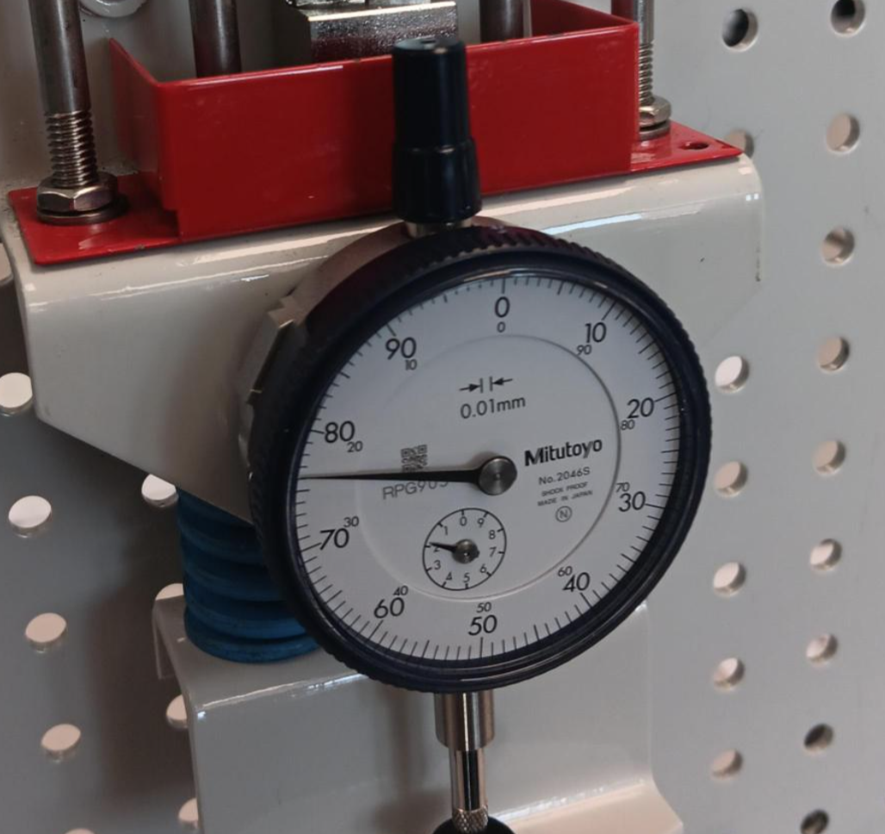
Figure 7, Dial Indicator Movement Display

Eventually once enough force is built up the material specimen shall fail, in this case, this being a tensile test, on a softer more ductile material, necking shall be seen before a shear failure shall be displayed. Please see figure 8.
9
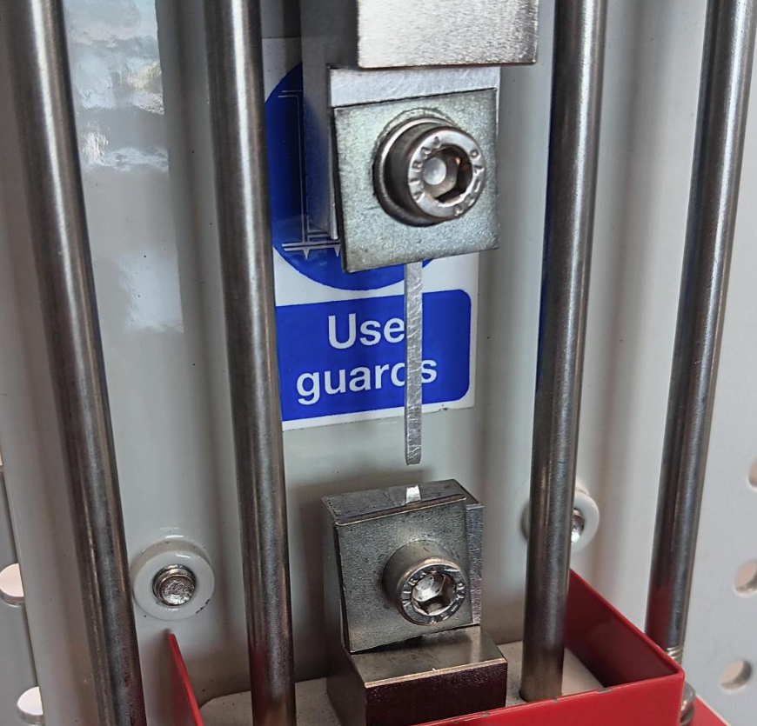
Figure 8, Test Specimen Failure

10
Chapter 4 – Test Results:

Table 1 – Collected Data
Load Nut Movement | Dial Indicator | Force | Extension | stress σ | Nominal Strain
mm | mm | N | mm | N/mm^2 | ɛ (No Unit)
0 | 0 | 0 | 0 | 0 | 0
0.2 | 0.16 | 16 | 0.04 | 0.265604 | 0.00133
0.4 | 0.34 | 34 | 0.06 | 0.564409 | 0.00199
0.6 | 0.53 | 53 | 0.07 | 0.879814 | 0.00232
0.8 | 0.71 | 71 | 0.09 | 1.178619 | 0.00299
1 | 0.88 | 88 | 0.12 | 1.460823 | 0.00398
1.2 | 1.05 | 105 | 0.15 | 1.743028 | 0.00498
1.4 | 1.23 | 123 | 0.17 | 2.041833 | 0.00564
1.6 | 1.41 | 141 | 0.19 | 2.340637 | 0.00631
1.8 | 1.6 | 160 | 0.2 | 2.656042 | 0.00664
2 | 1.76 | 176 | 0.24 | 2.921647 | 0.00797
2.2 | 1.92 | 192 | 0.28 | 3.187251 | 0.00930
2.4 | 2.1 | 210 | 0.3 | 3.486056 | 0.00996
2.6 | 2.25 | 225 | 0.35 | 3.73506 | 0.01162
2.8 | 2.36 | 236 | 0.44 | 3.917663 | 0.01461
3 | 2.48 | 248 | 0.52 | 4.116866 | 0.01726
3.2 | 2.54 | 254 | 0.66 | 4.216467 | 0.02191
3.4 | 2.65 | 265 | 0.75 | 4.39907 | 0.02490
3.6 | 2.75 | 275 | 0.85 | 4.565073 | 0.02822
3.8 | 2.81 | 281 | 0.99 | 4.664675 | 0.03287
4 | 2.86 | 286 | 1.14 | 4.747676 | 0.03785
4.2 | 2.92 | 292 | 1.28 | 4.847278 | 0.04250
4.4 | 2.96 | 296 | 1.44 | 4.913679 | 0.04781
4.6 | 2.98 | 298 | 1.62 | 4.946879 | 0.05378
4.8 | Fail | Fail | Fail | Fail | Fail
5 | N/A | N/A | N/A | N/A | N/A

Table 1 shows all the initial collected data from the tensile test, and some further parameters that can be simply calculated.
The extension in the test specimen can be found by subtracting the number given by the dial indicator, from the load nut movement.
To the calculate the force multiply the dial indicator number by 100 (TecQuipment Ltd, 2012).
11
Stress can be found by diving the force by the area acted on by force (The Engineering ToolBox, 2005).
Finaly strain can be found by dividing the change in length by the original length (TecQuipment Ltd, 2012).
From this data the best way to evaluate the material performance is to draw up a stress vs strain chart. This can be seen in figure 9.

Figure 9, Stress vs Strain Chart

After analysing this graph, we can see that the aluminium alloy test sample, with some fluctuation, hits it elastic limit at around 2.65 N/mm² of stress. This also happens to be the yield point where the material begins to permanently deform, not to return to its original size.
As the material enters the plastic stage, it shall begin necking, where it begins to stretch into thinner material. The highest point of the arc usually dictates the ultimate strength, however on this occasion it also coincides with the fracture or failure point at 4.94 N/mm² of stress. Figure 10 attempts to capture the necking displayed by the test sample, however due to the size of the total extension (1.62mm) it may be hard to make out.
12
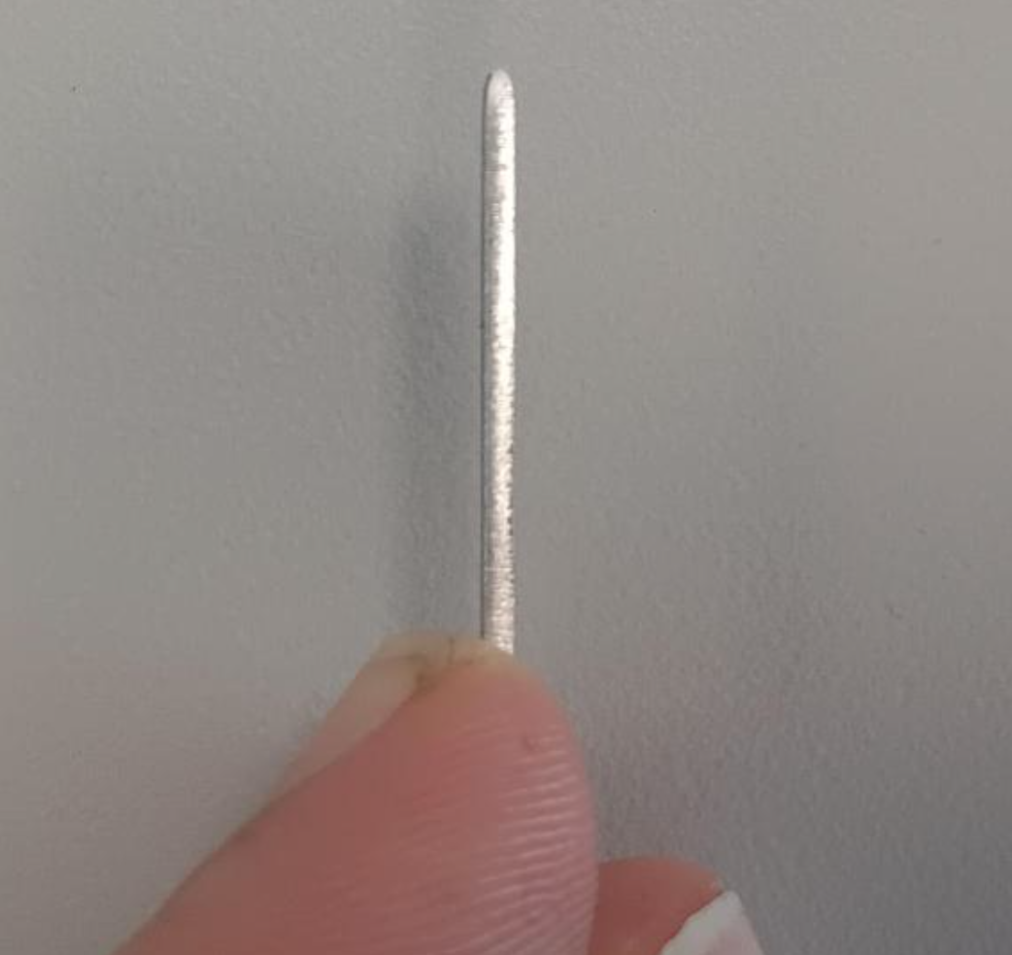
Figure 10, Display of Necking

Although valuable information has been gained about this material, for total clarity performing a simple tensile test on a small specimen isn’t enough to dictate the reason for the failure of the drive shafts.
As drive shafts mainly get cyclical forces exerted upon them (failure due to horizontal shear is rarely seen), I would suggest performing a torsion test on a full size sacrificial shaft if possible. This would give exact numbers for how much force and stress can be exerted on the shaft. One could then compare the current shaft iteration to the previous, and see if they are operating at the same strength. Due to the double failure, most likely not.
13
Chapter 5 – Analysis:

We have been asked to identify both the yield strength, and the ultimate tensile strength of our test specimen.
Yield strength can be found by referring back to figure 9, and identifying the point at which the material goes beyond its elastic limit. As previously mentioned said value is at 2.65 N/mm².
To find the ultimate tensile strength, once again as previously mentioned one can find it at the highest point of the arc, on a stress vs strain chart.
However one is also able to manually calculate it if the chart if unclear.
Use the equation: (Mecmesin, 2026).
$$UTS=\frac{F}{A} \left(Equasion 1\right)$$
Where:
- F = Maximum Force Applied (Newtons)
- A = Area of Test Piece (mm²)
- UTS – Ultimate Tensile Strength (N/mm²)
$$UTS=\frac{298}{(30.12 · 2)}= 4.94$$
Finaly we were asked to find the Young’s modulus, also known as the modulus of elasticity, of the material. This is done by calculating the gradient of the initial linear section of the graph.
$$Gradient=y=mx+c \left(Equasion 2\right)$$
Can also be written as:
$$Gradient=\frac{∆Stress}{∆Strain} \left(Equasion 3\right)$$
Young’s modulus equals (N/mm²):
$$\frac{2.65}{0.00664}=399.09$$
14
Convert to Pascals (most often used to display Young’s modulus):
- 1N/mm² = 1e+6 Pascal
- 1N/mm² = 0.001 GPa
- 399.09 N/mm² = 0.39909 GPa

If this last calculation is correct, this provides indisputable evidence as to why the drive shafts failed. There is more mass of metal, and therefore structural integrity in the drive shaft than the test specimen, however the test piece is exhibiting suspiciously soft properties.
For standard aluminium Young’s modulus is usually found to be around 68 GPa (MatWeb, 2026).

15
Chapter 6 – Conclusion:

To conclude this report, the tensile test conducted on the aluminium sample determined variables such as yield strength, and ultimate tensile strength. After analysing the results, we can see that the measured and calculated values are significantly lower than high grade materials used for drive shaft applications. Hence we have found that this material specifically, is not up to the test of being used for the Dakar rally.
For when a replacement material is selected, it would be highly recommended to follow a stricter material selection and validation process, such as those seen in chapter 2. My personal recommendation would be to consider the use of more thorough testing procedures, although expensive, it would outline more of the parameters and capabilities of the material.

16
Chapter 7 – References:

- Engineering Gone Wild (2026) How Mechanical Engineers Select the Right Material, YouTube. Available at: https://www.youtube.com/watch?v=jy7XrHhWJUk (Accessed: 24 April 2026).
- Material and Process Selection Charts (2009) GRANTA CES 2009 EDUPACK. (Accessed: 24 April 2026).
- McClements, D. and Keane, P. (2026) 21 different types of material testing, Xometrys RSS. Available at: https://www.xometry.com/resources/materials/material-testing/ (Accessed: 24 April 2026).
- Mecmesin (2026) Ultimate tensile strength, Mecmesin. Available at: https://www.mecmesin.com/test-type/ultimate-tensile-strength (Accessed: 26 April 2026).
- Online materials information resource - matweb (2026) MatWeb. Available at: https://www.matweb.com/ (Accessed: 26 April 2026).
- TecQuipment (2026) Tensile tester kit, TecQuipment. Available at: https://www.tecquipment.com/tensile-tester-kit (Accessed: 25 April 2026).
- TecQuipment Ltd (2012) Engineering Science Guidance Notes, Tensile Tester Kit ES6. (Accessed: 25 April 2026).
- The Engineering ToolBox (2005). Stress, Strain and Young's Modulus. [online] Available at: https://www.engineeringtoolbox.com/stress-strain-d_950.html (Accessed: 25 April 2026).

17

