University of Wales Trinity Saint David
LONDON CAMPUS
Individual Report
Module Name: Digital Skills and Research Methods
Module Code: LCHS 4007
Student name: Oksana Belkin
Student ID: 2510731
Lecturer’s Name: Dr Sadeque Imam Shaikh
Submitted 15/12/2025

Table of Contents
Research Topic: Vaccination and Immunisation in UK 1
Introduction 1
Problem Statement 2
Justification 2
Information Sources and Justification 2
Task 2: Research Methodologies 3
Give a brief overview of quantitative and qualitative research. 3
What type of research methodology will you use for your research and why? 3
Task 3: Data Collection 4
Overview of primary and secondary data collection 4
What form of data will be used to address your research problem, and why? 4
Conclusion 4
References 5

Research Topic: Vaccination and Immunisation in the UK

Introduction

This research will examine the issues regarding two essential medical practices within the Health and Social care sector like vaccination and immunisation in the UK; they are critical parts in modern medicine. Immunisation is the key to primary health care and vaccines are important to the prevention, control of infections and disease outbreaks (British Journal of General Practise, 2023). This report will be based on primary data and quantitative research methods which will explore the accessibility, public perception on vaccination, immunisation as well as their impact on the health care system. The angle will take an analysis of national immunisation schedules, accessibility, government policies, challenges and the impact on reducing illness and saving lives.

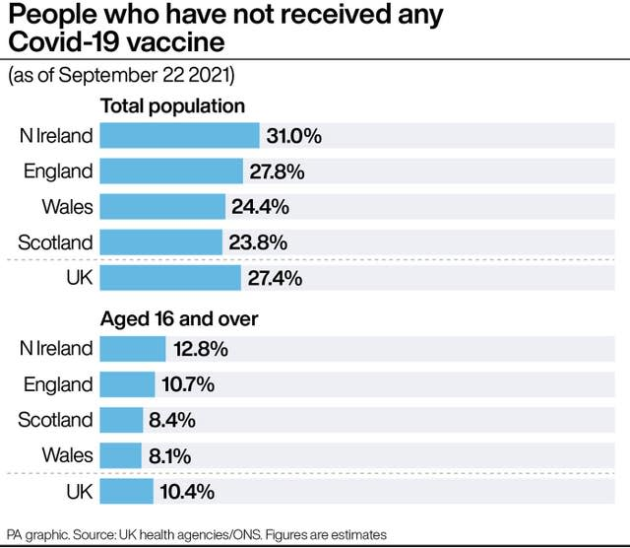

Problem Statement
The current issue is that although vaccines are widely available in the UK, not everyone gets vaccinated due to access, inconvenience, deprivation, parental concerns, lack of trusted sources and communication gaps. Despite the success of vaccination and immunisation programs in the UK, challenges remain to reach a wide audience and gain public trust. Vaccine hesitancy is caused by being misled by unofficial sources like social media and family networks. This poses a huge threat as it increases outbreaks of preventable diseases. There are also side effects which can make an individual reluctant to pursue vaccinations. These issues affect public health and put pressure on healthcare systems. As a result, this can lead to outbreaks of diseases that could have been prevented, putting public health at risk. Children and infants are affected in the long term due to the decisions being done by the parents, this includes difficulty booking appointments and attending them.

Justification
Data collection and research are a vital part of vaccination and immunisation in the UK. Without the accurate data it would be difficult for the NHS and public health organisations to understand who has been vaccinated or who has not so they can target where extra support is needed. Data research allows health authorities to monitor immunisation levels across different areas of UK, age groups and communities. This makes it easy to identify regions with low uptake and act accordingly. By doing this the risk of outbreaks of vaccine-preventable diseases, such as flu and measles can be reduced. As a result, data collection is monitoring the safety and effectiveness of vaccines. Recording information about side effects and outcomes helps healthcare professionals spot any concerns and reassures the public that vaccines are being carefully monitored. Immunisation data provides a better framework in the NHS like preparing vaccine quantity and ensuring resources used are up to standard. Therefore, data collection is vital to protecting public health in the UK, along with accurate data collection supports disease prevention, strengthens vaccination programs and improve the overall wellbeing.

Information Sources and Justification
Three relevant, truthful and up to date sources were chosen for the Vaccination and Immunisation research in UK.
Firstly, The UK Health Security Health Agency (UKHSA) site holds a dedicated immunisation section which includes national vaccination schedules, official guidance and regular data outputs (Gov UK, 2025). This ensures up to date vaccination coverage. The GOV UK source provides primary statistics, which are essential for any analysis of immunisation coverage in the UK. This source was chosen for my research as it is reliable and is sourced by the government. The information breaks down into geographical regions and goes deeper with variations like urban/rural communities and areas of deprivation. The official data is analytical, offers methodological variety and covers diverse populations and immunisation needs.
Secondly, The Green Book (UKHSA/GOV.UK, 2025) was published in 2006 and gets updated regularly; the government guidance covers each vaccine used in the UK. There is one part of the book which goes into detail about principles, practises and procedures, this includes vaccine safety, adverse events, contradictions and special considerations, immunisation on healthcare professionals and immunisation of individuals with underlying conditions. It is a primary handbook for healthcare practitioners delivering immunisations in the UK. It was chosen as part of my research because it is an authoritative source used to justify clinical facts, UK schedules and policy practice.
Thirdly, the NHS “Vaccinations and when to have them”, is a clear guide for patients and parents. It displays what is currently on offer, involving information that is age group specific and updated vaccine information. It is relevant to this research as it shows how the programme is presented to the public. It is useful for research on accessibility, public communication and community uptake. The reason why I selected this source is because it explains the patient/parent perspective and availability to schedule appointments.

Task 2: Research Methodologies

Give a brief overview of quantitative and qualitative research.
When it comes to research, there are two methods: quantitative and qualitative. The key difference is that in quantitative research the aim is to try and understand what is happening and to generalise this across a population. Quantitative research focuses on numerical data and statistical analysis. In qualitative research, the emphasis is more often on why something is happening or how it is happening. Qualitative research also explores methods like in-depth interviewing and focus groups which gives more detailed insight.

What type of research methodology will you use for your research and why?
This report will be based on quantitative research on vaccination and immunisation in the UK. I will be collecting numerical data, such as how many people are vaccinated and which groups have higher or lower vaccination rates and will focus on facts from reliable sources to investigate the cause of problem regarding accessibility and people’s beliefs. Quantitative method is an excellent, reliable method that is full of facts and numbers so it makes it easy to see patterns, compare different groups and understand what factors might influence whether people get vaccinated or not. The results are more reliable and objective, quantitative research helps present the results clearly and supports good decision making in the Health and Social care sector.

Task 3: Data Collection

Overview of primary and secondary data collection
There are two types of data collection: primary and secondary. Primary data is original and collected first hand, the information is gathered by a researcher for a specific purpose using methods like interviews, observations, experiments, surveys and questionnaires. As the collection of data is conducted by the researcher that makes the data highly relevant and accurate for the study. On the other hand, that sort of data is often time consuming and can damage data quality as responses may be affected by interview bias. Secondary data is pre-existing and collected by others such as books, journals, reports, research and articles which is quicker to use but may not perfectly fit the researchers needs and offers less control over how it was collected. Despite that, secondary data is highly useful, and it is time-efficient, offers a broad scope, and is easy to obtain information. However, the data needs to be carefully evaluated for reliability, relevance and accuracy. Secondary data collection has an ethical advantage: no need to involve human participants directly which avoids issues of consent and privacy.

What form of data will be used to address your research problem, and why?

I have chosen to use secondary data for my research about vaccination and immunisation in the UK. This is because there are already reliable and comprehensive resources of information available such as government reports and up to date UK medical sources. It covers large, scaled data and previous research studies to explore, providing me a broader perspective. Using secondary sources allows me to track vaccination rates, disease outbreaks, analyse trends, coverage rates as well as explore patterns in immunisation and vaccination of different regions. This allows me to identify pattens and long-term impacts without the time and cost of collecting new data. It is also providing a large and diverse data set that can straighten the accuracy of finding and support evidence-based conclusions. Data from organisations like NHS, GOV.UK, UKHSA and any other national health authorities is usually collected systematically and is highly trusted.

Conclusion
To conclude, using digital research by using secondary data and quantitative method has helped me to understand vaccination and immunisation patterns more clearly. By analysing existing statistics, medical data and numerical data from reliable sources, I was able to see trends, compare different groups and identify areas where vaccination coverage could be improved. This approach is efficient, accurate and provides strong evidence that can support better public health decision and strategies for the Health and Social care sector.

References

GOV.UK (2025) Immunisation [online] Available at: https://www.gov.uk/government/collections/immunisation (Accessed 30th November 2025).

British Journal of General Practice. (2023) How much should we care about vaccine hesitancy in UK primary care?(2023) [online] Available at: https://bjgp.org/content/73/732/295 (Accessed 30th November 2025).

GOV.UK/UKHSA. (2025) Immunisation against infectious disease [online] available at: https://assets.publishing.service.gov.uk/media/6196386dd3bf7f054f43e02d/Greenbook-cover-Nov21.pdf (Accessed 30th November 2025).

NHS. (2024) NHS vaccination strategy https://www.england.nhs.uk/long-read/nhs-vaccination-strategy/ [online] (Accessed 25th November 2025).

