Student id nr: 2133162
Students Name: Adebowale Ogungbure
Module code: BMSW4001
Lecturer:

Topic
WHAT IS THE MOST EFFECTIVE WAY TO MOTIVATE STAFF

Introduction
One would wonder why managers should spend time motivating their staff, but the explanation is simple: they do this in order to increase productivity and their lifespan.
Organizational commitment is very important for every business's success; without it, employees have no reason to produce their best work. A 1988 research found that 86 percent of firms had difficulty recruiting new workers, and 58 percent of those organizations had difficulty keeping present employees. Despite the study's age, its findings are still applicable today. A company may lose one million dollars if it loses 10 professional staff members. Not only do they lose money or suffer setback, but they also risk losing valuable personnel assets like the knowledge and expertise that the individual(s) had. To minimize or reduce this expense, companies should work to keep their workers motivated and invested in the company's mission and goals.

Four Different Ways Staff Can Be Motivated

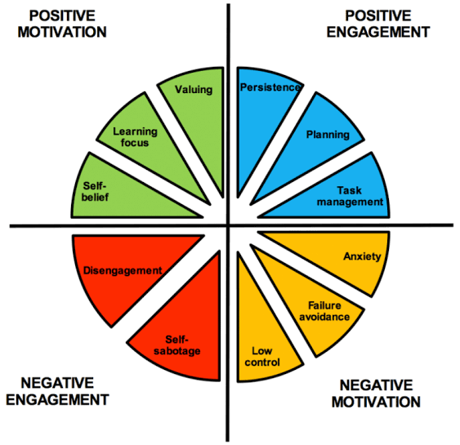

Source: Research gate, Andrew J. Martins

Staff Involvement
There's a strong correlation between work motivation and practices that help employees feel empowered and involved in their jobs. Worker participation is premised on the idea that individuals performing the job are most equipped to offer ideas and decide on the best ways to enhance the quality and efficiency of the work they do (Ichniowski, Kochan, Levine, Olson, & Strauss, 1996). For example, Hackman and Oldham's (1976, 1980) job design theory argues that more job autonomy is associated with better levels of employee engagement. Increased levels of participation and autonomy may lead to better levels of self-esteem, which in turn boosts motivation at work. Participants in team project decision-making have a greater likelihood of developing a sense of "ownership" and feeling self-assured about completing the tasks than those who are not. It is possible to stimulate creativity by giving these workers the freedom to experiment with their work techniques, as well as the order and speed in which they do it.

Compensation and Reward Systems
The major extrinsic reward individuals get in exchange for their organizationally aligned behavior is compensation, therefore it seems reasonable to analyze its function in motivating individual activity in support of organizational objectives. According to the findings of a first meta-analysis of the study, there is no other incentive or motivational approach that can match money in terms of its instrumental value. This is something that was stated by Locke, Feren, McCaleb, Shaw, and Denny (1980). In most cases, further meta-analyses supported this finding (e.g., Guzzo, Jette, & Katzell, 1985; Jenkins, Mitra, Gupta, & Shaw, 1998). It is most typical to get a bonus or boost in pay as a financial incentive. According to the Society for Human Resources Management, more than half of all workers believe that benefits and remuneration are critical to their job satisfaction ("2009 Employee Job Satisfaction"). For some people, pay is a stronger motivation than for others in the current economic climate. Additional compensation in the form of a bonus is a way to motivate workers and help the firm achieve its objectives (Hodder Education). For employees, a bonus helps them grasp precisely what the organization's objectives are and inspires them to be productive employee who ensures that the goals are reached, as well.

Career Progression, Upskilling, and the Transforming Nature of Careers
In the workplace, findings suggest that employees who are supported in their professional development are happier and more motivated to do their jobs. Employees who are just starting in their professions and are looking for knowledge about and aid in building these career paths are more likely to respond favorably to such information and assistance. Some research shows that introducing new workers to the company's various career pathways and other aspects of the company culture may help them develop more favorable views about their work and the company as a whole. It's also been shown that mentored personnel had better degrees of organizational self-esteem than their non-mentored counterparts; (Ragins, Cotton, & Miller, 2000). Helping employees learn about and progress along internal career paths is likely to have a comparable beneficial impact. Based on expectation theory, we believe that workers who believe they will be rewarded for their efforts if they work harder would be more motivated to do their best at their jobs. The changing nature of careers, especially the trend toward an emphasis on employability and career paths external to the business, has substantial consequences for work motivation.

Employment Security
Employee attitudes and work motivation are likely to be affected by the existence or lack of job security, notwithstanding recent efforts to build a new psychological contract focused on employability. As Pierce and Gardner (2004) postulated, "People who feel that their organizational security is challenged may come to believe that they are no longer an essential component of the organization" (p. 605), resulting in a decrease in organizational-based self-esteem and effort. Studies have shown a negative correlation between work uncertainty and self-esteem, which supports this claim (Hui & Lee, 2000; Proenca, 1999). Downsizing has been shown to have a negative impact on the remaining workforce in studies conducted by Batt, Colvin, and Keefe (2002). For example, they found an association between greater employee leave rates and the recent history of layoffs in the business. These findings suggest that downsizing tactics may increase employees' feelings of job insecurity, which may lead to a decrease in motivation and other undesirable work outcomes (e.g., reduced commitment).

Conclusion
It's important to remember that motivation is a multifaceted idea that, depending on how it's implemented in a company, may either benefit or hurt that company. The acknowledgment may be of great assistance if the manager makes the effort to comprehend the requirements of the workers under his or her supervision. There have been a lot of philosophers who have attempted to explain what drives individuals, but every person is different, and a theory can't represent all people because of this difference. Research has shown that a compensation and incentive system is the most effective way to encourage employees, and it is recommended that such a system be implemented in all types of businesses.

References

Arthur, J. B. (1994). Effects of human resources systems on manufacturing performance and turnover. Academy of Management Journal, 37,670-687
Arthur, W., & Bennett, W. (1995). The international assignee: The relative importance of factors perceived to contribute to success. Personnel Psychology, 48, 99-114
Batt, R., Colvin, A. J. S., & Keefe, J. (2002). Employee voice, human resource practices and quit rates: Evidence from the telecommunications industry. Industrial and Labor Relations Review, 55,573-594
Chris, Pearce. (2007). Ten steps to staff motivation. Nursing management Volume 13, Number 9.
Guzzo, R. A., Jette, R. D., & Katzell, R. A. (1985). The effects of psychologically based intervention programs on worker productivity: A meta-analysis. Personnel Psychology, 38,275-291
Guzzo, R. A., & Noonan, K. A. (1994). Human resource practices as communications and the psychological contract. Human Resource Management, 33, 447-462
Hackman, J. R., & Oldham, G. R. (1976). Motivation through the design of work: Test of a theory. Organizational Behavior and Human Performance, 16,250-279.
Hackman, J. R., & Oldham, G. R. (1980). Work design in the organizational context. Research in Organizational Behavior, 2,247-279
Hui, C., & Lee, C. (2000). Moderating effects of organization-based self-esteem on the relationship between perception of organizational uncertainty and employee response. Journal of Management, 26,215-232
Ichniowski, C., Kochan, T. A., Levine, D., Olson, C., & Strauss, G. (1996). What works at work: Overview and assessment. Industrial Relations, 35,299-333
Ilgen, D. R., & Hollenbeck, J. R. (1991). The structure of work: Job design and roles. In M. D. Dunnette & L. M. Hough (Eds.), Handbook of industrial and organizational psychology (pp. 165-207). Palo Alto, CA: Consulting Psychologists Press
Jackson, S. E., Schuler, R. S., & Rivero, J. C. (1989). Organizational characteristics as predictors of personnel practices. Personnel Psychology, 42, 727-786
Kevin, Murray. (2021). Eight ways bad managers kill conversations – and motivation. CMI
Locke, E. A., Feren, D. B., McCaleb, V. M., Shaw, K. N., & Denny, A. T. (1980). The relative effectiveness of four ways of motivating employee performance. In K. D. Duncan, M. M. Gruenberg, & D. Wallis (Eds.), Changes in working life (pp. 363 388)
Locke, E. A., & Henne, D. (1986). Work motivation theories. In C. L. Cooper & I. Robertson (Eds.), International Review of Industrial and Organizational Psychol- ogy (pp. 1-36). New York: Wiley
Pierce, J. L., & Gardner, D. G. (2004). Self-esteem within the work and organizational context: A review of the organization-based self-esteem literature. Journal of Management, 30,591-622
Ragins, B. R., Cotton, J. L., & Miller, J. S. (2000). Marginal mentoring: The effects of type of mentor, quality of relationship, and program design on work and career attitudes. Academy of Management Journal, 43, 1177-1194
Riordan, C. M., Weatherly, E. W., Vandenberg, R. J., & Self, R. M. (2001). The effects of preentry experiences and socialization tactics on newcomer attitudes and turnover. Journal of Management Issues, 13,159-177
Robinson, S. L. (1996). Trust and breach of the psychological contract. Administrative Science Quarterly, 41,574-599
Viachaslau, F., & Sara, C. (2020). Zero hours contracts and their perceived impact on job motivation of event catering staff. Department of Tourism and Hospitality, Bournemouth University, Poole, Uk. Https://doi.org/10.37271/15259951X15506259855869
Zosia Kmietowicz (2009). NHS could learn from John Lewis about motivating staff, says Nuffield Trust. BMJ Publishing Group Limited; 339:b2703

