MANAGING PROJECTS IN THE ORGANISATION
NAME: RODICA VIORICA CUC
STUDENT ID: 1906092
LECTURER: REXON NTING
Executive summary
This entire project has demonstrated the construction of a family restaurant in LAYNE'S cafe in the UK. After the pandemic situation, this cafe is planning to reopen with a new design and menu. Therefore, they had consulted with a project manager and provide detail about their requirements. The project manager had estimated the cost of this construction to the client and after analysis, they had said the entire project would end within 2month. Moreover, the project manager had analyzed the risk assessment of the project. They had identified that financial and time management is giving a major impact on the project.
Table of Contents
Task 1 4
Task 2 15
References 17

Task 1
Introduction
LAYNE'S is a small cafe which is situated in the UK and this company has been serving it for almost 15 years. The menu they serve for their customers is specifically coffee. Moreover, this company is limited in the UK and they established their business in 2011. Recently the owner of this company has decided to expand their cafe by including a family restaurant in that same cafe. Therefore, this project is about the entire project and the estimated time for completing the project.
Project outline
In this project, this organisation is consulted with a project manager and talks about their projects. The plan of the owner of this organisation is planning to include a family restaurant. Therefore, the existing building is required to extend and start new construction. The existing budding is a one-floor building in which a kitchen area and a dining area are present. Including this Laynes also arranged a seating area outside of the cafe. After seeing the entire construction area the project manager has decided to restructure the entire building. The members of this cafe have transformed a big room into a storeroom (Demirkesen and Ozorhon, 2017). Therefore, the project manager has planned to turn that storeroom into the dining area for the family restaurant. Besides this building, there is a small area that is giving an opportunity to this project that they are able to construct an entire kitchen area for this family restaurant. In this family restaurant, they are also planning to develop a small area for the live concert. Therefore, a small platform is also required to be constructed in this cafe. Additionally, this cafe is also planned to develop a small area behind the cafe for car parking for the customers and staff. Therefore, it could help their customers and staff to manage their cars in this cafe itself. Additionally, after the Covid-19 situation to maintain the sustainability of this project they have also ensured a room in which all the staff is able to sanitize themself and change their clothes before serving to customers (Mavi and Standing, 2018). In fact, the sitting arrangement is also arranged by maintaining distance which ensures the customer’s security.
All these plans are implemented by the project manager and this project is giving estimates of all the aspects of completing this project.
Business objective
This company is to develop this project, they are able to give facilities to the customers and give them more opportunity to explore foods. The objective of this project is to deliver main course dishes to the family of customers. Moreover, they are also expanding their business and increasing the attraction of customers to their company by providing them with all demanding food items.
Project scope
The scope of this project is giving an opportunity to this organisation to show the versatility of their company. Therefore, the customers are able to connect with them and more customers are showing interest in their company. In fact, including the concert arrangement in this Cafe could help the young generation to come and have food from the restaurant. As this cafe is also planning to develop a parking area behind the cafe it could give an opportunity to this cafe that they are able to give comfort to the customers as they can arrange their car in the parking area (Levy, 2018). Most of the people in the country have their own car. Therefore, while they are going to restaurants they are not able to manage their car in most of the small size restaurants. Hence the parking system is giving a great advantage to the customers. This project is giving an overall advantage to this organisation that they are able to give enough opportunities such as quality foods, many food items, parking facilities, and many others.
Project objective
- To develop a restaurant in time to give high quality and versatile food to their customers
- To change the perception of customers regarding environment and food for this restaurant
- To achieve the meet all the demands of the project within budget and time
High-level requirements
In this project, the project manager is going to renovate LAYNES cafe into a family restaurant. Hence, to implement this project the project manager is required to complete the electric work in this cafe (Levy, 2018). They are also required civil engineers to design the entire plot and interior decorators. The interior decorator would suggest to the owner of this company how to design their interior portion to attract customers. While they extend their restaurant, they are also required to design furniture. Therefore, they are also required by a furniture designer who would suggest the arrangement of furniture.
Deliverables
The effective deliverable of this project is proving high-quality versatile products to the customers along with entertainment (Åsgård and Jørgensen, 2019). This project also provides an opportunity for customers that they are able to enjoy their food while listening to music. It is also giving a prospect to the customers that they are getting a comfortable and enjoyable monument while coming to this cafe.
Project constraint /exclusion
The project constraint shows the limitation of the project manager who is facing issues during the compilation of the project (Åsgård and Jørgensen, 2019). The project manager is facing issues with time limitations and budget limitations. They can face issues regarding budget extension and be able to complete the project within time. The project manager is supposed to exclude low-quality designers and constructors.
Stakeholder analysis
Types of stakeholders | Stakeholders name | Role | Responsibilities | Involvement
External | Electrician | Work for electric set up | Check the electric line to set up lights for the restaurant | Indirect
Internal | Client | Give design to project manager | The client is required to give detail about the project | Direct
External | Raw material suppliers | Provide raw materials | Suppliers are required to give quality materials to the project manager | Indirect
External | Interior designer | Design the interior of the cafe | They are required to give an idea about the interior of the cafe and arrangement of seating area and decoration in the cafe (Mesároš and Mandičák, 2017) | Indirect
External | Governance | Give permission about project | The governance of the country provide food license and give permission for construction | Indirect
Internal | Staffs of cafe | Manage the entire project | The staff are required to operate and monitor the entire project | Direct
External | Customers | Come to attend the restaurant | They are ordering food, come to the restaurant and give feedback (Banihashemi et al. 2017) | Indirect
Table 1: Stakeholder analysis
(Source: Created by author)
The internal stakeholder of this project is affected by this project and they are also responsible for modification in the project. The internal stakeholders only give an idea of how the project is required to be constructed and what changes are required in this project. In fact, the internal stakeholders are also giving the idea that new things are required in this cafe to make it a family restaurant and they are also giving the estimation of the budget of the project. The external stakeholders are also involved in this project. The suggestion of customers is required to bring the modification in the cafe. The suppliers are the most important for this project as they are required to provide all the required materials to the project manager to complete the project. They are also required to provide all the required material while maintaining high quality.
Project organisational structure
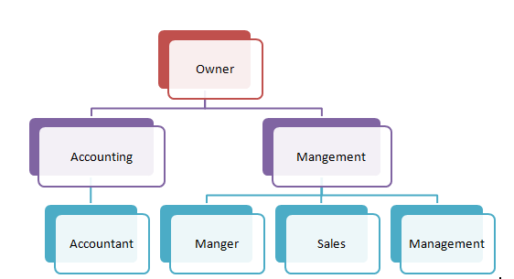
Figure 1: Project organisational structure
(Source: Created by author)
The project organisational structure is helping to get an idea of how many internal stakeholders are present in the organisation. The project manager would get an idea about the role of each member in the organisation (Ahmed, 2018). Therefore, they are able to connect with the right person while they are required for any necessity during the project construction. From this structure, it can be said that while the project manager is required money they could ask the accountant and while they are required any management-related requirements they are supposed to ask the manager of this cafe (Callistus and Clinton, 2018). Hence, it could help the project manager to get a clear vision about the roles and responsibilities of members which makes the project manager's work process easy.
Work Breakdown structure
The WBS of this project is included the initiation, planning, execution, and closing (Demirkesen and Ozorhon, 2017). In these five stages, there are many subtasks that are required to complete within the allocated time. Below the entire WBS structure is mentioned along with the start date of the subtask.
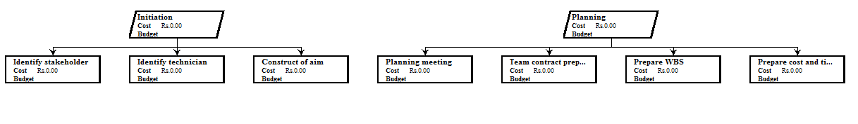
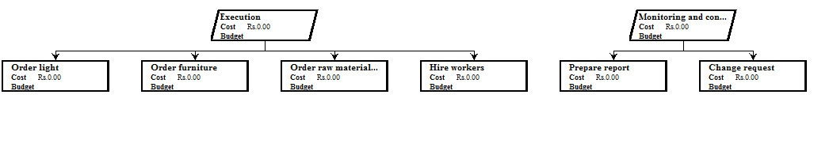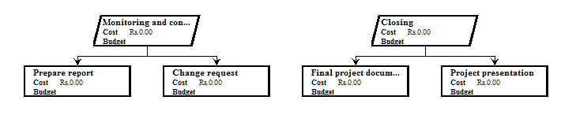

Figure 2: WBS of project
(Source: Created by author)

Activity | Sub-activity | Sub Sub-activity | Number of days/ Weeks/Months | Cost
Initiation | Identify stakeholder |  | 10days | £ 3500
 | Identify technician
 | construct aim
Planning | Planning meeting |  | 20days | £30000
 | team contract preparation
 | prepare WBS
 | prepare cost and timeline
Execution | order types of equipment |  | 20days | £ 1000000
Monitoring | prepare report |  | 20 days | £ 2000
Closing | Final project presentation |  | 10 days | 0
Table 2: WBS cost
(Source: Created by author)

Cost of resource
Types of resources | Resources | Cost
Essential | Refrigerator | £50000
Essential | Dishwasher | £3500
Essential | Utensils | £5000
Essential | Sanitisation equipment | £7000
Interior | Furniture | £40000
Interior | Decorators | £3600
Interior | Light | £2600
Construction | Raw materials | £50000
Table 3: Cost of resource
(Source: Created by author)
The cost resources of the project are helping to get an idea of how much money is required for the project. Including this, the cost of resources also could help to get an idea about which are the requirements that are essential for this project (Alothaimeen and Arditi, 2019). The cost estimation is also beneficial for the project as it helps the project manager and client to get an overall idea about how much money is required to complete the project.
Milestone of project
The milestone of the project is defined as the project life cycle as it gives an idea about the start and ends the time of the project (Chen et al. 2019). Before starting the project a milestone is required to identify the important task for this project and which tasks are required to start first. Below mentioned the list of the activities and the essential time required:
Activity | Time
Identify the stakeholder | 8 days
Plan the entire project | 20 days
Plan meeting | 10 days
Prepare WBS | 1 day
Preparation of cost and time of project | 2 days
Order all equipment | 20 days
Table 4: Milestone of project
(Source: Created by author)
Communication strategy
The communication strategy is helping the project managers to get an idea of how they are communicating with each other and how they are giving information related to the project to each other. Effective communication is helping the entire project members to complete the project with high performance (Kim et al. 2020). This communication strategy is engaging stakeholders of a project in which they can share when, how, and where the information would be shared. In this project management, the communication strategy is effectively important as it connects project managers, suppliers, and clients. The communication required for this project through the meeting to maintain the social distance. Project planning meeting time, date, and persons are mentioned in a mail by the project manager and send this mail to the stakeholder. In this meeting, they discussed the project plan and how the plan is supposed to be executed. Once the project has started the project manager is required to give all the updates to the stakeholders through the mail each month (Fewing and Henjewele, 2019). Moreover, the project manager is also required to conduct a meeting with the suppliers about what equipment they are required for the project, and this meeting they have conducted through Google Meet.
Name of communication | Media | Sender | Receiver
Project meeting | Mail | Project manager | All stakeholder Stakeholders
Stakeholder update | Monthly update through mail | Stakeholder | Project manager
Supplier meeting | Google Meet | Project manager | Suppliers
Table 5: Communication strategy
(Source: Created by author)

Project schedule
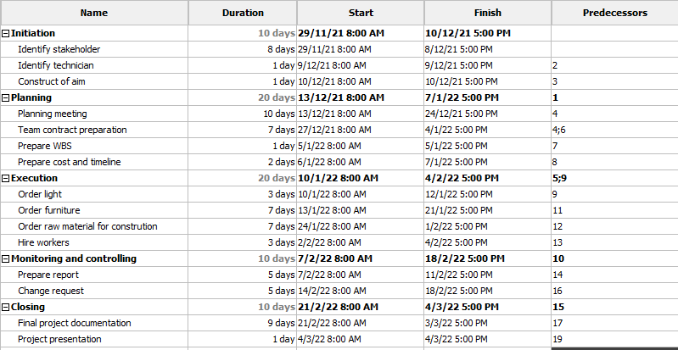
Figure 2: Activity list of project
(Source: Created by author)
The above figure shows the timetable of the project at which time the entire project can be evaluated. This entire project is completed in five steps and ends within 2month. This is the entire activity required for this project and the project manager of this project has distributed this entire task among the members.
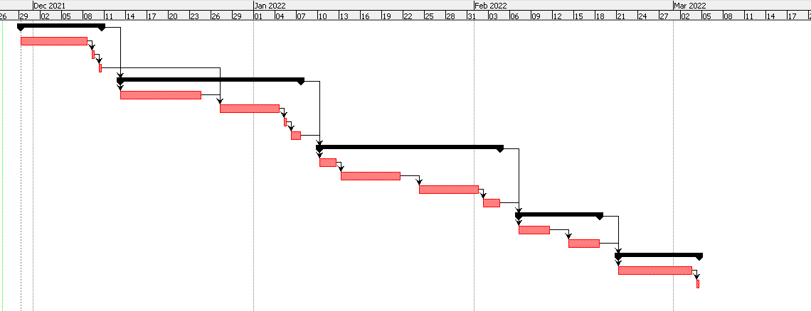
Figure 3: Gantt chart pf project
(Source: Created by author)
Risk assessment
Risk management is ensuring that the risk could appear during the project development (Marović and Hanak, 2017). This risk management is important as it makes the project more believable and acceptable. With the help of this risk assessment, the project manager is able to know what risks could appear and how to mitigate those risks.
Type of risk | Description | Likelihood | Severity | Impact | Mitigation
Financial | Lack of idea related to cost required for the project | High | High | High | Discuss the cost of raw materials and get enough knowledge about the price of products.
Lack of time | Lack of time management can occur due to short of employees and lack of time schedule of the project (Mesároš et al. 2021) | High | High | High | The project manager is required to develop a time schedule for the entire project
Communication | Remote working increases the possible lack of communication. Additionally, language gap among employees and differences of thinking related to projects (Dasović et al. 2020) | High | Low | High | The project manager and members are supposed to use a common language for communication
Remote working or employee | Due to the Covid-19 situation, some of the employees are working from home which leads to a lack of communication. | Low | Low | Low | They are supposed to train their employee how to communicate in remote working
Technical | Lack of expert electrician and insufficient knowledge about work is also leading to improper work finishing | High | High | High | The project manager is supposed to hire an efficient technician who is experienced
Supply chain issue | Lack to supply products for disrupted transport due to Covid-19. Not available all the products and high cost of products | High | High | High | The project manager is supposed to connect with various supply chain companies and select the most suitable one with the budget of this project (Cerezo-Narváez et al. 2020)
Poor documentation | This can occur while the project management team does not have proper knowledge and resources and is responsible for budget fluctuation (Reja and Varghese, 2019) | Low | Moderate | Low | The project members are required to discuss the entire project from the initiation stage of the project (Lalmi et al. 2021)
Table 6: Risk assessment
(Source: Created by author)
In this project the financial risk is giving a major impact as lack of budget is affecting the project and lack of budget is also responsible for the lack of resources. The project manager is also required to manage the time schedule as time is also required to complete the project. For communication, the project manager is required to communicate with their team members continuously. It could help to update about the project and complete this project efficiently.
Conclusion
It has been concluded from this project that LAYNE'S is a cafe and they are expanding their business by including a family restaurant in that same cafe. For this purpose, they have contact with a project manager to develop the entire construction plan. Therefore, the project manager of this project has first discussed the entire project with the client and decided the cost required for resources. As they have decided, the objective of the project is to complete the entire project within time to give proper facilities for staff and customers of this cafe. They have fixed the milestone of the project in which they have decided the time required for a specific task to complete. To complete a project successfully the communication strategy is most important. Hence, the project manager also demonstrates communication strategies. The project managers communicate with the suppliers through Google Meeting and they mail to stakeholders about updates of work. The most effective risk is the financial and time management risk which could appear during the project. Therefore, from this project, all the information has been discussed which is required for this project.
Recommendation
As per the recommendation to the project management that they are supposed to train their employees to work efficiently in remote working processes. They are also supposed to fix the cost of the resources and decide which products are required to complete this entire project. A time schedule is also required and the project manager is required to schedule all the tasks with time. It gives a clear view to employees of how they are supposed to start the project and how to end it. In fact, the project manager is also required to manage their supply chain cost by analysing multiple supply chain costs. They are also required to contact a supply chain that is in the local area. This reduces the issue of transportation of the supply chain due to the Covid-19 situation.

Task 2
Project title
Developing a family restaurant in the LAYNES cafe by reconstructing the entire cafe
Aim of the project
The aim of this project is to develop a family restaurant in LAYNES cafe within the allocated budget and time.
Project description
This cafe already has a small size cafe in the UK. The owner of this cafe decided to develop a family restaurant after reopening after the Covid-19 situation. This project is to maintain the sustainability of this business and reopen the family restaurant. In the meeting of the project manager and owner of the company, they have decided to turn a new room in the cafe into a family restaurant. In fact, they have also decided to construct a room for sanitisation of the staff and they are able to change their dress before serving to customers. In fact, the interior would also change to attract customers. Creative interior designers are changing the lighting, color of walls, and furniture design for this family restaurant into this cafe. Additionally, this project also included a parking area behind the cafe in which the customers and staff arranged their cars. The sitting arrangement of this cafe is also changed and arranged in a way to maintain sustainability. This entire project is going to end within 2 months and therefore the project manager has decided the time schedule for this project. The required suppliers are also bought from the local suppliers who are providing raw materials within budget.
Business needs
This cafe is required to provide the sustainable business to the customers after this Covid-19 citation along with this they are also required to expand their sales. Therefore, this project of construction of a family restaurant into this existing cafe is helping them to increase their sales. Moreover, they are also required to sustain the organisation to increase the belief of customers after this pandemic situation. Hence, this business is required to maintain social distance, proper sanitation in the organisation of their staff and the entire cafe.
Expected benefits
This business would get massive benefits while they are implementing this project in their sales and to increase the sustainability of the cafe. The owner of this business is getting expected benefits as this project has increased the customer's interest in the cafe. Due to maintaining proper sanitisation the customers are also able to believe in this cafe which gives competitive advantages. This will also help the customers to have quality food in a safe restaurant in this pandemic situation. In fact, it also increased the safety of the staff and they are also coming to the jobs safely. Therefore, this project is giving benefits to this cafe of sustainable growth and increased customer’s benefit.
Findings of project
The main findings of this project are to develop a sustainable family restaurant in the LAYNES cafe. Thus the customers are able to come to this project and enjoy their day with quality food. They have also included the concert area in the cafe which has increased the young customers' interest to come to the cafe. After calculating all the costs of resources and time schedule for each task, it has been concluded that within 2 months this entire project is going to end. Including this, they have also identified risks that appear in the project and which can affect the project negatively. The identification of this risk makes it easy to mitigate those issues. It has been seen that the most effective issue is the financial and time management issues which affected this project majorly. To mitigate the financial issue the project managers recognise the list of requirements in the initial stage of the project. On the other hand, in the time management issue, the project manager has made the entire project schedule. Therefore, it helps to meet the objective of this project successfully.
Limitation
The limitation of this project is the cost, quality, and time. The project manager of this project would face issues regarding maintaining the quality project while they are not able to get efficient products from the suppliers. They would also face issues reading time while the employees are short and they are not experts. Time management is also becoming challenging while the supply chain is not able to supply its products at the required time.

References
Ahmed, S., 2018. A review on using opportunities of augmented reality and virtual reality in construction project management. Organization, technology & management in construction: an international journal, 10(1), pp.1839-1852.
Alothaimeen, I. and Arditi, D., 2019. Overview of multi-objective optimization approaches in construction project management. Multicriteria Optimization-Pareto-Optimality and Threshold-Optimality.
Åsgård, T. and Jørgensen, L., 2019. Health and safety in early phases of project management in construction. Procedia Computer Science, 164, pp.343-349.
Banihashemi, S., Hosseini, M.R., Golizadeh, H. and Sankaran, S., 2017. Critical success factors (CSFs) for integration of sustainability into construction project management practices in developing countries. International journal of project management, 35(6), pp.1103-1119.
Callistus, T. and Clinton, A., 2018, January. The role of monitoring and evaluation in construction project management. In International Conference on Intelligent Human Systems Integration (pp. 571-582). Springer, Cham.
Cerezo-Narváez, A., Pastor-Fernández, A., Otero-Mateo, M. and Ballesteros-Pérez, P., 2020. Integration of cost and work breakdown structures in the management of construction projects. Applied Sciences, 10(4), p.1386.
Chen, T., Fu, M., Liu, R., Xu, X., Zhou, S., and Liu, B., 2019. How do project management competencies change within the project management career model in large Chinese construction companies?. International Journal of Project Management, 37(3), pp.485-500.
Dasović, B., Galić, M. and Klanšek, U., 2020. A survey on integration of optimization and project management tools for sustainable construction scheduling. Sustainability, 12(8), p.3405.
Demirkesen, S. and Ozorhon, B., 2017. Impact of integration management on construction project management performance. International Journal of Project Management, 35(8), pp.1639-1654.
Demirkesen, S. and Ozorhon, B., 2017. Measuring project management performance: Case of construction industry. Engineering Management Journal, 29(4), pp.258-277.
Fewings, P. and Henjewele, C., 2019. Construction project management: an integrated approach. Routledge.
Hasan, A., Ahn, S., Rameezdeen, R. and Baroudi, B., 2019. Empirical study on implications of mobile ICT use for construction project management. Journal of Management in Engineering, 35(6), p.04019029.
Kim, S., Chang, S. and Castro-Lacouture, D., 2020. Dynamic modeling for analyzing impacts of skilled labor shortage on construction project management. Journal of Management in Engineering, 36(1), p.04019035.
Lalmi, A., Fernandes, G. and Souad, S.B., 2021. A conceptual hybrid project management model for construction projects. Procedia Computer Science, 181, pp.921-930.
Levy, S.M., 2018. Project management in construction. McGraw-Hill Education.
Marović, I. and Hanak, T., 2017, October. Selection of adequate site location during early stages of construction project management: A multi-criteria decision analysis approach. In IOP Conference Series: Materials Science and Engineering (Vol. 251, No. 1, p. 012044). IOP Publishing.
Mavi, R.K. and Standing, C., 2018. Critical success factors of sustainable project management in construction: A fuzzy DEMATEL-ANP approach. Journal of cleaner production, 194, pp.751-765.
Mesároš, P. and Mandičák, T., 2017, October. Exploitation and benefits of BIM in construction project management. In IOP Conference Series: Materials Science and Engineering (Vol. 245, No. 6, p. 062056). IOP Publishing.
Mesároš, P., Behúnová, A., Mandičák, T., Behún, M. and Krajníková, K., 2021. Impact of enterprise information systems on selected key performance indicators in construction project management: An empirical study. Wireless Networks, 27(3), pp.1641-1648.
Reja, V.K. and Varghese, K., 2019, May. Impact of 5G technology on IoT applications in construction project management. In ISARC. Proc. Int. Symp. Autom. Robot. Constr (Vol. 36, pp. 209-217).



