

Chloe Daniels
Student ID: 2543330
LCLM4001

Task 1
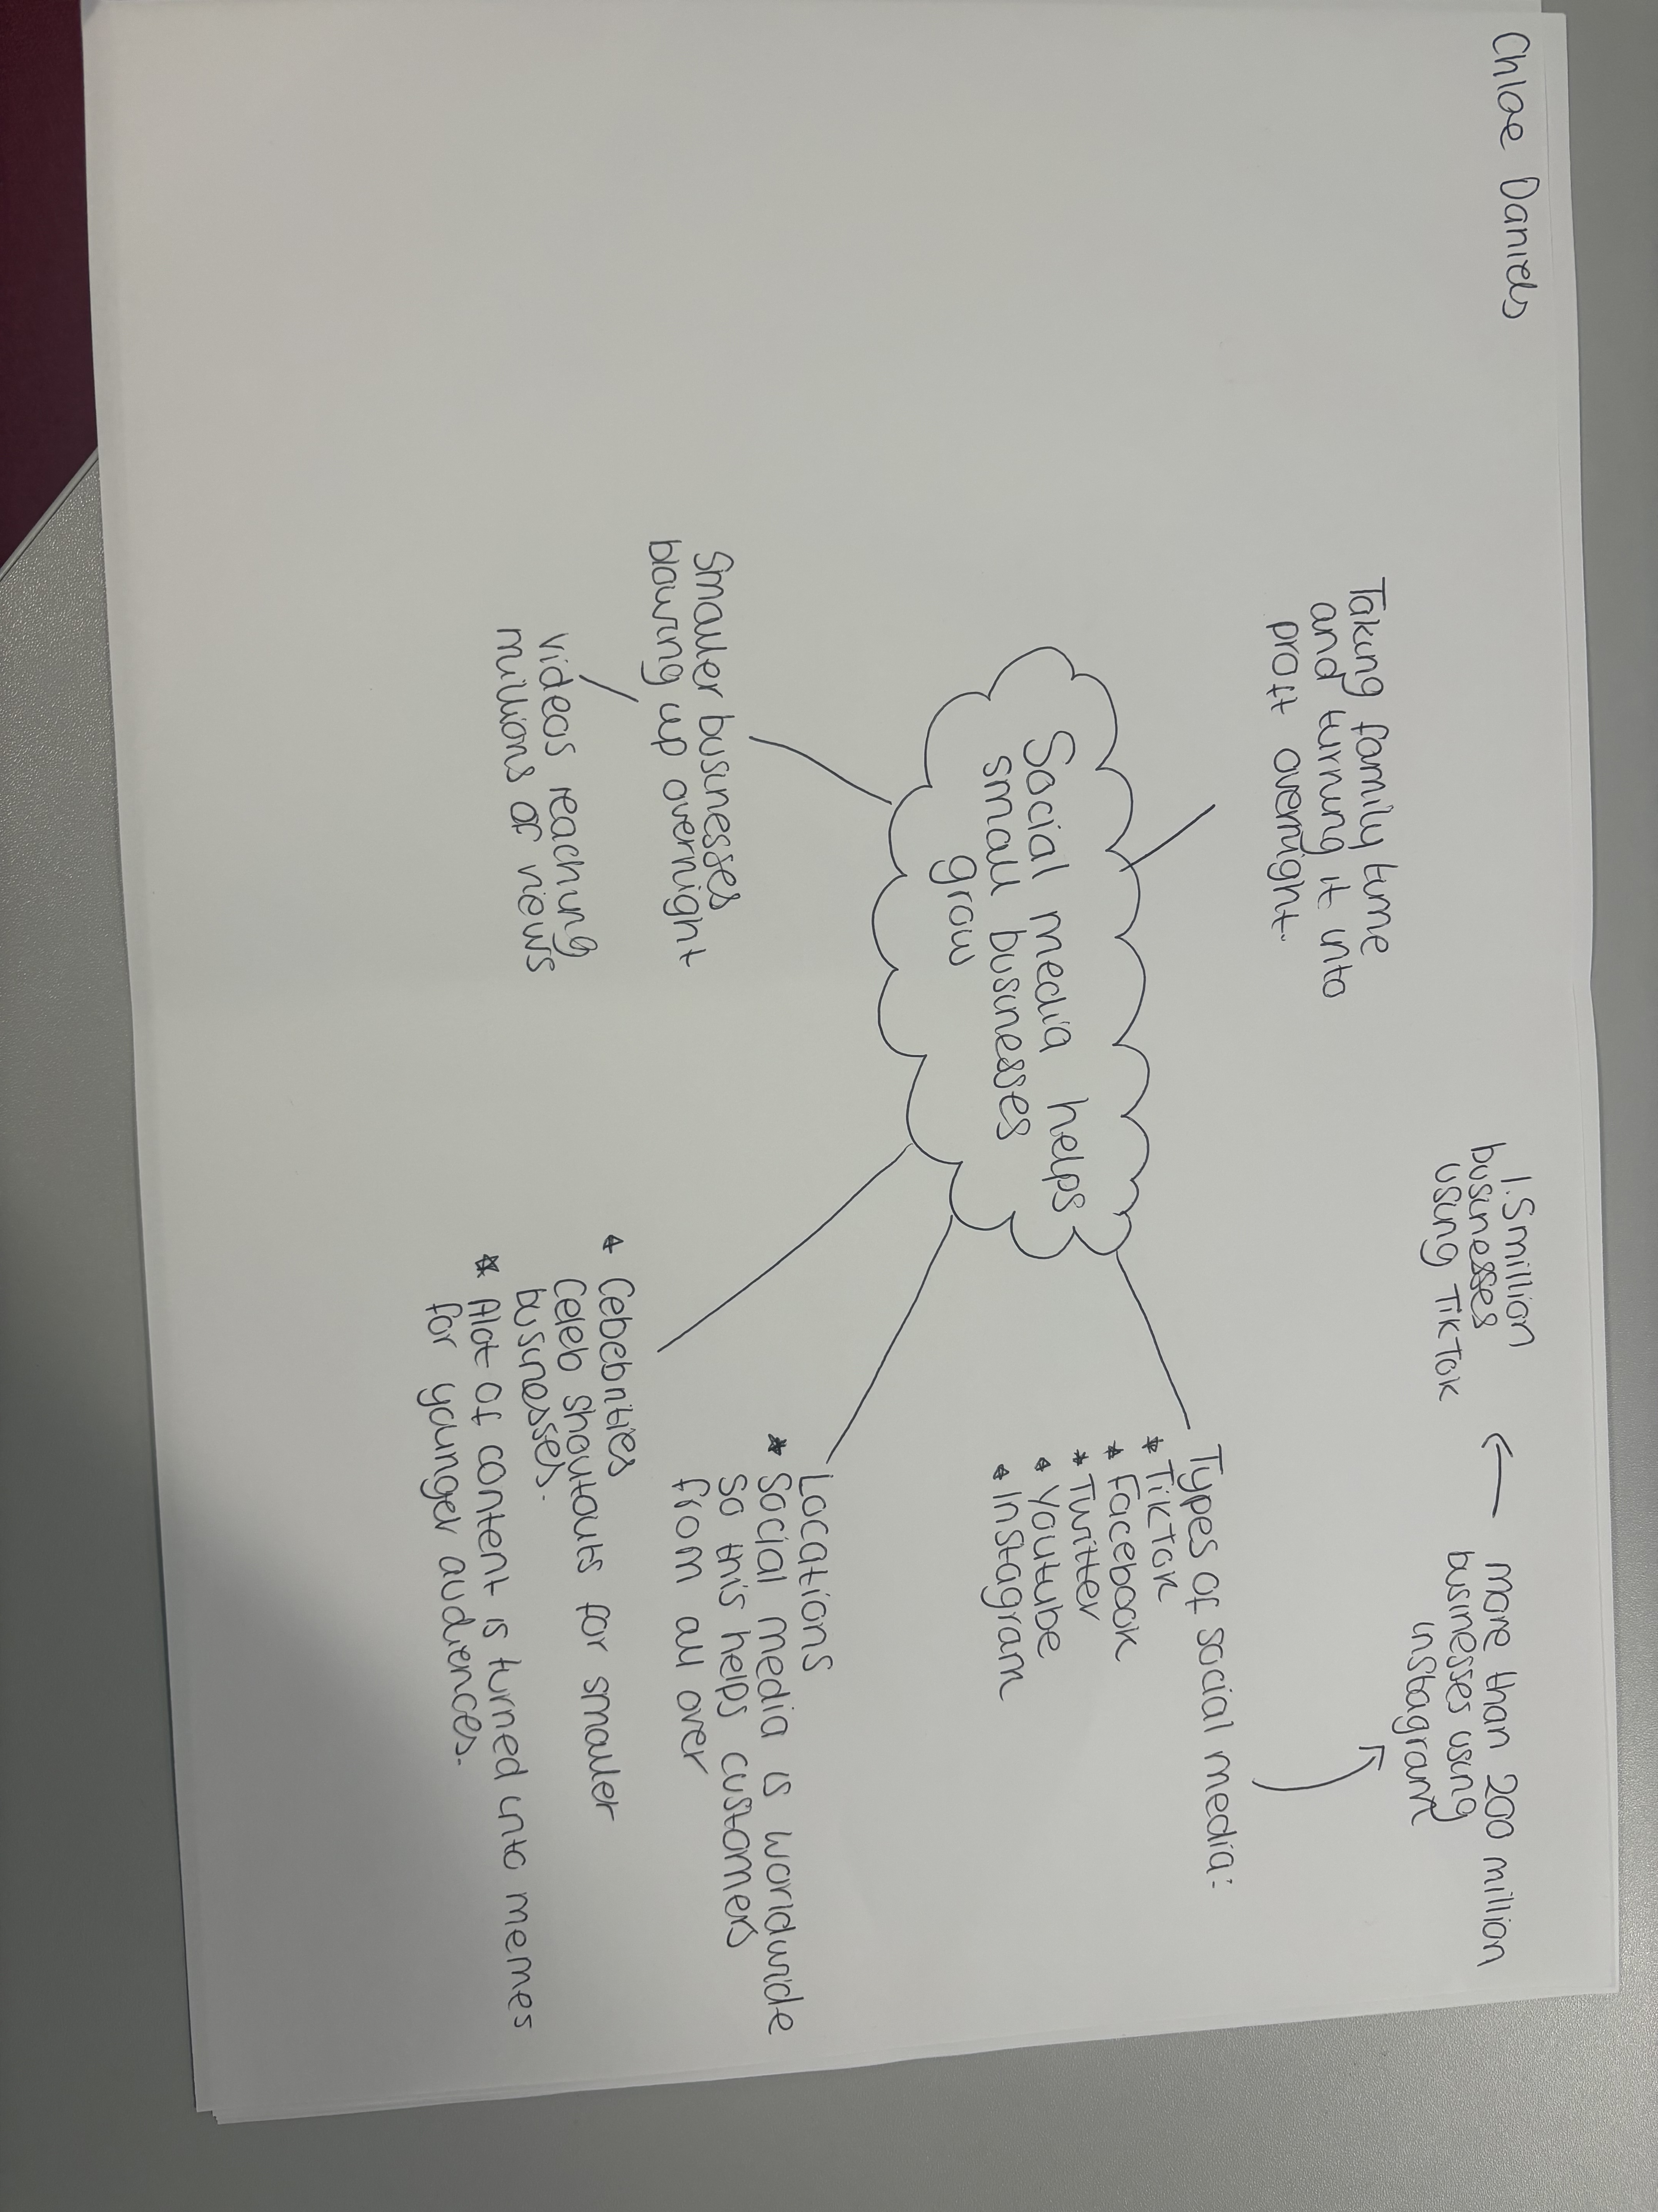

The main idea in the text is the power of social media promoting smaller businesses.
One key point is that it shows the rise in usage of different social media platforms used to advertise more local businesses. Another key point is the text shows in quite a few of the cases that this turnaround of popularity all happened in a short amount of time.
One bit of the text in particular which was most important to me was seeing the lengths people would go / travel just to try something that they had seen on social media. An example of this would be Kristy Chamberlain talking about her prom shop and saying people would travel from different countries just to try on some of her gowns.
One thing that was unclear to me was how does the algorithm know which videos / businesses to make viral to begin with. How does it know it is supporting something positive with how quickly something goes viral. The source does mention that half of the time it’s the customers creating the videos for it to get viral.
My group helped me understand the text better by openly discussing different ideas from reading the text and participating in creating the mind map with different categories noting down key parts of the text. This helped get more variety in opinions and helped me see different points of views.
The hardest part about the task was finding which bits of the text was relevant to each question and also keeping my answers relevant to what I’m talking about.

