Student: Ionut Gabriel Gheorghe (2222508)
Lecturer: Scott James Word count: 1365 other 438 for presentation
Individual Presentation and Supporting Marketing Plan
BMIH4005

This marketing plan is designed to elevate the brand awareness and patronage of a prestigious hotel in Las Vegas. Prepared for the hotel's management, this plan integrates renowned frameworks like PR Smith's SOSTAC model, McCarthy's 4Ps, and Ansoff's Matrix.

SOSTAC (Smith, 1990) is a strategic planning system involving six stages: Situation Analysis, Objectives, Strategy, Tactics, Action, and Control, employed to identify the current situation and determine where we want to be and how to get there.

The 4Ps (McCarthy, 1960) – Product, Price, Promotion, and Place – provides a practical framework to define our marketing mix, understanding what our offering is, its value, how it's communicated, and where it's available.

Ansoff's Matrix (Ansoff, 1957) guides the growth strategy, aiding us in deciding between market penetration, market development, product development, or diversification based on our market and product status.
The Las Vegas hotel operates in a dynamic environment, necessitating a comprehensive SWOT analysis.

Strengths: The hotel boasts a prime location, exceptional service quality, and a vast array of amenities, ensuring a luxury experience for patrons (Hotel Association of Las Vegas, 2023).
Weaknesses: High operational costs due to the premium location and luxury services are a concern. There's also overreliance on tourism, which can fluctuate with market conditions (Nevada Resort Association, 2023).
Opportunities: Increasing international tourism in Las Vegas offers an expansion avenue (US Travel Association, 2023). Moreover, with digitalization, online marketing channels present untapped opportunities.
Threats: The competitive Las Vegas hotel industry is a threat. External factors like economic downturns or pandemics can also severely impact the tourism sector (Nevada Resort Association, 2023).

The primary customer segments are affluent tourists and business travellers. Tourists are attracted to Las Vegas' recreational offerings, seeking luxury accommodation that complements their experience (UNLV Gaming Research, 2023). Business travellers, on the other hand, prioritize convenience, high-quality service, and luxury amenities for their stays during conventions or meetings (Global Business Travel Association, 2023).

The hotel targets these segments through personalized marketing strategies. Luxury-focused campaigns cater to tourists, while B2B marketing efforts are designed to attract businesses planning events or conventions.

The major competitors include other high-end hotels in Las Vegas, like The Venetian, Bellagio, and The Wynn.
A perceptual positioning map (Kotler et al., 2015) shows our hotel and competitors based on luxury level and price. Our hotel offers high luxury at a relatively high price, similar to Bellagio, while The Venetian offers slightly lower luxury at a lower price.
Bowman's Strategy Clock (Bowman & Faulkner, 1997) helps understand the competitive position. Aiming for a 'differentiation focus' strategy (like The Wynn), delivering high perceived value at a high price point, targeting a specific, high-end market segment.

The hotel maintains strong B2B relationships with event and conference organizers, which bring substantial business clients. Partnerships with luxury brands enhance the value proposition, offering exclusive experiences to guests. Collaboration with travel agencies and online travel platforms facilitates global reach, broadening the customer base. Additionally, the brand is part of a major international hotel chain, giving access to franchising advantages such as robust operational support, worldwide brand recognition, and shared marketing resources. These collaborations aid in bolstering the position in the competitive Las Vegas hospitality market (Jones, P., & Lockwood, A., 2004).

Las Vegas Hotel operates within a complex macro-environment, analysed through PESTLE.

Political: Policy changes and regulations in the hospitality sector influence operations (Haller, 2022).
Economic: Economic cycles and consumer spending patterns impact hotel occupancy and revenues (World Bank, 2023).
Sociocultural: Evolving consumer preferences and demographics shape our service offerings (PWC, 2023).
Technological: Digital innovations like AI and IoT enhance operational efficiency and guest experiences (Deloitte, 2023).
Legal: Laws around employment, safety, and environmental standards affect hotel operations (Haller, 2022).
Environmental: Sustainability is a growing concern, influencing our operations and brand reputation (Green Hotelier, 2023).

The Marketing Mix for Las Vegas Hotel consists of the following elements:

Product: Offers luxurious accommodation, fine dining options, and event spaces, accompanied by exceptional customer service.

Price: The pricing strategy is premium, reflecting the high-quality services and amenities that the hotel offers.

Place: The prime location in Las Vegas caters to tourists and business travellers. Online platforms also facilitate bookings.

Promotion: The hotel employs a mix of digital and traditional advertising, PR, direct marketing, and partnerships. Personalized campaigns target specific customer segments.

These elements work together to create a compelling value proposition for our target market (Kotler et al., 2015).

By leveraging strategic marketing initiatives, the aim is to increase the hotel's occupancy rate by 15%, improve brand awareness by 25% in key markets, and enhance online direct bookings by 20%, all within the next two years, utilizing measurable KPIs to track progress and adjust tactics as necessary.

The revised value proposition emphasizes "Unmatched Luxury, Personalized Experiences." The hotel wants to differentiate by offering unparalleled luxury amenities and unique, tailored experiences for each guest. This pivot caters to the increasing demand for personalized experiences within the hospitality industry (Deloitte, 2023). By integrating technology, the aim to offer personalized stays, from preferred room settings to curated activities.

Given the need to overcome poor reviews and improve brand reputation, the business will employ the 'Product Development' strategy from Ansoff's Matrix. Innovating and improving the existing services while remaining in the established market. The focus will be on enhancing service quality and guest experiences to surpass expectations, consequently improving reviews and reputation (Ansoff, 1957).

Changes in the Marketing Mix (McCarthy, 1960) will include:

1. Product: Enhance service standards and introduce unique guest experiences, ensuring high-quality and personalized service for every guest.

2. Price: Maintain premium pricing strategy, but add value by improving service quality and guest experiences.

3. Place: Keep the strategic location, while improving online presence for better accessibility and customer interaction.

4. Promotion: Increase focus on reputation management. Highlight positive guest experiences and improvements in promotional material, both offline and online. Engage with negative reviews constructively and publicize steps taken to rectify issues.

This comprehensive approach will foster better customer relationships, encourage positive reviews, and ultimately, restore and elevate our brand reputation.

Using the RACE (Reach, Act, Convert, Engage) digital marketing model (Chaffey, 2015), we'll implement new communications tactics:

Reach: Boost online presence using SEO, PPC ads, and targeted social media campaigns, focusing on positive guest experiences.
Act: Improve the website's usability and content to showcase service enhancements and user testimonials, fostering customer interaction.
Convert: Leverage email marketing and retargeting ads to convert interested individuals into guests, offering personalized packages to incentivize bookings.
Engage: Utilize social media and email to maintain relationships post-stay. Actively manage online reviews to demonstrate our commitment to service quality.

To improve, the hotel will adopt a more interactive social media approach, regularly engaging with followers through polls, Q&A sessions, and user-generated content. We'll utilize social listening tools to monitor brand mentions and address customer queries promptly.

The email campaigns will be more structured, implementing segmentation to provide personalized content. Also, introducing a regular newsletter to keep subscribers informed about new services, events, and offers.

Regarding the website, an SEO audit reveals opportunities for optimization to improve visibility in search engine results. Site navigation can be simplified, and booking process streamlined to enhance user experience.

The steps introduced will help improve digital presence, customer engagement, and eventually lead to higher conversion rates.

Gantt chart
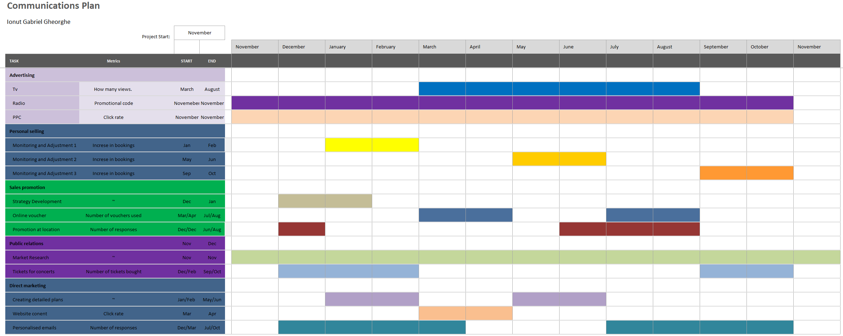

We will measure the success of the marketing plan using several KPIs:

1. **Occupancy Rate**: A 15% increase in hotel occupancy rate over the next two years.

2. **Brand Awareness**: Conduct customer surveys and monitor online mentions to measure a 25% improvement in brand awareness in key markets.

3. **Online Direct Bookings**: Track website and app analytics to aim for a 20% increase in direct online bookings.

4. **Customer Satisfaction**: Monitor review sites and social media for a positive shift in customer sentiment, aiming for a 15% improvement in average rating.

5. **Revenue**: Track revenue growth, aiming for a 10% increase year-on-year.

These metrics will help quantify the marketing effectiveness and inform future strategies.

The marketing plan faces several challenges, including intense competition in the Las Vegas hotel industry, fluctuating tourism trends, and the need to constantly innovate guest experiences. Moreover, effectively managing online reputation amidst increasing guest expectations can be demanding (Sigala, 2021).

To address these, is recommend a regular market research to stay attuned to industry trends and customer preferences. Investment in service quality, staff training, and digital infrastructure is critical. Further, a proactive approach to reputation management, including prompt responses to guest reviews and visible implementation of feedback, can help enhance brand perception (Xiang et al., 2017).

References
Ansoff, H.I. (1957). Strategies for Diversification. Harvard Business Review, 35(5), 113-124.
McCarthy, E.J. (1960). Basic Marketing. A Managerial Approach. Homewood, IL: Richard D. Irwin.
Smith, P.R. (1990). SOSTAC®. PR Smith’s SOSTAC® Planning Model. PR Smith.
Hotel Association of Las Vegas. (2023). Las Vegas Hotel Industry Report.
Nevada Resort Association. (2023). The State of Nevada Hotel Industry.
US Travel Association. (2023). US Travel and Tourism Overview.
UNLV Gaming Research. (2023). Las Vegas Tourism and Gaming Statistics.
Global Business Travel Association. (2023). Business Travel Market Trends.
Bowman, C., & Faulkner, D. (1997). Competitive and Corporate Strategy. Irwin.
Kotler, P., Keller, K. L., Manceau, D., & Hémonnet-Goujot, A. (2015). Marketing Management. Pearson Education France.
Jones, P., & Lockwood, A. (2004). The Management of Hotel Operations. Cengage Learning EMEA.
Haller, W. (2022). The Political and Legal Environment of Marketing. Journal of Marketing.
World Bank. (2023). Global Economic Prospects.
PWC. (2023). Consumer Insights Survey.
Deloitte. (2023). Tech Trends Report.
Green Hotelier. (2023). Sustainability in the Hospitality Industry.
Kotler, P., Keller, K. L., Manceau, D., & Hémonnet-Goujot, A. (2015). Marketing Management. Pearson Education France.
McCarthy, E.J. (1960). Basic Marketing. A Managerial Approach. Homewood, IL: Richard D. Irwin.
Chaffey, D. (2015). Digital Marketing. Pearson Education Limited.
Chaffey, D., & Ellis-Chadwick, F. (2019). Digital Marketing. Pearson Education Limited.
Ryan, D. (2016). Understanding Digital Marketing. Kogan Page Publishers.
Sigala, M. (2021). Tourism and COVID-19: Impacts and implications for advancing and resetting industry and research. Journal of Business Research, 117, 312-321.
Xiang, Z., Du, Q., Ma, Y., & Fan, W. (2017). A comparative analysis of major online review platforms: Implications for social media analytics in hospitality and tourism. Tourism Management, 58, 51-65.



