Changemakers: Building your Personal Brand for Sustainable Employment
BMHP5015

Component 2: Report

Student ID: 2333484
Student name: Georgiana Madalina Dedu
Lecture: Tsiwani Khumalo

Content
Introduction 3
Selection of a health and social care job role 3
Personal employability skills for this job 4
Job description and person specification for HCA in the UK 4
Required employability skills 7
Assessment of own skills using SWOT analysis 7
Qualification and experiences related to HCA role 9
Evaluation of own skills against job requirements and skills 9
An action plan and timeline for developing the required skills to achieve the job role 10
References 16

Introduction
By describing job related specification, and comparing with your own skills, this report will develop a personal brand for obtaining employment. Job role entails Healthcare Assistant (HCA) is considered for obtaining sustainable employment. For a successful career, individual proficiency needs to be aligned with job requirements to prevent skill mismatch and any void (Al Shanfari, 2024). Personal employability skills for HCA roles will be explained, and an evaluation of my own skill sets will be executed against job description and specification. Critical analysis will lead to the formulation of an action plan with a guided timeline. By discussing resources and activities in an action plan, required employability skills will be gained.

Selection of a health and social care job role
Taking into consideration valuable insights from component 1, the role of Healthcare Assistant (HCA) is opted for suitable employment. Considering clinical settings, HCA mainly works to support and assist physicians and nurses (Grainger, 2020). Behind choosing this role is allied to my proper communication approaches as evident previously. As stated, the role of HCA is essential in bridging the communication gaps between patients and nurses, which enable them to act as an effective medium in fostering trust (Palmer, 2021). As per NHS England (2026) HCA takes basic health measurements of patients with providing assistance in activities of daily living (ADL) like dressing and washing. Conversely, Rawles (2025) pointed out social skills of HCA connected to preparing equipment and arranging beds for patients. For acquiring the role of HCA in social and healthcare, certain needs to be undertaken. It includes identifying job description and person specification, employability skills assessment along with evaluation of qualification and experience.

Personal employability skills for this job

Job description and person specification for HCA in the UK
For sustainable employment, knowledge of different elements is pivotal for better navigating employment portals. As stated, a piece of document, capable of explaining responsibilities, duties and tasks related to a specific role is known as a job description (Kiselyova et al., 2021). Typical components encompass job title, key duties, working hour, salary and working conditions. Conversely, skills, experiences, personal qualities and experiences are explained under the person specification. The main purpose is to assist employers in selecting the desirable candidate for the role (Vernau et al., 2021). Evidence is presented for showcasing and comprehending job description and person specification associated to HCA in employment.
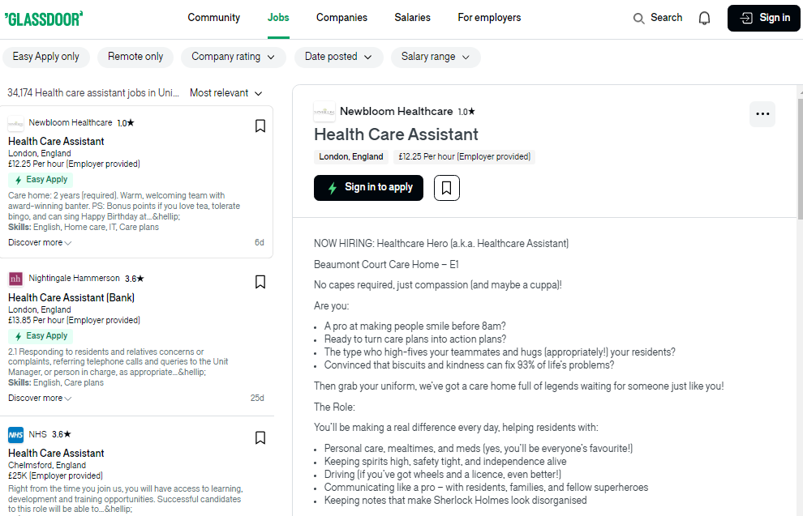
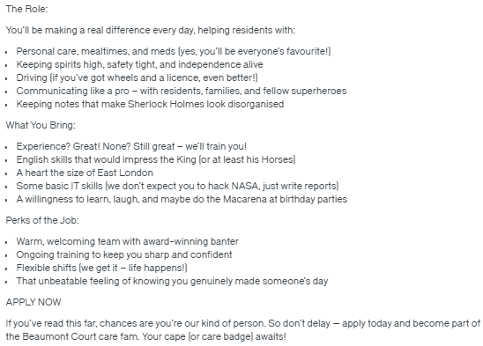
Figure 1: Job description for a HCA role
(Source: Glassdoor, 2026)
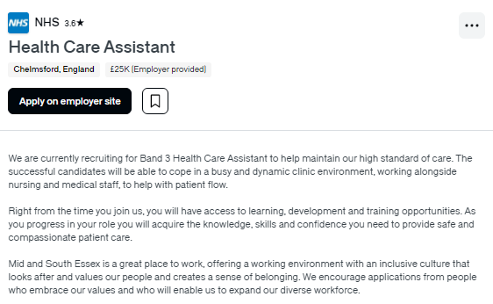
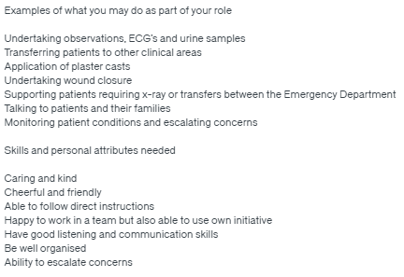
Figure 2: Person specification for a HCA role
(Source: Glassdoor, 2026)
Above evidence pointed out key personal attributes for applicants like caring nature and kind behaviour (Glassdoor, 2026). Following direct instructions, and maintaining a cheerful environment by interacting with patients in a friendly manner.

Required employability skills
Regarding employability skills pertaining to job description, flexibility and proactive approach are mentioned for HCA roles. Citing an example is the ability of the HCA to transform a care plan into an action plan for attaining maximum health outcomes. Accordingly, Dammann et al. (2022) mentioned that flexibility makes the way for healthcare professionals to adapt in difficult situations with critical patients. Negotiation as an effective means of employability skill is discussed in convincing patients to deal with their health problems (Glassdoor, 2026). Patients often lack the capacity to make decisions because of sufferings and restricted knowledge (Pesut et al., 2021). Discussed self-motivation as a pivotal role in HCA for keeping the spirit of the workplace high despite prevalent challenges.
For person specification, relevant employability skills are identified and mentioned in the post. Collaborative team working and using your own initiative to solve problems in clinical settings (Glassdoor, 2026). One of the most widely used skills for facilitating multidisciplinary team (MDT) working (Vernau et al., 2021). By shifting attention to good listening, communication as an employability skill is recognised, Supported by Barker et al. (2023) stating that showing empathy and compassion while actively listening to patients helps to build connection. Organising skills for preparing, scheduling, and arranging meetings are necessary. Considering the HCA role, ability to escalate concerns through appropriate channels are acknowledged in the person specification section.

Assessment of own skills using SWOT analysis
For assessing my skills and individual proficiency, SWOT analysis is taken into consideration, which is mentioned below in a tabular format.
Strengths | Weaknesses
Stronger grasp over communication, specifically listening and speaking.  Good knowledge in healthcare theories and principles from the module.  Empathy and compassionate behaviour are the core strengths of mine. | Lower confidence level often causes panic and nervousness.  Inadequate level of practical exposure confined my hands on ability in healthcare.  Lack of negotiation abilities, often fails to convince others.
Opportunities | Threats
Diversified roles in healthcare and social care, creating employability.  Stability and secured future in the health and social care sector. | Intense competition among individuals for HCA roles because of its high demand.  Physical and mental stress associated with high pressurised healthcare workplace.
Table 1: SWOT analysis of my own skills
(Source: Self-made)
Teachers play an important part in helping me to identify my improvement areas through summative and formative feedback (Irons and Elkington, 2021). Conversely, peer and classmates along with academic support, which are crucial for overcoming my weaknesses like low confidence and limited hand on ability.

Qualification and experiences related to HCA role
Besides discussing job description and person specification, practical experience and educational qualification is quintessential. Despite HCA jobs being entry level, organizations prefer candidates with appropriate qualifications. It takes into account Level 2 or Level 3 Diploma in Health and Social Care (Grainger, 2020). A vocational course in first aid training is a positive sign of getting employed for the HCA role.
But, Bender (2021) mentioned the necessity of Care certification, which is provided after completing an internship or placement at the time of study. Progressing forward, work experiences prioritise volunteering in hospitals, assisting in care or residential homes. Serving as a support worker or care assistant elevates the chances, and make sure competitive advantages to the candidates. In some cases, additional requirements entail Disclosure and Barring Service (DBS) check and basic training health and safety.

Evaluation of own skills against job requirements and skills
By reviewing the job description, it can be said that an individual needs to have excellent communication skills, active listening skills, team working skills and adaptability in order to achieve professional success as a healthcare assistant. By performing a personal SWOT analysis, I have realised that my strong communication skills and active listening skills make me a suitable candidate in terms of applying for the position of healthcare assistant in the NHS. I believe that my strong communication skills can enable me to manage communications with patient parties and the members of the multidisciplinary teams for sharing relevant information in order to maintain transparency regarding the patient's clinical condition and the treatment procedures (Rawles, 2025). On the other hand, by utilising my active listening skills, I can identify the needs and preferences of the patients and then can make clinical decisions considering their specific needs and can act at their best interests (Rawles, 2019). My empathetic and compassionate behavior can help me to win the trust and confidence of the patient parties (Moudatsou et al., 2020) I am efficient enough in working collaboratively with teams and whenever I work with my teams, I try to cooperate with my teams and try to avoid conflicts to enhance team performance. I believe that my teamworking abilities can help me to work collaboratively with my team members in the workplace for coordinating care, for making joint decisions on care delivery and to deliver better quality services to the patients (Carroll et al., 2024).
However, by evaluating my own skills, I have realised that I lack enough confidence in handling critical patients due to the lack of practical exposure to care delivery. I often become nervous while making clinical decisions regarding critical patients and for this reason, I often cannot make decisions independently. I believe that if I receive an opportunity to practically serve patients in any healthcare setting, I can enhance my confidence regarding handling patients. I also can understand that the lack of negotiation skills can make it difficult for me to handle conflicts and critical situations in the workplace (Rawles, 2019). I understand that though the intense competition in the job market for the position of the post Health Care Assistant can make it difficult for me get a job of Health Care Assistant in the NHS without having any practical experience in similar roles, I also strongly believe that if I can attend grooming sessions and get appropriate employability training, I can enhance my employability skills and knowledge and can perform my roles and responsibilities as a Health Care Assistant in any NHS organisation.

An action plan and timeline for developing the required skills to achieve the job role
Based on the above analysis, I have used the SMART framework to develop this action plan for enhancing my employability skills so that I can achieve my career aspirations.
Specific goal | Actions for achieving the goal | Resources required | Ways of measuring success | Timeline
Enhancing confidence in terms handling critical patients | - I will review real world case studies of patients to understand how professionals handle critical patients  - I will also take help from my seniors to understand the rules and regulations related to handling critical patients safely  - I will try to work as an intern in any healthcare organisation | Access to online databases from where I can find case studies of patients, support from seniors and supervisors. | If I find that I do not feel nervous while handling critical patients and I can safely handle them following organisational policies and regulations, I can think that the goal has been achieved. | 8 months
Improving clinical decision making skills | - I will try to use decision making tools like mind mapping, brainstorming and decision tree analysis for making effective decisions  - Appropriate clinical evidence like medical reports, research articles and other things can be used for evidence based clinical decision making (White et al., 2024) | Information regarding patient health, access to online articles and research reports and assistance from tutors | If I can analyse the consequences of my decisions and can make quick decisions independently without lacking confidence, I can think that the goal has been achieved. | 6 months
Improving negotiation skills | - I will try to communicate clearly with both the parties and will try to analyse different perspectives for understanding the interests of others before making decisions (White et al., 2024).  - I will practice negotiating and will try to resolve conflicts among known people to improve my negotiating abilities. | Support and guidance from tutors and seniors, knowledge regarding negotiation principles | If I can manage communications with conflicting parties and can resolve the conflicts by identifying appropriate solutions, I can say that my negotiation skills have improved. | 5 months
Table 2: Personal Development Plan
(Source: Created by self)

Building my personal brand and professional identity
Developing a strong personal brand is essential for gaining sustainable employment in the health and social care sector. A personal brand reflects how an individual presents their skills, values and professional identity to potential employers. For the role of Healthcare Assistant, my personal brand will focus on compassion, effective communication, reliability and a patient-centred approach.
My unique selling point (USP) is my strong ability to communicate with patients, combined with empathy and active listening skills. These qualities allow me to build trust with patients and contribute to high-quality care delivery.
To promote my professional identity, I will develop a professional CV tailored to Healthcare Assistant roles, highlighting my qualifications, skills and experiences. Additionally, I will create and maintain a LinkedIn profile to showcase my professional achievements, certifications and career goals. I will also use supporting statements in job applications to demonstrate how my skills match the job requirements.
Networking for achieving employment
Building a professional network is important for accessing job opportunities and gaining career advice. I will develop my network by connecting with tutors, classmates, and professionals within the healthcare sector. I will also use professional platforms such as LinkedIn and NHS Jobs to identify opportunities and connect with employers.
Furthermore, I will engage in volunteering and practical placements, which will allow me to gain experience and build relationships with healthcare professionals. These connections can support my career development and increase my chances of gaining employment as a Healthcare Assistant.
Communicating my skills to employers
To effectively communicate my skills to potential employers, I will use a range of methods including a professional CV, LinkedIn profile, and tailored job applications. I will ensure that my CV clearly demonstrates my employability skills, qualifications, and experience relevant to the Healthcare Assistant role.
In addition, I will prepare for interviews by practising responses that demonstrate my communication skills, empathy, and ability to work in a team. This will help me present myself confidently and professionally during the recruitment process.

Conclusion
On a concluding note, I can say that I want to achieve success as a Health Care Assistant in any NHS hospital and I have already developed some employability skills that are required for performing the roles and responsibilities associated with the position of Health Care Assistant. My strong communication skills, teamworking skills, empathetic and compassionate behavior make me an ideal candidate for the position of Health Care Assistant. However, as I lack confidence regarding handling critical patients and I also feel nervous while making independent decisions regarding delivery, it can become difficult for me to achieve success in this role. For this reason, I have developed an action plan for developing my confidence, my clinical decision making skills and my negotiation skills so that I can achieve my career aspirations. I have decided to work as an intern to develop my clinical decision-making abilities and patient handling capabilities and I will require enough support and assistance from my seniors, tutors and supervisors in terms of achieving those personal and professional development goals.
This report has also demonstrated how I can build my personal brand and promote my professional identity to achieve sustainable employment.

References
Al Shanfari, S.A. (2024) ‘Exploration on job mismatch with job placement: employers perspective in Sultanate of Oman’, International Journal of Academic Research in Business and Social Sciences, 14(1), pp. 541–552.
Barker, M.E., Leach, K.T. and Levett-Jones, T. (2023) ‘Patients’ views of empathic and compassionate healthcare interactions: a scoping review’, Nurse Education Today, 131, p. 105957.
Bender, D. (2021) ‘Internship assessment in professional program accreditation: a 10-year study’, Education + Training, 63(2), pp. 256–270.
Carroll, R.E., De Vries, K., Goodman, C. and Brown, J. (2024) ‘Health care assistant and registered nurse dyads, working together and apart: a qualitative study’, BMC Nursing, 23(1), p. 954.
Dammann, M., Staudacher, S., Simon, M. and Jeitziner, M.M. (2022) ‘Insights into the challenges faced by chronically critically ill patients, their families and healthcare providers: an interpretive description’, Intensive and Critical Care Nursing, 68, p. 103135.
Glassdoor (2026) Healthcare assistant jobs in the UK. Available at: https://www.glassdoor.co.uk/Job/united-kingdom-health-care-assistant-jobs-SRCH_IL.0,14_IN2_KO15,36.htm (Accessed: 27 March 2026).
Grainger, A. (2020) ‘Supporting others to learn: the role of the HCA’, British Journal of Healthcare Assistants, 14(5), pp. 240–245.
Irons, A. and Elkington, S. (2021) Enhancing learning through formative assessment and feedback. London: Routledge.
Kiselyova, E.I., Koroshchenko, K.R. and Robson, G. (2021) ‘Content of the job description: features and areas of concern’, Legal Horizons, p. 63.
Moudatsou, M., Stavropoulou, A., Philalithis, A. and Koukouli, S. (2020) ‘The role of empathy in health and social care professionals’, Healthcare, 8(1), p. 26.
NHS England (2026) Healthcare support worker programme. Available at: https://www.england.nhs.uk/nursingmidwifery/healthcare-support-worker-programme/ (Accessed: 29 March2026).
Palmer, S.J. (2021) ‘The expansion of the HCA role: introducing the “doctors’ assistant”’, British Journal of Healthcare Assistants, 15(6), pp. 279–283.
Pesut, B., Wright, D.K., Thorne, S., Hall, M.I., Puurveen, G., Storch, J. and Huggins, M. (2021) ‘What’s suffering got to do with it? A qualitative study of suffering in the context of Medical Assistance in Dying (MAID)’, BMC Palliative Care, 20(1), p. 174.
Rawles, Z. (2019) Essential knowledge and skills for healthcare assistants and assistant practitioners. London: Routledge.
Rawles, Z. (2025) Essential knowledge and skills for healthcare assistants. London: Taylor & Francis.
Vernau, J., Bishop, C., Chavda, S., Weldon, A., Maloney, S., Pacey, R. and Turner, A.N. (2021) ‘An analysis of job description and person specifications to define the requirements for obtaining employment within strength and conditioning’, Professional Strength and Conditioning, p. 07.
White, K.M., Dudley-Brown, S. and Terhaar, M.F. (eds.) (2024) Translation of evidence into nursing and healthcare. New York: Springer Publishing Company.

