Please delete the box below and replace it with an “appropriate” passport style photograph that clearly shows your face. Your photo should be roughly the same size as the box:

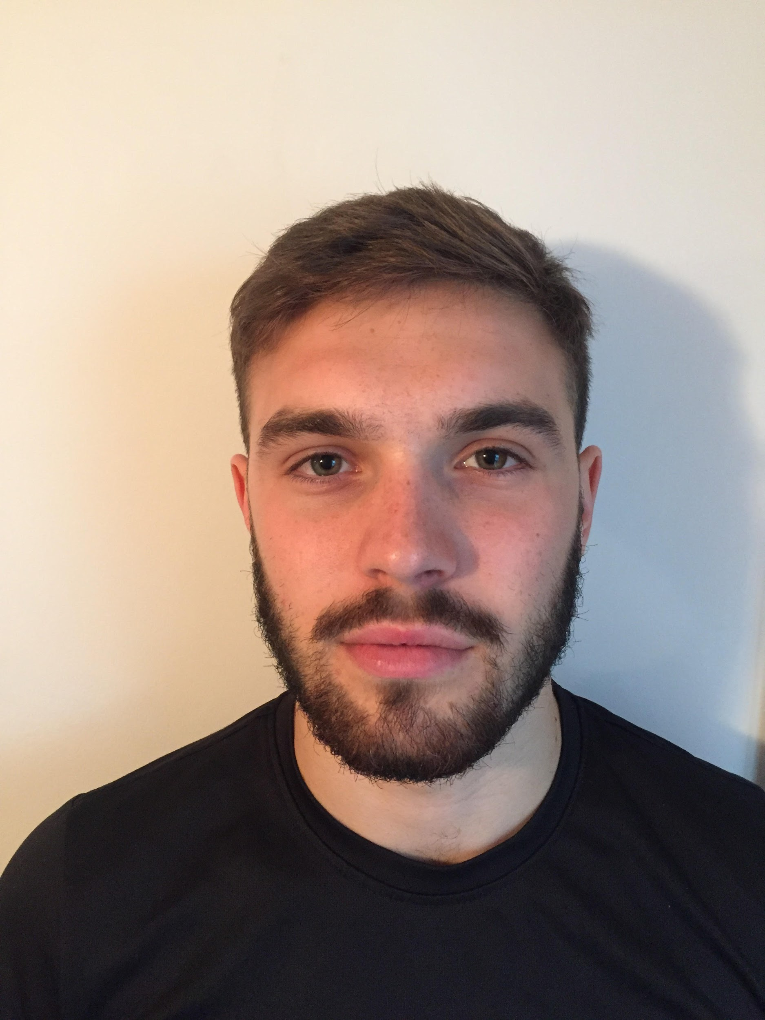

Name: Taliesin Fargeot

Student number: 1701295

Student email address: 1701295@student.uwtsd.ac.uk

Contact number: 07510604726

Please use the remaining space to give a brief outline of why you have chosen your course of study and any relevant special interests or experiences:

I have chosen to study sports therapy because I have always been intrigued in the human body and the mechanisms of injury.

