Personnel Resourcing and Development
Lecture’s Name | Dh Emma Roberts
Module Code: | BMIH5005
Module Title: | Personal Resourcing and Development
Student name: | Nahid Islam
Student ID: | 2110788

Employee engagement

This essay will be focusing on some of the major concepts and theories of employee engagement. Employee engagement is a concept, related to the workplace of an organization, that creates an environment where all employees feel valued and invested in the growth of the firm, are dedicated to achieving the company's stated values and objectives, and are eager to make a positive impact on the company as a whole (Bridger, 2022). Therefore, this paperwork will predominantly illustrate the contribution of employee engagement, ways and benefits of engaging teams, employee lifecycle, and a model of employee engagement while providing real-world examples from a hotel management perspective.
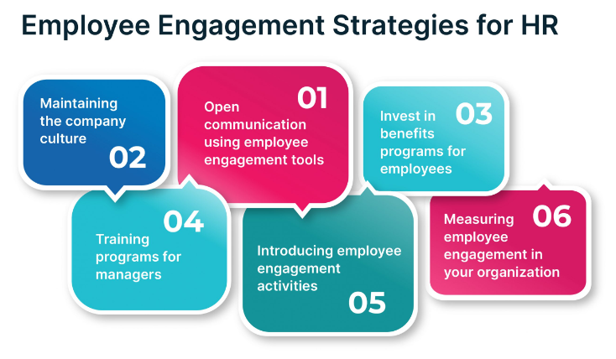
Source: (Garton, 2017)
Employee engagement is a metric for gauging how motivated workers are in their jobs. In addition to other corporate goals, employee engagement has a massive influence on a firm's bottom line. It is found by multiple researchers that actively involved workers reduced safety occurrences by nearly 64% and approximately 60% of workers tend to make mistakes in the workplace who are disengaged (Deloitte, 2015). Moreover, according to Kozlowski and Ilgen (2016), around 87% of workers do not want to leave an organization if the entity is concerned regarding the establishment of employee engagement initiatives.

Every business organization needs to address the aspects of employee engagement. But the employees of hotel industries especially need to be constantly engaged and motivated as they directly represent the business of a hotel company to the customers (Capelle, 2013). Even a small mistake by a hotel staff might turn a satisfied consumer into a dissatisfied one. Therefore, Human resources must take a broad view of the employment agreement to effectively engage workers. Human resources must guarantee that workers have the appropriate knowledge, equipment, and working conditions to carry out their duties effectively (Chalise, 2021). Also, the HR department must continuously invest in staff training and education to keep workers enthusiastic. According to an article published in the Harvard Business Review by Garton (2017), it is the workforce instead of financial capital that is the scarcest one to attain by an organization at present.
The HR of a hotel company can measure the human capital by combining the time employees invest in a company, the skills, and experiences they possess, and the degree of engagement they offer to the workplace (Garton, 2017). For the creation of the most appealing employee engagement programs, human resource managers play a significant role. An HR predominantly chooses the best candidates for the company, assign job tasks according to their capabilities and qualities, rewards those who perform most efficiently and consistently, and dismisses the staff that may not be utilizable by the company or hotel in the future (Dessler, 2018). In this entire procedure, the HR of a company contains the key to the organization's overall success is its workforce. For this reason, the HR department of any hotel company must be cautious regarding the creation of a healthy lifecycle for the employees.

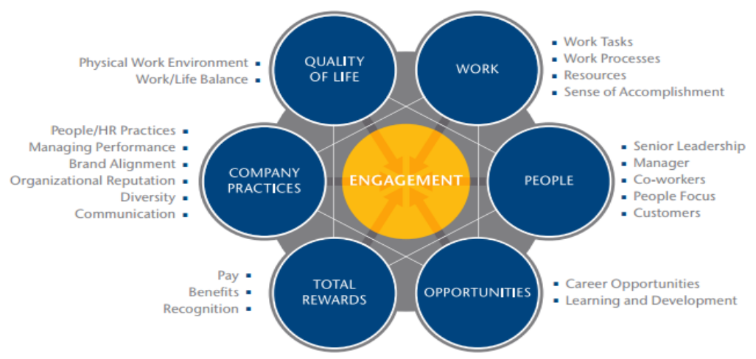
Image: Driving factors of employee engagement
Source: (Kumari and Yelkar, 2022)
The employee lifecycle is one of the core issues of personnel resourcing and development in hotel industries. According to Audenaert et al. (2021), an employee's journey through the firm is broken down into several phases, each with its own set of unique challenges and rewards, and the employee life cycle is employed to elaborate and explain these phases. Usually, the employee lifecycle for hotel management can be divided into six stages that are briefly outlined below:
Attraction: Working with staff does not begin the instant they clock in. And it does not begin with their application for the signing of an agreement for employment either. The process begins the moment a potential employee learns about the company (Yadav et al., 2022). This is why, as stated by Peters (2019), effective HR managers recognize the significance of cultivating positive company culture.
Recruitment: In this second stage, employers may use either the old or new method of recruitment. This stage is also crucial to create a good impression on the upcoming employees. Hotels or organizations should use as many advertising channels as possible to reach the greater talent pool (Mondy and Martocchio, 2015). The job adverts must outline the required skills and experiences for the vacancy. Hotels like Premier Inn and Holiday Inn post their job vacancies online with required job descriptions and the adverts are posted on every possible job site (Booking.com, 2022).
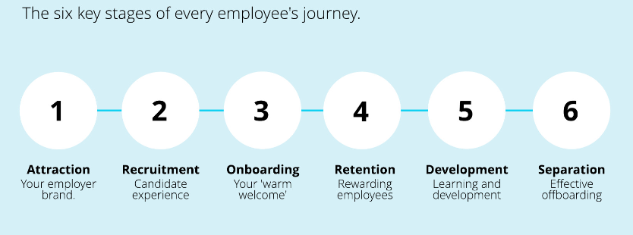
Image: Employee lifecycle
Source: (Hoyle, 2013)
Onboarding: In this stage, organizations must make the employees feel welcomed and at home. As argued by Murray (2017), company vision, mission, and value should be well perceived by the employees and the managers are responsible for this fact.
Development: After the employees have been perfectly placed in their respective positions, they must be provided with the necessary learning opportunities so that they can develop themselves. They should be encouraged by the leaders and managers to learn more and contribute more to the betterment of the company (Hoyle, 2013). For instance, insightful seminars and learning programs can be arranged by companies.
Retention: For better retention rates, employees need constant motivation and rewards from the leaders for their excellent performances over the years (Sharma and Kumra, 2022). For this purpose, performance measurement metrics can be utilized to measure and monitor employee performance (Riyanto et al., 2021). When they will be rewarded for quality input, they will be more motivated and the employee retention rate will increase.
Separation: Workers often opt to leave at some point. According to Rao (2017), employees may leave for a variety of reasons, such as a change in location or the availability of better employment possibilities, retirement, striking out on their own, or the temptation to accept a position with a competitor.
Till now, the concepts of employee engagement have been elaborately discussed. However, the question of how HR engages teams in a hotel remains undisclosed. There are multiple ways of engaging teams in a hotel. First of all, a lack of commitment to providing exceptional customer service may be the result of team members' grievances and objections (Hoyle, 2013). If workers do not perceive that their voices are being heard, they could vent their frustrations in ways that cause damage to the organization. If a hotel wishes to maintain its staff happily, it must encourage open lines of communication and encourage them to voice any problems they may have to upper management (Garton, 2017). For instance, UK's one of the leading hotels Premier Inn has established a Speaking Out Policy for its 37,000 team members (Premier Inn, 2022). Complaints can be reported confidentially and safely under this policy, and they will be handled according to a thorough and open process that guarantees no retaliation as per the companies annual reports. This policy assists its employees to discuss directly any grievances or disturbing issues in the workplace leading to a healthy communication system within the organization.
Secondly, for addressing any issue raised by employees related to their job tasks, the Grievance Policy has been introduced to the team members of Premier Inn (Rao, 2017). This policy promotes issues to be brought up unofficially at first to promote a transparent and open workplace culture (Premier Inn, 2022). This is another way of engaging employees where the HR manager along with the entire management team tries to establish healthy workplace culture for the team members so that they can give their best performance. Then, there should be well-managed reward systems both fiscal and non-fiscal for the employees who consistently provide top-notch performance to the organization. According to several studies, employees receiving performance-based rewards tend to thrive, develop, and contribute more to the organization in the future (Mayuri and Huybers, 2022). It also facilitates motivating the remaining below-average performance providers of the entity. Holiday Inn is another leading hotel business in the UK that has a performance-based reward system for its larger employee base (Murray, 2017). Besides that, Holiday Inn has also launched programs to assist its competent employees to develop their possessed skills and experiences (Deloitte, 2015). Thus, the leading hotels in the UK engage their teams in the workplace.
Now, setting up a suitable employee engagement model is as essential as implementing ways of engaging employees in the workplace. A company can make both modest adjustments to company cultures and large scale, continuing efforts have the potential to make a difference (Kozlowski and Ilgen, 2016). However, a company will require to have a comprehensive approach with quantifiable outcomes that points toward an employee engagement model bringing about meaningful and sustainable progress in the firm (Bridger, 2022). There are a bunch of employee engagement models including the JD-R model, the Deloitte model, the Zinger model, the AON Hewitt Model, etc. (Peters, 2019). Among all these popular models, the Deloitte model will be explained in this portion of the essay.
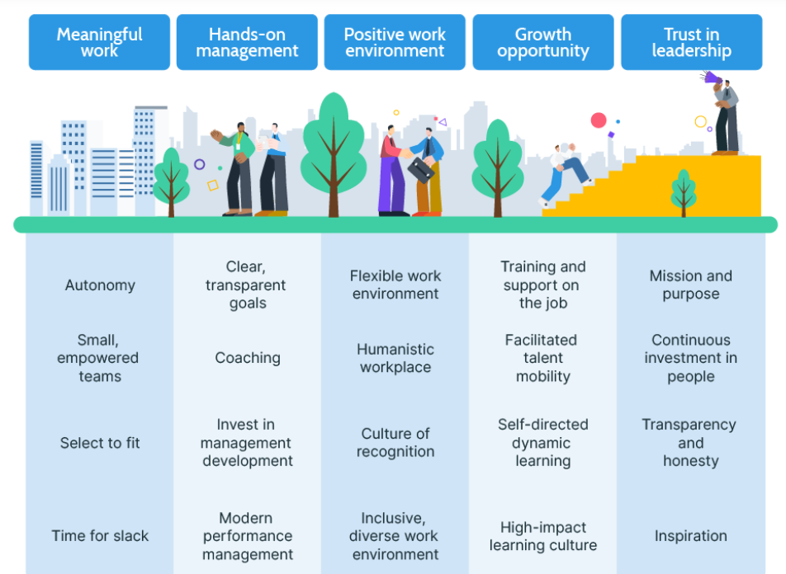
Image: Deloitte’s employee engagement model
Source: (Murray, 2017)
Deloitte, one of the leading accounting firms, has developed its employee engagement model which is named the Deloitte Model of employee engagement (Deloitte, 2015). The firm spent two years studying employee engagement to formulate this model and they hope it will make working for the company desirable to the existing and prospective employees (Kumari and Yelkar, 2022). Based on their findings, they concluded that employees are more likely to stay committed to their jobs when they have access to the following five factors: work that matter, managers who care about their employees, a welcoming workplace, chances to learn and advance, and a sense of confidence in their leaders (Rao, 2017). According to the Deloitte Model, employee engagement should have four core strategies that are the combination of twenty determinant factors of employee engagement.
For ensuring meaningful work, it's crucial to choose the right person for the right job, equip them with the resources and freedom they need to accomplish their finest performances as part of a collaborative unit and let them realize that their efforts are appreciated (Bridger, 2022).
With frequent mentoring and specific, attainable targets, teams can achieve great success. When companies fail to spend on their management, they risk having disengaged employees. Then, as part of a positive work environment, employees are more likely to feel appreciated in a place where they can be themselves, where there is racial and ethnic diversity, and where they have the opportunity to strike a healthy balance between their personal and professional lives (Chalise, 2021). Thus, employees must be given development opportunities and strong leadership so that they can enjoy a healthy employee lifecycle indeed.
The major aspects of employee engagement in a workplace especially in a hotel have been predominantly illustrated throughout the essay. HR managers play the biggest role in establishing quality employee engagement processes and employee lifecycle. For engaging employees, a hotel business should establish a direct communication system with the employees, set up positive and healthy corporate culture, create performance-based reward systems, and implement suitable leadership styles within the organization to effectively engage its employees. Finally, a suitable employee engagement model should be selected by the managers to implement all the best employee engagement practices.

References
Audenaert, M., Decramer, A. and George, B., 2021. How to foster employee quality of life: The role of employee performance management and authentic leadership. Evaluation and Program Planning, 85, p.101909.
Booking.com. 2022. Booking.com: The largest selection of hotels, homes, and vacation rentals. [online] Available at: <https://www.booking.com/holidayinn/index.en-gb.html> [Accessed 5 October 2022].
Bridger, E 2022, Employee Engagement: A Practical Introduction, Kogan Page, Limited, London. Available from: ProQuest Ebook Central. [5 October 2022].
Capelle, RG 2013, Optimizing Organization Design: A Proven Approach to Enhance Financial Performance, Customer Satisfaction, and Employee Engagement, John Wiley & Sons, Incorporated, Somerset. Available from: ProQuest Ebook Central. [5 October 2022].
Chalise, D.R. 2021, Factors Influencing Organizational Performance in Hotel Sector of Nepal.
Deloitte Insights. 2015. Becoming irresistible: A new model for employee engagement. [online] Available at: <https://www2.deloitte.com/deloitte-review/issue-16/employee-engagement-strategies.html> [Accessed 5 October 2022].
Dessler, G., 2018. Human resource management. 14th ed. Pearson.
Garton, E., 2017. HR’s Vital Role in How Employees Spend Their Time, Talent, and Energy. [online] Harvard Business Review. Available at: <https://hbr.org/2017/01/hrs-vital-role-in-how-employees-spend-their-time-talent-and-energy> [Accessed 5 October 2022].
Hoyle, R. 2013, Chapter 01: Employee life cycles, Kogan Page Ltd, London.
Kozlowski, S. and Ilgen, D., 2016. Enhancing the Effectiveness of Work Groups and Teams. Psychological Science in the Public Interest, 7(3), pp.77-124.
Kumari, S. & Yelkar, N. 2022, "Examining the Factors and Employee Engagement Model Design for a New-Age Hybrid Work Culture", Journal of Strategic Human Resource Management, vol. 11, no. 1, pp. 11-22.
Mayuri, M.A. & Huybers, T. 2022, "Motivational antecedents, employee engagement, and knowledge management performance", Journal of Knowledge Management, vol. 26, no. 3, pp. 528-547.
Mondy, R. and Martocchio, J., 2015. Human resource management. 14th ed. Pearson.
Murray, K. 2017, Chapter 03: Purpose and employee engagement Why giving employees a greater sense of purpose is every leader's job, Kogan Page Ltd, London.
Peters, J 2019, Employee Engagement: Creating High Positive Energy at Work, Knowledge Resources, Randburg. Available from: ProQuest Ebook Central. [5 October 2022].
Premier inn. 2022. Premier Inn hotels | Book direct. [online] Available at: <https://www.premierinn.com/gb/en/home.html> [Accessed 5 October 2022].
Rao, M.S. 2017, "Innovative tools and techniques to ensure effective employee engagement", Industrial and Commercial Training, vol. 49, no. 3, pp. 127-131.
Riyanto, S., Endri, E. and Herlisha, N., 2021. Effect of work motivation and job satisfaction on employee performance: Mediating role of employee engagement. Problems and Perspectives in Management, 19(3), pp.162-174.
Sharma, P.K. & Kumra, R. 2022, "Examining the mediating role of work engagement on the relationship between workplace mindfulness and organizational justice and its association with well-being", South Asian Journal of Business Studies, vol. 11, no. 2, pp. 129-148.
Yadav, A., Pandita, D. & Singh, S. 2022, "Work-life integration, job contentment, employee engagement and its impact on organizational effectiveness: a systematic literature review", Industrial and Commercial Training, vol. 54, no. 3, pp. 509-527.

