

Student Name: B M A RAHMAN
Student ID: 2526730

Module Name: Marketing Management
Module Code: LCMB7024

Lecturer’s Name: Dr. Laila Maazouz
Work Count: 2570

Term 1

Element 1: Brand Extension Poster
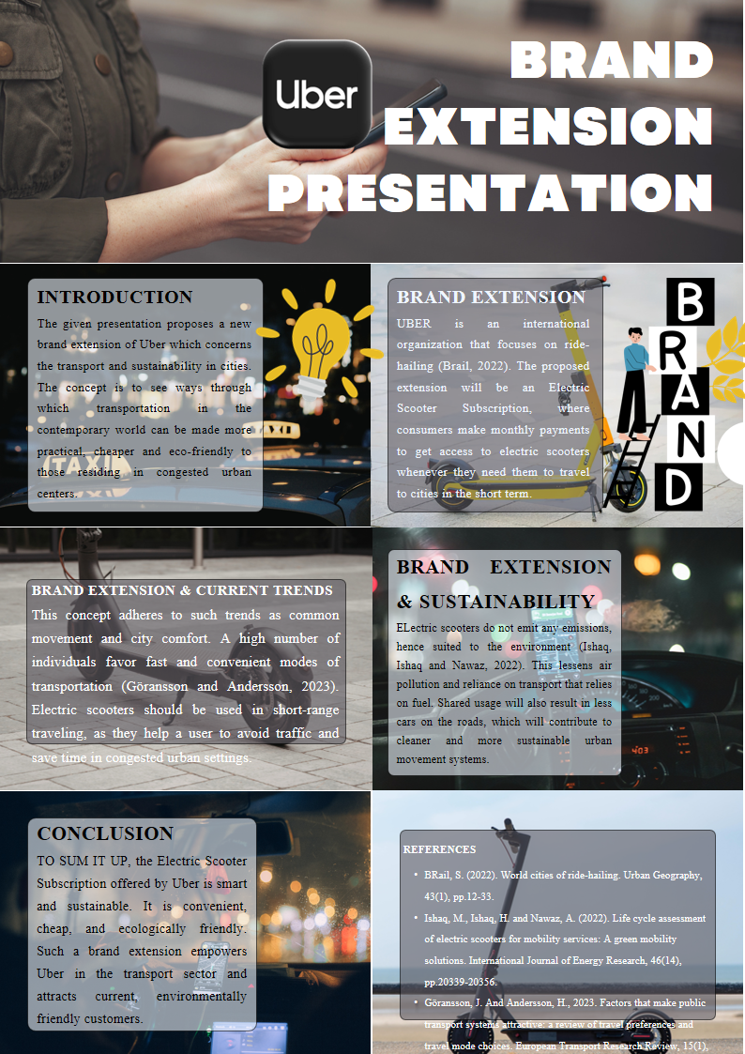

Contents
Element 1: Brand Extension Poster 2
Introduction and brand extension overview 4
Element 2: Segmentation Targeting Differentiation Positioning Analysis 4
Segmentation 4
Targeting 5
Differentiation 6
Positioning 7
Summary 8
Element 3: Marketing Mix — 7Ps 9
Product 9
Price 9
Place 9
Promotion 10
People 10
Process 11
Physical Evidence 11
Summary 12
Critical Evaluation 13
Element 4: Reflection 14
Reference 17

Introduction and brand extension overview
This portfolio outlines a brand strategy for Uber in the form of an Electric Scooter Subscription. The brand extension leverages Uber’s mobility service platform to offer an urban consumer a low-cost, convenient and eco-friendly micro-mobility service. Uber is a multinational ride-hailing and mobility platform that provides users with access to transportation services, and is well positioned to branch out into related urban mobility services (Uber Technologies Inc., 2026).
In terms of branding, a brand extension is when a company that is already well established in a particular category expands its product or service offering into a related category (Aaker and Keller, 1990). This is an apt extension for Uber because the electric scooters are still related to the company's original proposition of on-call transportation services. The subscription would enable users to pay a monthly subscription fee to access electric scooters for short-distance urban travel, particularly in cases where cars are less convenient, affordable and environmentally friendly.
The concept is responsive to recent trends in urbanization, sharing, convenience, sustainability and mobility preferences of young city dwellers (Garus et al., 2024). Studies suggest ride-sharing services are playing an increasingly significant role in urban travel, while microscooters can promote sustainable short-distance travel if managed correctly (Ishaq, Ishaq and Nawaz, 2022). This portfolio assesses the proposed expansion using the STDP analysis, 7Ps marketing mix and reflection.

Element 2: Segmentation Targeting Differentiation Positioning Analysis

Segmentation
Market segmentation is the process of dividing a large market into smaller segments of customers with similar needs, characteristics and behaviours in order to create more targeted marketing efforts (Kotler, Keller and Chernev, 2022). For the proposed Uber Electric Scooter Subscription, geographic, demographic, psychographic and behavioural segmentation can be used to explain customer differences and market opportunities (Kotler and Armstrong, 2023).
Geographical segments include customers in major cities, congested urban centres, college towns and urban business centres. These areas are ideal because short-distance travel issues are more prevalent where congestion, parking scarcity and high transport costs limit travel convenience. The ride-hailing literature suggests that digital mobility solutions are especially important in urban areas, where consumers need transport flexibility (Brail, 2022). Research on public transport also supports that the convenience, reliability and accessibility affect travel mode choice, suggesting that urban areas are suitable for micro mobility (Göransson and Andersson, 2023).
Demographically, the service appeals to customers who are students and young workers, low-to-middle income earners, especially those between 18-35 years old. They are likely to be frequent travellers for education, work and leisure trips, and are more likely to be cost-conscious car travellers. Psychographically, the extension is suitable for eco-friendly users, convenience seekers, tech-savvy consumers and the "new carless" who prefer access-to-ownership. This is in line with broader trends towards the sharing economy, sustainable travel and dynamic mobility services (Badia and Jenelius, 2023; Ishaq, Ishaq and Nawaz, 2022).
Behaviourally, the main segments are frequent users of short trips, existing Uber app users, cost-conscious travellers and subscription-based customers who prefer to pay an up-front fee instead of a pay-per-use fee. This is significant as a subscription service can increase user loyalty and service use by making it seem more affordable, predictable and convenient (Zeithaml, Bitner and Gremler, 2018).

Targeting
The best target market is urban students and young professionals (18-35 years) who require low-cost and frequent travel over a short distance, and are existing users of app-based mobility services. During targeting, the organisation assesses the attractiveness of different segments and chooses the most suitable customer group (Kotler and Armstrong, 2023). This market is attractive because it has high-frequency travel, tech-savviness and a willingness to try new mobility options.
University students and young professionals travel between residences, university, workplaces, sports and shopping centres, and transport hubs. They are also likely to be budget-conscious, thus preferring a monthly subscription to multiple car rides. Younger city dwellers are more likely to use smart phone-based services, easing the uptake of an Uber-connected scooter service. They are also likely to be concerned about sustainability, which makes electric scooters a good option compared with conventional fossil-fuelled car rides (Ishaq, Ishaq and Nawaz, 2022; Reis, Baptista and Moura, 2023). Therefore, this market segment presents both a growth opportunity and a fit with Uber's urban mobility strategy.

Differentiation
Differentiation is the process of making a significant difference between a brand and its competitors that is important to customers (Keller and Swaminathan, 2020). Uber's Electric Scooter Subscription service will compete against operators like Lime, Bolt, Tier and city scooter operators. But Uber can leverage its brand awareness, customer base and app ecosystem to create differentiation. Brand extension theory postulates that brand extensions are more likely to succeed where there is a fit between the brand and the new service category (Sunde and Brodie, 1993; Aaker, 2012).
A critical differentiation is being part of the Uber app. There would be no need to learn a new app, set up a new account and payment method. This minimises transaction costs and improves the convenience of the service, which is critical in managing customer experience (Zeithaml, Bitner and Gremler, 2018). Uber could also provide subscription packages and not just on-demand services, making it more appealing to regular users. Furthermore, Uber could offer a bundle of the scooter subscription with Uber rides or Uber One subscriptions. Safety features would also add to the differentiation, such as tutorials in the app, helmet recommendations, insurance solutions, route planning and charging options. These would make Uber a convenient, safe and responsible mobility provider.

Positioning
Positioning is about how a brand wants to maintain its image in the minds of target customers relative to other brands (Kotler, Keller and Chernev, 2022). The positioning statement could be:
For city students and young professionals seeking affordable, sustainable and flexible short-distance transportation, Uber Electric Scooter Subscription offers a convenient monthly mobility package integrated with the Uber app, enabling faster journeys in the city with a smaller carbon footprint than driving a car.

Position Map
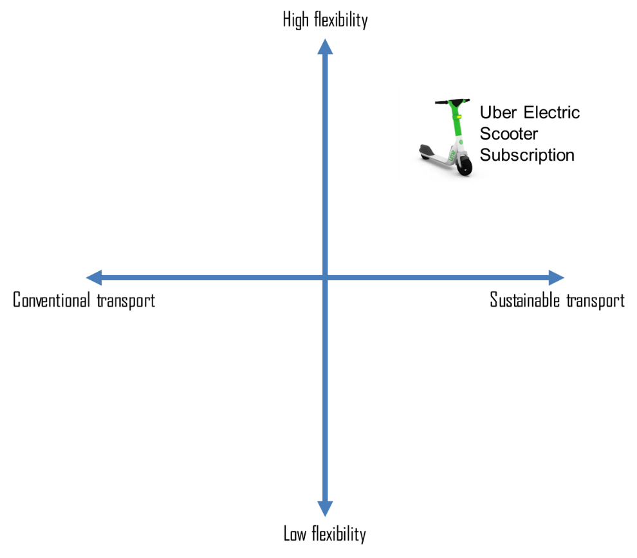
Figure 1: Positioning Map: Uber Electric Scooter Subscription. Source: Own Contribution.
The Uber Electric Scooter Subscription is best positioned in the high flexibility + sustainable travel space because it offers convenience (access via an app), short-distance utility, subscription value (per month) and is less carbon-intensive than car travel. The positioning map highlights three main benefits - affordability, flexibility and sustainability. These attributes are important because e-scooter studies identify their potential as a short-distance urban transport option, but their sustainability is dependent on their efficient use, maintenance and management (Badia and Jenelius, 2023; Mitropoulos et al., 2023). On a positioning map, Uber Electric Scooter Subscription would be positioned as affordable to mid-premium because it provides greater value with the added subscription service and the Uber brand. It would also be positioned on the sustainable end compared to car driving. Lastly, it would be more convenient than one-off scooter hire because the subscription model promotes repeat use and builds customer loyalty. This also helps to build Uber's brand further by moving its business model from transport to urban mobility (Uber Technologies Inc., 2015).

Summary

Figure 2: STDP elements summary for Uber electric scooter subscription. Source: Own Contribution.

Element 3: Marketing Mix — 7Ps
The 7Ps model is relevant as Uber Electric Scooter Subscription is a service-based brand extension in which customer satisfaction is not only related to the product, but also to price, access, communication, people, process and physical evidence (Zeithaml, Bitner and Gremler, 2018; Febriansyah, 2019).

Product
The product would be a monthly subscription for access to a fleet of electric scooters for short trips. It would be tied to the Uber app, where customers could hire, locate and unlock scooters. This contributes to brand extension fit as the new product is still related to Uber's primary service (Aaker and Keller, 1990). The service could have three plans: Basic (limited monthly rides), Plus (unlimited short rides a day) and Premium (unlimited short rides a day and savings on car rides with Uber). Features should include safety tips in the app, trip tracking and a "sustainability score" for estimated carbon emissions saved. This enhances the value proposition by offering convenience while benefiting the environment (Ishaq, Ishaq and Nawaz, 2022).

Price
The price of the service should be set on a subscription basis to create revenue streams and frequency. This is appropriate because it establishes a longer-term customer relationship that encourages retention and loyalty (Zeithaml, Bitner and Gremler, 2018). Uber could provide student discounts, a free trial, and discounts for Uber One to boost take-up by young users in cities. The subscription must be less expensive than regular short car rides to promote economics. But costs to maintain scooters, charge them, redistribute them and ensure insurance must be taken into account. Research on e-scooters demonstrate that environmental and economic benefits rely on good fleet management, maintenance and vehicle life cycle (Badia and Jenelius, 2023; Baumgartner et al., 2024).

Place
Place is the geographic location where and how the service is sold (Kotler, Keller and Chernev, 2022). Uber should introduce the scooter subscription initially in crowded, dense cities with a high demand for short trips. These areas include university campuses, railway stations, business and shopping hubs and densely populated neighbourhoods (Turoń et al., 2023). Dockless or semi-docked scooters will be convenient, but semi-docked parking around transport stations could help with issues such as street clutter and bad parking. Scooters should be visible to users in the Uber app, with maps and scooter locations. City councils, transport and university partnerships would be vital due to the role of local government regulation and city planning in micro-mobility (Mitropoulos et al., 2023).

Promotion
Promotion should emphasise benefits to both customers and investors. The campaign slogan could be: "Short trips. Lower cost. Cleaner cities." Uber can market the scooters via in-app notifications, email, social media, student ambassador programs and referrals. Online marketing is suited to the target market, which is young, tech-savvy and accustomed to using apps. The promotion must convey convenience, cost and sustainability, and demonstrate the benefits of scooters over short car trips. For investors, it should focus on regular subscription revenue, growth in urban micro-mobility and complementing Uber's broader sustainability strategy. Uber's own sustainability strategy aligns with achieving cleaner mobility, adding to the extension's strategy fit (Uber Technologies Inc., 2024; Uber, 2026).

People
People are a key element of service quality because they influence customer confidence and loyalty (Zeithaml, Bitner and Gremler, 2018). While the scooter service is largely digital, Uber would still require a customer service team, maintenance personnel, battery charging team and safety support. Online safety training, videos and customer support would ensure assurance, particularly for first-time customers. Maintenance teams are also essential because scooters that aren't working properly can negatively impact the customer experience and Uber's brand image. So, Uber needs to ensure that people are aligned with reliability, safety and customers' needs.

Process
Process relates to the sequence of actions that the customer takes in using the service (Booms and Bitner, 1981). The customer process should be straightforward: the customer opens the Uber app, subscribes to the scooter service, locates a scooter, unlocks it with a QR code, rides safely, parks safely and reviews a trip summary with emissions-saving statistics. Good process is easy, efficient and reliable, which increases service adoption as customers are more likely to use the service if it is convenient and quick to use (Kotler and Armstrong, 2023). It should also include parking, safety and route information. This is crucial because poor process design may lead to confusion, unsafe or illegal riding or parking, which may negatively affect service uptake.

Physical Evidence
Physical evidence is important because services are intangible, so customers infer quality from physical cues (Zeithaml, Bitner and Gremler, 2018). For Uber Electric Scooter Subscription, physical evidence includes the scooter design and condition, Uber branding, app design, safety guidelines, parking locations, reviews and sustainability rating. The scooters should look clean, contemporary and safe. Uber branding and visual identity would link with the company. The app should also list the number of rides taken, money saved and carbon saved to highlight the green benefit. This would help bolster Uber's positioning as a convenient and sustainable urban mobility company.

Summary
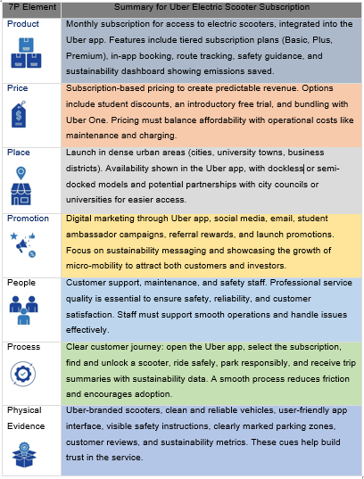
Figure 3: 7P Element summary for Uber electric scooter subscription. Source: Own Contribution.

Critical Evaluation
The extension is appealing because it leverages Uber's brand to a related segment and matches trends towards sustainability, convenience and collective urban transport (Brail, 2022; Göransson and Andersson, 2023). But the extension is risky. Safety, regulation, vandalism, charging, maintenance and competition from Lime, Bolt and Tier may impact operations. Evidence shows that shared e-scooters are not inherently sustainable; they are dependent on operations, lifespan, charging practices and whether they replace car trips instead of walking or public transport (Badia and Jenelius, 2023; Reis, Baptista and Moura, 2023). So Uber needs to collaborate and plan with local government, invest in safe parking, offer insurance and promote safety. If not managed well, the strategy could backfire by hurting the Uber brand.

Element 4: Reflection
This is a reflection on the Gibbs' Reflective Cycle, which involves description, feelings, evaluation, analysis, conclusion and action plan (Gibbs, 1988).

Figure 4: Summarised Reflective Cycle. Source: Own Contribution.

Description
I created and presented a poster on Uber Electric Scooter Subscription as a brand extension for this assessment. I described Uber as a transportation company and how a scooter subscription could be used for short trips. The poster highlighted concept, trends, sustainability and benefits.

Feelings
Initially I felt a little nervous as I had to explain the concept in 3-5 minutes. But at the same time I was confident because the idea was feasible and connected to Uber's current transport services. As I presented, I felt relaxed because I was able to explain the convenience, cost and sustainability advantages of the brand extension.

Evaluation
The good thing was that the poster was able to explain the brand extension simply. It explained how the service will help consumers avoid traffic, save time and money and reduce carbon emissions (Neves and Brand, 2019). But the poster could have provided more market information, a better comparison with its competitors and more investor-friendly evidence. The poster was functional, but could have been more appealing.

Analysis
This challenge helped me understand brand extension and how an established brand can leverage on existing brand equity to move into an existing service category (Aaker and Keller, 1990). Uber Electric Scooter Subscription is aligned with the Uber brand as it is related to app-based mobility. STDP assisted me in considering how marketing strategy should include segmenting, targeting, differentiating and positioning of customers (Kotler, Keller and Chernev, 2022). The 7Ps also revealed that marketing a service involves product, price, place, promotion, people, process and physical evidence (Booms and Bitner, 1981; Zeithaml, Bitner and Gremler, 2018). I also learned that sustainability is not only good for the environment, but for marketing.

Conclusion
In conclusion, I have gained marketing skills, presentation skills and the ability to pitch a business in this experience. I discovered a successful brand extension needs to be feasible, relevant to customers and backed up by theory and evidence. I also realised the need to create a poster that appeals to customers and investors.

Action plan
In the future, I will provide more market data, comparisons and financial proof. I will also make the poster clearer and more appealing by using less text, better images and better data representation. Finally, I will rehearse giving the presentation to build confidence, speed and rhythm.

Reference
Aaker, D.A. (2012). Building Strong Brands. New York ; London: Free Press.
Aaker, D.A. and Keller, K.L. (1990). Consumer Evaluations of Brand Extensions. Journal of Marketing, 54(1), pp.27–41. doi:https://doi.org/10.1177/002224299005400102.
Badia, H. and Jenelius, E. (2023). Shared e-scooter micromobility: review of use patterns, perceptions and environmental impacts. Transport Reviews, 43(5), pp.1–27. doi:https://doi.org/10.1080/01441647.2023.2171500.
Baumgartner, C. and Helmers, E. (2024). Life cycle assessment of electric kick scooters: consolidating environmental impact quantification and concluding climate-friendly use options. Environmental sciences Europe, 36(1). doi:https://doi.org/10.1186/s12302-024-00920-x.
Brail, S. (2020). World cities of ride-hailing. Urban Geography, 43(1), pp.1–22. doi:https://doi.org/10.1080/02723638.2020.1775030.
Febriansyah, R. (2019). Marketing Mix 7Ps . KnE Social Sciences, 3(13), p.619. doi:https://doi.org/10.18502/kss.v3i13.4235.
Garus, A., Mourtzouchou, A., Suarez, J., Fontaras, G. and Ciuffo, B. (2024). Exploring Sustainable Urban Transportation: Insights from Shared Mobility Services and Their Environmental Impact. Smart Cities, [online] 7(3), pp.1199–1220. doi:https://doi.org/10.3390/smartcities7030051.
Gibbs, G. (1988). Learning by doing: a Guide to Teaching and Learning Methods. Programmed Learning & Educational Technology, 25(2).
Göransson, J. and Andersson, H. (2023). Factors that make public transport systems attractive: a review of travel preferences and travel mode choices. European Transport Research Review, 15(1). doi:https://doi.org/10.1186/s12544-023-00609-x.
Ishaq, M., Ishaq, H. and Nawaz, A. (2022). Life cycle assessment of electric scooters for mobility services: A green mobility solutions. International Journal of Energy Research. doi:https://doi.org/10.1002/er.8009.
Keller, K.L. and Swaminathan, V. (2019). Strategic Brand Management: Building, Measuring, and Managing Brand equity. 5th ed. Pearson Education.
Kotler, P., Armstrong, G. and Balasubramanian, S. (2023). Principles of Marketing. 19th ed. Pearson Higher Ed.
Kotler, P., Keller, K.L. and Chernev, A. (2022). Marketing Management, Global Edition. 16th ed. S.L.: Pearson Education Limited.
Mitropoulos, L., Stavropoulou, E., Tzouras, P.G., Karolemeas, C. and Kepaptsoglou, K. (2023). E-scooter micromobility systems: Review of attributes and impacts. Transportation research interdisciplinary perspectives, 21, pp.100888–100888. doi:https://doi.org/10.1016/j.trip.2023.100888.
Neves, A. and Brand, C. (2019). Assessing the potential for carbon emissions savings from replacing short car trips with walking and cycling using a mixed GPS-travel diary approach. Transportation Research Part A: Policy and Practice, [online] 123(1), pp.130–146. doi:https://doi.org/10.1016/j.tra.2018.08.022.
Reis, A.F., Baptista, P. and Moura, F. (2023). How to promote the environmental sustainability of shared e-scooters: A life-cycle analysis based on a case study from Lisbon, Portugal,. Journal of Urban Mobility, 3, p.100044. doi:https://doi.org/10.1016/j.urbmob.2022.100044.
Sunde, L. and Brodie, R.J. (1993). Consumer evaluations of brand extensions: Further empirical results. International Journal of Research in Marketing, 10(1), pp.47–53. doi:https://doi.org/10.1016/0167-8116(93)90032-t.
Turoń, K., Kubik, A., Folęga, P. and Chen, F. (2023). Perception of Shared Electric Scooters: A Case Study from Poland. Sustainability, 15(16), pp.12596–12596. doi:https://doi.org/10.3390/su151612596.
Uber (2026). Our Road to Zero Emissions | Uber. [online] Uber. Available at: https://www.uber.com/gb/en/about/sustainability/.
Uber Technologies Inc. (2026). Annual Report 2025 / Form 10-K. [online] Sec.gov. Available at: https://www.sec.gov/Archives/edgar/data/1543151/000154315126000015/uber-20251231.htm.
Zeithaml, V.A., Bitner, M.J. and Gremler, D.D. (2018). Services Marketing: Integrating Customer Focus Across the Firm. 7th edn. New York: McGraw-Hill.

