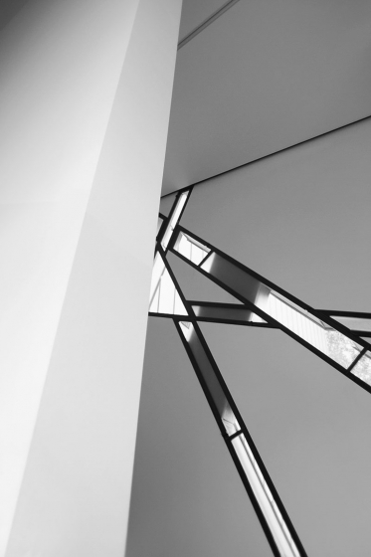
THE
JEWISH MUSEUM
BERLIN
ACAA5003 – HISTORY & THEORY 2
DREW DENNEHY 2100980 09/03/2023

INTRODUCTION
In 1735 a building was constructed in the Baroque style that served as the “Collegienhaus” (Supreme Court building) in Berlin, Germany (Jewish Museum Berlin, 2023). It was designed by Philip Gerlach and became the first large administrative building during the Friedrich I (1713-1740) era. In 1913 the court moved to a different location and the Collegienhaus became a Protestant Consistory (Jewish Museum Berlin, 2023).
The building was then closed by the Gestapo during WWII and suffered near-total damage (Architecture Point, 2015). It was rebuilt in 1969 as the Museum of Berlin, devoted to displaying the history of the Capital and in 1988, after 15 years of discussion, an anonymous competition was held for an extension that would acknowledge Jewish presence within the city’s past (Saindon, 2012). The brief outlined that the extension must fit with the existing museum and surrounding neighbourhood, whilst highlighting the murder and expulsion of Jews.
165 architects entered the competition worldwide and the winning proposal was written on the staves of a musical score, titled “between the lines”, which was produced by Daniel Libeskind (Libeskind, 1990). Born in 1946 in Lodz, Poland, Libeskind was a Polish-American architect who, up to the date of the competition, hadn’t realised any buildings (Zukowsky, 2022). Before deciding to be an architect he travelled to New York for a music scholarship, where he then decided to begin studying architecture under Peter Eisenman and John Hejduk (Zukowsky, 2022). From here he travelled to the University of Essex, England where he graduated with a master’s degree in architecture theory (1972). In 1988, his design was chosen for its expressive nature, using the building form itself to emphasise Jewish lives throughout World War II (Pavka, 2010).
This essay explores the architecture of Libeskind’s Jewish Museum Berlin, identifying and examining the history, philosophies, and design of the project.
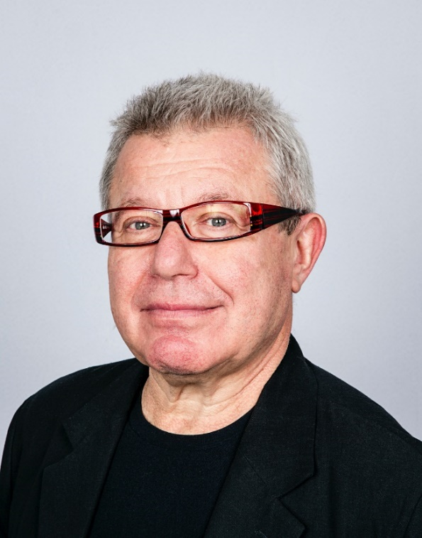
Figure 1, Photograph of Daniel Libeskind (Megson, 2017)
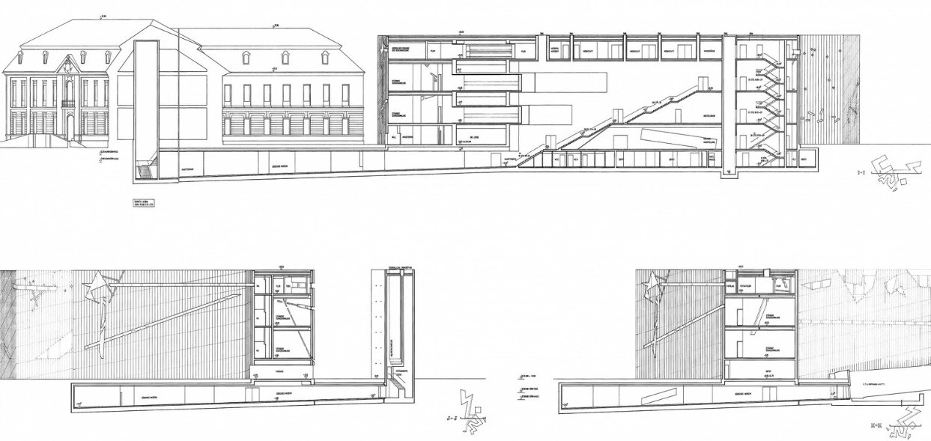
Figure 2, Section elevation of the Jewish Museum Berlin (Pavka, 2010)

DESIGN AND SYMBOLISM
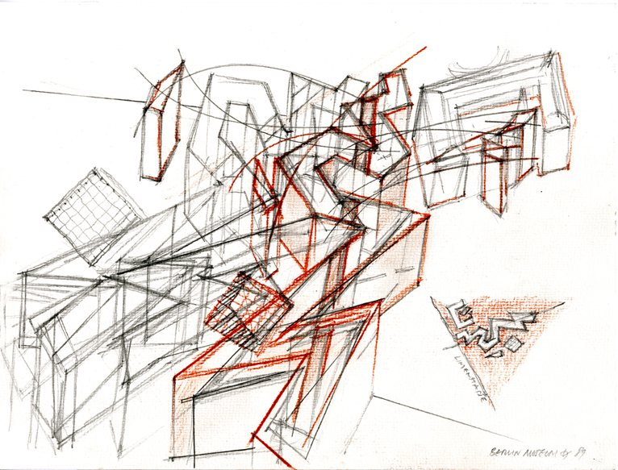
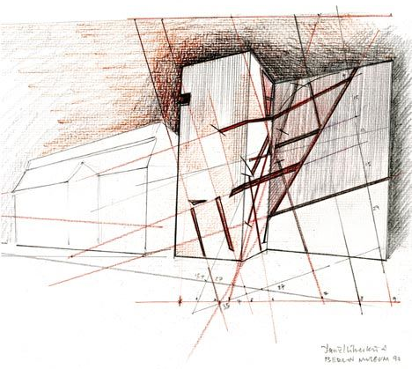
The museum is exemplar of the deconstructivist style that fragments the Jewish star of David to produce a tortured-like form: it has also been named “the blitz” for resembling a bolt of lightning (Architecture Point, 2015). The characteristic windows had to be sourced from a windscreen manufacturer and serve both a functional and philosophical purpose (Architecture Point, 2015). The larger openings provide natural light into office spaces whereas the slits offer glimpses of light throughout the exhibition routes. Libeskind was criticised for designing windows on a tilt but defended his idea by stating that the openings offered an opportunity for people to see Berlin from a different angle, literally and metaphorically (Belogolovsky, 2022). These “gashes, cuts and scars” were mapped out on the building by plotting the addresses of prominent Jewish and German citizens to form a matrix that he spread across the building. (The Jewish Museum Berlin, 2023)
Figure 4, Concept street view sketch of the Jewish Museum Berlin (Keskeys, n.d.)
Figure 3, Concept sketches of the Jewish Museum Berlin (Keskeys, n.d.)
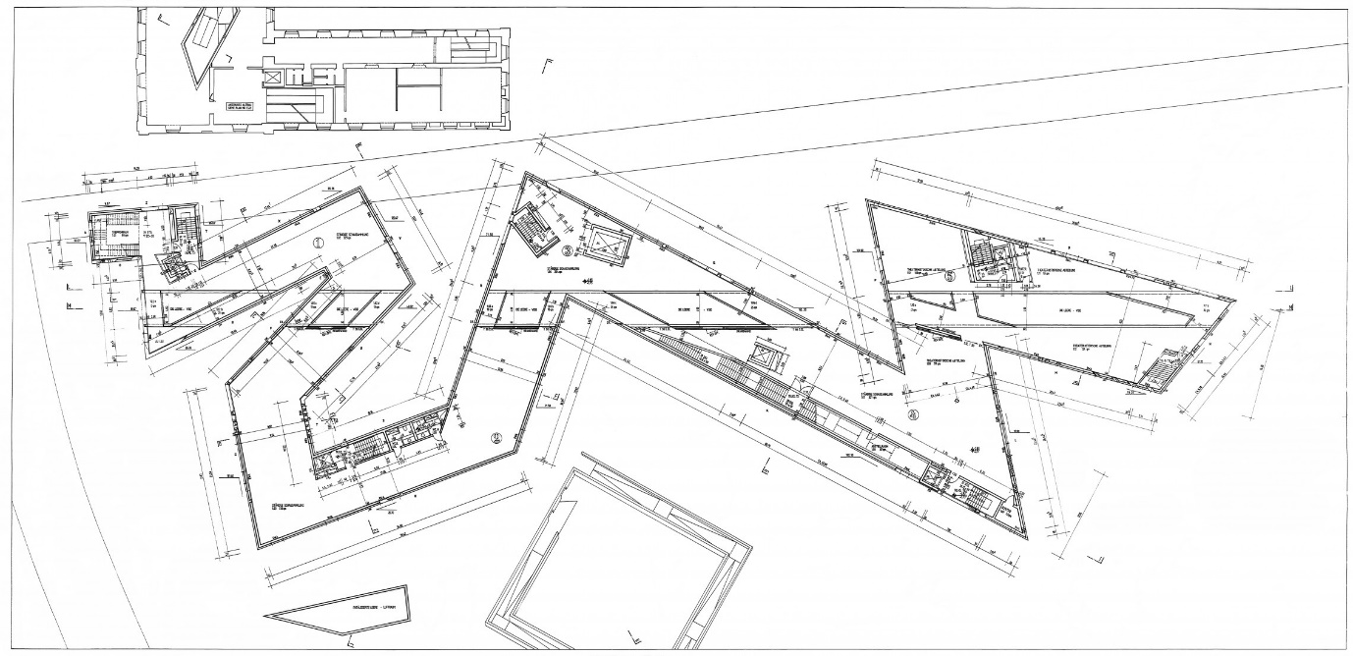
Figure 5, Jewish Museum Berlin ground floor plan

As you walk along the external perimeter, you will discover that there is no formal entrance into the large titanium-zinc clad building. Instead, the architect located the entrance inside the existing Baroque building alongside it, which takes visitors down into the foundations where their journey begins (Architecture Point, 2015). He did this to signify that Jewish history is hidden, as such is his entrance into the museum (Astbury, 2022).
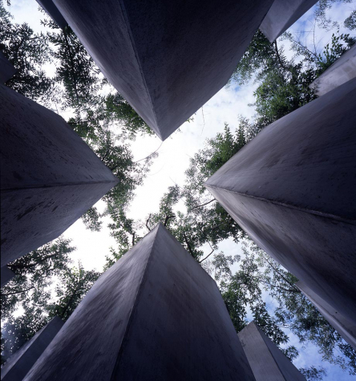
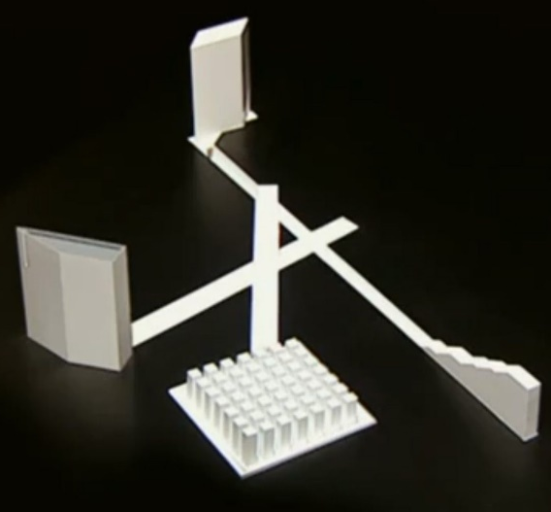
At the bottom of the stairs, 12m below ground level, the user is faced with 3 axes. These corridors represent the experiences of a Jew during wartime: exile, death, and continuity (Sugumar, 2018). The axis of exile leads outside to a 7 x 7 grid of tall, concrete stelae, which is fittingly named “the Garden of Exile”. All but one of the concrete posts is filled with German soil, while the central post is filled with soil from Jerusalem, and Russian olive trees grow out from each of them, signifying hope that is out of reach (Astbury, 2022). There is nowhere to go but back the way you came: Libeskind did this to present that exile was another form of imprisonment.
Figure 7, Garden of Exile (The Jewish Museum Berlin, 2023)
Figure 6, Diagram illustrating the underground axis (Architecture Point, 2015)

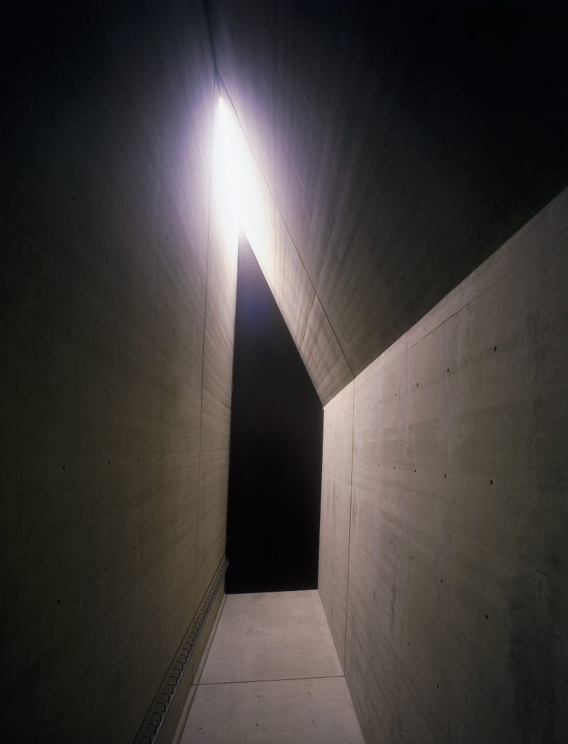
The axis of the holocaust leads to a dead end, which terminates in the holocaust tower. This dark, cold space penetrates through to the roof which allows only a slither of light inside (Mindel, 2015). On the surface, the tower is disconnected from the rest of the museum, demonstrating isolation (Astbury, 2022). Libeskind initially intended to design out any light into some of these spaces, until he spoke to a Holocaust survivor who described a sliver of light shining into the cattle car when they were being transported to a concentration camp (Libeskind, Architecture should not be comforting, 2015). He was influenced by this and adjusted his design to capture their experience. The bare, silent, and eery atmosphere makes it one of the most striking aspects of the design.
Figure 8, Holocaust Tower

The axis of continuity is the only one that leads into the upper floors of the museum. Visitors are met with an 82-step staircase at the end of the corridor, with an atrium space that slices up through the floor levels (The Jewish Museum Berlin, 2023). The reinforced concrete interior matches the exterior with sharp forms and angular edges: the geometries are dynamic and appear to seek their place throughout.
Voids disturb the user’s experience throughout the building, which initially appear as bare, black blocks (Jiang, 2012). However, a view out of an adjacent window will inform the visitor that these are yet another powerful metaphor. The Oxford dictionary defines the word “void” as “emptiness,” which is the feeling Libeskind aimed to express by creating these unheated, moody spaces that penetrate through the building: a sense of absence (Oxford dictionary, 2023). The architect made only a couple of them accessible; the rest purely serve a philosophical purpose.
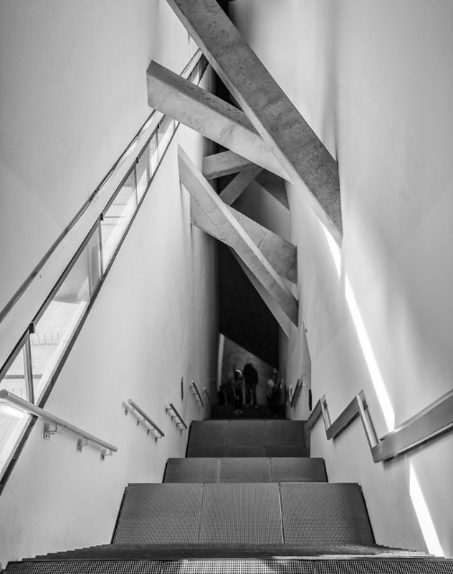
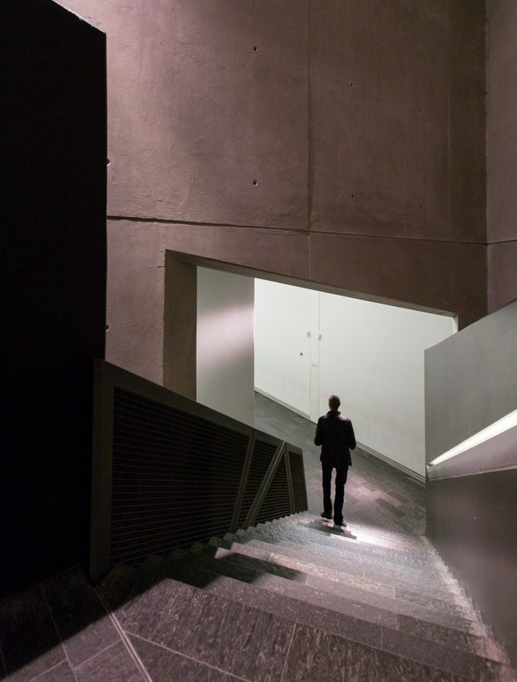
Figure 10, Interior spaces (AD Editorial team, 2015)
Figure 9, teps leading into Daniel Libeskind’s Museum (Mateo, 2012)

ARCHITECTURE AND MEMORY
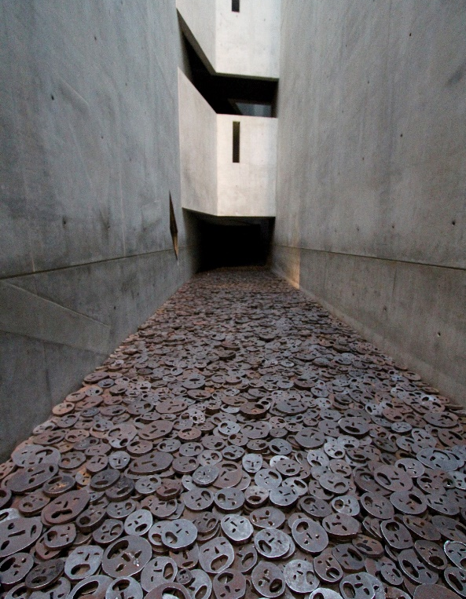
“Architecture and memory” is an idea that explores ways that architecture can be used to commemorate historical events. The primary influence for the design was to create a powerful metaphor that would express the experiences of the Jews, both individually and collectively. Along with a series of exhibition spaces, this museum seeks to educate people by drawing out dark emotions that help to understand the torment they endured.
Figure 11, The Void of Memory (Thogers, 2012)

Amidst their journey, visitors are confronted by 10,000 iron faces expelled onto the ground: the work of Israeli artist Menashe Kadishman, named “Shalekhet” (Fallen Leaves). This piece was selectively placed into one of the voids to convey that the destruction caused by the war cannot be refilled and reinforces the idea of scarring which is seen on the exterior.
Material and texture are other tools used throughout the structure to reflect the concept of architecture and memory. Surfaces are rough, abrasive, and uneven, to evoke feelings of discomfort and unease. Similarly, visually cold materials such as concrete and steel indicate the industrial nature of the Holocaust and the dehumanisation of its victims. The harsh and brutal material choices highlight the severity of the event and convey emotion in a language that words cannot speak.
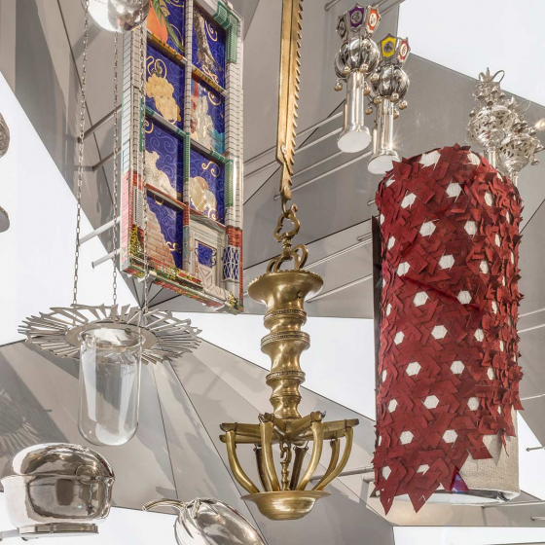
Aside from World War II, the museum presents other aspects of Jewish history in the form of paintings, sculptures, and interviews with Leaders within Judaism.
Figure 12, Exhibits within the Jewish Museum Berlin (The Jewish Museum Berlin, 2023)

“Germany must acknowledge the erasure of Jewish life in its history,” and Daniel Libeskind believed that this could be accomplished by establishing a lost identity in the heart of the country. He went on to say, “it is important not to repress the trauma, it is important to express it, and sometimes the building is not something comforting” (Libeskind, Architecture should not be comforting, 2015).

EXHIBITION DESIGN
The museum was completed and opened in 1999 with no collections within it until September 2001, when it received a collection of over 4,000 items. During the two-year period before the collection was added, over 350,000 people visited the bare museum: some claimed that it was better this way. The architecture itself was an exhibition and was unique in the way it left an impression.
As well as conventional, static exhibits, the museum boasts impressive and interactive displays to engage with the audience, as seen in Figure 13. These come in the form of video and audio recordings, interactive touchscreens, and immersive installations. This approach allows the audience to engage with the exhibits in a more creative and dynamic way, resulting in a more memorable experience.
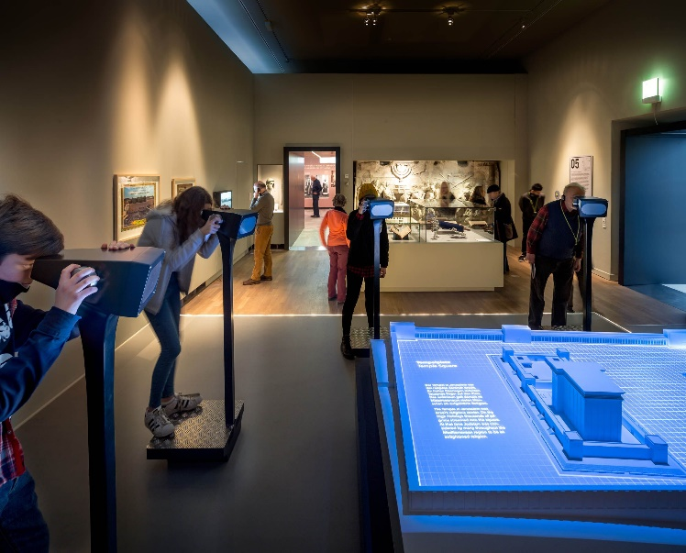
Figure 13, Interactive displays within the museum (Kossmanndejong, 2017)

A notable feature of the exhibition layout is its chronological structure and narrative. The form of the building allows the interior spaces to be organised into different collections starting from early Judaism up to the present day. This offers a wider perspective of the religion and its people throughout time, rather than focusing solely during the war. The floor plan makes it impossible to have an overall vision which encourages the public to seek and explore.
The museum also offers guided tours in 7 different languages, including sign language, which can be booked in advance or purchased on arrival. The tour finishes in gift shop where you can buy merchandise that mimics the form of the structure (as seen in Figure 14).

Figure 14, merchandise sold in the museum gift shop

The architect met with bureaucrats weekly to justify his decisions, most often the decision to build large, empty voids that disrupt the flow of circulation. He claimed that they were necessary. That Berlin could not just build a museum and move on; instead, it should tell a story that will go on forever.

VISITOR EXPERIENCE
In addition to providing an interesting collection, the museum is designed to elicit emotions from each visitor. The journey through the building captures a series of moments that promotes contemplation and self-reflection. The spaces encourage you to place yourself in the different positions of these people during this time.
Libeskind cleverly demonstrates how to draw out particular feelings and how to engage certain senses, while suppressing others. An example of this can be seen in the Garden of Exile, as shown in Figure 15. The floor plane has been tilted at a 10° slope to exude a sense of disorientation, lostness and instability. The narrow passages through the grid are intended to provoke claustrophobia and displacement. These feelings are unpleasant and uncomfortable, supporting the idea that those who narrowly avoided the camps, were far from free.
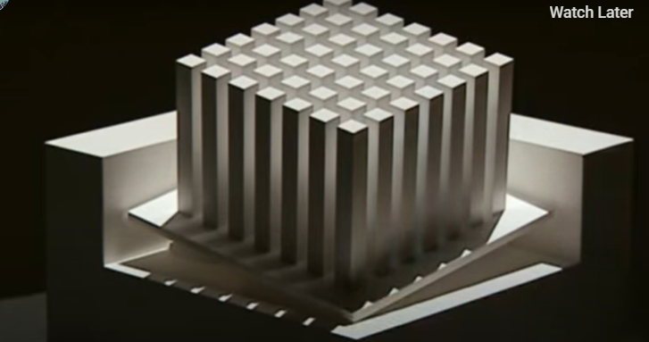
The beams that stretch across the entrance stairway (shown in figure 9) appear to be buckling, creating the sense that the space is compressing inward. This creates a contrast between the white surfaces and tall ceiling height, against the idea of compression and shrinking space.
Figure 15, an illustration to show the tilted plane within the Garden of Exile

A harrowing silence resonates through the exhibition spaces, this is most prominent in the Holocaust Tower. The tower is entered through a heavy, prison-like door where you are then plunged into obscurity. The only sympathy within this space is a narrow slit of light in the roof, representing the only thing the Jews weren’t stripped of: hope. Previous visitors have described this as a “haunting experience” and have retreated into the underground axis, feeling oppressed and insecure.
The Void of Memory, where the “Shalekhet” is sited, is a disturbing environment. To cross this channel, visitors must step across uneven ground made up of tormented iron faces. Multiple senses are exploited here: the faces are loose on the ground, allowing people to pick them up and feel the cold, course surfaces, and the clanging of dense metal-to-metal contact is unavoidable as people step across. A distressing scene for most.

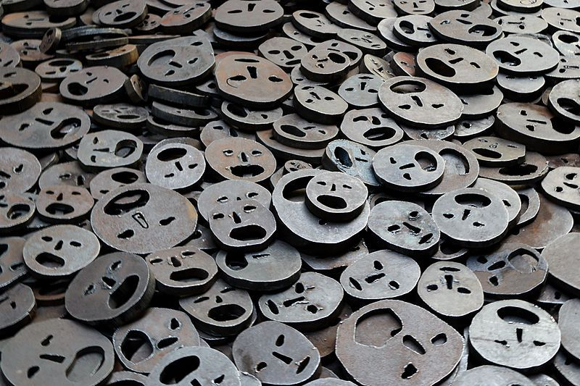
figure 16, “Shalekhet” installation within the void of Memory

CRITIQUE AND CONTROVERSY
The Jewish Museum Berlin is highly praised by credible architecture magazines such as Architects Journal, Arch Daily, Dezeen etc for its commendable in-depth theory and delivery. Though it has also received criticism from other groups. Some, regard the form as unnecessary and argue that it sacrifices the quality of interior spaces which are needed to frame the exhibits. Jewish leaders and organisations have criticised the building for focusing too heavily on the holocaust, claiming that it creates a false identity and distorted view of Jewish culture. Despite this, the majority perceive this building to be a compelling representation of Jewish lives and its culture.
The project has won awards for the building itself, the unique exhibition spaces, and sculptures within, most namely the German Architecture prize in 1998. Since its opening, the museum has been the winner of the “Understanding and Tolerance Award” eighteen times, awarded most recently in 2019 for the “Breaking of the Vessels” structure made by Anselm Kiefer. Libeskind was also commissioned to design two more extensions: a contemporary glass extension on the original baroque building and an academy building.

CONCLUSION
To summarise, Daniel Libeskind’s Jewish Museum Berlin is an excellent example of how architecture can communicate history, identity, and culture. Despite the criticism it received, its contribution to contemporary architecture cannot be denied. The building’s success led to a series of Jewish Museums around the world: USA, Denmark, Portugal to name a few. From this project, Daniel Libeskind was able to establish himself within the profession and introduced a new side to deconstructivism. The building’s ability to draw different emotions from individuals generates interesting debates about how we represent our museums in the future.

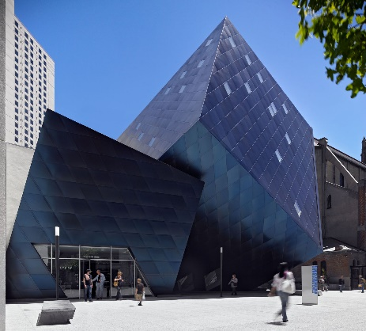
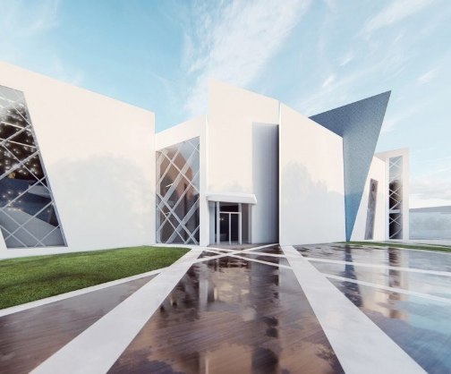
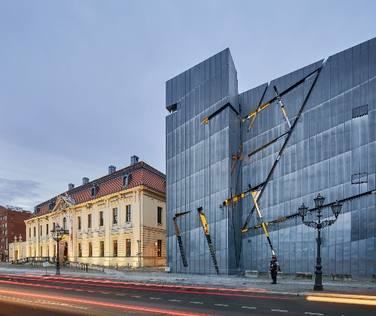
Figure 18, Jewish Museum San Francisco
Figure 19, Jewish Museum Portugal
Figure 17, Jewish Museum Berlin

Dezeen
Libeskind said he initially intended a portion of the building to be lightless because "nobody can bring light to a holocaust". But he changed his mind after reading an account from a holocaust survivor, who recalled a sliver of light shining through the grilles of a cattle car used to transport her to a concentration camp, and decided to add lightwells.

Construction of jewish museum video
In between space
Sober, restrained and subtle design
The first volume penetrates the building. Dynamic and finding their place

Arch daily video
1988 and 1999 – international competition
Metaphor of jewish metaphor, before during and after the holocaust
Abstract jewish star of David
Reinforced concrete interiror
Lose sense of direction
Wanted to convey absence, emptiness, invisibility

1993 – 1998
To replace the one the gestapo closed
165 architects entered.
Walter Benjamin book – one way street – influence
Wrote his proposal on the staves of the musical score and entitled it “between the lines” image of this at 4:10
Nicknamed “the blitz”
Tortured form
Hidden in the trees
Nothing on the surface links the 2 buildings
Entance is via inside the baroque one
Starts underground. Starts in fundations of old building.
Impossible to have an overall vision
3 axis to represent jewish experiences– continuity, excile, death
12 metres below foundation
One axis leads to the museum, the axis of continuity. Continuity of jewish presence in Germany
Staircase at the end. Compressed space then released with upward large free space. Highlights difficulty of path to return to light of day.
Axis of the holocaust. Leads to black door which plunges user into obscurity/darkness.
Axis of excile leads to open air. Garden of excile. Loss of reference point. Unbalancing. Uneven. Escape into free air is illusion. Excile is also imprisonment. No other way out than to return to the axis.
Building is covered in zinc.
Gashes, cuts and scares
Functional, made by manufacturer of windscreens.
Linear openings are drawn lines on the city of berlin, linking the addresses of emblematic figures of German Judaism.
Finished in 1998
350,000 vissted the empty museum in 2 years. Sone said it was better. The architecture itself was the display.
Sep 2001, collection of more than 4,000 objects. Jewish history in berlin.
Bare black blocks, disturbing. Concrete towers that penetrate through all floors. Only light is through skylight. No way in or out. Architect calls them the voids. Represents absence.
Met every week with beurocrats. Had to fight for his reasons why. Necessary. Cant just do the museum and move on. Tells a story that will go on forever.
The void of memory. Mentally uncomforting, uneven, stepping on faces, the sound of the metal.

Museums own website
Titanium zinc
Left with insecurity and disorientation
Won the competition in 1989, the first time one of his design was actually built
Page mentions influences
Like a piece of music, you can hear it, and you don’t need to understand it to feel it.
The shafts are unheated and aren’t air conditioned
Shalekhet (fallen leaves) – Israeli artist menashe kadishman – destruction the cannot be refilled.
82 stairs that lead to the 2nd floor of the museum building
Holocaust tower, people feel oppressed and anxious.
49 concrete stelae are laid out in a 7 by 7 square on a slanting ground. Russian olive bushes growing out the top are a symbol of hope.forty eight are filled with soil from berlin and the forty ninth in the center is filled with soil from jerulsalem. The slant gives a dizzying feeling of unsteadiness. Only vegetation is high and out of reach.

Arch daily
Anonymous competition held by berlin government for an expansion to the original jewish museum in berlin that opened in 1933. To bring presence back
1988 Daniel chosen as winner. His was the only design that implemented a radical, formal design as a conceptually expressive tool to represent jewlish lives before, during and after.
Completed in 1999, opened in 2001
Establishing identity that was lost
Architecture as a narrative. An experience.
No formal exterior entrance
Slivers of light to show that even in the darkest of places, they had to keep hope.
10,000 course iron faces

Arch daily 3d way
Born 1946 in Lodz Poland
People were against the windows being shifted/tilted. He wanted the windows to see something that wasn’t there, an idea of how we look at the world. Must look at it from a different angle.

Libeskind page –
Prussian Court of Justice building serves as entance
Germany must acknowledge jewish arasure of jewish life in its history
Zigzagging plan
Awards- buber Rosenzweig medal from dkr 2010
1999 the german architecture prize
1998 – the best of 1998- art forum international
Structural/ mechanical engineer and landscape architect info

DEZEEN
Titanium – zinc – clad
Deconstrcutivist
Sharp forms, angular walls and unusual openings.
Entrance is underground because jewish history is hidden.
“it ius important not to repress the trauma, it is important to express it and sometimes the building is not something comforting”
The voids run in a straight line throughout the building to interrupt the flow of movement. Take image of diagram from utube vid
Daniel was brought back to do 2 extensions

