Note: the file provided to phill is the image files all images added there are talking especially about those images if not then they are just highlighted in the document below with the same subheading as the CD file.

First day

This is a solo project that I have planned to do over the course of the next few months. The project is still called “First day” (but this is still a working title and most likely will be changed before the final hand in). “First day” is a short slapstick comedy film primarily aimed at kids between five to eight years old, with parents being the secondary target audiences. This short has two characters first being a young, inexperienced and clumsy Busines man (unnamed, left) and the second being an older, experienced and calm handyman (Henry the Handyman,right).
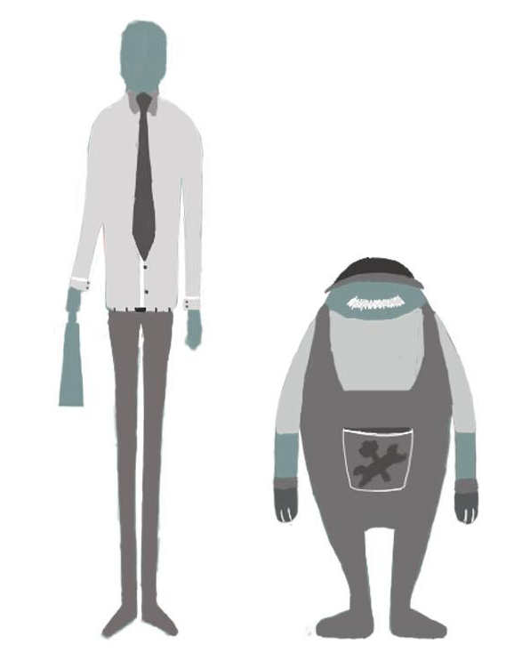
The log line for my short film is “What could go wrong on your first day? How about everything.” Just as the logline suggest the story is about a person first day in their new job, but things don't go his way, such as losing his tie on the bus, walking into a glass door or walking into a lamp pole. These are all things that most people have already experienced in their life, such as; getting your clothes trapped in a door, not paying attention and walking into something, plus the very simple but probably the most common being lost in a new area/environment. However at the same time, the movements are exaggerated to give the over the top effect, this is to separate from reality and fiction.

Plus this helps the impact of the gag; this is because as human we know the embarrassment of being in these situations. This is called dark humor, as we know the event is not something to laugh at but we still do, this is a way for people to release stress and the pent of emotion behind the situation. An example of this would be 9/11, a tragic event that shook the world plus with hundreds of people losing their lives and about nine months of work to clear the aftermath. At that time jokes about 9/11 was seen in a bad light but now people laugh at the 9/11 joke, this doesn't take away from the fact it was a national digester, but it is used as a coping mechanism.

Thumbnails
For my thumbnails, I started by thinking about gags I would use. However, this was a more significant challenge than I thought. As I would come up with a gag I like but, the more I worked on it, the less entertaining and humorous the gag become over time which leads to me either scraping the idea or trying to add more and more. It got to a point where the joke was lost in the madness of everything, and I had to scrape it, again.

I went back, and I did more research on slapstick comedy by watching some of the greats of slapstick comedy Buster Keaton and Charlie Chaplin. From their gags, I see that their build-up was a lot better than mine and this was a big reason why my gags were not hitting the marks.

after i went back into my thumbnails and started to see how can I build up my gags, I knew the primary idea/method of building up a joke which is a 3 step process of build up, anticipations and then the punch line.
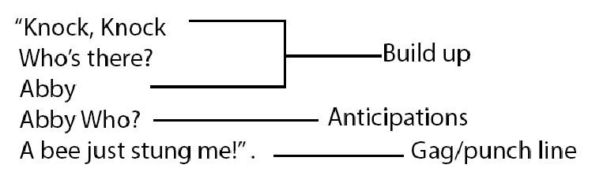
However, I was having problems with the first step the build up, my build up to gag was too weak meaning that there were no anticipations drastically lower the impact of the punch line. Therefore I added a slower and more clear build-up leading to the gag. This was a good start as now I had a decent build up the impact of the gag improved, and more people understood what was happening.
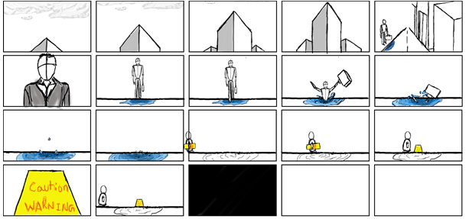

This lead to my second problem was each punch line had its, and this was slowing down the pace which the story was moving in. Furthermore, the process of creating build up for each gag was taking much time, and this slowed down my progress. Plus the fact the more I worked on the gag, the less funny I found the joke then I started to go back to where I was scraping ideas again.

After I realised I was getting back to the loop of working on a gag for few days then scraping it again, I decided to keep most of my jokes and then when it's all done start to cut it out after I get all my jokes done. Now, this pushed me to a point where I could not create a build up for each gag, so I had to match punch line with a punch line.

This was something I noticed while doing my research in comedy, that much stand up comedians have a long and slow build up (compared to visual comedy as they have to paint the scenario in our head first) with smaller gags in between. After the build up the is usually a pause (anticipations) then followed by multiple punch lines.

After noticing this, I started to seeing this method in slapstick comedy as well. An example of this is Buster Keaton famous roof jump stunt, where a jump from roof to another roof but he fails and ends up falling. After falling through the roof, he holds on to a steel pipe which breaks and throws him into a room with a sliding pole (firefighter pole) where he slides down and lands in the fire engine room and acts as nothing has happened. However, as you can see things just escalated, and the pace keeps on speeding up and comes to abrupt end.

In the same way, I have implemented this for my falling into water gag. It started with almost no build up, and the joke itself lacked a lot of impacts but now as you can see the joke has been replaced with what I haved explained just before, the slow build up for multiple gags.

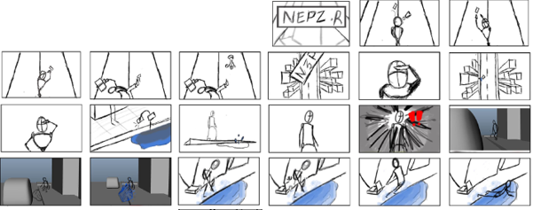

Starting from the nametag being kicked in the air and landing in the puddle of water the situation keeps on getting worse and worse, as the pace of the gag keeps on speeding up till it comes to an abruptly ends.

Later in my research, I saw that a lot of Buster Keaton's gag have some basic rule like, if the audiences can’t see it or hear it neither can the actors in the frame. Without this rule, some of this famous gag would not have worked example, “One Week” (September 1 1920) an indie short film. In this film, there is a shot where their wedding gift, a portable house is stuck in the train tracks.

As the audience can see the train coming from the right side so does Keaton and his wife, but at the end, the train coming from the right side is travelling on the other tracks missing his portable home. However suddenly out of nowhere train from the right side appears and takes out his house, as the audience has not seen the second train neither did the actors in the frame.

By using this rule, I have created some gag such as the elevator gag, as the audience did not see the second elevator neither did “businessman”.

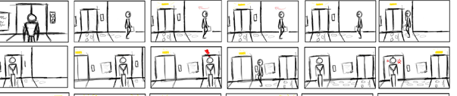

This gag had good reviews, so I decided to apply this method again. I used this method later on the unseen staircase gag after “businessman” dropped his briefcase on his foot then he falls down the stairs. Afterwards, Henry comes in the room to place an emergency door sign indicating there is set of a stair going down.
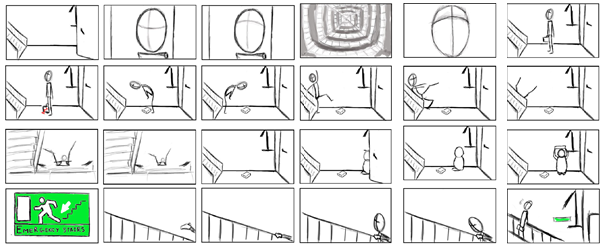

This gag didn’t come across clearly, as on my feedback from my peers they didn’t understand what had happened and why Henry came to place the sticker. After trying to find a way to make the gag work I found out that it would work if I rearrange the shots. Such as having the fall scene then have Henry come in with the sign then seeing the reaction of “Businessman” for what has just happened. However, the gag does improve, but Henry come off as someone going out of his way to make “ businessman’s” fail on his first day. Therefore I have decided to remove the briefcase gag out of the lycee reel.

Background
The story takes places in a city so for my research I looked into famous, well-known cities like London, New York City and Shanghai city to name a few. However, the shapes of the building were not the style that match shows for my target audiences. Therefore, I looked into a more cartoonish style such as “Zootopia” (Disney, 2016) and “Sing” (Illumination, 2016). Both of these movies have large cities and also had a very bright palate. The images for background colour are from “Zootopia”.

The reason I have chosen “Zootopia” for my colour as it has bright colours and a vast range of colours.

Form my “background references” you can see the building shape are not straight and bit tilted. Therefore, we can see in my concept art I tried to create unusual building shapes. I also tried some simple shape shapes, but that didn’t work out well. However, there were some great shapes as well, for example, the image shown below.
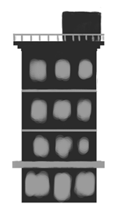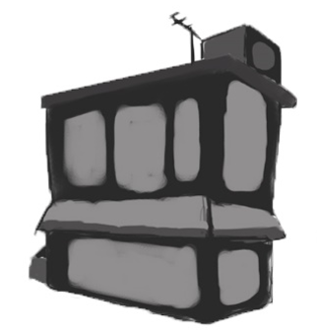
The concept art fell more toward local shops, so I had decided to alter it later to match the more urban style of background.

Characters
For my character “Businessmen” I looked at skinny and tall characters such as Jack Skellington from The Nightmare Before Christmas (1993), Aku from Samurai Jack (2001-2004 Cartoon network, 2017 Adult swim). These characters are tall and skinny but somewhat evil. Then I started to look more at male models, from this I tried to create something in the middle an exaggerated but not to a point like Aku.

Once i found the general shape I wanted I decided to get a range of dress code from classic, clean-cut suit to casual work dress too sloppy untucked shirt. From these different ranges, I chose a simple shirt and tied look. This choice was made because having a shirt and tie makes him look more like a new and inexperienced worker, which help on me make a point of this being his first day.

For Henry, I looked at small and chubby characters such as the Manny from the movie “Cloudy with a chance of meatballs” (2009). The idea behind why Henry is small and chubby is to show the visual differences between “Businessman” and Henry, this help to show the differences in their personality.

When designing the shape of Henry i started with an egg shape then I added exaggerated arms and legs. Furthermore, as his job description is a handyman I looked into overall and heavy working belts, this was the bases that I worked from. Afterword I started to think about facial hair as I wanted to portray him to be an older male. In the end, I decided on a white moustache and a cap that covers his face.

3D
From my concept art, I have created some 3D models. These are all basic shape to see if my concept art would work in 3d. After looking at these model, you can see I have added an overly large door and weird shape windows, this is done quite often in a kids show. I have tried to replicate and also try to create some that not too overly exaggerated. Overall I think the all of them came out well. Especially the one shown below, this was the building I talked about before, and I have made some changes like the shape of the windows and turned the bottom window to a food stall which fits a city theme rather than a small house.

While modelling my concept art, I also tried some new buildings such as the one shown below. I think this also came out well but a bit to square, if I use this building, I will probably try to make the square more wavey to match the other large building shapes.

At the very end, I have a simple shape of how my city will be laid out with the bus stop at the end of the road.

