

Postgraduate/Distance Learning
Assignment coversheet & feedback form

THIS SHEET MUST BE THE FIRST PAGE OF THE ASSIGNMENT YOU ARE SUBMITTING (DO NOT SEND AS A SEPARATE FILE)

For completion by the student:
Student Name: Steve McDonald

Student University Email: 2325822@student.uwtsd.ac.uk
Module code: HPCA7028  Module title: Sacred Skies | Student ID number:  2325822 |  |  | Educational support needs:  No
Assignment title: A Critical Examination of the Sky in Relation to Material Culture.

Assignment due date: 1 May 2025
This assignment is for the 1st 2nd 3rd 4th 5th 6th module of the degree
I confirm that this is my original work and that I have adhered to the University policy on plagiarism.
Signed ……………………………………………………………
Email submission:if you are submitting this form via email, please tick this box
(as a substitute for your signature) to confirm that you agree to the above declaration.
Assignment Mark
1st Marker’s Provisional mark
2nd Marker’s/Moderator’s provisional mark
External Examiner’s mark (if relevant)
Final Mark

NB. All marks are provisional until confirmed by the Final Examination Board.

For completion by Marker 1 :
Comments:

Marker’s signature: |  |  | Date:
For completion by Marker 2/Moderator:

Comments:

Marker’s Signature: |  | Date:
External Examiner’s comments (if relevant)

External Examiner’s Signature: |  | Date:

A Critical Examination of the Sky in Relation to Material Culture.
Introduction
The aim of this essay is to examine the sky in relation to two chambered cairns located within sight of each other in the Vale of Glamorgan, South Wales. One chamber is at a location known as Tinkinswood with the other almost a mile away at St Lythans. It is proposed on the Archaeoastronomy Database that the line of sight between the two locations closely matches the azimuth of the northern moonset and southern moonrise positions at major lunar standstill; given that the Moon is at this position at the time of writing this essay in April 2025 it is this connection that will be investigated. The question more specifically is therefore to understand if there is a major lunar standstill relationship between the Tinkinswood and St Lythans chambered cairns and if so, to understand if evidence implies that the alignment was intentional by the culture that built them.

Nicholas Campion points out that the sky has always held a sense of awe and wonder for humanity, arguing that there is potentially evidence going back 70,000 years that people ‘had the awareness to regard the sky as a source of meaning.’ As the sky remains relatively consistent over thousands of years Stanisław Iwaniszewski suggests it can provide ‘a link between us and our remote ancestors.’ He goes on to describe the theoretical assumption that if our ancestors did indeed regard the sky in this way then evidence would be left in the material record, such as the chambered cairns at Tinkinswood and St Lythans. Iwaniszewski states that it is this assumption that underpins archaeoastronomy, a field of which Clive Ruggles defines as the investigation of ‘human perceptions and actions relating to the skies and celestial phenomena.’

Ronald Hutton writes of the history of Archaeoastronomy and of how it has often been rejected by archaeologists. He contends that this is due in part to many assertions put forward by early enthusiasts such as Sir Norman Lockyer eventually being proved wrong, before later work by Alexander Thom who by failing to frame his findings in the archaeological record helped to fuel the counterculture of the 1960s that was opposed to scholarly orthodoxy. Hutton also points out that to test the claims of these researchers archaeologists ‘would require an expertise in astronomy, mathematics, and statistics’, all of which are separate sciences. More recently scholars such as Ruggles have attempted to bridge the divide between archaeology and archaeoastronomy by drawing on expertise from a range of disciplines to develop a scientifically rigorous approach to the latter. Additionally, Fabio Silva lays out an holistic methodology whereby archaeoastronomy and archaeology can come together for ‘a fuller and more balanced exploration and understanding of the location and orientation of the European megaliths.’

The first part of this study is to apply the approach laid out by Ruggles to quantitatively establish if an alignment indeed exists between the two chambered cairns in question and the major lunar standstill. Ruggles points out that the existence of an alignment does not prove that it was intended or even that it was noticed by anyone from its time of construction until it’s identification by modern archaeoastronomers. He goes on to suggest that the correct starting point for the analysis of structural alignments is their cultural context. Clifford Geertz defines culture as ‘an historically transmitted pattern of meanings embodied in symbols.’ The second part of the study is therefore a qualitative investigation into what is known by archaeologists of the people who used these sites, their rituals, beliefs and practises, the meaning behind the symbols they contain, and if it that meaning could imply intentionality in an observed alignment.

The Vale of Worship

The Tinkinswood and St Lythans chambered cairns lie near to the villages of St Nicholas and St Lythans in Glamorgan, in a small area known as Dyffryn Golwch (Fig. 1). This Welsh place name can be translated as Vale of Worship, and given that there are no churches in the vicinity may suggest that this was a place of ritual practise from before the arrival of Christianity in Britain which according to English Heritage can be traced back to the 4th century AD. The landscape is a gently undulating countryside covered by farmland and small wooded areas, leading down towards the coastline approximately 4 miles away. Ffion Reynolds describes the ground around Tinkinswood as being punctured by large mud-stone slabs dating to the Triassic period much of which has been cleared to field boundaries but may have previously formed a wider scatter and ‘must have been conspicuous features of that landscape to early Neolithic communities.’ Around the chambered cairn at Tinkinswood lie a number of ancient structures; there are at least two tumuli to the northeast, an earthwork and standing stone to the northwest, a possible standing stone to the southwest and the St Lythans cairn to the southeast.

Reynolds puts the age of the Tinkinswood cairn at approximately 6,000 years old, and Vicky Cummings and Alisdair Whittle state that the most recent studies of human bone fragments found at the site revealed deposition dates of around 3,700 cal. BC, placing it in the neolithic period. According to Coflein (the Welsh Government sponsored online catalogue of archaeology) the resemblance of the plan of the St Lythans cairn with that at Tinkinswood means that they are thought to be contemporaneous. The two cairns share common features with Scottish chambered cairns, Scandinavian passage graves and Iberian dolmens, all of which are described by Silva as consisting ‘of an artificial mound—a tumulus or cairn—that includes inner megalithic structures, usually one or more chambers and/or a passage leading to an entrance.’ More specifically Steve Burrow classifies the Tinkinswood and St Lythans cairns as being of the ‘Cotswold-Severn’ type, due to their similarity with others found around the River Severn.

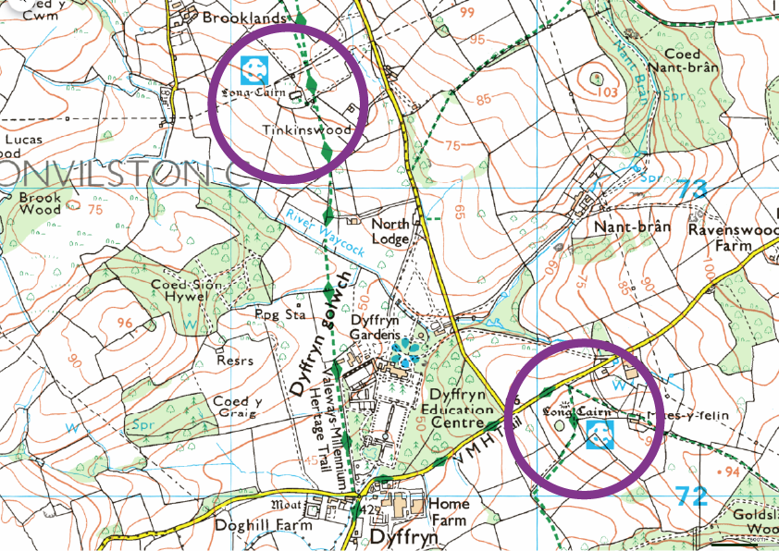
Figure 1: Map indicating locations of Tinkinswood (top) and St Lythans (bottom) burial chambers in the vicinity of Dyffryn Golwch. Image: OS Maps.

The Tinkinswood cairn (Fig. 2) faces an east-northeast direction and sits on a slight spur which gently slopes southwards down to the River Waycock. The first significant excavation here was undertaken by John Ward in 1914, in which he gives the measurements of the tumulus as approximately 40m long by 17m wide and describes it as being surrounded by a small retaining wall called a revetment. Within the tumulus itself Ward identifies several rows of stones running across its width and a pit which he suggests is likely a later addition. On the east end of the cairn the revetment is described as curving inwards towards the entrance passage of the chamber with the capstone above. The size of the capstone is given as almost 7m long, approximately 4.5m wide and weighing an estimated 40 tonnes, with Ward stating that it ‘has long been regarded as the largest in Great Britain.’ It is in and around the chamber and entrance passage that Ward describes ‘an abundance of broken human bones’ along with fragments of pottery being found.

Though now obscured by trees there is a line of site from the Tinkinswood to St Lythans cairn (Fig. 2) which lies 1.3km away in a south-easterly direction. Situated on a hill on the opposite side of the river valley it too is orientated to the east-northeast. Coflein gives estimated dimensions of the tumulus as 27m long by 11m wide, making it smaller than Tinkinswood but there is no trace of a revetment. The chamber at St Lythans is in a similar position to Tinkinswood at the eastern end of the tumulus but is again smaller. According to Coflein human remains were found in the chamber in 1875 and the only excavation of the site took place in 2011; I have however, been unable to locate any associated published papers. Coflein also describes how cattle erosion around the chamber led to the chance discovery in 1992 of fragments of a polished stone axe and flint arrowheads documented by Toby Driver.

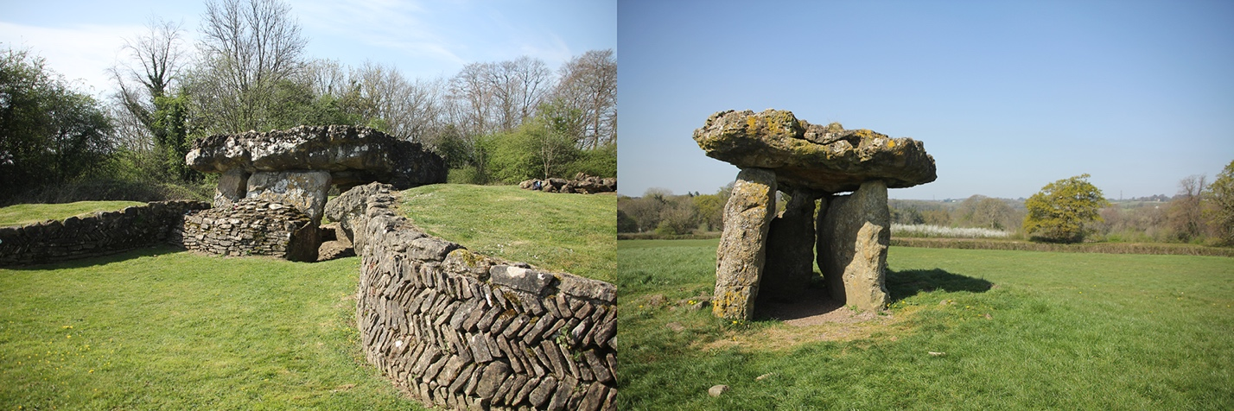
Figure 2: The burial chambers at Tinkinswood (left) and St Lythans (right). Images: Steve McDonald.

Christopher Tilley investigates several ‘Cotswold-Severn’ type long cairns in the Black Mountains of South Wales, specifically looking at their relationship to landscape. He suggests that the Usk and Wye valleys provided links between the Black Mountains and the coastal lowlands of Glamorgan. Reynolds points out that it is generally accepted that Neolithic communities ‘engaged in a process of settlement mobility’, it would therefore seem possible that the same communities who used the chambered cairns of the Black Mountains travelled to and from those at Tinkinswood and St Lythans. Tilley points out that many studies of ancient cultures look at environmental factors such as food source or seasonality to explain location use, with ritual, myth and cosmology seemingly deemed irrelevant. Conversely, he states that many studies of ritual, myth and cosmology seem to consider the environment equally irrelevant. Tilley’s approach is to merge the two by looking at what people believed in order to broaden understanding of how they might relate to the landscape. Belden Lane states that ‘the human role in completing the task for jointly perceiving a given landscape is to tell its story, to weave a narrative that embraces the energies of land and sky in suggesting common meanings only discovered together.’ The aim of this essay is to build on Tilley’s approach by incorporating Lane’s ideas, to better understand how people relate to their environment by considering the sky as an equal factor to the land.

Lunar Motion

A. César González-García describes the orbit of the Moon as being inclined at nearly 5° (i) to the orbit of the earth around the sun known as the ecliptic, which is itself angled at approximately 23.5° ($ε$) to the axis of the rotation of the earth. He states the nodes at which these two orbits intersect have a retrograde motion with a period of 18.6 years. He goes on to explain that this means the Moon, as viewed from earth will reach two extreme positions over that period with maximum declinations of approximately ±28.5° at one extreme and approximately ±18.5° at the other with these two positions respectively termed ‘major’ and ‘minor lunar standstill’ by Thom. Erica Ellingson and Fabio Silva point out that the major lunar standstill season reaches the peak of its 18.6 year cycle in 2024 and 2025. From an observational point of view González-García states that that during this time the Moon will appear both further north and further south on the horizon than the most extreme solar positions. (Fig. 3)

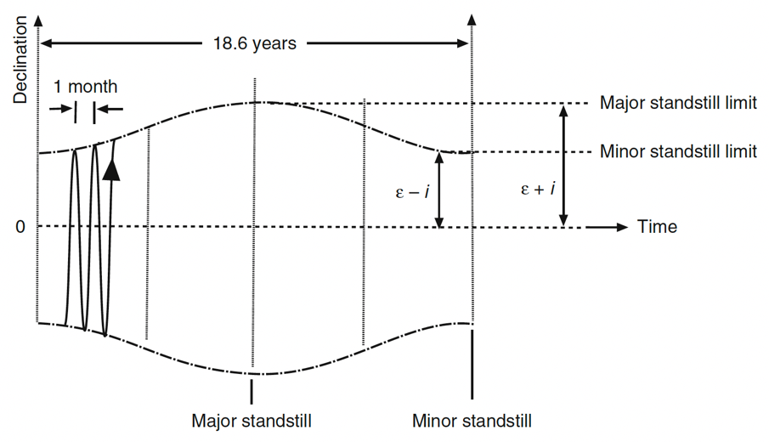

Figure 3: Representation of lunar motion, showing the variation in the Moon’s declination over the 18.6-year node cycle and the monthly cycle. Credit: Clive Ruggles.

González-García suggests that the use of term ‘standstill’ is misleading given that the Moon moves away from the position of extreme declination within a day, unlike the sun which appears to stay at its solstice position for several days. He goes on to explain that this factor, together with local weather conditions, lunar parallax, and that extreme declination may not coincide with moonrise or set, all mean that ‘actual standstill limit is a very difficult and rare event to witness.’ The inherent problems in the accurate observation of the major lunar standstill is perhaps one contributing factor as to why Ruggles states that ‘lunar motions were not in fact observed and recorded to a high position in prehistoric times’, according to Hutton he instead only finds evidence for symbolic alignments. Furthermore, Ruggles points out ‘that the amount of ethnohistoric or ethnographic evidence showing that the standstills were conceptualised as such outside Western culture is precisely zero.’ Having highlighted the issues with the identification of any potential alignment with the major lunar standstill, Ruggles suggests that it does not necessarily follow that the builders of these structures would not have appreciated the phenomenon. As the Moon appears on the horizon in positions beyond the declination of 23.5° reached by the sun at the solstice as noted by González-García, Ruggles suggests that ‘special significance might have been ascribed’ to this part of the horizon. He proposes that this appreciation could be ‘reflected in the design of ceremonial architecture— resulting, for example, in the apparent existence of deliberate, low-precision alignments upon the lunar standstill limits.’

Methodology for Measuring Orientation

Positional astronomy is defined by Ruggles as ‘the study of where things appear in the sky as viewed from points on the earth’s surface.’ He explains two coordinate systems that allow the use of spherical geometry to calculate the point in the sky that aligns through an horizon feature from a point on the ground. One system known as the “equatorial system” is used to indicate any point on the celestial sphere; where the celestial sphere is described as rotating around the point of observation and on which, for sufficiently short timescales, all celestial bodies can be considered to have a fixed location. The coordinates of the “equatorial system” are given as declination ($δ$) and right ascension (RA), where declination is the distance above or below the celestial equator measured in degrees and right ascension is the distance east around the sphere from the point of the vernal equinox measured in hours. Ruggles however points out that it is usually only the declination that is of interest to archaeoastronomers as, again for sufficiently short timescales, celestial bodies can be considered to move around lines of constant declination. The second system known as the “horizontal system” is described as being useful for defining horizon features, and uses the coordinates azimuth ($A$) and altitude ($h$) where azimuth is the horizontal angle in degrees measured clockwise from true north and altitude is the vertical angle between the horizontal plane and the observed point, also measured in degrees. According to Ruggles ‘the astronomical potential of a given structural orientation may be assessed quantitatively by establishing the “indicated declination”,’ that is the declination indicated by the line of sight from the observer, through the horizon feature to the point on the celestial sphere. The “horizontal system” varies according to location meaning latitude ($φ$) needs to be measured along with azimuth ($A$) and altitude ($h$); these measurements can then be translated to an indicated declination on the celestial sphere using the following standard formula given by Ruggles.

$\sin{δ=\sin{φ\sin{h+\cos{φ\cos{h\cos{A}}}}}}$

In this study the measurement of the three variables required to make this calculation will be done using two methods with the results of each being combined to improve accuracy. The first method will be a desk study making use of digital tools which Zotti states have reached a level by which reliable results can be achieved. The latitude and azimuth of sites will be measured using Google Earth, these will then be entered into Hey What’s That, a web based tool that uses location and terrain data to build a visual representation of the horizon allowing the altitude measurement to be taken. Zotti points out that digital tools while accurate, are unable to ‘include the “spiritual” component of a landscape in its respective time and culture which may be required to understand the feelings, beliefs, and motivation of the prehistoric inhabitants.’ The second method will be a field study to take in person measurements of the three variables using the Theodolite smart phone app. Additionally by taking time to observe the landscape features, horizon, line of sight, and by walking between the locations, the hope is to gain a deeper understanding of the landscape and of potential motivations for their selection.

For accuracies with which archaeoastronomy is concerned Ruggles points out that the distance to most celestial bodies mean that their declination and right ascension can be considered the same no matter what point on earth they are being observed from. However, the proximity of the Moon means that it’s declination can vary depending on the location from which it is viewed. Thom states that for most applications a “mean parallax” allowance of 0.95$\cos{h}$ allows the calculation of the Moon’s declination to a sufficient degree of accuracy.

Findings

Google Earth gave the latitude reading from the centre of each capstone as 51.451487° for Tinkinswood and 51.442567° for St Lythans. The azimuth from Tinkinswood towards St Lythans was measured as 138.52°, as the azimuth from St Lythans to Tinkinswood is in the opposite direction 180° was added giving a value of 318.52°. Entering the latitude and longitude values for Tinkinswood into Hey What’s That gave an horizon altitude of 0° when viewing in the direction of 139° azimuth towards St Lythans. In addition, the Hey What’s That tool has a feature that allows you to view the area of visibility from a point on a map. It is interesting to note that when the other ancient structures in the area are plotted on this map they appear to generally lie around the boundary of this area of visibility, meaning that it may be possible to view them all from Tinkinswood near to the horizon. (Fig. 4)

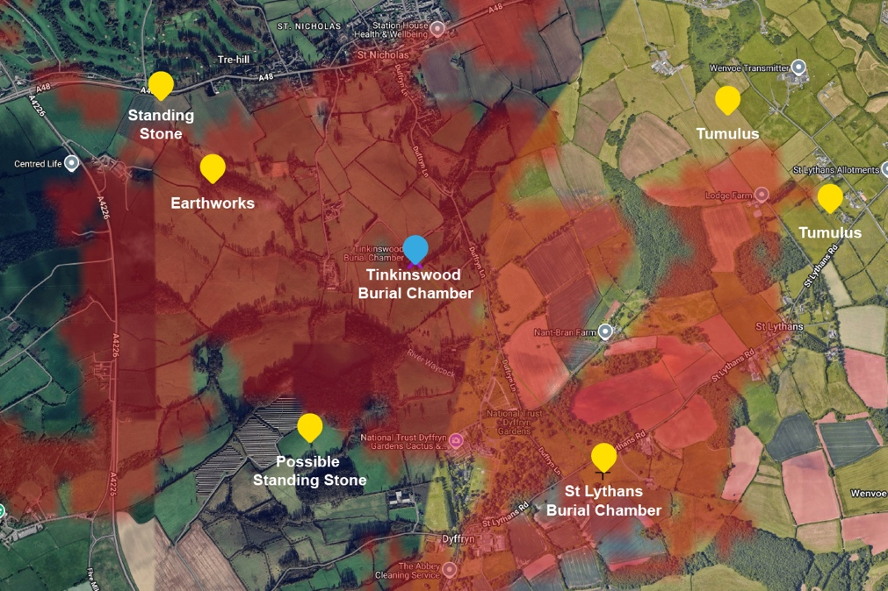
Figure 4: Map showing the locations of other ancient structures in the vicinity of the Tinkinswood Chambered Cairn in relation to the area of visibility shaded in red. Image: Hey What’s That.

The latitude values recorded in the field were measured as 51.451505° at Tinkinswood and 51.442579° at St Lythans. The azimuth was difficult to measure due to the line of sight being obscured by trees, though it was possible to identify an electricity pylon that sits immediately behind the chamber at Tinkinswood and use this to obtain an azimuth reading towards it from St Lythans. This was measured at 319°, taking 180° from this value to obtain an azimuth value looking from Tinkinswood towards St Lythans gives a value of 139°. The height above sea level was measured as 79m at both locations, meaning the altitude angle between them is 0°. It was noticed during the field study that Tinkinswood sits approximately 1° below the horizon when viewed from St Lythans. (Fig. 5) When viewing in the opposite direction from Tinkinswood the horizon line is obscured by trees, but the chamber was tentatively measured as sitting 0.1° below the horizon. As the chamber at St Lythans sits closer to the horizon it is assumed that if there is an alignment between the sites and major lunar standstill it seems more likely that the southernmost moonrise was the intended target as viewed from Tinkinswood.

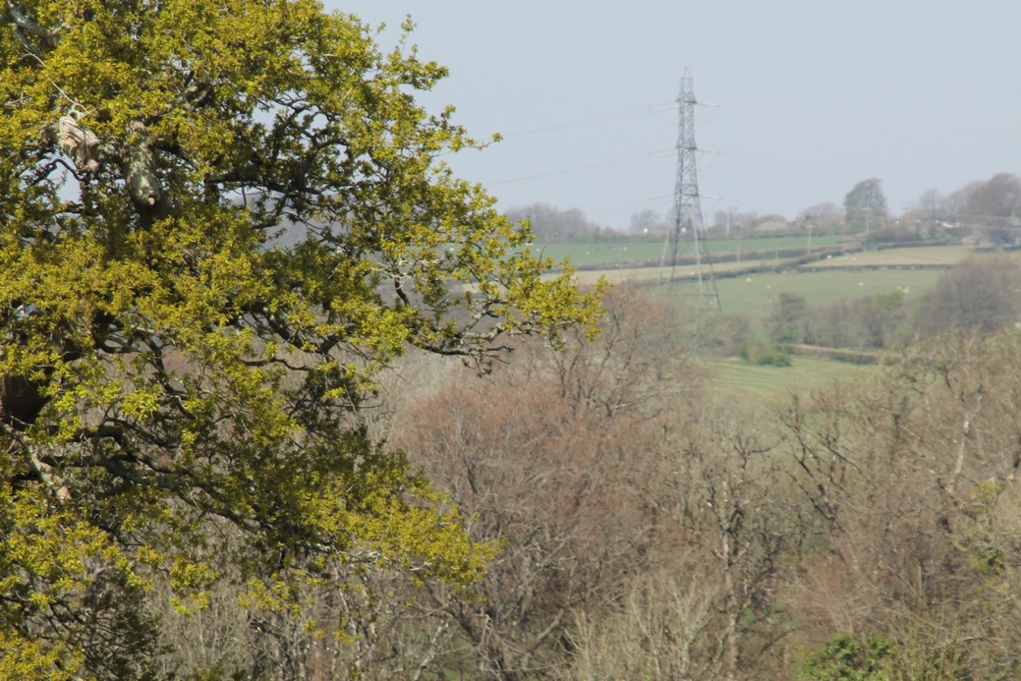
Figure 5: View towards Tinkinswood from the chamber at St Lythans. The chamber at Tinkinswood sits at the base of the electricity pylon measured at 1° below the horizon. Image: Steve McDonald.

With Tinkinswood as the point of observation looking towards St Lythans the measurements from the desk and field studies were averaged giving a latitude value of 51.451496°, azimuth of 138.76° and altitude of 0°. Entering these values into the indicated declination equation and allowing for lunar parallax resulted a value of -26.54°. Ellingson and Silva give declination values of between -28.5° and -29.5° for southern moonrise during the current major lunar standstill period. Using the open-source planetarium software Stellarium the nearest major lunar standstill to the estimated age of Tinkinswood is identified as occurring in 4005BC. Stellarium indicates that on the 23 June of this year a full Moon rose at an apparent declination of -28.5°. The declination indicated by the alignment from Tinkinswood towards St Lythans measured in this study is above the maximum reached by the sun but approximately 2° below values given for the Moons declination at major lunar standstill given by Ellingson and Silva and by Stellarium. While no high precision alignment has been established this result may fall into the category of symbolic ‘low-precision alignments upon the lunar standstill limits,’ identified by Ruggles in other megalithic structures. However, González-García advises caution in connecting orientations with declinations that fall into this range with the Moon stating that they could also be connected to Venus.

Cultural Context

Silva investigates local folklore to better understand orientations in megalithic structures in Iberia, and a similar approach can be adopted here through an investigation of the Welsh folk tales known as The Mabinogion. Ward draws attention to the old Welsh names of these structures, with Tinkinswood previously known as Llech-y-Filiast translated as ‘stone of the greyhound’, and St Lythans known as Gwal-y-Filiast or ‘kennel of the greyhound’. Ward associates these names with tale of Culhwch and Olwen, in which the hero Culhwch is tasked with hunting a wolf; the argument being that over time the word for wolf morphed into that translated as greyhound. Ward does point out that he deems this interpretation unlikely, but seems to miss that greyhounds are directly referenced in this tale. In Sioned Davies’ translation of The Mabinogion Culhwch is described as being outfitted in many gold items, which could associate him with the Sun. Mircea Eliade writes about the association between gold and the sun in ancient cultures, citing Mithraism as a specific example. Culwch is accompanied by ‘two spotted, white breasted greyhounds’ who continually change the side on which they run with Culhwch ‘like two sea-swallows swooping around him.’ The Moon matches this description as spotted and white breasted, and Eliade again writes of the colour white’s lunar association in ancient cultures. The Moon also changes the side of the Sun it appears on by both rising and setting further south and further north on the horizon than the sun over its monthly cycle as previously described by González-García. The fact that two greyhounds are mentioned is harder to understand, perhaps one is associated with the Moon and the other to Venus which also changes the side of the Sun it appears on. Andrew Welsh however points out that in The Mabinogion ‘doubling is a storytelling device used in various ways, with various meanings,’ perhaps in this case suggestive of an understanding of the Moon as dual in nature, an understanding that Radcliffe Edmonds argues existed in other ancient cultures. In this analysis, while at major lunar standstill the Moon could be understood as residing in her kennel at St Lythans when viewed from Tinkinswood.

While it is interesting to note the suggestion of a link between the Moon and these sites through the local folklore, attention must be drawn to the length of time that elapsed between their construction in 6,000BC and the earliest written form of The Mabinogion which Davies states comes from manuscripts dated to approximately 1400CE. She points out that their roots lie in an oral tradition that evolved over centuries and, González-García explains that, ‘for oral societies, statistics and modelling seem an appropriate way to unveil possible lunar orientations.’ In this regard Ruggles does identifies several megalithic structures in the British Isles that have potential lunar alignments, such as Stonehenge, the Recumbent Stone Circles in Scotland and the Scottish Short Stone Rows, supporting the hypothesis that the low precision lunar alignment identified in this study may have been intentional. The hypothesis would receive further support if similar lunar alignments were identified in other Cotswold-Severn type cairns such as those in the Black Mountains, or perhaps by the identification of alignments with other celestial bodies in the structures around Tinkinswood.

Thom labels megalithic sites in which celestial alignments have been identified as observatories, there are however several factors that could be understood as what Hutton describes as ‘expressions of a belief system focused upon ritual and cosmic truths rather than observation for its own sake.’ One such factor is the identification in this study of a potential low precision alignment, suggesting that it was symbolic rather than accurate corresponding to Ruggles ideas on the orientation of megalithic structures. Another factor is the effort that would have been required of the builders to move and raise these stones, when if observation was the only objective then just watching the horizon would suffice as stated by Hutton. Furthermore, Reynolds points out that the human bones found at Tinkinswood are likely to have been used in ceremonies and the area is known in Welsh as the Vale of Worship, though it is not known if the neolithic builders of the cairns used a name of the same meaning. Finally, the discovery of the Coligny calendar examined by Garret Olmsted showed that Celtic druids likely followed a lunar calendar, Eliade writes of the how lunar rhythms are often mirrored in religious rituals indicating the neolithic builders of these cairns may have had a focus on ritual. The building of the cairns long antedates this calendar, the development of which is dated by Olmsted to around the third century BCE; but if the builders did also follow a lunar calendar, it could explain why they may be inclined to orient their structures towards the moon. None of these factors prove intentionality in the identified alignment at these sites, they are however suggestive of a society focused on ritual with the moon being an important component.

Conclusion

The aim of this study was to critically examine the sky in relation to material culture, specifically investigating whether the alignment between the Cotswold-Severn type chambered cairns at Tinkinswood and St Lythans, dated to the neolithic period, is such that it could mark the moonrise at major lunar standstill. Furthermore, evidence was sought that might imply intentionality in an identified alignment by the culture that built them. Following the methodology laid out by Ruggles, considering latitude, azimuth and horizon altitude, the declination indicated by the alignment from the Tinkinswood chamber looking towards the one at St Lythans was calculated as -26.54°. This value is below of the extreme declination values of between
-28.5° and -29.5° for southern moonrise during the major lunar standstill period given by Ellingson and Silva, but above Sun’s declination value of -23.5° at the winter solstice. Though an accurate alignment has not been identified González-García points out that the speed at which the moon moves away from extreme declination, local weather conditions, and lunar parallax, all mean that ‘actual standstill limit is a very difficult and rare event to witness.’ This lack of accuracy could be understood by Ruggles suggestion that ancient cultures may have ascribed special significance to the part of the horizon indicated by major lunar standstill resulting in ‘the apparent existence of deliberate, low-precision alignments.’ With the identification of a potential low-precision alignment Ruggles posits the starting point for its analysis is its cultural context, a position supported by Silva who states that archaeology can provide a fuller understanding of the location and orientation of megaliths. In this regard a number of factors have been identified which are suggestive of the site being used for ritual practise with a particular focus on the moon. These include a symbolic rather than accurate alignment, the effort in moving and raising the stones which could have been achieved by simpler methods if observation was its sole purpose, place names and local folklore, and that bones found on site are likely to have been used for ceremonial purposes as pointed out by Reynolds. Additionally the Coligny calendar analysed by Olmsted suggests that pre-Roman Celtic peoples followed a lunar calendar with a potential focus on ritual and cyclical religious practice. These factors do not prove an intentional alignment with much of the evidence coming from oral traditions. González-García states that, ‘for oral societies, statistics and modelling seem an appropriate way to unveil possible lunar orientations.’ Indeed, lunar alignments have been identified by Ruggles in several megalithic structures in the British Isles such as Stonehenge, the Recumbent Stone Circles in Scotland and the Scottish Short Stone Rows. However, the identification of lunar alignments in other Cotswold-Severn type structures, or of alignments with other celestial bodies at Tinkinswood would help support the hypothesis that the low precision alignment identified in this study was intentional.

BIBLIOGRAPHY

Archaeoastronomy Database, St Lythans And Tinkinswood < https://www.exploreglobe.net/st-lythans--tinkinswood-investigation.html > [accessed 2 April 2025]

Burrow, Steve, The Tomb Builders In Wales 4000–3000 BC. (Cardiff: National Museum Wales Books, 2006)

Campion, Nicholas, A History Of Western Astrology, Vol. 1. (London: Bloomsbury, 2008)

Coflein, St Lythans Chambered Long Cairn < https://coflein.gov.uk/en/site/227289/ > [accessed 8 April 2025]

Cummings, Vicky C. and Whittle, Alasdair W.R., Places Of Special Virtue: Megaliths In The Neolithic Landscapes Of Wales. (Oxford: Oxbow Books, 2004)

Davies, Sioned, The Mabinogion, (Oxford: Oxford University Press, 2007)

Driver, Toby, ‘St Lythans Chambered Tomb, South Glamorgan’, Archaeologia Cambrensis 141 (1992) 181-182

Edmonds III, Radcliffe G., ‘The Faces of the Moon: Cosmology, Genesis, and the Mithras Liturgy, in Heavenly Realms and Earthly Realities in Late Antique Religions, ed. by Ra'anan S. Boustan & Annette Yoshiko Reed, (Cambridge: Cambridge University Press, 2004), pp. 275-295

Eliade, Mircea, Patterns In Comparative Religion, tr. by Rosemary Sheed (London: Sheed & Ward, 1958)

Ellingson, Erica and Silva, Fabio, ‘The Major Lunar Standstill Season Is Here!’, Journal Of Skyscape Archaeology, 9.2 (2024), 281-288

English Heritage, Early Medieval: Religion < https://www.english-heritage.org.uk/learn/story-of-england/early-medieval/religion/ > [accessed 8 April 2025]

Geertz, Clifford, ‘Religion As A Cultural System’, in Anthropological Approaches To The Study Of Religion, ed. by Michael P. Banton (London: Tavistock and New York: Frederick A. Praeger Press, 1966)

González-García, A. César, ‘Lunar Alignments – Identification And Analysis’, in Handbook Of Archaeoastronomy And Ethnoastronomy, ed. by Clive L.N. Ruggles (New York: Springer, 2015), pp. 493-506

Google Earth, < https://earth.google.com > [accessed 2 April 2025]

Hey What’s That, < https://www.heywhatsthat.com > [accessed 2 April 2025]

Hutton, Ronald, ‘The Strange History Of British Archaeoastronomy’, in The Imagined Sky, ed. by Darrelyn Gunzburg (Sheffield: Equinox, 2026), pp. 1-22

Iwaniszewski, Stanisław, ‘Cultural Interpretation Of Archaeological Evidence Relating To Astronomy’, in Handbook Of Archaeoastronomy And Ethnoastronomy, ed. by Clive L.N. Ruggles (New York: Springer, 2015), pp. 315-324

Lane, Belden, Landscapes Of The Sacred: Geography And Narrative In American Spirituality, Expanded ed. (Baltimore, Md.; London: Johns Hopkins University Press, 2001)

Lockyer, Sir J.N., Stonehenge And Other British Stone Monuments Astronomically Considered (London: Macmillan, 1906).

Olmsted, Garrett, The Gaulish Calendar: A Reconstruction From The Bronze Fragments From Coligny With An Analysis Of Its Function As A Highly Accurate Lunar/Solar Predictor As Well As An Explanation Of Its Terminology And Development, (Bonn: Habelt , 1992)

Reynolds, Ffion, ‘A Site’s History Does Not End: Transforming Place Through Community Archaeology At Tinkinswood Chambered Tomb And Surrounding Landscape, Vale Of Glamorgan’, Journal Of Community Archaeology & Heritage, 1.2 (2014), 173-189

Ruggles, Clive L.N., ‘Analyzing Orientations’ in Handbook Of Archaeoastronomy And Ethnoastronomy, ed. by Clive L.N. Ruggles (New York: Springer, 2015), pp. 411-425

Ruggles, Clive L.N., Astronomy In Prehistoric Britain And Ireland, (London: Yale University Press, 1999)

Ruggles, Clive L.N., ‘Basic Concepts of Positional Astronomy’ in Handbook Of Archaeoastronomy And Ethnoastronomy, ed. by Clive L.N. Ruggles (New York: Springer, 2015), pp. 459-472

Ruggles, Clive L.N., Handbook Of Archaeoastronomy And Ethnoastronomy, (New York: Springer, 2015)

Ruggles, Clive L.N., ‘Pushing Back The Frontiers Or Still Running Around The Same Circles? “Interpretative Archaeoastronomy” Thirty Years On, in Archaeoastronomy And Ethnoastronomy: Building Bridges Between Cultures (IAU symposium 278), ed. by Clive L.N. Ruggles, (Cambridge University Press: Cambridge, 2012) 1–18.

Ruggles, Clive L.N., ‘Recumbent Stone Circles’ in Handbook Of Archaeoastronomy And Ethnoastronomy, ed. by Clive L.N. Ruggles (New York: Springer, 2015), pp. 1277-1285.

Ruggles, Clive L.N., ‘Scottish Short Stone Rows’ in Handbook Of Archaeoastronomy And Ethnoastronomy, ed. by Clive L.N. Ruggles (New York: Springer, 2015), pp. 1287-1296.

Ruggles, Clive L.N., ‘Stonehenge And Its Landscape’ in Handbook Of Archaeoastronomy And Ethnoastronomy, ed. by Clive L.N. Ruggles (New York: Springer, 2015), pp. 1223-1238.

Silva, Fabio, ‘A Tomb With A View: New Methods For Bridging The Gap Between Land And Sky In Megalithic Archaeology’, Advances In Archaeological Practice: A Journal Of The Society Of American Archaeology, 2.1 (2014), 24-37

Stellarium < https://stellarium.org > [Accessed 2 April 2025]

Theodolite, < https://theodolite.appstor.io > [accessed 2 April 2025]

Thom, Alexander, Megalithic Sites In Britain, (Oxford: Oxford University Press, 1967)

Thom, Alexander, ‘The Lunar Observatories Of Megalithic Man’. Vistas in Astronomy 11 (1969), 1–29

Tilley, Christopher, A Phenomenology of Landscape, (Oxford: Berg, 1994)

Ward, John, ‘The St Nicholas Chambered Tumulus, Glamorgan’, Archaeologia Cambrensis 15.6 (1915) 253-320

Welsh, Andrew, ‘Doubling and Incest in the Mabinogi’, Speculum, 65.2 (1990), 344-362

Zotti, Georg, ‘Visualization Tools and Techniques’ in Handbook Of Archaeoastronomy And Ethnoastronomy, ed. by Clive L.N. Ruggles (New York: Springer, 2015), pp. 445-457

Archaeoastronomy Database, St Lythans And Tinkinswood < https://www.exploreglobe.net/st-lythans--tinkinswood-investigation.html > [accessed 2 April 2025].
Nicholas Campion, A History Of Western Astrology, Vol. 1. (London: Bloomsbury, 2008) p. 5.
Stanisław Iwaniszewski, ‘Cultural Interpretation Of Archaeological Evidence Relating To Astronomy’, in Handbook Of Archaeoastronomy And Ethnoastronomy, ed. by Clive L.N. Ruggles (New York: Springer, 2015), pp. 315-324 (p. 315).
Iwaniszewski, p. 316.
Iwaniszewski, p. 316.
Clive L.N. Ruggles, ‘Pushing Back The Frontiers Or Still Running Around The Same Circles? “Interpretative Archaeoastronomy” Thirty Years On, in Archaeoastronomy And Ethnoastronomy: Building Bridges Between Cultures (IAU symposium 278), ed. by Clive L.N. Ruggles, (Cambridge University Press: Cambridge, 2012) pp 1–18 (p. 1).
Ronald Hutton, ‘The Strange History Of British Archaeoastronomy’, in The Imagined Sky, ed. by Darrelyn Gunzburg (Sheffield: Equinox, 2026), pp. 1-22 (p. 1).
Sir J.N. Lockyer, Stonehenge And Other British Stone Monuments Astronomically Considered (London: Macmillan, 1906).
Hutton, p. 4.
Alexander Thom, Megalithic Sites In Britain, (Oxford: Oxford University Press, 1967).
Hutton, p. 7.
Hutton, p. 8.
Clive L.N. Ruggles, Handbook Of Archaeoastronomy And Ethnoastronomy, (New York: Springer, 2015).
Fabio Silva, ‘A Tomb With A View: New Methods For Bridging The Gap Between Land And Sky In Megalithic Archaeology’, Advances In Archaeological Practice: A Journal Of The Society Of American Archaeology, 2.1 (2014), 24-37 (p. 25)
Clive L.N. Ruggles, ‘Analyzing Orientations’ in Handbook Of Archaeoastronomy And Ethnoastronomy, ed. by Clive L.N. Ruggles (New York: Springer, 2015), pp. 411-425 (p. 412).
Ruggles, ‘Analyzing Orientations’, p. 413.
Clifford Geertz, ‘Religion As A Cultural System’, in Anthropological Approaches To The Study Of Religion, ed. by Michael P. Banton (London: Tavistock and New York: Frederick A. Praeger Press, 1966) p. 3.
English Heritage, Early Medieval: Religion < https://www.english-heritage.org.uk/learn/story-of-england/early-medieval/religion/ > [accessed 8 April 2025]
Ffion Reynolds, ‘A Site’s History Does Not End: Transforming Place Through Community Archaeology At Tinkinswood Chambered Tomb And Surrounding Landscape, Vale Of Glamorgan’, Journal Of Community Archaeology & Heritage, 1.2 (2014), 173-189 (p. 176).
Reynolds, ‘A Site’s History Does Not End, p. 176.
Vicky C. Cummings and Alasdair W.R. Whittle. Places Of Special Virtue: Megaliths In The Neolithic Landscapes Of Wales. (Oxford: Oxbow Books, 2004) p. 59.
Coflein, St Lythans Chambered Long Cairn < https://coflein.gov.uk/en/site/227289/ > [accessed 8 April 2025]
Silva, ‘A Tomb With A View’, p. 24.
Steve Burrow, The Tomb Builders In Wales 4000–3000 BC. (Cardiff: National Museum Wales Books, 2006) p. 52.
John Ward, ‘The St Nicholas Chambered Tumulus, Glamorgan’, Archaeologia Cambrensis 15.6 (1915) 253-320.
Ward, The St Nicholas Chambered Tumulus, Glamorgan’, p. 310.
Ward, The St Nicholas Chambered Tumulus, Glamorgan’, p. 262.
Ward, The St Nicholas Chambered Tumulus, Glamorgan’, p. 299.
Coflein, St Lythans Chambered Long Cairn.
Coflein, St Lythans Chambered Long Cairn.
Toby Driver, ‘St Lythans Chambered Tomb, South Glamorgan’, Archaeologia Cambrensis 141 (1992) 181-182.
Christopher Tilley, A Phenomenology of Landscape, (Oxford: Berg, 1994), p. 22.
Reynolds, ‘A Site’s History Does Not End, p. 176.
Belden Lane, Landscapes Of The Sacred: Geography And Narrative In American Spirituality, Expanded ed. (Baltimore, Md.; London: Johns Hopkins University Press, 2001), p. 58.
A. César González-García, ‘Lunar Alignments – Identification And Analysis’, in Handbook Of Archaeoastronomy And Ethnoastronomy, ed. by Clive L.N. Ruggles (New York: Springer, 2015), pp. 493-506 (p. 494).
Alexander Thom, ‘The Lunar Observatories Of Megalithic Man’. Vistas in Astronomy 11 (1969), 1–29 (p. 27).
Erica Ellingson and Fabio Silva, ‘The Major Lunar Standstill Season Is Here!’, Journal Of Skyscape Archaeology, 9.2 (2024), 281-288 (p. 281).
González-García, ‘Lunar Alignments’, p. 495.
González-García, ‘Lunar Alignments’, p. 494.
Clive L.N. Ruggles, Astronomy In Prehistoric Britain And Ireland, (London: Yale University Press, 1999) p. 67.
Hutton, p. 11.
Ruggles, Astronomy In Prehistoric Britain And Ireland, p. 149.
Ruggles, Astronomy In Prehistoric Britain And Ireland, p. 149.
González-García, ‘Lunar Alignments’, p. 495.
Ruggles, Astronomy In Prehistoric Britain And Ireland, p. 149.
Ruggles, Astronomy In Prehistoric Britain And Ireland, p. 149.
Clive L.N. Ruggles, ‘Basic Concepts of Positional Astronomy’ in Handbook Of Archaeoastronomy And Ethnoastronomy, ed. by Clive L.N. Ruggles (New York: Springer, 2015), pp. 459-472 (p. 460).
Ruggles, ‘Basic Concepts of Positional Astronomy’, p. 461.
Ruggles, ‘Analyzing Orientations’, p. 413.
Ruggles, ‘Basic Concepts of Positional Astronomy’, p. 461.
Georg Zotti, ‘Visualization Tools and Techniques’ in Handbook Of Archaeoastronomy And Ethnoastronomy, ed. by Clive L.N. Ruggles (New York: Springer, 2015), pp. 445-457 (p. 455).
Google Earth, < https://earth.google.com > [accessed 2 April 2025].
Hey What’s That, < https://www.heywhatsthat.com > [accessed 2 April 2025].
Zotti, ‘Visualization Tools and Techniques’, p. 456.
Theodolite, < https://theodolite.appstor.io > [accessed 2 April 2025].
Ruggles, ‘Basic Concepts of Positional Astronomy’, p. 462.
Alexander Thom, Megalithic sites in Britain. (London: Oxford University Press, 1967) p. 118.
Google Earth, < https://earth.google.com > [accessed 2 April 2025].
Hey What’s That, < https://www.heywhatsthat.com > [accessed 2 April 2025].
Ellingson and Silva, ‘The Major Lunar Standstill Season Is Here!’, p. 284.
Stellarium < https://stellarium.org > [Accessed 2 April 2025]
Ellingson and Silva, ‘The Major Lunar Standstill Season Is Here!’, p. 284.
Stellarium < https://stellarium.org > [Accessed 2 April 2025]
Ruggles, Astronomy In Prehistoric Britain And Ireland, p. 149.
González-García, ‘Lunar Alignments’, p. 495.
Silva, ‘A Tomb With A View’, p. 32.
Ward, The St Nicholas Chambered Tumulus, Glamorgan’, p. 282.
Ward, The St Nicholas Chambered Tumulus, Glamorgan’, p. 285.
Sioned Davies, The Mabinogion, (Oxford: Oxford University Press, 2007) p. 180.
Mircea Eliade, Patterns In Comparative Religion, tr. by Rosemary Sheed (London: Sheed & Ward, 1958), p. 105.
Davies, The Mabinogion, p. 181.
Eliade, Patterns In Comparative Religion, p. 163.
González-García, ‘Lunar Alignments’, p. 495.
Andrew Welsh, ‘Doubling And Incest In The Mabinogi’, Speculum, 65.2 (1990), 344-362 (p. 360).
Radcliffe G. Edmonds III, ‘The Faces Of The Moon: Cosmology, Genesis, And The Mithras Liturgy, in Heavenly Realms And Earthly Realities In Late Antique Religions, ed. by Ra'anan S. Boustan & Annette Yoshiko Reed, (Cambridge: Cambridge University Press, 2004), pp. 275-295 (p. 293).
Davies, The Mabinogion, p. x.
González-García, ‘Lunar Alignments’, p. 495.
Clive L.N. Ruggles, ‘Stonehenge And Its Landscape’ in Handbook Of Archaeoastronomy And Ethnoastronomy, ed. by Clive L.N. Ruggles (New York: Springer, 2015), pp. 1223-1238 (p. 1234).
Clive L.N. Ruggles, ‘Recumbent Stone Circles’ in Handbook Of Archaeoastronomy And Ethnoastronomy, ed. by Clive L.N. Ruggles (New York: Springer, 2015), pp. 1277-1285 (p. 1284).
Clive L.N. Ruggles, ‘Scottish Short Stone Rows’ in Handbook Of Archaeoastronomy And Ethnoastronomy, ed. by Clive L.N. Ruggles (New York: Springer, 2015), pp. 1287-1296 (p. 1292).
Thom, ‘The Lunar Observatories Of Megalithic Man’, p. 28.
Hutton, p. 11.
Ruggles, Astronomy In Prehistoric Britain And Ireland, p. 90.
Hutton, p. 11.
Reynolds, ‘A Site’s History Does Not End, p. 177.
Garrett Olmsted, The Gaulish Calendar: A Reconstruction From The Bronze Fragments From Coligny With An Analysis Of Its Function As A Highly Accurate Lunar/Solar Predictor As Well As An Explanation Of Its Terminology And Development, (Bonn: Habelt , 1992), p. 1.
Eliade, Patterns In Comparative Religion, p. 154.
Olmsted, The Gaulish Calendar, p. 74.
Ruggles, ‘Analyzing Orientations’, p. 411.
Ellingson and Silva, ‘The Major Lunar Standstill Season Is Here!’, p. 284.
González-García, ‘Lunar Alignments’, p. 494.
Ruggles, Astronomy In Prehistoric Britain And Ireland, p. 149.
Ruggles, ‘Analyzing Orientations’, p. 413.
Fabio Silva, ‘A Tomb With A View’, p. 25.
Reynolds, ‘A Site’s History Does Not End, p. 177.
Garrett Olmsted, The Gaulish Calendar, p. 74.
González-García, ‘Lunar Alignments’, p. 495.
Ruggles, ‘Stonehenge And Its Landscape’, p. 1234.
Ruggles, ‘Recumbent Stone Circles’, p. 1284.
Ruggles, ‘Scottish Short Stone Rows’ p. 1292.

