
Lecturer : Dr Olusoyi Ashye
Name of Student: William Fernandez
Student ID Number: 1707878
Date: 13th May 2019
Case Study of Sainsbury’s
MODULE CODE/ COD Y MODIWL: BMSK5006 KNOWLEDGE AND INFORMATION MANAGEMENT SKILLS FOR THE WORKPLACE
Table of Contents
1.0 Introduction 1
1.1 Overview of Sainsbury’s 2
2.0 The Relationship Between Data, Information, Knowledge and Wisdom 2
3.0 Identifying Knowledge Assets 3
4.0 Knowledge Audits 4
4.1 Knowledge Needs Analysis (K – Needs Analysis) 5
4.2 Knowledge Inventory Analysis (K – Inventory Analysis) 7
4.3 Knowledge Flow Analysis (K – Flow) Analysis 7
4.4 Knowledge Mapping (K-Mapping) Analysis 8
5.0 Knowledge Management Life Cycle and Tools 9
5.1 Knowledge Acquisition 9
5.2 Knowledge Retention 10
5.3 Knowledge Transfer (KT) 12
5.4 Knowledge Application 12
6.0 Recommendations 14
7.0 Conclusion 14

1.0 Introduction
Nowadays, knowledge management is essential for every business organisation to maintain a dynamic, productive and competitive working environment. Knowledge is the combination of facts, skills and information obtained through experience or education. However, knowledge is complex and managing it is not an easy task. Knowledge management (KM) can be defined as a process that includes collection of knowledge and transforming it into a form that permits to be used within the business organisation. It is a system that assists individuals in organisation sharing, accessing and updating business knowledge and information. KM key objective is to utilise business organisation practices and incorporating technology to create a positive leverage on corporate knowledge. According to research, 74 % of business organisation has been estimated that effective discipline of knowledge management has increased production by 10-40 % (Butterworth, 2013) .
This case study illustrates the importance of KM in Sainsbury’s operational procedures. The operation encompasses daily activities from logistics up customer services to achieve efficient performance of the store. To have a better understanding on knowledge management, the connection and differences between data, information, knowledge and wisdom on organisational knowledge and personal knowledge as well is to be explained. Analysis and modelling techniques are going to be applied to determine knowledge assets which are valuable to the company. Knowledge acquisition and knowledge transfer in Sainsbury’s are keys for potential growth, sustainability and efficiency. As a result, it is suggested that after acquisition of knowledge, it needs to be properly stored, apply and integrate it within the organisation. Intellectual property rights need to be safeguarded and controlled for the protection of the company. A protocol from knowledge acquisition, knowledge transfer up to knowledge retention are vital to be established. Sainsbury’s, retail giant in the United kingdom, have to be updated on operational knowledge which are dynamic in nature. For the company to be successful and competitive, innovation is the key and if the company is aware on knowledge and information needed, the organisation may be more efficient. Although Sainsbury’s has a good knowledge management framework, there is still a room for improvement.

1.1 Overview of Sainsbury’s
Sainsbury’s is a public limited company which is registered under the business name of J Sainsbury plc. The company was founded by John James Sainsburys and his spouse when both of the couple started a retail shop at Drury Lane, London. For 150 years, the business organisation maintains its top position of being one of the market leaders and competitiveness in retail industry due to innovation and grabbing the opportunities of new technology. At the moment, the business organisation has an annual revenue of about £51 billion which employs more than 340,000 workers with more than 2,800 stores. With this number of stores and employees, knowledge management is essential to the daily operations of the business (Sainsbury's Annual Report, 2018).

2.0 The Relationship Between Data, Information, Knowledge and Wisdom
Although data, information, knowledge and wisdom can sometimes be identified as the same or even interchange, there are distinctions among the four. Data are raw facts or observation such as numbers, random letters or images. It has no meaning unless it has been processed. When data is processed, it has a given context to become useful is called information. For example, 20000 has no meaning or it is impossible to identify what it represents. Nevertheless, if it is considered as weekly sales in pounds, the processed data has meaning, and it is converted to information as £20000 of weekly sales. Whereas knowledge is the combination of understanding gained through experience and awareness of information. For instance, the management of the store is aware that the weekly sale has an average of £20000. Knowledge is the combination of experience and understanding of information to make it useful. When the company has learned that the weekly sale is £20000, it can make decisions on how many workers are needed or think of strategies to increase sales. Wisdom is something to do with the practical application of knowledge in a responsible way or in the above example in an execution of action in a cost-effective manner to optimise profit (Butterworth, 2013).
The relationship between data, information, knowledge and wisdom can be illustrated using Data-Information-Knowledge-Wisdom (DIKW) hierarchy. It is a tool for KM process for many modern businesses. It shows how data evolves into data, information, knowledge and wisdom. As it is converted from data to wisdom, the level of understanding and the context independence increase as shown in figure 1 below. This paves way to a better decision-making and a clearer view on informed choices and its consequences (Lobov, 2018).

DIKW Model
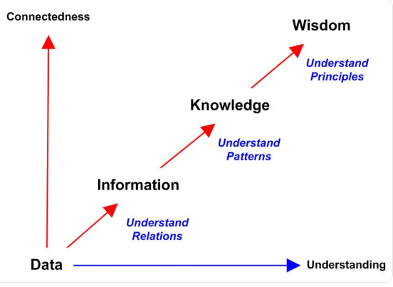
Figure 1
Source: (Lobov, 2018)

3.0 Identifying Knowledge Assets
Important ‘knowledge assets’, (knowledge necessary to generate profits or improve performance), of Sainsbury’s on its store operation procedures need to be identified. Vital knowledge assets of Sainsbury’s on its daily store activities can be unstructured, tacit knowledge or structured, explicit knowledge. Explicit knowledge is a set of knowledge that are reproduced or documented in writing while tacit knowledge is characterised by factors such as experienced or intuition. Knowledge assets can be classified into three categories which are people, processes and technology. When it comes to store operation procedure, important knowledge assets of Sainsbury’s are customer’s information, skills of key employees, changing customer’s behaviour, target sales, waste disposal information, future trends and economy. Nevertheless, as many companies are managing their knowledge assets, business organisations realised that the traditional ways are more focused on its tangible assets and leave not managing their knowledge assets. By having a vast understanding on knowledge assets of the company, it could lead to proper execution of strategic knowledge management (Sanchez, 2014).
Knowledge Assets
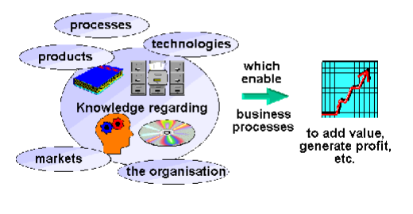

Figure 2

4.0 Knowledge Audits
Sharma et al (2015) argue that knowledge is difficult to manage when it cannot be measured. A Knowledge Audit (K-Audit) is an organised evaluation and examination of the company’s knowledge health which enables to determine whether knowledge can be exploited when it is needed. K-Audit can analyse knowledge needs, knowledge assets, knowledge gaps and the methods in sharing and creating knowledge of business organisation. This process can determine the strength, weaknesses, threats and opportunities of the company. K-Audit can be performed in the following sequence from Knowledge Needs (K-Needs) analysis, Knowledge Inventory (K-Inventory) analysis, Knowledge Flow (K-Flow) analysis and Knowledge Mapping (K-Mapping) as shown in figure3. The sequence of this cycle has laid the foundation of KM.

Principal Components of K-Audit

Figure 3

4.1 Knowledge Needs Analysis (K – Needs Analysis)
Identifying precisely the existing knowledge assets of the company is the main objective of this task and the knowledge asset that is required in the future to achieve organisational goals. K- Needs analysis can be utilised for future development and growth for a strategic decision (Sharma et al, 2015).
K – Needs Analysis
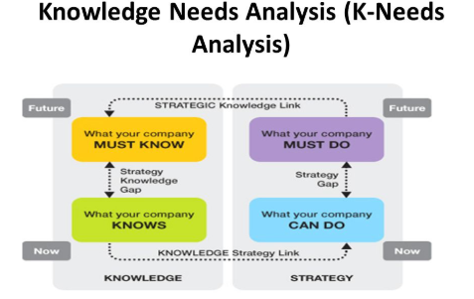
Figure 4
(Sharma et al, 2007).
The existing knowledge assets of the company is information of customers who avail ‘Nectar Card’ (loyalty card of Sainsbury’s), updated technologies (Apps and gadgets) for retail store, different customer’s touch points and skills necessary to compete in the market. The company has customer data and information for those who signed up for Nectar Card. This knowledge could be used to understand customer’s behaviour with regards to shopping groceries and the company can personally tailor the needs of customers for marketing and promotions. If the customers are normally shopping basmati rice, the company could email sales on a particular brand of basmati rice or different menus utilising basmati rice and ingredients available inside the store. The real challenge is to lure as many people as the company can to sign up for the nectar card by adding cost-effective benefits on it by giving additional discounts for a certain period for Nectar Card membership which the company is not implementing at the moment (Nectar, 2019). Researching for the demography is essential to identify what products must the company has in that area or region.
The new method to check availability, product inventory, waste disposal, reduction management, location finder and ticketing can be done by just one handheld device. The company can train every employee on operating this new handheld device. Every employee must know how to operate this new gadget. All employee must adopt to the new technology and grab the benefits of this new device.
Sukhvinder (2018) argues that retail landscape in the UK is dynamic and it is continuously changing. There is an increase demand for different touchpoints to shop like internet and the number of demands on smaller but nearer store to the residents are becoming more popular. The company is investing more money on online shopping and opening new convenient stores instead of the tradition large supermarkets. It is vital to invest on these different touchpoints. However, quality of the product should be maintained or improve, prices should be competitive and maintain quality customer service. Retail business has a competitive market in the UK. When technology is evolving and customers’ behaviour is changing, skills necessary for the business change with it. Training and development are necessary to update employees with the new technology. The company needs more IT personnel in the future as the process of doing business is digital and online.
K-Needs analysis is an important tool in a dynamic business environment such as Sainsbury’s. It assists the company to compete in the future. Business strategies can enhance business performance by improving quality of products and services. Thus, by having a deeper understanding on knowledge assets, the company is more competitive in the future (Butterworth, 2013).

4.2 Knowledge Inventory Analysis (K – Inventory Analysis)
Knowledge inventory is identifying and locating stocks of knowledge assets all over the company. It includes tacit and implicit knowledge within the organisation. this analysis is used to record the possible knowledge assets. The explicit knowledge assets of Sainsbury’s are databases, intranet and links. Customer and employee databases are restricted only for top management level for confidentiality and strategic purposes. Intranet can be accessed only by employees inside the company however there are some links that are restricted to normal employee such as target sales and number of labour-hours necessary for the store. Most of the time, only the store manager or top management has the access. On the other hand. Tacit knowledge is more difficult to quantify like the expertise of people, job profiles and various skills of employees. The expertise could be IT, leadership skills, bakery trained and so on. Usually, this is the main concern of human resource management for training and development (Suliman, 2013).

4.3 Knowledge Flow Analysis (K – Flow) Analysis
Knowledge flow analysis is about how knowledge move around in the organisation. It is about where it is to where it is needed. People in the organisation find the useful knowledge and the challenge is how to share the knowledge. However, there are some barriers on the flow of knowledge. With K-flow analysis, it involves people, processes and system. When it comes to people, it concerns the habit, knowledge and behaviour of sharing, using and disseminating of information (Jennex, 2014). The flow of information can be informal networking through the relationship that has been built. It could be either face-to-face communication or social media networking like creating WhatsApp group on every sore or department. Moreover, the flow could be affected by the process such as company policy. The manager needs to ensure the dissemination of information on disposal so that there is a consistent method of doing things. Furthermore, company technical infrastructure such as intranet can be utilised for training, information dissemination and even communication among staff. Sainsbury’s is utilising ‘mysainsburys.co.uk’. Booking a holiday is automated utilising the self-service Kronos system. However, there are some restrictions such as ordering, inventory and sales information. Only key people such as store managers have an access on it.

4.4 Knowledge Mapping (K-Mapping) Analysis
Knowledge mapping permits for better knowledge organisation to facilitate retrieval of knowledge. It segregates skills, documents, training material, induction materials, tore updates and many more for easy access from the system. It is a knowledge organiser wherein the map shows what knowledge exists in the organisation and where it can be found. At Sainsbury’s, there is also search menu to type the knowledge to be retrieved as shown in the figure 5 below. Moreover, popular links and latest news are organised for easy access.

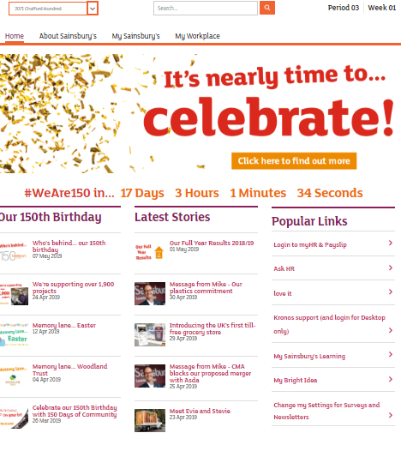
Figure 6
Source: Sainsburys Portal (2019)

5.0 Knowledge Management Life Cycle and Tools
Knowledge management cycle is a process of converting information into knowledge inside the business organisation. It is about capturing, processing and distributing knowledge within an organisation. Prior on managing knowledge, it must be acquired. Afterwards, the management needs to retain it as well as its mechanism to transfer among employees within an organisation and important external parties such as customers and suppliers. For knowledge to be a source of enhancing performance and efficiency, it necessitates to be applied in the business operations. Henceforth, knowledge needs to be transferred to and absorb by significant people or group of people so that it can be practically applied to provide competitive advantage of the organisation (Maund, 2018) . The knowledge management life cycle can be illustrated in figure 6.
Knowledge Management Life Cycle

Figure 6

5.1 Knowledge Acquisition
Bwalya and Sebina (2014) states that obtaining knowledge from external sources refers to knowledge acquisition (KA). Two vital elements of KA are innovation and creativity in the sense that knowledge is acquired for the purpose of enhancing competitiveness of the business organisation. For example, Sainsbury’s may hire knowledge-intensive services like consultancy and training programmes from outside the firm. Furthermore, knowledge may be attained through the buying of access to databases or equipment in which knowledge is embedded.
There are many ways or different channels to obtain knowledge. As a result, it can favour different type of knowledge. When Sainsbury’s bought Argos, the company did not purchase only the tangible assets which are buildings, machineries, products and equipment. Moreover, Argos intangible assets such as customer’s information and the logistics and systems of its online operation may benefit Sainsbury’s in the modern era (Hope, 2016).
Furthermore, Sainsbury’s acquire knowledge through the employment of new workers who brings knowledge with them or through existing workers who absorb knowledge from environment outside the company. When Sainsbury’s launched its online fulfilment centre at Bromley-by Bow, most of the operational managers were from Tesco. The head of its IT department were formerly working from Tesco. In addition to this, the online fulfilment centre recruited existing employees, but the company sent the employees to train on its new roles.
Another way to acquire customer data aside from the demography of the area is through Nectar card. It is a loyalty scheme launched in 1996. About 20 million clients are using nectar cards that gives couple of points for every 1£ worth of grocery items. Accumulated 500 points is worth £2.50 grocery voucher. The loyalty card can be obtained by requesting it online and the customer has to fill up his/her email address and client’s postal code (Nectar, 2019). Nevertheless, the primary use of nectar card is to gather customer’s data and analysing buying behaviour of an individual. The marketing campaign can be tailored to each customer. Furthermore, the store can control inventory for availability and avoid overstocking. With this reasoning, the more data are collected, the more beneficial for the company.

5.2 Knowledge Retention
Once knowledge has been acquired, the business organisation needs to store and protect it to remain as an important source for competitive advantage. Knowledge retention is a process of capturing knowledges so that it be utilised in the future (Bosij et al., 2019). Yet the knowledge capabilities of a business organisations such as Sainsbury’s only offer a vital source of company edge against its competitors if access to it is restricted, thereby preventing its widespread dissemination.
It is crucial for the company to have a knowledge retention strategy by assessing the situation by asking three questions as shown in Figure 7 (Sanchez, 2014).

Knowledge Retention Strategy
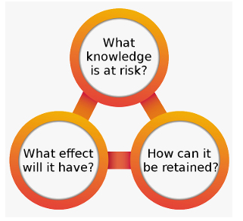
Figure 7

To apply the knowledge retention strategy, the organisation needs to identify the knowledge assets at risk and must be retained and protected. By using the three question as shown in figure 7. The business organisation can develop vital steps of knowledge retention upon expanding these questions. Customer information from Argos database and Nectar card can be stored utilising a protection that can only be accessed by the key people of the company. If competitors can access the database of customers, it would not be an advantage or beneficial to the company. It may also breach the privacy of individual and if it can be acquired by the wrong people, the consequences might be catastrophic (Sanchez, 2014).
Determining the essence of tacit and implicit knowledge is critical for a company to manage and retain its advantages. Another challenge is preventing it from leaking. For example, the trade secrets of Sainsbury’s on the ingredients of its bakery and prepared food products on producing it by bulk by maintaining its quality.
Another way to have a knowledge retention is knowledge sharing within the company which will be discussed as the next part of knowledge management cycle.

5.3 Knowledge Transfer (KT)
Nowadays, knowledge is a significant asset of a modern enterprise. It can be gone if worker leaves the business organisation, retired or fired. To prevent losing a valuable information, the company should find a way to share a knowledge and experience. The process of transferring knowledge within the organisation is called knowledge transfer (KT) (Trong, 2014). However, the transfer of knowledge of organization may sometimes not easy to obtain. The challenges of KT at Sainsbury’s could be lack of trust, poor incentives, leadership issues, no support from corporate management and internal conflicts. The process involved on KT transfer is to identify the knowledge holders within an organisation. Afterwards, provide a program or activity for the knowledge provider to share. At Sainsbury’s, it could be cross-training, mentoring, job shadowing, company policies and even job rotation. For example, a new employee at a convenience store needs to shadow different activities of the store from replenishment, disposal, code check and many more. With this way, the knowledge of the experienced employee is going to be transferred into a new employee. Moreover, for planning and strategy for managers, mentoring is one of the appropriate methods of knowledge transfer. With the context of organisational perspective KT can directly influence the performance and sustainability of the business (Butterworth, 2013).

5.4 Knowledge Application
Knowledge application can be manifested on making a logical or informed decision through the availability of sufficient knowledge. The different knowledge of every employee can be assessed, and the manager can decide if a colleague has the ability to perform a certain task. For example, a person who has the knowledge on system disposal can work independently on that department. Moreover, if the person has a training and experience on till, the manager can send that worker when it is needed.
One of the biggest benefits of Sainsbury’s is its Nectar card program. This loyalty scheme has a tremendous capacity to store and process data about customer’s buying behaviour. The company has a data warehouse and a customer database that include transactions for analysis and decision-making. As a result, the company can stock more of a particular product like Jasmine rice in a specific store or the strategy to sell more Polish products in a particular store. There is a decision support system in transaction intensive workplace. However, there are also barriers or risk such as correct interpretation of data. If the system is relying only on monthly pattern, it needs to consider that some products are seasonal like hot cross buns sales. The peak season for selling it is during lent season. Hence, it takes months or even years to apply the data to become useful. The practical application of computer- based information system (CBIS) by organisational level as shown from figure 8 below. Strategic decisions are made by the corporate management. While the operational procedures are executed by customer service assistants (Bosij et al, 2019)
Organisational CBIS
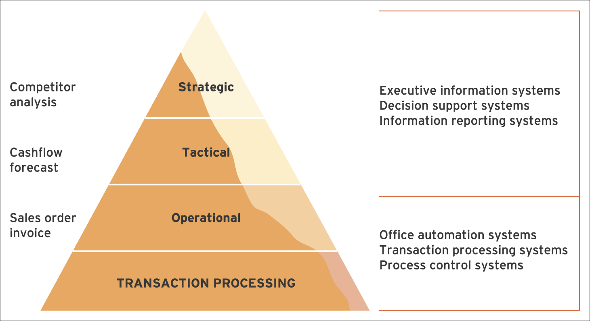
Source: (Bosij, et al., 2019)
On the other hand, not only customer data has been centralised and analysed. Inventory of stocks and ordering is automated in the grocery by gathering data and its target sales. However, it can be override by the manager to avoid overstocking if it is not selling and availability if it is selling more than expected. Number of labour hours can be monitored by the top management and set a target to maximise profit. Waste disposals can be controlled by having a data on it. If it is more than the expectation, there is a high probability that some workers are not rotating properly. Training and close monitoring are necessary. Thus, even if the top management is not physically present in the store, corporate managers can decide based on the acquired knowledge through the system. However, change takes time because Sainsbury’s has hierarchical organisational structure

6.0 Recommendations
With respect to the Nectar card, it may cause unnecessary delay and hassles from the customer. If the company could develop a faster method by linking nectar points to bank card or instead of swiping, contactless would ease the transaction. Moreover, Nectar card can be acquired online only. It is much better if can be done also inside the store. There are instances that the decline of sales is not on the availability of product. It could be affected by price of competitors or change of quality of the item. Hence, more research is necessary for declining sales. It is important to get a feedback from employees who are working inside for the real reason for a sudden change of pattern of sales. Minimise turnover rate by paying more those who have more years of experience in the workplace. This could improve knowledge retention High performing managers should be a mentor and to be shadowed by a potential manager in the future to ensure good managerial skills inside the company. Moreover, it is highly recommended that customer and employee information should be highly protected. The protection should be regularly updated as the technology advances.

7.0 Conclusion
Data are any random letter, number or images. When data has been processed, it becomes information which has meaning. Whereas, knowledge is the acquired experience and comprehension of information to transform it to be useful. Wisdom is the practical execution of knowledge. As the link and understanding of data increases, the data evolves into wisdom for beneficial practical purposes. The knowledge needed to improve performance is knowledge asset. It could be classified into tacit knowledge and explicit knowledge. Furthermore, knowledge assets have three categories which are people, processes and technology. Knowledge Audit is used to analysed knowledge needs, knowledge assets, knowledge gaps and the flow of knowledge management. K-needs analysis is a vital tool of Sainsbury’s to remain competitive in the future. Whereas K-inventory analysis is determining the knowledge assets of the company. On the other hand, K-flow analysis is the movement of knowledge of the company. Furthermore K-mapping analysis is for facilitating retrieval of knowledge. Knowledge management cycle is the process of transforming information into knowledge within the organisation. It comprises of knowledge acquisition, knowledge retention, knowledge transfer and knowledge application. The customer database of Sainsbury’s is from Nectar card, which is a loyalty card scheme. Every transaction, data is updated and stored on database. Employees with credentials can access it for decision-making and strategic plan. another way of acquiring knowledge is to perform external training but it is only available for selected people because of the cost involve on it is high. Moreover, hiring a consultant or new talented workers might be beneficial on enhancing knowledge assets for the company. Customer and employee database need to be protected for the risk is high if it goes to the wrong hand. Knowledge transfer is vital for leaving key employees so that the knowledge may remain to the company. With the availability of knowledge, strategic planning and informed decisions are vital aspects to give Sainsbury’s a competitive advantage in retail industry. Thus, knowledge management assists the company to be one of the market leaders in the UK.

References
Bosij, P et al (2019) Business Information Systems; Technology, Development and Management. 6th edn. Essex: Prentice Hall.
Butterworth, H. (2013.)Information and Knowledge Management. Oxford: Elsevier Ltd.
Bwalya, K. and Sebina, M. (2014) Concepts and advances in Information and Knowledge Management. 2nd edn. Oxford: Elsevier Ltd.
Hope, K. (2016) 'Why does Sainsbury's want to buy Argos?'.
https://www.bbc.co.uk/news/business-35290161 [Accessed:7 May 2019].
Jennex, M. (2014) Knowledge Management in Modern Organizations. 2nd edn. San Diego: Idea Group Publishing.
Lobov, A. (2018) 'Climbing the DIKW Pyramid' IEEE Journal, 2(3), pp. 4730-4735.
Maund, A (2018) BA in Leadership and Management. London: Sage Publications Ltd.
Nectar (2019) 'Nectar Card'. https://www.nectar.com/ [Accessed: 8 May 2019].
Sainsbury's (2018) 'Annual Report and Financial Statement.'.
https://www.about.sainsburys.co.uk/investors/annual-report-2018
[Accessed: 1 April 2019].
Sainsbury's (2019.) 'Company Portal'. https://jsainsbury.sharepoint.com/sites/OurSainsburys
[Accessed :7 May 2019].
Sanchez, R. (2014) Knowledge Management and Organisational Competence. Oxford: Oxford Press.
Sharma, R. et al (2015) 'On The Use Of A Diagnostic Tool For Knowledge Audits' Journal of Knowledge Management Practice, 8(4), pp. 3-7.
Sukhvinder, G. (2018) Changing Retai Landscape, Warwickshire: ADHB.
Suliman, A. (2013) Knwledge Management: Cultivating knowledge professionals. 3rd edn. Oxford: Chandon Publishing Limited.
Trong, T. (2014) 'Behind Knowledge Transfer' Management Decision Journal, 50(3), pp. 459-478.

