Task 1

By Jacob Gough

2306131

Table of Contents
2 Calculate the resistance of E and H for the circuit’s configuration. [3] 2
3 Given that B and C are identical and the current passing through A is 0.5A, calculate the current passing through B and C. [2] 2
4 Resistor A dissipates 1.25J of energy every second. Using this fact calculate: 2
5 The Resistance of A. [2] 2
6 The Resistance of B and C [3] 2
7 The potential difference across A, B and C in [1] 2
8 Since the total potential difference across L to M is 6V, calculate the potential difference across D and find its Resistance. [2] 2
9 The ‘lost volts across one of the cells in the parallel arrangement is 2 V. Calculate r and hence the total resistance of the parallel combination of cells. [3] 2
10 Given that the resistance F is 6Ω, calculate the voltage drop across it. [2] 2
11 Calculate the total resistance of the circuit, this includes total internal and the resistance cause by the reverse polarity battery and the open diodes in given scenario (ignore any “non-open diodes”). [2] 2
12 Calculate the emf of each of the cells in the parallel combination. [3] 2

Calculate the resistance of E and H for the circuit’s configuration. [3]

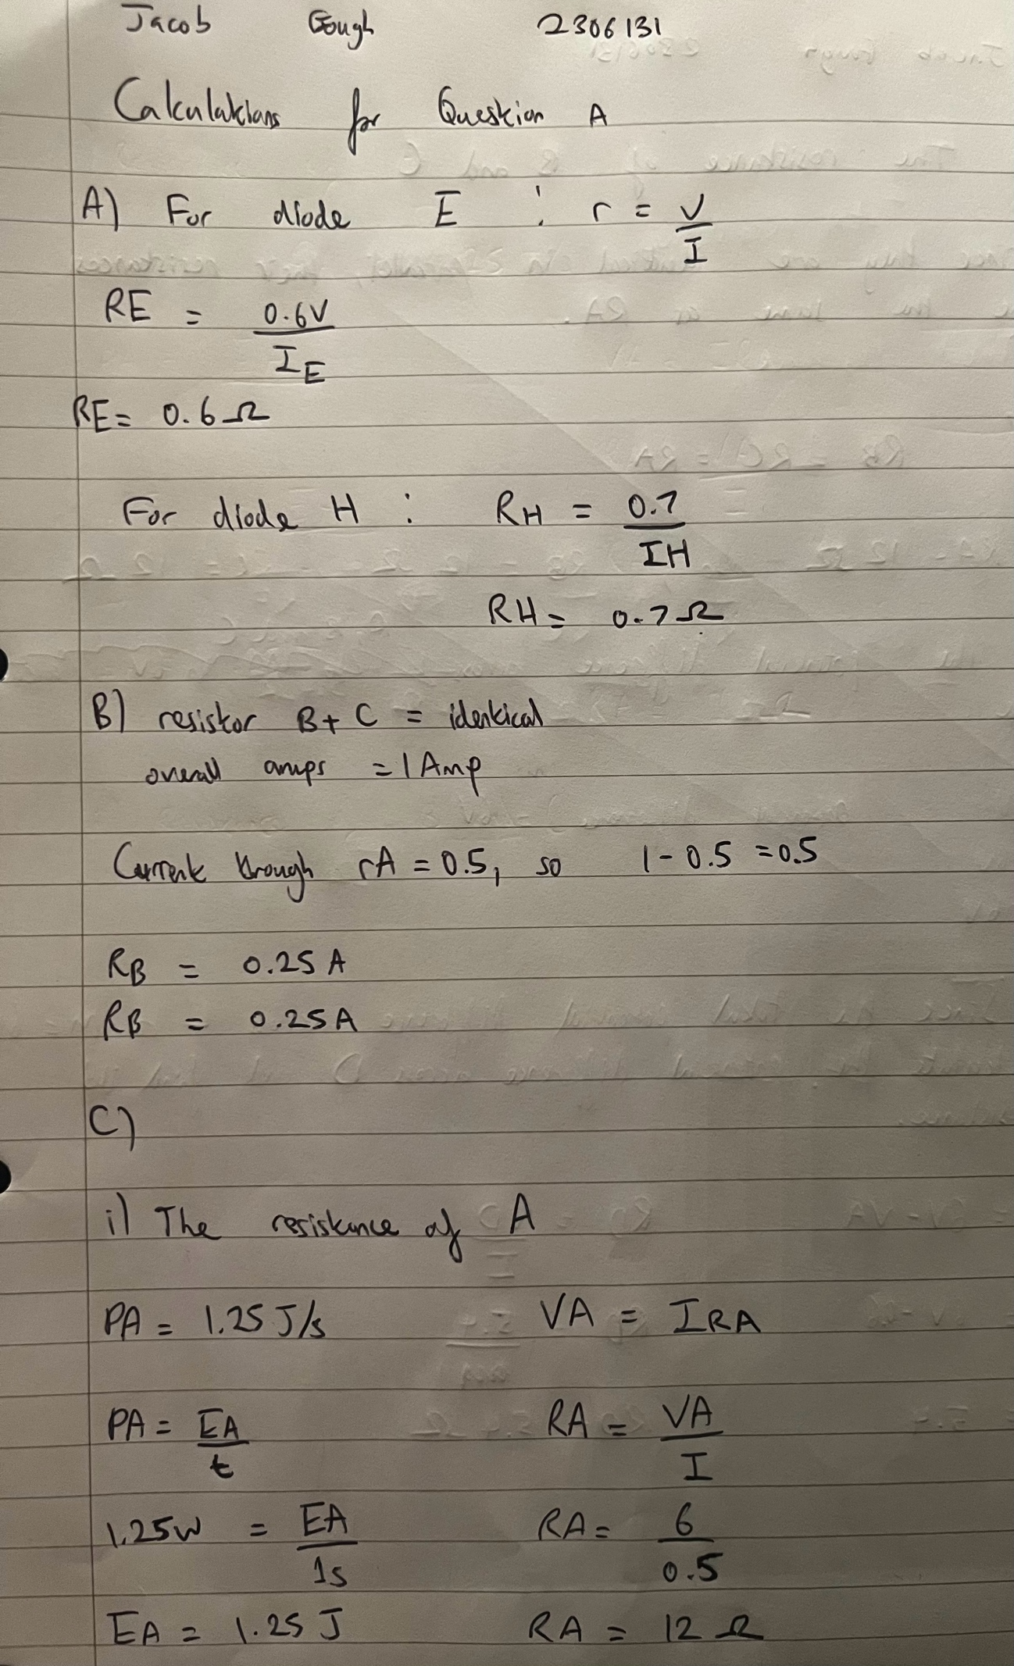

Given that B and C are identical and the current passing through A is 0.5A, calculate the current passing through B and C. [2]

Resistor A dissipates 1.25J of energy every second. Using this fact calculate:

The Resistance of A. [2]

The Resistance of B and C [3]

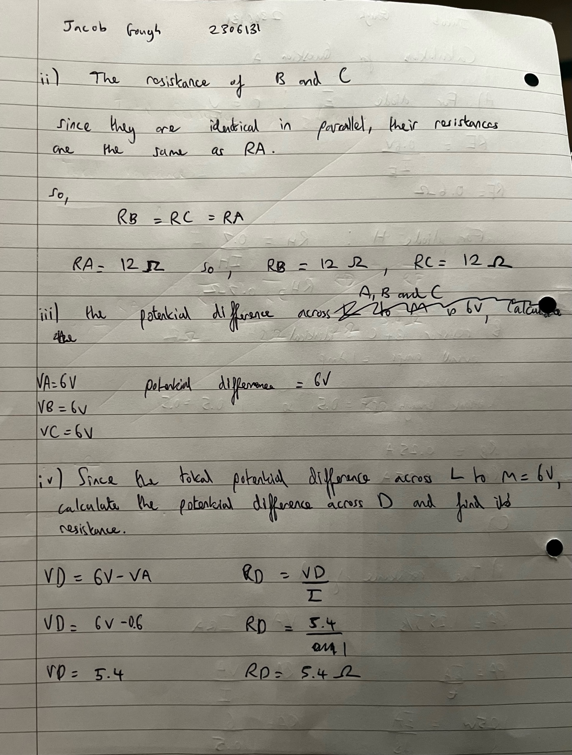

The potential difference across A, B and C in [1]

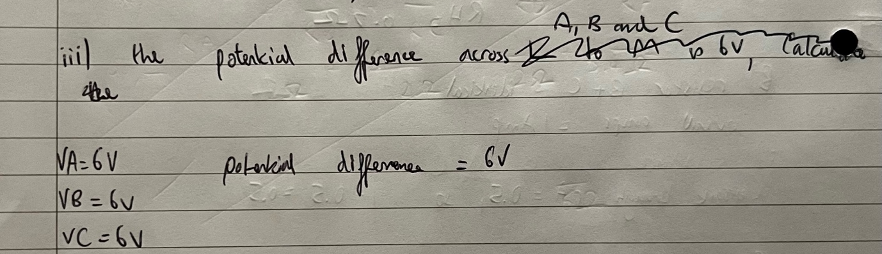

Since the total potential difference across L to M is 6V, calculate the potential difference across D and find its Resistance. [2]

The ‘lost volts across one of the cells in the parallel arrangement is 2 V. Calculate r and hence the total resistance of the parallel combination of cells. [3]

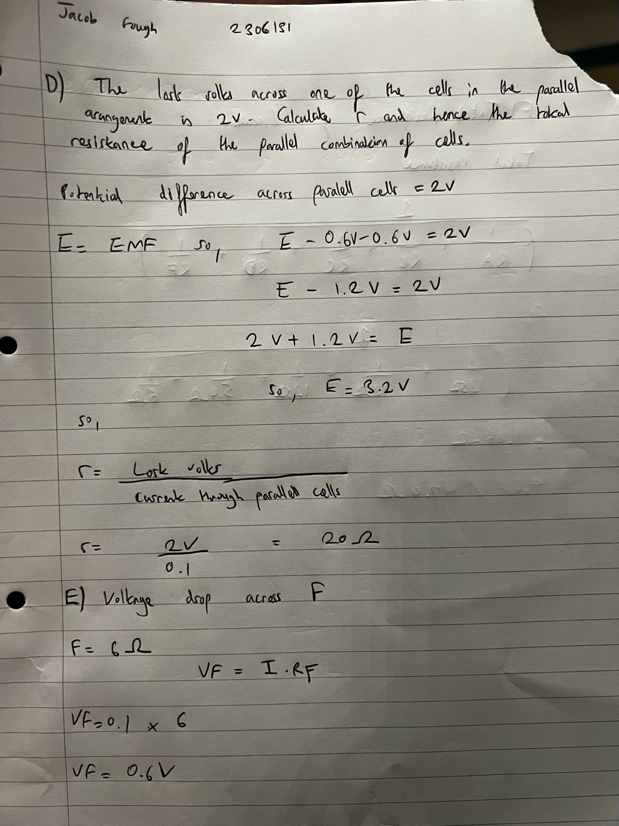

Given that the resistance F is 6Ω, calculate the voltage drop across it. [2]

Calculate the total resistance of the circuit, this includes total internal and the resistance cause by the reverse polarity battery and the open diodes in given scenario (ignore any “non-open diodes”). [2]
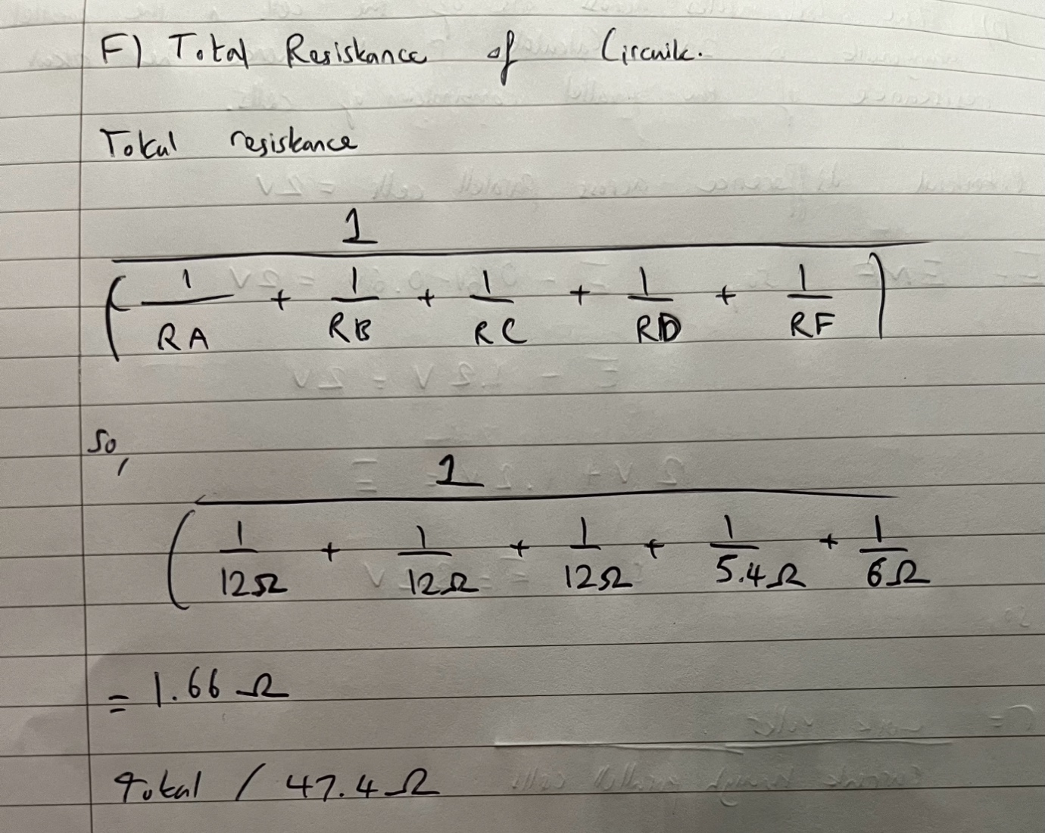

Calculate the emf of each of the cells in the parallel combination. [3]

