Lab 4

Task 1
Device | IP bin | IP dec
0 | 1100 0000.1010 1000.0100 1000.0001 1110 | 192.168.72.30
1 | 1100 0000.1010 1000.0100 1000.0010 1000 | 192.168.72.40
2 | 1100 0000.1010 1000.0100 1000.0011 0010 | 192.168.72.50
3 | 1100 0000.1010 1000.0100 1000.0100 0110 | 192.168.72.70

Set up switch with passwords
Running config
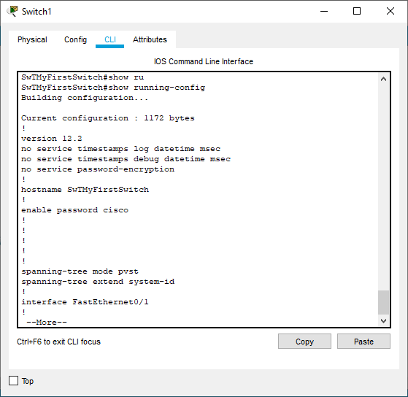
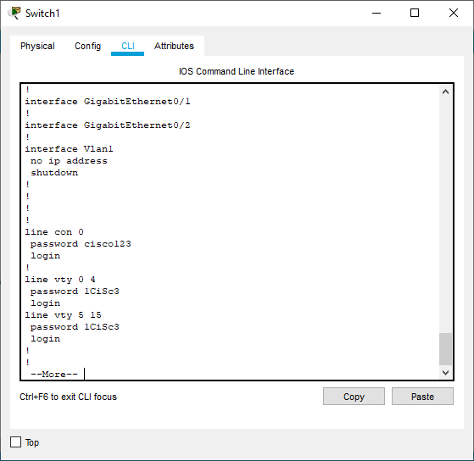
Create privilege password
Observe the running configuration of your switch and note the configuration
Is your privileged password shown in running-configuration? (Yes/No) If Yes, how is it displayed?
Enable password cisco
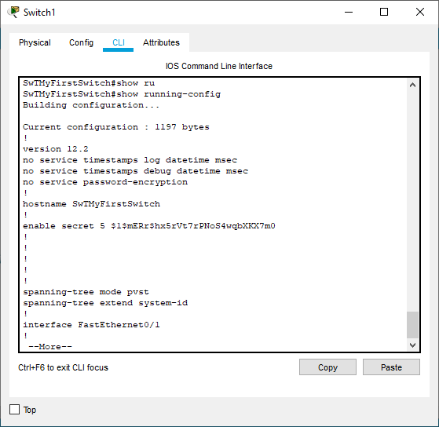
Observe the running configuration of your switch again and note the difference between password and secret
Password is shown by array of random letters
How are the other passwords?
Shown as normal

Password-encryption
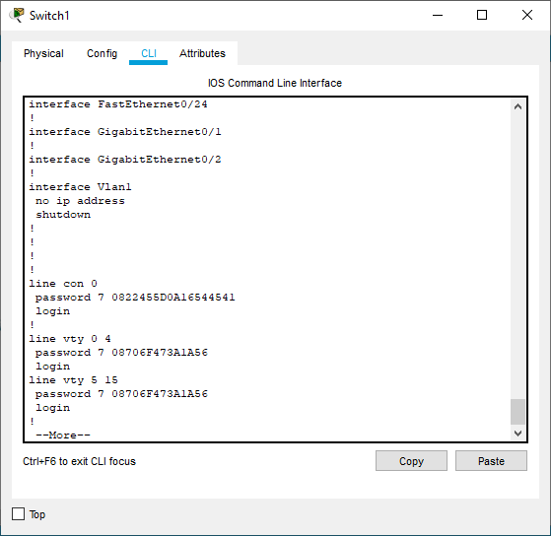
Observe the running configuration of your switch again and note the difference now
Passwords are hidden

IP address
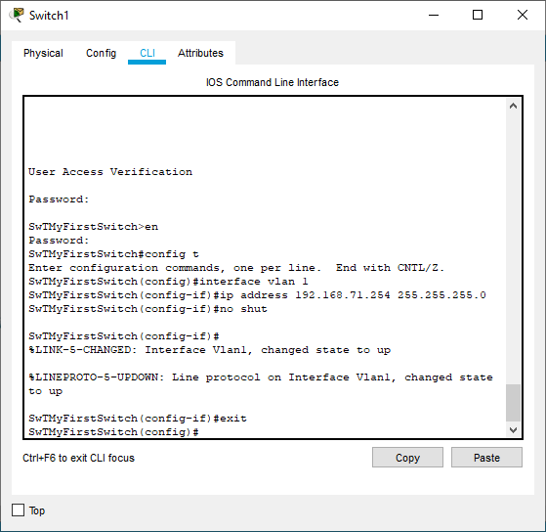

Erase start-up config
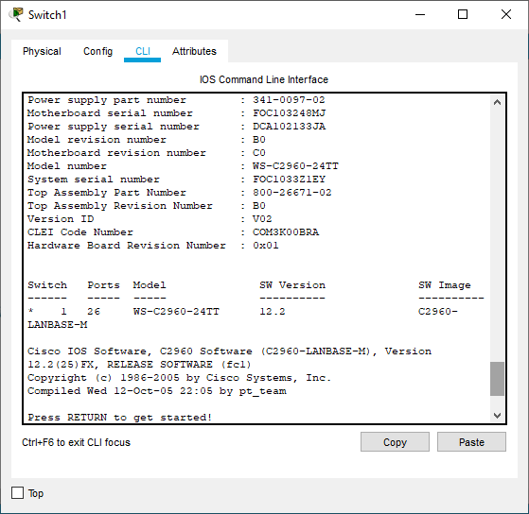

Add a banner
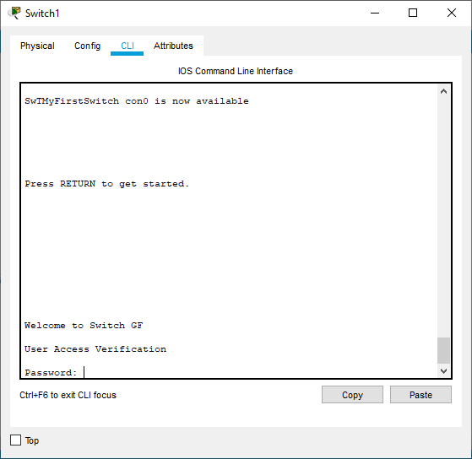

Set up router to same configurations
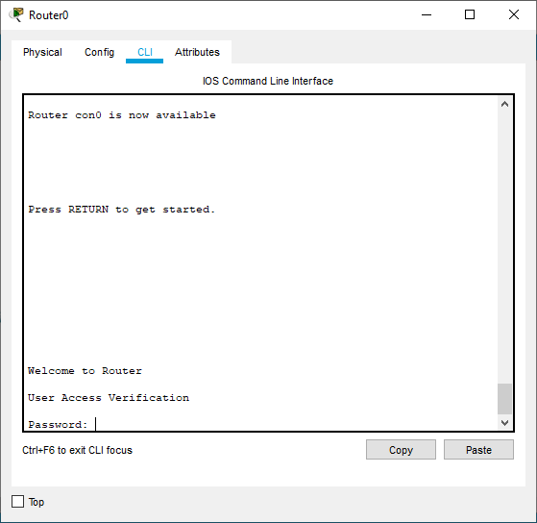
Record reflections
Successful

Task 2
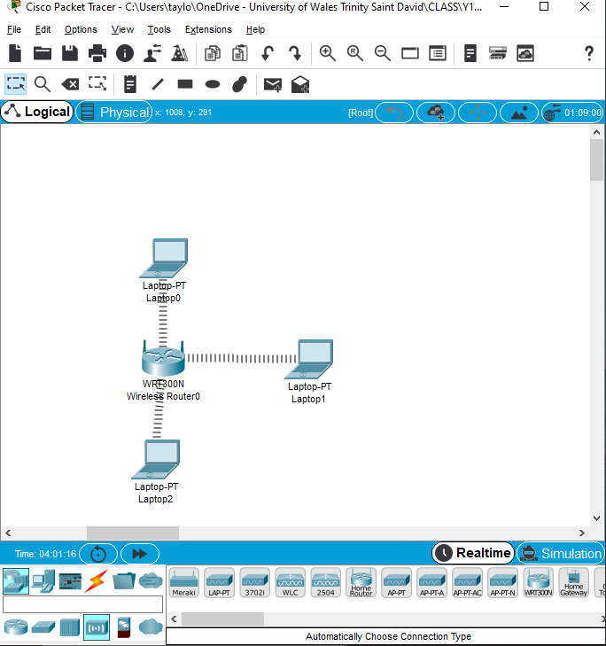
Did all the laptops successfully connected to the wireless router?
Yes
Did all the laptops gain DHCP IP address?
No
Record your understanding, why all the laptops could not get IP address assigned from the DHCP.
IP address is different to router
Disable and enable the DHCP IP Configurations in the Laptop and check the status.
IP address is reassigned to a new address.

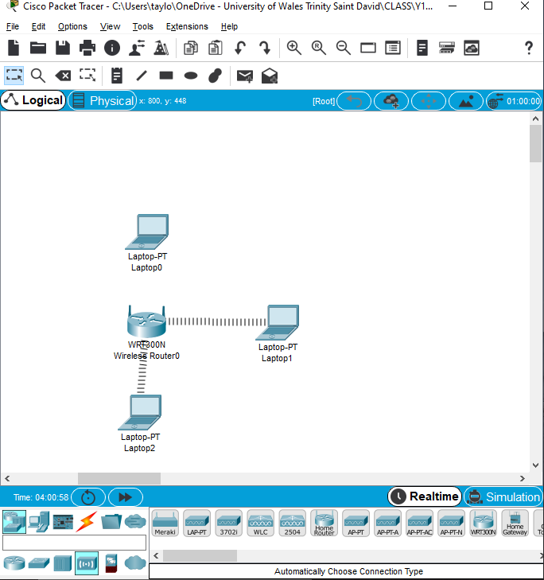
Observe the changes in the network and record your reflections about MAC Filtering and enhancing the security in Wireless Networks.
Laptops with Listed Mac address are disconnected

