|
Student Name: trinity james
Student ID: 2505460
Programme: Certificate of Higher Education Skills for the Workplace (Health & Social Care)
Module: Introduction to Health and Social Care
Module Code: LCHS4003
Assignment Title: Portfolio – Two Tasks
Lecturer:
Submission Date: 23 March 2026

TASK 1 – POSTER
Community Mental Health Services in the United Kingdom

What Are Community Mental Health Services? 
Community Mental Health Services provide treatment, support, and rehabilitation for individuals experiencing mental health conditions while allowing them to remain within their communities. These services focus on helping people manage mental health conditions such as depression, anxiety disorders, bipolar disorder, and schizophrenia without requiring long-term hospitalisation.
In the United Kingdom, community mental health care is mainly delivered through the National Health Service in partnership with local authorities and social care organisations. These services aim to support recovery, independence, and social inclusion by ensuring that individuals receive appropriate care while maintaining their daily lives and relationships.
Support is usually provided by multidisciplinary teams consisting of psychiatrists, psychologists, mental health nurses, social workers, and occupational therapists. Each professional contributes specialised knowledge to develop personalised treatment plans for service users (NHS, 2023).
Community mental health services may include:
• Psychological therapy and counselling
• Medication management
• Crisis intervention support
• Rehabilitation programmes
• Support with employment, housing, and social integration
Providing care in the community helps individuals maintain independence and reduces the stigma historically associated with institutional mental health care.

📜 Brief History of Community Mental Health Services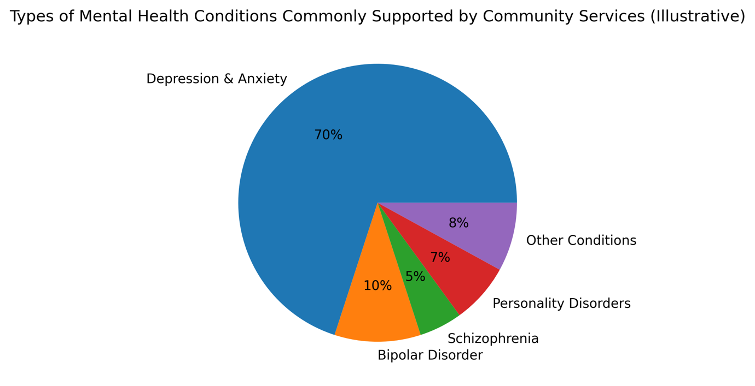
Historically, individuals with severe mental health conditions were often treated in large psychiatric hospitals known as asylums. During the early twentieth century, many patients remained institutionalised for long periods, sometimes for the majority of their lives. These institutions were frequently overcrowded and isolated individuals from society.
A significant change occurred with the introduction of the Mental Health Act 1959, which encouraged treatment within community settings rather than long-term institutional care (Thornicroft & Tansella, 2004).
Later reforms were introduced through the policy known as Care in the Community during the 1980s and 1990s. This policy aimed to close many large psychiatric hospitals and replace them with community-based services that could provide treatment while allowing individuals to remain integrated within society (Department of Health, 2015).
These changes represented a major shift in mental health care, focusing on patient rights, dignity, and social inclusion rather than institutionalisation.

⚙️ How the Service Works Today
Today, Community Mental Health Services operate through several specialised teams that work together to support individuals with mental health conditions.
One of the most common services is the Community Mental Health Team (CMHT). These teams assess patients referred by general practitioners (GPs), hospitals, or other healthcare professionals. After assessment, a personalised care plan is developed that may include therapy, medication, or social support.
Crisis resolution teams are also an important part of the system. These teams respond quickly to individuals experiencing severe mental health crises and aim to provide immediate support in order to prevent hospital admission.
Early intervention services are designed to support individuals who are experiencing early signs of mental illness, particularly psychosis. Research suggests that early treatment significantly improves long-term recovery outcomes (NHS England, 2022).
Community services often collaborate with charities, housing organisations, and employment programmes in order to address the wider social needs of service users.

⚠️ Challenges Facing Community Mental Health Services
Increasing Demand
One of the biggest challenges facing community mental health services is the growing demand for support. Mental health conditions such as anxiety and depression have become increasingly common, particularly following the COVID-19 pandemic. As a result, many services face long waiting times for assessment and treatment (NHS Digital, 2023).
Workforce Shortages
Another challenge is the shortage of trained mental health professionals. Community mental health teams rely on psychiatrists, psychologists, and mental health nurses, but recruitment and retention in these professions remain difficult. Staff shortages
TASK 2 – ESSAY
Ambulance Services in the United Kingdom
Introduction
Ambulance services are a vital component of the healthcare system in the United Kingdom. These services provide rapid emergency medical care for individuals experiencing serious illness, accidents, or life-threatening injuries. By delivering immediate medical assistance and transporting patients to healthcare facilities, ambulance services play a critical role in protecting public health.
In the UK, ambulance services operate as part of the National Health Service and respond to millions of emergency calls each year. Modern ambulance crews consist of highly trained paramedics and emergency medical technicians who are capable of delivering advanced life-saving treatment before patients reach hospital (NHS, 2023).

Origins and Historical Development
The origins of ambulance services can be traced back to the nineteenth century when organised systems for transporting injured individuals began to emerge. Early ambulance services were particularly influenced by military medicine, where rapid transport of wounded soldiers from battlefields was essential.
In the United Kingdom, voluntary organisations played a significant role in early emergency care. One notable organisation is St John Ambulance, which was founded to provide first aid training and emergency medical assistance during public events and disasters (St John Ambulance, 2022).
During this period, ambulances were primarily used as transport vehicles rather than treatment units. Medical care during transport was minimal, and the main objective was simply to deliver patients to hospitals as quickly as possible.
A major turning point occurred in 1948 with the creation of the National Health Service. The establishment of the NHS integrated ambulance services into a national healthcare system, allowing for better coordination and improved access to emergency medical care.
Over time, paramedic training expanded significantly, enabling ambulance crews to provide advanced medical interventions before hospital admission.

How Ambulance Services Function Today
Today, ambulance services are far more advanced than their historical predecessors. When an individual calls 999, emergency call handlers assess the situation and determine the urgency of the response required. Ambulances are then dispatched using sophisticated communication systems and GPS tracking technology.
Paramedics are trained to manage a wide range of emergencies including cardiac arrest, strokes, trauma, respiratory distress, and severe allergic reactions. Early treatment provided by paramedics can significantly increase survival rates in life-threatening situations.
However, ambulance services also face operational challenges. Increasing demand for emergency care has placed pressure on response times across the UK. In addition, overcrowding in hospital emergency departments can sometimes delay the transfer of patients from ambulances to hospital staff.
Despite these challenges, ambulance services remain an essential component of the healthcare system and continue to deliver life-saving care to the public.

Importance for Quality of Life
Ambulance services significantly enhance the quality of life within communities by ensuring that rapid medical assistance is available in emergencies. The presence of trained paramedics and advanced equipment allows patients to receive critical treatment immediately.
Early medical intervention can prevent complications, reduce mortality rates, and improve long-term recovery outcomes. Furthermore, ambulance services contribute to public safety by responding to accidents, medical emergencies, and large-scale incidents.
In addition to emergency responses, ambulance services also provide patient transport services for individuals who require assistance attending hospital appointments. This service is particularly important for elderly individuals and people with disabilities who may struggle to access healthcare independently.
Overall, ambulance services play a fundamental role in maintaining public health and ensuring that individuals receive timely medical care during emergencies.

REFERENCES (Harvard Style)
Department of Health (2015) Mental Health Policy in the UK. London: Department of Health.
Health Foundation (2023) Workforce Challenges in NHS Mental Health Services. London: Health Foundation.
NHS (2023) Mental Health Services Overview. Available at: https://www.nhs.uk (https://www.nhs.uk/)
NHS Digital (2023) Mental Health Statistics in England. Available at: https://digital.nhs.uk (https://digital.nhs.uk/)
NHS England (2022) Community Mental Health Framework. London: NHS England.
St John Ambulance (2022) History of St John Ambulance. Available at: https://www.sja.org.uk (https://www.sja.org.uk/)
Thornicroft, G. and Tansella, M. (2004) ‘Components of a modern mental health service’, British Journal of Psychiatry, 185(4), pp. 283–290.

