

Victor Badaluta 2212187
Academic Discipline of Hospitality & Tourism Management

BA International Hotel Management

BMIH5003

Foreign Languages and Cultural Awareness LEVEL 5

Assessment 2 – Cultural Awareness

Japan

17th November 2023

Executive Summary
Japan, a nation in history and modernity, possesses a distinct cultural fabric delicately woven with values and rituals. Employing Hofstede's cultural model affords a lens to explore the complexity of Japanese culture. The GLOBE Project further shows these cultural complexities by comparing Japan to the UK. In this context, cultural knowledge and sensitivity become crucial, especially for hotel personnel managing Japanese traditions. Understanding these cultural features is vital for providing excellent service and developing cross-cultural connections.

Table of Contents
Executive Summary 2
1 Introduction 4
2 Main Body 4
2.1 Cultural Overview 4
2.2 GLOBE Project/Country Analysis 5
2.3 Importance of Cultural Intelligence and Sensitivity for Hotel Personnel 6
3 Conclusion 7
4 Recommendations 7
5 References 8

Introduction
The report will briefly outline the culture and customs of Japan to discuss the overview of its cultural overview. A 5-star hotel company in the UK, Diversity Hotel & Spa, recently decided to expand the company to overseas countries, and for this purpose, Japan has been selected. For the country analysis, the GLOBE project's culture and leadership study will be used in this report.

Main Body

Cultural Overview
Japan is a country rich in culture and modernity, with a lengthy history. The power distance of Japan is low, reflecting that hierarchical structures are present but not strictly followed in the country. Although it is usual to speak in an oblique manner to keep the peace intact, authorities are respected.
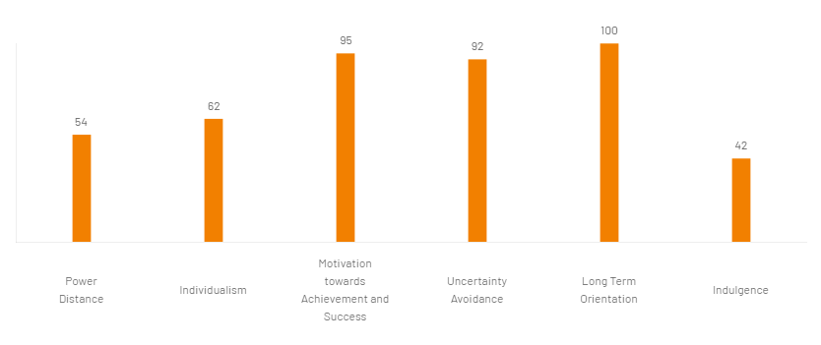
Figure 1; Hofstede Cultural Model of Japan
Source: Hofstede Insights (2023)
Japan is highly collectivist on the individualism spectrum. Maintaining social cohesiveness and collective agreement is more important than being loyal to work, family, or community. In Japan, the debate over masculinity and femininity is generally balanced, approving both aggression and compassionate qualities. A culture that acknowledges the need for a good work-life balance is one that places equal emphasis on personal fulfilment and financial success (Latheef, 2021). The limited avoidance of uncertainty in Japan suggests that its culture is relatively tolerant of it. Routines and social customs provide support for confidence while navigating unfamiliar situations. A long-term orientation that prioritises forbearance, thrift, and patience is prevalent.

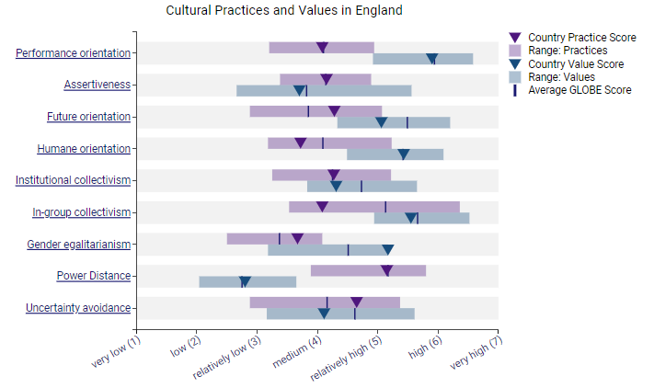
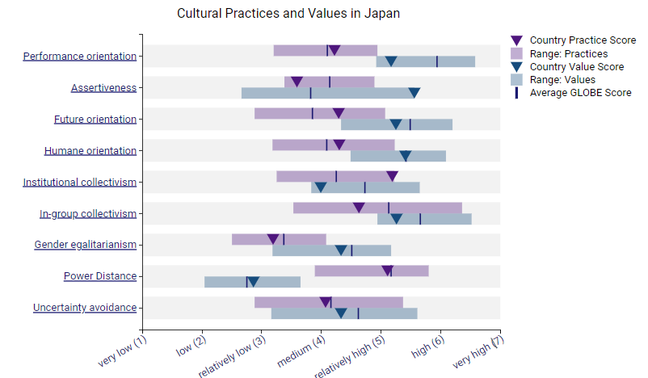
GLOBE Project/Country Analysis
Cultural Practices and Values in Japan and the UK
The cultural components of the GLOBE Project provide a framework for comparing Japan and the UK in detail. In the UK, a culture that emphasises competitiveness, achievement, and innovation is indicated by a high-performance orientation score. In many businesses, addressing problems quickly and creatively is highly valued. Japan, on the other hand, has a more nuanced perspective, emphasising interpersonal ties in addition to performance. Although success is important, the emphasis on fostering group cohesiveness and reaching agreement tames the competitive spirit. Openness and honesty are highly valued in British communication, which is typically more forceful (Cui, 2021). This aligns with the principles of an intellectual community that supports free speech. Conversely, Japanese people prefer to communicate in a more subdued and indirect manner, emphasising peace over violence.
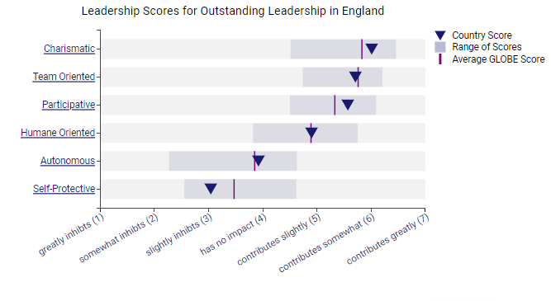
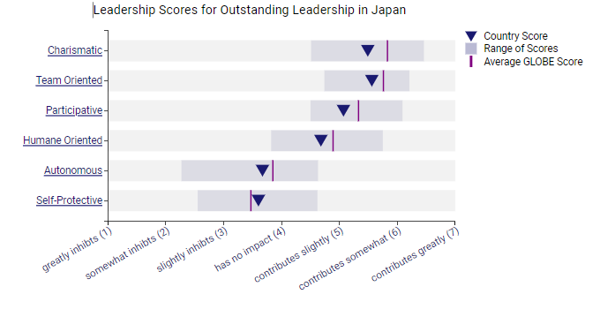
Leadership Scores for Outstanding Leadership in Japan and the UK
When it comes to the future, the UK places a high priority on strategy, planning, and adaptability. Leaders in businesses are often progressive and receptive to new ideas. The inhabitants of Japan are generally more patient and situation-sensitive since they value tradition and long-term connections while being forward-thinking. The commitment of the UK to freedom, justice, and respect for everyone is what makes it a compassionate country (Zotti, 2021). Ethics and corporate social responsibility are growing in significance. The humane orientation of Japan is characterised by a strong sense of duty and responsibility towards the well-being of the community, which in turn fosters a communal consciousness that extends beyond narrow self-interest. In British society, the rights of individuals inside formal institutions are valued more highly than institutional collectivism. The strong institutional collectivism of Japan suggests that upholding group unity takes precedence over individual interests.
Compared to the rest of the world, Japan values collectivism and ties within groups more (Takakura, 2021). While intimate connections are sometimes neglected in favour of task-oriented groups, collaboration is highly valued in the UK. It has made greater progress in achieving workplace gender equality, which has resulted in more advanced gender equality. Notwithstanding efforts to bridge gender inequalities, traditional gender norms are still prevalent in Japan. Compared to many other nations, Britain has a lower power distance, indicating a preference for more democratic systems of governance. Japan, on the other hand, exhibits a moderate power disparity since it promotes consensus-building and consultation while acknowledging the presence of hierarchical institutions (Şahin, 2023). In addition, the British have a moderate degree of uncertainty avoidance, indicating that they are adaptable and able to deal with uncertainty. A greater inclination to steer clear of ambiguity is suggestive of Japanese society's quest for order and predictability.

Importance of Cultural Intelligence and Sensitivity for Hotel Personnel
Hotel employees need to be very sensitive to and knowledgeable about other cultures, especially in a nation with as many complicated and subtle cultural traditions as Japan. In Japanese culture, being thorough, polite, and respectful are highly valued traits (McConachy and Fujino, 2021). Culturally savvy hotel staff members will be able to easily satisfy these guests' expectations and make them feel good about themselves in the process. In Japan, where hospitality is deeply rooted, it is essential to comprehend cultural aspects in order to provide exceptional service. Employees who are sensitive to cultural differences can be better able to anticipate and meet the needs of their Japanese guests (Jhaiyanuntana and Nomnian, 2020). Furthermore, cultural awareness creates an environment of understanding that is advantageous to both hosts and visitors. Consideration of individual preferences, such as the need for a quiet atmosphere in public places or a specialised diet, significantly increases guest happiness. The willingness of staff to pick up on and adjust to these cultural quirks can only help the reputation of the hotel for satisfying the needs and surpassing the expectations of its international customers.

Conclusion
In conclusion, the cultural overview using Hofstede's model and the in-depth investigation via the GLOBE Project illustrates the subtle disparities between Japan and the UK. While both nations achieve the challenging balance between tradition and modernisation, comprehending these cultural subtleties is vital for effective cross-cultural partnerships. Particularly in the hospitality sector, such as hotels, cultural intelligence and sensitivity emerge as key assets, ensuring not only visitor delight but also building a comfortable and inclusive environment for various international consumers.

Recommendations
Prior to anything else, the general manager should inform of the customs and culture of the host nation by learning about topics like the local tongue, cuisine, and business etiquette. It is important to modify the curriculum to suit the cultural context and emphasise how important cultural sensitivity is to the success of the company. General Managers need to initiate and oversee cross-cultural training initiatives to encourage candid dialogue and increased cultural knowledge. Additionally, to provide insights into the relevant sector, it is beneficial to think about including local experts or consultants.

References
Cui, Y., 2021. The role of emotional intelligence in workplace transparency and open communication. Aggression and Violent Behavior, p.101602.
Globe Project, 2023. England. [Online] Available at https://globeproject.com/results/countries/GBR?menu=list#country [Accessed on 11th November 2023].
Globe Project, 2023a. Japan. [Online] Available at https://globeproject.com/results/countries/JPN?menu=list#country [Accessed on 11th November 2023].
Hofstede Insights, 2023. Japan Country Comparison Tools. [Online] Available at https://www.hofstede-insights.com/country-comparison-tool?countries=japan [Accessed on 11th November 2023].
Jhaiyanuntana, A. and Nomnian, S., 2020. Intercultural communication challenges and strategies for the Thai undergraduate hotel interns. PASAA: Journal of Language Teaching and Learning in Thailand, 59, pp.204-235.
Latheef, Z.I., 2021. Paradigm and cultural shifts on employee leave and work-life initiatives. Advances in Developing Human Resources, 23(2), pp.185-192.
McConachy, T. and Fujino, H., 2021. Negotiating politeness practices and interpersonal connections in L2 Japanese: Insights from study abroad narratives. In Teaching and Learning Second Language Pragmatics for Intercultural Understanding (pp. 19-39). Routledge.
Şahin, S., 2023. Conflict Management Capacity of ASEAN in the Context of Regional Peace and Security: An Evaluation on Its Normative and Institutional Power. Turkish Studies-Economics, Finance, Politics, 18(3).
Takakura, H., 2021. Individualism and collectivism in small-scale fisheries post-3.11 Japan. Disaster Prevention and Management: An International Journal, 30(6), pp.26-38.
Zotti, A., 2021. The immigration policy of the United Kingdom: British exceptionalism and the renewed quest for control. The EU Migration System of Governance: Justice on the Move, pp.57-88.

