JACK LAYTHAM 1901706
HPMF4007
PRE PORDUCTION

Mood board
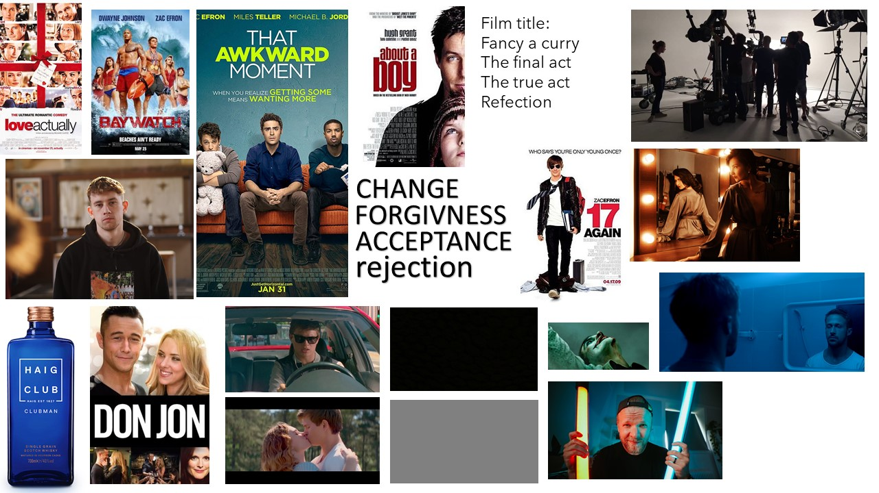

LOG LINE
Can an egotistical man win the love of a girl set against him? Can he defy all odd lose his ego?

TREATMENAT
Mike Brody is in his cold and lifeless dressing room dressing room looking himself in his mirror. Questioning who he is, push away his true feeling. Getting himself ready to put on a show. by now he was used to it, taking the whisky, holding the tear and being the person he thinks he need to be. As he slowly walks to the door taking one final breath in to proper himself to go on set.
Mike walked onto the set with his back straight and exuding testosterone in the matter of second mike had become a completely different person. As he stepped onto his mark being blinded by the light he could just about make out what the director looked like. As he starts to act out the corner of his eye he see this woman clear as day. The girl was Sophia a young intern looking to get into the backstage industry and didn’t have time to waste on men like mike. Mike the stutters causing the director to call cut in owe of this woman he heads over to talk to her. Mike walk over to Sophia to try and filter with here but due to is cocky act Sophia declined mike is in shock of what has happened and tris to laugh it off but this is the first time he has felt anything like this in years .

That night mike got straight onto his phone to call his mate Mark to talk about what had just happen in work shocked. On the phone he talks about how being adopted has effected the way he trusts people and that he is just scared of rejection. Mark who was playing video games not being very help full tells mike to watch rom coms and after he dose he realises he as to be honest to win Sophia’s love so the next day he goes to speak to her.
Mike goes up to t o her and opens up about how he feels about her, but everyone around is looking but mike doesn’t care and keeps going to show that when has with Sophia he doesn’t care. Sophia stops him and says “I fancy a vin-da-loo.

Recce Sheet

Title of production Date of recce:13.02.2020
Location: Flat 9
Present: THE LIVING ROOM

Please indicate Comments/Details
Yes/No for each area
Local Condition:  • Any known problems  If yes, please detail (including source of information) | No □ Yes □
• Aid needed  If yes, please detail name, address and contact numbers for each person/organization  • Permission needed  • Protective clothing needed  If yes, please detail | No □ Yes □  No □ Yes □  No □ Yes □
Viewpoints:  • Appropriate viewpoints isolated  • Any obstructions  • Easy to reach and safe  If no, please detail requirements | No □ Yes □  No □ Yes □  No □ Yes □
Requirements:  • Power available  If no, please detail alternative arrangements  • Lighting appropriate  If no, please detail alternative arrangements  • Sound equipment (please detail) | No □ Yes □  No □ Yes □
Anticipated problems:  • Sound  If yes, please detail  • Picture  If yes please detail  • People  If yes, please detail  • Other  If yes, please detail | No □ Yes □  No □ Yes □  No □ Yes □  No □ Yes □
Other considerations (please provide details for each):
• Security considered
• Welfare considered (transport, food, First Aid etc.)
• Set dressing required
• Props required
Comments:

Please attach sketches (including power points, anticipated camera viewpoints, position of lighting etc.) and
photographs of the location and its site

Recce Sheet

Title of production Date of recce:13.02.2020
Location: PARRY
Present: SMALL DRAMA STUDIO

Please indicate Comments/Details
Yes/No for each area
Local Condition:  • Any known problems  If yes, please detail (including source of information) | No □ Yes □
• Aid needed  If yes, please detail name, address and contact numbers for each person/organization  • Permission needed  • Protective clothing needed  If yes, please detail | No □ Yes □  No □ Yes □  No □ Yes □ | Will need to speak to a member of staff to rent it out.
Viewpoints:  • Appropriate viewpoints isolated  • Any obstructions  • Easy to reach and safe  If no, please detail requirements | No □ Yes □  No □ Yes □  No □ Yes □
Requirements:  • Power available  If no, please detail alternative arrangements  • Lighting appropriate  If no, please detail alternative arrangements  • Sound equipment (please detail) | No □ Yes □  No □ Yes □
Anticipated problems:  • Sound  If yes, please detail  • Picture  If yes please detail  • People  If yes, please detail  • Other  If yes, please detail | No □ Yes □  No □ Yes □  No □ Yes □  No □ Yes □
Other considerations (please provide details for each):
• Security considered
• Welfare considered (transport, food, First Aid etc.)
• Set dressing required
• Props required
Comments:

Please attach sketches (including power points, anticipated camera viewpoints, position of lighting etc.) and
photographs of the location and its site

Equipment
Canon m50 KIT LEN + 50MM
LED PANDELS X 10
MONITOR 4K
SONY AS3 KIT LENS
BOOM MIC

Crew list
Jobs | names
Director / producer | Jack
DOP | James
1st AD | Liam
Sound OP | Kat
Editor | Elliot
Runner | Will

Strength  Easy to find a location, all on campus.  Equipment is all funded by the uni.  Talent will be uni.  We have a hospital close by with an ad on set | Weakness  Talents won’t be as adaptable as professional actors.  Limited range on equipment  Basic sets
Opportunities.  Try equipment I wouldn’t be able afford.  Will bring new opportunity | Threats  Talents not turning up or dropping out  Production values
SWOT

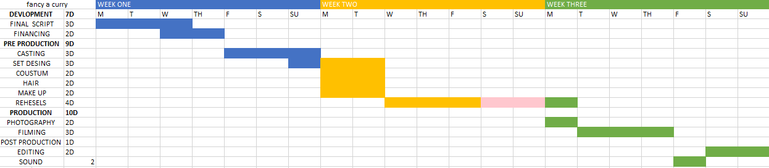

Gantt chart



