Name: Kalpana Chiranjilal Mahawar
Student number: 2133406
Module: Human Marketing Management(LCMB7001)
Lectures’ name: Tushara Balendran
Date of Submission:
Word count:



Introduction: Maybelline New York trading as Maybelline is an American Multinational Cosmetics, Skin care, Fragrance and Personal Care Company based in New York. It was founded in Chicago in 1914 and has a Subordinate of French Cosmetics Company Loreal since 1996. Mabelline company was founded by Pharmacist Thomas Lyle Williams based in Chicago. Williams observed his older sister who use to apply a mixture of Vaseline and Coal dust to give her eyes darker and fuller look. He adapted the technique and used the same in Chemistry and made a product and sold it in the local market called Lash-Brow-Ine. William named this eye beautifier as “ Maybelline” in honour of her sister. In 1917, the company produced Maybelline Cake Mascara which was the First Modern eye Cosmetic for everyday use.

Background: In 1967, Maybelline was sold by Williams to Schering Plough in Memphis, Tennessee. The entire company was shifted from Chicago to Memphis. Schering Plough sold Maybelline to New York investment firm, Wesserstrein Perella & co. Maybelline headquarters remained in Memphis until its acquisition by Loreal 1996. The Headquarter was then moved to New York in 1996 and factory to Broklyn in 2000.

Communication: A communication is a process by which information is exchanged between a sender and a received through a medium either verbally, by symbols, signs or behaviour.

Laswell Communication Model:

American Pychologist , Harold Lasswell developed his communication model in the year 1948.

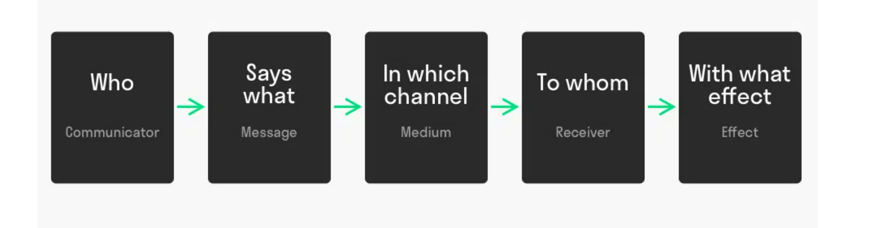
The Laswell Communication Model describes verbal communication with five elements as described below:
- Who?
It is about the sender who sends the message to other end.

- What?
It is the content of the message or the message that a sender sends.

- Which channel?
This is the medium of communication. It can be digital, verbal and written.

- To whom?
It is the receiver at the other end.

- With What effect?
This is about how accurate the message is conveyed from one end to the other end. It depends on the language known whether it is verbal or written communication.

IMC (Integrated Marketing Communication):

Integrated Marketing Communication is the marketing Strategy that links all the medium of Advertising or Promotion like Social Media(Instagram, Facebook, Twitter) and offline media like Newspapers, Magazines, Television, Radio, Cinema and outdoor. Its approach is to achieve maximum brand awareness among consumers through this channels combined.

Below are the tools for Integrated Marketing Communication:

- Advertising:
Advertising is making use of multiple platforms to create a brand awareness. By Advertising a brand can convey a message across various audience. This is the most expensive method, however it is the most effective one.

- Sales Promotion:
It is a method for short term branding success. The sole purpose of this method is to draw attention towards a particular product or a brand.

- Personal Selling:
By this methos the interaction between the salesperson and the customer can be maximized which will help customers with the simple queries as well which won’t be possible in Advertising or Sales Promotion.

- Public Relations:
This is the method in which workshops, seminars are conducted to raise the brand awareness.

- Direct Marketing:
This is the online way of communicating directly to the customer. It includes emails, text messages or phone calls.

IMC for Maybelline:

Maybelline being in a Beauty Industry can use all the forms of IMC, however the most effective one would be Advertising, sales promotion and Personal selling.

Advertising: Advertising it through the celebrity is the most common method in beauty industry, but Maybelline should endorse common women with average looks rather than celebrities to advertise just like Dove is doing. This way the consumers can relate themselves and will be more influenced to buy the products rather than thinking that it is a fake publicity.

Sales Promotion: Promoting Maybelline at Workplaces, Colleges and Universities can prove effective to raise the brand awareness. This is because nowadays women are more working and independent and they are conscious about their looks. They can display tester products at those places and even offer them an a goodies or reward to influence them to use the products and that will create a image in their mind and they will go for a purchase later on. Even offers like buy 2 get 1 free or a free product on the shopping of some amount though digital marketing prove fruitful because this will help to advertise other products as well which customers might not have thought of or not have heard about.

Branding and Brand Equity:

Branding is a logo name that a company uses for its identity in the market.

Brand Equity refers to the value premium that a company generates from a product or a range of products. Company can create their Brand Equity by making them memorable, easily recognizable and better in quality and reliability. A company with good brand name can claim higher price for those products which are available at lower price from competitors because they has developed trust with the customers.

There are three components in Brand Equity: Consumer Perception, negative and positive effects. Consumer perception is about the knowledge and experience. The perception that consumer holds directly impacts positive or negative impact. These factors can turn into either Tangible or intangible value.

Keller’s Brand Equity Model:

Keller’s Brand Equity model is a pyramid structure which guage the Company’s identity, Its Identification and uniqueness, The customer’s response and the relationship between customer and the brand.

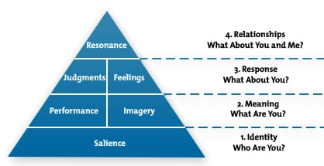

Keller’s Brand Equity Model for Maybelline:

- Identifying: Maybelline new York is one of the recognised cosmetic brand in the world, available in 120 countries. Its products ranges from Cosmetics like Foundation, Concealers, Primer, Colour corrector, Highligher, Kajal, Mascara, etc to Fragrances and hair care. Maybelline focuses on realistic picture of the brand rather than just the celebrity looks. Majority if customers are happy that Maybelline has around 32 shades of Foundation which other brands lack which is one of the USP. Apart from that the easy availability of products in different is another USP.

- Meaning: Maybelline meets customer needs on a large scale. The products has long lasting effect and does not causes harmful effects on skin until in a scenario where customer’s skin is too sensitive. These qualities are also provided by other brands like Mac, Estee Lauder and Revlon however the price for the same range of product is less in case of Maybelline. Maybelline has met the Psychological need of the customer because women with different skin colour feels valued that they are able to get the product which suites their skin colour and texture rather than an image of a fair complexed beauty which existed in the market for long time.

- Brand Response: Maybelline has received mixed response from consumers, but that will be the case for every brand. But on the positive side, Maybelline provides great customer service. There was a campaign launched called “B2me” which goals to educate customer about choosing and using the product according to their requirement. Maybelline has also introduced a colour studio Tour that treated customer like VIP. This studio provided customers with makeup consultations because makeup without a correct way can damage the look.

- Brand Resonance: This is at the top of the Pyramid because it is the most difficult stage to reach and many brands fail to do so. The average rating for Maybelline has increased from 2.7 to 4.4 starts and the number of reviews above 4 stars has risen by 35%. Hence this factor is fulfilled to a certain extent but not to the fullest because Maybelline has still not reached the Maturity stage in its Product Life Cycle.

Customer Journey
Customer Journey is a path of interaction between a customer and brand. Customer plays role right from evaluating a brand to making a decision to purchasing to Feedback. In order to read a customer journey, a company should think from the customer’s point of view rather than as an entrepreneur. Customer journey mapping is a common strategy to understand the customer journey, which will provide the sum of the experience the customer has with the brand. This will help the brand to improve their Marketing strategy which will ultimately benefit brand and the customer both.

The Stages in the Customer Journey Map:

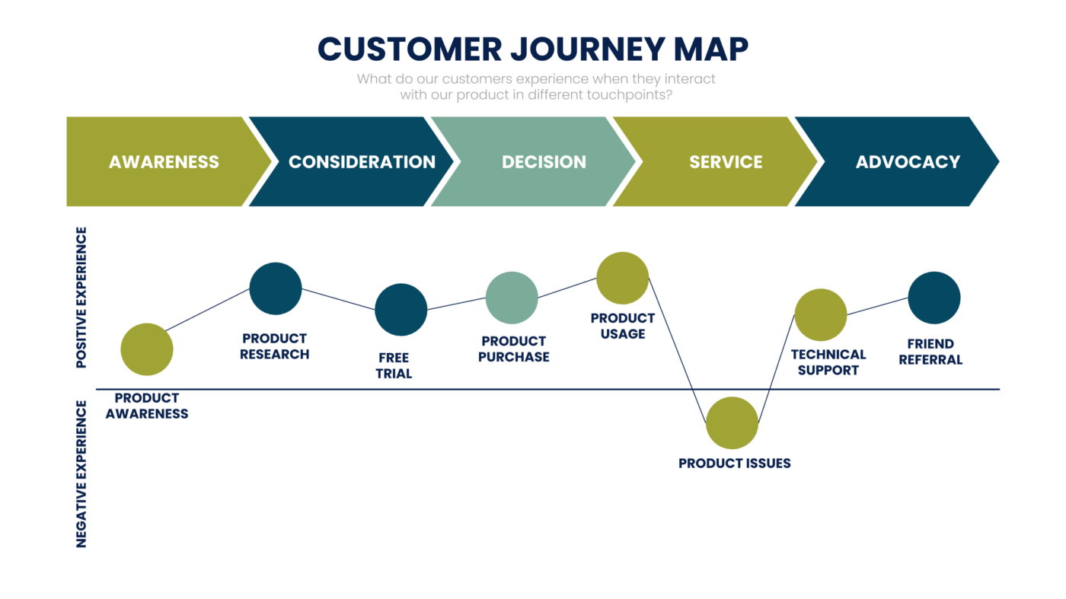

- Awareness: The Awareness stage is where a potential buyer becomes aware of your brand, through google, social media, or from a website or a reference.
- Consideration: The Consideration stage is where a potential customer has decided the product but wants to do more evaluation for other options in the market. In this stage they compare your brand with other brands.
- Decision: This is the stage where customer buys the product or sign up for the service.
- Retention: This stage is where the brand retain their customer by involving them to purchase the product on regular basis.
- Advocacy: This is the stage where customer shops with you and spreads the word about your product or service, by online reviews or to friends through word of mouth.

Maybelline’s Customer Journey:
Maybelline primary focus is on digital but offline conversations has has soared in recent times according to data from Engagement Labs. Its Integrated Marketing Strategy is increasing brand sharing, which is the extent to which to which people are sharing or talking about brand’s marketing.

Strengths of Maybelline in Customer Journey Map:
- Give Customer to talk about: Maybelline’s strategy is to focus both on online and offline, they allow customer’s to share the reviews on social media and website and also to review offline directly with the salesperson. Maybelline has increased its offline brand sharing since July 2017, and reached its highest point in February 2018. This was 75% jump for this period compared to the previous 6 month period. Also online Branding increased 8% during the same period. The Visual content of Maybelline is so attractive that the customers has shared it face to face to friends as well.
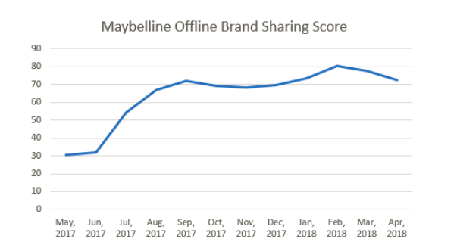

- Leverage an Integrated Marketing Strategy: Celebrity Partnership are another pillar of Maybelline’s Marketing strategy. Maybelline’s collaboration with supermodel Gigi Hadid has given the required limelight to be in the market. She has also advertised on her Instagram page about the new collection. This activities has created Favourable impact on the brand image.

- Harness the power of Everyday Influencers:
Maybelline also understand that celebrities are not the only one catching customer’s eye.
They have also collaborated with the the paid influencer’s like Shayla Mitchell. Apart from paid, they also go for unpaid influencers like customers who are also everyday influencers.
The offline referencing rose to 10.3% in the six months ending January 2018.
Weaknesses in the Customer Journey for Maybelline:
- Poor Social Media Presentation: Maybelline do not have that attractive social media presence like its rivals Revlon, Mac, Estee Lauder which does not leaves a great access for options
- Chemicals in Makeup: Maybelline has been alleged with the presence of too many chemicals in their makeup range. However this can be the case with any cosmetic Brand whether it has global recognition.

Recommendations:
Maybelline can go all vegan and Herbal products like many brands has already switched to. People nowadays are shifting more towards vegan diet and herbal products. This is difficult to achieve because being in a cosmetic industry the products will not have that effective and long lasting effect and might stand out form other brands like Revlon, Mac, Estee Luder, etc.

