

Assessment 1 – Reading Task Template
PART 1: Upload your photo of your A3 in-class notes here:
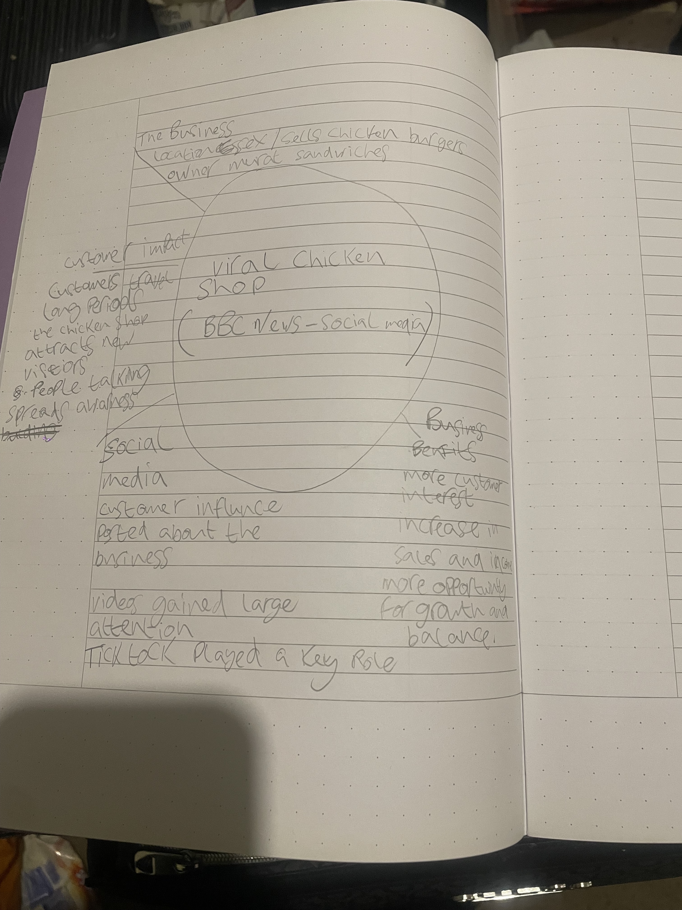

PART 2:
- Answer every question below in 1-3 full sentences.
- Use your own words. Do not use generative AI to answer these questions.
- Include a specific detail from the text when asked.
REMINDER
- The main idea is the overall message of the whole text.
- A key point helps to explain the main idea.
- A specific detail or example from the text shows that the key point is true.

- What is the main idea of the whole text?
The main idea and purpose of this article and text is that the power of social media can help small business grow. For example customers play a key role posting videos online which can gain popularity which can then increase sales.

- What is one key point that supports the main idea, and which specific example from the text shows this?

One of the key points is that customers travelled from far away this is the power of social media which is so key in this text as the chicken shop became so popular after videos were posted this shows how vital social media is as a tool in gaining customers.

- What is a different key point that supports the main idea, and which specific example from the text shows this?

Another main key point in this article and text is that running a new popular business can create new challenges for staff and the owner. A key example is the shop will ne busy with lots of customers so this would put pressure on staff to make food quicker this means more business brings responsibility and benefits.

- Which part of the text do you think is most important, and why?
I think the most important text for me is the customers travelling from long distances just to come get food from the shop this show a small business which becomes popular can attract customers from all different places as the company gets bigger and gains value and substance.

Reflection:
- What did you find difficult in this task (including in-class components), and why was it difficult?

I found it kind of difficult to find key points of the text at the start as some of the points were kind of similar which was challenging as I had to read the article carefully.

- What helped you with this difficulty, and how did it help you?
What helped me was reading the article properly and creating a mind map which gave me the vison and guidance to help me get information from the text and right it in my own words properly .

