
Portfolio of Health and Social Care Services: Domiciliary Care and Ambulance Services
Student Name: Ashfaq Mohammad
Student ID Number: 2504711
Programme: Certificate of Higher Education Skills for the Workplace (Health & Social Care)
Module Code and Title: LCHS4003 - Introduction to Health and Social Care
Lecturer: Dr Helen Parsons
Assignment Title: Portfolio - Domiciliary Care Services and Ambulance Services
Submission Date: 23 February 2026

Portfolio Introduction
This portfolio explores key services within health and social care in the United Kingdom. It is divided into two parts. Task 1 focuses on domiciliary care services and explains what the service is, its history, how it works today, the challenges it faces, and why it is important for service users. Task 2 examines ambulance services by exploring their historical development, current functioning, and their role in improving quality of life. Together, both tasks highlight how health and social care services support independence, wellbeing, and safe care within the community and the wider healthcare system.

Poster Domiciliary Care Services (Home Care)
What is domiciliary care?  Brief history of domiciliary care  In the past, most care was provided by family members and neighbours. During the 20th century, local authorities began organising home help services for older and disabled people. After the creation of the National Health Service (NHS) in 1948, community-based care continued to develop alongside hospital services. Today, domiciliary care is an important part of adult social care in England (NHS England, 2017)  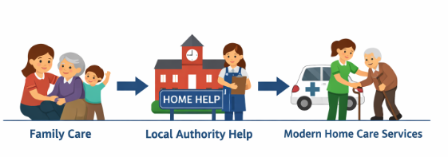 | How domiciliary care works today (Current Functioning)  - Domiciliary care services are provided by local councils, private care agencies, and charities. People can access care through a referral from a GP, hospital staff, or social services.  - Some people also arrange care privately. Before care starts, a needs assessment is carried out and a care plan is created. Care workers then visit the person’s home at agreed times to provide support (NHS, 2023).  - Care services are monitored by the Care Quality Commission (CQC) to help make sure care is safe and effective (CQC, 2024).  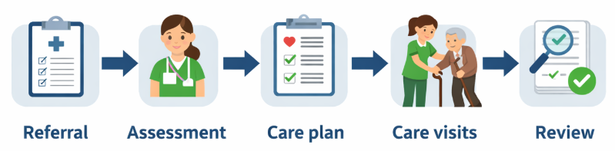  Why domiciliary care is important?  - Domiciliary care helps people stay in their own homes, close to family and friends. It supports independence, dignity, and wellbeing.  - Home care can also reduce pressure on hospitals by helping people return home sooner and avoid unnecessary admissions (NHS England, 2022).  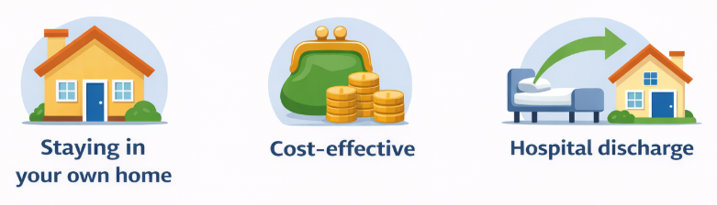
References
Care Quality Commission. (2024). The state of health care and adult social care in England 2023–24. https://www.cqc.org.uk/publications/major-report/state-care
NHS. (2023). Help at home from a paid carer. https://www.nhs.uk/social-care-and-support/care-services-equipment-and-care-homes/homecare/
NHS England. (2017). End of life care: Route to success – domiciliary care. https://www.england.nhs.uk
NHS England. (2022). Care closer to home. https://www.england.nhs.uk/nhs-at-home/
Skills for Care (2024) The state of the adult social care sector and workforce in England. https://www.skillsforcare.org.uk

Essay - Ambulance Services: Origins, Current Functioning, and Importance for Quality of Life

Introduction
Ambulance services are a vital part of the healthcare system in the United Kingdom. They provide urgent medical care, emergency transport, and life-saving treatment. This essay explores the origins of ambulance services, examines how they function today, and discusses their importance in improving the quality of life of service users.

Origins and historical development
Ambulance services in the UK began in the late nineteenth century. Early ambulance care was mainly provided by voluntary organisations such as St John Ambulance and the British Red Cross. These services focused on first aid and transporting injured people, often using horse-drawn vehicles (St John Ambulance, 2023).
During the early twentieth century, local authorities started to organise ambulance transport, especially for people with infectious diseases and those injured at work. The Second World War played a major role in developing emergency medical response systems due to the high number of casualties (NHS England, 2022).
A major turning point came in 1948 with the creation of the National Health Service (NHS). Ambulance services became publicly funded and more structured. Over time, the role of ambulance staff expanded from transport only to providing clinical care. The introduction of paramedics in the 1970s significantly improved pre-hospital emergency care (O’Cathain et al., 2014).

How ambulance services function today
Today, ambulance services in England are delivered through NHS ambulance trusts under NHS England. They respond to emergency calls made through the 999 system and are supported by the NHS 111 service for urgent but non-emergency care (NHS England, 2023).
Ambulance calls are prioritised using a triage system. Life-threatening emergencies such as cardiac arrest receive the fastest response. Modern ambulance crews include paramedics and emergency medical technicians who can assess patients, provide advanced treatment, and decide whether hospital transport is needed (O’Cathain et al., 2014).
A key strength of current ambulance services is their expanded role. Many patients are now treated at home or referred to community services instead of being taken to hospital. This will decongest the emergency departments. Nevertheless, the ambulance services are experiencing serious challenges such as staff shortages, high demand and delays during hospital handovers. These challenges may influence the response time and the welfare of the staff (NHS Providers, 2024).
More importantly, ambulance services are not isolated. Their success is conditional on the broad health and social care system. Hospital or community care problems may decrease the availability of ambulances and lead to an increase in patient waiting time.

Importance for quality of life
Ambulance services play a crucial role in improving the quality of life of service users. Fast emergency response can save lives and reduce long-term disability. Timely intervention in the case of strokes, heart attacks, and serious injuries will enhance recovery and autonomy (NHS England, 2022).
The ambulance personnel also offer assurance and emotional support in cases of emergencies, a factor that lessens the panic of the patients and their families. The creation of the treat and refer and community paramedic jobs enables the patients to be treated at home since it promotes dignity and comfort. This will assist individuals to save time and money that are spent in hospitals not as vital and stay near to the support they have (O’Cathain et al., 2014).
In general, ambulance services can increase the quality of life, provide care in a timely manner, reduce health complications, and assist in decision-making that is patient-focused.

Conclusion
In conclusion, ambulance has evolved since the primitive transport services to become highly qualified emergency medical service providers. They are still vital to the NHS despite the existing demands. The ambulance services help save the life of service users and enhance the quality of life by delivering quick response in treating patients, assisting them achieve independence, and minimizing hospitalization.

Portfolio Conclusion
Conclusively, this portfolio has indicated the significance of domiciliary care service and ambulance service in the health and social care system of the UK. Domiciliary care helps individuals to live freely and with dignity in their own homes, whereas ambulance services help people with lifesaving care that is urgent and expedient during emergencies. Despite the issue of staff shortage and higher demand in both services, they are critical in supporting the needs of the service users. All in all, these services are useful to improve the quality of life, decrease the load on the hospitals, and promote person-centred care in the community.

References
Care Quality Commission. (2024). The state of health care and adult social care in England 2023–24. https://www.cqc.org.uk/sites/default/files/2024-10/20241025_stateofcare2324_print_0.pdf (Accessed: 4 February 2026).
NHS England. (2022). Urgent and emergency care plan. https://homelinkhealthcare.co.uk/wp-content/uploads/2023/07/NHS-England-Delivery-Plan-for-Urgent-and-Emergency-Care-Jan2023.pdf (Accessed: 4 February 2026).
NHS England. (2023). Ambulance services. https://www.england.nhs.uk (Accessed: 4 February 2026).
NHS Providers. (2024). Ambulance service pressures and performance. https://nhsproviders.org/resources/nhs-activity-tracker-202425/august-2024/ambulance-sector/ (Accessed: 4 February 2026).
NHS. (2023). Help at home from a paid carer. https://www.nhs.uk/social-care-and-support/care-services-equipment-and-care-homes/homecare/ (Accessed: 4 February 2026).
NHS England. (2017). End of life care: Route to success – domiciliary care. https://www.england.nhs.uk/improvement-hub/wp-content/uploads/sites/44/2017/11/End-of-Life-Care-Route-to-Success-domiciliary-care-1.pdf (Accessed: 4 February 2026).
NHS England. (2022). Care closer to home. https://www.england.nhs.uk/setting/care-close-to-home/ (Accessed: 4 February 2026).
O’Cathain, A., Knowles, E., Turner, J., Maheswaran, R., Goodacre, S., Hirst, E., & Nicholl, J. (2014). Explaining variation in emergency admissions: a mixed-methods study of emergency and urgent care systems. Health Services and Delivery Research, 2(48), 1–126. https://doi.org/10.3310/hsdr02480
Skills for Care. (2024). The state of the adult social care sector and workforce in England. https://www.skillsforcare.org.uk (Accessed: 4 February 2026).
St John Ambulance. (2023). Our history. https://www.sja.org.uk (Accessed: 4 February 2026).

