Nathan J Morris

This dissertation focusses on the grout repair methods of boreholes within concrete spillways, and which type is most effective
Borehole Repairs On Concrete Spillway Structures

Authors declaration
I declare that the work in this dissertation was carried out in accordance with the
regulations of UWTSD. The work is original except where indicated by special
references in the text and no part of the dissertation have been submitted for any other degree.
Any views expressed in the dissertation are those of the author and in no way
represent those of the UWTSD.
The dissertation has not been presented to any other University for examination either in the United Kingdom or overseas.
I hereby give permission for my work, if accepted, to be available for photocopying
and inter-library loan, and for the title and summary to be made available to outside
organisations.

Signed:

Date: 15/04/2026

Acknowledgements
I would like to thank Hannah Williams for her incredible support throughout my dissertation, without her guidance I wouldn’t have been able to complete this project, I am extremely grateful. I would also like to thank Sergio Gerate for his assistance in the Laboratory and help with ordering all the materials and allowing me the time to complete the testing of my samples.

Abstract
This dissertation investigates the effectiveness of cementitious, epoxy, and polyurethane grouts in restoring the compressive strength of drilled boreholes in concrete spillway structures. A laboratory-based experimental programme was undertaken using 100 mm concrete cubes with centrally drilled 25 mm diameter boreholes to simulate intrusive investigation works commonly required in dam safety projects. Specimens were repaired using each grout type and tested in accordance with BS EN 12390-3.

Test groups comprised of intact control cubes (n = 6), drilled but unfilled cubes (n = 5), and drilled cubes repaired using cementitious, epoxy, and polyurethane grouts (n = 5 per group). Specimens were tested in compression and peak failure load (kN) were recorded. Independent-sample Welch t-tests were performed to assess statistical significance between groups and Cohen’s d tests were used to determine the difference between the samples.

Drilling resulted in a substantial and statistically significant reduction in mean capacity. Among repaired specimens, cementitious grout achieved the highest mean recovery and demonstrated a statistically significant improvement compared to drilled-unfilled specimens. Polyurethane grout produced intermediate recovery but with greater variability, while epoxy grout performed significantly worse than expected and did not demonstrate statistically significant improvement relative to drilled-unfilled specimens within this dataset.

The findings confirm that drilled boreholes represent a structurally significant discontinuity and that grout type significantly influences strength recovery. In this experimental programme, cementitious grout provided the most effective structural reinstatement, while polyurethane and epoxy systems exhibited greater variability and lower mean recovery. These results support the need for material specific repair strategies in spillway maintenance and contribute evidence-based guidance for dam safety practice under increasingly demanding loading conditions.

Table of Contents
Authors declaration 1
Acknowledgements 1
Abstract 2
1. Introduction 6
2. Literature Review / Background 8
2.1 Spillway Failures 8
2.2 Importance of Spillways in Dam Safety 10
2.3 Concrete in Spillway Construction 10
2.4 Degradation Mechanisms in Spillways 12
2.5 Effects of Drilled Holes on Concrete Integrity 12
2.6 Grouting Techniques in Concrete Repair 14
2.7 Historical Applications of Grouting in Dam Spillways 14
2.8 Grout types 14
2.8.1 Cementitious Grouts 14
2.8.2 Epoxy Grouts 15
2.8.3 Polyurethane Grouts 17
2.9. Summary 18
3. Methodology 19
3.1 Experimental Design 19
3.2 Materials and Equipment 19
3.2.1 Materials 19
3.2.2 Equipment 20
3.3. Concrete methodology 20
3.3.1 Concrete mix design 20
3.4. Concrete Mixing and Casting 21
3.4.1 Hole Drilling Procedure (Day 29 - 35) 22
3.4.2 Grouting Procedure (Day 29 - 35) 22
3.4.3 Compressive Strength Testing (Day 63–Day 68) 22
3.5. Health and Safety 22
3.6. Data Recording 22
3.7. Data Analysis Plan 23
3.8. Expected Outcomes and Hypothesis 23
3.9 Declared hypotheses: 23
4. Results 25
4.1 Concrete Quality 25
4.1.1 Initial Mix 25
4.1.2 Modified Mix design 26
4.2 Mix Comparison 27
4.3 Sieve analysis 28
4.4 Drilled Cubes 30
4.5 Compression test results 31
4.6 Descriptive Statistics 33
4.6.1 Inferential Statistics: Independent-Samples t‑Tests (Welch) 34
4.7 Interpretation of Findings 36
4.7.1 Notes on Assumptions and Reporting 37
4.7.2 Cohen’s d Effect Size Calculations 38
4.7.3 Anomalies 40
4.7.4 Limitations to the study 41
5. Conclusion 42
5.1 Overall findings against objectives 42
5.2 Dam safety spillway significance 44
5.2.1 Practical considerations 45
5.2.2 Cost considerations 45
5.3 Findings 45
5.4 Dam safety best practice 46
5.5 Recommendations for future research 46
6. References 48
Appendix 51
1. Task Risk Assessment 51
2. BRE concrete mix design 53
3. 20mm aggregate sieve analysis 54
4. Sand sieve analysis 54
5. Compression comparison graphs 55
6. Statistical calculations summary 61
7. Two tailed significance t test tables 63

Figure 1. Typical Earth embankment dam, Talybont reservoir, Brecon, South Wales (DCWW, 2020). 7
Figure 2 Toddbrook reservoir auxillary spillway failure (BBC news, 2019). 9
Figure 3 – Overview of Talybont earth embankment dam and typical Dam features 11
Figure 4 – Types of spillways -Standard spillway chute, stepped spillway and Ogee spillway 12
Figure 5 Typical core hole and part of a sample taken in a concrete spillway at Talybont reservoir (Morris N, 2024). 14
Figure 6 Grouting of borehole void within Talybont spillway (Morris N, 2024). 14
Figure 7 Image of voiding from Mix A (Morris N, 2026) 27
Figure 8 SDS drill and concrete cube (Morris N, 2026). 32
Figure 9 - Max failure rates for the concrete cubes 34
Figure 10 - Left – Concrete cube undergoing compression testing. Right – Concrete cube after failure. 34
Figure 11- Task Risk Assessment 54
Figure 12- Solid specimen compression test results 55
Figure 13- Hole specimen compression test results 56
Figure 14- Epoxy resin specimen compression test results 57
Figure 15- Cementitious specimen compression test results 58
Figure 16- Polyurethane specimen compression test results 59
Figure 17- Average compression test results for all specimens 60
Figure 18 - T-Test table (Scribbr, 2023). 63
Figure 19- Concrete mix design form (BRE, 2010). 64

Introduction
Reservoirs and dams are critical components of the United Kingdom’s water infrastructure, providing essential services that extend far beyond simple water storage. They underpin domestic and industrial water supply, agricultural irrigation, hydropower generation, and flood mitigation (Environment Agency, 2023). The strategic significance of reservoirs lies in their ability to manage hydrological variability, ensuring water availability even under conditions of drought or excessive rainfall, both of which are being exacerbated by climate change (UK Government, 2025). Consequently, the integrity and safe operation of dams and their associated structures, such as spillways, are of paramount importance.

In the context of climate change, the UK faces increasing hydrological volatility, with more intense rainfall events and prolonged dry spells (Met Office, 2022). Reservoirs therefore serve as essential buffers against these extremes. They store surplus rainfall during wetter months for use during dry periods, supporting both population centres and ecological systems (Bates, et al., 2008). However, this increased variability also places greater stress on reservoir infrastructure, particularly spillways, which act as crucial safety features by allowing controlled release of excess water to prevent overtopping and potential dam failure (Bruggeman & Cordeira, 2016). The design, capacity, and maintenance of spillways are therefore vital to the long-term resilience of these assets.

Investigations into spillway integrity require intrusive investigative work such as coring into the spillway slab, while necessary, drilling introduces geometric discontinuities that impact the strength of the concrete and may create leakage paths if left unrepaired. While grouting is routinely specified following core extraction, limited comparative evidence exists regarding the relative structural effectiveness of different grout systems under compressive loading. This dissertation addresses a practical yet under-researched question: How well do common grout materials (cementitious, epoxy and polyurethane) restore the structural integrity of these drilled boreholes in concrete spillways?

The objectives of this study are to:
- Analyse contemporary literature on spillway performance, concrete degradation and repair grouting.
- Quantify the compressive strength of an unfilled borehole.
- Compare strength recovery of filled boreholes using cementitious, epoxy and polyurethane grouts
- Translate findings into actionable guidance for dam safety best practice.


Figure 1. Typical Earth embankment dam, Talybont reservoir, Brecon, South Wales (DCWW, 2020).

Despite extensive research into concrete repair materials and grouting techniques, existing literature predominantly focuses on bond performance, durability, and general repair applications, with limited emphasis on the direct structural implications of intrusive investigative works such as borehole drilling in spillway structures. There is a lack of controlled experimental data quantifying the loss of compressive strength caused by drilled discontinuities and the extent to which different grout materials can effectively reinstate that strength. This represents a critical gap, given the increasing reliance on intrusive investigations within ageing dam infrastructure and the need to ensure that such interventions do not compromise structural integrity. To address this, the present study adopts a laboratory-based experimental methodology using 100 mm concrete cube specimens with centrally drilled boreholes, repaired using cementitious, epoxy, and polyurethane grouts, and tested under compressive loading to enable direct comparison of strength recovery. This study contributes new comparative experimental evidence regarding the structural effectiveness of grout materials used to reinstate boreholes in concrete spillway structures.

The dissertation is structured as follows: Chapter 2 reviews relevant literature on spillway performance, concrete degradation, and grouting technologies; Chapter 3 outlines the experimental methodology and data analysis approach; Chapter 4 presents and analyses the results; and Chapter 5 discusses the findings in relation to existing research and provides conclusions and recommendations for practice and future study.

Literature Review / Background
The Reservoirs Act 1975 forms the cornerstone of legal oversight for reservoir safety in the UK. It mandates regular inspections by qualified civil engineers and the implementation of safety measures for all reservoirs with capacities exceeding 25,000 cubic metres in England and 10,000 cubic metres in Wales (UK Legislation, 2026). This legislation, strengthened by provisions in the Flood and Water Management Act 2010, aims to ensure that reservoir owners adopt proactive management and maintenance strategies and emergency planning (UK Legislation, 2026). This dissertation will look at Spillway failures and their significance, the importance of spillways within dam safety, concrete as a material and its degradation as well as grout materials and their role in repairing holes within these spillways and what grout type is the most appropriate.

2.1 Spillway Failures
The significance of spillway performance and dam safety was most recently brought into focus within the UK by the 2019 Toddbrook Reservoir incident in Whaley Bridge, Derbyshire. 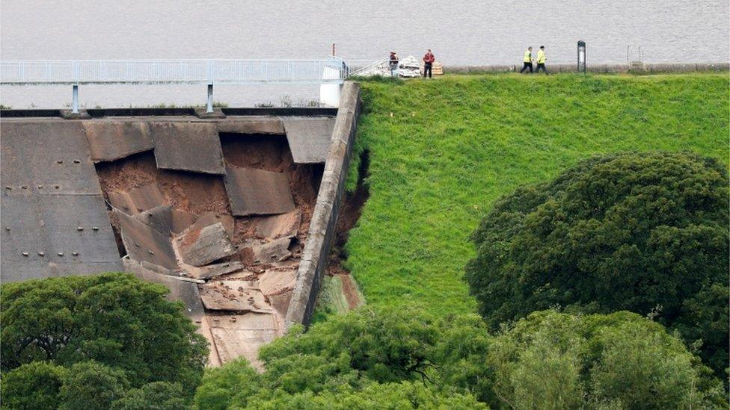
Figure 2 Toddbrook reservoir auxillary spillway failure (BBC News, 2019).

Following intense rainfall, severe damage occurred to the auxiliary spillway, prompting the evacuation of approximately 1,500 residents due to fears of a catastrophic failure of the dam (Environment Agency, 2020).

The subsequent Bamforth Report (Bamforth, 2020) provided an independent review of the incident, and it revealed that the spillway’s deterioration was the result of long-term degradation, inadequate maintenance, and outdated design standards. Constructed in the 1960s, the spillway did not meet modern design expectations for hydraulic loading or resilience, which is extremely common within the UK, and nearly all spillways fall into this category of not meeting the latest modern design standards. The concrete slabs were poorly anchored, lacked sufficient drainage beneath them, and suffered from erosion of joint material, which allowed seepage and pressure fluctuations to weaken the structure over time (Bamforth, 2020). Additionally, earlier inspections under the Reservoirs Act 1975 had not identified the scale of vulnerability within the spillway. The review found that visual inspections alone were insufficient to detect underlying structural deterioration and that risk-based assessment approaches should be adopted going forward. Crucially, it underscored that climate change is likely to increase the frequency of extreme rainfall events that test the limits of spillway capacity and structural integrity. (Bamforth, 2020).

Following on from this incident existing spillways are now part of very thorough testing, both intrusively and remotely. Non-intrusive methods are always undertaken first using ground penetrating radar equipment, combined with some physical boreholes to accompany these surveys. The intrusive works involve coring through these concrete slabs to identify the underlying geology. These investigative boreholes can then introduce additional weaknesses in the monolithic concrete.

In the aftermath of Toddbrook, there has been renewed emphasis on ensuring that the statutory framework evolves to reflect both ageing infrastructure and emerging climatic risks. The Environment Agency (2021) has since prioritised the reassessment of spillway design, existing condition, their capacities and the adoption of modern hydraulic modelling techniques to better predict performance under extreme conditions (Environment Agency, 2022).

The lessons from Toddbrook and the Bamforth Review highlight that reservoir safety cannot rely solely on compliance with minimum legal standards; it must be an ongoing process of innovation, monitoring, and adaptation. Spillways once considered passive, secondary features must now be recognised as active components of dam safety management, requiring rigorous design review and maintenance in the face of increasingly unpredictable weather events. As Bamforth argues, the integration of climate resilience into reservoir safety management is not optional but essential for safeguarding communities, ecosystems, and national water security.
While the Toddbrook incident highlights the importance of spillway integrity and maintenance, the literature largely focuses on large-scale structural failure mechanisms, inspection limitations, and hydraulic loading conditions. Comparatively little attention is given to the secondary effects of investigative practices themselves, particularly the structural implications of intrusive borehole drilling within concrete spillway slabs. Although such investigations are necessary for condition assessment, they introduce localised discontinuities that may reduce structural capacity. The extent to which these artificially introduced defects influence compressive strength, and how effectively they can be mitigated through repair, remains insufficiently explored in current literature.

2.2 Importance of Spillways in Dam Safety
Spillways are engineered structures designed to convey a controlled release of water from a dam, typically into the river below. The main function of the spillway is to safely discharge excess flows during storm events, while maintaining appropriate flood freeboard (Environment Agency, 2022). Spillways are essential for preventing overtopping of the dam, which can lead to catastrophic failure of the structure.
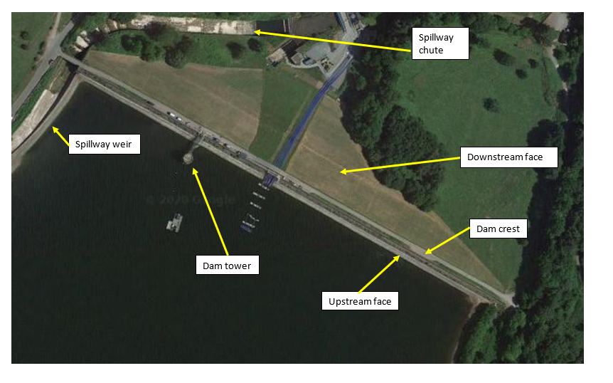
Figure 3 – Overview of Talybont earth embankment dam and typical Dam features

2.3 Concrete in Spillway Construction
Concrete is commonly used in the construction of spillways due to its durability, resistance to erosion and ability to withstand significant hydraulic forces, its exceptional combination of mechanical strength, impermeability, and adaptability to complex hydraulic structures. Reinforced concrete additionally combines the compressive strength of concrete with the tensile capacity of steel reinforcement, allowing it to resist dynamic and impact loads caused by turbulent water and debris (Environment Agency, 2022). Moreover, concrete’s inherent rigidity and mass provide stability against uplift and sliding forces, ensuring long-term integrity of the spillway structure.
Spillways are continuously subjected to high energy water flows often laden with abrasive sediments and rocks. Concrete, particularly when designed with a dense microstructure and proper surface finishing, provides excellent abrasion resistance (Environment Agency, 2022). Proper curing and compaction further ensure that the material maintains low porosity, preventing water ingress and freeze thaw deterioration (Neville, 2011).

Another key advantage of concrete is its formability and adaptability during construction. It can be cast into various geometries, which is essential for developing spillways with complex profiles such as ogee, stepped, or chute configurations that help control and dissipate flow energy (Environment Agency, 2022).
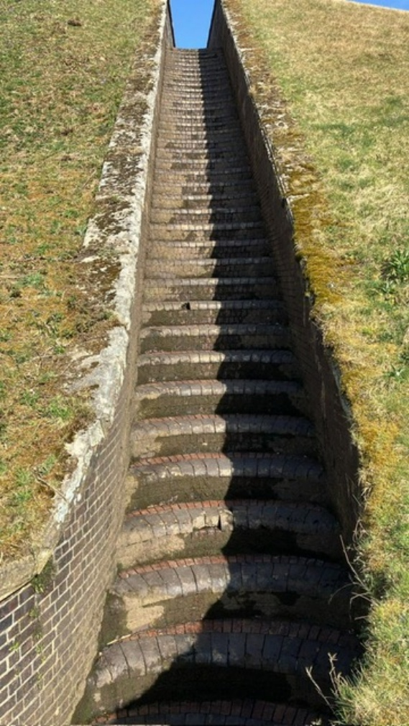
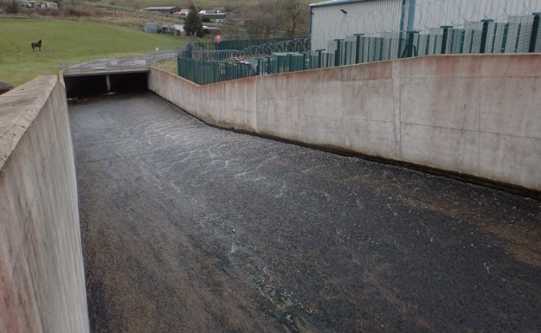



Figure 4 – Types of spillways -Standard spillway chute, stepped spillway and Ogee spillway

From an economic and practical standpoint, concrete is also favoured due to its relative cost effectiveness and availability. The raw materials cement, aggregates, and water are widely accessible, and the technology for concrete placement and curing is well established globally (Barbhuiha, 2024). When combined with appropriate design, quality control, and maintenance, concrete spillways can achieve operational lifespans exceeding 50 to 100 years with minimal major repair (Environment Agency, 2022).

2.4 Degradation Mechanisms in Spillways
Although concrete spillways can achieve significant lifespans, over the course of this they are subject to various degradation mechanisms as summarised by (Neville, 2011) below, including:
Chemical Attack: Exposure to aggressive agents such as sulphates and chlorides can lead to chemical reactions that deteriorate the concrete matrix.
Freeze-Thaw Cycles: In colder climates, the freeze-thaw cycle can cause expansion and contraction within the concrete, leading to cracking and spalling.
Abrasion and Erosion: High-velocity water flow can cause physical wear on the spillway surface, leading to material loss and surface roughness.
Alkali-Aggregate Reaction: A chemical reaction between alkalis in cement and reactive silica in aggregates can cause expansion and cracking in concrete.
All the above can significantly impact the spillway and its ability to safely discharge water and how the spillway can safely withstand the hydraulic load (compressive strength), this constant cyclic loading can weaken the concrete comprising its structural integrity, efficiency and combined with additional intrusive boreholes lead to increased failure rates/

These degradation mechanisms necessitate regular inspection and maintenance to ensure the continued performance of spillway structures.

2.5 Effects of Drilled Holes on Concrete Integrity
Drilling holes for ground investigation boreholes into these concrete structures introduces discontinuities that can significantly affect their mechanical properties. Studies have shown that the presence of holes can lead to stress concentrations, which may reduce the load-bearing capacity of concrete elements. (Yehia et al, 2024).

Additionally, the behaviour of concrete columns with drilled holes has been examined, revealing that drilling can cause instability and reduce specimen strength by 10% to 46%, depending on the size and location of the holes (Son, 2006) It is therefore essential that these holes are repaired correctly to ensure the structural integrity of the spillway is not compromised.

To mitigate these effects, grouting techniques are employed to fill the drilled holes, aiming to restore the monolithic nature of the concrete and regain close to its original design strength.

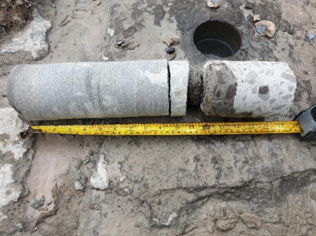
Figure 5 Typical core hole and part of a sample taken in a concrete spillway at Talybont reservoir (Morris N, 2024).
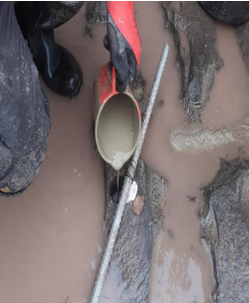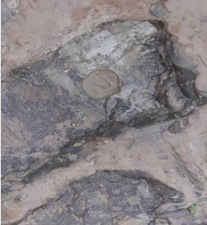
Figure 6 Grouting of borehole void within Talybont spillway (Morris N, 2024).

2.6 Grouting Techniques in Concrete Repair
Grouting is a widely used technique for repairing and strengthening concrete structures. It involves injecting a fluid material which cures hard into boreholes, voids or cracks to restore structural integrity and prevent water ingress (Lianyang Zhang, 2006). The selection of appropriate grouting materials and methods is critical for the success of repair works and depends on various factors, including the nature of the damage, the size of the void, environmental conditions, and structural requirements.

2.7 Historical Applications of Grouting in Dam Spillways
Grouting has been employed in numerous dam projects to address issues related to seepage, voids, and structural weaknesses. Notable examples include:

Tunstall Reservoir, UK: In 1876, engineer Thomas Hawksley utilised pressure grouting with cement grout to reduce leakage within the rock foundation under an earth embankment dam. This marked one of the earliest applications of grouting in dam construction and set a precedent for future projects (Science Museum Group, 2026).

Oroville Dam, USA: In 2017, the Oroville Dam experienced significant spillway damage due to heavy rainfall and subsequent erosion. Emergency repairs involved extensive grouting to stabilise the structure and prevent further deterioration (Irfan Alfi, 2019).

Grouting is also used extensively on more routine filling of borehole voids within spillways; it is this type of repair that will be the focus of this research project; however, all of these cases underscore the critical role of grouting in maintaining the safety and functionality of dam spillways.

2.8 Grout types

2.8.1 Cementitious Grouts
Cementitious grouts are widely used due to their compatibility with concrete and cost-effectiveness. They are suitable for filling large voids and provide good structural strength. However, they may be prone to shrinkage and require proper curing (Gomes, 2023).
As mineral-based materials, they exhibit good volumetric compatibility with mass concrete, especially in large-volume applications like dam spillways (Silva, 2019). They are typically used in pressure grouting to fill voids and cracks and offer acceptable compressive strength under controlled conditions.

However, the literature is critical of their mechanical limitations. According to (Gomes, 2023) cementitious grouts can be susceptible to plastic shrinkage and cracking, particularly if hydration is incomplete or environmental moisture control is inadequate. Despite admixtures designed to mitigate shrinkage, performance is still highly dependent on-site conditions.

Furthermore, cementitious grouts are not recommended in dynamic or structurally sensitive zones. (Silva, 2019) argue that their relatively low bond strength and stiffness make them less suitable for critical load-bearing applications, especially where reinstatement of mechanical continuity is essential.

A comprehensive review of cementitious grouts highlights the importance of complete void filling and good adhesion to surfaces to ensure effective repairs.

Cementitious grouts are widely used in structural repair due to their compatibility with concrete substrates, particularly in terms of stiffness, thermal expansion, and load transfer characteristics. However, much of the literature evaluates their performance in terms of durability, permeability reduction, or crack filling, rather than their ability to restore compressive strength in elements with discrete geometric discontinuities such as drilled holes. This suggests that, despite perceived limitations, cementitious grouts may be more effective for load-path reinstatement than is typically assumed in the literature. Although cementitious grouts are often considered weaker in bond strength than polymer systems, their compatibility with concrete may make them more suitable for compressive load transfer applications. As such, while cementitious materials are generally assumed to be structurally compatible, their effectiveness in reinstating load-bearing capacity in this specific context requires further investigation.

2.8.2 Epoxy Grouts
Epoxy grouts offer high strength and excellent adhesion, making them suitable for structural repairs. They are less prone to shrinkage but are more expensive and may be sensitive to temperature variations during application (Emmons, 1995).

Epoxy grouts have gained prominence due to their superior bond strength, low permeability, and chemical resistance (Lim, 2015). Their application in core hole repair is particularly suited to dry environments where structural recovery is a priority. (Hollaway, 2008) demonstrated that epoxy-bonded concrete interfaces restore nearly 95% of original compressive capacity under laboratory conditions.

Despite these strengths, epoxy grouts are not without limitations. First, their thermal expansion coefficients often differ from those of surrounding concrete, potentially leading to stress concentrations under fluctuating temperatures (Neville, 2011). Secondly, they require rigorous substrate preparation and strictly controlled moisture conditions. This makes their application in spillways, often exposed to groundwater and runoff, challenging in practice.

While epoxy grouts are often cited as offering “structural grade” performance, the literature lacks large-scale, in-situ testing under hydraulic loading.

Much of the supporting literature is derived from bond strength, tensile interface, or flexural performance testing rather than volumetric compressive reinstatement of removed concrete mass, most existing data are based on controlled laboratory environments, raising concerns over their field robustness.

This distinction is critical. Borehole repair in spillways primarily concerns axial load-path continuity rather than adhesive interface performance alone. The present study therefore provides a more context specific assessment by examining compressive load restoration within a removed core volume, a parameter less frequently addressed in published repair comparisons.

Epoxy grouts are frequently reported to exhibit superior bond strength and tensile properties compared to cementitious systems, leading to their widespread use in high-performance repair applications. However, these advantages are often evaluated in the context of bonding and crack injection rather than bulk compressive behaviour. Additionally, the higher stiffness and differing failure mechanisms of epoxy-based systems may result in stress concentrations when used in conjunction with concrete substrates under compressive loading. This gap in research raises questions regarding whether the theoretical advantages of epoxy translate into improved structural reinstatement in borehole repair scenarios as most supporting research focuses on interface behaviour rather than direct restoration of compressive capacity.

2.8.3 Polyurethane Grouts
Polyurethane grouts are flexible and expand upon application, making them ideal for sealing leaks. However, they do not provide significant structural strength and are typically used in conjunction with other repair methods (Meimei, 2026).

Polyurethane (PU) grouts are praised for their expansive characteristics and ability to function in wet or saturated environments. Unlike cementitious or epoxy systems, PU grouts can react with moisture to expand and fill voids, making them highly effective in leak-sealing applications (Alchatek, 2023). Their use in hydrodynamic environments such as dams and spillways is widespread for non-structural repairs.

However, a critical review of available sources indicates significant limitations. Firstly, PU grouts exhibit lower compressive and tensile strength than both epoxy and high-grade cementitious grouts (Lim, 2015). This restricts their application in load-bearing repairs, a limitation often overlooked in promotional literature by manufacturers. (Haruna, 2024) observed that while PU grouts effectively halted leakage, they showed structural deficiencies under sustained load, failing to restore 47.3% of the original strength in drilled specimens.

Furthermore, the literature reveals a lack of consensus on the long-term behaviour of PU grouts. Questions remain over their dimensional stability over time, particularly in chemically aggressive or high-temperature environments. Case studies detailing PU grout degradation due to hydrolysis and microbial activity have yet to be robustly incorporated into industry best practices.

Although some studies (Haruna, 2024) highlight the adaptability of PU systems to complex geometries and rapid set times, these benefits may be outweighed by their lower modulus and vulnerability to thermal cycling, which are under-explored in long-term monitoring research.

Recent evaluations indicate that polyurethane grouts effectively repair concrete structures with adequate bond strength, exceeding the minimum allowable bond strength for rehabilitation of impaired concrete structures (Haruna, 2024), but have lower stiffness and strength relative to cementitious and epoxy systems. This may limit their effectiveness in applications where structural load transfer is critical. Much of the existing literature focuses on sealing and waterproofing applications rather than structural reinstatement. Consequently, there is limited evidence regarding their performance in restoring compressive capacity in drilled concrete elements, particularly under controlled loading conditions and therefore their lower stiffness may limit their suitability for structural reinstatement.

2.9. Summary
Existing literature provides limited comparative analysis of the performance of various grouting materials in restoring the compressive strength of mass concrete structures, and in particular the grouting of the boreholes drilled within the spillway structure itself, there is also a lack of standardised methodologies for assessing the efficacy of grouting repairs in laboratory settings.

Most studies test bond strength or sealing and not the compressive strength after reinstatement. This study aims to address these gaps by conducting a comprehensive laboratory investigation using concrete cube tests. By drilling holes into standard concrete specimens and repairing them with different grouting materials, the study will evaluate the extent to which each material restores the compressive strength of the repaired concrete. The findings will inform best practices for the maintenance and repair of boreholes within concrete spillways, contributing to the broader field of dam safety and infrastructure resilience.

Overall, the current literature demonstrates a strong understanding of spillway performance, concrete degradation mechanisms, and the properties of various grout materials used in repair applications. However, there remains a notable gap in experimentally validated research that directly links intrusive investigative practices, such as borehole drilling, with subsequent structural performance and repair effectiveness.
Existing studies tend to focus on material properties, bond strength, or durability, rather than quantifying the recovery of compressive strength following repair. Furthermore, limited comparative data exists evaluating different grout types within a controlled and consistent experimental framework. This gap is significant given the increasing reliance on intrusive investigations in ageing dam infrastructure. Therefore, this dissertation seeks to address this gap by experimentally quantifying strength loss due to borehole drilling and evaluating the effectiveness of different grout materials in restoring compressive capacity under controlled laboratory conditions.

3. Methodology

3.1 Experimental Design
An experimental program was designed to assess the impact of drilled holes and subsequent grouting on the compressive strength of concrete cubes. The study involved preparing concrete specimens, introducing controlled defects, applying various grouting materials, and conducting compressive strength tests. Although cube specimens simplify real spillway geometry, they provide a controlled and repeatable method for comparing grout behaviour under compressive loading. Concrete cubes were cast and cured under standard conditions for 28 days. After curing, holes of 25mm diameter were drilled centrally in selected specimens to simulate real world boreholes within concrete spillways. Grouting materials were then applied according to manufacturer specifications. Risk assessments for the task can be found in the appendix to this report.

Table 1 Total Specimens: 25 concrete cubes (100 mm x 100 mm x 100 mm)
Group Number | Description | Quantity
1 | Control (no hole) | 6
2 | Drilled hole (unfilled) | 5
3 | Drilled + cementitious grout | 5
4 | Drilled + epoxy grout | 5
5 | Drilled + polyurethane grout | 5

3.2 Materials and Equipment

3.2.1 Materials
Concrete Mix: A standard mix design targeting a compressive strength of 35N/mm at 28 days.
- Ordinary Portland Cement (CEM I 35N)
- 20 mm coarse aggregates
- Fine aggregates (sand)
- Clean potable water
- Specimens: 100mm x 100mm x 100mm concrete cubes.

Grout materials
- Cementitious grout
- Epoxy grout (2-part system)
- Polyurethane grout

3.2.2 Equipment
- Concrete mixer
- Cube moulds (100 mm x 100 mm x 100 mm)
- Vibrating table or rod for compaction
- Digital weighing scale
- Water curing tank
- Core drill with 25 mm bit and pilot hole drill bit
- Universal Compression Testing Machine (UTM)
- Mixing and pouring tools (trowels, buckets etc)

3.3. Concrete methodology

3.3.1 Concrete mix design
Concrete mix design is the process of finding the correct proportions of sand, cement, and aggregate to achieve a specified target strength that has been pre-defined for its intended use (BSI, 2019).

Concrete cubes are required for the experiment and to do this an initial design for a control sample of concrete was needed using a traditional mix design (Cement, water, fine and coarse aggregate).

For the mix design a target specified strength of 35N/mm² at 28 days was specified due to its common use in structural building elements such as foundations, columns, slabs and its specified use for environmental durability (BSI, 2013).

To calculate the required parameters for this target strength the BRE concrete design form was used, this can be seen in the appendix to this report.

The Concrete mix design form allows in conjunction with various graphs and tables on free water cement ratios, slump test and density charts to determine the various parameters for the mix design and enable calculation of the correct quantities of materials to be used in the experiment.

Working through the BRE table and calculating the required parameters it was possible to determine the correct volumes and quantities to enable the initial concrete design.
The specified characteristics of this mix were outlined prior to the experiment and can be found below.

- Characteristics of compressive strength (fc), 35N/mm2 at 28 days
- Portland cement class C35
- Slump required up to 100mm
- Coarse aggregate, uncrushed up to 20mm
- Max free water cement ratio 0.5
- Minimum cement content 390 kg/m3
- Aggregate relative density 2.5
- Fine aggregate (sand) 90% passing 600 micron sieve

The completed Quantities from the BRE form can be found below.
Table 2 – Completed BRE mix design form
Quantities | Cement (Kg) | Water (ltr) | Fine Aggregate (Kg) | Course aggregate (Kg)
 |  |  |  | 10 mm | 20 mm | 40 mm
Per m3 (5kg) | 390 | 195 | 689.7 |  | 1125.3
Trial mix 0.03m3 | 11.7 | 5.85 | 20.7 |  | 33.76

The mix design form was then further amended to calculate the volumes required of materials for the concrete moulds, this meant a design of 0.03m³ trial mix to be developed. This was calculated based on needing sufficient concrete for the 25 moulds required to test (0.025m³) with a 20% (0.005m³) wastage built in.

3.4. Concrete Mixing and Casting
- Mix standard C35 concrete per BS 8500.
- Prepare cube moulds with mould oil to avoid sticking.
- Fill each mould in 2 layers of concrete mix, compact each layer using vibrating table or tamping rod.
- Level the top surface with a trowel.
- Place all moulds together on metal tray.
- Store in controlled environment for 24 hours (20°C ±2, 95% RH).
- Demould and place in water curing tank for 28 days.

3.4.1 Hole Drilling Procedure (Day 29 - 35)
- Securely clamp each cube in position.
- Measure centre hole accurately and drill pilot hole
- Use a 25 mm core drill to bore a hole through the centre (vertically).
- Drill depth must span 2/3 cube height to create a realistic cavity but prevent grout loss through the base (66 mm).
- Clean the holes using compressed air and water with a hard brush to remove debris, as this can impact grout adhesion to the concrete cube.

3.4.2 Grouting Procedure (Day 29 - 35)
Prepare grout materials per manufacturer instructions.
- Mix cementitious grout to a fluid consistency.
- Use two-component mix for epoxy and polyurethane grouts.
Insert grouts into drilled holes using approved manufacturer methods.
Gently vibrate or tap cubes to avoid void formation.
Allow grouted cubes to cure under appropriate conditions:
- Cementitious: 7 days at room temperature.
- Epoxy and Polyurethane: air cure at room temperature for 7 days.

3.4.3 Compressive Strength Testing (Day 63–Day 68)
- Test all 25 cubes using a UTM as per BS EN 12390-3:2019.
- Record peak load at failure and calculate compressive strength:
- Strength MPa = Failure Load (kN) / 22500 mm^2
- Note failure mode and surface observations.

3.5. Health and Safety
All tasks must comply with Risk assessment criteria in Appendix 1

3.6. Data Recording
- Record mix ratios, curing times, hole depths, grout types, ambient conditions.
- Store compressive strength and failure mode in structured table.
- Take photos of each failure for documentation.

3.7. Data Analysis Plan
Calculate average compressive strength and standard deviation for each group.
Perform percentage recovery comparison:
Recovery %= Grouted Strength\ Control Strength * 100
- Use graphs for initial comparison and statistical analysis for in depth explanations
- Highlight and explain results

3.8. Expected Outcomes and Hypothesis
In this study, the null hypothesis (H^{₀}) states that there is no statistically significant difference in mean peak failure load between the groups being compared, and that any observed differences are due to random variation within the sample data rather than a genuine effect of drilling or repair material. In practical terms, this means that, under the null hypothesis, drilling a borehole or repairing it with a particular grout would not be expected to produce a meaningful change in compressive load capacity beyond normal specimen-to-specimen variability. The alternative hypothesis (H^{₁}), by contrast, is that a real difference does exist between the group means. For this investigation, the working hypothesis was that drilling would reduce the compressive strength of the concrete specimens and that the application of grout materials would restore strength to differing extents depending on the repair material used. More specifically, it was expected that epoxy grout would provide the most reliable structural recovery, while cementitious and polyurethane grout would show lower or more variable levels of reinstatement under the conditions tested. Statistical testing was therefore used to assess whether the observed differences between groups were large enough to reject the null hypothesis and support the research hypothesis.

3.9 Declared hypotheses:
H^{₀}: There is no statistically significant difference in mean peak failure load between the control, drilled, and repaired specimen groups.
H^{₁}: There is a statistically significant difference in mean peak failure load between the control, drilled, and repaired specimen groups.

It was anticipated that the introduction of a drilled borehole would lead to a measurable reduction in the compressive strength of the concrete specimens. The presence of a void within a concrete element alters the internal stress distribution and introduces stress concentrations, which can reduce the load-bearing capacity of the material. Previous research indicates that such discontinuities can significantly weaken concrete elements particularly when the void interrupts the primary compressive load path. Following this reduction in strength, it was expected that the installation of grout materials would provide varying levels of structural recovery depending on the mechanical properties and compatibility of each material with the surrounding concrete. Epoxy grout systems are commonly cited in the literature as providing very high bond strength and compressive performance and therefore were anticipated to restore a large proportion of the original structural capacity. Cementitious grout systems were expected to provide a moderate but reliable level of strength recovery due to their compatibility with concrete and widespread use in structural repair applications. In contrast, polyurethane grout systems were anticipated to demonstrate lower levels of structural strength recovery. While these materials are highly effective at sealing voids and controlling water ingress, they typically possess lower compressive strength and stiffness compared with cementitious and epoxy systems.

As a result, polyurethane was expected to provide improved void filling and sealing performance but a more limited contribution to compressive load-bearing capacity.

Overall, the experimental programme was therefore designed to test the extent to which each grout type could restore compressive strength relative to intact control specimens. By comparing repaired specimens with both control and drilled–unfilled samples, the study aimed to quantify the structural implications of borehole drilling and evaluate the effectiveness of commonly used grout materials in reinstating the compressive load path within concrete spillway structures.
Based on the current literature, results may show the below expected outcomes
- Drilled specimens will show ~25% reduction in strength.
- Epoxy grout will likely restore ~95% strength based on research.
- Cementitious grout may recover ~85% of original strength.
- Polyurethane will show lower mechanical recovery but good sealing.
- Establish guidance for appropriate grout choice based on repair function.

4. Results
This section presents and evaluates the experimental results obtained from the laboratory programme. Results are structured to first assess concrete quality and specimen validity, followed by the effect of drilled boreholes and the comparative performance of each grout type.

4.1 Concrete Quality

4.1.1 Initial Mix
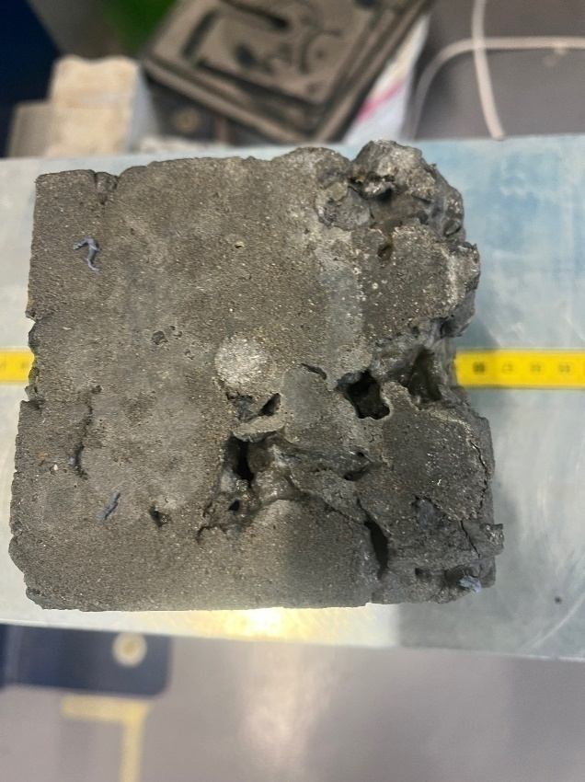
The initial results for the concrete cubes were varied, despite a normal 70mm slump test for the mix, (which indicates a good healthy workable concrete mix and no indication of any issues) some cube samples were of good quality but it was evident after demoulding that some cubes suffered significant voiding. Initial 7 day testing
Figure 7 Image of voiding from Mix A (Morris N, 2026)

showed that they were well below the expected 50% strength values anticipated, this was confirmed when the cubes were tested at the 28 day point where some cubes achieved compressive strength results of 405.43KN but others displayed significant voiding and poor 28 day compressive strength of only 251KN. (Figure 7 above). This variation in strength proved significant and would make comparison of grout types impossible due to the inability to differentiate between the concrete cube strength and or the influence of the grout type on strength recovery. Consequently, the Mix A specimens cannot be relied upon for meaningful compressive strength comparison.

Because compressive strength testing assumes homogeneous specimens prepared in accordance with recognised standards (e.g. BS 8500-1), the observed voiding and post-casting modification of the Mix A cubes undermine their compliance with these assumptions. Accordingly, the Mix A results are excluded from quantitative strength comparison and are instead treated as a diagnostic trial illustrating the sensitivity of small-scale specimens to aggregate size and compaction procedure (BRE, 2010).

Due to this variability between concrete cubes, it was decided to design a second set of cubes with a slightly different mix design and both batches have been labelled “Mix A” for the first mix and the second mix has been called “Mix B”.

4.1.2 Modified Mix design
In Mix B the aggregate sizing had been reduced, based on research by the concrete society (2026) it was found that in a 100 mm cube, 20 mm aggregate is relatively large compared with the specimen dimension. Larger particles have higher settling tendency, particularly during placement and consolidation when the mortar phase is temporarily mobilised which may have led to the weaker compressive strength results (Concrete.org, 2026).

In cube manufacture, standards emphasise controlled filling and compaction to avoid segregation and non-uniformity (BRE, 2010), and due to the poor voiding experienced in Mix A, it was decided a good option to improve the cubes second time around and minimise potential voiding would be to use a smaller sized aggregate but keep all quantities the same.

Compaction issues from Mix A, may also have contributed to potential voiding, the cubes were compacted using a trowel alone. Although the cubes looked perfectly fine within the moulds this is non-standard best practice and can introduce two competing problems:

- Inadequate air removal, leaving voids and reducing strength; and
- Local ‘stirring’ or dragging of coarse particles, encouraging settlement and non-uniform distribution.

Standard cube-making guidance calls for thorough re-mixing, layered filling, and systematic rodding or controlled vibration, with finishing by trowel only after compaction (BSI, 2013). Mix B was tamped 30 times for each of the two layers placed within the mould and carefully vibrated to remove any entrapped air particles to potentially improve the quality of the cubes.

By contrast, the second series of cubes cast using 10 mm aggregate (Mix B) demoulded cleanly and displayed a dense, uniform appearance with no visible honeycombing or segregation. Despite the higher measured slump during casting, the hardened specimens exhibit satisfactory surface integrity and dimensional consistency. These cubes are therefore considered suitable for subsequent compressive strength testing, with the caveat that increased workability and potential bleeding effects are acknowledged and discussed elsewhere in this section.

4.2 Mix Comparison
Below is a brief overview of both mix designs and observations during the cube making process
Table 3 - Mix designs
Mix | Cement (kg) | Water added (L) | Sand (kg) | Coarse aggregate (kg; size)
Mix A | 11.7 | 5.85 | 20.7 | 33.76; 20 mm
Mix B | 11.7 | 5.85 | 20.7 | 33.76; 10 mm

Table 4 - Mix comparison descriptions
Comparison criterion | Mix A (20 mm; 70 mm slump) | Mix B (10 mm; 140 mm slump)
Primary observed issue | Visible coarse aggregate settlement to the base of 100 mm cubes (segregation). | Excessive measured slump; increased risk of bleeding and strength distribution.
Most plausible dominant cause | Aggregate size vs specimen scale + non-standard compaction with trowel. | Higher effective water content from sand moisture + possible wet cone/base influence on slump reading.
Underlying explanation | Under placement/working, large particles migrate downward while mortar phase rises; trowel compaction can exacerbate particle rearrangement. | Extra free water reduces cohesion; water migrates upward (bleeding) while solids settle; high workability amplifies sensitivity to handling.
Expected hardened-state impacts | Non-uniform aggregate distribution; higher void content; reduced and more variable compressive strength. | Potential higher effective w/c, bleeding; potentially lower strength and higher variability if moisture differed across moulds.
Validity threats (experimental) | Compaction method not aligned to BS 8500-1; distribution may not represent ‘in situ’ concrete. | Uncontrolled aggregate moisture and potential test-method artefacts; effective w/c likely differed from design.

4.3 Sieve analysis
To ensure consistent aggregate sizes, a sieve analysis was carried out on the nominal 10 mm coarse aggregate used in Mix B to assess its grading and to identify the presence of oversized particles and fines that may influence workability, segregation potential, and overall concrete performance. The total sample mass tested was 5.0 kg of the total 33.76kg sample, this amount was the average distribution of aggregate throughout the total mix. The sieve analysis for the 20mm aggregate and sand can be found within the appendix.

The measured mass retained on each sieve and the corresponding percentage by mass are summarised below.
Table 5 - 10mm Sieve analysis
Sieve size (mm) | Mass retained (kg) | Percentage of total (%)
Less than 10 mm (predominantly fines/dust) | 0.24 | 3.6
10 mm | 3.08 | 61.6
16 mm | 1.44 | 28.8
20 mm | 0.30 | 6.0

The results indicate that approximately 61.6% of the aggregate mass falls within the nominal 10 mm size fraction, confirming that the material is predominantly a 10 mm aggregate. However, a notable proportion of oversize particles is present, with 28.8% retained on the 16 mm sieve and a further 6.0% retained on the 20 mm sieve. In addition, 3.6% of the sample passed the 10 mm sieve, consisting primarily of fine particles and dust.

The presence of oversize particles may partially explain the sensitivity of small (100 mm) cube specimens to compaction and segregation effects, even when nominally using a 10 mm aggregate. Conversely, the fines content is likely to have increased the apparent workability of the mix, contributing to the higher measured slump observed during casting. These grading characteristics should therefore be considered when interpreting both fresh and hardened concrete behaviour associated with Mix B (The sand sieve analysis can be found in the appendix to this report.

The slump test result of mix B was recorded as 140mm, significantly higher than the same mix design that Mix A recorded (70mm). This may be attributed to the fine aggregate (sand) which readily exchanges moisture with the surrounding environment. After oven drying, sand particles exhibit a strong tendency to re-absorb water vapour from ambient air until equilibrium moisture content is reached (Neville, 2011). The rate and magnitude of this re-absorption depend on temperature, relative humidity, particle size distribution, and available surface area (Duan, et al., 2022).

Cold laboratory environments like the UWTSD CWIC building can exacerbate moisture uptake. Lower air temperatures reduce the saturation vapour pressure of air, increasing the likelihood of condensation on aggregate surfaces when relative humidity is moderate to high (Mehta, 2014). Studies show that dried aggregates stored in unsealed containers may regain a significant proportion of their original moisture content within several days to one week (Duan, et al., 2022).

Research indicates that oven-dried natural sands can re-absorb approximately 0.5–2.0% moisture by mass within 3–7 days when stored at relative humidities of 50–75% (Mehta, 2014). Even a 1% moisture increase corresponds to 10 kg of additional water per tonne of sand.

Unmeasured moisture re-absorption directly increases effective mixing water. Variations in fine aggregate moisture are a dominant cause of slump variability in both laboratory and field concrete production (Mehta, 2014). In small batches, the proportional effect is particularly pronounced.

Sand that had previously been dried was stored for approximately one week in a cold laboratory prior to use. Based on published data, it is reasonable to assume moisture re-absorption in the range of 0.5–2.0% by mass. For the quantities used, this corresponds to approximately 0.1–0.4 litres of unaccounted water, which is sufficient to explain the observed increase in slump.

This is what could have increased the water content to a level where it was of a much higher workability, this however didn’t impact the cube manufacturing and all cubes appeared of good quality enabling the next stage of the process, which was to test the grout strength and drill the cubes.

4.4 Drilled Cubes
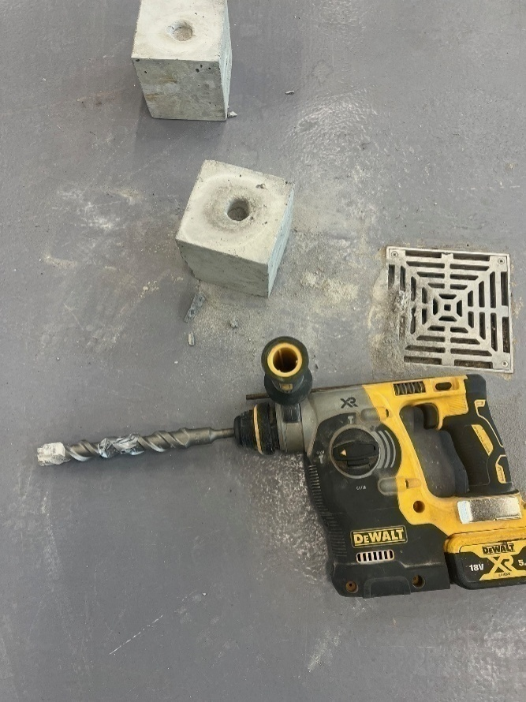
The cubes were drilled vertically to a depth of 66mm with a diameter of 25mm, these were drilled using a battery operated SDS drill, resembling how on-site boreholes would be drilled within spillway structures.
Figure 8 SDS drill and concrete cube (Morris N, 2026).

The specimens were then cleaned and prepared ready for the three grout types to be added, these were then left to set for 7 days prior to the compressive strength testing.

The orientation of concrete specimens during compressive strength testing was carefully considered to ensure methodological robustness, repeatability, and compliance with relevant United Kingdom standards. In accordance with BS EN 12390-3:2019, the concrete cubes were positioned such that the compressive load was applied vertically as this resembles the forces experienced in the real world and the hydraulic loading from the water on the spillway structure. This orientation was selected deliberately to assess the structural reinstatement of the primary load path through the concrete element and reflects standard UK laboratory practice and ensures consistency with established strength determination procedures used for structural compliance testing (BSI, 2019).

Rotating specimens onto their side would have altered the orientation of the void relative to the applied load, introducing an additional experimental variable and potentially influencing failure mode. Such an approach may lead to differing stress concentrations, crack propagation mechanisms, and splitting behaviour, thereby reducing comparability between test groups. By maintaining a consistent vertical orientation across all specimens (control, drilled-unfilled, and drilled-filled), the study isolates grout performance as the primary independent variable, strengthening the internal validity of the results.

Furthermore, adherence to BS EN 12390-3:2019 supports methodological reliability and professional credibility (BSI, 2019). In UK practice, compressive strength results inform structural design verification and compliance assessment. Aligning this experimental programme with those procedures enhances the transferability and defensibility of the findings within the context of dam safety and spillway maintenance.

4.5 Compression test results
This section presents the compressive test results for all specimen groups and evaluates differences between repair materials using independent samples (t‑tests) as well as Cohen’s d tests. Test outcomes were recorded as peak failure load (kN). All specimens shared the same geometry and loading arrangement, comparisons based on load are directly equivalent to comparisons based on compressive strength (MPa). For reference, where a 100 mm × 100 mm loaded area is assumed, strength (MPa) may be obtained by multiplying load (kN) by 0.1; this conversion does not affect statistical outcomes because it is a linear scaling.

Figure 9 below visually illustrates the failure point of each specimen and details of the full compression test results for all samples can be found within the appendix of this report, further statistical analysis will explain the results and look for quantifiable trends within the data. The control specimens achieved a mean compressive strength of 356 KN at 28 days, slightly below the nominal cube strength expected for C35 concrete. However, it is recognised that smaller cube sizes, laboratory batching variability, curing conditions and scale effects may influence measured strength, and as all specimens were cast from the same batch, the relative comparisons between test groups remain valid.
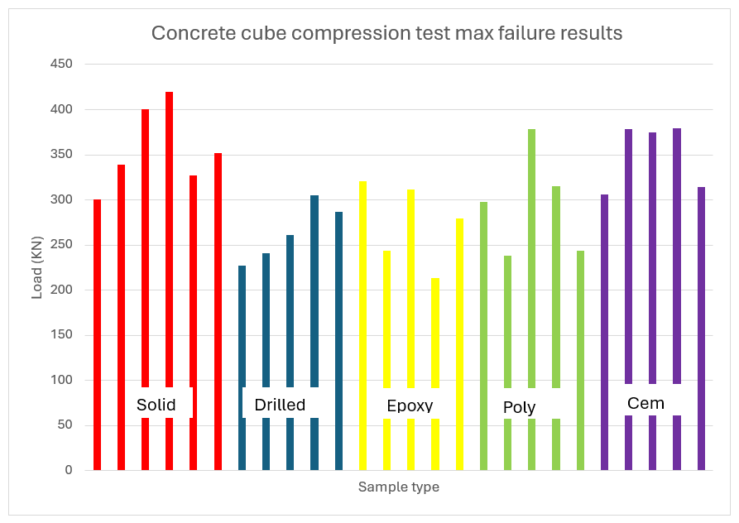
Figure 9 - Max failure rates for the concrete cubes

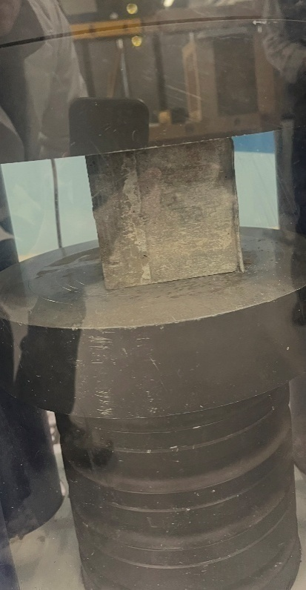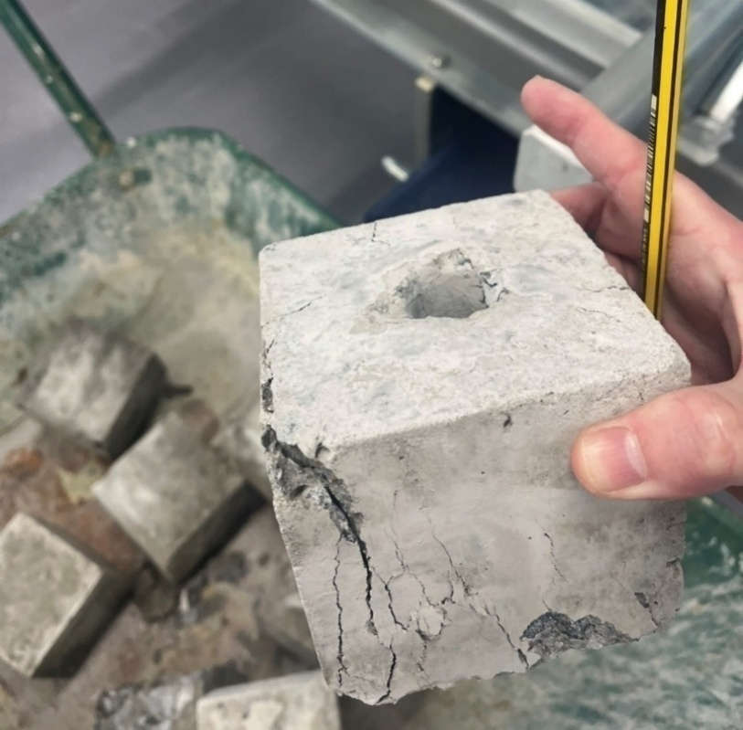
Figure 10 - Left – Concrete cube undergoing compression testing. Right – Concrete cube after failure.

4.6 Descriptive Statistics
To provide an initial quantitative overview of specimen performance, descriptive statistics were calculated for each test group. Descriptive statistics are used to summarise the main features of a dataset, allowing patterns in strength performance to be identified before more detailed inferential testing is undertaken (Green, 2023). In this study, they provide an overview of average load capacity, the spread of results within each group, and the extent to which repaired specimens approached the performance of the intact control cubes. Examining these values is important because it allows the relative consistency and effectiveness of each grout type to be assessed before determining whether any observed differences are statistically significant.

Table 6 summarises the descriptive statistics for each group. These values provide an overview of both average performance and the degree of variability within each specimen group and the central tendency and dispersion of each group. The drilled (unfilled) specimens showed a clear reduction in mean capacity relative to intact control cubes. Among repaired specimens, cementitious grout produced mean loads closest to the control group, while epoxy grout exhibited the lowest mean of the three grout types in this dataset. Polyurethane grout showed an intermediate mean but with the greatest variability (highest standard deviation), indicating inconsistent performance across replicates. All statistical calculations have been worked out in the same way and example calculations can be found in the Appendix.

Table 6 - Descriptive statistics for peak failure load (kN) and indicative strength (MPa)*.
Group | n | Mean (kN) | SD (kN) | Variance (kN²) | Min (kN) | Max (kN) | % of control | Mean (MPa)*
Solid (Control) | 6 | 356.257 | 45.180 | 2041.23 | 300.493 | 419.353 | 100.0% | 35.63
Drilled (Unfilled) | 5 | 264.044 | 32.081 | 1029.19 | 227.126 | 305.197 | 74.1% | 26.40
Epoxy grout | 5 | 273.831 | 45.512 | 2071.34 | 213.264 | 320.945 | 76.9% | 27.38
Polyurethane grout | 5 | 294.817 | 57.651 | 3323.64 | 238.628 | 378.807 | 82.8% | 29.48
Cementitious grout | 5 | 350.503 | 36.878 | 1359.99 | 305.909 | 379.164 | 98.4% | 35.05

*MPa values are indicative and assume a 100 mm × 100 mm loaded face; they are included to aid interpretation and do not alter comparative conclusions.

4.6.1 Inferential Statistics: Independent-Samples t‑Tests (Welch)
To test whether observed differences between groups were statistically meaningful, independent-samples t‑tests were performed. Welch’s t‑test was used throughout because it does not assume equal variances and is widely recommended where group variances and sample sizes may differ (West, 2021).

The experimental groups were of comparable sample size, which supports balanced comparison across the dataset. However, inspection of the descriptive statistics showed that the variance was not consistent between groups, with certain grout types displaying a wider spread of results than others. This suggests differing variances and justifies the use of a statistical test that does not require equal variances.

Variance is a statistical measure of dispersion that shows how far individual results are spread around the group mean. In this study, the underlying measured values are peak failure loads in kilonewtons (kN), so the variance values are expressed in kN². Higher variance indicates a greater spread of results and therefore less consistent behaviour within a group, whereas lower variance indicates that the results are more tightly clustered and therefore more repeatable

All tests are two‑tailed with α = 0.05.(Please see appendix 7, (Scribbr, 2023)).

The significance level (α) defines the threshold for determining whether a result is statistically significant. In this study, α = 0.05 was used, meaning that results with a p-value below 0.05 were considered unlikely to have occurred by chance alone and were therefore treated as statistically significant. Results with p-values above this threshold were not considered statistically significant within this dataset (West, 2021).

Given the number of pairwise comparisons, Holm’s sequential correction is also reported to indicate which findings remain significant under familywise error control.

Table 7 - Welch t‑tests comparing specimen groups (kN).
Comparison | Mean diff (kN) | t | df | p | p (Holm) | Sig (Holm) | 95% CI low | 95% CI high
Solid (Control) vs Drilled (Unfilled) | 92.213 | 3.946 | 8.84 | 0.0035 | 0.0350 | Yes | 39.202 | 145.223
Drilled (Unfilled) vs Cementitious grout | -86.459 | -3.955 | 7.85 | 0.0044 | 0.0393 | Yes | -137.03 | -35.883
Drilled (Unfilled) vs Epoxy grout | -9.787 | -0.393 | 7.19 | 0.7057 | 1.0000 | No | -68.361 | 48.786
Drilled (Unfilled) vs Polyurethane grout | -30.773 | -1.043 | 6.26 | 0.3356 | 1.0000 | No | -102.24 | 40.703
Solid (Control) vs Cementitious grout | 5.754 | 0.233 | 9.00 | 0.8213 | 1.0000 | No | -50.218 | 61.726
Solid (Control) vs Epoxy grout | 82.425 | 3.001 | 8.62 | 0.0157 | 0.1254 | No | 19.866 | 144.985
Solid (Control) vs Polyurethane grout | 61.440 | 1.938 | 7.56 | 0.0907 | 0.5444 | No | -12.412 | 135.293
Cementitious grout vs Epoxy grout | 76.672 | 2.927 | 7.67 | 0.0200 | 0.1399 | No | 15.807 | 137.536
Cementitious grout vs Polyurethane grout | 55.687 | 1.819 | 6.80 | 0.1129 | 0.5644 | No | -17.110 | 128.483
Epoxy grout vs Polyurethane grout | -20.985 | -0.639 | 7.59 | 0.5417 | 1.0000 | No | -97.450 | 55.479

4.7 Interpretation of Findings
Drilling a 25 mm borehole produced a substantial reduction in strength capacity. The mean peak load reduced from 356.3 kN (control) to 264.0 kN (drilled–unfilled), equivalent to 74.1% of the control mean. This difference was statistically significant under Welch’s t‑test (t = 3.95, p = 0.0035), with a 95% confidence interval for the mean reduction of 39.2 to 145.2 kN. The magnitude of the effect is large in practical terms, supporting the premise that intrusive investigation holes should be treated as structurally relevant discontinuities if left unrepaired.

Comparison of repaired specimens indicates that grout type materially influenced strength recovery. Cementitious grout achieved the highest mean load (350.5 kN), corresponding to 98.4% of the control mean. Relative to drilled–unfilled specimens, cementitious repair increased mean capacity by 86.5 kN (from 264.0 kN to 350.5 kN). This increase was statistically significant in the unadjusted Welch test (p = 0.0044) and remained significant after Holm adjustment (p = 0.0393). This supports the view that material compatibility may be more important than absolute bond strength in compressive reinstatement.

Epoxy grout produced a mean load of 273.8 kN (76.9% of the control mean), only marginally higher than the drilled–unfilled mean (264.0 kN). The epoxy vs drilled comparison was not statistically significant (p = 0.7057). This contrasts with Hollaway (Hollaway, 2008), who reported near-complete strength recovery under controlled conditions, suggesting that bond performance does not directly translate to compressive load-path reinstatement. In this dataset, epoxy performance was more variable and included a low-strength replicate, which increased dispersion and reduced the mean.

Although epoxy systems are frequently marketed as providing superior structural repair, the present dataset did not demonstrate statistically significant compressive strength reinstatement relative to drilled–unfilled specimens. This outcome suggests that bond strength alone does not guarantee restoration of primary compressive load strength. The observed variability further indicates sensitivity to installation quality and curing control. These findings emphasise that material performance must be evaluated against structural function rather than manufacturer specification alone.

Polyurethane grout achieved an intermediate mean load of 294.8 kN (82.8% of control), but with the largest variability (SD = 57.7 kN). This indicates potential value where sealing and moderate structural recovery are both required and aligns with existing literature identifying polyurethane grout systems as effective sealing materials but limited in structural loading applications. The polyurethane vs drilled comparison did not reach statistical significance (p = 0.3356). The wide spread of results suggests sensitivity to factors such as void filling completeness, mixing/injection consistency, and/or curing conditions, which should be controlled tightly if polyurethane is to be assessed for any structural contribution but is unrealistic in real world conditions.
Overall, the ranking of mean performance in this programme was:
- Cementitious
- Polyurethane
- Epoxy
- Drilled – Unfilled.
However, given the small sample sizes (n = 5 per repaired group) and observed variability, especially for polyurethane and epoxy, these findings should be interpreted as evidence from a controlled comparative study rather than definitive field performance. The statistically robust outcome is that drilled holes significantly reduce capacity, and that cementitious grouting in this dataset delivered a statistically significant recovery relative to unfilled holes.

4.7.1 Notes on Assumptions and Reporting
Sample sizes were inevitably limited by laboratory constraints (Limited moulds, time and small-scale mixing capabilities). With small n, formal normality testing has low power; consequently, the analysis prioritised effect sizes, confidence intervals, and the use of Welch’s t‑test to reduce sensitivity to unequal variances (West, 2021). Reporting both unadjusted and Holm‑adjusted p‑values provides transparency around multiple testing while allowing the primary engineering interpretation to be grounded in practical effect magnitude and repeatability.

4.7.2 Cohen’s d Effect Size Calculations
In addition to hypothesis testing, effect sizes were calculated using Cohen’s d to quantify the magnitude of differences between specimen groups. While p-values indicate whether a difference is statistically detectable within a given sample size, they do not describe how large or practically meaningful that difference is. Cohen’s d addresses this limitation by expressing the mean difference between two groups relative to pooled variability (RPsychologist, 2026).
Cohen’s d was calculated using the standard formula:
$$d=\frac{(M_{1}-M_{2})}{SDpooled}$$
where M₁ and M₂ represent the group means, and SDpooled is calculated as:
$$SDpooled=\sqrt{\frac{({SD}_{1}^{2}+{SD}_{2}^{2})}{2}}$$
Given the relatively small and similar group sizes (n = 5–6), this pooled standard deviation approach provides a robust estimate of standardised difference magnitude.

Conventional interpretation thresholds proposed by Cohen (1988) classify effect sizes of approximately d = 0.2 as small, d = 0.5 as medium, and d = 0.8 or greater as large. These thresholds provide a useful guide for understanding the practical magnitude of the difference between two groups, independent of sample size (RPsychologist, 2026).

A small effect size suggests that the difference between group means is noticeable but modest relative to the variation within the data. A medium effect size indicates a more substantial difference that is likely to be meaningful in practical terms, while a large effect size represents a strong separation between groups and suggests that the observed difference is not only statistically detectable but also likely to be important in real-world applications.

In engineering-based experimental studies, effect sizes that exceed 0.8 are often particularly significant because they indicate that the change in performance is large relative to natural specimen-to-specimen variability.

Therefore, Cohen’s d is valuable because it complements p-values by helping to distinguish between results that are merely statistically significant and those that are also practically or structurally meaningful.

Within structural engineering contexts, values substantially exceeding 1.0 indicate differences that are not only statistically significant but structurally meaningful in practice (RPsychologist, 2026).
Control vs Drilled-Unfilled
Pooled SD = √[(45.180² + 32.081²) / 2] = 39.18 kN
Cohen’s d = (356.257 − 264.044) / 39.18 = 2.35
Interpretation: d = 2.35 is far greater than 0.8 (large threshold). This represents a very large structural effect, confirming substantial reduction in compressive capacity due to drilling.

Drilled-Unfilled vs Cementitious Grout
Pooled SD = √[(36.878² + 32.081²) / 2] = 34.56 kN
Cohen’s d = (350.503 − 264.044) / 34.56 = 2.50
Interpretation: d = 2.50 indicates a very large practical recovery effect. Cementitious grout produces a structurally meaningful restoration.

Drilled-Unfilled vs Epoxy Grout
Pooled SD = √[(45.512² + 32.081²) / 2] = 39.37 kN
Cohen’s d = (273.831 − 264.044) / 39.37 = 0.25
Interpretation: d = 0.25 represents a small effect size, supporting the finding that epoxy did not significantly restore compressive capacity.

Drilled-Unfilled vs Polyurethane Grout
Pooled SD = √[(57.651² + 32.081²) / 2] = 46.65 kN
Cohen’s d = (294.817 − 264.044) / 46.65 = 0.66
Interpretation: d = 0.66 represents a small-to-moderate effect size, indicating partial structural contribution but not large recovery.

Cohen’s d provides a standardised measure of magnitude, independent of sample size. Whereas p-values assess statistical detectability, effect sizes quantify engineering relevance. In small-sample laboratory testing (n = 5–6), effect size reporting is particularly important because statistical power may be limited. Large values of d in this study confirm that drilling has a major structural impact and that cementitious repair produces a significant recovery effect on compressive strength.

4.7.3 Anomalies
Inspection of the compression curves in the appendix showed that for Cementitious data point C1 and Polyurethane data point P5 behaved differently from the other specimens in their respective groups. In the C specimens, C2, C3 and C4 followed a very similar pattern, reaching peak loads of approximately 375–380 kN at around 62–64 s, whereas C1 reached a substantially lower peak load of around 305 kN much earlier, at approximately 29 s. In the Polyurethane P specimens, P1, P3 and P4 showed a broadly similar progressive increase in load before reaching peak values between approximately 300 and 380 kN, while P5 peaked much earlier at approximately 245 kN and deviated clearly from the overall group trend.

When all specimens were included, the results showed greater within-group variability, particularly in relation to time to failure and peak load. This makes both specimen sets appear less consistent and suggests a wider spread in mechanical behaviour. C1 and P5 reduce the visual uniformity of the curves and may give the impression that the material behaviour is less repeatable.

When C1 and P5 were excluded, the remaining curves in both groups appeared more closely clustered. For the C group, the remaining specimens showed a much more consistent pattern of load development and peak load, with failure occurring later and at higher loads. For the P group, exclusion of P5 similarly made the group appear more uniform, although some variability remained because P2 also showed a somewhat lower peak load than P3 and P4. Overall, removing C1 and P5 would make the analysis appear clearer and more consistent, with the dominant trend in each group easier to identify.

However, excluding these specimens does not fundamentally change the overall conclusion that both groups show a general increase in load with time followed by post-peak softening. Instead, their removal mainly reduces scatter and strengthens the impression of repeatability within each group. For this reason, C1 and P5 are best described as potentially anomalous or atypical results, and their influence should be acknowledged through a brief sensitivity analysis rather than ignored entirely.

4.7.4 Limitations to the study
While the experimental programme undertaken in this dissertation provides a controlled comparison of grout performance in reinstating compressive strength, several limitations should be acknowledged when interpreting the findings. These limitations do not invalidate the results obtained but define the context within which the conclusions should be applied and highlight areas where further research would be beneficial.

Firstly, the number of specimens tested within each experimental group was relatively limited. Each repair category contained five specimens, which is common in small-scale laboratory investigations but restricts the statistical power of the analysis. With smaller sample sizes, individual specimen variability can have a greater influence on the calculated mean values and statistical comparisons. Although appropriate statistical methods such as Welch’s t-test and effect size analysis were employed to mitigate this limitation, future studies with larger datasets would improve the reliability and robustness of the conclusions.

Secondly, the study utilised 100 mm unreinforced concrete cube specimens to assess compressive strength recovery following borehole drilling and repair. While this approach provides a standardised and widely accepted method for evaluating concrete strength, it does not fully replicate the structural behaviour of reinforced spillway slabs. In practice, spillway structures experience multi‑axial stress states, reinforcement restraint, uplift pressures, and hydraulic forces that cannot be reproduced within small laboratory cube specimens. As such, the results should be interpreted primarily as a comparative assessment of material performance rather than a direct prediction of full-scale structural behaviour.

A further limitation relates to the controlled laboratory conditions under which the experimental programme was conducted. The specimens were prepared, repaired and tested within a stable indoor environment, allowing consistency between test groups. However, spillway structures in the field are exposed to significantly more complex environmental conditions including temperature fluctuations, moisture variation, hydrostatic pressure and chemical exposure. These factors may influence grout curing behaviour, bond performance and long-term durability in ways that are not captured within a laboratory setting.

In addition, the study focused on short‑term compressive strength recovery following grout installation and curing. Long‑term performance characteristics such as creep, shrinkage compatibility between grout and concrete, freeze–thaw resistance and durability under cyclic loading were beyond the scope of the investigation. For infrastructure such as dam spillways that are expected to operate safely over many decades, long‑term material behaviour is an important consideration and would benefit from further research.
Finally, the installation of grout materials within the specimens was performed under carefully controlled laboratory procedures in accordance with manufacturer guidance. In real construction environments, factors such as surface preparation, moisture conditions, installation technique and operator experience can influence the quality of grout placement and overall repair effectiveness. Variations in these practical factors may lead to differences between laboratory performance and field application outcomes. Future work investigating installation variables and field-based repair performance would therefore enhance the applicability of the findings presented in this study.

5. Conclusion

5.1 Overall findings against objectives
The first objective of this study was to quantify the loss in compressive strength caused by drilled investigative boreholes. This objective was successfully achieved, with the results demonstrating a clear and statistically robust reduction in load-bearing capacity following drilling. The mean peak failure load decreased from 356.3 kN in the solid control specimens to 264.4 kN in the drilled but unfilled specimens, representing a reduction to 74.2% of the control mean, or an overall strength loss of 25.8%. Statistical analysis confirmed that this reduction was significant using Welch’s t-test (p < 0.01), indicating that the presence of a drilled borehole had a measurable detrimental effect on structural performance. These findings suggest that investigative boreholes should not be regarded as minor or purely superficial defects, but rather as structurally relevant interventions that can reduce compressive load capacity unless appropriately repaired.

The second objective was to compare the degree of strength recovery achieved using different grout materials. This objective was also achieved, with clear differences identified between the repair materials in both mean performance and variability. Of the three grout types tested, cementitious grout produced the highest mean peak failure load at 350.5 kN, which corresponds to 98.4% of the control strength. Polyurethane grout achieved a mean peak load of 294.8 kN, equivalent to 82.8% of the control value, while epoxy grout produced the lowest mean recovery of the repaired groups at 273.8 kN, or 76.9% of the control mean. Inferential statistical testing showed that the cementitious grout group demonstrated a significant improvement when compared with the drilled–unfilled specimens (p < 0.01), and this result remained significant following Holm adjustment. By contrast, neither the epoxy nor polyurethane groups showed statistically significant improvement over the drilled specimens within this dataset. Taken together, these findings indicate that cementitious grout provided the most effective and consistent structural recovery under the conditions tested.

The third objective was to assess the suitability of the grout materials for structural and non-structural repair functions. This objective was met through evaluation of both average performance and the variability observed within each repair group. Cementitious grout performed best in terms of compressive load recovery and demonstrated relatively stable behaviour, indicating its suitability for structural reinstatement where restoration of the load path is the primary objective. Polyurethane grout, while achieving a moderate level of mean recovery, showed greater variability between specimens, suggesting that its structural contribution may be less reliable. However, given its known advantages in sealing and void filling applications, it may still be appropriate where watertightness rather than structural strength is the principal concern. Epoxy grout, although often expected to perform strongly due to its high bond strength and repair credentials in the literature, did not demonstrate a statistically significant improvement over the drilled group in this study. This may indicate sensitivity to factors such as installation quality, curing conditions, or specimen variability. Overall, the results suggest that grout selection should be led by the intended repair function, with a clear distinction made between structural reinstatement and non-structural sealing applications.

The fourth objective was to provide evidence-based guidance for spillway borehole repair. This objective was achieved through the practical implications drawn from the experimental findings. The results indicate that boreholes should be treated as structural interventions rather than cosmetic defects, particularly where the integrity of the compressive load path is important. Based on the findings, cementitious grout appears to be the most appropriate default material where the aim is to restore compressive strength capacity, especially when its structural performance is considered alongside its cost-effectiveness, availability, and compatibility with existing concrete. Polyurethane grout may still have a role in situations where leakage control or void sealing is the main requirement, but the current results suggest that it should not be relied upon for structural reinstatement. Overall, the study provides practical guidance for repair specification by demonstrating that borehole repairs should be selected according to performance requirements, rather than general repair assumptions alone. This study contributes practical evidence for dam safety engineers selecting grout materials following intrusive spillway investigations.

In summary, the study has shown that drilling significantly reduces the compressive strength of concrete, that the type of grout material used in repair has an important influence on the level of strength recovery achieved, and that cementitious grout provided the most effective structural reinstatement of the materials tested. More broadly, the findings support the view that spillway borehole repairs should be specified according to the intended repair function, with a clear distinction between structural restoration and sealing performance. Under the conditions examined in this investigation, cementitious grout emerged as the most practical and structurally effective option for restoring compressive load capacity.

5.2 Dam safety spillway significance
The results of this experimental programme demonstrate that drilled boreholes represent a structurally significant discontinuity within concrete elements and should not be ignored following investigative works. The introduction of a 25 mm diameter borehole through 100 mm cube specimens resulted in a statistically significant reduction in mean peak failure load, reducing capacity to approximately 74% of that of intact control specimens. This confirms that intrusive investigations undertaken within spillway slabs have the potential to compromise compressive load paths if not appropriately repaired. Within spillway structures, which are subjected to high hydraulic forces, uplift pressures and dynamic loading during flood events, such reductions cannot be disregarded from a dam safety perspective.

Among the repair materials tested, cementitious grout demonstrated the highest mean strength recovery. Statistical testing confirmed that cementitious repair produced a significant improvement relative to drilled unfilled specimens. In contrast, epoxy grout did not demonstrate a statistically significant increase in capacity within this dataset and exhibited greater variability between replicates. Polyurethane grout achieved intermediate mean performance but showed the highest dispersion of results, indicating inconsistency in structural contribution. These findings suggest that, under the controlled laboratory conditions adopted in this study, cement-based grout was the most effective material in reinstating compressive load-bearing capacity following drilling.

It is acknowledged that 100 mm laboratory cube specimens do not fully replicate the confinement conditions, reinforcement restraint, multi-axial stress states, or hydraulic uplift pressures present within full-scale spillway slabs. However, because all specimens were prepared and tested under identical boundary conditions, comparative internal validity remains robust. Future research could extend this investigation through reinforced slab specimens, cyclic loading regimes, or large-scale mock-up testing to enhance external validity and field transferability.

5.2.1 Practical considerations
From a practical engineering perspective, the implications for spillway maintenance are considerable. Repair materials should be selected not solely on perceived bond strength or manufacturer specification, but on demonstrated performance within representative structural conditions. In this programme, cementitious grout not only achieved superior mean strength recovery compared to epoxy but also displayed comparatively stable behaviour across specimens. The lower variability observed is particularly important in safety-critical infrastructure, where predictability and repeatability are essential to ensuring reliability.

5.2.2 Cost considerations
Cost considerations further reinforce the suitability of cement-based systems. Cementitious grouts are typically significantly less expensive than proprietary epoxy formulations and are widely available within the UK construction sector. For spillway inspection programmes involving numerous boreholes, cumulative material cost differences may become substantial. Where a cement-based grout can achieve equivalent or superior structural reinstatement at lower cost, its selection represents both a technically and economically rational decision. Furthermore, cementitious materials offer compatibility with existing mass concrete in terms of stiffness and thermal behaviour, reducing the potential for differential movement or long-term material incompatibility.

5.3 Findings
While epoxy systems are often promoted for high bond strength and low shrinkage, the present results demonstrate that performance is context-dependent and influenced by installation quality and curing control. Within the scope of this controlled investigation, cementitious grout provided the most consistent and highest recovery of compressive capacity. Accordingly, for the repair of investigative boreholes within concrete spillways where the principal objective is reinstatement of compressive load paths rather than adhesive or flexural performance, cement-based grout appears to offer the most appropriate and cost-effective solution.

Overall, the evidence supports the conclusion that borehole repairs should be treated as structural interventions rather than cosmetic sealing operations. Cementitious grout, within this experimental programme, delivered the strongest, most consistent and most reliable recovery of load capacity while also offering advantages in cost efficiency and material compatibility. These findings provide practical guidance for dam safety engineers undertaking intrusive investigations and contribute to the development of evidence-based repair strategies for ageing spillway infrastructure.

5.4 Dam safety best practice
From a governance perspective, these findings support the classification of investigative boreholes as structural interventions within formal asset management frameworks. Under inspection regimes established by the Reservoirs Act 1975 and associated guidance, repair specification may benefit from explicit performance criteria relating to compressive load reinstatement rather than solely permeability or void-filling capability. Incorporating material performance evidence into technical specifications would align repair strategy with contemporary risk-based dam safety management principles.

Overall, this dissertation advances the understanding of borehole repair performance within concrete spillways by combining controlled laboratory experimentation, statistically robust interpretation, and critical engagement with existing literature

5.5 Recommendations for future research
While the experimental programme presented in this study provides meaningful insight into the structural performance of grout materials used to repair investigative boreholes in concrete spillway structures, several areas remain open for further investigation. The results presented here should therefore be viewed as a controlled laboratory comparison that establishes relative performance under compressive loading, rather than a definitive representation of full‑scale field behaviour.

Firstly, future research would benefit from an expanded experimental dataset. The present study utilised five specimens per repair group due to laboratory and material constraints. Although sufficient for comparative statistical analysis, larger sample sizes would improve statistical confidence and reduce the influence of variability between individual specimens. Increasing the number of test specimens would allow more robust statistical interpretation and provide stronger evidence regarding the relative performance of grout systems.

Secondly, the experimental work was conducted using 100 mm unreinforced concrete cube specimens. While this approach provides a controlled method for evaluating compressive strength recovery, it does not fully replicate the structural behaviour of reinforced spillway slabs. Future investigations should consider testing larger reinforced concrete elements subjected to flexural loading, which would more closely represent real spillway structural conditions and enable evaluation of load path reinstatement within reinforced systems.

In addition, the present study focused primarily on short‑term compressive strength performance. However, spillway structures are exposed to a range of environmental conditions over long service lives. Further work should therefore examine long‑term durability characteristics of repaired boreholes, including freeze–thaw resistance, shrinkage compatibility between grout and host concrete, resistance to hydraulic seepage, and thermal compatibility under fluctuating temperature conditions.

Finally, field‑based validation studies would provide valuable insight into the practical performance of borehole repairs in operational infrastructure. Monitoring repaired boreholes within existing spillway structures would enable comparison between laboratory findings and real‑world behaviour, thereby strengthening the external validity of the results and contributing to the development of evidence‑based guidance for dam safety inspection and maintenance programmes.

6. References

Alchatek, 2023. Repairing Dams with Polyurethane. [Online]
Available at: https://info.alchatek.com/blog/repairing-dams-with-polyurethane
[Accessed 12 01 2026].
Bamforth, P., 2020. Independent Review of Toddbrook Reservoir Spillway Failure, London: DEFRA.
Barbhuiha, S., 2024. A comprehensive review on integrating sustainable practices and circular economy principles in concrete industry. Journal of Environmental management, 370(3), pp. 122-702.
Bates, B., Kundzewicz, Z. ,. Z. W. & Wu, S. ,. s., 2008. Climate Change and Water Technical Paper,, Geneva: IPCC Secretariat.
BBC News, 2019. Whaley Bridge dam collapse: Evacuation over Toddbrook Reservoir fears. [Online]
Available at: https://www.bbc.co.uk/news/uk-england-derbyshire-49189955
[Accessed 10 11 2025].
BRE, 2010. Design of normal concrete mixes. 2 ed. watford: IHS BRE Press.
Bruggeman, D. J. & Cordeira, ,. R. J., 2016. Dams – Benefits and Disbenefits; Assets or Liabilities. London: ICE.
BSI, 2013. Concrete - specification, performance, production and conformity. [Online]
Available at: https://www.thenbs.com/PublicationIndex/documents/details?Pub=BSI&DocID=315767
[Accessed 23 02 2026].
BSI, 2019. Testing hardened concrete. [Online]
Available at: https://knowledge.bsigroup.com/products/testing-hardened-concrete-compressive-strength-of-test-specimens-1
[Accessed 08 01 2026].
BSI, 2019. Testing hardened concrete - Compressive strength of test specimens. [Online]
Available at: https://knowledge.bsigroup.com/products/testing-hardened-concrete-compressive-strength-of-test-specimens-1
[Accessed 05 02 2026].
Concrete.org, 2026. Hardened Concrete. [Online]
Available at: https://www.concrete.org.uk/fingertips/hardened-concrete-european-standards/
[Accessed 16 11 2025].
DCWW, 2020. Talybont reservoir. Cardiff: Dwr Cymru Welsh water.
Duan, Z., Zhao, W., Ye, T. & Zhang, T., 2022. Measurement of Water Absorption of Recycled Aggregate. Materials, 15(15).
Emmons, P., 1995. Performance Criteria for Concrete Repair Materials. Construction and Building Materials, 9(1), pp. 5-16.
Environment Agency, 2020. Toddbrook Reservoir: Lessons Learned and Next Steps, Bristol: Environment agency.
Environment Agency, 2022. Spillway design guide, Bristol: Environment agency.
Environment Agency, 2023. water supply reservoirs. [Online]
Available at: https://www.gov.uk/government/publications/water-supply-reservoirs-their-role-in-flood-risk-management/water-supply-reservoirs-their-role-in-flood-risk-management
Gomes, S., 2023. A comprehensive review of cementitious grouts: Composition, properties, requirements and advanced performance. Construction and building materials, 375(2), pp. 130-991.
Green, J., 2023. Descriptive Statistics. 4 ed. London: Elsevier.
Haruna, S., 2024. Evaluation of Bond Strength of Concrete Repaired Using Polyurethane Grout Material under Static and Impact Loads Coupled with Statistical Analysis, Basel: Polymers.
Hollaway, L., 2008. Strengthening and rehabilitation of civil infrastructures using fibre-reinforced polymer (FRP) composites, Online: Semantic scholar.
Irfan Alfi, 2019. Dam safety.org,. [Online]
Available at: https://damsafety.org/reference/dam-failure-case-study-oroville-dam-california-2017
[Accessed 17 02 2026].
Lianyang Zhang, 2006. Engineering properties of rocks. 4 ed. London: Elsevier.
Lim, K., 2015. Comparison of mechanical properties of epoxy grouts for pipeline repair. Journal of Applied Sciences, 11(12), p. 14301434.
Mehta, P., 2014. Concrete: Microstructure, Properties, and Materials. 4 ed. New york: Mcgraw - Hill.
Meimei, H., 2026. Experimental study of polyurethane grout propagation and sealing efficiency in connected fractures with flowing water. unnelling and Underground Space Technology, Volume 167, pp. 1878-4364.
Met Office, 2022. Uk Met Office climate predictions. [Online]
Available at: https://www.metoffice.gov.uk/binaries/content/assets/metofficegovuk/pdf/research/ukcp/ukcp18_headline_findings_v4_aug22.pdf
Morris N, 2024. Talybont spillway photos. Brecon: DCWW.
Morris N, 2026. Photo from CwIC Laboratory. Swansea: s.n.
Neville, A., 2011. Properties of concrete. 5 ed. London: Pearson education ltd.
RPsychologist, 2026. cohend. [Online]
Available at: https://rpsychologist.com/cohend/
[Accessed 22 02 2026].
Science Direct, 2025. Grouting. [Online]
Available at: https://www.sciencedirect.com/topics/earth-and-planetary-sciences/grouting
[Accessed 04 12 2025].
Science Museum Group, 2026. Science museum group. [Online]
Available at: https://collection.sciencemuseumgroup.org.uk/people/ap24407/t-c-hawksley-and-company
[Accessed 15 02 2026].
Scribbr, 2023. statistics-t-table. [Online]
Available at: https://www.scribbr.com/statistics/students-t-table/
[Accessed 28 02 2026].
Sealboss, 2025. Sealboss.com - Epoxy vs Polyurethane Injection. [Online]
Available at: https://sealboss.com/epoxy-versus-polyurethane-crack-injection/
[Accessed 12 12 2025].
Silva, J., 2019. Use of cement-based grouts in the rehabilitation of concrete dams. Lisbon, National laboratory civil engineering.
Social science statistics, 2026. T-Test calculator. [Online]
Available at: https://www.socscistatistics.com/tests/studentttest/
[Accessed 19 02 2026].
Son, K., 2006. Behaviour of concrete columns with drilled holes. Magazine of Concrete, 58(7), pp. 411-419.
Testbook, 2026. Concrete Mix Design: Know the Definition, Different Methods, Types & Processes. [Online]
Available at: https://testbook.com/civil-engineering/concrete-mix-design-definition-and-methods#:~:text=Concrete%20mix%20design%20is%20the,a%20large%20volume%20of%20concrete.
[Accessed 17 02 2026].
The foundation experts, 2023. Epoxy vs Polyurethane Crack Repair: Choosing the Right Solution. [Online]
Available at: https://thefoundationexperts.com/epoxy-vs-polyurethane-crack-repair-choosing-the-right-solution/
[Accessed 5 1 2026].
UK Government, 2025. Climate change committee,. [Online]
Available at: https://www.theccc.org.uk/publication/progress-in-adapting-to-climate-change-2025/
UK Legislation, 2026. Reservoirs act 1975. [Online]
Available at: https://www.legislation.gov.uk/ukpga/1975/23
[Accessed 12 12 2025].
Viktor Pavlov, 2022. Spillway design guide, Bristol: Environment agency.
West, R., 2021. Best practice in statistics. International journal of laboratory medicine, 58(10).
Yehia et al, 2024. Effect of existing holes under the loading plate on local compressive strength of plain concrete blocks. Construction Materials, 21(1), pp. 03-397.

Appendix

Task Risk Assessment


Figure 11- Task Risk Assessment

BRE concrete mix design

Figure 19- Concrete mix design form (BRE, 2010).

20mm aggregate sieve analysis
Table 8 - 20mm aggregate sieve analysis
Sieve size (mm) | Mass retained (kg) | Percentage of total (%)
Less than 10 mm (predominantly fines/dust) | 0.06 | 1.15
10 mm | 0.14 | 2.69
16 mm | 3.02 | 58.08
20 mm | 1.58 | 30.38
Above 20mm | 0.4 | 7.69

Sand sieve analysis

Table 9 - Sand sieve analysis
Sieve Size (mm & µm) | Mass retained (kg) | Percentage of total (%)
3.35 | 0.00371 | 99.629
2 | 0.0072 | 98.909
1.18 | 0.01505 | 97.404
600µm | 0.1038 | 87.024
425µm | 0.44572 | 42.452
300µm | 0.23985 | 18.467
<300µm | 0.18447 | 0.02

Compression comparison graphs

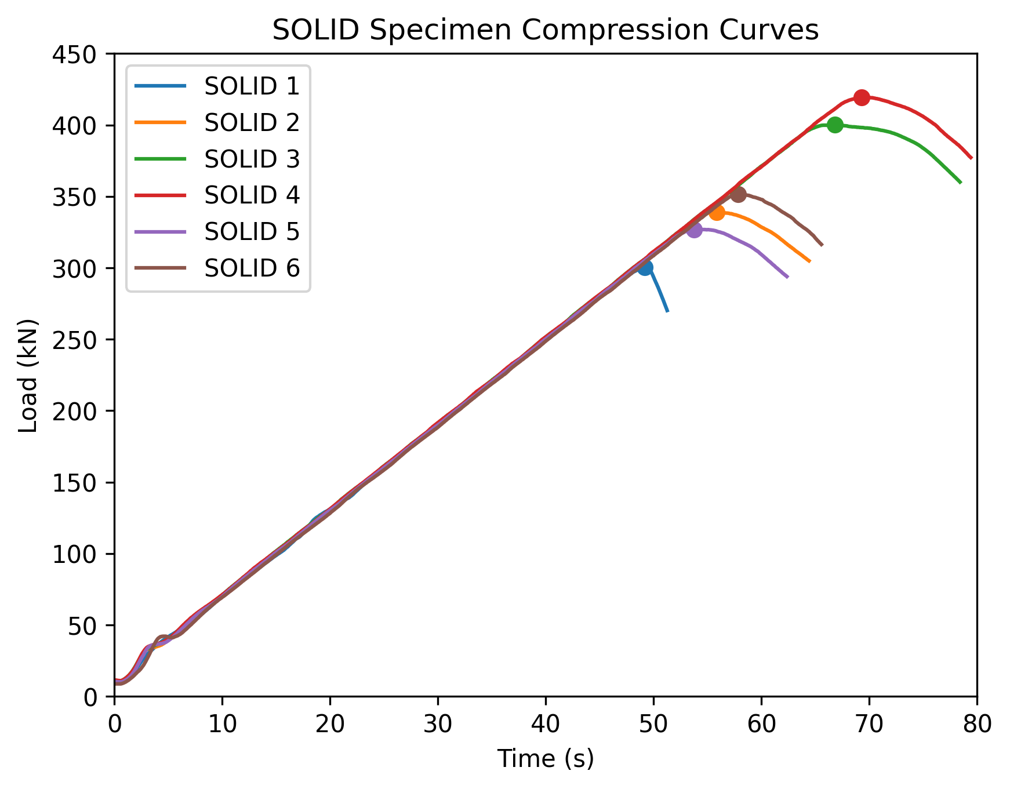
Figure 12- Solid specimen compression test results
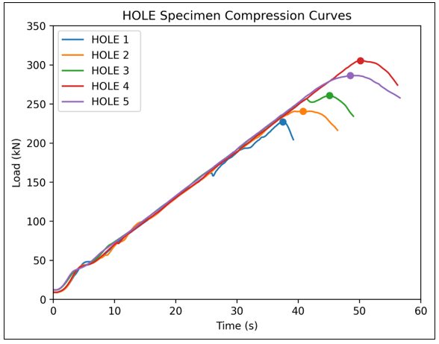
Figure 13- Hole specimen compression test results
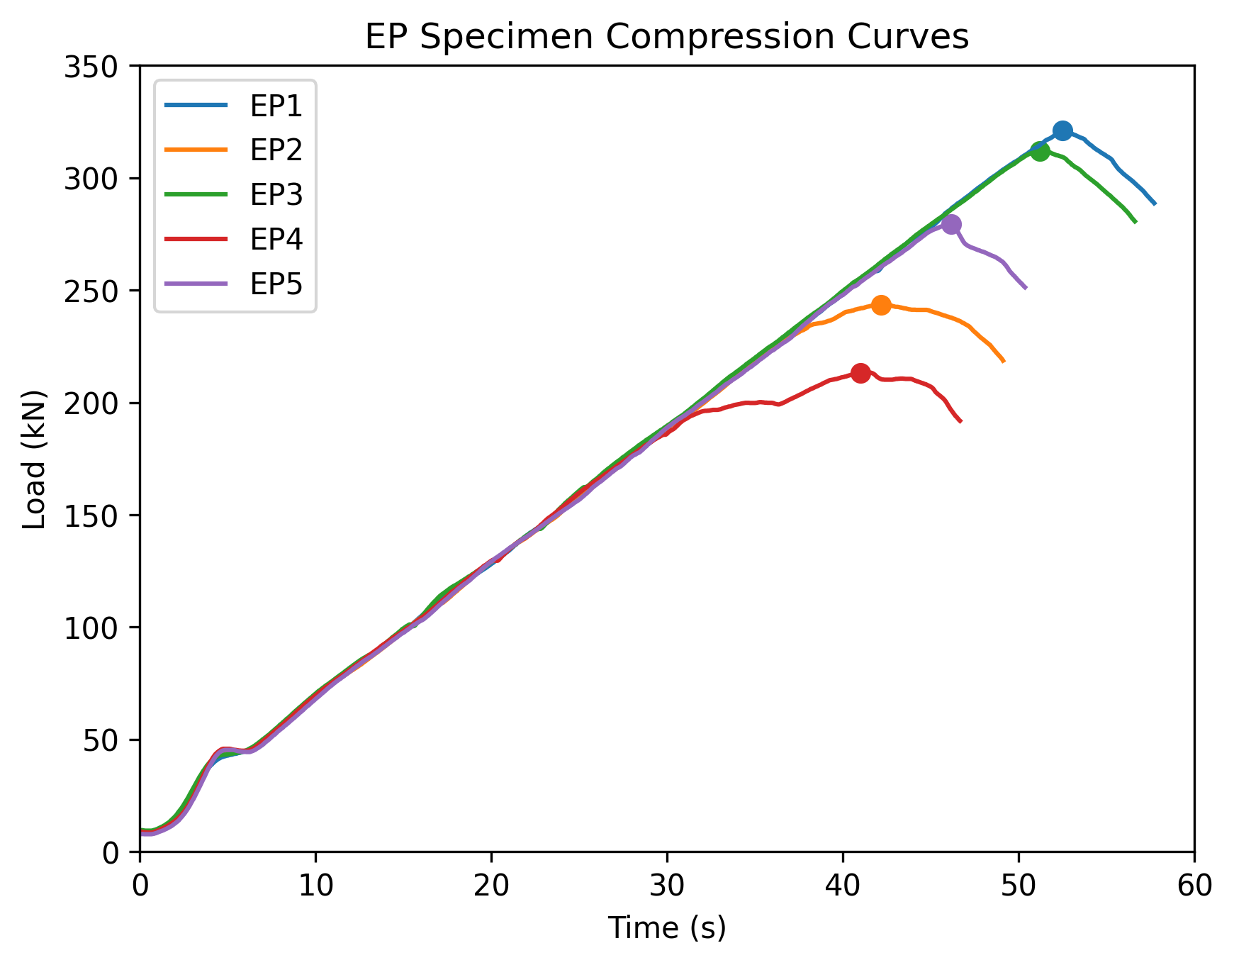
Figure 14- Epoxy resin specimen compression test results

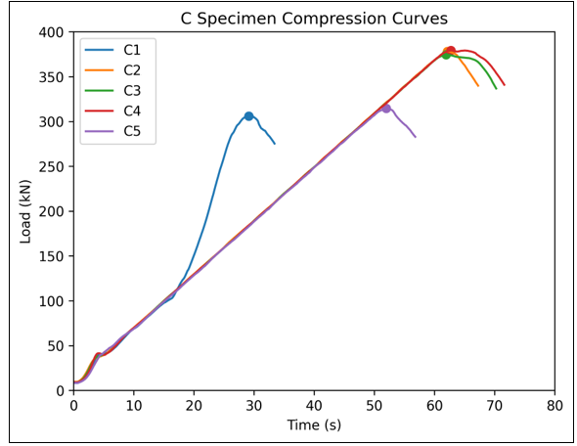
Figure 15- Cementitious specimen compression test results
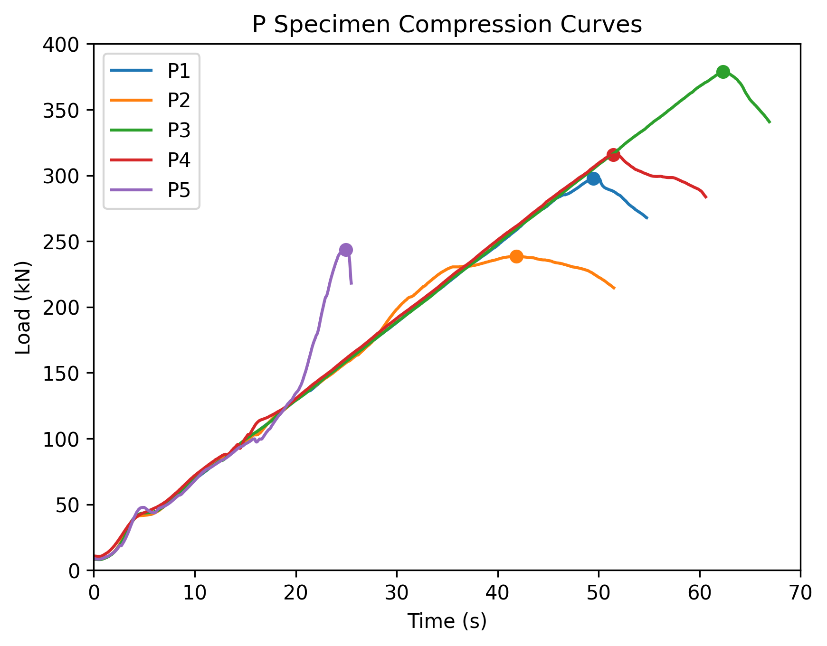
Figure 16- Polyurethane specimen compression test results
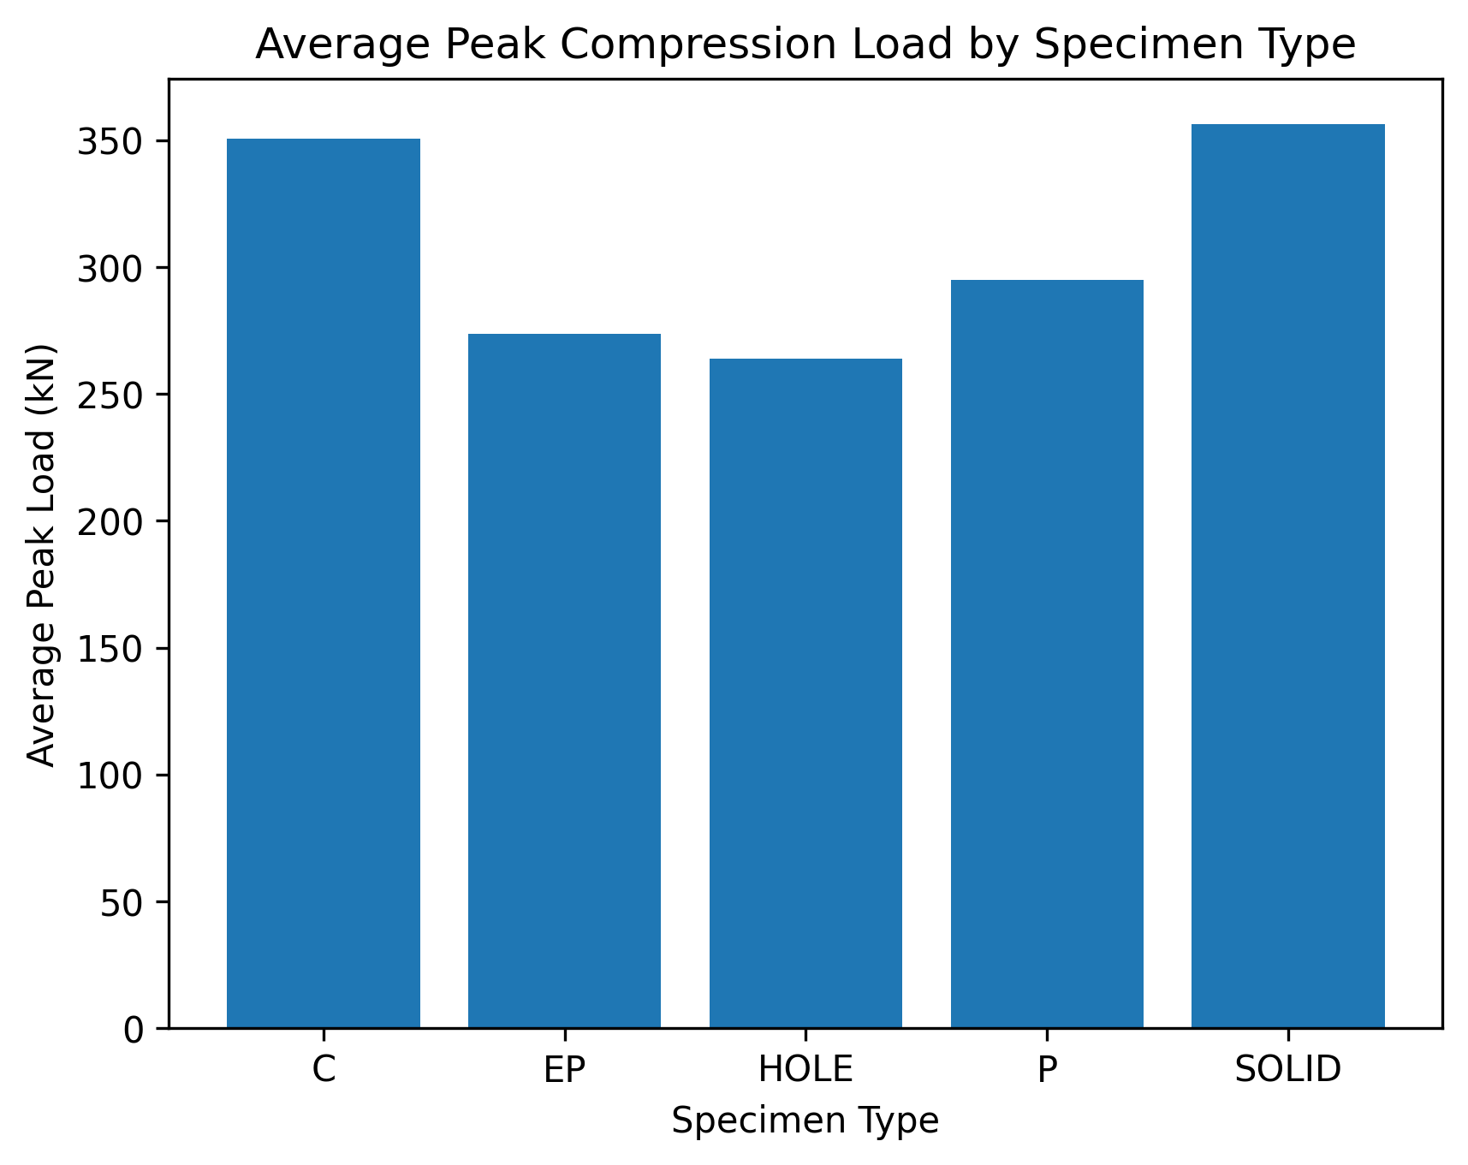
Figure 17- Average compression test results for all specimens

Statistical calculations summary

The screenshots below summarise how the statistics in the results section were calculated from the raw peak failure loads (kN). All calculations were performed using standard formulae for Cohens d and Welch’s independent-samples t-test. An example of each calculation have been shown below. Where confidence intervals are reported, a 95% level was used (α = 0.05, two-tailed) (Social science statistics, 2026).
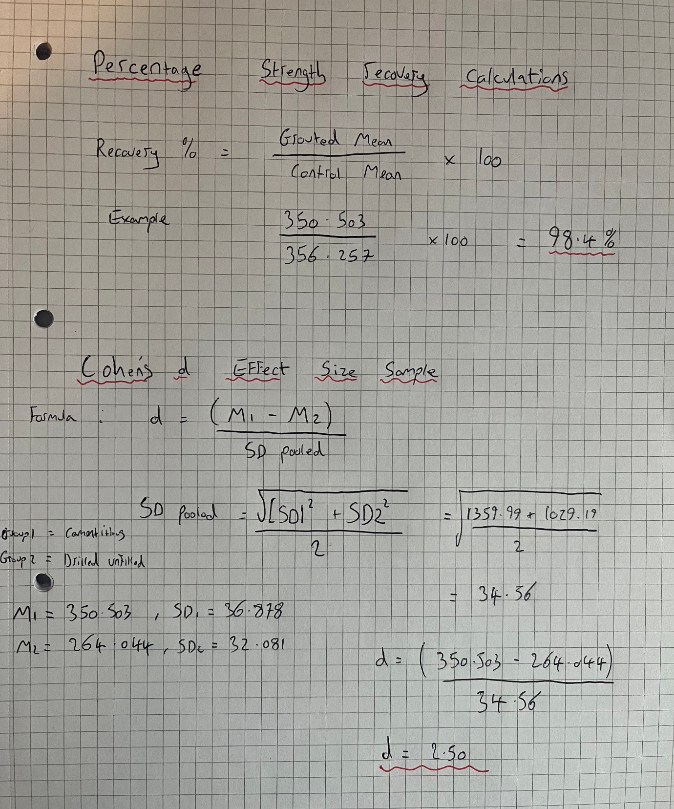
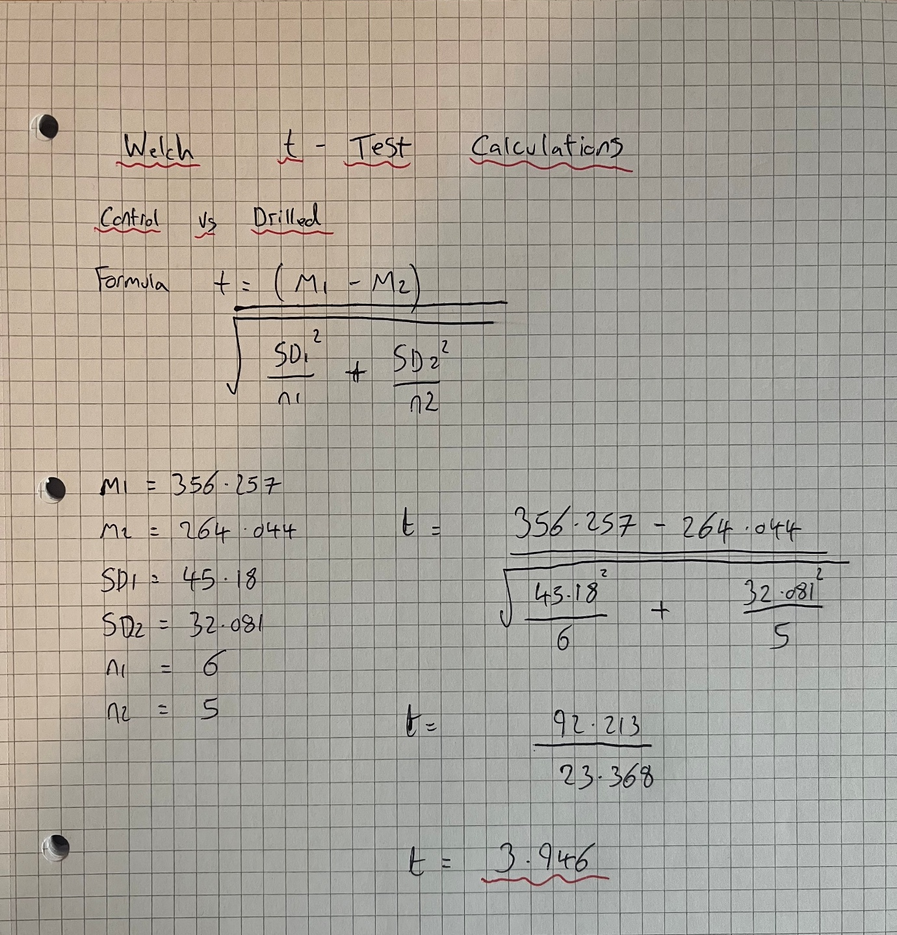

Two tailed significance t test tables

Note: Independent-samples Welch t-tests were used to compare differences between specimen groups. The calculated t statistics were evaluated against critical values obtained from two-tailed t-distribution tables below using the appropriate degrees of freedom and significance level (α = 0.05). Where the calculated t value exceeded the corresponding critical value, the null hypothesis of no difference between groups was rejected. Corresponding p-values were also reported to quantify the probability of observing the calculated test statistic under the null hypothesis and to provide a precise measure of statistical significance.

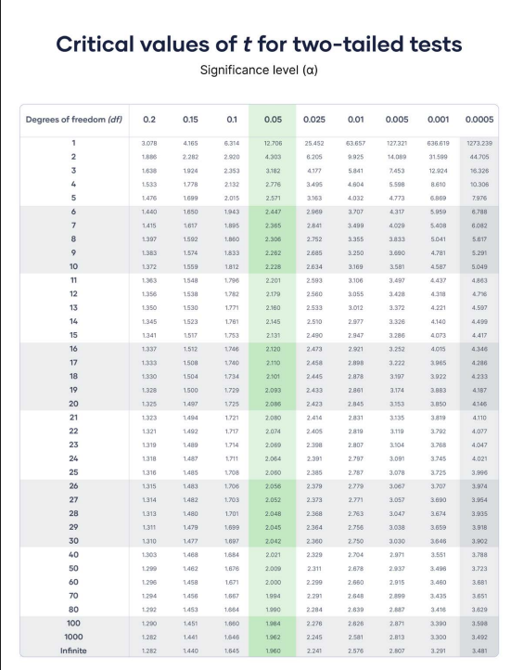
Figure 18 - T-Test table (Scribbr, 2023).

