Summary of essential employment skills
Below are a few of the skills that may be required in a working games design environment; I will briefly break down the reasons why these are helpful.

Team working
Useful as games studios will always be broken up into teams of individuals, no one person can create an entire AAA game in the time required by industry, so a team is needed to get this done and get the best out of the end result. ⁶
¹
Creativity
This may seem obvious however fresh ideas are needed to push games forward, no-one needs another crash from re-hashing the same games over and over! ⁷
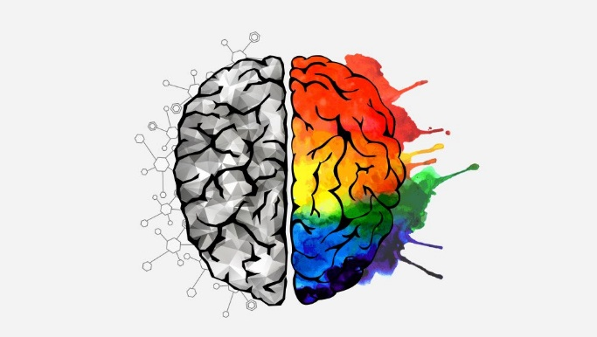²

Time management
Essential to get projects delivered on time and to good quality, customer loyalty quickly waivers in the gaming industry if deadlines keep getting pushed back. ⁸
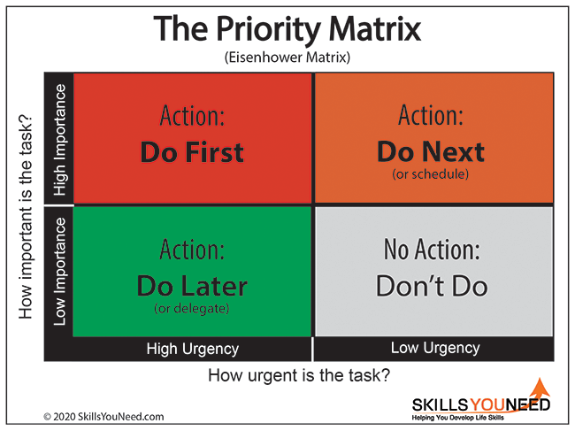³
Communication
Time management between individuals and teams needs good communication to make sure bits of projects that rely on each other are getting finished at the right time, for creative reasons to bounce ideas off each other, in order to make sure the vision of the game is being respected in everyone’s work so that the game makes sense and lines up when finished, in short, it’s essential to be able to get your point across and be understood. “The more effective you are at communicating the more powerful you are as a designer.” ⁹
 ⁴
Problem solving
Individuals will need to solve many issues in the workplace, this could be something technical like a model or mesh not working, it could be something creative like a story point not lining up, many companies will find it desirable if you can problem solve on your feet. ¹⁰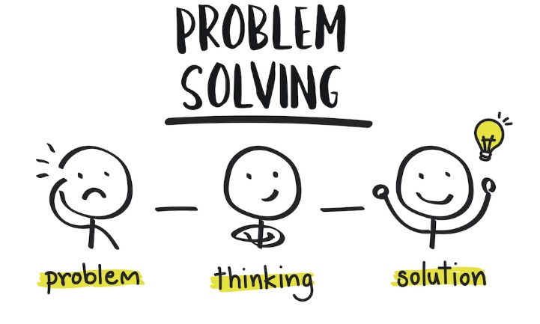⁶
References
1: “Image and video upload, storage, optimization and CDN,” Cloudinary, 17-Mar-2023. [Online]. Available: https://cloudinary.com/. [Accessed: 02-Apr-2023].
2: “Content delivery api,” Back to Contentful.com. [Online]. Available: https://www.contentful.com/developers/docs/references/content-delivery-api/. [Accessed: 02-Apr-2023].
3: (c) C. skillsyouneed.com 2011-2023, “Skills you need,” SkillsYouNeed. [Online]. Available: https://www.skillsyouneed.com/. [Accessed: 02-Apr-2023].
4: “Nurture an engaged and satisfied workforce: Vantage Circle HR Blog,” Nurture an Engaged and Satisfied Workforce | Vantage Circle HR Blog, 28-Mar-2023. [Online]. Available: https://blog.vantagecircle.com/. [Accessed: 02-Apr-2023].
5: Casey, “Creative problem solving templates,” Innovation Training | Design Thinking Workshops, 07-Sep-2022. [Online]. Available: https://www.innovationtraining.org/creative-problem-solving-templates/. [Accessed: 02-Apr-2023].
6: Souvik, “11 key roles to build a successful game development team,” RS Web Solutions, 03-Feb-2023. [Online]. Available: https://www.rswebsols.com/tutorials/software-tutorials/game-development-team-roles-responsibilities. [Accessed: 02-Apr-2023].
7: D. Beren, “What was the video game crash of 1983 and why did it happen?,” History, 22-Dec-2022. [Online]. Available: https://history-computer.com/what-was-the-video-game-crash-of-1983-and-why-did-it-happen/. [Accessed: 02-Apr-2023].
8: R. Valentine, “Ubisoft says delays, cancellations were because it was making too many games at once,” IGN, 16-Feb-2023. [Online]. Available: https://www.ign.com/articles/ubisoft-says-delays-cancellations-were-because-it-was-making-too-many-games-at-once. [Accessed: 02-Apr-2023].
9: G. Ellenor, “Communication is a game design skill,” Medium, 28-May-2017. [Online]. Available: https://gellenor.medium.com/communication-is-a-game-design-skill-84df4b200700. [Accessed: 02-Apr-2023].
10: S. Brodie, “The five basics of being a game design problem solver,” Game Developer, 01-Jul-2013. [Online]. Available: https://www.gamedeveloper.com/design/the-five-basics-of-being-a-game-design-problem-solver. [Accessed: 02-Apr-2023].

Assignment 1B – Similarity Test
    - Your similarity score and how you could improve it next time.
My score was 35%, looking through the highlighted material in this section, the only highlighted part of my work that is not an IEEE reference is a quote directly from one of the sources (appropriately referenced in the bibliography at the end), this could be improved next time by paraphrasing instead of direct quotes.
    - Using the ‘Generic Assessment criteria’ as a guide, state the mark out of 100% you would award yourself and briefly explain why. The ‘Generic Assessment criteria’ is located at the bottom of the Assignment Specification below.
Marks will be allocated based on how well the student has met the generic assessment criteria in each task. | Marks available | Marks  awarded
1. Engagement with Literature Skills

Varied and numerous sources, however could have used books or journals as well as internet references. | 20 | 15
2. Knowledge and Understanding Skills

Understands the assignment and subject matter and presents this logically and succinctly | 20 | 20
3. Cognitive and Intellectual Skills

Evidence based conclusions drawn from the source material and presented well, could be expanded on | 20 | 10
4. Practical Application Skills

Included real world examples in the work | 20 | 20
5. Transferable Skills for Life and Professional Practice
Work contains a varied use of language and expression and is presented neatly and professionally. | 20 | 20
Assessment Mark (Assessment marks are subject to ratification at the Exam Board. These comments and marks are to give feedback on module work and are for guidance only until they are confirmed. ) | Late Submission Penalties (tick if appropriate) |  | %
 | Up to 1 week late (40% Max) |  | %
 | Over 1 week late (0%) |  | %
85
Assignment 1 Task 3
Managing emotions is an important part of growing up and becoming an effective adult, the three things that usual denote and characterise an emotional response are :
A subjective experience (something that has happened or you have perceived happening)
A internal sociological response (how you reacted to the experience internally and how you processed it based on your past experiences)
An external response (how you outwardly respond to the experience)
The seven basic feelings outlined are in “The book of rites” from 1st century China are:
Joy
Sadness
Anger
Fear
Love
Like
Dislike
These however do not come alone, they can be accompanied by feelings of bitterness or jealousy that can spin out of control and cause harm to those around. It is said that you cannot control how you feel but you can manage how you react to the situation in hand, understanding your emotional triggers can help with this as if you understand yourself, you can change yourself and successfully manage the emotions you are feeling to stop them spiralling out of control.
Changing how you think about negative situations or emotional triggers can also help to make situations more positive and possibly even lead to unexpected paths or benefits due to the positive nature of your responses, it’s possible to you may become more open to these good experiences and they may happen more frequently, to help this it is sometimes good to take a step back and take stock of the situation to gain perspective, this can help to break down the situation and make it easier to manage.
Managing emotions is an important and useful skill to master and can open many doors in life, most professional businesses will prefer a level headed individual in an office setting for instance and especially in high stress roles such as Police or Fire, these skills would be invaluable.

