

A Study of the integration of Realwear hardware with existing permit to work application

by
Nick Hinder

Supervisor: Mike Dacey

Project submitted as part of the requirements for the award of
BSc (Hons) Software Engineering

April 2021
DECLARATION
I, Nick Hinder declare that I am the sole author of this Project; that all references cited have been consulted; that I have conducted all work of which this is a record, and that the finished work lies within the prescribed word limits.
This work has not previously been accepted as part of any other degree submission.

Date : 20/04/2021

FORM OF CONSENT
I Nick Hinder hereby consent that my Project, submitted in candidature for the B.Sc.(Hons) Computing (Software Engineering) degree, if successful, may be made available for inter-library loan or photocopying (subject to the law of copyright), and that the title and abstract may be made available to outside organisations.

Date : 20/04/2021

Contents
Introduction 3
Literature Review 4
Research Methodology 10
Development Methodology 11
Implementation / Design 12
Specification 12
Implementation 13
Testing 16
Conclusions 24
Further Work 25
Minimum requirements 25
Suggestions 25
Reflection 26
Bibliography 27
Appendix 29

Introduction
Yokogawa RAP are a software company dedicated to providing applications to assist in the safe working of many workplaces, predominantly heavy industries such as the petrochemical industry.
The core product the company provides is its RAP-PTW system; a Permit To Work system that facilitates for planning and execution of on-site work to be carried out safely. The PTW system allows for work to be properly risk assessed, enforcement of appropriate authorisations via its user competency system and provision of printable permit documentation.
Due to the hazardous nature of the industries that predominantly use the PTW system it is often the case that the environment is not suitable to usage of tablets or phones as carrying these would subject the holder to extra risk by occupying their hands. Realwear provide a hands-free solution to this in the form of a wearable, helmet mounted, android tablet.
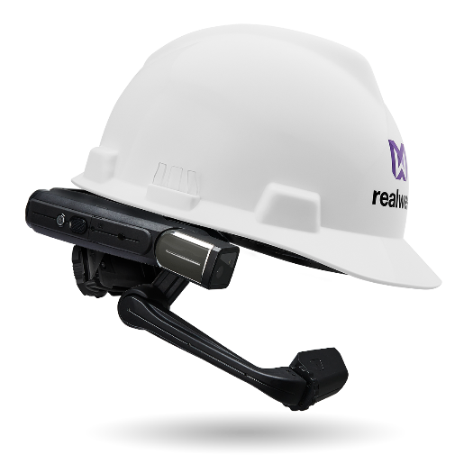
Figure 1. Realwear HMT-1
This hardware is controlled via voice commands, therefore allowing for operations to be carried out whilst keeping hands free.
This aim of project is a case study investigating the usage of smart apparel in hazardous environments.
Objectives:
- Investigate the usage of smart apparel in PTW and systems and to develop a set of formal requirements for the case study.
- Evaluate the effectiveness of the Realwear hardware solution through integration of the technology with the existing RapCore PTW application.
- Analyse the Realwear integration prototype to determine whether the formal requirements have been met effectively

Literature Review
Yokogawa RAP as a company provide electronic safety software with the primary product being its PTW system used to control on-site work and the risks/hazards posed by it.
As Edward Hodson of the Royal Society for the Prevention of Accidents (1) stated in 2009 “A PTW system can be looked at as simply a way of meeting the requirements of the Health and Safety at Work etc 1974 (HSWA) which places duties on employers to provide a safe system of work”.
However there have been numerous incidents in the past whereby PTW’s used were not adequate for the task at hand; an example of this can be seen in the case study by Nigel Cann (2) where the permit had the permit had been poorly prepared and there was a lack of communication of the details and changes to work being undertaken, which unfortunately led to a gas release and explosion.
This highlights the importance of a well prepared PTW, ensuring that all involved parties are aware of the work undertaken and the risks involved, as well as the need to communicate changes to the permit to all parties.

The prototype to be developed for the application may need to be built using android native code, however the existing mobile app has been developed using flutter. Flutter, Google’s recent mobile UI toolkit, was introduced at the end of 2018 and has a number of upsides such as being cross platform, quick and potentially quicker to develop thanks to Stateful Hot Reload. Williams (3) of Electronics Weekly suggests that the presence of Flutter in general mobile app development will rise throughout 2020.
Flutter applications are coded using the Google’s Dart language that was developed to be a class-based, type sound system that runs approximately two times faster than javascript. Dart itself is not actually type sound, however as Erik Ernst et al claim (4) it “strikes an interesting new balance, with a type system far less restrictive than required for traditional soundness”. The static type checker can miss certain type related errors which can appear at runtime; “message-not-understood” and “subtype-violation” errors. Through usage of their calculus, named Fletch, they proceeded to prove that Dart is what they termed a “message-safe” program that never encounters a message-not-understood error – leaving subtype-violation errors as the only typing error that can arise from such a program. Therefore we can come to the conclusion that; whilst Dart as a language is not immune to the issues that plague other weakly typed languages such as javascript, it can at least limit the issues that can arise from weak typing.

In recent years there has been increased interest in exploring the potential posed by wearable technology. In 2012 the Google Glass was introduced to the public however was met with numerous issues and was finally abandoned three years later. Zuraikat (5) suggests that one of the major issues with Google Glass was the lack of an organization goal regarding the technology. This suggestion indicates that whilst the concept of the Google Glass was one with promise, there was no clear application for the technology.
Steve Aukstakalnis (6) also posits that the key challenge facing hardware and software manufacturers are the questions of what is the specific intended use of the technology. He outlines a number of other augmenting displays that are available on the market, both binocular and monocular.
In this situation, the application is clear and is the motivation driving the project, as such its important to identify technology that clearly aligns with the goals of the project.
In a Harvard Business Review article (7), Magid Abraham et al discussed the impact that wearable augmented reality (AR) devices have had in recent years alongside the potential the technology provides. The article claims that a number of firms are reporting that incorporating AR technology in some tasks has yielded an average productivity improvement of 32%.
With AR technology, the user is able to be delivered information whilst their hands are kept free; yielding both safety and productivity benefits.

Realwear aims to provide solutions using very similar wearable technologies to the Google Glass, however Realwear has a clear application in mind; supporting heavy industries. The Realwear hardware is built to be usable in these industries with it being ruggedised and having an intrinsically safe option available. PC Business Products (8) reported on StateGrid’s implementation of Realwear quoting State Grid’s reasoning for choosing RealWear as being “for its unique purpose-built, safety-conscious form factor, including a 100% hands-free user experience”.
Travis Hessman of New Equipment Digest (9) also believes that RealWear may have found the correct formfactor and interface that actually fits the needs of the market, as reinforced by the implementations and sales of the HMT-1.
Therefore it is clear to see that RealWear is not only designed to support the needs of the project, but has also been marketed toward, and adopted by some of, the same target market as Yokogawa RAP’s solutions.
Whilst the RealWear devices have been developed with the clear intention of being utilised in hazardous areas, and with a focus on being easy to use for any with familiarity with android tablets/phones, there will remain a question of just how usable would a solution provided by it be.
Questions such as this will remain relevant for many years as is evidenced by recent research related to usability problems for smart TV among elderly Chinese users undertaken by Jinhua Dou et al (10). This research found that the pinyin input mode, whilst a standard for smart tv’s, was a great inconvenience to its users. More relevant to this project however, the study found that the best user experience was a voice driven one due to the simplicity of voice searching on smart tv’s. The users did however encounter issues with low recognition due to user accents and background noise.
This reinforces the importance of testing the voice recognition layer provided by RealWear; Realwear claim (11) that the HMT-1 (and HMT-1Z1) models respond to voice commands with 98% accuracy in ambient noise of up to 95dB.
Realwear provide language support for 12 languages; English, Chinese, French, German, Italian, Spanish, Portuguese, Russian, Japanese, Korean, Polish and Thai. This is a wide spread of languages and will support the majority of existing and prospective clients due to current business focus on the European and Asian regions.

One of the primary features that is desired from the prototype is the usage of the devices GPS to provide information that is geographically relevant to the user such as permits and work in the nearby area. A concern for this is the accuracy of GPS of mobile devices, especially within heavy industrial areas. Merry et al (12) performed a study into the accuracy of GPS that suggests the horizontal position error within an urban area was between 7-13m. Whilst this study was performed with the iPhone 6 only and only in an urban environment rather than an industrial one; however it still serves as a fair indication of the accuracy we can expect from GPS positioning. Whilst 7-13m is not a small margin of error, it may fall within the tolerance of the needs of the application.
This margin of error of course has a direct effect on the usability of the application in that some of the proposed features use device location to drive the data presented to the user; if the margin of error is too large then the application ceases to perform in a way that is usable.
A countermeasure to the lack of accuracy in GPS would be to investigate methods of establishing a user’s position using other technologies such as Bluetooth. Such a method would ideally be avoided due to the requirement of additional hardware to be installed on client sites which is not in keeping with an “out of the box” solution.
One example of such a system is the GlassPhysicalWeb project initiated in the University of South Wales Trinity Saint David (13). This project used low energy Bluetooth beacons in different areas that broadcast a URL using the Eddystone protocol. Users devices would connect to the URL in question, however the URL broadcast by each device is set up to be different so that a user will be directed to different resources based on which beacon is closest.
In order to properly test and demonstrate the geospatial features of the project it is important that the application has methods to mock the devices location – fortunately Google provided this functionality as a developer feature in android. The android developer documentation shows that to enable this feature you must enable the ACCESS_MOCK_LOCATION permission in the applications manifest; then it will be possible to set mock locations programmatically within the application. This will allow for a predefined set of locations to be provided to the application; these locations will be geospatial positions on the RapCore demo systems map – allowing for the devices mock location to be related to data already in the web system.
One of the primary methods of measuring the usability of an application is through usage of the System Usability Scale (SUS) that was developed by John Brooke. Despite the SUS being developed as a “quick and dirty” method of measuring the usability of a system, as Jeff Sauro (14) points out; there is a lot of evidence to support the usage of SUS and has been widely adopted, in part due to its versatility.
It is also important to bear in mind the entire user experience rather than just usability – whilst usability is a big factor in the user experience, it is important to note that there are hedonic and pragmatic factors that play into how positive (or negative) a user experience is. As Jim Lewis (15) points out however, the measurement of such factors is relatively new, arising through the 2000s, and lacks the research and adoption of older methods such as SUS.
Once such measurement for hedonic and pragmatic qualities is the User Experience Questionnaire (UEQ) which aims to measure the perspicuity, efficiency, dependability, novelty and stimulation of a given application. According to Jim Lewis (15) UEQ has the advantage over other techniques used to measure hedonic and pragmatic qualities as it does not “lack norms for interpreting scores” whereas other methods do not have such norms; leaving the results far more open to interpretation.

Once the prototype has been created, it will be presented to a variety of test users who will then be presented with a System Usability Scale (SUS) questionnaire as well as a User Experience Questionnaire (UEQ) in a bid to acquire quantitative date that can provide some insight into the overall experience for users of the system with the aim of meeting acceptable ratings as detailed below.
The SUS questionnaire is made up of 10 standard questions:
- I think that I would like to use this system frequently.
- I found the system unnecessarily complex.
- I thought the system was easy to use.
- I think that I would need the support of a technical person to be able to use this system.
- I found the various functions in this system were well integrated.
- I thought there was too much inconsistency in this system.
- I would imagine that most people would learn to use this system very quickly.
- I found the system very cumbersome to use.
- I felt very confident using the system.
- I needed to learn a lot of things before I could get going with this system.
With the answer being 1 (strongly disagree) to 5 (strongly agree).
- For odd items: subtract one from the user response.
- For even-numbered items: subtract the user responses from 5
- This scales all values from 0 to 4 (with four being the most positive response).
- Add up the converted responses for each user and multiply that total by 2.5. This converts the range of possible values from 0 to 100 instead of from 0 to 40.
The Sauro/Lewis Curved Grading Scale devised by Sauro and Lewis (16) is a widely accepted grading scale for SUS scores.
SUS Score Range | Grade | Percentile Range
84.1–100 | A+ | 96–100
80.8–84.0 | A | 90–95
78.9–80.7 | A– | 85–89
77.2–78.8 | B+ | 80–84
74.1–77.1 | B | 70–79
72.6–74.0 | B– | 65–69
71.1–72.5 | C+ | 60–64
65.0–71.0 | C | 41–59
62.7–64.9 | C– | 35–40
51.7–62.6 | D | 15–34
0.0–51.6 | F | 0–14
Figure 2. Sauro/Lewis Curved Grading Scale (16)
In accordance with the empirical evaluation of SUS carried out by Aaron Bangor et al (17) the target SUS score used should be above 70 even though scores of above 50 are likely “acceptable”. Scores below a SUS score of 50 are unacceptable and will lead to a very high chance of users encountering usability issues.
As with most empirical data, larger sample sizes lead to more reliable results; however SUS have been found to be very reliable with even small sample sizes. Orfanou et al (18) found that a SUS sample size of 6 to 14 participants was sufficient to provide reliable results to form a conclusion. They also found that gender and age did not strongly influence SUS scores provided by participants.

The UEQ is also a standardised questionnaire and one that is not only widely adopted; but one that has annual updates to benchmark data so that the benchmarks do not become outdated and irrelevant.
The questionnaire is a series of scales that a user is asked to evaluate the system against. The scales that will be used, scored 1 – 7, are as follows:
 | 1 | 2 | 3 | 4 | 5 | 6 | 7
Annoying |  |  |  |  |  |  |  | Enjoyable
Not Understandable |  |  |  |  |  |  |  | Understandable
Creative |  |  |  |  |  |  |  | Dull
Easy to Learn |  |  |  |  |  |  |  | Difficult to Learn
Valuable |  |  |  |  |  |  |  | Inferior
Boring |  |  |  |  |  |  |  | Exciting
Not Interesting |  |  |  |  |  |  |  | Interesting
Unpredictable |  |  |  |  |  |  |  | Predictable
Fast |  |  |  |  |  |  |  | Slow
Inventive |  |  |  |  |  |  |  | Conventional
Obstructive |  |  |  |  |  |  |  | Supportive
Good |  |  |  |  |  |  |  | Bad
Complicated |  |  |  |  |  |  |  | Easy
Unlikable |  |  |  |  |  |  |  | Pleasing
Usual |  |  |  |  |  |  |  | Leading Edge
Unpleasant |  |  |  |  |  |  |  | Pleasant
Secure |  |  |  |  |  |  |  | Not Secure
Motivating |  |  |  |  |  |  |  | Demotivating
Meets Expectations |  |  |  |  |  |  |  | Does Not Meet Expectations
Inefficient |  |  |  |  |  |  |  | Efficient
Clear |  |  |  |  |  |  |  | Confusing
Impractical |  |  |  |  |  |  |  | Practical
Organized |  |  |  |  |  |  |  | Cluttered
Attractive |  |  |  |  |  |  |  | Unattractive
Friendly |  |  |  |  |  |  |  | Unfriendly
Conservative |  |  |  |  |  |  |  | Innovative
Figure 3. UEQ questionnaire matrix
The target of the prototype is for the mean results for each of the measured scales to be at least “above average” when using the benchmarks provided by UEQ’s data analysis tools.

Figure 4. Graph display of UEQ benchmarks
This graph is a visual indicator of the current benchmarks according to UEQ (as of February 2021). Once the questionnaires have been undertaken, the data analysis tools allow for the participant answers to be input to a data table which will allow for the generation of useful data such as readouts of the distribution of answers per item and of course a comparison of the mean results of each scale compared to the benchmark.
A further concern for the project is that of the potential negative effects on spatial awareness and depth perception whilst using a monocular augmented reality device. Dean Melmoth et al (19) found that participants exhibited similar early movement phases when limited to a monocular view as compared to regular binocular view. The results of the study do however strongly suggest that the participants struggled far more in the later phases of movements when using monocular vision. This suggests that whilst users limited to monocular vision are able to gauge positioning of their surroundings, they seem to struggle with depth perception to some extent. There is quite a number of similar studies that suggest the same findings, one such recent study by Woong Choi et al (20) found that tracking circular movements in the frontal plane led to lower temporal and spatial errors than tracking circular movements in the sagittal plane. Woong Choi et al posit that the lack of depth information caused by monocular vision is what causes users tracking of movement in the sagittal plane to be less accurate.
With such studies demonstrating that there is a measurable impact on spatial awareness of participants utilising monocular vision rather than binocular vision; it would be negligent if consideration was not put in to ensuring that wearing the hardware would not impede the users ability to work safely.
As such, we will perform an additional test with the users who will be undertaking the survey; they will be asked to perform a series of simple tasks and these tasks will be observed and timed. The tasks will be as follows:
- Writing the participants name on a piece of paper.
- Picking up a glass of water and drinking.
- Standing from a seated position to walk to the light switch and turn it on.
By undertaking these tasks both with and without the hardware, it will be possible to judge whether the users are significantly inconvenienced by it. If there are any concerns performing these tasks; the viability of the hardware assisting in maintaining health and safety is slim.

Research Methodology
There are three major research types that projects fall into:
Exploratory research; whereby work is undertaken to gather data in order to investigate a problem. Exploratory research is often work that is carried out to discover information about problems that may not be well defined or there is not yet a definitive outcome needed. Exploratory research is often used to later enable more in-depth research.
Descriptive research; whereby work focuses on better understanding a specific problem or phenomenon. A prime example of this type of research is a case study; where the research aims to assess the exact details of the study’s focus rather than attempting to discern why the situation occurred.
Explanatory research; whereby the work focuses on dissecting a specific problem presented, often to establish a relationship of cause and effect. Such work often entails experiments as they endeavour to answer the questions of why certain phenomenon occur.
Of the three major research types, this project falls firmly into that of exploratory research. Whilst a number of minimum requirements have been produced for the prototype to be developed to meet, simply meeting these requirements does not necessarily mean a usable product. The primary aim of this project is to investigate if smart apparel can be integrated into the RAP Core system in a way that is user friendly; this prototype serves as exploratory research towards that goal. Provided this research yields positive results, further research and iterations would need to be carried out in order to provide an adequate, user friendly solution that does in fact help in the endeavour of keeping workers safe.
Whilst a user’s experience and opinion of using applications are subjective, through employment of the SUS and UEQ; clear efforts are being made to gather primary data that is both informative and measurable. Both questionnaires operate on the principle of allowing quantitative results to be derived from subject matter that should be inherently qualitative.
This primary data will form the primary basis for determining the usability of the application; the sample for the data gathering, whilst limited, is one that contains a number of individuals with vast experience in the safety and technology sectors.
This experience means that the results returned from the questionnaires may not be representative of all users; all results will be taken from individuals with prior experiences with RAP applications and work within the company.
Ideally such questionnaires would be distributed to existing clients who could provide a more valid set of results as this would remove familiarity and reduce the concerns over confirmation bias as the clients would not have been involved in the development of the application in any way.
Unfortunately, the project is an internal prototype to investigate the potential of integrating smart wear with our existing applications, therefore it is not possible to involve any interested external parties until there is evidence to support that the project can be deemed a success.
The main concerns over research tend to be its reliability, validity and generalisability.
By using SUS and UEQ, steps have been taken to improve the reliability of the results gathered as these use standard questions so should not lead to bias.
The validity of the results is a concern in that whilst there is a level of confidence that the answers provided from the questionnaire are what is desired from them, after all these are standard questionnaires that have seen heavy usage over the years since their inception, the people being questioned may not be the correct people. This concern is allayed somewhat by the fact that the people in question are specialists in health and safety and safety software, so should be able to provide well informed answers.
The generalisability of the results is a major concern however; the sample for the questionnaires are generally tech-savvy individuals and are familiar with other RAP applications. This means that it may not be quite as simple to generalise the data to that of an everyday end user.

Development Methodology
For the purpose of this project it has been decided that the most appropriate development methodology to employ is a mixed approach that draws upon various strengths of methodologies to allow for a well fitted methodology for this project.
As this is a solo investigation into the usability and success of a prototype, there will be only one working party involved in the majority of its development. Although there may be need to communicate with others regarding stages of the project, such as the mobile development or RAP Core API teams; such time will be limited and will be irregular.
Due to this it is not feasible to implement the majority of features of agile working such as sprints and scrums; these require a level of teamwork to be available which will not be present for this project.
However due to the rigid nature of iterative processes such as the waterfall method, such an approach is also not available; whilst estimates of timescales can be provided, these must be flexible such as those in agile so that if unforeseen issues mean that the sole developer is unable to meet a deadline, this wont necessarily mean the whole project is delayed.
By utilising a mixed approach, the aim is to provide a number of smaller sections of work that can serve as individual “sprints” in their own manner. These “sprints” should ideally be undertaken and completed one at a time, however; if planned correctly, it could be possible that if an issue arises with one such “sprint”, that sprint can be placed into an “on hold” status whilst other “sprints” are worked on. This means that in an instance whereby communication is required with another party, work on the project need not be suspended entirely before a time when such communications can actually take place.
The project will be undertaken on a branch taken from a recent stable commit of the main knockout branch of the RAPCore solution – this will allow for the work to be undertaken in a way that it can be easily integrated in the long term and allow for the project to be tested in relation to the full system and its features. The source control management system used for the project will remain in line with the company’s standard of using Mercurial hg.
As this project is being undertaken to be part of the RAPCore solution, it is important that it utilises the same technologies that are currently in place for the existing projects. The existing API used for the mobile device has been developed in C# and this project will be adding new endpoints to the existing API. The existing mobile application for RAPCore has been written in Flutter; this project will be attempting to add new pages and functionality to this application and as such will also be written in Flutter.
In regards to any C# API work that is to be undertaken as part of the project, visual studio will be used due to it not only being the company standard application for such work, but also due to the comprehensive nature of the application and the features it provides to developers such as Intellisense.
The Flutter code will be undertaken using Android studio due to the need to be able to not only produce code, but to test it. Android studio allows for device emulation for debugging software but can also debug using USB connected device; allowing the flutter code to be tested on the physical Realwear device without needing to build and deploy an APK file.
Realwear provide an application that will be used to ease the development and testing of applications for Realwear devices; RWexplorer is an application that allows a screen mirror, and remote control, of a Realwear device connected either by wireless or USB connection. RWexplorer allows for the devices screen to be seen on the connected PC and allows for the user to control the device from the PC and its input devices. This means that rather than using the voice commands to navigate the system, it can instead be mouse driven – making it behave more like the RAPCore application would on a normal device. This allows for faster development and testing when the voice commands are not the subject of tests at hand.
Microsoft Teams and Outlook 365 will be used to communicate with management and other developers as needed. These applications are the companies standardised communication applications and all work related digital communication should be undertaken via these if possible.

Implementation / Design

Specification
Through discussion with Yokogawa RAP management and the developer of the existing RAPCore mobile application, a number of minimum requirements have been decided in order for this case study to be deemed a success.
The requirements of the prototype will be as follows:
- The application will display geographical contextual information utilising the devices GPS positioning in conjunction with RAPCore’s existing geospatial data.
- The application will also facilitate displaying of live notifications and/or messages from the RAPCore system derived from the notifications system.
- The final requirement of the application is that it must allow for the creation of system notes to store data captured by the device in the form of photographic, video or sound recordings.

To ensure that the above requirements have been adequately met by the prototype, the following user stories have been created and approved by management:
  - User Story 1
As a shift worker, I want to be able to view active permits in my vicinity whilst moving around plant, so that I can be safer, knowing what work is being carried out nearby

  - User Story 2
As a team leader, I want to be able to view the details of a given permit in the nearby area, so that I can ensure that myself and others are safer by enforcing the required safety measures for work is in place.

  - User Story 3
As an engineer, I want to be able to record notes, images and video for my current location, so that I can ensure that I can make others aware of concerns or important information regarding the area.

  - User Story 4
As an area manager, I want to be able to view any notes, images or videos that have been added for the nearby area, so that I can address issues that need to be addressed to support the running of the plant and safety of employees

  - User Story 5
As a general user, I want to be able to be able to view notifications that are sent to me, so that I can keep up to date with changes to permits I am working on and messages from other users.

Implementation
The prototype was built within a branched version of the existing mobile app, with the intention of utilising components that already existed rather – allowing for an optimal upgrade path in future so that it can be fully integrated into the production version of the application.
The application first needed to be modified so that there was a Boolean preference in the settings tab that would control whether the user would be taken to the standard mobile system or the new “Realwear view”.
The primary concern facing this project was that of compatibility between Realwear and Flutter; Realwear fully supports native and react, however does not officially support Flutter applications.
Through testing the existing flutter application on the Realwear device we were able to establish that simple components such as buttons operated fine, however this was not the case for most controls including textboxes.
Fortunately Andre Klaptsov created a Gradle plugin (21) that once implemented would override Flutter’s AccessibilityBridge class to write semantics node values as the content-desc attribute of an element; thereby allowing Realwear to be compatible with Flutter through setting a semantics value for elements to be the desired phrase.
A few points became immediately apparent upon using the system on the Realwear device;
- The original application was developed with a vertical display in mind; Realwear is a horizontal display device, this means that a number of the screens utilise space poorly or lack an appropriate amount of vertical real estate to effectively display the view in an acceptable manner.
- The login screen for the app is not user friendly without access to an onscreen keyboard and is not appropriate for a horizontal layout. The login screen is a feature that is on a shortlist of features to be redeveloped in the future to implement new login methods such as QR codes / NFC cards and a new layout.

In order to obtain the users current location we decided to use the Flutter plugin Geolocator created by baseflow.com (22) which would allow us to get the current location and track location changes by distance. However for the purpose of testing and demonstrating location based features we created a setting to enable location mocking; when this feature is enabled the current location of the user is not obtained from Geolocator but instead from preferences. The preference for the current location will be set to one of 3 locations, stored by longitude and latitude. A navigation link to a new page was added to the realwear main page to allow the user to switch between the 3 predefined locations.
Following is an image of the location map for the test system. There are 3 red circles visible; these circles originate from permits located at their centre and extend 50m from those origins. The longitude and latitude of these permits are what were used to set the 3 test locations.
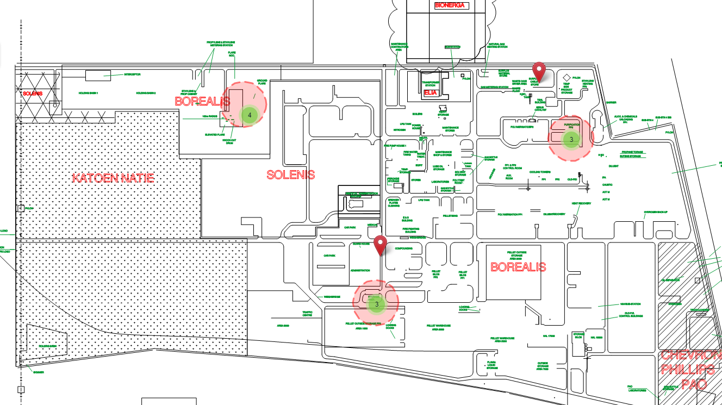
Figure 5. RAPCore map displaying test data in their plotted positions
Using the circles as guidance we were able to create sample data to demonstrate position based filtering of data; each of the 3 locations includes the following set of data:
- Origin permit
- Nearby permit 1
- Nearby permit 2
- Out of range permit
This can be better seen with an increased level of zoom as is the case in the following image which zooms in on location 1.
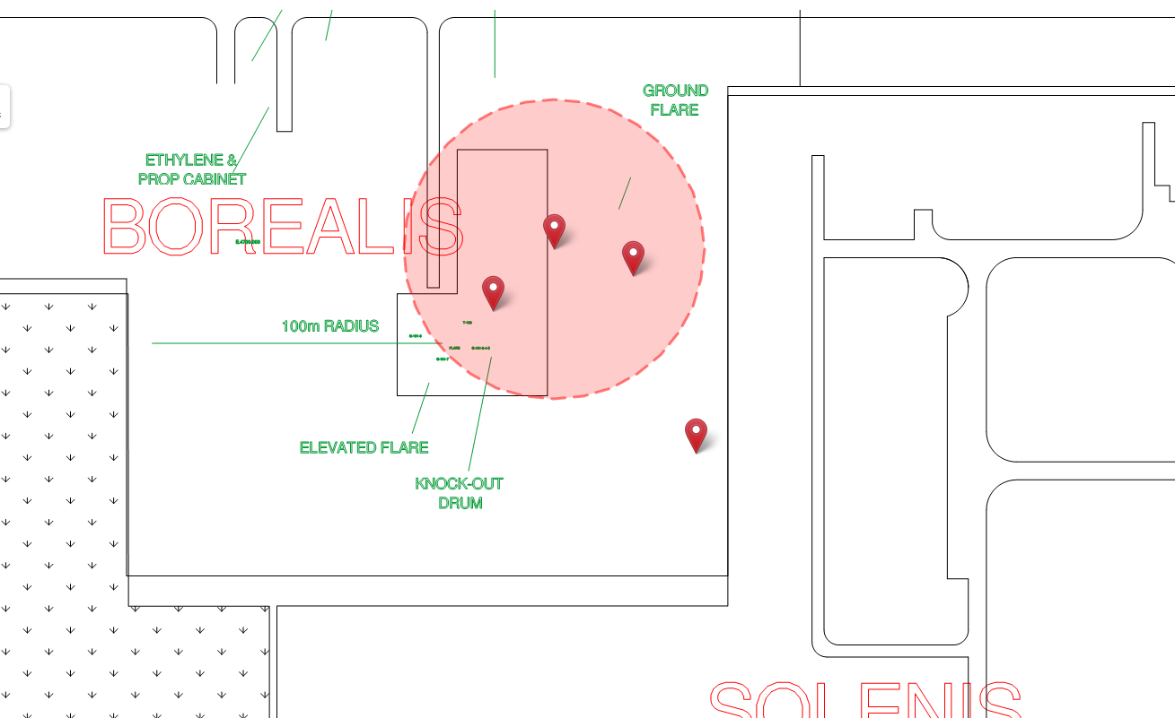
Figure 6. RAPCore map displaying the permits in the vicinity of location 1 at a high level of zoom
With this information, we created a new class in the API to house Realwear endpoints and created a new endpoint that would receive the users position in longitude/latitude in order to convert to a geoJSON instance that could be used to compare against the geoJSON data stored for each permit plotted – allowing for only permits within the range of 50m to be returned.
The other requirement for position based data was to be able to access and record nearby notes, images and videos. To do this we added a new “Map Notes” page, which when accessed will show any notes within 50m of the users current location, by stating “show note” and the notes number the note in question will be shown to the user. The user can also state “take a note”, which will take the user to a screen that will allow for text to be added as a text note, “take photo”, which will take the user to the devices camera to take a picture to upload to the server, and “record video” which also takes the user to the devices camera but set to record mode.
The addition of the notification system from RAPcore was one that required implementation in multiple places within the application:
Permit Conversations – when viewing a permit, the user should be able to view the conversations that have the permit as the target.
User notifications – the user must be able to have a readout of any notifications targeting that users such as being notified about a permit or direct messages.
The permit conversations were added as a list to an alternate page to the permit preview, this way when viewing the permit you can see any conversations regarding it and have the ability to view the conversation to see all messages in the conversation.
The user notifications feature was added as the “Messages” page which was added to the Realwear main page. The realwear main page employs a 10 second interval timer in order to continuously poll the server for a count of unread notifications. If the value returned by the API call is greater than the value in memory (from the last poll or default) then a beep sound is played using the plugin flutter_beep by created by gonoter.com (23).
The Messages page lists all the unread notifications to the user, detailing the name of the user who the message originated from, the notification number, the date/time of the notification and most importantly the notification itself; which is displayed differently depending on the type of notification as the notifications feature is a large feature with multiple uses where the type can mean different properties are/aren’t used.
The user can acknowledge a message as read by stating “dismiss message” and the number of the message, this marks the message as read in the API and decrements the unread notification count.

Testing
The first tests to be carried out are to verify that the location based data is being returned as expected, as such the following permits are expected to be found at the given locations:
Location 1 | Location 2 | Location 3
Location 1 Origin Permit | Location 2 Origin Permit | Location 3 Origin Permit
Permit Near Location 1 No 1 | Permit Near Location 1 No 1 | Permit Near Location 3 No 1
Permit Near Location 1 No 2 | Permit Near Location 2 No 2 | Permit Near Location 3 No 2
Figure 7. Table of expected data for the three test locations

Permit | Expected | Present
Location 1 Origin Permit | Yes | Yes
Permit Near Location 1 No 1 | Yes | Yes
Permit Near Location 1 No 2 | Yes | Yes
Any Other Permits | No | No
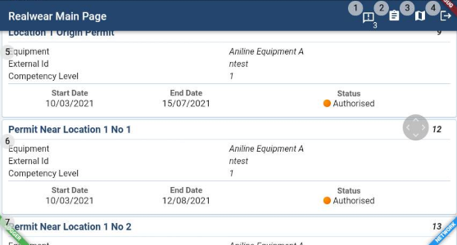
Location 1 Trial:
Figure 8. Application display of data for location 1
Figure 9. Table of expected vs measured data for location 1

Permit | Expected | Present
Location 2 Origin Permit | Yes | Yes
Permit Near Location 2 No 1 | Yes | Yes
Permit Near Location 2 No 2 | Yes | Yes
Any Other Permits | No | No
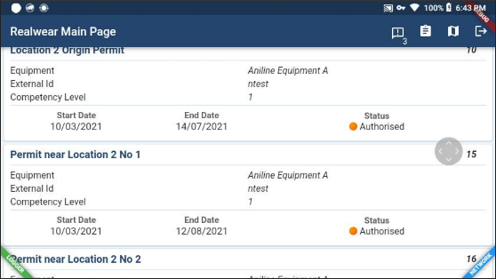
Location 2 Trial:
Figure 10. Application display of data for location 2
Figure 11. Table of expected vs measured data for location 2

Permit | Expected | Present
Location 3 Origin Permit | Yes | Yes
Permit Near Location 3 No 1 | Yes | Yes
Permit Near Location 3 No 2 | Yes | Yes
Any Other Permits | No | No
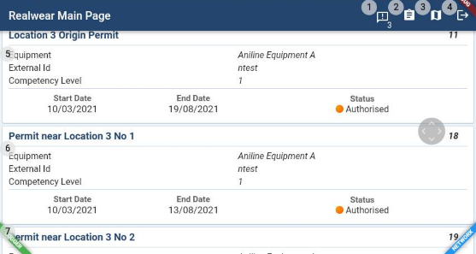
Location 3 Trial:
Figure 12. Application display of data for location 3
Figure 13. Table of expected vs measured data for location 3

From the above tests we are able to establish that the location based filtering is working, however we will further test this by creating map notes in location one and trying to view them in location 2.
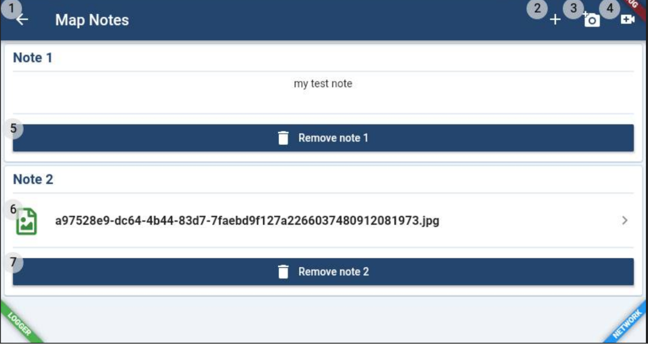
Figure 14. Location 1 map notes view after creation of two example notes in the location
By creating two notes in location one, we are able to view them as expected.
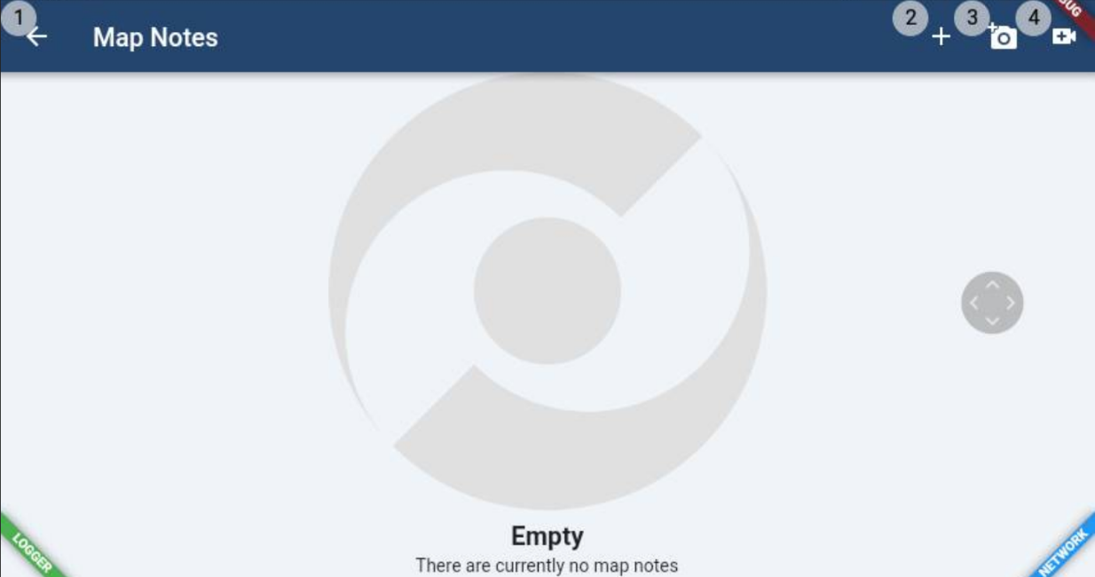
Figure 15. Location 2 map notes view without creating any example notes in the location
When accessing the map note feature in location two, the page informs us there are no map notes, demonstrating successfully that the map notes are being filtered by location correctly.

The next major test is to test the use cases provided by the user stories provided earlier.
  - User Story 1
As a shift worker, I want to be able to view active permits in my vicinity whilst moving around plant, so that I can be safer, knowing what work is being carried out nearby

This user story has been successfully demonstrated and tested by the previous location based tests. The user is presented data within 50 meters of the given current position.
  - User Story 2
As a team leader, I want to be able to view the details of a given permit in the nearby area, so that I can ensure that myself and others are safer by enforcing the required safety measures for work is in place.

This user story builds upon the previous and to test this we needed to ensure that permits could be accessed from the list provided.
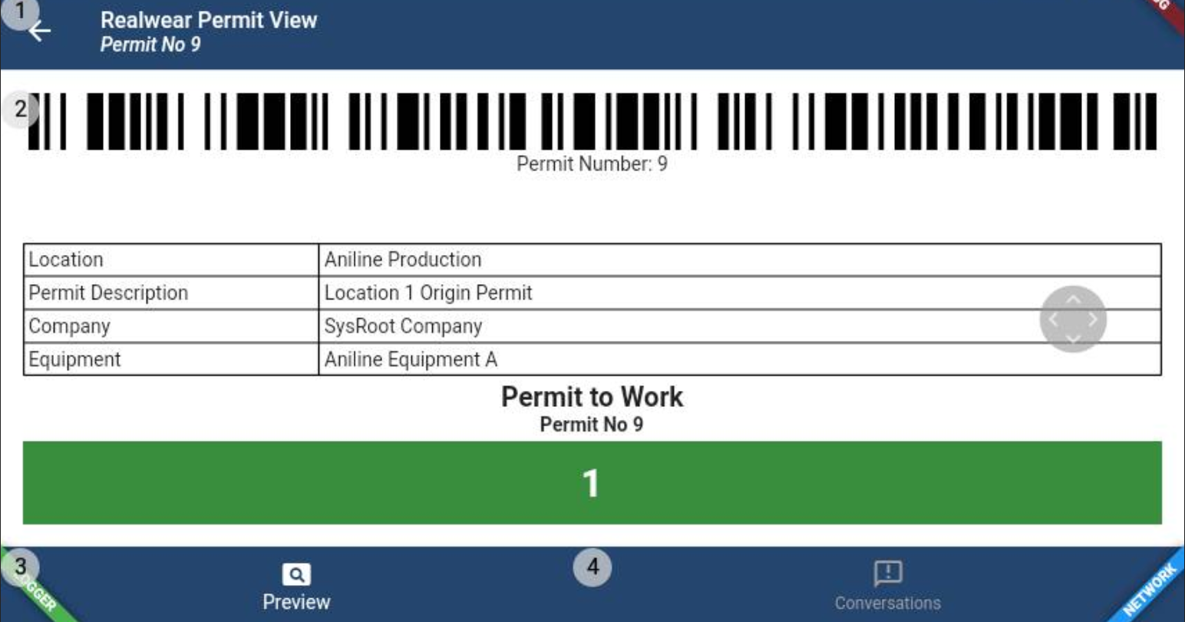
Figure 16. Permit view of Permit accessed from Location 1 permit board
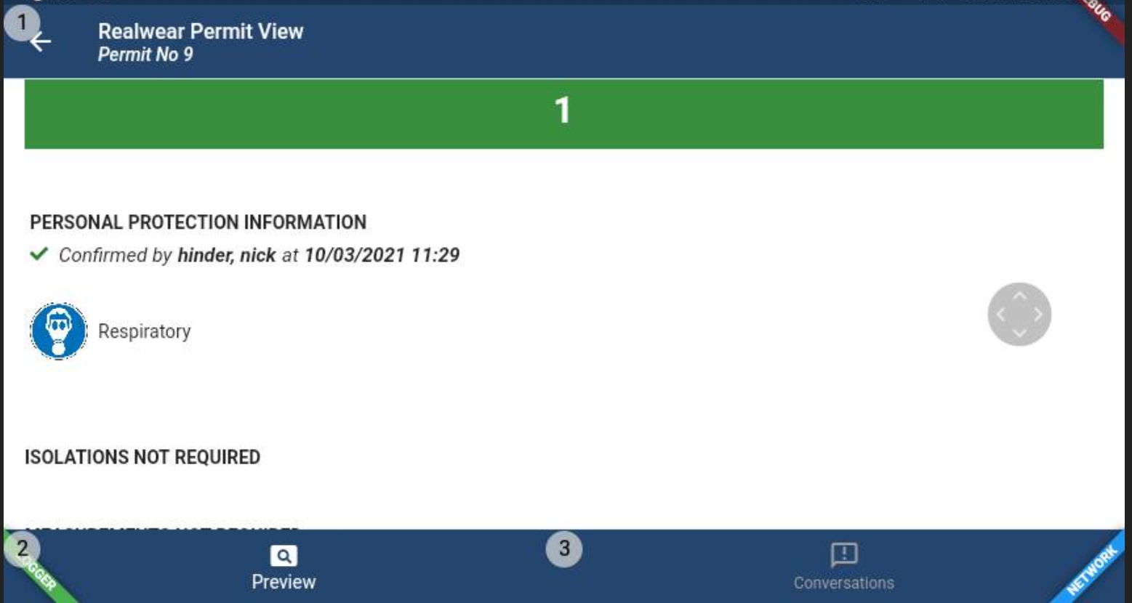
Figure 17. Continued view of the same permit
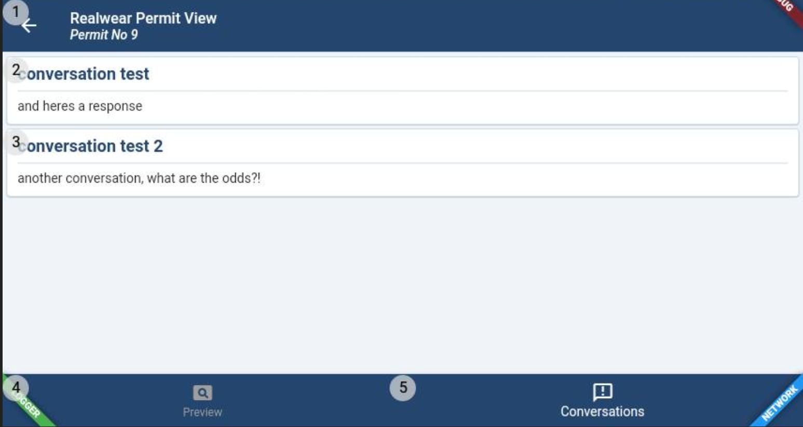
Figure 18. Conversation view for the same permit
As the images demonstrate, permits from the list are accessible, the permit preview yields the information about the permit in its printable form and the conversations tab shows displays any conversations regarding the permit in question.
  - User Story 3
As an engineer, I want to be able to record notes, images and video for my current location, so that I can ensure that I can make others aware of concerns or important information regarding the area.
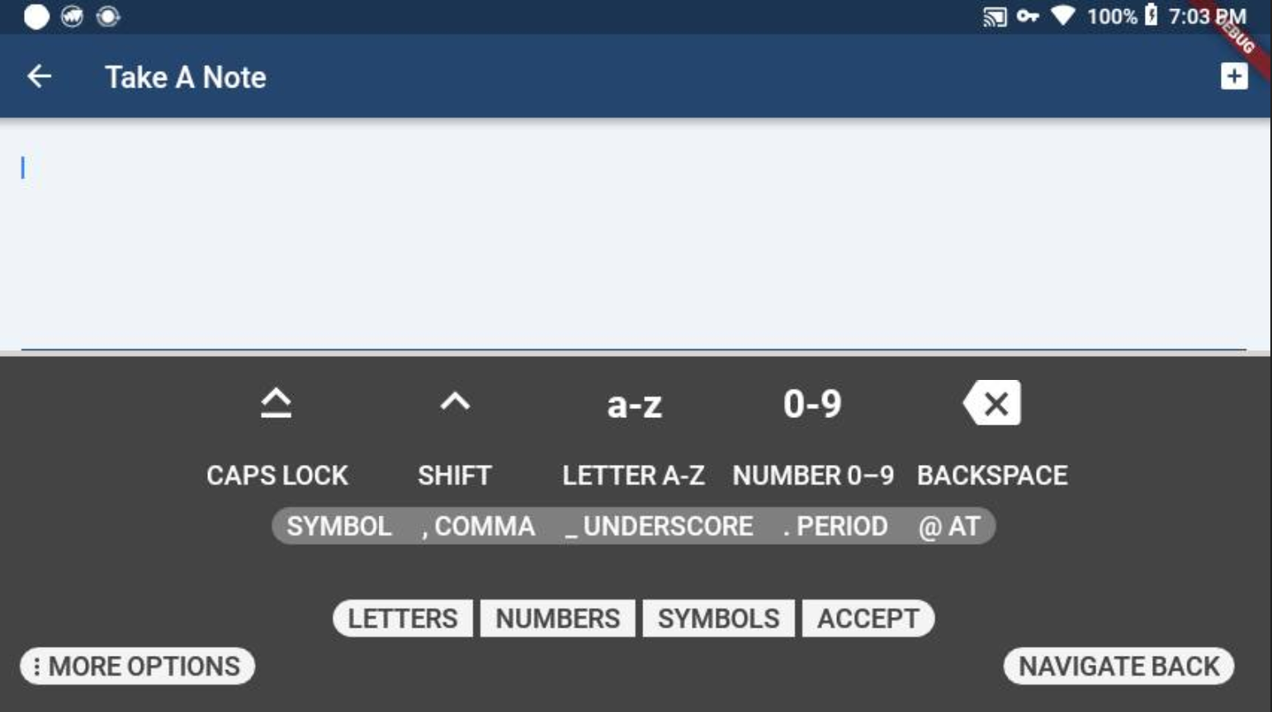
Figure 19. Take note screen
When the user requests to “Take a note” they are taken to the page shown in this image which allows for a text note to be created at the current location; dictation mode can be accessed via the more options Realwear tab.

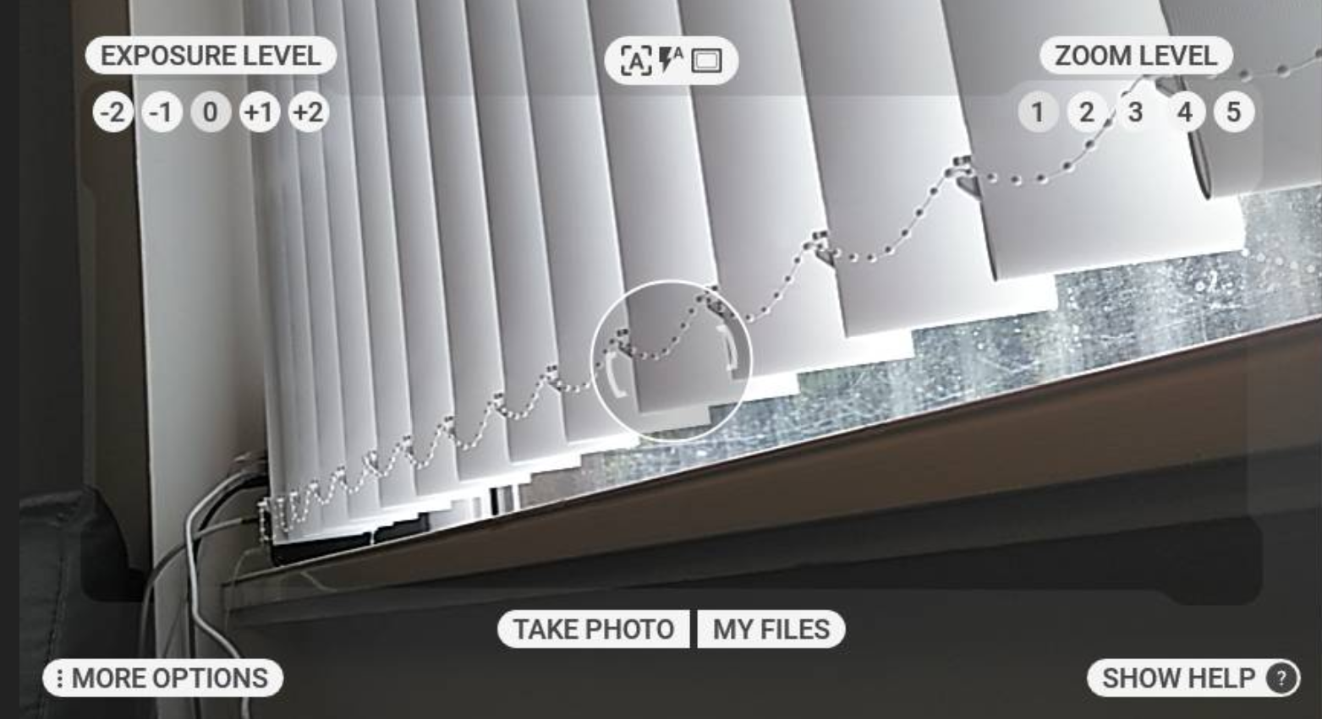
Figure 20. Realwear device's default camera application after app camera call
When either the “take photo” or “record video” commands are given, the user is taken to the devices camera app in either photo mode or video mode; photo mode can be seen in the image above.

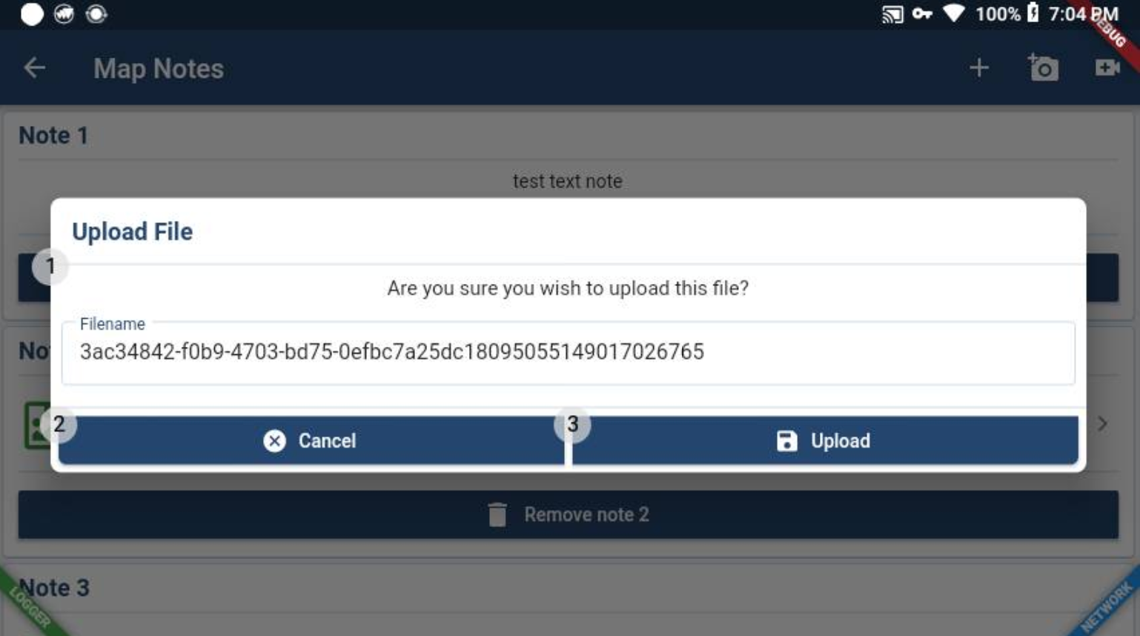
Figure 21. Upload prompt for image taken on device
When a photo or video has been recorded by the camera app the user is prompted to upload the file to the server or to cancel. Once the file has been uploaded the note is officially created and will be returned in future listings. This upload can be seen in the image above.

  - User Story 4
As an area manager, I want to be able to view any notes, images or videos that have been added for the nearby area, so that I can address issues that need to be addressed to support the running of the plant and safety of employees
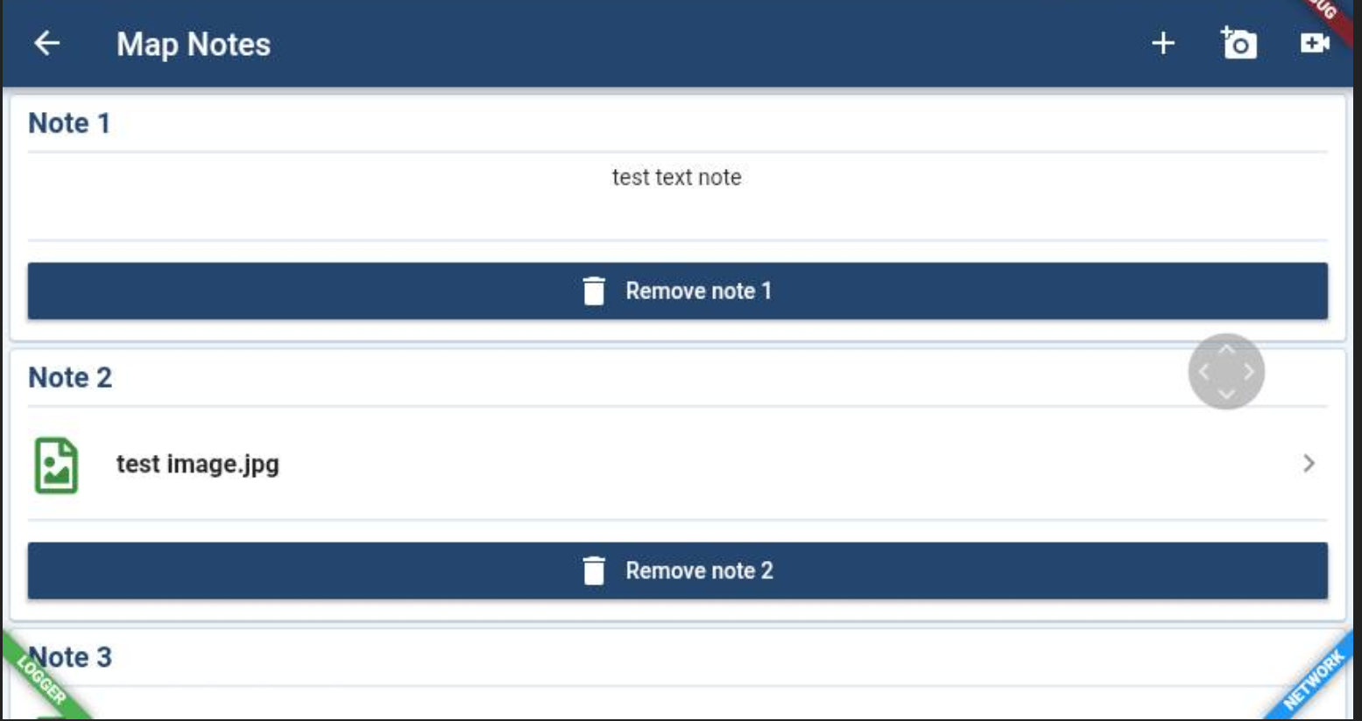
Figure 22. Display screen for added map notes
When the map notes screen is accessed, as well as the ability to add new notes, all existing notes within range are returned to the user, this can be seen in the image above which features 3 previously created notes of different types.

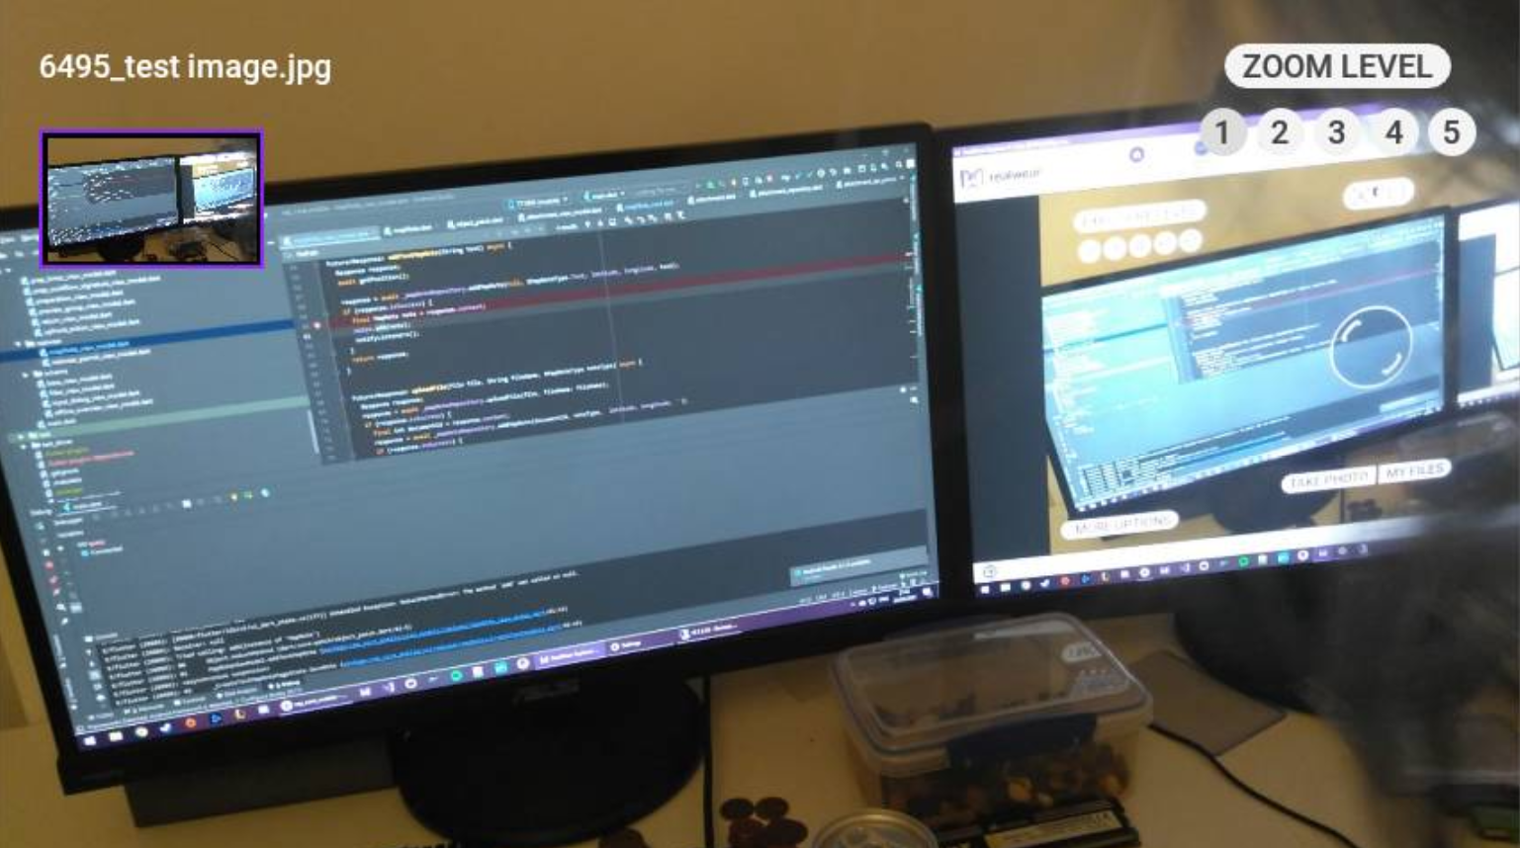
Figure 23. Image gallery view for selected map note
When the user uses the command “View note” and the notes number, if the note is an image or video type the content will be downloaded and displayed to the user using the devices gallery. This can be seen used with note 2, an image note, in the picture above and used with note 3, a video note, in the picture below.

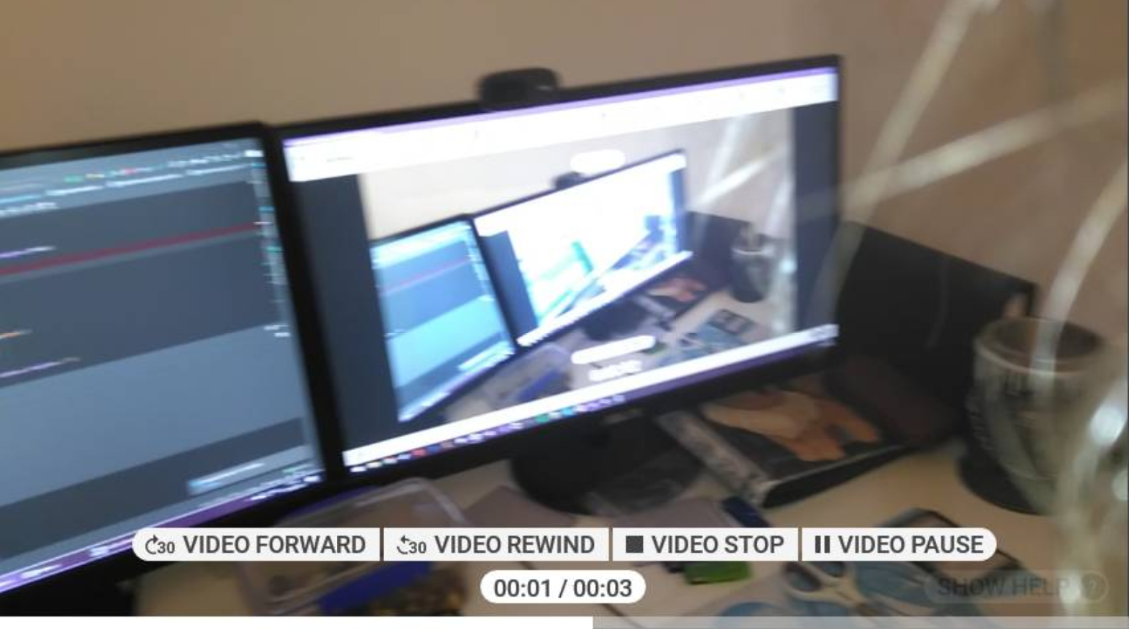
Figure 24. Video gallery view for selected map note

  - User Story 5
As a general user, I want to be able to be able to view notifications that are sent to me, so that I can keep up to date with changes to permits I am working on and messages from other users.

When a user logs into the system they are directed to the Realwear main page which, on the app bar at the top of the page, features an icon display for the messages feature. This messages icon contains the number of “unread” messages for the logged in user, as seen in the image below.
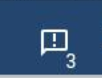
Figure 25. Unread messages icon and counter
When this number changes and is greater than the count previously, including on log-in to the system, the device will emit a beep so that the user is made aware audibly that there are messages to be viewed.
When the user navigates to the messages page they are presented a view of the messages they have yet to dismiss, this can be seen in the image below.

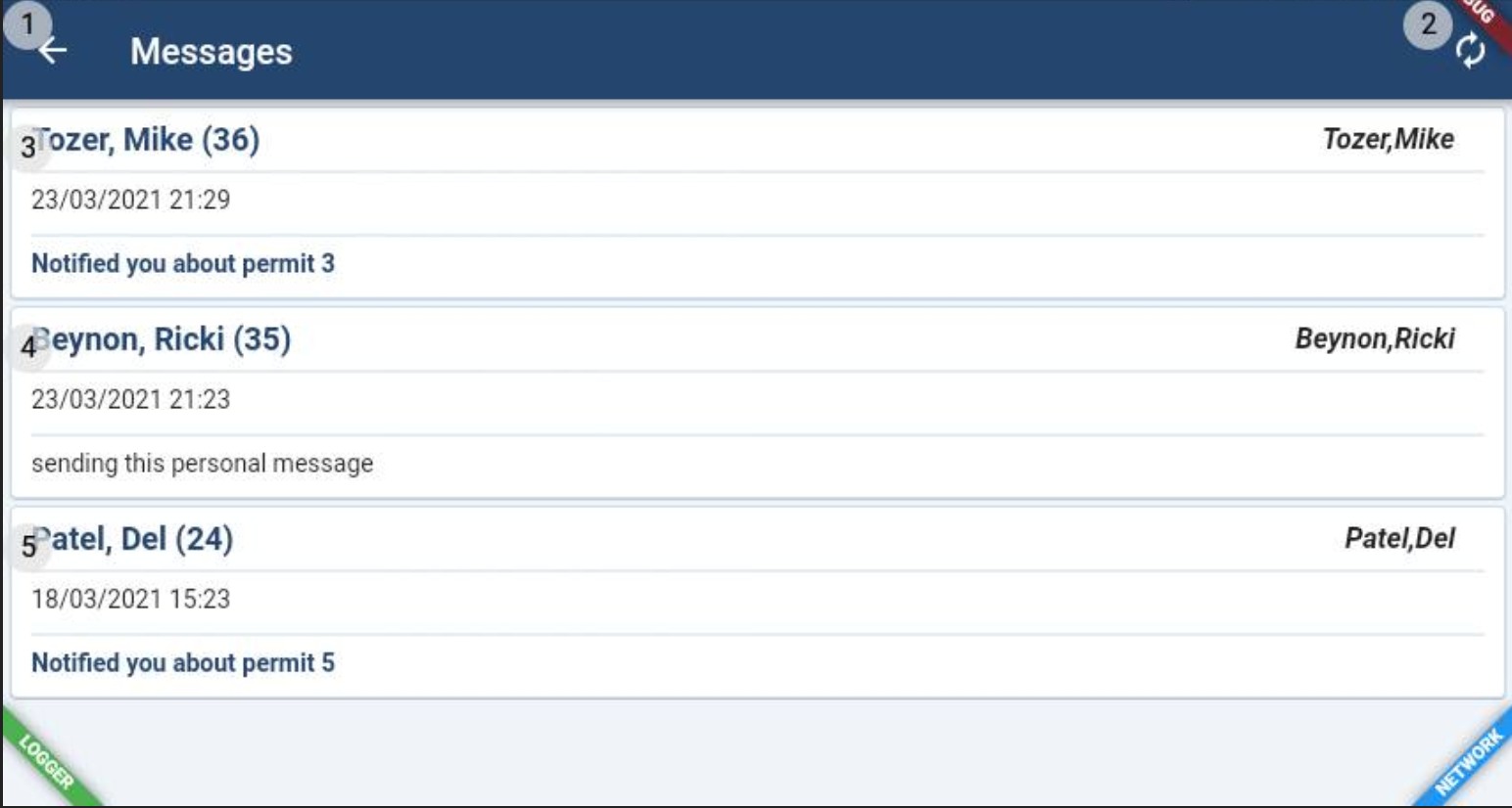
Figure 26. Application view of users unread messages
The image below demonstrates that the user is able to dismiss messages with the command “dismiss message” and the messages number that is displayed in brackets.
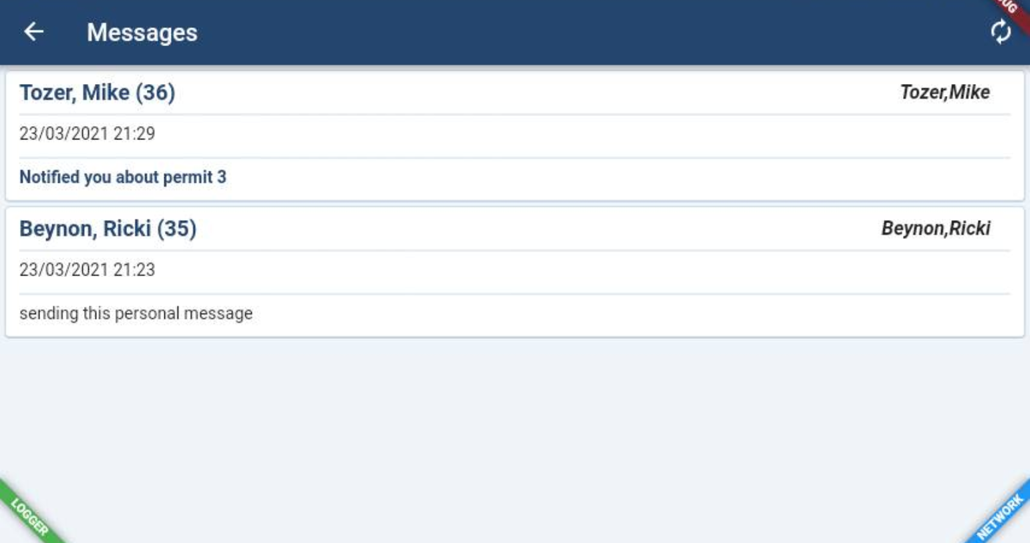
Figure 27. Unread messages after dismissing one of the messages

Conclusions
During this project the existing Flutter mobile application for RAPCore was modified so that it would be usable with Realwear devices.
The three primary objectives of this project have all been met through the implementation of this projects prototype.

- Investigate the usage of smart apparel in PTW and systems and to develop a set of formal requirements for the case study.
Alongside the management team, a set of formal requirements, supported by a series of user stories, was created to form the basis of operations for which the prototype would be developed to enable.
- Evaluate the effectiveness of the Realwear hardware solution through integration of the technology with the existing RapCore PTW application.
The evaluation of the effectiveness was demonstrated through successfully meeting each test case in a manner that was user friendly. This was also verified by management and other developers upon demonstration of the application.

- Analyse the Realwear integration prototype to determine whether the formal requirements have been met effectively
The prototype has been demonstrated to management who have confirmed that the formal requirements of the prototype were met sufficiently. There is further insight and analysis that has been noted and will be discussed in the Further Work section of this report.

Whilst the persisting Covid-19 situation meant that the aim of undertaking usability studies alongside the development of a prototype, that would meet the specification set out by management, was not able to be undertaken; the application was deemed to appear sufficiently intuitive for a prototype by management upon seeing the application demonstrated.
The prototype was demonstrated in a Microsoft Teams meeting with several members of the management team.
The prototype not only met the requirements set by management, but was met with positive opinions from the management team; suggesting that this particular usage of RAPCore may be one that will be pursued further.
The Development manager officially confirmed that the user stories sufficiently demonstrated that the specification provided by management had been met as of April 19th following the aforementioned demonstration see appendix 1.

Further Work
In order for the application to reach a client ready state there are a number of minimum requirements that would need to be addressed and a few features that would be worth investigating.

Minimum requirements
- The Realwear device has a horizontal display so before a client ready solution can be made available, the application would need dedicated Realwear pages for all functionality that is to be supported and used on the Realwear device.
- Comprehensive testing of Realwear position data required before the solution can be sold to clients – this will require a test system with data based in the local area that can be used for testing in a full system test plan.
- The prototype forewent a number of performance improvements that would be required in further iterations of the application such as local data caching.

Suggestions
- The notifications system in the application currently relied on polling the server every 10 seconds to check for new notifications, this is fine for a prototype but for an application to be delivered to clients its not an optimal solution. The polling should be replaced with a more applicable alternative such as socketing.
- There are a number of useful features that the application could include that take advantage of the wearable nature of the device; this should be further explored so as to provide a more complete solution to clients. An example would be potential inclusion of a Voice Over IP (VOIP) feature to allow members of a working party to communicate, whilst working, using the device rather than requiring a traditional radio for such communications.

Reflection
This project and the circumstances surrounding it have provided quite the unique challenge and led to improvements in the ability to adapt to changing circumstances and unexpected issues.
Originally one of the major goals of this project was to undertake a number of usability tests using a fair sized sample of test users from within the business; due to the Covid-19 situation this goal was not feasible due to the current UK guidelines of working from home if possible and social distancing ruling. This project is heavily reliant on the physical device; whilst an approximation of a usability test could be undertaken through online chat, this would introduce a number of uncontrollable variables that would make the results entirely unreliable such as the fact that test users would have to convey their intentions to the user “driving” the application – introducing potential communication issues and removing some degree of feedback that the test user would have by wearing the device.
Before beginning the project there was a concern raised regarding the potential issues that might arise trying to use a Flutter application with the Realwear device; despite this concern, the business and project decision was to pursue the usage of the existing Flutter application unless the case arose that the device was completely incompatible with the framework. This led to a fairly substantial amount of research into the Flutter framework and the way the Realwear launcher interact; this was quite the learning experience, one that demonstrated the importance of due diligence when researching issues and solutions.
The experience of presenting the prototype to management reinforced the satisfaction of meeting the requirements set by product owners. The feedback from some members of the management team highlighted the importance of stressing the point that this, and other projects like it, are prototypes and as such are not client ready products.

Bibliography
1. Hodson, Edward. Permits 'that' work. RoSPA Occupational Safety & Health Journal. 2009, Vol. 39, 8.
2. Cann, Nigel. Lessons from a Permit-to-Work incident. Loss Prevention Bulletin. 2014, 236.
3. Williams, Alun. A mobile UI toolkit to make Flutter. Electronics Weekly. [Online] 2 January 2020. [Cited: 15 November 2020.] https://www.electronicsweekly.com/news/mobile-ui-toolkit-make-flutter-2020-01/.
4. Ernst, Erik, et al. Message safety in Dart. Science of Computer Programming. 2017, Vol. 133.
5. Zuraikat, Laith. Google Glass: A Case Study. Performance Improvement. 2020, Vol. 59, 6.
6. Aukstakalnis, Steve. Practical Augmented Reality: A Guide to the Technologies, Applications and Human Factors for AR and VR. s.l. : Pearson Education, 2016. 9780134094359.
7. Abraham, Magid and Annunziata, Marco. Augmented Reality Is Already Improving Worker Performance. Harvard Business Review. [Online] 13 March 2017. [Cited: 11 January 2021.] https://hbr.org/2017/03/augmented-reality-is-already-improving-worker-performance.
8. PC Business Products. State Grid Deploys Hands-Free Wearable Computer. PC Business Products. 2019, Vol. 30, 3.
9. Hessman, Travis. The High-Tech Disconnect. New Equipment Digest. 2019, Vol. 84, 2.
10. Dou, Jinhua, et al. dentification of usability problems and requirements of elderly Chinese users for smart TV interactions. Behaviour & Information Technology. 2019, Vol. 38, 7.
11. Realwear. RealWear Adds Noise Capture Capabilities and ABC Mode to both HMT-1 and HMT-1Z1. Realwear. [Online] 12 September 2019. [Cited: 11 January 2021.] https://realwear.com/blog/noise-capture-hmt-release-10-2/#:~:text=HMT%2D1%20responds%20to%20voice,time%2C%20even%20in%20extreme%20conditions..
12. Merry, Krista and Bettinger, Pete. Smartphone GPS accuracy study in an urban. PLoS ONE. 2019, Vol. 14, 7.
13. Learning beacons - using the Internet of Things to deliver health and safety materials in student workshops. Whitehead, Nik and Telford, Colin. 2017.
14. Sauro, Jeff. Measuring usability wtih the system usability scale (SUS). MeasuringU. [Online] 2 February 2011. [Cited: 07 12 2020.] https://measuringu.com/sus/.
15. Lewis, Jim and Sauro, Jeff. Three branches od standardized UX measurement. MeasuringU. [Online] 28 January 2020. [Cited: 07 12 2020.] https://measuringu.com/three-branches-ux/.
16. Lewis, J. R and Sauro, J. Quantifying the user experience: Practical statistics for user research. Waltham : Morgan Kaufmann, 2012.
17. Bangor, Aaron, Kortum, Philp T and Miller, James T. An Empirical Evaluation of the System Usability Scale. International Journal of Human-Computer Interaction. 2008, Vol. 24, 6.
18. Orfanou, Konstantina, Tselios, Nikolaos and Katsanos, Christos. Perceived Usability Evaluation of Learning Management Systems: Empirical Evaluation of the System Usability Scale. International Review of Research in Open and Distributed Learning. 2015, Vol. 16.
19. Melmoth, Dean R, et al. Advantages of binocular vision for the control of reaching and grasping. Experimental brain research. 2006, Vol. 171, 3.
20. Choi, Woong, Li, Liang and Lee, Jongho. Characteristic of Motor Control in Three-Dimensional Circular Tracking Movements during Monocular Vision. BioMed Research International. 2019.
21. Klaptsov, Andrei. com.rockwellits.patchflutteraccessibility. Gradle. [Online] 2 July 2020. [Cited: 19 February 2021.] https://plugins.gradle.org/plugin/com.rockwellits.patchflutteraccessibility.
22. baseflow.com. geolocator 7.0.1 . pub.dev. [Online] 23 February 2021. [Cited: 26 February 2021.] https://pub.dev/packages/geolocator.
23. gonoter.com. pub.dev. flutter_beep 0.2.0. [Online] 5 May 2020. [Cited: 26 February 2021.] https://pub.dev/packages/flutter_beep.
24. Motor Sport News. Visor heads-up display on trial. Motor Sport News: The Voice of British Motorsport. 22 August 2018. p. 5.
25. U.S General Services Administration. System usability scale (SUS). Usability.Gov. [Online] [Cited: 2020 12 07.] https://www.usability.gov/how-to-and-tools/methods/system-usability-scale.html.
26. Google. Android API reference. Android Developers. [Online] developer.android.com/reference.

Appendix
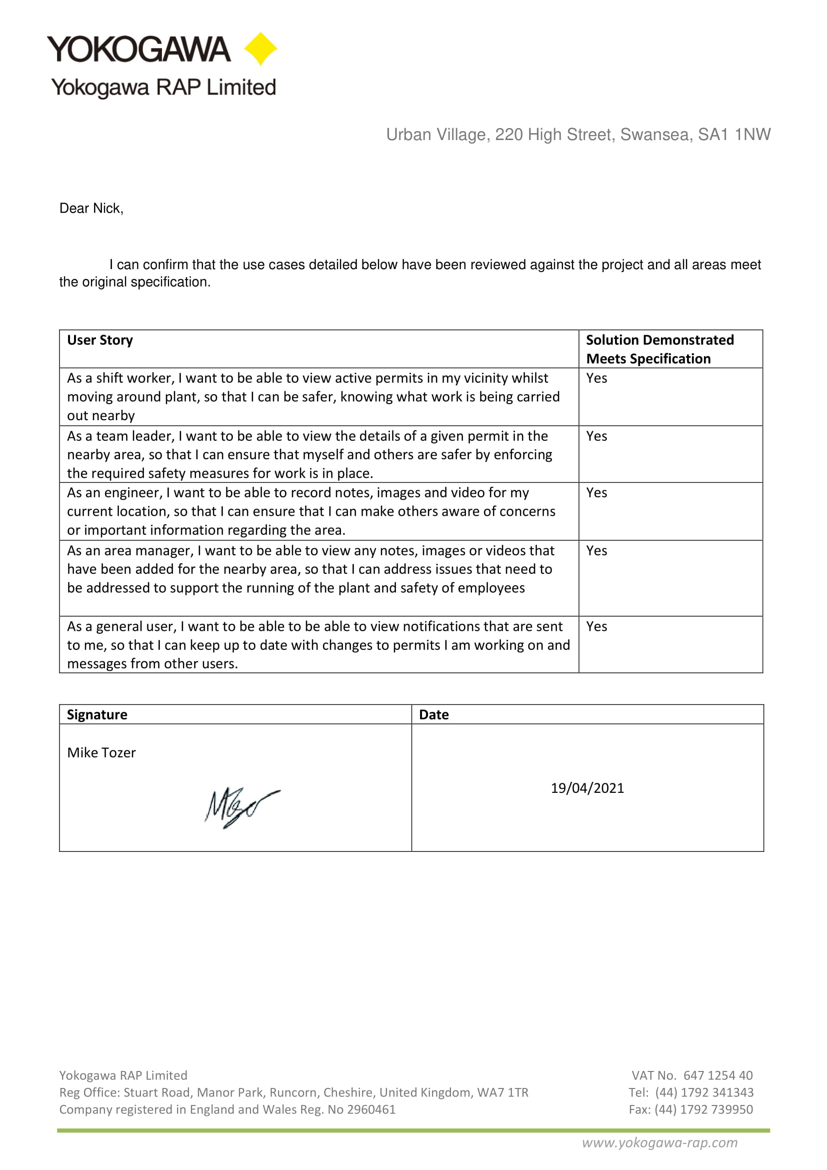
Appendix 1. Letter of confirmation of sign off for prototype
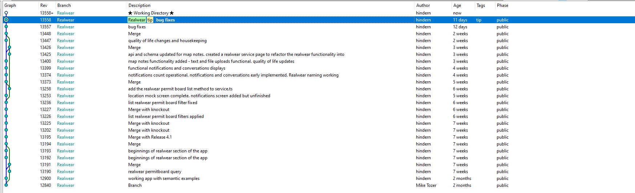
Appendix 2. Source control history for prototype

